
LEVEL 4 ASSESSMENT SPECIFICATION

Student name: | Ruhul Islam Rubel | Student ID number: | 2533221
Programme: | CertHE Computing Skills for Workplace
Module: | Introduction to Web and Database Concepts
Module code: | ACCA4023 | Contribution to  Overall Module Assessment (%): | 50%
Lecturer: | ANUM PRACHA | Internal Verifier: | Sadhana Jha
Assignment Title: | HTML & CSS Web  Development | Word count (or equivalent): | 2000

Contents
I. INTRODUCTION 3
II. REQUIREMENTS 3
III. IMPLEMENTATION 4
IV. EVALUATION 5
A. Website Usability 5
B. Accessibility 5
C. Search Engine Optimisation (SEO) 6
D. Evaluation of the Developed Website 6
E. Comparison with the British Red Cross Website 6
V. CONCLUSION 7
VI. REFERENCES 7
VII. APPENDIX 7

Design and Development of a Responsive British Heart Foundation Website

Abstract- This report details the design, development and evaluation of a responsive website of the British Heart Foundation using HTML5 and CSS3. The purpose of the site was to inform people better about cardiovascular diseases and healthy living, to provide educational resources and opportunities to engage the community through conducting research, volunteering, and making donations. It will be implemented with a set of five connected webpages with a standard set of navigation, responsive design, and convenient accessibility. The quality of the websites was checked by ensuring that the HTML and CSS were successfully validated, which ensured that the websites were up to the recognised web standards. The report critically assesses the usability, accessibility, search engine optimisation, overall functionality, as well as comparing its performance with that of the British Red Cross site.
Keywords: British Heart Foundation, HTML5, CSS3, Responsive Website, Website Usability, Accessibility, Search Engine Optimisation (SEO), Cardiovascular Health, Web Development, User Experience (UX).

I. INTRODUCTION
Cardiovascular disease is one of the leading causes of morbidity and mortality in every country of the world, and access to reliable digital tools that promote prevention, education, and community engagement is imperative. The British Heart Foundation is an old charity organisation that has been striving towards the aim of funding life-saving cardiovascular research, generating awareness among the population and providing viable guidance towards a healthier lifestyle. The establishment of its own British Heart Foundation website provides an effective online platform that allows critical information on heart health, research, support and how people can be engaged by means of volunteering and donation to be highlighted [1]. The website was built as an HTML5 and CSS3 website to give a responsive, standards-compliant and user-friendly interface that gives a comparable browsing experience, regardless of the device used (desktop, tablet, or mobile). The objective of this report is to evaluate how the site was planned, designed, developed and implemented, and to critically evaluate the site against its usability, accessibility, search engine optimisation and overall capacity to deliver on the needs of the users and the organisation with a well-planned and professionally designed web solution.

II. REQUIREMENTS
The primary objective of the developed site is to create an informative and convenient web resource that could assist in achieving the mission of the British Heart Foundation, which consists of increasing the level of awareness of cardiovascular health and establishing healthy relationships with the population. The site is aimed at informing visitors about the most typical heart conditions, encouraging them to make healthier lifestyle choices, discussing current research efforts, and persuading them to donate money to charity and participate in volunteering. By incorporating educational materials and a convenient design, the site will contribute to spreading awareness and helping individuals who require credible health resources [2].
The target audience consists of adults of different ages, patients with cardiovascular diseases, and relatives who care about health information, healthcare providers, volunteers, and potential donors. The user groups will vary in the level of technical knowledge and health literacy, and therefore simplicity, readability and accessibility are the design principles that will be taken into consideration. The site has five pages that are interconnected with the rest: Home, About Us, Heart Health, Research and Support and Contact, allowing the user to locate the information without any problems with a similar structure of navigation.
Some functional requirements were identified in the planning process. They include a responsive navigation menu, organised content sections, informative images with descriptive alternative texts, internal links to all pages, a contact form where users can pose questions, and a common footer with organisational information [3].
Non-functional requirements are related to the quality and performance of the site. It has been developed with accessibility concepts which advance its usability among various users, as well as responsive design which enables it to be compatible with various screen sizes. Image resources are optimised to provide a faster-loading interface, and a clean interface makes it easier to read and navigate.

III. IMPLEMENTATION
The British Heart Foundation web application was developed using HTML5 and CSS3 in such a way that it would generate a responsive, accessible and user-centred web application, which would effectively communicate cardiovascular health information. The systematic development strategy was adopted to ensure that the design is uniform, the navigation is user-friendly, and the site can be used with different devices. The finished version of the site comprises 5 linked pages including Home, About Us, Heart Health, Research & Support, and Contact. All pages have the same layout to enhance visual identification and user experience.
The visual design has been completed in red, white and dark grey colour palette because it is the common colour palette of the branding that tends to go hand in hand with the awareness of cardiovascular, and provides an excellent readability with a high level of visual contrast. It was decided to use typography to make it clear to provide headings and body text in such a way that users can quickly distinguish the important information [4]. The large hero banners, good medical images and strategically located call-to-action buttons all contribute to an interesting interface that helps users navigate towards the required health resources and organisational services. The upper section of each page is a responsive navigation bar which allows easy navigation across the various sections and consistency in interfaces across the various sections of the site.
Semantic HTML5 elements like header, nav, main, section and footer have been used to complete the site, and this has made the site well-structured and standards compliant. All five webpages are linked with internal hyperlinks which enable visitors to easily access information. Alternative text is descriptive and facilitates access and assistive technology [5]. The contact page features a structured enquiry form, and shared common header and footer features make the website look and feel the same way across.
The style of the presentation of the website was managed by CSS3, which allowed managing the site with only one external style sheet, which enhanced its maintainability and minimised the amount of code reuse. Modern layout styles, such as Flexbox, were used to structure the navigation menus, content areas, cards and responsive elements. Layouts were also customised to desktop, tablet and mobile devices with media queries to ensure that they could be easily read and used across different screen resolutions. Interactive features like hover effects, button styling, space and colour transitions make it easier to interact with the user and have a professional appearance [6].
The quality of the websites was checked with the help of the W3C HTML Validator and W3C CSS Validator. The validation proved that there were no errors or warnings in the HTML, and the CSS was validated without any errors, which proves that the web standards are met and the quality of the developed site is technical.
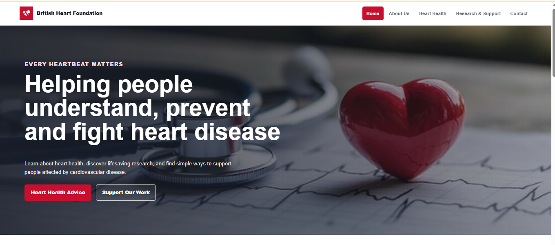
FIGURE 1: HOME PAGE
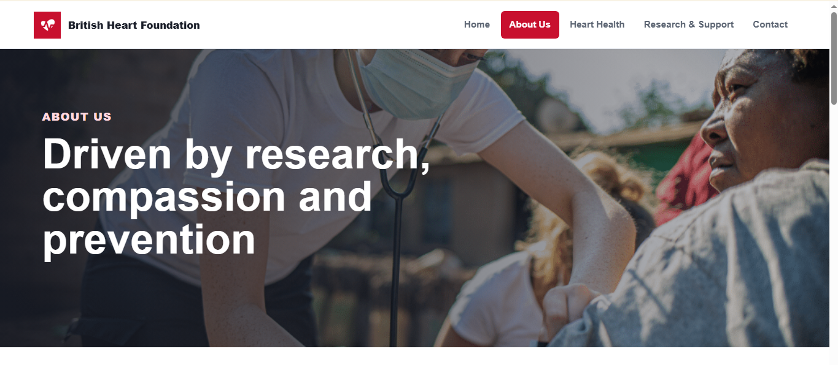
FIGURE 2: ABOUT US PAGE
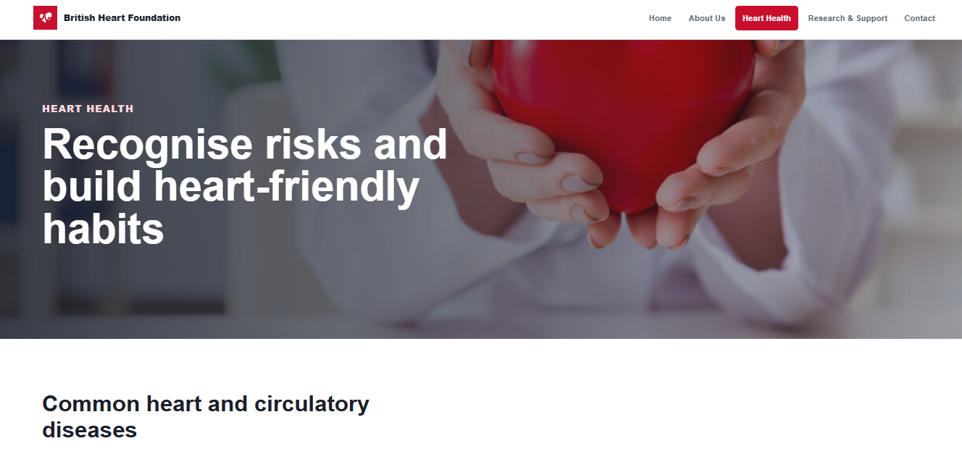
FIGURE 3: HEART HEALTH PAGE
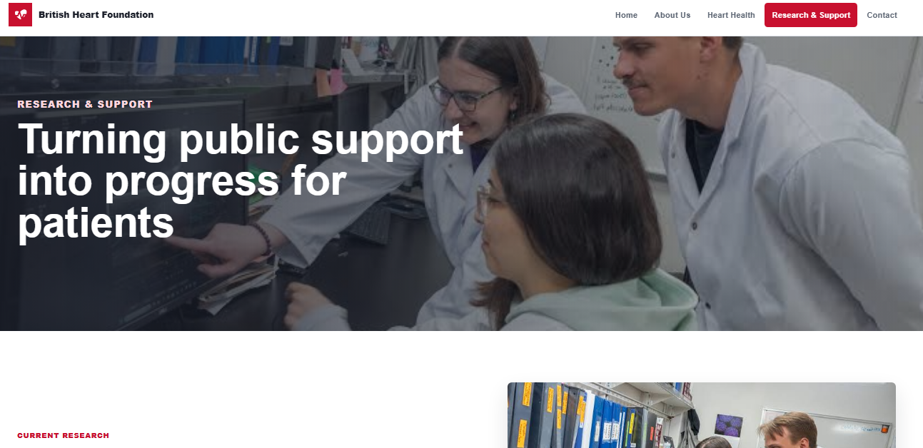
FIGURE 4: RESEARCH & SUPPORT PAGE
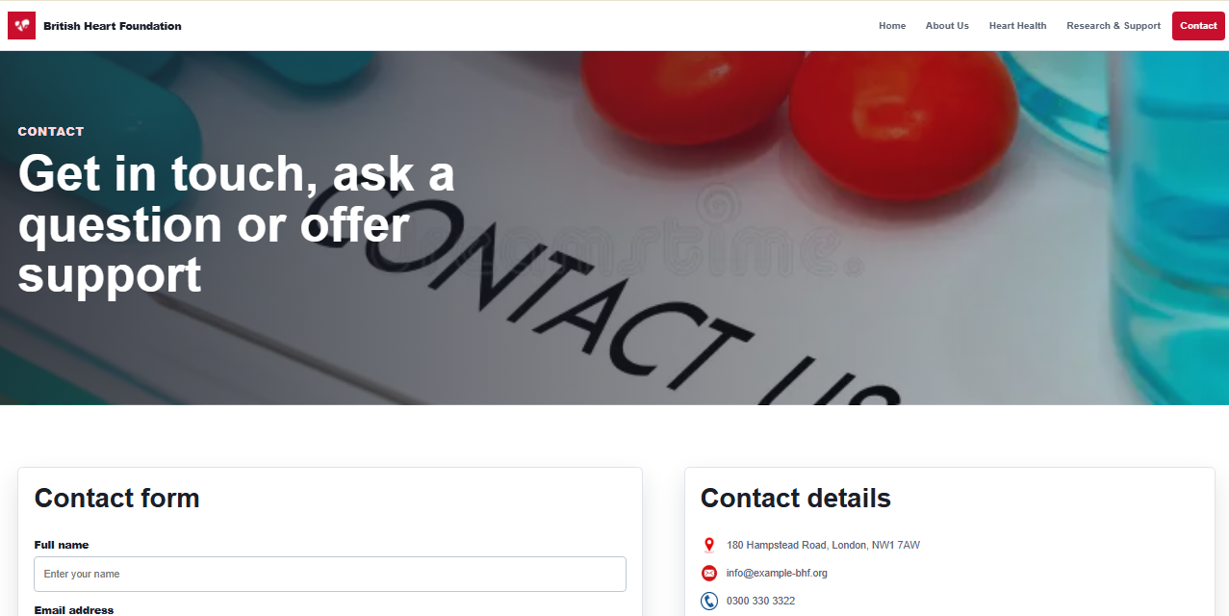
FIGURE 5: CONTACT PAGE
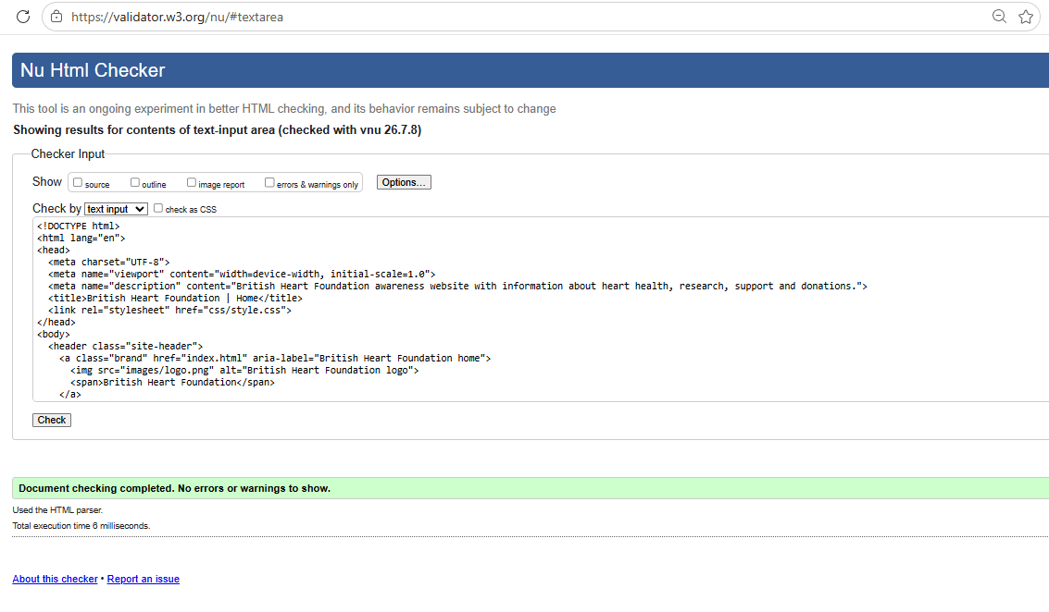
FIGURE 6: HTML VALIDATION RESULT
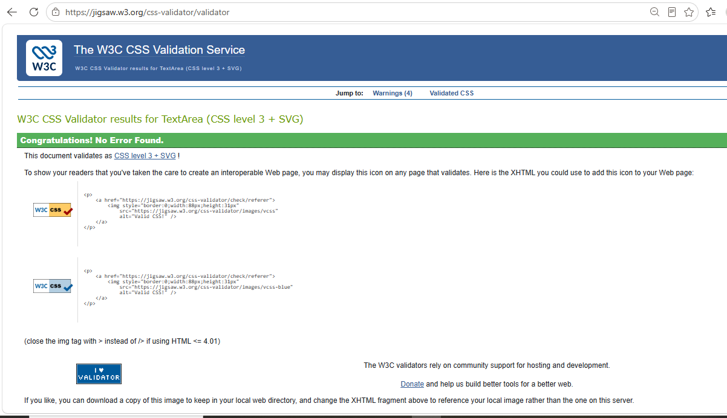
FIGURE 7: CSS VALIDATION RESULT

IV. EVALUATION

A. Website Usability
The concept of website usability is a key element that determines the effectiveness of the customer's interaction with the online platform and access to the necessary information. The created British Heart Foundation website was created to ensure an easy and smooth user experience for people with different digital literacy levels. The five webpages all contain an effective navigation menu that allows the user to navigate effectively through the Home, About Us, Heart Health, Research and Support and the contact sections. Such a logical structure minimises the complexity in navigation and allows visitors to find information with minimal effort.
The site has a clear graphic design through the assistance of regular typography, spacing, as well as logical hierarchy of headings and content sections. Properly designed hero images not only render the web pages more pleasing to the eye, but also enhance the purpose of each webpage [7]. The responsive design will enable the text, images and navigation elements to automatically resize to fit different screen sizes to provide a pleasant browsing experience on desktop, tablet and smartphones. The interactive elements, such as navigation links and call-to-action buttons, are well defined and enhance the overall user interaction.
Overall, the design implemented fulfils the main goals of usability by integrating simplicity, uniformity, and openness. The site is easy to use and enables the user to navigate freely around the site without any unnecessary distraction to enable easy access to information.

B. Accessibility
The concept of accessibility is crucial to the effectiveness of digital content being available and utilised by people with varying physical, sensory and cognitive disabilities. The British Heart Foundation site was designed to incorporate the significant aspects of the four principles of WCAG 2.1, principles: Perceivable, Operable, Understandable and Robust, which has increased inclusivity and user experience.
This perceivability is achieved by the provision of descriptive alternative text for informative images to enable the use of screen readers to relay visual information to the visually disabled [8]. Readability is enhanced by text and background contrasting colours, and easier structuring of the text is supported by a regular heading structure. A simple-to-follow menu, clearly identifiable interactive objects, and flowing design make it easy to navigate without having to scroll horizontally, enabling it to work well on desktops, tablets, and smartphones.
Understandability is promoted through the use of simple language, logical page order and consistent navigation of all five webpages, since users can find the information with the least effort. Standards-compliant HTML5 and CSS3 are reinforced by passing HTML and CSS tests, making sure that it is compatible with the latest browsers and assistive technologies [6].

C. Search Engine Optimisation (SEO)
Search Engine Optimisation (SEO) is an important part which contributes to the improved visibility of the site and enables people to find the required information with the help of the search engines. The British Heart Foundation website that has been created has several on-page SEO activities in order to improve discoverability and, at the same time, has a user-friendly design. The web pages have their own page titles which are unique and descriptive, and reflect the content of the webpage, complemented by brief meta descriptions that enhance search engines and user interest. The hierarchical structure of the headings (one main and several secondary headings) contributes to enhancing the readability and structure of the content.
Descriptive alternative text has been provided on all informative pictures, and this helps in indexing images and making them more accessible. The five webpages have internal hyperlinks which enable effective search engine crawling of the website and enable users to move about related sections. The keywords used are related to cardiovascular health and awareness of heart diseases, healthy lifestyles, research and charitable support that have been used naturally and without overuse of repetition throughout the content [9]. Further improvements can include structured schema markup, XML sitemaps, browser caching, image compression, and Open Graph metadata to make the search visible and online engagement even more.

D. Evaluation of the Developed Website
The end product, the British Heart Foundation website, has achieved its main goal of creating a responsive, informative and easy-to-use site that facilitates awareness of cardiovascular health. The site is functionally good, having a steady weight in terms of navigation to five linked web pages, responsive design to suit the various screen sizes and a well-structured contact form to assist in responding to the enquiries posted by the users. The repetition of the design features the navigation menu, the colour scheme, the typography, the footer brings unity to the images and makes the user more used to the image as they browse the site.
Regarding usability, the clean interface, the structure of the content and effective use of images will make the experience of browsing interesting and minimise the cognitive effort. Presentation of educational information is done in a logical manner, and visitors can easily find relevant health guidance depending on the level of medical knowledge. Technical quality is also proven by the successful HTML and CSS validation, which proves that they are in accordance with the accepted web standards and can be enhanced to work with the latest browsers [10]. These strengths can be enhanced by incorporating an online donation system, live chat service, personalised newsletters, advanced search utilities, multilingual support, and making appointments, which can make the site better.

E. Comparison with the British Red Cross Website
Both the British Heart Foundation and British Red Cross websites are credible charity websites that are designed to provide information, support, and community interaction. Nonetheless, they have different overall focus and user experience based on their organisational goals. The developed British Heart Foundation site adheres to a simplified version of navigation with five clearly arranged web pages, and through these, cardiovascular health information can be accessed easily and efficiently by the users of the site [9]. Comparatively, the British Red Cross website possesses a wider range of humanitarian services; hence, it has a greater number of categories and subcategories in the system of navigation.
The two websites have high accessibility as regards responsive layouts, readable typeface, semantic structure of the content and compatibility with both desktop and portable devices. Equally, both sites use good SEO techniques, such as descriptive page titles, headings, internal links and mobile-friendly design. However, the British Red Cross site has more frequently updated content and online authority, which also contributes to greater search engine presence [5].

V. CONCLUSION
The British Heart Foundation is a London-based outfit that has been able to demonstrate how HTML5 and CSS3 can be effectively applied to the development of a responsive, accessible, and standards-compliant informational site. The implementation and deployment achieve the objectives by providing sequential navigation, consistent visual design, pedagogical information and effective interactive use on five interconnected web pages. Technical quality and maintainability were ensured by validation that both HTML and CSS met recognised web standards. The analysis of the website has shown high ratings in the sphere of usability, accessibility, and search engine optimisation and demonstrated the possibilities to improve the user experience in the future by providing more advanced interactive services, online donation, personalised communication options, and greater accessibility support.

VI. REFERENCES
[1] A. Parlakkiliç, “Evaluating the Effects of Responsive Design on the Usability of Academic Websites in the Pandemic,” Education and Information Technologies, vol. 27, no. 1, July 2021, doi: 10.1007/s10639-021-10650-9.
[2] B. C. Vinaykarthik and Mohana, “Design of Artificial Intelligence (AI) Based User Experience Websites for E-commerce Application and Future of Digital Marketing,” 2022 3Rd International Conference on Smart Electronics and Communication (ICOSEC), Oct. 2022, doi: 10.1109/icosec54921.2022.9952005.
[3] T. Chatziemmanouil and C. Katsanos, “Accessibility Academy: Interactive Learning of the WCAG 2.1 Web Accessibility Guidelines,” 2024 IEEE Global Engineering Education Conference (EDUCON), pp. 1–7, May 2024, doi: 10.1109/educon60312.2024.10578915.
[4] J. Ara and C. Sik-Lanyi, “Automated evaluation of accessibility issues of webpage content: tool and evaluation,” Scientific Reports, vol. 15, no. 1, Mar. 2025, doi: 10.1038/s41598-025-92192-5.
[5] S. S. AMAN, B. G. N’GUESSAN, D. D. A. AGBO, and T. KONE, “Search engine Performance optimization: methods and techniques,” F1000Research, vol. 12, p. 1317, May 2024, doi: 10.12688/f1000research.140393.3.
[6] U. F. Ahmad, J. Mahdee, and N. A. Bakar, “Search engine optimisation (SEO) strategy as determinants to enhance the online brand positioning,” F1000Research, vol. 11, no. 2, pp. 714–714, Feb. 2024, doi: 10.12688/f1000research.73382.2.
[7] V. Gor, “HTML5 and Responsive Web Design,” Creating Responsive Websites Using HTML5 and CSS3, pp. 23–60, 2023, doi: 10.1007/978-1-4842-9783-4_2.
[8] K. Washington, “Modern Practices for Responsive Web Design and Web Accessibility,” DigitalCommons@University of Nebraska - Lincoln, 2023. https://digitalcommons.unl.edu/honorstheses/640/ (accessed July 09, 2026).
[9] M. Saad, A. Zia, M. Raza, M. Kundi, and M. Haleem, “A comprehensive analysis of healthcare websites usability features, testing techniques and issues,” IEEE Access, vol. 10, pp. 1–1, 2022, doi: 10.1109/access.2022.3193378.
[10] R. Hallal, Samir Abdul Aal, M. Wahab, Moied Al Sakan, Ruba Hadla, and Karim Zahed, “Assessing the Usability and User Experience of Health Information Systems: A Rapid Review,” Telemedicine Journal and e-Health, Sept. 2025, doi: 10.1177/15305627251381636.

VII. APPENDIX
Index code:
<!DOCTYPE html>
<html lang="en">
<head>
<meta charset="UTF-8">
<meta name="viewport" content="width=device-width, initial-scale=1.0">
<meta name="description" content="British Heart Foundation awareness website with information about heart health, research, support and donations.">
<title>British Heart Foundation | Home</title>
<link rel="stylesheet" href="css/style.css">
</head>
<body>
<header class="site-header">
<a class="brand" href="index.html" aria-label="British Heart Foundation home">
<img src="images/logo.png" alt="British Heart Foundation logo">
<span>British Heart Foundation</span>
</a>
<nav class="main-nav" aria-label="Main navigation">
<a class="active" href="index.html">Home</a>
<a href="about.html">About Us</a>
<a href="heart-health.html">Heart Health</a>
<a href="research.html">Research &amp; Support</a>
<a href="contact.html">Contact</a>
</nav>
</header>

<main>
<section class="hero hero-home">
<div class="hero-content">
<p class="eyebrow">Every heartbeat matters</p>
<h1>Helping people understand, prevent and fight heart disease</h1>
<p>Learn about heart health, discover lifesaving research, and find simple ways to support people affected by cardiovascular disease.</p>
<div class="hero-actions">
<a class="button primary" href="heart-health.html">Heart Health Advice</a>
<a class="button secondary" href="research.html">Support Our Work</a>
</div>
</div>
</section>

<section class="section split">
<div>
<p class="eyebrow">About the charity</p>
<h2>Working towards a healthier future</h2>
<p>The British Heart Foundation is a UK charity dedicated to funding research, sharing health information and supporting people living with heart and circulatory conditions.</p>
<p>This website presents clear information for visitors, patients, families, students and supporters.</p>
</div>
<img src="images/about.jpg" alt="A healthcare professional talking with a patient">
</section>

<section class="section">
<div class="section-heading">
<p class="eyebrow">Latest campaign</p>
<h2>Small choices can protect your heart</h2>
<p>Healthy daily habits can lower risk and help people feel more confident about their wellbeing.</p>
</div>
<div class="card-grid three">
<article class="card">
<img class="icon" src="icons/heart.png" alt="">
<h3>Move more often</h3>
<p>Regular physical activity supports circulation, blood pressure and overall health.</p>
</article>
<article class="card">
<img class="icon" src="icons/doctor.png" alt="">
<h3>Know your numbers</h3>
<p>Checking blood pressure and cholesterol helps identify risks earlier.</p>
</article>
<article class="card">
<img class="icon" src="icons/support.png" alt="">
<h3>Ask for support</h3>
<p>Advice from health professionals can make lifestyle changes easier to maintain.</p>
</article>
</div>
</section>

<section class="stats-band" aria-label="Heart disease statistics">
<div>
<strong>1 in 4</strong>
<span>UK deaths are linked to heart and circulatory diseases.</span>
</div>
<div>
<strong>Millions</strong>
<span>of people live with heart and circulatory conditions.</span>
</div>
<div>
<strong>Research</strong>
<span>helps improve diagnosis, treatment and recovery.</span>
</div>
</section>

<section class="section cta">
<img src="images/donation.jpg" alt="A volunteer holding a donation box">
<div>
<p class="eyebrow">Make a difference</p>
<h2>Your support can help fund research and care</h2>
<p>Donations, fundraising and volunteering all help charities continue their work in communities and hospitals.</p>
<a class="button primary" href="contact.html">Get Involved</a>
</div>
</section>
</main>

<footer class="site-footer">
<div>
<h2>British Heart Foundation</h2>
<p>An educational student website about heart health, research and community support.</p>
</div>
<div class="footer-links">
<a href="about.html">About</a>
<a href="heart-health.html">Heart Health</a>
<a href="research.html">Research</a>
<a href="contact.html">Contact</a>
</div>
</footer>
</body>
</html>
About code:
<!DOCTYPE html>
<html lang="en">
<head>
<meta charset="UTF-8">
<meta name="viewport" content="width=device-width, initial-scale=1.0">
<meta name="description" content="Learn about the mission, vision, history, values and achievements of the British Heart Foundation.">
<title>British Heart Foundation | About Us</title>
<link rel="stylesheet" href="css/style.css">
</head>
<body>
<header class="site-header">
<a class="brand" href="index.html" aria-label="British Heart Foundation home">
<img src="images/logo.png" alt="British Heart Foundation logo">
<span>British Heart Foundation</span>
</a>
<nav class="main-nav" aria-label="Main navigation">
<a href="index.html">Home</a>
<a class="active" href="about.html">About Us</a>
<a href="heart-health.html">Heart Health</a>
<a href="research.html">Research &amp; Support</a>
<a href="contact.html">Contact</a>
</nav>
</header>

<main>
<section class="page-hero about-hero">
<div>
<p class="eyebrow">About us</p>
<h1>Driven by research, compassion and prevention</h1>
</div>
</section>

<section class="section split">
<div>
<h2>Mission</h2>
<p>Our mission is to support lifesaving research, raise awareness of heart and circulatory diseases, and help people make informed health choices.</p>
<h2>Vision</h2>
<p>We want a future where fewer families lose loved ones to preventable heart conditions and more people receive effective treatment at the right time.</p>
</div>
<img src="images/volunteer.jpg" alt="Volunteers preparing community support materials">
</section>

<section class="section">
<div class="section-heading">
<p class="eyebrow">Our story</p>
<h2>History and impact</h2>
<p>For decades, heart charities have helped turn scientific discoveries into better care, clearer guidance and stronger public awareness.</p>
</div>
<div class="timeline">
<article>
<span>Research</span>
<h3>Funding discoveries</h3>
<p>Supporting studies that improve understanding of heart disease, stroke and related conditions.</p>
</article>
<article>
<span>Education</span>
<h3>Sharing knowledge</h3>
<p>Providing advice on symptoms, risk factors, healthy living and when to seek help.</p>
</article>
<article>
<span>Community</span>
<h3>Supporting people</h3>
<p>Encouraging fundraising, volunteering and local support for patients and families.</p>
</article>
</div>
</section>

<section class="section values">
<div class="section-heading">
<p class="eyebrow">Core values</p>
<h2>What guides the work</h2>
</div>
<div class="card-grid four">
<article class="card"><h3>Compassion</h3><p>Putting people affected by heart conditions at the centre of every message.</p></article>
<article class="card"><h3>Evidence</h3><p>Promoting health information that is clear, responsible and research informed.</p></article>
<article class="card"><h3>Inclusion</h3><p>Making advice accessible to people from different backgrounds and needs.</p></article>
<article class="card"><h3>Action</h3><p>Encouraging practical steps that can improve heart health and wellbeing.</p></article>
</div>
</section>
</main>

<footer class="site-footer">
<div>
<h2>British Heart Foundation</h2>
<p>An educational student website about heart health, research and community support.</p>
</div>
<div class="footer-links">
<a href="index.html">Home</a>
<a href="heart-health.html">Heart Health</a>
<a href="research.html">Research</a>
<a href="contact.html">Contact</a>
</div>
</footer>
</body>
</html>
Heart-health code:
<!DOCTYPE html>
<html lang="en">
<head>
<meta charset="UTF-8">
<meta name="viewport" content="width=device-width, initial-scale=1.0">
<meta name="description" content="Heart health information covering symptoms, risk factors, lifestyle tips and emergency advice.">
<title>British Heart Foundation | Heart Health</title>
<link rel="stylesheet" href="css/style.css">
</head>
<body>
<header class="site-header">
<a class="brand" href="index.html" aria-label="British Heart Foundation home">
<img src="images/logo.png" alt="British Heart Foundation logo">
<span>British Heart Foundation</span>
</a>
<nav class="main-nav" aria-label="Main navigation">
<a href="index.html">Home</a>
<a href="about.html">About Us</a>
<a class="active" href="heart-health.html">Heart Health</a>
<a href="research.html">Research &amp; Support</a>
<a href="contact.html">Contact</a>
</nav>
</header>

<main>
<section class="page-hero health-hero">
<div>
<p class="eyebrow">Heart health</p>
<h1>Recognise risks and build heart-friendly habits</h1>
</div>
</section>

<section class="section">
<div class="section-heading">
<h2>Common heart and circulatory diseases</h2>
<p>Heart conditions can affect how blood moves around the body. Learning the basics helps people take symptoms seriously.</p>
</div>
<div class="card-grid three">
<article class="card"><h3>Coronary heart disease</h3><p>Occurs when arteries supplying the heart become narrowed, reducing blood flow.</p></article>
<article class="card"><h3>Heart attack</h3><p>A medical emergency caused when blood supply to part of the heart is blocked.</p></article>
<article class="card"><h3>Stroke</h3><p>Happens when blood supply to part of the brain is interrupted or reduced.</p></article>
</div>
</section>

<section class="section split reverse">
<img src="images/healthy-heart.jpg" alt="Healthy food, trainers and a heart symbol">
<div>
<p class="eyebrow">Symptoms</p>
<h2>Warning signs to notice</h2>
<ul class="check-list">
<li>Chest pain, tightness, pressure or heaviness</li>
<li>Pain spreading to arms, neck, jaw, back or stomach</li>
<li>Shortness of breath, sweating or feeling sick</li>
<li>Sudden weakness, facial drooping or speech problems</li>
</ul>
</div>
</section>

<section class="section risk-section">
<div class="section-heading">
<p class="eyebrow">Risk factors</p>
<h2>What can increase risk?</h2>
</div>
<div class="risk-grid">
<span>High blood pressure</span>
<span>Smoking</span>
<span>High cholesterol</span>
<span>Diabetes</span>
<span>Low physical activity</span>
<span>Unbalanced diet</span>
<span>Family history</span>
<span>Stress and poor sleep</span>
</div>
</section>

<section class="section">
<div class="section-heading">
<p class="eyebrow">Healthy lifestyle</p>
<h2>Simple habits that support your heart</h2>
</div>
<div class="card-grid four">
<article class="card"><h3>Eat well</h3><p>Choose vegetables, fruit, wholegrains, lean proteins and unsaturated fats.</p></article>
<article class="card"><h3>Stay active</h3><p>Aim for regular movement that suits your age, ability and medical advice.</p></article>
<article class="card"><h3>Avoid smoking</h3><p>Stopping smoking is one of the strongest ways to reduce heart risk.</p></article>
<article class="card"><h3>Manage stress</h3><p>Sleep, social support and relaxation can help protect long-term wellbeing.</p></article>
</div>
</section>

<section class="emergency">
<h2>Emergency advice</h2>
<p>If someone may be having a heart attack or stroke, call emergency services immediately. This website is for education and does not replace medical advice.</p>
</section>
</main>

<footer class="site-footer">
<div>
<h2>British Heart Foundation</h2>
<p>An educational student website about heart health, research and community support.</p>
</div>
<div class="footer-links">
<a href="index.html">Home</a>
<a href="about.html">About</a>
<a href="research.html">Research</a>
<a href="contact.html">Contact</a>
</div>
</footer>
</body>
</html>
Research code:
<!DOCTYPE html>
<html lang="en">
<head>
<meta charset="UTF-8">
<meta name="viewport" content="width=device-width, initial-scale=1.0">
<meta name="description" content="Discover heart research, patient support, community services, fundraising and volunteer opportunities.">
<title>British Heart Foundation | Research & Support</title>
<link rel="stylesheet" href="css/style.css">
</head>
<body>
<header class="site-header">
<a class="brand" href="index.html" aria-label="British Heart Foundation home">
<img src="images/logo.png" alt="British Heart Foundation logo">
<span>British Heart Foundation</span>
</a>
<nav class="main-nav" aria-label="Main navigation">
<a href="index.html">Home</a>
<a href="about.html">About Us</a>
<a href="heart-health.html">Heart Health</a>
<a class="active" href="research.html">Research &amp; Support</a>
<a href="contact.html">Contact</a>
</nav>
</header>

<main>
<section class="page-hero research-hero">
<div>
<p class="eyebrow">Research &amp; support</p>
<h1>Turning public support into progress for patients</h1>
</div>
</section>

<section class="section split">
<div>
<p class="eyebrow">Current research</p>
<h2>Improving diagnosis, treatment and recovery</h2>
<p>Research helps scientists and healthcare professionals understand why heart and circulatory diseases happen, how they can be prevented, and how treatment can become more effective.</p>
<p>Areas of study include inherited conditions, heart attacks, strokes, heart failure, imaging, medicines and rehabilitation.</p>
</div>
<img src="images/research.jpg" alt="Researchers studying heart health data">
</section>

<section class="section">
<div class="section-heading">
<p class="eyebrow">Support services</p>
<h2>Helping people beyond the hospital</h2>
</div>
<div class="card-grid three">
<article class="card">
<img class="icon" src="icons/support.png" alt="">
<h3>Patient support</h3>
<p>Clear advice can help patients understand a diagnosis and prepare questions for appointments.</p>
</article>
<article class="card">
<img class="icon" src="icons/heart.png" alt="">
<h3>Community services</h3>
<p>Local groups, information events and campaigns can reduce isolation and encourage prevention.</p>
</article>
<article class="card">
<img class="icon" src="icons/research.png" alt="">
<h3>Education resources</h3>
<p>Accessible information supports families, carers, students and the wider public.</p>
</article>
</div>
</section>

<section class="section split reverse">
<img src="images/donation.jpg" alt="Donation box and fundraising materials">
<div>
<p class="eyebrow">Fundraising</p>
<h2>Community action funds future care</h2>
<p>People can support heart charities through sponsored challenges, school events, workplace fundraising, charity shop donations and regular giving.</p>
<a class="button primary" href="contact.html">Start Supporting</a>
</div>
</section>

<section class="section">
<div class="section-heading">
<p class="eyebrow">Volunteer opportunities</p>
<h2>Give time, skills or a voice</h2>
</div>
<div class="feature-list">
<article><h3>Charity shops</h3><p>Support retail teams with customer service, sorting donations and displays.</p></article>
<article><h3>Events</h3><p>Help with fundraising events, awareness stands and community activities.</p></article>
<article><h3>Campaigns</h3><p>Share reliable health messages and encourage people to seek help early.</p></article>
</div>
</section>
</main>

<footer class="site-footer">
<div>
<h2>British Heart Foundation</h2>
<p>An educational student website about heart health, research and community support.</p>
</div>
<div class="footer-links">
<a href="index.html">Home</a>
<a href="about.html">About</a>
<a href="heart-health.html">Heart Health</a>
<a href="contact.html">Contact</a>
</div>
</footer>
</body>
</html>
Contact code:
<!DOCTYPE html>
<html lang="en">
<head>
<meta charset="UTF-8">
<meta name="viewport" content="width=device-width, initial-scale=1.0">
<meta name="description" content="Contact the British Heart Foundation website team using the contact form, address, email and phone information.">
<title>British Heart Foundation | Contact</title>
<link rel="stylesheet" href="css/style.css">
</head>
<body>
<header class="site-header">
<a class="brand" href="index.html" aria-label="British Heart Foundation home">
<img src="images/logo.png" alt="British Heart Foundation logo">
<span>British Heart Foundation</span>
</a>
<nav class="main-nav" aria-label="Main navigation">
<a href="index.html">Home</a>
<a href="about.html">About Us</a>
<a href="heart-health.html">Heart Health</a>
<a href="research.html">Research &amp; Support</a>
<a class="active" href="contact.html">Contact</a>
</nav>
</header>

<main>
<section class="page-hero contact-hero">
<div>
<p class="eyebrow">Contact</p>
<h1>Get in touch, ask a question or offer support</h1>
</div>
</section>

<section class="section contact-layout">
<form class="contact-form" action="#" method="post">
<h2>Contact form</h2>
<label for="name">Full name</label>
<input id="name" name="name" type="text" placeholder="Enter your name" required>

<label for="email">Email address</label>
<input id="email" name="email" type="email" placeholder="Enter your email" required>

<label for="topic">Topic</label>
<select id="topic" name="topic" required>
<option value="">Choose a topic</option>
<option>Heart health advice</option>
<option>Fundraising</option>
<option>Volunteering</option>
<option>General enquiry</option>
</select>

<label for="message">Message</label>
<textarea id="message" name="message" rows="6" placeholder="Write your message" required></textarea>

<button class="button primary" type="submit">Send Message</button>
</form>

<aside class="contact-panel" aria-label="Contact details">
<h2>Contact details</h2>
<p><img src="icons/location.png" alt=""> 180 Hampstead Road, London, NW1 7AW</p>
<p><img src="icons/email.png" alt=""> info@example-bhf.org</p>
<p><img src="icons/phone.png" alt=""> 0300 330 3322</p>
<div class="social-links" aria-label="Social media links">
<a href="#" aria-label="Facebook">Facebook</a>
<a href="#" aria-label="Instagram">Instagram</a>
<a href="#" aria-label="X">X</a>
</div>
</aside>
</section>

<section class="section map-section">
<div class="section-heading">
<p class="eyebrow">Find us</p>
<h2>Google Map location</h2>
</div>
<iframe
class="map-frame"
title="Map showing British Heart Foundation London office area"
src="https://www.google.com/maps?q=180%20Hampstead%20Road%2C%20London%20NW1%207AW&output=embed"
loading="lazy"
referrerpolicy="no-referrer-when-downgrade">
</iframe>
</section>
</main>

<footer class="site-footer">
<div>
<h2>British Heart Foundation</h2>
<p>An educational student website about heart health, research and community support.</p>
</div>
<div class="footer-links">
<a href="index.html">Home</a>
<a href="about.html">About</a>
<a href="heart-health.html">Heart Health</a>
<a href="research.html">Research</a>
</div>
</footer>
</body>
</html>
Css code:
/* 1. General Styles */
:root {
--red: #c8102e;
--red-dark: #8f1025;
--ink: #1b1f2a;
--muted: #5b6472;
--soft: #f6f7f9;
--line: #dfe3ea;
--white: #ffffff;
--teal: #087f8c;
--green: #2f7d4f;
--shadow: 0 18px 40px rgba(27, 31, 42, 0.12);
}

* {
box-sizing: border-box;
}

html {
scroll-behavior: smooth;
}

body {
margin: 0;
color: var(--ink);
background: var(--white);
font-family: Arial, Helvetica, sans-serif;
line-height: 1.6;
}

img {
display: block;
max-width: 100%;
}

a {
color: inherit;
}

/* 2. Typography */
h1,
h2,
h3,
p {
margin-top: 0;
}

h1 {
max-width: 850px;
font-size: clamp(2.25rem, 5vw, 4.8rem);
line-height: 1.02;
letter-spacing: 0;
}

h2 {
font-size: clamp(1.7rem, 3vw, 2.6rem);
line-height: 1.15;
}

h3 {
font-size: 1.2rem;
line-height: 1.25;
}

p {
color: var(--muted);
}

.eyebrow {
margin-bottom: 0.8rem;
color: var(--red);
font-size: 0.82rem;
font-weight: 800;
letter-spacing: 0.08em;
text-transform: uppercase;
}

/* 3. Header */
.site-header {
position: sticky;
top: 0;
z-index: 10;
display: flex;
align-items: center;
justify-content: space-between;
gap: 1.5rem;
padding: 1rem clamp(1rem, 4vw, 4rem);
background: rgba(255, 255, 255, 0.96);
border-bottom: 1px solid var(--line);
backdrop-filter: blur(10px);
}

.brand {
display: inline-flex;
align-items: center;
gap: 0.75rem;
color: var(--ink);
font-weight: 800;
text-decoration: none;
}

.brand img {
width: 44px;
height: 44px;
}

/* 4. Navigation */
.main-nav {
display: flex;
align-items: center;
justify-content: flex-end;
flex-wrap: wrap;
gap: 0.25rem;
}

.main-nav a {
padding: 0.65rem 0.85rem;
color: var(--muted);
border-radius: 6px;
font-size: 0.95rem;
font-weight: 700;
text-decoration: none;
}

.main-nav a:hover,
.main-nav a:focus,
.main-nav a.active {
color: var(--white);
background: var(--red);
}

/* 5. Hero Section */
.hero,
.page-hero {
min-height: 72vh;
display: grid;
align-items: center;
padding: clamp(3rem, 7vw, 7rem) clamp(1rem, 5vw, 5rem);
color: var(--white);
background-position: center;
background-size: cover;
}

.hero {
background-image:
linear-gradient(90deg, rgba(27, 31, 42, 0.88), rgba(27, 31, 42, 0.34)),
url("../images/hero-banner.jpg");
}

.page-hero {
min-height: 48vh;
}

.about-hero {
background-image:
linear-gradient(90deg, rgba(27, 31, 42, 0.84), rgba(27, 31, 42, 0.26)),
url("../images/about.jpg");
}

.health-hero {
background-image:
linear-gradient(90deg, rgba(27, 31, 42, 0.86), rgba(27, 31, 42, 0.25)),
url("../images/heart-health.jpg");
}

.research-hero {
background-image:
linear-gradient(90deg, rgba(27, 31, 42, 0.86), rgba(27, 31, 42, 0.24)),
url("../images/research.jpg");
}

.contact-hero {
background-image:
linear-gradient(90deg, rgba(27, 31, 42, 0.86), rgba(27, 31, 42, 0.24)),
url("../images/contact-banner.jpg");
}

.hero p,
.page-hero p {
max-width: 680px;
color: rgba(255, 255, 255, 0.9);
font-size: 1.1rem;
}

.hero .eyebrow,
.page-hero .eyebrow {
color: #ffd7df;
}

.hero-actions {
display: flex;
flex-wrap: wrap;
gap: 0.9rem;
margin-top: 1.6rem;
}

/* 6. Buttons */
.button {
display: inline-flex;
align-items: center;
justify-content: center;
min-height: 46px;
padding: 0.8rem 1.2rem;
border: 2px solid transparent;
border-radius: 6px;
font-weight: 800;
text-decoration: none;
cursor: pointer;
}

.button.primary {
color: var(--white);
background: var(--red);
}

.button.secondary {
color: var(--white);
border-color: rgba(255, 255, 255, 0.75);
background: rgba(255, 255, 255, 0.08);
}

.button:hover,
.button:focus {
transform: translateY(-1px);
box-shadow: var(--shadow);
}

/* 7. Cards */
.section {
padding: clamp(3rem, 7vw, 6rem) clamp(1rem, 5vw, 5rem);
}

.section-heading {
max-width: 760px;
margin-bottom: 2rem;
}

.card-grid {
display: grid;
gap: 1rem;
}

.card-grid.three {
grid-template-columns: repeat(3, minmax(0, 1fr));
}

.card-grid.four {
grid-template-columns: repeat(4, minmax(0, 1fr));
}

.card,
.timeline article,
.feature-list article {
min-height: 100%;
padding: 1.35rem;
background: var(--white);
border: 1px solid var(--line);
border-radius: 8px;
box-shadow: 0 10px 24px rgba(27, 31, 42, 0.06);
}

.card .icon {
width: 46px;
height: 46px;
margin-bottom: 1rem;
}

/* 8. About Section */
.split,
.cta,
.contact-layout {
display: grid;
grid-template-columns: minmax(0, 1fr) minmax(320px, 0.85fr);
gap: clamp(2rem, 5vw, 4rem);
align-items: center;
}

.split.reverse {
grid-template-columns: minmax(320px, 0.85fr) minmax(0, 1fr);
}

.split > img,
.cta > img {
width: 100%;
border-radius: 8px;
box-shadow: var(--shadow);
}

.timeline {
display: grid;
grid-template-columns: repeat(3, minmax(0, 1fr));
gap: 1rem;
}

.timeline span {
color: var(--teal);
font-size: 0.85rem;
font-weight: 800;
text-transform: uppercase;
}

.values,
.risk-section,
.map-section {
background: var(--soft);
}

/* 9. Heart Health Section */
.check-list {
padding: 0;
list-style: none;
}

.check-list li {
position: relative;
margin-bottom: 0.8rem;
padding-left: 2rem;
}

.check-list li::before {
content: "";
position: absolute;
left: 0;
top: 0.45rem;
width: 0.8rem;
height: 0.8rem;
border-radius: 50%;
background: var(--green);
}

.risk-grid {
display: grid;
grid-template-columns: repeat(4, minmax(0, 1fr));
gap: 0.8rem;
}

.risk-grid span {
padding: 1rem;
color: var(--ink);
background: var(--white);
border-left: 5px solid var(--red);
border-radius: 6px;
font-weight: 700;
}

.emergency {
margin: 0 clamp(1rem, 5vw, 5rem) clamp(3rem, 7vw, 6rem);
padding: 2rem;
color: var(--white);
background: var(--red-dark);
border-radius: 8px;
}

.emergency p {
max-width: 900px;
margin-bottom: 0;
color: rgba(255, 255, 255, 0.92);
}

/* 10. Research Section */
.feature-list {
display: grid;
grid-template-columns: repeat(3, minmax(0, 1fr));
gap: 1rem;
}

.cta {
background: var(--soft);
}

/* 11. Contact Form */
.contact-layout {
align-items: start;
}

.contact-form,
.contact-panel {
padding: 1.5rem;
border: 1px solid var(--line);
border-radius: 8px;
box-shadow: var(--shadow);
}

.contact-form label {
display: block;
margin: 1rem 0 0.35rem;
font-weight: 800;
}

.contact-form input,
.contact-form select,
.contact-form textarea {
width: 100%;
padding: 0.85rem;
border: 1px solid #bfc7d2;
border-radius: 6px;
font: inherit;
}

.contact-form input:focus,
.contact-form select:focus,
.contact-form textarea:focus {
outline: 3px solid rgba(200, 16, 46, 0.22);
border-color: var(--red);
}

.contact-form button {
margin-top: 1rem;
}

.contact-panel p {
display: flex;
align-items: center;
gap: 0.8rem;
}

.contact-panel img {
width: 28px;
height: 28px;
}

.social-links {
display: flex;
flex-wrap: wrap;
gap: 0.6rem;
margin-top: 1.4rem;
}

.social-links a {
padding: 0.55rem 0.8rem;
color: var(--red);
border: 1px solid var(--line);
border-radius: 6px;
font-weight: 800;
text-decoration: none;
}

.map-frame {
width: 100%;
min-height: 340px;
border: 0;
border-radius: 8px;
box-shadow: var(--shadow);
}

/* 12. Footer */
.site-footer {
display: flex;
justify-content: space-between;
gap: 2rem;
padding: 2.5rem clamp(1rem, 5vw, 5rem);
color: var(--white);
background:
linear-gradient(rgba(27, 31, 42, 0.92), rgba(27, 31, 42, 0.92)),
url("../images/footer-bg.jpg");
background-size: cover;
}

.site-footer h2 {
font-size: 1.5rem;
}

.site-footer p {
max-width: 520px;
color: rgba(255, 255, 255, 0.82);
}

.footer-links {
display: flex;
flex-wrap: wrap;
gap: 0.8rem;
align-content: start;
}

.footer-links a {
color: var(--white);
font-weight: 800;
text-decoration: none;
}

/* 13. Responsive Design */
@media (max-width: 900px) {
.site-header {
position: static;
align-items: flex-start;
flex-direction: column;
}

.main-nav {
justify-content: flex-start;
}

.card-grid.three,
.card-grid.four,
.timeline,
.feature-list,
.risk-grid,
.split,
.split.reverse,
.cta,
.contact-layout {
grid-template-columns: 1fr 1fr;
}

.split > div,
.split.reverse > div,
.cta > div,
.contact-form {
grid-column: 1 / -1;
}

.split > img,
.split.reverse > img,
.cta > img,
.contact-panel {
grid-column: 1 / -1;
}
}

@media (max-width: 640px) {
.brand span {
font-size: 0.95rem;
}

.main-nav {
width: 100%;
display: grid;
grid-template-columns: 1fr;
}

.main-nav a {
width: 100%;
}

.hero,
.page-hero {
min-height: 56vh;
}

.card-grid.three,
.card-grid.four,
.timeline,
.feature-list,
.risk-grid,
.split,
.split.reverse,
.cta,
.contact-layout {
grid-template-columns: 1fr;
}

.hero-actions,
.site-footer {
flex-direction: column;
}

.button {
width: 100%;
}
}

