Academic and employability skills
Task 2
Reflective report

Table of Contents
Task 2: Reflective Report 3
Introduction 3
Brief about the Gibbs reflection model 3
Stage 1: Description 4
Stage 2: Feelings 5
Stage 3: Evaluation 5
Stage 4: Analysis 6
Stage 5: Conclusion 6
Stage 6: The action Plan 6
Conclusion of the assignment 7
Bibliography 8

Task 2: Reflective Report

Introduction
Reflective report is a type of report with the help of which the experiences, feelings and the emotions of the students are evaluated and explained in the most effective way. This particular reflective report is entirely based on the feedbacks that has been delivered by the student after performing the task 1 in the most appropriate way (Collet et al., 2016). The list of feedbacks comprises of several activities and the experiences that has been led by the students of the educational institutes as per the requirement. Considering the list of feedbacks, what exactly has been analysed that all the necessary factors and the experiences have been discussed based on the problem solving skills, managerial and leadership skills, communication skills time management skills and many more. In order to perform the reflective report without any issues and errors, the gibbs reflective model has been taken into consideration. With the help of the varying stages of the gibbs reflective model, the experiences would be explained in order to make it easier for the readers to understand (Collet et al., 2016).

Brief about the Gibbs reflection model
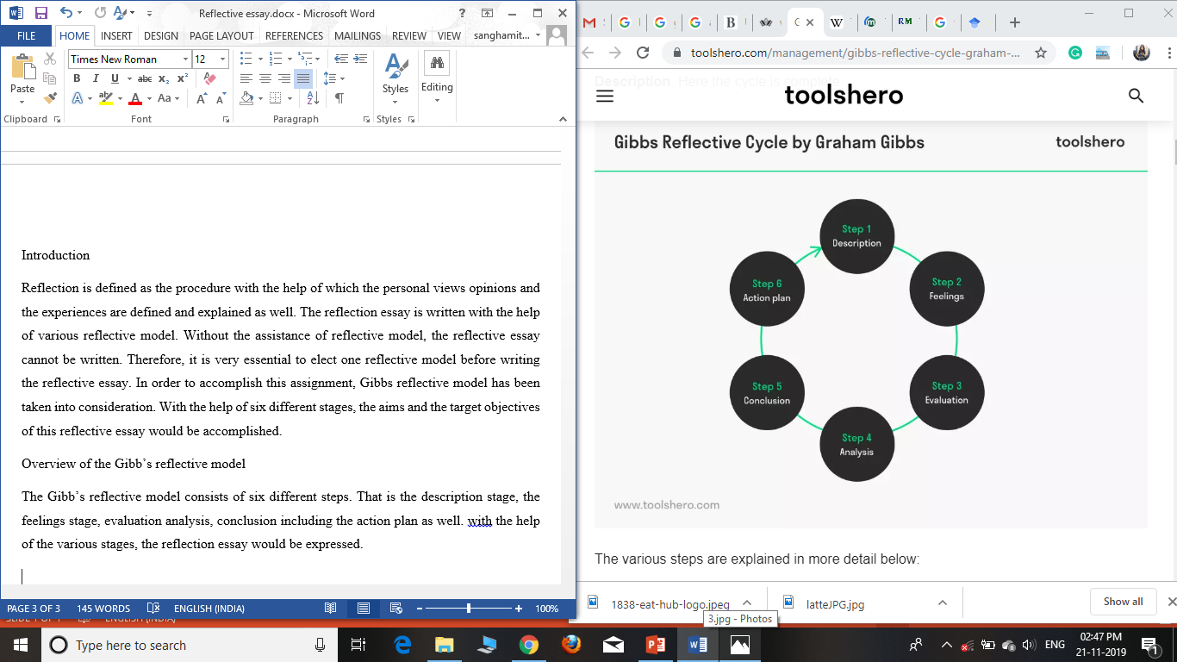
Gibbs reflective model is one of the static and the oldest reflective model implementing which the reflection reports are conducted and executed considering each of the varying facts. The reason behind the choice of this model is that it consist of six different stage. In fact each of the varying stage comprises of various other multiple types of aims and target objective which are essentially required to explain the facts present within it. The list of various stages are the description stage, feelings, evaluation, analysis, conclusion and the action plan. The description stage is the stage where the activities and the experiences faced by the students are described over here in this section. All the issues, errors, negative and the positive aspects are described in the description stage (Gibbs et al., 1988). The second stage is about the feelings that the students faced while achieving the activities in their educational institutes. All the related and the positive feelings related to the students and their corresponding feedbacks would be discussed in the second stage. The third stage is the evaluation stage where the listed feedbacks would be taken into consideration in order to understand their conveyed facts in the most appropriate way. Each of the facts would be described accurately so that its analysis could be proceeded in the most appropriate way. The fourth stage is the analysis stage where the explained data and information would be analysed appropriately in order to reach to the concrete outcomes of the reflective research. On the basis of the analysis and the deduced results, the conclusion would be drawn in order to explain the exact impact of the experiences faced by the students. The conclusion may either be positive or else be negative as well. The last and the 6th stage of the gibbs reflective model is the action plan where the weakness are determined and strategies are planned with the help of which the weaknesses can be changed into strengths. The action plan need to be appropriate in nature (Gibbs et al., 2018). This is because of the fact as per the action plan, the weaknesses would be considered and further would be improved as well. Therefore, the entire structure of the Gibbs Reflection model is as follows:
Figure 1: Gibbs Reflection model by Saunders

Stage 1: Description
My university has assisted me to learn a lot about the various employability skills that are essentially important to develop for achieving great success in the upcoming future generation. This is because of the fact, as per the belief of my teachers, acquiring the employability skills would assist each and every students to grow effective as an individual to tackle the professional challenges without any issues. Some of the most important and the vital employability skills communication skills, team management skills, leadership and managerial skills, listening skills and problem solving skills as well (Messum et al., 2016). Initially, my personality was introvert in nature. I was not at all an introvert neither my communication skills were appropriate in nature. During the commencement of this session, each of the student’s team were allotted with at least 10-12 members and had to go through the group discussion procedure. What exactly has been analysed that almost all the students including me possess the same type of issues and the teachers need to perform rigorous activities in order to train the students including me in the most effective way. In this way all other activities related to the above mentioned skills have been performed by me and other students as well in order to assist the teachers to develop a path for commencing the training sessions (Messum et al., 2017).

Stage 2: Feelings
When I had to go through the all these activities, initially I was feeling very nervous. This is because of the fact all these activities were exceptionally new for me and other students as well except few of them. However, with due time, as the days of training sessions are passed by I started to build up a lot of confidence within myself effectively in the most impact full way (Tsitskari et al., 2017). However, if I take my initial performances into consideration, my performance was not at all good. In fact I was lagging behind in each of the activities that were conducted and executed by the teachers of the universities. As a result of this fact, I was feeling depressed and my confidence started to diminish as well. Moreover, my other team mates were tend to improve themselves with the training sessions in the most efficient way. One of the major reason behind the arisen of negative thoughts is that I wasted a lot of time to understand the directions delivered by the teachers in the most accurate way. As a result of this fact, the moment when I tried to understand and analyse their directions, I started to develop compatibility within myself and thus, positive thoughts started to find its space within my mind. More precisely, it can be said that my feelings were full of mixtures because of the ups and the downs that I have faced while commencing the activities suggested by the teachers of the universities (Suleman et al., 2017).

Stage 3: Evaluation
Taking my experiences into consideration, it have evaluated the fact that, a lot of skills in regard to the employability and professionability have been acquired by me in the most effective way. After the execution of the training session for 3-4 weeks I have evaluated the fact that my communication skills have increased considerably as compared to the level of skills that I used to possess. Moreover, with the increase in the time management skills, I started to accomplish my each and every allotted tasks within the stipulated amount of time period. Initially my time management skills was really very poor. In fact I used to take up and consume a lot of time while accomplish a particular task. As a result of this fact, it was very important for me to improve my time management skills in the most accurate way. However, in order to achieve this feat, my teachers played the most vital role in developing the effective skills within myself in the most accurate way (Tsitskari et al., 2016). This is because of the fact all the factors and the necessary suggestion were extremely inconvenient for me and thus, they help me and other team mate as well in the most appropriate way. Including the above mentioned skills, some other skills such as the leadership and the management skills, problem solving skills all these have been developed by me in the most appropriate way.

Stage 4: Analysis
From the above mentioned stage that is the evaluation stage, it has been analysed the fact that the development of the employability skills play the major role in developing the personality of the students. This is because of the fact it improvises the individuality of the candidates in the most appropriate way. Taking myself into consideration, I as an individual have developed myself in the most positive way. This is because of the fact, communication and the personality development skills have been acquired by me appropriately. Now I am not an introvert person at all. In fact, I have become more extrovert and thus I love to deal and socialize with people in the most accurate way. One of the major thing that have been changed or rather has been improved accurately is the self confidence (Tsitskari et al., 2016). Maintaining the confidence within myself would help me to achieve success without any kind of issues and errors as well. And thus would also help me to grow and develop in the professional field as well. When I analyse myself as an individual I feel like I have developed positively. Moreover, during the final days of the training session I have analysed accurately without any issues and errors.

Stage 5: Conclusion
From this entire reflective report it has been understood the fact that the employability skills have been improved by me in the most appropriate way with the help of the training sessions and with the teachers of the universities as well. What exactly has been understood that in future, these skills would assist the students to possess a bright future and success as well.

Stage 6: The action Plan
The various action plan that is essentially need to be conducted are as follows:
- To improve and enhance the leadership skills within 5 weeks of time period
- To enhance and to improve the managerial skills within the next 10 weeks of time period (Wilkes et al., 2015).
- To improvise the listening skills in the most accurate way in the next 5 weeks
- Though the problem solving skills are appropriate still some changes would be required as per the necessary situations.

Conclusion of the assignment
From this entire assignment, it has been analysed and understood the fact that the employability skills play the major role in developing the personality and the behaviour of the individuals in the most practical way (Wilkes et al., 2015). This is because of the fact to grow and develop within the professional world, each and every individual need to be practical in nature. As a result of this fact, the employability skills have improvised the practical factors of the students within the universities.

Bibliography
Collet, C., Hine, D. and Du Plessis, K., 2015. Employability skills: perspectives from a knowledge-intensive industry. Education+ Training, 57(5), pp.532-559.
Gibbs, G (1988). The reflective cycle. Kitchen S (1999) An appraisal of methods of reflection and clinical supervision. Br J Theatre Nurs, 9(7),313-7
Messum, D., Wilkes, L., Peters, C. and Jackson, D., 2017. Senior Managers' and Recent Graduates' Perceptions of Employability Skills for Health Services Management. Asia-Pacific Journal of Cooperative Education, 18(2), pp.115-128.
Suleman, F., 2017. Employability skills of higher education graduates: Little consensus on a much-discussed subject. Procedia-Social and Behavioral Sciences, 228, pp.169-174.
Tsitskari, E., Goudas, M., Tsalouchou, E. and Michalopoulou, M., 2017. Employers’ expectations of the employability skills needed in the sport and recreation environment. Journal of hospitality, leisure, sport & tourism education, 20, pp.1-9. Messum, D.G., Wilkes, L.M., Jackson, D. and Peters, K., 2016. Employability Skills in Health Services Management: perceptions of recent graduates. Asia-Pacific Journal of Health Management, 11(1), pp.25-34.
Tsitskari, E., Goudas, M., Tsalouchou, E. and Michalopoulou, M., 2015. Employers’ expectations of the employability skills needed in the sport and recreation environment. Journal of hospitality, leisure, sport & tourism education, 20, pp.1-9. Messum, D.G., Wilkes, L.M., Jackson, D. and Peters, K., 2016. Employability Skills in Health Services Management: perceptions of recent graduates. Asia-Pacific Journal of Health Management, 11(1), pp.25-34.

