Routes and Roots of the Black Atlantic: Cultural Histories of the African Diaspora
HPHI5006

2500-word essay interpreting the biography of Amy Ashwood Garvey and comparing it The Black Atlantic by Paul Gilroy.

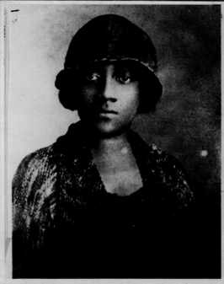 Amy Ashwood Garvey
In this essay I aim to interpret the biography of Amy Ashwood Garvey as I believe her life story exemplifies some of the themes of the module. In the course of this essay I will place emphasis on applying the concepts which were covered in the modules earlier review of The Black Atlantic, by Paul Gilroy. Further, I will contrast and compare political and cultural aspects of the explorations of The Black Atlantic undertaken by Amy Ashwood Garvey as she uncovered and developed her personal and societal black history and I will demonstrate, defend and explain aspects of her ‘puzzling’ and ‘abstract’ behaviour which exemplarises the double consciousness concept that Gilroy develops. I will also reveal how Ashwood Garvey based much of her thinking on Pan-Africanism which Alistair Boddy-Evans researcher and historian, from Heriot-Watt and Imperial College London, describes as being developed from the ‘anti-slavery and anti-colonial movement amongst black people of Africa and the diaspora in the late 19th century’. Gilroy shows how important the African Diaspora is to the questions on which this essay is based, when he explains that the African Diaspora has ‘spatial focus’ relating to history, memory and the narrative which articulate the ‘principles of black political countercultures that grew inside modernity’ and in saying this he shows the importance of the African Diaspora to his book The Black Atlantic because is attached to the traditions of ‘cultural critique, history and politics’.
To conclude, I will compare the ways of Ashwood Garvey and the Gilroy concept of double consciousness to explain why culturally, though not exclusively, Ashwood Garvey possibly adopted differing strategies to cope with her life and learned to divert away from painful situations and issues which she could not change and took alternative courses of action in the hope of creating positive influences for growth to benefit those with the diverse black cultural roots routed by the African Diaspora of The Black Atlantic.

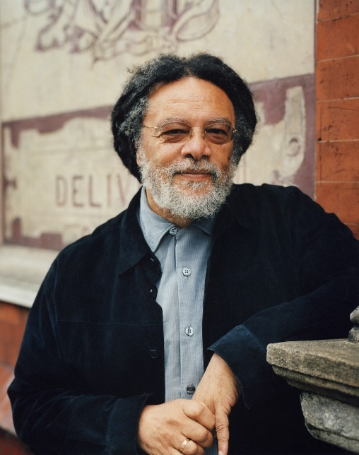 Professor Paul Gilroy
To illustrate how the biography of Ashwood Garvey is exemplary of some of the themes of the module and show how she attempted in her lifetime to affect change in black history, politics and culture we see that she was a citizen of The Black Atlantic who in her working years, of the early to mid-twentieth century, travelled widely by ship throughout the British Empire and beyond.
Firstly, with regard to black history, in 1944, the American Federal Bureau of Investigation kept Ashwood Garvey on their radar and reported on her as a ‘West Indian Negress and the widow of the late Marcus Garvey’ who was known to ‘consort with communists’ and was identified for active participation in election campaigns such as that of Adam Clayton Powell who the FBI called a ‘Negro Preacher’ but who rose to represent Harlem in The House of Representatives in 1944. The FBI said that Ashwood Garvey said she supported Powell because he was ‘a friend of West Indians’ but it may have been that Powell did not welcome her attentions as in his newspaper he referred to Ashwood Garvey as the ‘Madame Chang Kai Shek of the Caribbean’. We may never establish whether Powell was suggesting that Ashwood Garvey used her excellent command of the English language and her femininity to seduce men into supporting her cause or maybe he was just being complimentary and trying to show her to be an independent influential figure across many continents, including those of The Black Atlantic. Regardless of whether Ashwood Garvey was invited to participate in the election of Powell she was eager to endorse him as being ‘fitted by experience and knowledge to fight the battle in Congress to preserve Americanism against home-grown fascists and bigots’ and said that ‘No one has a greater stake in this fight than the Negro woman’. Here Ashwood Garvey does what Gilroy does not do, she takes American culture and includes black women to be an active component of it. In contrast, Gilroy states it is the aim of his book to address ‘one small area in the grand consequence of this historical conjunction’ and that is the togetherness of movement of all peoples of The Black Atlantic as they adapt with double consciousness ‘to face (at least) two ways at once’. Gilroy talks inclusively of men and women as people whereas Ashwood Garvey frequently takes a feminist track as part of the cause in which she is interested, that of reviewing the black history of the past to ensure a more equal place for black women in The Black Atlantic and in the world, in the future. Firmly returning to the topic of black history, both Ashwood Garvey and Gilroy promote a joint aim but from different angles and in different times, they both seek to oppose the Modernity which set in place, in earlier centuries, ill-founded prejudices against people of African origin, and those with dark skin tones, for the benefit of accumulating wealth based on a slave-economy.
Secondly, turning to black politics the Trinidadian born British barrister, Marxist, academic and founder of the Africana Studies Department at the Michigan State University in America, Tony Martin, shows the pull of The Black Atlantic to its subjects which confirms the Gilroy view of the ocean being the home to black culture rather than the countries which surround it. Martin tells us that Ashwood Garvey campaigned to influence political revisions in Abyssinia, America, Australia, Britain, Canada, Ghana, Haiti, Jamaica, Liberia, Nigeria, Panama, Rhodesia, South Africa, Trinidad, Venezuela and may be more. This demonstrates the Ashwood Garvey use of the routes that Gilroy describes in The Black Atlantic and illustrates that the ‘most consistent ideological current running through her life was her Pan-African interest in the freedom of Africans’. It would seem there may have been a closer connection between Paul Gilroy and Ashwood Garvey than has been talked of as in London, in 1958, following the Notting Hill riots where West Indians and white Londoners had racially clashed, Ashwood Garvey arrived in support of her black-feminist Marxist cause and worked with local activists. Ashwood Garvey aimed to review issues of racial inequality in London: This was the time of the appointment of the first black British head teacher, namely Beryl Gilroy. Beryl Gilroy was very aware of prejudice in British schools and she took twelve years out of her career to home-school her two children, Paul and Darla, and preventing their exposure to what she considered to be racist education in Britain. Beryl Gilroy was the Head of Beckford School which was just four miles from the site of the riots. It seems unlikely that Ashwood Garvey and Beryl Gilroy would not have known of and respected the beliefs and presence of each other, even if they never met, especially as Beryl Gilroy was founder of the activist organisation, the Calabash Camden Black Sisters which ‘works with other similar organisations’ and is described by Sokari Ekine, the twenty first century Nigerian British ‘Feminist, diasporic nomad and activist writer’, to support those living with ‘daily struggles across race, sexual orientation, gender, class ’.
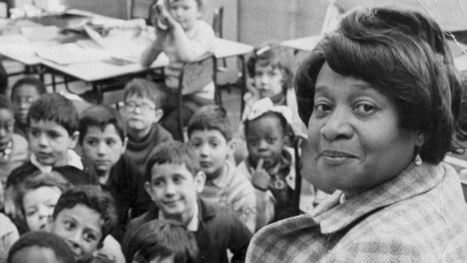
Beryl Gilroy
To move on to further illustrate the Ashwood Garvey commitment to Pan African culture it must be noted that she was involved in what Gilroy called the ‘redemptive return to an African homeland’ when she, with Marcus Garvey, co-founded and operated the Pan African Black Star Line. The Black Star line of the 1920s era was formed to increase trade between Africa and America and to provide a means of relocation for African American who wanted to pursue black independence in Africa. Marcus Garvey and Ashwood Garvey started the line together and it definitely supported the softly non-confrontational approach of Booker T Washington rather than the militant inclusion and integration sought by Gilroy who explores ‘the continuing lure of ethnic absolutisms cultural criticisms produced by blacks and whites’. Gilroy appears to be basing his concepts in The Black Atlantic more to the left of the line on which Du Bois based his original cultural theories. In addition, Gilroy describes ships as having a unique independent culture without respect for ‘boundaries and integrity of modern nation states’ because each ship is ‘a living, micro-cultural, micro-political system in motion’ and this very much reflects the life and ways of the transient Ashwood Garvey who had opinions and work which changed with the current and serendipity of the times and tides. Martin outlines how Ashwood Garvey lacked ‘boundaries and integrity’ by reinventing herself to suit the moment, at one times supporting and promoting politics, working as a poet and playwright, running a nightclub and having numerous affairs with men of influence as she travelled from country to country seeking her fortune but never finding who she herself really was.
Thirdly, to show how Ashwood Garvey affected black culture we look at her Pan African approach to life. Pan Africanism brings to black culture what Zionism bring to the people of the Jewish faith: A concept of oneness of origin and in some cases that is also seen as the right to return to the place in which the culture originated and possibly to the exclusion of others from the right for races to co-exist in that place and Gilroy beautifully compares Zionism to the Pan African theory of Blyden, a mid-nineteenth century pioneer of the concept, and shows how the Parisienne Negritude of the decade of 1930 developed from Pan African routes and grew to develop as a ‘metaphors of journey and exile’. Just as the ‘Critical evaluation of … blackness might be connected to the controversies over … racism and Anti-Semitism in the work of Enlightenment figures like Kant and Voltaire’ and as much as I would like to include these arguments and contrast them here, particularly to the feminist approach of Ashwood Garvey, I stand with Gilroy in saying that extended discussion ‘cannot be provided here’. The opinion and words of Ashwood Garvey on her experience of ‘unreasonable racism’ as an international sailor on The Black Atlantic is as poignant as the ‘racialised reason’ described in the mainly British-cultural-experience of Gilroy. Gilroy rationally states, how for those of black African origin, discrimination by race is based in the ‘distinctive English idioms of cultural reflection’ but Ashwood Garvey does not have the analytical skills of Gilroy and she suffers ‘ideological confusion’ which results in being seen as ‘inconsistent and uncomfortable … in her latter-day integrationism’. Unlike Gilroy, Ashwood Garvey can not separate her Marcus Garvey based beliefs of African people living together apart from other races and despite changes in societies and the progressive development of integration of races around The Black Atlantic, her cultural understanding is rooted in her age and time and reflect the Booker T Washington-style segregation which is opposed by the more academic militant Gilroy-Du Bois projection of impartiality between cultures leading to equality of opportunity in society.
To conclude, Amy Ashwood Garvey was prolific in her political appeals, international communications, feminist writing and actions supportive of black people: She must therefore be regarded as having made an active contribution to the development of black history and politics. In addition, Ashwood Garvey impacted on the cultures of the countries to which she travelled in the world and specifically in the area of The Black Atlantic. She suffered the pains of the African Diaspora and from the description that Tony Martin gives of her life, he questions whether she was mentally ill which is evidenced in a letter to Marcus Garvey, when she was about twenty years of age, she wrote ‘I am sick at heart’ and question whether ‘I will ever find peace’. . Strangely this ties her in again to the Gilroy concept of double consciousness. Gilroy latches on to the double consciousness as it was described by Du Bois to explain how the African Diaspora creates confusion. Du Bois was not the originator of this concept: While studying social philosophy in Berlin, Du Bois reviewed the emerging reaction to Hegelian theories of inward “twoness” and related this to the experience of African-Americans who through ‘racialized oppression and disvaluation in a white-dominated society’ displayed certain forms of behaviour and from this Du Bois formed his theory of double consciousness.
It is likely that if Amy Ashwood Garvey was exhibiting such extensive displays of dysfunctionality and identity crisis today and if Du Bois was involved in current day psychology, it is likely that the condition which Gilroy describes as double consciousness would be renamed as Dissociative identity disorder. In modern psychology Dissociative identity disorder is an acknowledged mental health condition reflective of ‘feeling like there are different people within you’ and individuals suffering this condition are frequently diagnosed as being ‘uncertain about their identity and who they are’, of ‘feeling like a stranger’ to themselves because within them they have the ‘presence of other identities’. This causes of this illness are said to be previous trauma. A person who displays Dissociative disorder is likely to have experienced physical, sexual or emotional abuse and they may dissociate after experiencing war, kidnap or invasive actions. Switching off from reality, or inventing ones own reality, is said to be a normal defence mechanism that relays the situation if ‘not happening to me’ and it occurs when a person feels they live in trauma because an action or a situation has not been dealt with processed by the brain to become a thing of the past that does not interfere with life today.
As Gilroy evidences the kidnap of slaves in the past, the continued abuse of racism and terror in Pan African daily life today and the ongoing discrimination in housing, education and opportunity we must question how many other people will suffer ‘twoness’ and just when the traumas, as suffered by Amy Ashwood, will cease in our society and what the cost of this double consciousness of the African Diaspora to the world and specifically to the people of The Black Atlantic?

Bibliography

Du Bois, W.E. Burghardt, The Souls of Black Folks: Essays and Sketches, 2nd edn (Cambridge, U.S.A.: A.C. McClurg, 1903), p. 42.
Gilroy, Paul, The Black Atlantic: Modernity and Double Consciousness, 1999 edn (London: Verso, 1993), p. 4.
Martin, Tony, Amy Ashwood Garvey: Pan Africanist, Feminist Mrs Garvey No.1 Or A Tale of Two Amies, New Marcus Garvey library: No.4 edn (Dover MA United States of America: The Majority Press, 2007).
Martin, Tony, Race First: The Ideological and Organisational Struggles of Martin Garvey and the Universal Negro Improvement Association., 1986 edn (Dover, Massachusetts: The Majority Press, 1976).

Beck, Hamilton, 'W. E. B. Du Bois as a Study Abroad Student in Germany, 1892-1894 ', Frontiers: The Interdisciplinary Journal of Study Abroad, 2.3, (2000), 1-13 (p. 1-5), in <https://files.eric.ed.gov/fulltext/EJ608183.pdf> [accessed 23 January 2020].
Lola Paprocka, Professor Paul Gilroy (2020) <https://www.ucl.ac.uk/institute-of-advanced-studies/sites/institute-of-advanced-studies/files/professor_paul_gilroy_by_lola_paprocka.jpg> [accessed 31 January 2020].
Tony Martin, Garvey, Amy Ashwood (1895/1897–1969) (2004) <https://www-oxforddnb-com.ezproxy.uwtsd.ac.uk/view/10.1093/ref:odnb/9780198614128.001.0001/odnb-9780198614128-e-67673;jsessionid=664F8580778DC56A120DE32911050171> [accessed 10 January 2020].
, Dissociative disorders (2020) <https://www.nhs.uk/conditions/dissociative-disorders/> [accessed 30 January 2020].
<https://sta.uwi.edu/igds/20thanniversary/amyashwoodgarvey.asp> [accessed 13 January 2020].

Tony Martin, Amy Ashwood Garvey: Pan Africanist, Feminist Mrs Garvey No.1 Or A Tale of Two Amies, New Marcus Garvey library: No.4 edn (Dover MA United States of America: The Majority Press, 2007). Cover photograph of Amy Ashwood Garvey
Paul Gilroy, The Black Atlantic: Modernity and Double Consciousness, 1999 edn (London: Verso, 1993). P. 1. Hamilton Beck, 'W. E. B. Du Bois as a Study Abroad Student in Germany, 1892-1894 ', Frontiers: The Interdisciplinary Journal of Study Abroad, 2.3, (2000), 1-13 (p. 1-5), in <https://files.eric.ed.gov/fulltext/EJ608183.pdf> [accessed 23 January 2020].
Alistair Boddy-Evans, The Origins, Purpose, and Proliferation of Pan-Africanism (2019) <https://www.thoughtco.com/what-is-pan-africanism-44450> [accessed 30 January 2020].
Gilroy. P. 191.
Gilroy. P.1
Lola Paprocka, Professor Paul Gilroy (2020) <https://www.ucl.ac.uk/institute-of-advanced-studies/sites/institute-of-advanced-studies/files/professor_paul_gilroy_by_lola_paprocka.jpg> [accessed 31 January 2020].
Amy Ashwood Garvey: Pan Africanist. P.172-4 Charles V. Hamilton, 'Adam Clayton Powell, Jr.: The Political Biography of an American Dilemma', Oxford Academic Journal of American History, 79.2, (1991), 714.
Gilroy. P. 3.
Tony Martin, Amy Ashwood Garvey: Pan Africanist, Feminist Mrs Garvey No.1 Or A Tale of Two Amies, New Marcus Garvey library: No.4 edn (Dover MA United States of America: The Majority Press, 2007). P.169
Martin. P.16-320
Martin. P. 318.
, England's pioneering black head teachers (2020) <https://www.bbc.co.uk/news/uk-england-42649541> [accessed 1 February 2020].
Sokari Ekine, 'With Thanks to Black-Looks', The New Black Magazine, 2013, P.1.
, England's pioneering black head teachers (2020) <https://www.bbc.co.uk/news/uk-england-42649541> [accessed 1 February 2020].
Gilroy. P. 4.
Martin, Tony, Race First: The Ideological and Organisational Struggles of Martin Garvey and the Universal Negro Improvement Association., 1986 edn (Dover, Massachusetts: The Majority Press, 1976), p. 6-7.
Gilroy. P. 3.
<https://sta.uwi.edu/igds/20thanniversary/amyashwoodgarvey.asp> [accessed 13 January 2020].
Gilroy. P. 209-211
Gilroy. P. 7-9.
W.E. Burghardt Du Bois, The Souls of Black Folks: Essays and Sketches, 2nd edn (Cambridge, U.S.A.: A.C. McClurg, 1903), P. 27-29.
Tony Martin, Garvey, Amy Ashwood (1895/1897–1969) (2004) <https://www-oxforddnb-com.ezproxy.uwtsd.ac.uk/view/10.1093/ref:odnb/9780198614128.001.0001/odnb-9780198614128-e-67673;jsessionid=664F8580778DC56A120DE32911050171> [accessed 10 January 2020].
Martin. P353.
John P. Pittman, 'Double Consciousness', Stanford Encyclopedia of Philosophy, Summer 2016 Edition.1, (2016), 2:1, in Stanford Center for Study of Language and Information <https://plato.stanford.edu/entries/double-consciousness/> [accessed 23 January 2020].
, Dissociative disorders (2020) <https://www.nhs.uk/conditions/dissociative-disorders/> [accessed 30 January 2020].
Gilroy. P. 190. Gilroy. P. 5. John P. Pittman, 'Double Consciousness', Stanford Encyclopedia of Philosophy, Summer 2016 Edition.1, (2016), 2:1, in Stanford Center for Study of Language and Information <https://plato.stanford.edu/entries/double-consciousness/> [accessed 23 January 2020].

