1.D Ground Investigation
As part of the initial desk study, an investigation into the sites ground, both current and historically was undertaken. This was conducted to establish the site’s strata, hydrology, and to identify any possible concerns that may arise before the construction phase began.
As of the time of this report, a ground investigation is being carried out by Apex Drilling Services.
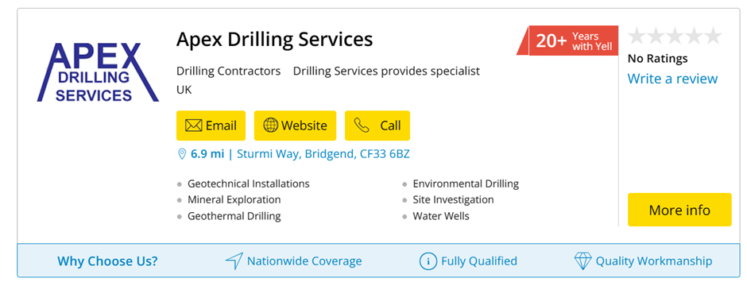
Apex Drilling Services can provide a full site investigation, geotechnical installations and investigations and environmentally friendly drilling services.
Geotechnical survey costs between £12,000-£20,000- including borehole investigation, geotechnical installations, in situ-tests, and trial pits.
Site investigation without borehole data will cost between £2,000-£5,000.
This ground investigation was discussed with the clients during the feasibility report and the clients were happy to go ahead with the full investigation before construction began. The main elements that the investigations are searching for is weaknesses in the soil left by former structures such as basements or coal chutes.
Expect to be paying towards the higher end of the scale due to size of site. Expect all site investigations to cost roughly £25,000 on the high end.

Using geodatabase, Apex construction were able to obtain previous borehole data collected nearby the site which will be enough to gain the foundation substantiations from but a full site survey is still undergoing to provide any recent data as the last borehole records obtained near the site were collected over 50 years ago so would not have taken account for any treatment of the soil when the site was turned into a carpark in the1970’s.
There was also the concern of the borehole records being collected roughly 250 metres away from the site so the soils makeup may have changed slightly from location to location.
Below is the map showing the location of the borehole records as well as the records.
Record title: Redevelopment of Port Talbot Town Centre Bridges26
Ref No:SS78NE243 Dated: 1969

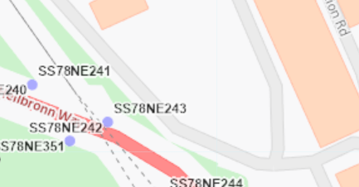
(Figure 1)

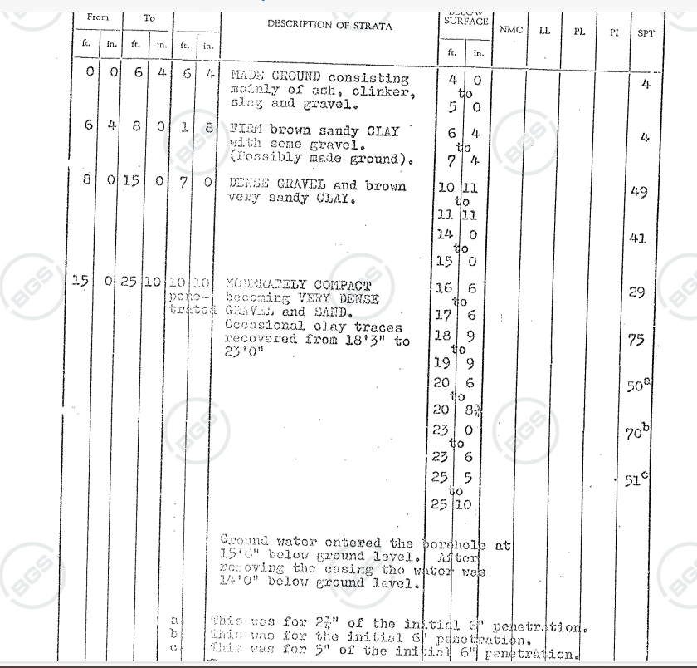
(Figure 2)
As you can see from the report in figure 2, the ground from surface level to 6 ft mainly consist of ashy gravel so would be of no use for foundation and may be a concern for settlement.
The ground from 6ft-8ft consists of sandy clay that would still not be firm enough for footing.
When the ground gets to 15ft it becomes moderately dense to dense gravel going deeper so this would be the most suitable level for foundations due to the size and shape of the building.
Foundation substantiations will be discussed further in this report. See section 2.P

UXO Reports
After investigation into the history of the site we have discovered a nearby location was previously a target of the German Luftwaffe. This is not an immediate concern however we do recommend, for the safety of all involved to consider a UXO survey.
This will involve hiring a company to investigate the historical archives on and around the site to find where bombs were dropped or likely dropped. They will do this by looking into anecdotal evidence, other reports recorded nearby, news, nearby bomb incident records, historical maps, and arial imagery.
The image below is from a bomb density map of all the U.K so this can give us a very rough idea of where bombs may be. The symbol in the bottom left shows how close the target zone was to the site, but it is very hard to locate all the bombs if there are any UXO’s. it is likely with these bombs that the entrance hole was covered up by debris or vegetation over time so it is within the best interest of the company to hire a company that can complete a UXO survey for the site.
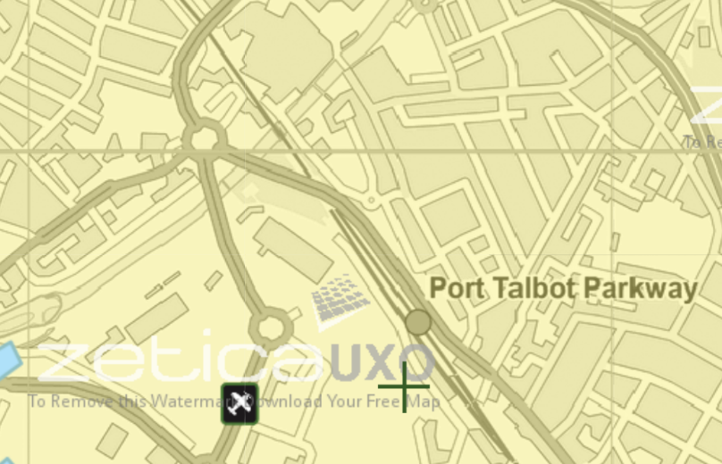

Site Location

(Figure 3)
Foundation Substantiation

As discussed previously in the feasibility report, there will be another ground investigation and borehole investigation taking place but as a rough guide, based on information given, we will be recommending concrete piled foundations. We are recommending theses foundations as they can transfer the weight of the building down to the lower, more compact gravel rather relying on the higher-level clay. The building is also very large with an uneven structure so the piled foundations can add strength, rigidity, and stability to the structure. The costs of these foundations will be discussed further in the report.

