
Professional Career Development in Health and Social Care (LCHS 4009)

ASSIGNMENT 2

Name of Student: Iryna Hetman

I.D. Number: 2509568

Name of Tutor: Dilhara Mampitiya

Acknowledgement of AI use: AI was used to support English grammar and wording. All ideas and personal experiences are my own.

Table of Contents

Task 1 – Job Vacancy and Skills …………………………………. ……………. 3 — 4

Task 2 – Personal Statement …………………………………….. …………….. 5 — 6

Task 3 – SWOT Analysis and Personal Development Plan (PDP) …. ………. 7 — 8

Task 4 – Critical Reflection – Gibbs Reflective Model …………. …………….. 9 — 10

References ………………………………………………………………………….. 11

IRYNA HETMAN
MASSAGE THERAPIST
London, UK | 07384 616412 | irynahatmanua@gmail.com

PROFILE SUMMARY
Highly skilled, trilingual (Ukrainian, Polish and English) and compassionate Massage Therapist with 15 years of professional experience, including experience in the UK spa and wellness sector since 2022.Experienced in providing personalised treatments tailored to individual client needs, supporting relaxation, reducing muscular tension and promoting overall wellbeing. Strong communication and customer care skills, with professional knowledge of a wide range of massage techniques and high standards of hygiene and client care.

CORE SKILLS & TREATMENTS

•⁠ ⁠Deep Tissue Massage
•⁠ ⁠Swedish & Relaxing Massage
•⁠ ⁠Pregnancy Massage
•⁠ ⁠Lymphatic Drainage Massage
•⁠ ⁠Aromatherapy Massage
•⁠ ⁠Hot Stone Massage
•⁠ ⁠Hammam Rituals
•⁠ ⁠Client Consultation & Assessment
•⁠ ⁠Professional Spa Standards
•⁠ ⁠Customer Care & Communication

Work Experience
Massage Therapist – SPA & MASSAGE, London | 2024–Present

Providing personalised massage treatments tailored to individual client needs and preferences. Delivering deep tissue, Swedish, relaxing, pregnancy and other therapeutic treatments while maintaining high standards of hygiene, professionalism and client care. Building strong client relationships and supporting relaxation, pain reduction and overall wellbeing.

Massage Therapist – Beauty & Melody Spa, London – 2022–2024
Provided professional massage treatments in a luxury spa environment, adapting each treatment to clients’ individual needs. Worked with a diverse international clientele while maintaining excellent customer service, professional standards and a welcoming environment.

Self-Employed Massage Therapist – Ukraine – 2007–2022

EDUCATION & CERTIFICATIONS
•⁠ ⁠Health and Social Care – University of Wales Trinity Saint David – 2025–Present
•⁠ ⁠Qualifi Level 3 Certificate in Facial Electrotherapy – London Aesthetics Training Academy – 2024
•⁠ ⁠VTCT Level 3 NVQ Diploma in Beauty Therapy Massage – London Aesthetics and Training Academy – 2024
•⁠ ⁠Massage in Pregnancy & Labour – London School of Massage – 2023

KEY PROFESSIONAL STRENGTHS
•⁠ ⁠Excellent communication skills
•⁠ ⁠Patient cantered care
•⁠ ⁠Professional, reliable and compassionate approach
•⁠ ⁠Strong awareness of hygiene, safety and confidentiality
•⁠ ⁠Ability to work independently and as part of a team
•⁠ ⁠Experience working with diverse and international clients

INTERESTS
Swimming, walking, hiking in the mountains and reading.
REFERENCES
Available upon request.

Task 2 of 4

PERSONAL STATEMENT
To whom it may concern,
I am an experienced and dedicated Massage Therapist with 15 years of professional experience. Massage therapy has been an important part of my working life for many years, and I have always enjoyed helping people to feel better, reduce tension and improve their overall wellbeing. My main career aim is to continue developing professionally in the health and wellbeing sector, using my experience and skills to provide a high standard of care to every client.

I began my career as a Massage Therapist in Ukraine, where I gained many years of practical experience working with different clients and learning how important it is to understand each person’s individual needs. Working in London has given me valuable experience with people from different backgrounds and cultures and has helped me develop my communication and customer service skills. For example, I have treated pregnant clients who asked for a very strong massage, including strong pressure on their feet. I explained that I could not provide a treatment that I considered unsafe for them. I always ask about their health, pregnancy and any advice or restrictions from their doctor. I explain clearly why I may need to change the treatment and offer a safer alternative. In my experience, when I explain the reasons calmly and professionally, clients understand and accept my recommendation.
During my career, I have developed a wide range of professional massage skills. These include deep tissue massage, Swedish and relaxing massage, pregnancy massage, lymphatic drainage, aromatherapy, hot stone massage and hammam rituals. I understand that every client is different, so before providing a treatment I listen carefully, discuss their needs and make sure that the treatment is appropriate for them. (NICE, 2021). I always aim to create a comfortable, professional and respectful environment.

My education and professional training have also helped me develop my knowledge and confidence
My education and professional training have also helped me develop my knowledge and confidence. I have completed professional qualifications including the VTCT Level 3 NVQ Diploma in Beauty Therapy Massage, the Qualifi Level 3 Certificate in Facial Electrotherapy and Pregnancy Massage training. I am also studying Health and Social Care in London. This course is helping me improve my understanding of health, wellbeing, communication, safeguarding and professional responsibilities when working with people.
I believe that my main personal strengths are reliability, patience, empathy and good communication. I am hardworking and take my responsibilities seriously. I understand the importance of hygiene, confidentiality, professional boundaries and treating every person with dignity and respect. (HCPC, 2024) I can work independently, but I am also comfortable working as part of a team.

I believe I would be valuable to an employer because I can combine many years of practical experience with professional knowledge and a genuine commitment to client care. I am willing to continue learning and developing my skills. If I am given the opportunity to work in this role, I will bring experience, professionalism, responsibility and a positive approach to the workplace.

Task 3 of 4

SWOT ANALYSIS – MASSAGE THERAPIST
Strengths
•⁠ ⁠I have strong practical massage skills and experience with different treatments.
•⁠ I communicate well with clients and listen carefully to their individual needs.
•⁠ ⁠I am reliable, patient, caring and professional.
•⁠ ⁠I have experience working with clients from different backgrounds and cultures.
•⁠ ⁠I understand hygiene, confidentiality and professional boundaries.
Weaknesses
•⁠ Language proficiency
•⁠ Lack of understanding of health and social care in UK
•⁠ Attention to detail
•⁠ ⁠Digital skills
Opportunities
•⁠ Career and advice service in university
•⁠ I would like to complete professional training in acupressure massage to develop new skills and offer a wider range of treatments to my clients.
•⁠ I can continue to improve my English communication skills, which will help me communicate more confidently with clients and develop my career.
Threats
•⁠ ⁠There is strong competition for good Massage Therapist positions in London.
•⁠ ⁠Massage therapy is physically demanding and requires good personal health and stamina.
•⁠ ⁠Client demand and working hours can sometimes be unpredictable.
•⁠ Professional standards and industry requirements can change, so I need to keep my knowledge and training up to date.

Analysis
My strengths can help me develop my career as a Massage Therapist because I have many years of practical experience and I communicate well with different clients. I can also use my strengths to improve my weaknesses. For example, working with clients every day gives me an opportunity to improve my English, learn more professional vocabulary and become more confident when expressing my thoughts.

My opportunities can help me develop new professional skills. I would like to complete additional training in acupressure and abdominal massage. This would allow me to offer more treatments and improve my professional knowledge.

I also understand the threats in my profession. There is strong competition for Massage Therapist jobs in London, and the work can be physically demanding. This encourages me to continue learning, look after my health and keep my professional knowledge up to date. By working on my weaknesses and using my strengths and opportunities, I can continue to develop my career.
My SWOT analysis has helped me think more carefully about where I am now professionally and what I need to do next. It shows me that having experience is important, but professional development should continue throughout my career. I need to regularly review my performance, recognise areas where I can improve and take responsibility for my own development. This will help me make better decisions about training, education and future employment.

One area I want to develop is my ability to reflect on my work. After working with a client, I can consider what went well and what could have been done differently. Client feedback can also help me understand the quality of my work from another perspective. Instead of seeing feedback as criticism, I can use it as useful information for improving my practice. Keeping a simple record of feedback and achievements would allow me to see my progress over time and identify areas that may need more attention.

Another important part of my development is keeping my professional knowledge current. Massage therapy is not only about performing practical techniques. A therapist also needs to understand safe practice, professional responsibilities and when a treatment may not be appropriate for a client. I therefore need to continue reading professional information and reviewing what I learn through my studies and training. This can support safer decision-making and help me take greater responsibility for the service I provide.

My future development also requires realistic planning. I cannot improve every area at the same time, so it is important to decide which goals are most important and work towards them gradually. Setting a timeframe for each goal gives me a clear direction and makes my progress easier to evaluate. For example, I can review what I have achieved after several months and decide whether I need to change my actions or set a new target.

The PDP gives me a practical way to turn my SWOT analysis into action. Rather than simply identifying areas for development, I can connect them with specific actions, timescales and evidence of progress. This makes my professional development more organised and measurable. By reviewing my plan regularly, I can recognise achievements, adjust my goals when necessary and take greater responsibility for the direction of my career.

PERSONAL DEVELOPMENT PLAN (PDP)

Goal | Action | Timeframe | How I will measure progress
Improve my professional English | Practise English with clients and colleagues | Next 2 years | Feedback and improved confidence
Develop my professional knowledge and qualifications | Continue my studies and complete relevant training | Next 2 years | Completed courses, certificates and new skills
Progress my career as a Massage Therapist | Gain more experience and improve my massage techniques | Within 1 year | More work experience and positive client feedback

Task 4 of 4

CRITICAL REFLECTION – GIBBS REFLECTIVE MODEL

I have used Gibbs’ Reflective Cycle to structure my reflection, as it provides a clear process for reflecting on an experience through description, feelings, evaluation, analysis, conclusion and an action plan (Gibbs, 1988).

Description
For my LCHS4009 Component 1 assessment, I gave a presentation about critical thinking in health and social care. I explained what critical thinking means, why it is important in professional practice and how I can use it in my work. I prepared for the presentation and tried to understand the information instead of only learning the words. During the presentation, the lecturer asked me how I would use critical thinking in the future. I answered the question and explained my own thoughts.

Feelings
Before the presentation, I felt a little nervous because presenting in English is more difficult for me than speaking about the same subject in my own language. At the same time, I felt confident about the topic because I had prepared and I understood what I wanted to say. When the lecturer asked me a question, I needed to think and answer without reading from my prepared text. After the presentation, I felt pleased that I had completed it and had been able to answer the question.

Evaluation
I think one positive part of my presentation was that I understood the subject. I did not only memorise the information. I knew what critical thinking meant and why it is useful in professional practice. Answering the lecturer’s question also showed me that I could use my knowledge and give my own answer.
However, I also noticed something that I want to improve. I would like to speak more freely in English during presentations. I know what I want to say, but sometimes I need more time to find the correct words in English. Because of this, I can depend too much on my prepared notes.

Analysis
This experience helped me understand the difference between knowing a subject and being able to explain it clearly. I am confident in my professional knowledge, but I want to improve my English so that I can express my ideas more naturally without reading from a paper
The question from the lecturer about how I would use critical thinking in the future was useful because it made me think about practical situations. In my work as a Massage Therapist, I need to listen to clients, consider different information and make appropriate decisions. Critical thinking can help me consider each client individually instead of automatically doing the same thing for everyone.

I also realised that improving my English will help me both academically and professionally. It will make it easier for me to explain my ideas, answer questions and communicate clearly with other people.

Conclusion
Overall, I think the presentation was a useful experience. I was prepared, understood my topic and was able to answer the lecturer’s question. I also identified an important area that I want to develop. I want to improve my spoken English so that I can express my knowledge and opinions more freely and rely less on written notes. This will help me in future presentations and in my professional development.

Action Plan
For future presentations, I will practise speaking aloud more often before presenting. I will also continue developing my English vocabulary, particularly terminology connected with health and social care. Instead of only reading and learning information, I will practise explaining it naturally in my own words.

I will give myself more opportunities to speak English in professional and academic situations. Before my next presentation, I will practise answering possible questions as well as preparing the main content. This will help me communicate my knowledge more clearly and make future presentations stronger.

REFERENCES

Gibbs, G. (1988) Learning by Doing: A Guide to Teaching and Learning Methods. Oxford: Oxford Polytechnic.

Health and Care Professions Council (HCPC) (2017) Continuing professional development and your registration. London: HCPC.

Health and Care Professions Council (HCPC) (2024) Standards of conduct, performance and ethics. London: HCPC.

Helms, M.M. and Nixon, J. (2010) ‘Exploring SWOT analysis – where are we now?’, Journal of Strategy and Management, 3(3), pp. 215–251.

National Institute for Health and Care Excellence (NICE) (2021) Shared decision making. London: NICE.

Skills for Care (2024) Communication skills in social care. Leeds: Skills for Care.

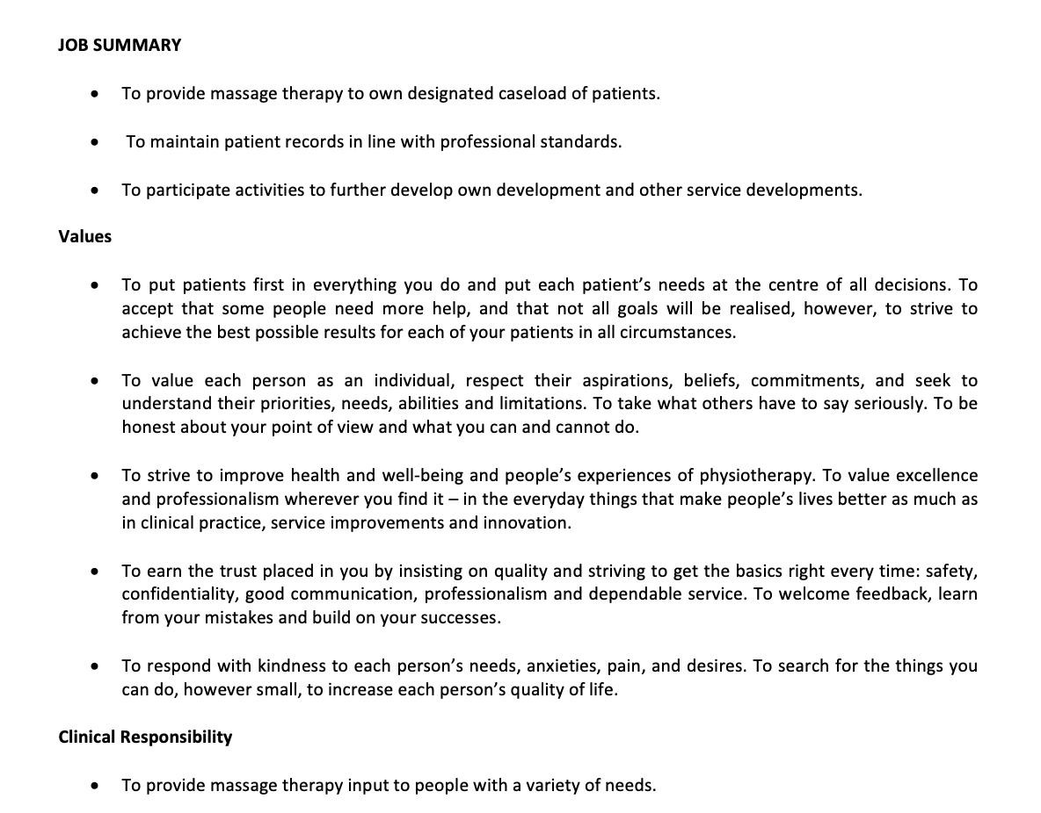
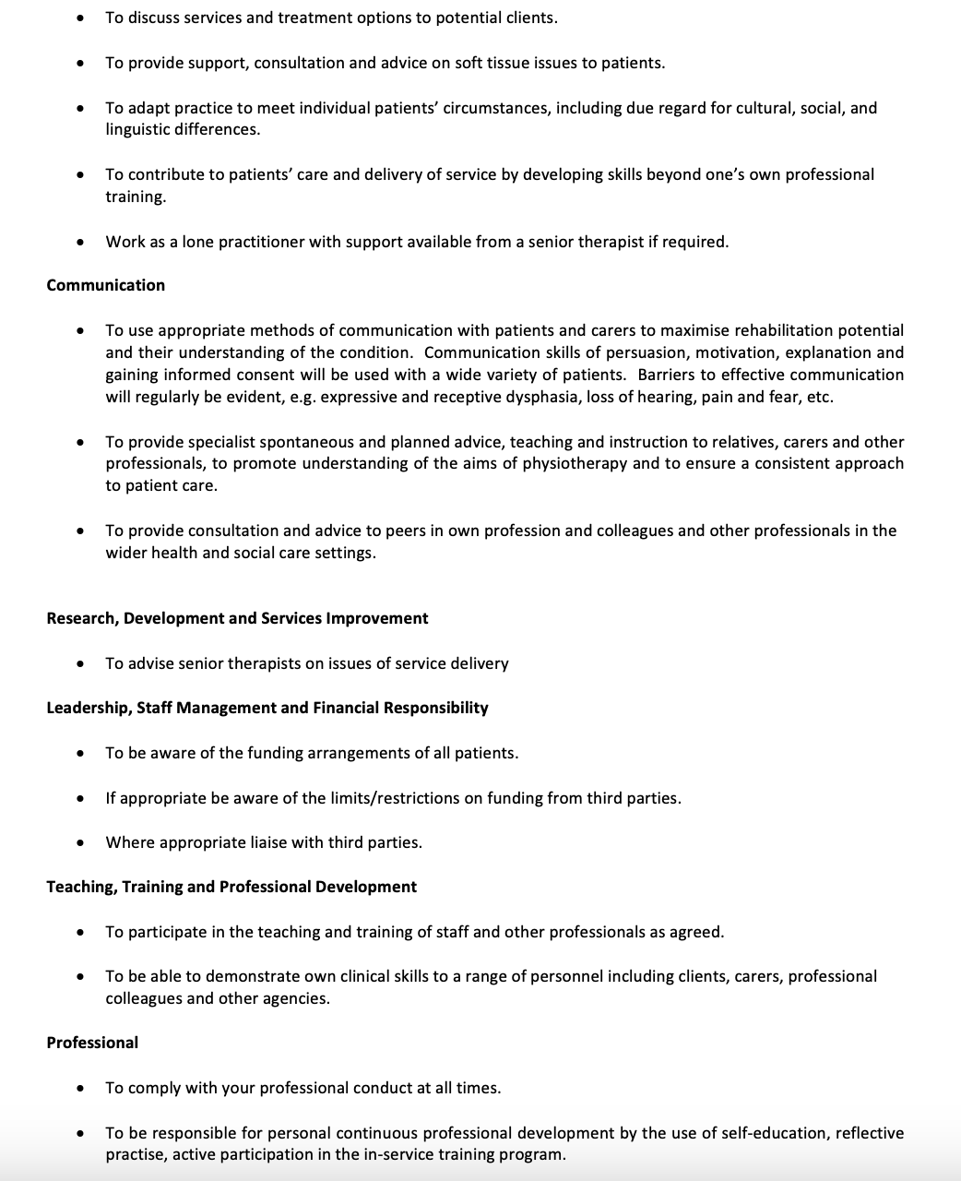

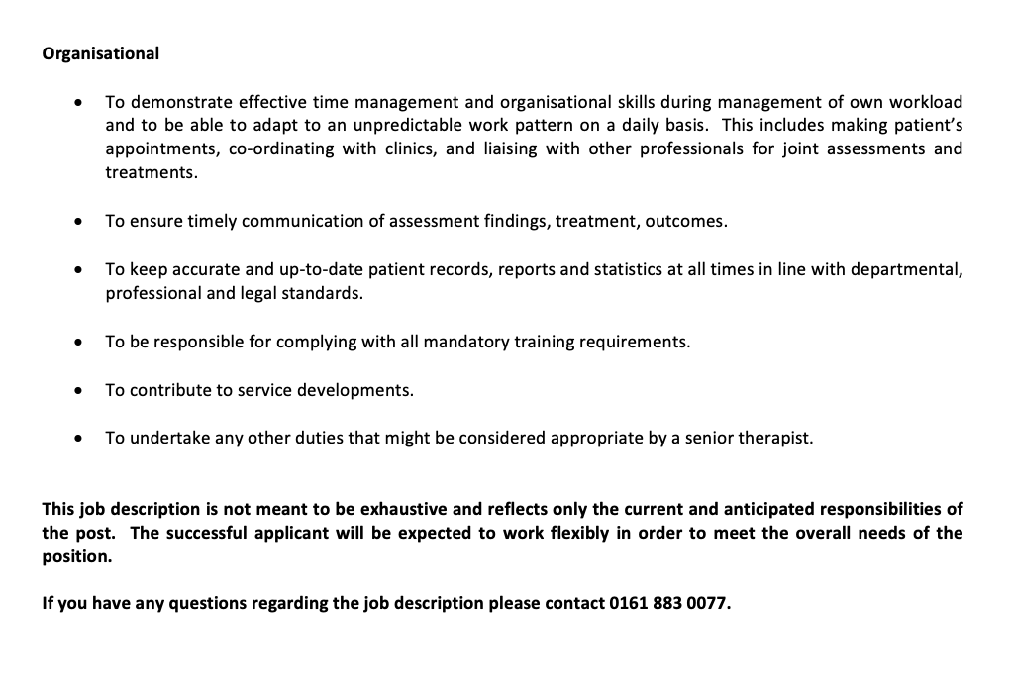

I believe that I can contribute more to my profession by continuing my studies in Health and Social Care at the University of Wales Trinity Saint David. My goal is to complete my degree, develop my professional knowledge and gain a deeper understanding of how to provide high-quality care and services to clients.
I have many years of practical experience as a Massage Therapist in Ukraine and the UK. I am confident in working with different clients, following professional guidelines and adapting treatments to individual needs. I would like to continue improving my knowledge, qualifications and English communication skills so that I can progress further in my career and provide the best possible service to my clients.
In the future, I would also like to continue my studies at Levels 5 and 6 to further develop my professional knowledge and qualifications.

