Sut mae dysgwyr, yr ysgol a’r gymuned leol yn gweithio gyda’i gilydd i gyflwyno un o bedwar diben y cwricwlwm?

Linc i’r fideo ar OneDrive

https://uowtsd-my.sharepoint.com/:f:/g/personal/1902872_student_uwtsd_ac_uk/Es0hen-VM7RDl93qfAo9EqYBJiNJQuWEFF38AEclu5Q6Tg?e=ZvN8yu
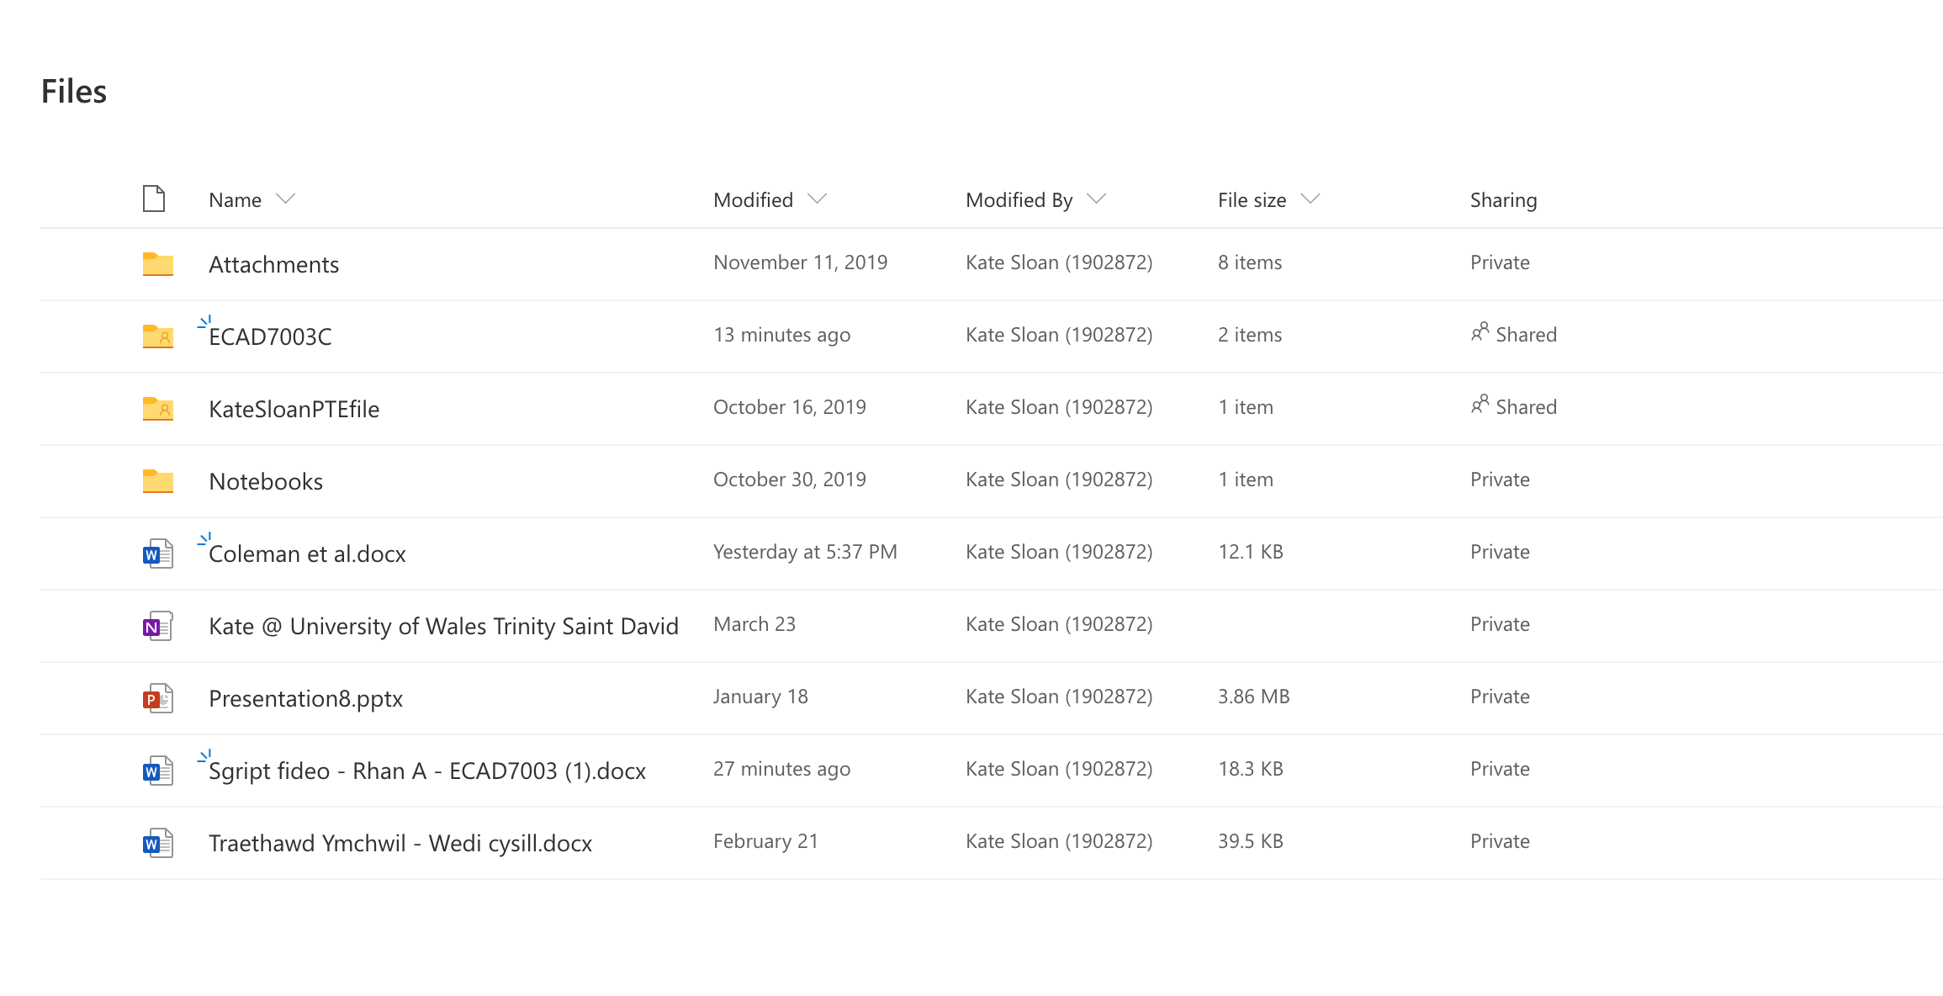

Rhestr Cyfeirio

American Acadamy of Pediatrics. (2004). School Based Mental Health Services. United States: American Academy of Pediatrics.

Coleman, N., Sykes, W., Groom, C. (2017). Peer Support and Children and Young People’s Mental Health. Llundain: Department for Education
Collier E. (2020) How Can Schools Promote Positive Mental Health? [ar-lein] Ar gael: https://www.highspeedtraining.co.uk/hub/promoting-mental-health-in-schools/ [gwelwyd: 21 Chwefror 2020]

Department for Education. (2018). Mental Health and Behaviour in schools. Llundain: Crown Publications

Donaldson, G. (2015). Dyfodol Llwyddiannus: Adolygiad Annibynnol o’r Cwricwlwm a’r Trefniadau Asesu yng Nghymru. [ar-lein] Ar gael: <https://llyw.cymru/sites/default/files/publications/2018-03/dyfodol-llwyddiannus.pdf>. [Gwelwyd 8 Ebrill 2020]

Graham, A., Phelps, R., Maddison., Carrie a Fitzgerald, R. (2011) Supporting Children’s mental health in schools: teacher views, Teachers and Teaching, 17:4. [ar-lein] Ar gael: https://doi.org/10.1080/13540602.2011.580525 [gwelwyd: 1 Ebrill 2020]

House of Commons a Education and Health Committees. (2017). Children and Yound People’s mental Health – The Role of Education. Llundain: Authority of the House of Commons

Llywodraeth Cymru. (2020) Curriculum for Wales Guidance. [ar-lein] Ar gael: https://hwb.gov.wales/storage/afca43eb-5c50-4846-9c2d-0d56fbffba09/curriculum-for-wales-guidance-120320.pdf [gwelwyd: 1 Chwefror 2020]

McGinnis, S. a Jenkins, P. (2006) Good Practice guidance for counselling in schools. [ar-lein] Ar gael: http://youthcounsellinghull.co.uk/resources/BACP%20School%20Counselling%20Good%20Practice.pdf [gwelwyd: 20 Chwefror 2020]

National Assembly for Wales. (2018). Mind Over Matter: A report on the step change needed in emotional and mental health support for children and young people in Wales. Caerdydd: Cynulliad Cenedlaethol Cymru
Public Health England. (2015). Promoting Children and Young People’s Emotional Health and Wellbeing. Llundain: Public Health England

Stirling, S., a Emery, H. (2016). A Whole School Framework for Emotional Well-being and Mental Health. Llundain: National Children’s Bureau

