

Enterprise and Innovation Group Project
ACDA5003

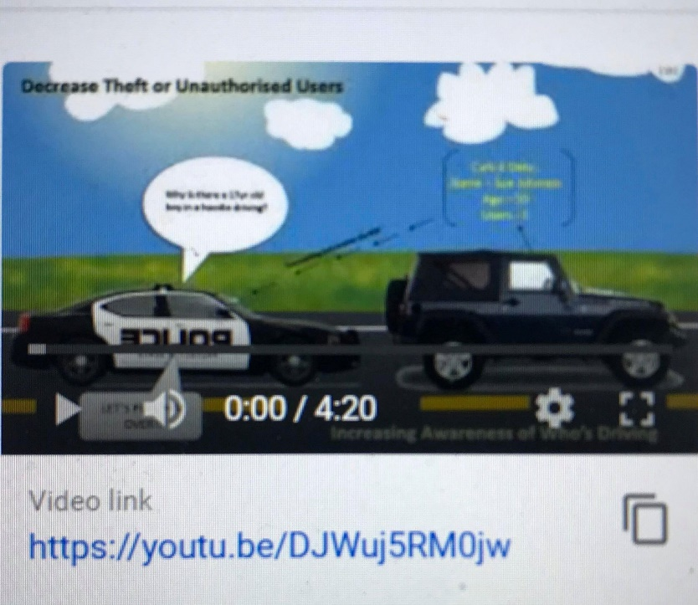

EIGP 3 -Final Pitch
Ddraig Coch & CARK-E
Submitted To: James Williams
Submitted By: Anthony Smith 1704559

Please find below, the link to the PowerPoint Slide show of the final presentation.
It has been converted into a Video File and uploaded to YouTube.
It covers section 2 (idea and USP)

https://youtu.be/DJWuj5RM0jw

