Programme: MSc Public Health and Social Care in Practice.
Module: Population Health and Digital Health Promotion
Module code: LCHS7007
Assignment Title: Component 1
Task 1- Blog
Task 2- Poster
Student Name: Ruksana Akter
Student Number: 2412069
Lecturer: Dr Ping Wu



Table of contents
Task-1: Blog-1 the role of wearable devices to reduce Hypertension…………….
Blog- 2: The impact of digital technology to reduce Cardiovascular Disease (CVD)……..
Task-2: Poster - Digital Health Technology for reducing the risk of hypertension Using wearable device……………………..
References…………………………………………………………………………………………………

Task-1: Blog-1 the role of wearable devices to reduce Hypertension
Introduction: Addressing Hypertension as a Public health concern
- The disease known as hypertension, or elevated blood pressure, is characterized by a consistently elevated pressure in the blood arteries. The "silent killer," as it is sometimes called, is hypertension, a major risk factor for cardiovascular illnesses, which include heart attacks and strokes and are among the leading causes of early death worldwide (World Health Organization: WHO, 2019).
- One major medical issue that might raise the risk of heart, brain, kidney, and other disorders is hypertension. However, it impacts over 1.28 billion individuals between the ages of 30 and 79, with two-thirds residing in low- and middle-income nations in globally (World Health Organization: WHO, 2019). Around 31% of men and 26% of women are affected by hypertension respectively in the UK, which causes more than 75,000 fatalities a year (Health matters: combating high blood pressure, 2017).
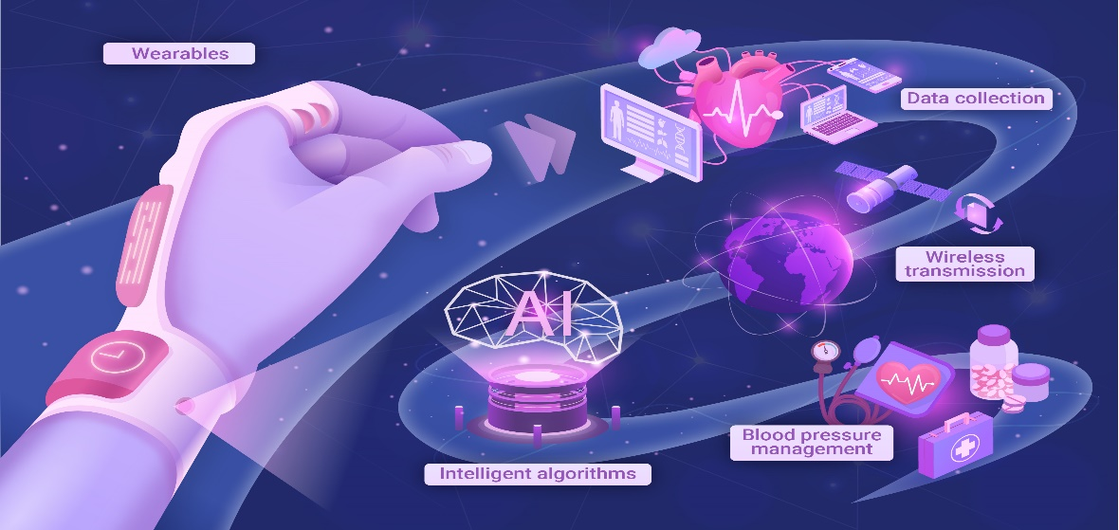
The function of wearable technology in hypertension health promotion

(Song et al, 2023)

In the modern era, smartwatch-based cuffless blood pressure (BP) measuring devices make easier to assess disease like hypertension which is major concern in worldwide (Mbeta,James, 2024). However, Islam et al demonstrates that, this device incorporates functions like activity tracking, heart rate monitoring, and reminders for exercises or medications and encourage adherence to treatment programs (Islam et al, 2022).

Supporting Data for Wearable Technology
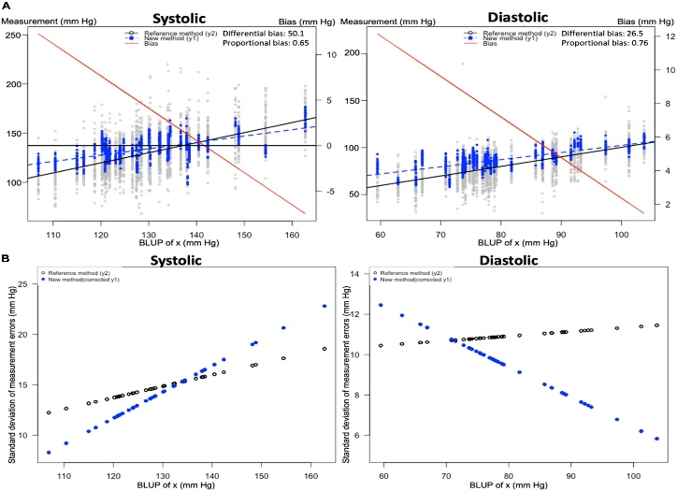
- A recent evidence recommend that, wearable blood pressure monitors and computerized HTN management are the technologies of the future. Regarding smartwatches lowering or even preventing cardiovascular events in hypertension individuals, these strategies provide a realistic possibility (Konstantinidis et al, 2022).
- Furthermore, smartwatches assist in detecting hypertension phenotypes that could otherwise go unnoticed, including masked hypertension.
(Falter et al., 2022)

Smartwatch-Based Cuffless Blood Pressure Device in Health Promotion
Nonetheless, continuous, non-invasive monitoring is being provided by smartwatch-based cuffless blood pressure sensors, which are transforming the treatment of hypertension and it has pros and cons also-
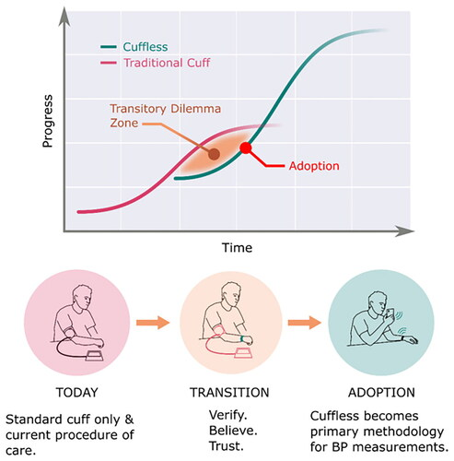
Benefits
- On the one hand, this device is more convenient and it can carry anywhere without requiring heavy machinery and it monitor blood pressure anytime (Lee et al, 2021). On the other hand, smartwatch connect to health applications, providing progress monitoring, reminders, and tailored feedback. This integration encourages people to stick to their good habits (Islam et al, 2022). Furthermore, real time data can be monitored by this device which offers useful information on blood pressure patterns, allowing users to pinpoint triggers and modify their lifestyle (Mbeta,James, 2024).
(Henry et al, 2024)

Limitations
Although smartwatch has various merits but it has some demerits also for instance- misdiagnosis and inappropriate treatment could be happen at a certain time (Mbeta,James, 2024). Also, due to their high cost, high-quality smartwatches with blood pressure monitoring capabilities may not be affordable for those with modest incomes (Islam et al, 2022). Therefore, the majority of smartwatches have somewhat short battery lives, often lasting one to two days. This implies that it must frequently charge your watch, which might be inconvenient (Colombari, 2023).
Shortcomings of Smartwatch
Basically, smartwatch has a few number of deficiencies such as blood pressure can vary between two arms while calibrating using the contralateral arm may not be reliable in practical situations (Yong Suk Jang et al, 2024). Another study illustrates that, it required more concentration when interpreting blood pressure otherwise it could be biased (Sinou et al., 2024).
(Jang et al., 2023)

Blog- 2: The impact of digital technology to reduce Cardiovascular Disease (CVD)
Introduction: Addressing Cardiovascular Disease as a public health concern
The term "cardiovascular disease" refers to a collection of conditions that impact the heart and blood arteries and one or more heart and/or blood vascular components may be impacted by these illnesses (Cleveland Clinic, 2022).
- Cardiovascular disease (CVD) is the world's largest cause of mortality, causing an estimated 17.9 million deaths a year, or almost 32% of all fatalities worldwide (World Health Organization, 2021).
- Every year in the UK, CVD is a contributing factor in more than 160,000 fatalities. It is one of the leading causes of early death, especially in those under 75 (NICE, 2024).

Introducing Enhanced Corrie Health Fitness Tracker: Designed Digital Technology
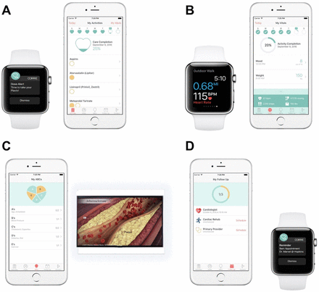

(Hung et al., 2020)

The Enhanced Corrie Health Fitness Tracker is a cutting-edge digital health tool, to lower cardiovascular disease. It was created in partnership with Apple designers by cardiologists and engineers at Johns Hopkins, enabling patients to take charge of their own heart health (Spaulding et al, 2019). With features including vitals tracking, medicine reminders, workout schedules, and progress tracking, the tracker connects with gadgets like Fitbit and Apple Watch. (Nino Isakadze et al, 2024).
The impact of Enhanced Corrie Health Fitness Tracker to reduce the risk of CVD
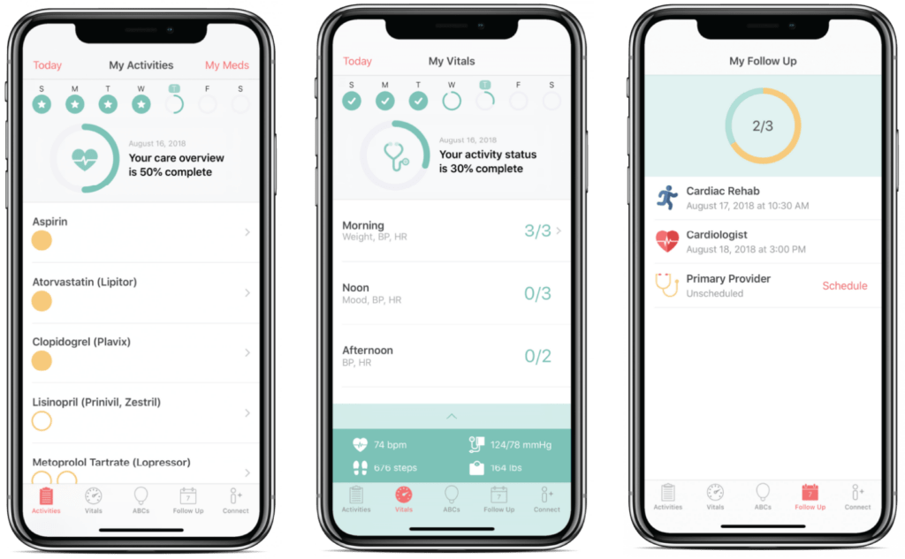
The Enhanced Corrie Health Fitness Tracker uses digital technology in creative ways to battle cardiovascular diseases (CVD) and enhance health. These are following-
(icon_arrow-left, 2023)

- Firstly, it offers users individualized instructional content on heart health, including details on risk factors, lifestyle modifications, and the advantages of consistent physical exercise, the tracker empowers users (Spaulding et al., 2019).
- Secondly, vital indicators such as blood pressure, heart rate and activity level can be monitored by it and users may keep tabs on their health and make well-informed decisions (Hung et al, 2022).
- Finally, by addressing early detection of disease it works for preventing disease through improving access to treatment, physical activity and self- management (Santo and Redfern, 2020).

Advantages
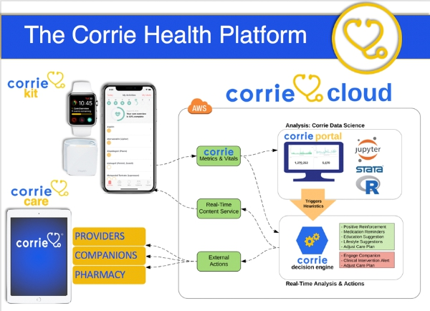
First and foremost merits is it decrease healthcare costs and improving resource allocation rather than using traditional approaches and it easy to use (Gray et al, 2022). Therefore, through gathering data examination of extensive information, offering significant perspectives on health patterns, risk factors, and the efficacy of therapies and it helps to manage individual health, promoting self-monitoring, adherence to treatment plans, and lifestyle changes (Wongvibulsin et al, 2019).
(Brown, 2019)

Disadvantages
However, a number of barriers facing the users while using this tracker for instance- there are serious privacy and security issues with the gathering, storing, and using of personal health data and it requires more skills and high internet speed that’s why the rural people cannot access this tracker (Savience, 2023). Another weakness of this digital intervention there are worries over the possible effects of many digital health attempts as they lack sufficient research and proof of efficacy (Koh et al., 2021).
Shortfalls
Moreover, this technology should have strict data collection privacy and regulations and to develop scientific procedures to guarantee people safety and efficacy (Ferretti, Hubbs and Vayena, 2023). As it needs more skills for running so it could offers requisite abilities and expertise to use digital health technology efficiently and adapt treatments to each person's requirements and preferences while accounting for variables including age, gender, ethnicity, and health status (Abernethy et al, 2022).

Task-2: Poster - Digital Health Technology for reducing the risk of hypertension Using wearable device
Background: Hypertension is one of the main causes of early mortality globally and a key risk factor for heart disease and stroke (Chockalingam et al, 2006). It is called silent killer just because early identification and treatment are crucial since many persons with hypertension don't exhibit any symptoms.Globally, in adults, just approximately 1 in 5 have their hypertension under control, and less than half (42%) have a diagnosis and treatment yet (World Heart Federation, 2022). The examples of both digital and non-digital technologies are Wearable Smartwatch Technology, Telemedicine & Remote Monitoring, Mobile Health Apps, Community Blood Pressure Screening, Legislation on Salt Reduction and Exercise & Dietary Programs. According to clinical research, wearable technology helps regulate blood pressure and encourages healthy lifestyle choices. To maximize efficacy, nevertheless, issues including user engagement, pricing, and accuracy must be resolved (Jafleh et al, 2024).
Health promotion values and principles: The goal of health promotion is to enable people and communities to enhance their health by policy initiatives, education, and preventative measures according to Furbe et al, 2023. Key ideals include holistic health, which addresses social, emotional, and physical aspects of health; participation, which involves people in choices that impact their well-being; equity, which guarantees that everyone has access to health resources; and sustainability, which encourages long-term health gains (St. Catherine University, 2022). And, Smartwatch-Based Cuffless Blood Pressure devise is more sustainable to engage with patient in hypertension by offering accessible, personalized, and preventive care and therefore continuous feedback, lifestyle tracking, and reminders improve engagement and promote long-term wellbeing (Odeh et al, 2024).
Behavioural change theory: The Transtheoretical Model (Stages of Change) is a popular behavioral change theory which includes precontemplation, contemplation, preparation, action, and maintenance. Anyway, each step describes how wearable smartwatch support individuals to decline the risk of hypertension (Prochaska and Velicer, 1997). Loma Linda University described that, wearable devices raise awareness of the hazards of hypertension by educating users about health issues (Loma Linda University, 2022). Through the contemplation and action phase people might set the goals for health and ensuring about the healthy habits of regular life significantly. Last stage tailored ongoing observation to reinforce long term behavior change which is in maintenance phase (Prochaska and Velicer, 1997).
Expected outcome: It is anticipated that using the Transtheoretical Model (Stages of Change) in a wearable wristwatch intervention for hypertension treatment would result in better blood pressure control, continued behavioral change, and increased adherence to good habits. With consistent exercise, medication adherence, and lifestyle changes, users will gradually go from awareness to action (Mohrag et al., 2024).
Conclusion: To conclude, research, education, and policy are all significantly impacted by the use of wearable wristwatch technology for managing hypertension. Legislators may include digital health into preventative care plans, encouraging the use of health technology and establishing legal frameworks to protect patient privacy and effectiveness (Mohrag et al., 2024b). In addition, this digital intervention supports healthy habits, enables early intervention to lower cardiovascular risks, and empowers people to actively manage their blood pressure—all of which are in line with the principles of health promotion (Katz et al, 2024).

