Joshua Willis (2405267)

Assignment 2
Introduction to web and database concepts

Contents
Scenario description 2
Screenshots 3
Design choices 5
Summary 5
Reflection on challenges and how to improve 6
References 6

Scenario description

The scenario for this project is centred around a bike rental service to promote the use of bikes in and around cities to reduce use of cars and other motor vehicles. This will improve people’s fitness and personal health as well as the environment and reducing carbon emissions each year. With a small expanding company, a creation of a database to store and manage all the user, employee and bike information. This database will offer ease to achieve visibility and awareness of bikes and their condition and location to employees along with relevant others. Finally, to prevent doubling bookings also putting a stop to potential unregistered or tracked bikes and users. The purpose of the assessment creating a database to streamline and help organise all collected data in one single database compared to several paper-based forms which can get lost or inputted incorrectly.

Screenshots
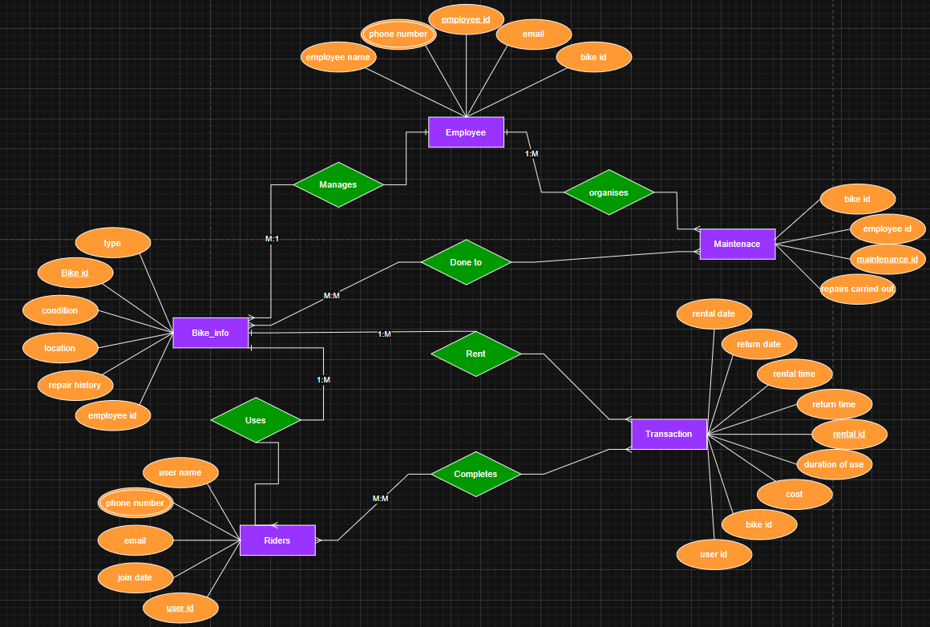
figure 1 of a created ERD relating to the database created for this scenario

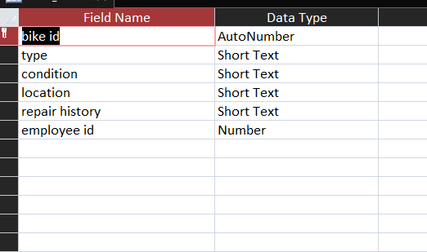
figure 2 of design view in Microsoft access of bike information table with attributes and data types displayed

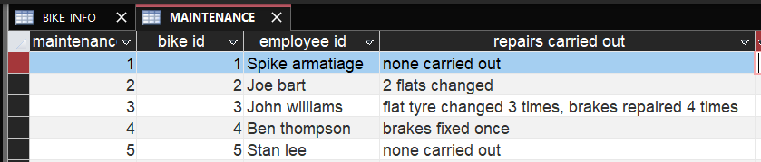
figure 3 of data view in Microsoft access of maintenance table displaying clear inputted information under relevant attributes

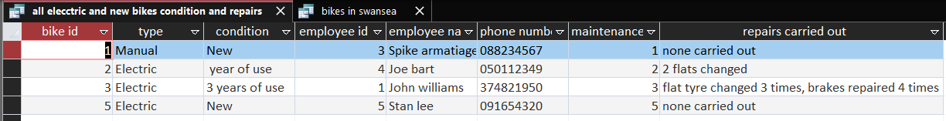
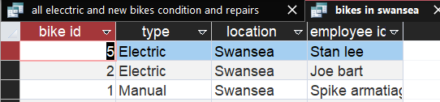
Figure 4 and 5 showing queries with database from using multiple tables to compile relevant data
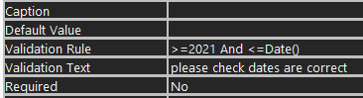
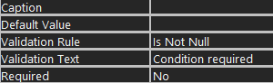
Figure 6 and 7 shows use of validation rules to ensure data isn’t missed or incorrect

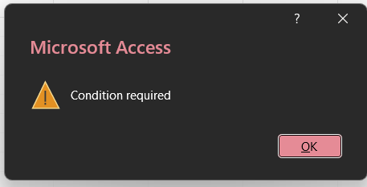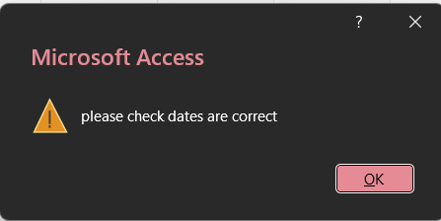
Figure 8 and 9 show error messages prompted after data entered does not meet requirements of validation

Design choices

The importance of having a well-designed database is beneficial to any company as having the data managed efficiently and organised for people to have ease of access to gain the data they need is crucial [1]. Having an application over the top of a database is standard however if the database presents issues and contains potential errors the overlaying application will break down until the problem is fixed so having a well-designed database is critical to performance [2]. The choices made for the design of the database were chosen because they made the most logical sense to separate and develop the entities within the database with each of their corresponding attributes which offer all the required information for each employee to bike details. This design ensures accurate data is stored and effectively for people with access to retrieve relevant data for their search in the database.

Summary

The built database is there to assist and maintain an accurate list of information submitted into the database offering a way of well organised data to track and understand user issues. The database has five separate entities which all play a key role in efficiently using data. Finally using queries within the database is an excellent way to retrieve data through prompting the information that is required and with entities it will be acquired from.

Reflection on challenges and how to improve

Challenges that were faced in this process was defining the relevant attributes for each entity but also the foreign keys within them were a difficult process to achieve. The normalisation section of the implementation aspect of this assignment has not been introduced into the database however the in future it would be best to make the attributes used now atomic to separate and create a broken down version of for example an address attribute and having the house and street address within different attributes to achieve a more efficient system for queries and data analysis, also having the attributes all being separated and linked to keys. In future to improve this database it can be done by creating more attributes within entities while also creating new entities to encapsulate more data and separate more information into specific defined entities. Finally, the ERD had challenges when creating the relations between entities and understanding the notation links between each to improve next time it will be best to organise the ERD in a better format while also planning the entities and all relationships be the creation begins.

References

[1] “Why Is Database Design Important? | Miro,” https://miro.com/, 2026. https://miro.com/diagramming/why-is-database-design-important/#why-is-database-design-important? (accessed Jan. 17, 2026).
‌
[2] “Why Is Database Design Important?,” www.linkedin.com. https://www.linkedin.com/pulse/why-database-design-important-colbytech/
‌

