
LCHS4003: Introduction to Health and Social Care

Programme: Certificate of Higher Education Skills for the Workplace

Assignment Title: Portfolio

Lecturer Name: Muhammad Aliyu

Student Name: Shen Sami Nesrin
Student ID:2512896

Table of Contents
Task 1: Poster on Community Disability Services 3
Task 2: Essay on Pharmacy Services 6
References 9

Task 1: Poster on Community Disability Services
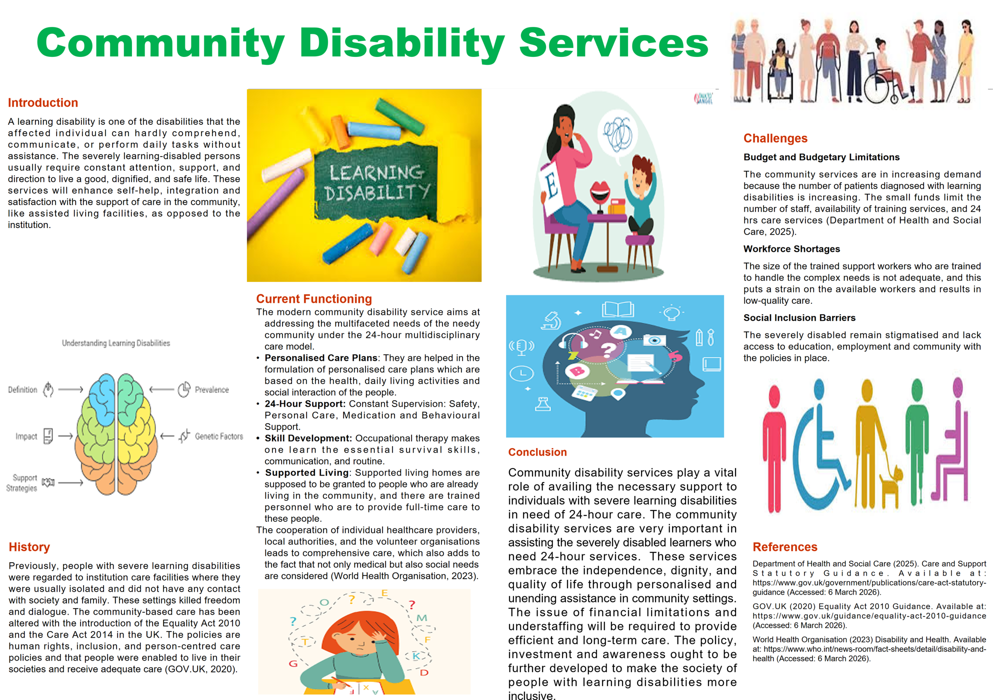

Introduction
A learning disability is one of the disabilities that the affected individual can hardly comprehend, communicate, or perform daily tasks without assistance. The severely learning-disabled persons usually require constant attention, support, and direction to live a good, dignified, and safe life. These services will enhance self-help, integration and satisfaction with the support of care in the community, like assisted living facilities, as opposed to the institution.
History
Previously, people with severe learning disabilities were regarded to institution care facilities where they were usually isolated and did not have any contact with society and family. These settings killed freedom and dialogue. The community-based care has been altered with the introduction of the Equality Act 2010 and the Care Act 2014 in the UK. The policies are human rights, inclusion, and person-centred care policies and that people were enabled to live in their societies and receive adequate care (GOV.UK, 2020).
Current Functioning
The modern community disability service aims at addressing the multifaceted needs of the needy community under the 24-hour multidisciplinary care model.
- Personalised Care Plans: They are helped in the formulation of personalised care plans which are based on the health, daily living activities and social interaction of the people.
- 24-Hour Support: Constant Supervision: Safety, Personal Care, Medication and Behavioural Support.
- Skill Development: Occupational therapy makes one learn the essential survival skills, communication, and routine.
- Supported Living: Supported living homes are supposed to be granted to people who are already living in the community, and there are trained personnel who are to provide full-time care to these people.
The cooperation of individual healthcare providers, local authorities, and the volunteer organisations leads to comprehensive care, which also adds to the fact that not only medical but also social needs are considered (World Health Organisation, 2023).
Challenges
Budget and Budgetary Limitations
The community services are in increasing demand because the number of patients diagnosed with learning disabilities is increasing. The small funds limit the number of staff, availability of training services, and 24 hrs care services (Department of Health and Social Care, 2025).
Workforce Shortages
The size of the trained support workers who are trained to handle the complex needs is not adequate, and this puts a strain on the available workers and results in low-quality care.
Social Inclusion Barriers
The severely disabled remain stigmatised and lack access to education, employment and community with the policies in place.
Conclusion
Community disability services play a vital role of availing the necessary support to individuals with severe learning disabilities in need of 24-hour care. The community disability services are very important in assisting the severely disabled learners who need 24-hour services. These services embrace the independence, dignity, and quality of life through personalised and unending assistance in community settings. The issue of financial limitations and understaffing will be required to provide efficient and long-term care. The policy, investment and awareness ought to be further developed to make the society of people with learning disabilities more inclusive.

Task 2: Essay on Pharmacy Services
In this essay, the history of the pharmacy services will be analysed, their operation in contemporary society will be critically analysed, and the relevance of the pharmacy services to enhance the living standards of people who consume their services.
History of the Pharmacy Services
The history of pharmacy goes back to early apothecaries who participated in the preparation and supply of medicinal substances to cure diseases. The emergence of medical knowledge and pharmaceutical products in the nineteenth century created the need to have some form of regulatory system to ensure the safe delivery of the drugs. One move that was used to regulate drug sales and provide professional rules for pharmacists was the introduction of the Pharmacy Act in the United Kingdom in 1868. It was a law that helped to save the lives of the people since the drugs were extracted by certified practitioners (Department of Health and Social Care, 2022).
The establishment of the National Health Service (NHS) in 1948 was another great step in the evolution of pharmacy services development. Since the introduction of universal healthcare, pharmacy services were regarded as an element of the healthcare system, which implied that patients could use the services that were financed by the government to obtain the required medicines (GPhC, 2025). The pharmacologist's job description evolved and became more encompassing of the healthcare service, like counselling patients, evaluation of medications and disease prevention programmes, saying what they dispensed. The historical events shaped the contemporary profession of a pharmacist that is concerned with patient safety, accessibility, and professional accountability.
Critical Evaluation of service functions
Pharmacy services are highly important today, as they help in the maintenance of healthcare services within communities. The most prevalent healthcare facility in the community is the pharmacies since they are widely spread and most of them operate long hours. Pharmacists are individuals who dispense the medication that has been prescribed and provide information on how to take the medications and help individuals manage long term diseases such as diabetes, asthma and blood pressure.
One strength of the pharmacy services is the accessibility of the pharmacy services. Patients do not need to make an appointment since they can receive instant health consultations, and this eases the burden on general practitioners and hospital services (NHS England, 2025). Preventive health care such as vaccination programmes, smoking quit programmes and screening is also offered by the pharmacists. These services help in the well-being of the individuals and prevent diseases.
However, as much as there are these strengths of pharmacy services, there are also some challenges. This has resulted in the high demands of healthcare services, thereby imposing pressures on the pharmacists and pharmacy staff. The issue of the workforce and inadequate funding may affect the pharmacy services. Additionally, the expanding role of the pharmacists is also a cause to guarantee the continuous professional development and further training to ensure that the high care standards are maintained. Therefore, pharmacy services are a good solution to healthcare assistance, and the problem of workforce and resources can be a critical challenge to address to be effective.
Importance in enhancing Quality of Life
Pharmacy services are relevant in improving the quality of life of the service users as they are safe and have effective control over their medication. The patients are guided by the pharmacists to be informed on how to use their medication in the best way possible and reduce the risks of medication errors and adverse effects. This service is particularly important to persons with chronic conditions who will be seeking long-term care. Drug control and pharmacy services increase preventive health services through vaccination programs and lifestyle advice (Schoenmakers et al., 2022). These services help in the prevention of diseases and encourage patients to adopt healthier behaviours. The ease and availability of community pharmacies also make individuals access healthcare, especially for persons who may have impediments in other healthcare services. Thus, the pharmacy services play a role in improving the health outcome of the population and well-being.

Conclusion
Pharmacy services are a very important component of the health care systems in modern societies, particularly in the United Kingdom National Health Service (NHS). This essay discussed that the history of pharmacy services has evolved over the years. Particularly, the position of apothecary has become significant to the modern-day health care systems. The historical events that happened had a major impact on the professional role of a pharmacist, and among them were the discovery of the NHS and the formation of the Pharmacy Act of 1868. The modern-day healthcare provision through pharmacy is facilitating easy access to medication, health promotion and preventive healthcare.

References
Department of Health and Social Care (2022) Women’s Health Strategy for England. Available at: https://www.gov.uk/government/publications/womens-health-strategy-for-england/womens-health-strategy-for-england (Accessed: 6 March 2026).
Department of Health and Social Care (2025) Care and Support Statutory Guidance. Available at: https://www.gov.uk/government/publications/care-act-statutory-guidance (Accessed: 6 March 2026).
GOV.UK (2020) Equality Act 2010 Guidance. Available at: https://www.gov.uk/guidance/equality-act-2010-guidance (Accessed: 6 March 2026).
GPhC (2025) Standards and Guidance for Pharmacy Professionals. Available at: https://www.pharmacyregulation.org/pharmacists/standards-and-guidance-pharmacy-professionals (Accessed: 6 March 2026).
NHS (2023) Learning Disabilities. Available at: https://www.nhs.uk/conditions/learning-disabilities/ (Accessed: 6 March 2026).
NHS England (2025) Community pharmacy advanced service specification: NHS new medicine service. Available at: https://www.england.nhs.uk/long-read/community-pharmacy-advanced-service-specification-nhs-new-medicine-service/ (Accessed: 6 March 2026).
Schoenmakers, S., Verweij, E.J. (Joanne), Beijers, R., Bijma, H.H., Been, J.V., Steegers-Theunissen, R.P.M., Koopmans, M.P.G., Reiss, I.K.M. and Steegers, E.A.P. (2022) ‘The Impact of Maternal Prenatal Stress Related to the COVID-19 Pandemic during the First 1000 Days: A Historical Perspective’, International Journal of Environmental Research and Public Health, 19(8), pp.4710. Available at: https://doi.org/10.3390/ijerph19084710
World Health Organisation (2023) Disability and Health. Available at: https://www.who.int/news-room/fact-sheets/detail/disability-and-health (Accessed: 6 March 2026).

