University Name + Campus
Full Name
Student ID
Programme: CertHE Computing Skills for Workplace
Module Name: Software Solutions for Business
Module Code: ACCA4026
Lecturer Name
Submission Date

Table of Contents
INTRODUCTION 5
1.1 Purpose of the Portfolio 5
1.2 Importance of Software in Modern Business Operations 5
2 TASK 1: e-Commerce Website Builders 6
2.1 Introduction to e-Commerce Website Solutions 6
2.2 Platform 1: Shopify 6
Figure 1: Shopify Admin Dashboard Interface 7
2.3 Platform 2: WooCommerce 7
2.4 Comparative Analysis 8
3 TASK 2: Mind Mapping & Contemporary Software Applications 9
3.1 What is Mind Mapping? 9
3.2 Benefits of Mind Mapping in Business Operations 10
3.2 Practical Component – Mind Map Creation 11
4 TASK 3: Office Applications for Creating, Storing, Presenting and Analysing Information 12
4.1 Introduction to Office Software in Business 12
4.2 Microsoft Word 13
4.3 Microsoft PowerPoint 14
4.4 Microsoft Excel 15
4.5 Microsoft Access 16
4.6 Practical Testing Section 16
4.6.1 Feature 1: Pivot Table (Microsoft Excel) 16
4.6.2 Feature 2: IF Function (Microsoft Excel) 19
5 TASK 4: Communication and Collaboration Applications 21
5.1 Introduction 21
5.2 Communication Tool Analysis: Microsoft Teams 22
5.2.1 Overview 22
5.2.2 Key Features 22
5.2.3 Business Benefits 22
5.2.4 Security Considerations 23
5.2.5 Limitations 23
5.2.6 Practical Test – Microsoft Teams 23
5.3 Collaboration Tool Analysis: Google Drive 25
5.3.1 Overview 25
5.3.2 Key Features 25
5.3.3 Benefits 26
5.3.4 Comparison with Alternatives 26
5.3.5 Practical Test – Google Drive 26
6 CONCLUSION 28
References 30

LIST OF FIGURES
Figure 1: Shopify Admin Dashboard Interface ............................................. 7
Figure 2: WooCommerce Dashboard ............................................................. 8
Figure 3: Mind Map of Contemporary Software Applications ............... 11
Figure 4: Raw Dataset in Excel................................................................. 17
Figure 5: Pivot Table Creation................................................................. 18
Figure 6: Pivot Table Output Analysis..................................................... 18
Figure 7: IF Function Formula Entry ...................................................... 19
Figure 8: IF Function Output................................................................. 20
Figure 9: Creating Meeting in Microsoft Teams ..................................... 23
Figure 10: Chat Interface in Microsoft Teams ....................................... 24
Figure 11: Screen Sharing During Meeting ............................................. 24
Figure 12: Creating Shared Document in Google Drive....................... 26
Figure 13: Permission Settings Panel ...................................................... 27
Figure 14: Real-Time Collaborative Editing............................................ 27

INTRODUCTION

Purpose of the Portfolio
The purpose of this portfolio is to demonstrate the practical and theoretical understanding of contemporary software solutions used in modern business environments. The assignment tests the skills of search, evaluation and utilization of various digital tools, which assist in the day-to-day organizational functioning [1]. According to the module learning outcomes, this portfolio demonstrates the understanding of software packages and application in business situations and the skills to convey and communicate well-organized data. The test combines research, analysis and practice test to exemplify core competencies of computing in a workplace environment.
The portfolio focuses specifically on e-commerce platforms, office productivity applications, communication tools, and collaboration software. Each part is a combination of theoretical explanation and practical examples of how digital tools help to improve operational efficiency. The work will follow a critical awareness formation approach by analyzing the advantages and shortcomings of the chosen applications instead of a mere descriptive one [2]. The style is an indication of the Level 4 level of analyzing the concepts formed in the background and putting them into practice.

Importance of Software in Modern Business Operations
Digital software solutions are central to modern organizational productivity and competitiveness. Cloud computing and unified systems allow automating the routine procedures, minimize the number of mistakes, and allocate resources more efficiently [1]. The studies show that the digital transformation initiatives have an effective role in operational efficiency and organizational performance in cases of successful implementation.
Software applications streamline workflow by integrating tasks such as document management, financial analysis, customer relationship management, and internal communication into unified systems [2]. This minimizes the redundancy of work and enhances inter-departmental coordination. Moreover, digital communication devices help to work together in real-time, especially when dealing with a hybrid and remote workplace.
Data-driven decision-making is another major benefit of contemporary software systems. Business intelligence tools and analytical functionalities in office applications enable organizations to make correct interpretation of quantitative data and act in response to market trends in a strategic manner [3]. Therefore, software solutions are not supportive tools only but strategic resources that define the productivity, optimization of the workflow, effectiveness of communication and managerial decisions making.

TASK 1: e-Commerce Website Builders

Introduction to e-Commerce Website Solutions
E-commerce website builders are digital platforms that enable individuals and organizations to create, manage, and operate online stores without extensive programming knowledge [4]. These services usually offer hosting, template web sites, payment gateway access, inventory and marketing modules on a single platform. Online retail has developed so fast that it has become a mandatory part of digital business transformation plans.
E-commerce solutions support organizational scalability, global reach, and data-driven marketing. The SMEs, especially the small companies have the advantage of lower infrastructure costs and easy control of their stores [5]. Modern platforms are principally based on the principles of cloud-based subscriptions, which reduce the capital investment and allow expansion to be scaled.

Platform 1: Shopify
Shopify is a cloud-based e-commerce platform designed to allow businesses to build and manage online stores through a subscription model. It offers professionally created templates, secure checkout services, inventory software, shipping automation, and analytics of marketing services [5]. The report submitted by Shopify in 2024 showed that it serves millions of merchants worldwide, which is a much more promising result in terms of scaling and infrastructure sustainability.
Core features include integrated payment gateways (Shopify Payments), multi-channel selling (including social media and marketplaces), mobile optimization, and advanced analytics dashboards. In the case of SMEs, Shopify is easy to use and requires little technical skills due to the drag-and-drop user interface and the low technical specifications. This minimizes the need of specialized developers and minimized the complexity of operations.
However, Shopify operates on monthly subscription fees with additional transaction costs unless Shopify Payments is used [3]. The entry-level plans start at about PS25-PS30 monthly and the higher plans cost more depending on the features and size. Transaction costs and premium integrations of applications may also add to the costs of operations with time.
Shopify is particularly effective for growing SMEs seeking scalability and integrated solutions. It has been strong in its ability to be deployed quickly and use reliable hosting infrastructure [6]. Nonetheless, certain companies that need more design flexibility or reduced recurring expenses might find the platform to be not the most cost-effective either on the long-term basis.
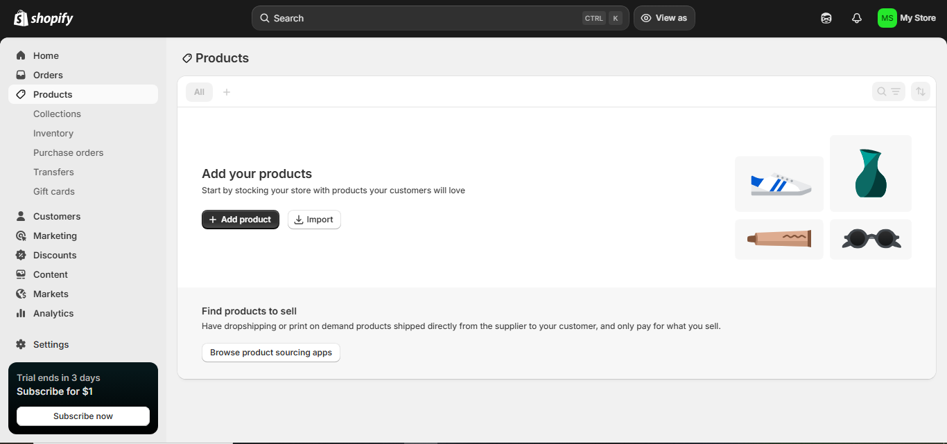

Figure 1: Shopify Admin Dashboard Interface

Platform 2: WooCommerce
WooCommerce is an open-source e-commerce plugin designed for WordPress websites. In contrast to Shopify, WooCommerce is free to install, but users have to pay to host on it, have a domain name, and optional extensions [4]. It is open-source, and this allows it to be heavily customized and also to integrate with third-party tools.
Core features include product management, secure payments, inventory tracking, and numerous plugin extensions. WooCommerce works well especially with business organizations that are already on the WordPress sites. It offers more design freedom and control of data ownership as opposed to fully hosted solutions.
The main advantage for SMEs is lower initial subscription costs. Nevertheless, other costs like hosting services, premium themes and security plugs can augment the overall costs [6]. In addition, it might only be set up and maintained by technical knowledge and therefore not user-friendly by individuals who are not skilled in web development.
WooCommerce is most effective for businesses requiring high levels of customization and long-term cost control. It is also most appropriate where the organizations have internal technical skills, or where web developers are available.
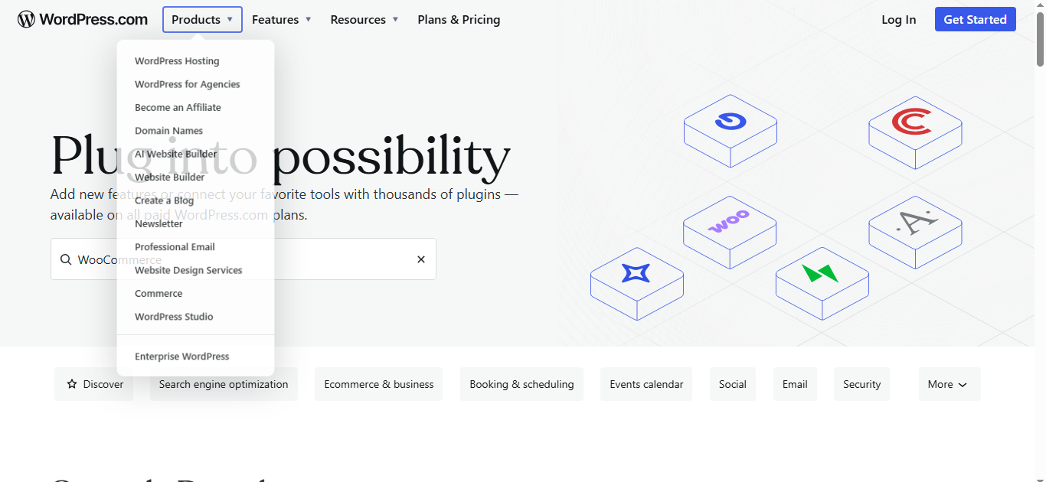
Figure 2: WooCommerce Dashboard

Comparative Analysis
Feature | Shopify | WooCommerce
Ease of Use | Very user-friendly, hosted platform | Moderate – requires WordPress knowledge
Cost | Monthly subscription + transaction fees | Free plugin but hosting & extensions required
Scalability | Highly scalable, enterprise options available | Scalable but dependent on hosting quality
Customization | Limited to theme/app ecosystem | Highly customizable (open-source)
Table 1: Comparative Analysis Table
Overall, Shopify is more suitable for SMEs seeking simplicity, rapid deployment, and minimal technical management. WooCommerce is more suitable in businesses with low cost consciousness or those that have technical expertise and need complete customization [6]. To the majority of simple businesses that do not have technical teams, Shopify is more convenient to operate at the cost of increased recurrence expenses.

TASK 2: Mind Mapping & Contemporary Software Applications

What is Mind Mapping?
Mind mapping is a visual thinking technique used to organize information hierarchically around a central concept. It entails constructing a map with the important concepts diverging around a main theme with the help of keywords, colors, and visual links. This technique was popularized by Tony Buzan who has contended that radial diagrams represent the associative network of human cognition and help to improve memory retention [6]. Modern studies affirm the cognitive worth of the visual knowledge structure, which means that the diagrammatic representation enhances the understanding and retention as opposed to the linear approach to note taking.
From a cognitive perspective, mind mapping aligns with dual coding theory, which suggests that combining verbal and visual information enhances learning efficiency. Visual mapping provokes associative thinking, allowing the user to connect ideas, find a relationship, and organize large amounts of information [2]. This is even improved by digital mind-Mapping tools, which can be dynamically edited, collaboratively and, also, integrated with other software systems.
In business planning, mind mapping supports structured idea generation and strategic alignment. It allows organizations to have a visual representation of objectives, operational elements and resource dependencies as one framework. As per the current research regarding visual management tools, to a larger extent, structured diagrammatic techniques enhance clarity in the planning processes and assist more coherent translations of decisions in the organizational settings [7]. Consequently, this has increased the use of mind mapping in project design, strategic analysis as well as in innovation workshops.

3.2 Benefits of Mind Mapping in Business Operations
Mind mapping contributes significantly to strategic planning by allowing managers to visualize organizational goals, market factors, risks, and operational requirements in an interconnected format. Ideas are organized in a relational way instead of being present as isolated lists, which allows prioritizing and dependency more easily to be identified [8]. Studies have emphasized that visual strategy tools increase the pace of cognitive processes to make management judgments better.
In brainstorming sessions, mind mapping encourages non-linear thinking. There is the ability to use creativity in generating ideas without loss of order and at the same time still, the participants are free to think any way but still, maintain some level of order in their thinking without the organization becoming ambiguous. Visual representations will be used in workflow mapping to enable the teams to have an insight into the stages of a process, bottlenecks, and dependencies between tasks. This enhances coordination and minimizes inefficiencies.
In project management, mind maps provide simplified overviews of deliverables, timelines, and responsibilities [6]. They are a complement to the traditional Gantt charts which provide conceptual clarity ahead of time before getting into actual scheduling. Another significant advantage is knowledge organization; the teams are able to organize information into organized groups and retrieval and review becomes more effective.
Visual thinking improves decision-making because it reduces cognitive overload. Textual data may be hard to process, though, with visual structures, pattern recognition or relationship analysis may become easy within a short time [9]. Increasing organizational productivity and collaborative efficiency Mind mapping is positively associated with heightened clarity when it comes to understanding and collective understanding.

Practical Component – Mind Map Creation
The mind map for this portfolio was created using Microsoft PowerPoint to demonstrate accessibility within standard office software environments. The central node of Contemporary Business Software was built with the help of PowerPoint SmartArt and shape tools. Out of this core idea, there were six main branches that were created to indicate the main categories of software that are employed in contemporary organizations.
Central Node | Primary Branches
Contemporary Business Software | Office Applications
 | Communication Tools
 | Collaboration Platforms
 | eCommerce Solutions
 | Data Analytics Tools
 | Cloud Storage
Table 2: Mind Map Structure Summary
Each category was selected to represent essential operational domains within contemporary business environments [7]. Office applications are used to support documentation and analysis; communication tools facilitate interaction, collaboration platforms can be used to work on a team, e-commerce solutions can be used to make online sales, data analytics tools can be used to make decisions, and cloud storage makes it accessible and secure.
This structured layout supports business operations by presenting interconnected digital systems in a single visual framework. It shows how software ecosystems interact with each other as opposed to independently, which supports the value of integrated digital infrastructure as strategic.
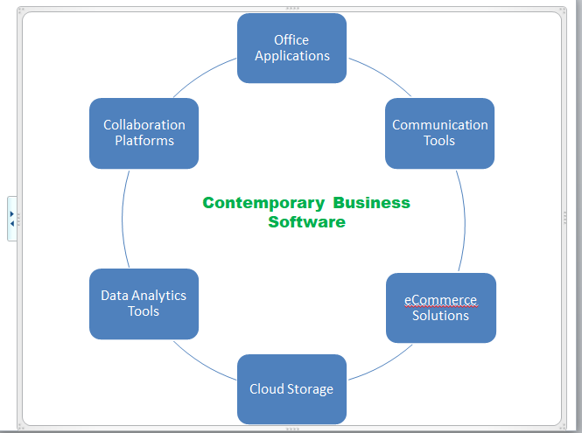
Figure 3: Mind Map of Contemporary Software Applications
The chosen categories reflect core functional areas within modern organizations and illustrate how software tools contribute to productivity, workflow efficiency, communication effectiveness, and data-driven decision-making.

TASK 3: Office Applications for Creating, Storing, Presenting and Analyzing Information

Introduction to Office Software in Business
Office software applications form the operational backbone of modern organizations. They facilitate organized data processing, formalized information management, internal and external communication as well as performance report. Digitally enabled workplaces are directly connected to productivity and the efficient utilization of modern office platforms that cannot only simplify documentations, analysis, but also knowledge-sharing processes [2]. The recent studies on the transformation of the digital workplace point to productivity improvement as closely linked with the use of combined productivity tools that will lessen the repetition of operations and increase the availability of information.
In terms of data handling, spreadsheet and database applications allow businesses to capture, store, analyze, and interpret quantitative information. Proper data management improves transparency, minimization of operation error, and adherence to regulatory measures [15]. Document control systems, versioning and organization of files enhance the information management. Word processing software can be used to conduct formal reporting and presentation tools can be used to deliver the findings to stakeholders in a form that is easy to understand.
Communication and reporting are increasingly interconnected within cloud-based office suites. The reports prepared in Excel may be integrated into PowerPoint slides, exchanged with collaboration systems, and stored at organized document storage. Microsoft's Work Trend Index (2023) shows that organizations that embrace integrated digital tools have a better workflow and are more efficient in making decisions within hybrid environments [11]. As such, the use of office software must be regarded as an administrative tool rather than an administrative tool but as a strategic tool to enable efficiency, accountability, and informed managerial decision-making.

Microsoft Word
Microsoft Word is a professional word-processing application widely used for creating structured documents such as reports, contracts, proposals, and correspondence. Its document formatting options consist of styles, headings, page layouts, tables, automatic referencing and template functionality. These are tools that bring about consistency and professional presentation in the face of organizational documents.
One of Word’s most significant automation features is Mail Merge, which enables the creation of personalized bulk documents by linking a template document to a structured data source such as an Excel spreadsheet [15]. This feature eliminates the manual repetition and improves efficiency in communication with the customers. Templates are also used to enhance productivity by having document formats of recurring business documents like invoices and policy documents to be standardized.
Collaboration tools such as Track Changes and comment functions allow multiple users to review and edit documents while maintaining version control. This will be especially useful in the development of policies, reviewing contracts, and academic reporting situations [10]. The studies about collaborative digital tools prove that document co-authoring and tracked revisions contribute to a considerable enhancement of the working process transparency and decrease the delays at approval stages.
The benefits of Microsoft Word include professional documentation, improved workflow efficiency through automation, and structured formatting capabilities that enhance readability and credibility [14]. Nonetheless, its drawbacks are formatting variations on opening documents in other software versions or when the documents are exported to PDF format. Also, files with high-resolution images or inserted objects can lead to large files, which can influence the effectiveness of storage and sharing. Generally Word is still vital in formal documentation, legal communication and a structured reporting in the business worlds.

Microsoft PowerPoint
Microsoft PowerPoint is a presentation software application designed to communicate information visually and persuasively. It has the capability of slide templates, animation, multimedia integration, SmartArt graphics, and inbuilt charts to visualize data [15]. The Presenter View option allows presenters to control the notes and watch time elapsing without showing them to the audience.
PowerPoint plays a critical role in business reporting, sales presentations, and staff training sessions. Complex quantitative data can be converted into charts and diagrams using data visualization tools which aid in understanding [12]. It is also indicated in the research on visual communication that the audience is more likely to retain information when it is formatted as a graphical representation and not as a text.
In reporting contexts, PowerPoint enables managers to summarize key performance indicators (KPIs) and strategic objectives in structured slide formats. Persuasive visual stories improve the client-levels in sales settings [14]. Systematized slide sequences can be used in training as uniform source of instructions to different departments.
Despite these advantages, PowerPoint may encourage excessive text use or overreliance on decorative animations, potentially reducing audience engagement. Also, the lack of interactivity in the opposite, static slide formats, can be avoided only through the addition of live demonstrations or interactive tools [13]. PowerPoint, however, can be an effective communication tool when applied in a very strategic and professional way.

Microsoft Excel
Microsoft Excel is a spreadsheet application widely used for financial modeling, budgeting, forecasting, and performance analysis. It has a wide array of functionality in the form of formulas, Pivot Tables, conditional formatting, data validation, and analytical features, like Goal Seek.
Formulas such as IF and VLOOKUP automate logical evaluation and data retrieval tasks. Pivot Tables summarize high volumes of data in aggregate form allowing managers to understand the performance patterns in a short period of time [13]. Conditional formatting is used to visually indicate patterns or abnormalities, which are easy to analyze. Based on the official documentation of Microsoft, Excel is still a backbone analytical tool in any industry because of its flexibility and integration features.
Within the business environment, Microsoft Excel is also useful in financial modeling to predict the revenue and expenses, manage inventory levels through stock track, budgeting in financial management through monitoring departmental expenditure, and data analytics through the summarization of the important organizational performance indicators to make informed decisions.
Excel is particularly appropriate for small to medium datasets requiring structured numerical analysis. It is user-friendly, versatile and comprehensible in most industries [16]. But when working with large-scale enterprise data including real-time dashboards and advanced predictive analytics then specialized applications like Power BI or enterprise database systems might offer more scalability and automation. The use of complex spreadsheets in excel can as well pose the risk of formula errors unless one handles it meticulously.
Excel is, hence, most appropriate when organizations have need to make flexible and structured analysis which is not costly to implement but can be accompanied by sophisticated systems in large scale analytics.

Microsoft Access
Microsoft Access is a relational database management system designed to store structured data efficiently. Its fundamental elements are tables (data storage), queries (data retrieval), forms (data entry interfaces), and reports (formatted outputs).
Access allows relationships between tables, reducing redundancy and enhancing data integrity. Questions allow extracting filtered data by particular criteria, whereas forms allow ease of entering data by people not familiar with technology [17]. Reports create organized summaries that can be viewed by the managers.
The primary business benefits include structured data storage, improved organization of large datasets, and support for multi-user environments within small organizations [16]. Access also allows automation via macros which helps in increasing efficiency in tasks involving repetitive data management.
However, Access has scalability limitations compared to enterprise database systems such as SQL Server. It can also be a learning curve to users who are not conversant with principles of relational database [12]. Access therefore is most appropriate in small to medium enterprises that do not have the complexities of an enterprise and therefore do not need a sophisticated internal database.

Practical Testing Section

Feature 1: Pivot Table (Microsoft Excel)

Dataset and Business Context
A simulated retail sales dataset was created containing the following columns: Product Category, Region, Month, and Sales Revenue. The sales data in the form of twenty five rows of fictional data were created based on performance in three regions on monthly basis. To reflect a realistic managerial reporting situation, in which decision-makers need summarized revenue information, the dataset was chosen.
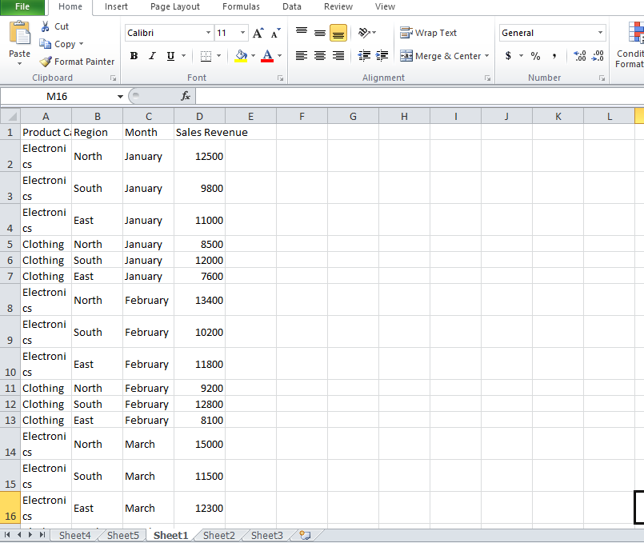

Figure 4: Raw Dataset in Excel

Pivot Table Creation
The dataset was selected, and the Pivot Table function was inserted via the “Insert” tab [14]. Product Category was placed in the Rows field, Region in the Columns field, and Sales Revenue in the Values field (summarized by sum).
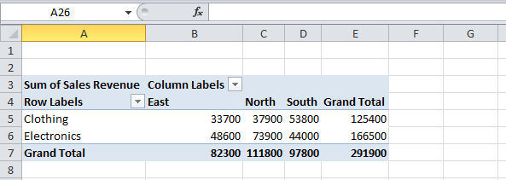
Figure 5: Pivot Table Creation

Output Analysis
The Pivot Table summarized total revenue by category and region, automatically aggregating numerical values.
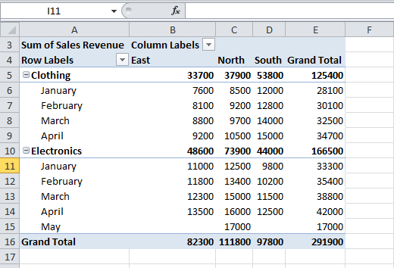
Figure 6: Pivot Table Output Analysis
The analysis revealed that Electronics generated the highest revenue in the North region, while Clothing performed strongly in the South. These are useful in managerial decision making to help in the identification of profitable product lines and to direct specific investments on marketing. In the absence of Pivot Tables it would be time consuming to perform manual aggregation and it is subject to error. In this way, this feature improves efficiency in strategic planning and reporting.

Feature 2: IF Function (Microsoft Excel)

Context
The IF function was applied to determine whether monthly sales met a performance target of £10,000. A new column titled “Performance Status” was added.

Process
The formula entered in the first row was:
=IF (D2>=12000,"Target Met”, “Below Target")
This formula was copied down the column to evaluate all entries.
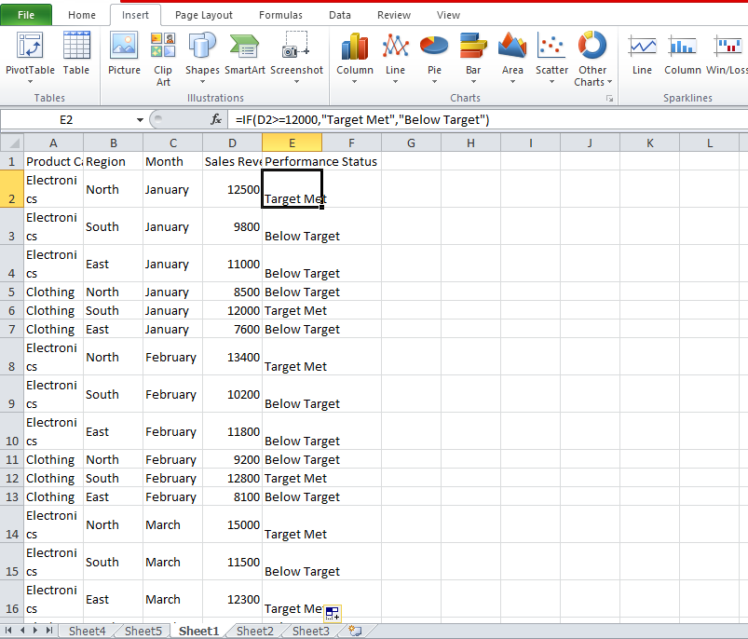
Figure 7: IF Function Formula Entry
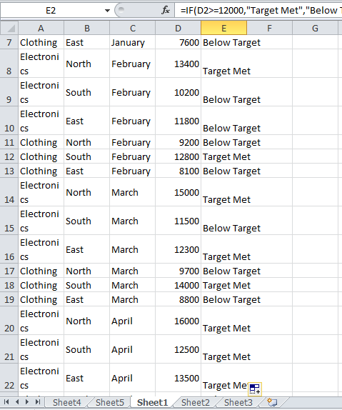
Figure 8: IF Function Output

Interpretation and Business Application
The output automatically classified months according to performance status. This eliminates the use of manual analyses and enables the managers to detect underperforming times easily. The IF function shows the ability of automation in Excel enhancing reporting and aids in proactive intervention measures [17]. The Pivot Table itself and the use of IF functions combined confirm the usefulness of Excel in both operational and strategic settings because it can turn raw data into usable information.

TASK 4: Communication and Collaboration Applications

Introduction
Digital communication technologies are fundamental to modern organizational performance. It is becoming common that almost every business performs its activities over geographical limits, and the tools needed include the capability to engage in real-time communication, share documents, and manage tasks in a coordinated way. The transition to hybrid and remote types of work has increased the popularity of cloud-based communication and collaboration systems [18]. Microsoft Work Trend Index (2023) indicates that hybrid work is a new regularity in the organizational structure and the digital platform has become the main infrastructure that coordinates and provides productivity.
The hybrid workplace combines remote and in-office working arrangements, necessitating reliable video conferencing, instant messaging, and shared digital workspaces. Cloud based collaboration sites enable workers to view documents, follow projects and communicate asynchronously such that continuity is maintained even when workers are spread across long distance. It has been proposed through research that organizations that adopt integrated communication platforms have enhanced transparency of the workforce and reduced decision-making processes [16]. Thus, communication and collaboration applications are not just the tools of convenience, but they are strategic systems enabling business agility and operations resilience.

Communication Tool Analysis: Microsoft Teams

Overview
Microsoft Teams is a cloud-based communication platform that integrates chat, video conferencing, file sharing, and application integration within a single interface. It is a component of the Microsoft 365 ecosystem and is very common both in corporate, educational and public sector organizations.

Key Features
Key features include instant messaging, video meetings, screen sharing, file integration with One Drive and SharePoint, channel-based team organization, and calendar scheduling. Teams also can be used together with other Microsoft programs like Word, Excel and PowerPoint enabling the team to do the meetings together by editing documents.

Business Benefits
Microsoft Teams enhances workflow efficiency by centralizing communication channels. Rather than using disjointed email conversations, teams can manage conversations in structured channels co-aligned to projects or departments [17]. Video conferencing facility lowers the expenditure on travelling as well as enhancing cross-regional cooperation. Live screening allows the participants to present the data, go through the documents, and address the problems together.
Integration with Microsoft 365 applications strengthens productivity by enabling seamless document access and co-authoring [14]. Studies show that collaborative integration platforms play a great role in coordinating teams and decreasing delays during communication in a hybrid setup.

Security Considerations
Microsoft Teams employs enterprise-grade encryption, multi-factor authentication, and compliance standards aligned with GDPR and ISO certifications. Administrative controls enable the organizations to control user access and data governance policies. Nevertheless, the bad setup or poor passwords can be a source of vulnerability.

Limitations
Despite its strengths, Teams can become overwhelming due to notification overload and excessive channel creation. Moreover, this could be influenced by the quality of the internet, especially when it comes to video conferencing.

Practical Test – Microsoft Teams
The practical test involved creating a scheduled meeting, sending a message within a team channel, and sharing the screen during a simulated presentation.
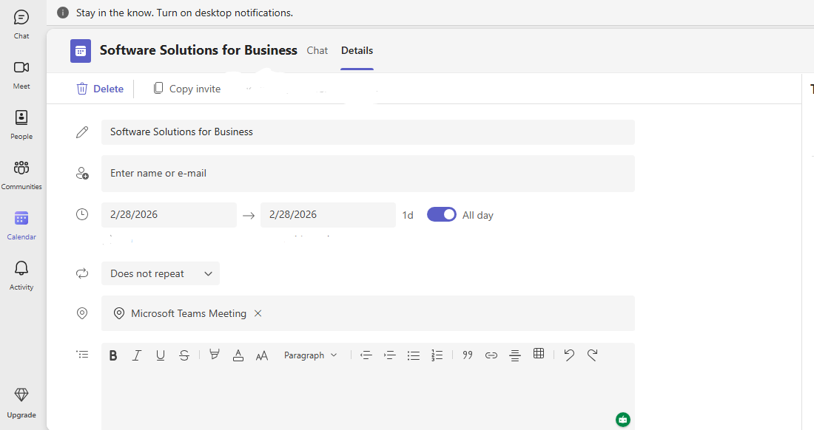

Figure 9: Creating Meeting in Microsoft Teams
A meeting was scheduled using the calendar function, selecting date, time, and participants.


Figure 10: Chat Interface in Microsoft Teams
A message was posted within a project channel to simulate team communication.
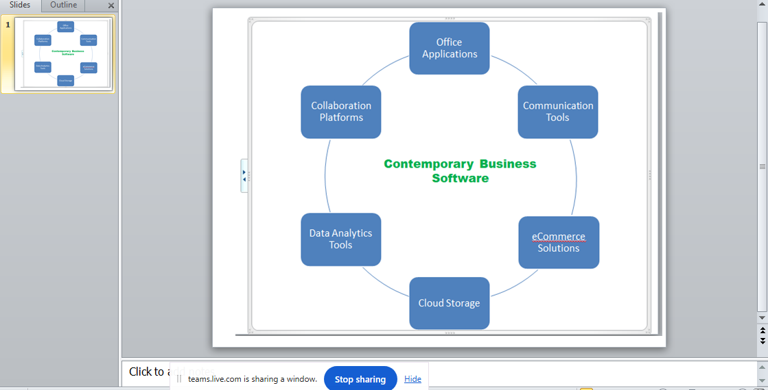
Figure 11: Screen Sharing During Meeting
The screen-sharing function was activated to present a PowerPoint slide.
These features enhance workflow by enabling real-time communication, structured discussion, and collaborative review. Scheduling tools improve time management, while screen sharing supports interactive problem-solving and transparent communication.

Collaboration Tool Analysis: Google Drive

Overview
Google Drive is a cloud-based collaboration platform that provides file storage, document creation, and real-time collaborative editing [19]. It also collaborates with Google Docs, sheets and slides which allow many people to simultaneously work on common documents.

Key Features
It has core features of cloud storage, real-time co-authoring, version history management, comment threads, and flexible permission controls (viewer, commenter, and editor). There is automatic saving of documents thus lessening the risk of data loss. Connection with Gmail and Google Meet also contributes to the continuity of the workflow.

Benefits
Google Drive improves accessibility by allowing users to access documents from any internet-enabled device. Live editing minimizes time wastage by duplication of work and improves coordination of teams [15]. Version history helps users to enhance accountability within the organization in terms of tracking changes and restoring older versions of documents.
Compared to traditional file-sharing methods such as email attachments, Google Drive reduces redundancy and storage inefficiencies. It is especially applicable in projects of collaboration with several stakeholders living in different locations.

Comparison with Alternatives
Feature | Google Drive | Microsoft OneDrive
Real-time editing | Yes | Yes
Integration ecosystem | Google Workspace | Microsoft 365
Storage model | Cloud-based | Cloud-based
Offline access | Limited | Available with sync
Table 3: Comparison Table
Google Drive is more suitable for organizations using Google Workspace, while OneDrive integrates better within Microsoft ecosystems.

Practical Test – Google Drive
The practical test involved creating a shared document, adjusting permission settings, and demonstrating collaborative editing.
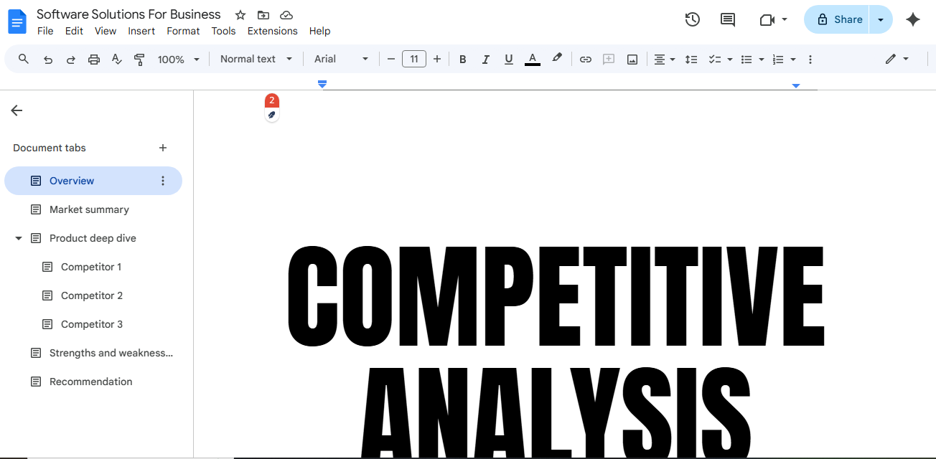
Figure 12: Creating Shared Document in Google Drive
A Google Docs file was created within Drive.
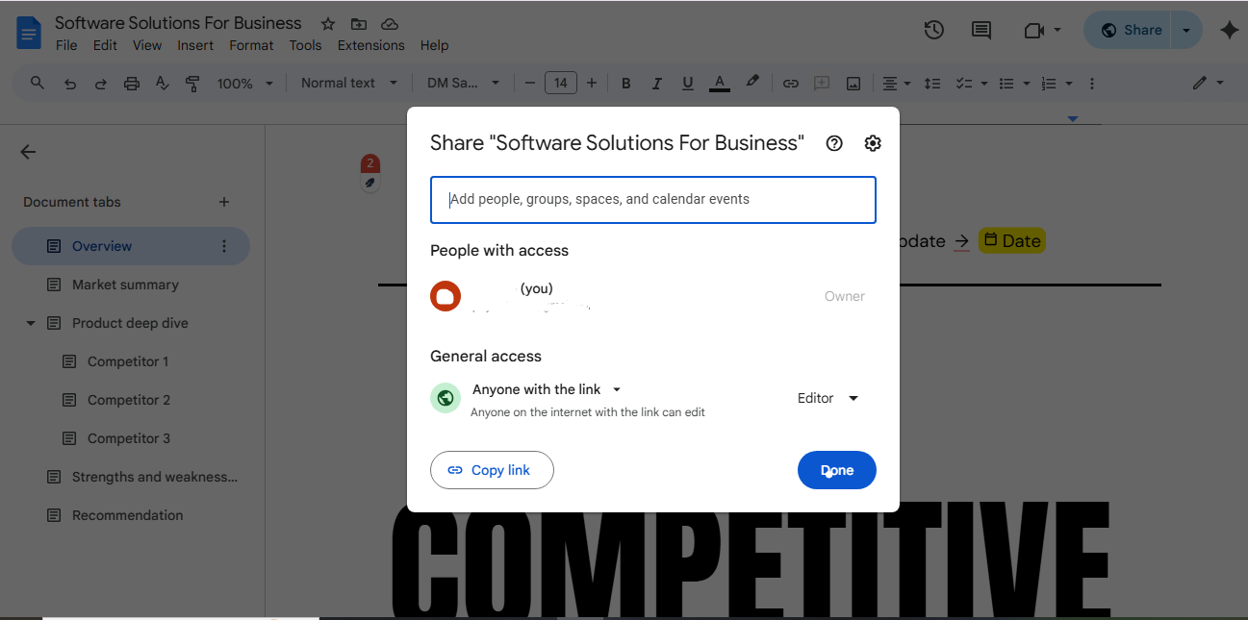
Figure 13: Permission Settings Panel
Access was granted to another user with “Editor” rights.
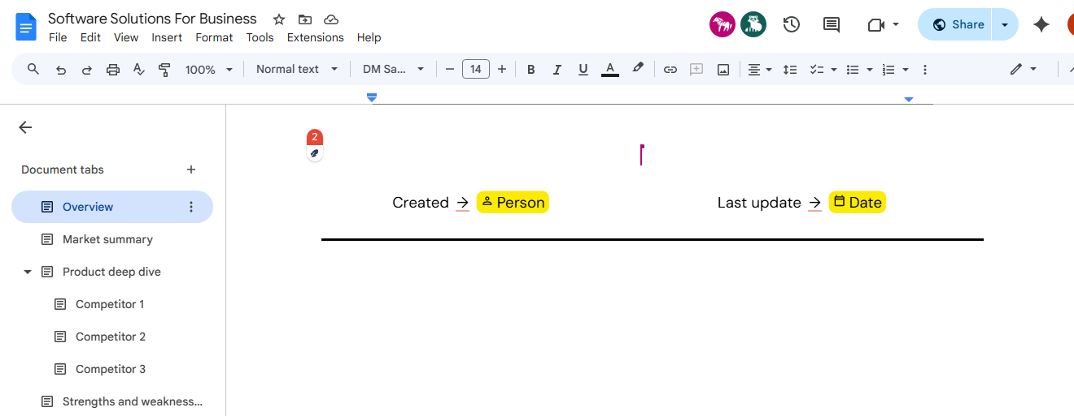
Figure 14: Real-Time Collaborative Editing
Two user cursors were visible editing the same document simultaneously. In business scenario, the functionality helps teams to create reports together without having to send numerous email attachments. Real time editing saves time and improves productivity by ensuring that every stakeholder resorts to a single and updated copy of the document.

CONCLUSION
This portfolio has critically examined a range of contemporary software solutions used to support business operations, including e-commerce platforms, office productivity applications, communication tools, and cloud-based collaboration systems [3]. This analysis has shown that digital software is not merely a technical support system but a strategic facilitator of productivity, efficiency and informed decision making. All types of applications have a different impact on organizational performance: e-commerce platforms lead to the availability of a digital market, office applications maintain organized data management and reporting, communication tools enhance the organization, and collaboration platforms allow integrative teamwork in hybrid setups.
A key finding from this portfolio is the importance of software integration. Although they have different applications, the value of these applications is interoperability. Indicatively, Microsoft Teams can be used together with word, Excel, and sharepoint and can be used to continue the workflow flow [1]. On the same note, strategic decisions made based on data analyzed in Excel can be presented using PowerPoint and communicated through collaborative platforms. Lack of integration can be disastrous to organizations because it may result in disjointed processes, overlapping of efforts and inefficiencies in operations. Thus, the key to successful digital transformation lies in a combination of not only the implementation of separate tools but also linking them in a logical digital ecosystem.
The practical testing component reinforced the applied relevance of these applications. The development of a Pivot Table and the IF function in Excel showed how raw data may be converted into actionable information to make managerial decisions [17]. In the same manner, the exploration of communication and collaboration tools revealed that real-time interaction and the ability to share documents enable minimizing delays and create greater transparency. These activities enhanced the real-life practice and showed the effectiveness of theoretical knowledge in practice.
In relation to the module learning outcomes, this portfolio has demonstrated knowledge of core software packages used in business and the ability to present and communicate structured information effectively. It has also demonstrated the ability to assess software tools in the workplace environments as opposed to describing them [3]. Altogether, research, analysis, and practice demonstrate the necessity of applying digital software solutions in the modern organizational setting and significance of the basic skills in computing in professional practice.

References
[1] M. Verhoef, T. Broekhuizen, Y. Bart, A. Bhattacharya, J. Dong, N. Fabian, and M. Haenlein, “Digital transformation: A multidisciplinary reflection and research agenda,” Journal of Business Research, vol. 122, pp. 889–901, 2021.
[2] J. Vial, “Understanding digital transformation: A review and a research agenda,” MIS Quarterly Executive, vol. 20, no. 1, pp. 1–17, 2021.
[3] M. Schrage, D. Kiron, and B. Prentice, “The new decision makers: How data and analytics are reshaping managerial work,” MIT Sloan Management Review, vol. 63, no. 3, pp. 1–10, 2022.
[4] United Nations Conference on Trade and Development (UNCTAD), Digital Economy Report 2023: Shaping the Future of the Digital Economy, Geneva, Switzerland, 2023. [Online]. Available: https://unctad.org
[5] Shopify Inc., Annual Report 2024, Ottawa, Canada, 2024. [Online]. Available: https://investors.shopify.com
[6] OECD, E-commerce in the Time of Digital Transformation, OECD Digital Economy Papers, 2022. [Online]. Available: https://www.oecd.org
[7] S. M. Kalyuga and P. Singh, “Cognitive load theory and diagrammatic representations in learning,” Educational Psychology Review, vol. 33, no. 4, pp. 1257–1276, 2021.
[8] M. Eppler and J. Hoffmann, “Visual management tools for strategy implementation: Enhancing clarity and decision-making,” Journal of Business Strategy, vol. 42, no. 3, pp. 169–177, 2021.
[9] B. Speier-Pero, J. Arribas, and L. M. K. Chan, “Visualization and managerial decision-making effectiveness in digital environments,” Decision Support Systems, vol. 150, 2022.
[10] Microsoft, Work Trend Index Annual Report 2023, Microsoft Corporation, 2023. [Online]. Available: https://www.microsoft.com/worklab
[11] Deloitte, Digital Collaboration and Workplace Productivity Report, Deloitte Insights, 2022. [Online]. Available: https://www2.deloitte.com
[12] A. Eppler, “Improving presentation effectiveness through visualization techniques,” Journal of Business Communication, vol. 59, no. 2, pp. 215–228, 2022.
[13] Microsoft Corporation, “Microsoft Excel data analysis and business intelligence capabilities,” Microsoft Documentation, 2024. [Online]. Available: https://support.microsoft.com
[14] McKinsey & Company, The State of AI in 2023: Generative AI’s Breakout Year, McKinsey Global Institute, 2023. [Online]. Available: https://www.mckinsey.com
[15] Gartner, Magic Quadrant for Analytics and Business Intelligence Platforms 2023, Gartner Research, 2023. [Online]. Available: https://www.gartner.com
[16] J. Gibbs, N. Rozaidi, and J. Eisenberg, “Overcoming the ‘virtual distance’ in hybrid teams,” MIT Sloan Management Review, vol. 63, no. 3, pp. 34–41, 2022.
[17] S. Raisch and S. Krakowski, “Digital transformation and organizational change: How digital technologies reshape business processes,” California Management Review, vol. 64, no. 1, pp. 5–27, 2021.
[18] McKinsey & Company, The State of AI in 2023: Generative AI’s Breakout Year, McKinsey Global Institute, 2023. [Online]. Available: https://www.mckinsey.com
[19] Gartner, Magic Quadrant for Analytics and Business Intelligence Platforms 2023, Gartner Research, 2023. [Online]. Available: https://www.gartner.com

