
Modern and TRADITIONAL
ASSIGNMENT 1

2014508
kAMRAN dAVIES
Deborah Hughes



Contents
1. Introduction 1
2. Research 2
3. A - Findings (Part 1) 2
4. Primary Structure 2
5. Foundation Type 3
6. Structural Element 5
6.1 Beams and Columns 5
6.2 Walls 6
6.3 Roof 6
6.4 Floor 6
7. Wind load 7
8. B - Identify And Annotate Drawings (Part 1) 7
9. A - System Of Enclosure (Part 2) 8
10. External Walls 8
11. Cladding - Rainscreen 9
12. B - Identify And Annotate Drawings (Part 2) 11
13. References 12

Introduction
Part 1
A - Select and briefly describe a system of primary structure that you consider appropriate for the building, to include your choice of:
- Foundation type
- Structural elements such as columns, walls, beams, floors and roof
- Appropriate strategy towards the accommodation of wind loads.
B - Identify and annotate the locations of all primary structural elements on ‘overlays’ of the plans and section drawings provided.
Part 2
A - Select and describe a system of enclosure that you consider appropriate for the building, conducive to the primary structural system than you have selected in Task 1.
B - Identify and annotate the locations (and schematic architectural effect) of the elements of enclosure on ‘overlays’ of the elevation drawings provided.

Research

All my findings and research within this report will be used through online reading, books and lecture notes.

A - Findings (Part 1)
Research shows that the main material used for primary structures are steel, wood and concrete. In retrospect, each of the 3 material has its positives and negatives. However, the material I consider best appropriate for this case study for my primary structure is steel.
(House, 2020)

Primary Structure
Structural steelwork can be used to make the 'skeleton' frame of a building or other built property. A steel frame structure consists of beams, columns and bracing. Beams are horizontal, columns are vertical, and bracing is diagonal, shown in image 1 below. This then supports any structure erected internal floors and exterior walls and holds all loads to ground level.
(Buildings, 2021)
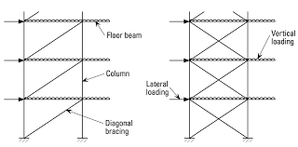
(Images, n.d.)
Steel formation, which is made of sections that link each other to hold the loads and support maximum rigidity. Due to steel having such a high-level of strength, this structure is

reliable and requires fewer raw materials than other type of frame structures, such as concrete and timber.
(Buildings, 2021)
There are several benefits on having steel as your primary structure. Steel, unlike its competitors concrete and timber is far denser, stronger and durable. When erecting steel structures, they provide a by far the quickest for installation and can be manufactured into many shapes and sizes. This is very beneficial for budget and time as for projects in such a high demand for completion as per programme. Having it fabricated off-site majority of the time, this then reduces labour costs and lowers the risk for potential human error. Due to such high demand for its popularity and pricing, it has become a lot lower than what its usual rate.
(Services, 2020)
Structural steel in the UK has an average price at around £700 per ton.
(Checkatrade, 2022)
By selecting for steel frame construction, you can certainly reduce the expense of your project. Structural steel means a lessened amount of maintenance, suggesting that cost saving that would follow by cutting construction in order for labour and time.
(Services, 2020)
As a material, a steels strength, versatility and recyclability makes it sustainable. It routinely delivers sustainable buildings. And most importantly in today’s climate does so cost effectively. One of, if not the greatest advantage with steel is that it is 100% eco-friendly. Meaning that that they are fully recycled. Structural steel frame construction is a perfect solution for keeping your project environmentally friendly. For any waste created at the end of the project can be utilised all over again. The plus side of it all for any steel left over is that it does not lose any fundamental properties i.e., strength in this method.
(Services, 2020)
Current recovery rates from sites in the UK are 99% for structural steelwork and 96% for all steel construction products. The figures alone are considerably ahead and exceeding those for any other building material.
(Construction, n.d.)

Foundation Type

Based on the data taken within the bore hole log provided within the assignment brief, the most suitable foundation detail would be pile foundation.

Pile foundations compared to others are deep foundations. Pile foundations consist of lengthy, slim, columnlike components usually made from steel or reinforced concrete. These can be defined as multiple columns constructed or inserted into the ground to transmit the capacity of a building to a lower level of subsoil.
(Kovac, 2020)
When describing a ‘piled foundation, it means that the depth is greater than three times its width. The primary objective of a pile foundation is to transport loads from superstructures, through weak, compressible strata or water onto tougher, more dense, less compressible and stiffer soil or rock at depth, increasing the effective size of a foundation and resisting horizontal loads. They are usually used for large structures, and in circumstances where the soil is not suitable to counteract unwarranted settlement.
(Buildings, 2021)
Below is a list of other factors for the use of pile:
- Natural low bearing capacity of subsoil.
- Filled ground.
- High water table.
- Highly compressible soils.
- Subsoils that may be subject to moisture failure.
(Kovac, 2020)
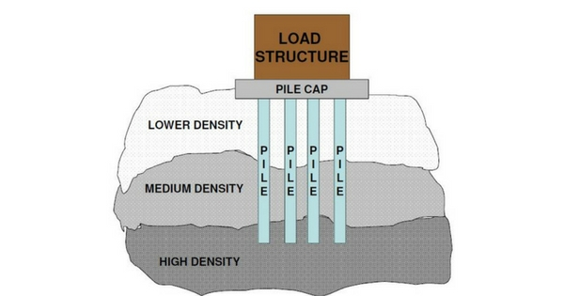

(Images, n.d.)

Structural Element

A structural elements is a make-up of the building. Components such roof, the slabs, the beams, columns, girders and other structural members and connections, the interior and exterior of all exterior walls, window frames and windows and all other sections of the building's structure and supports.
(Insider, 2022)

Beams and Columns

In relation to my case study one of the most important considerations for any structure is stability to ensure its safety. Both beams and columns are two crucial structural features that play an essential role in supporting the building’s weight and constructing a secure capacity path from the slab to the structure’s foundations.
(MPA, n.d.)
Beams

Beams are horizontal and their duty is to carry loads vertical to their longitudinal route. They are supported at both ends of installation and transfer loads from slab to column. They are located and used to support the weight of a building’s walls, ceilings and roofs. The size and thickness all depend on the forces and stresses of the structure and an appropriate beam will allocate this need.
(MPA, n.d.)
Columns

Columns, like beams are used for structural support. They are vertical that transmit compressive loads. Their purpose is to support the floor. Columns should be placed constantly on all floors wherever viable. This will improve the strength of the lowest collection of columns. Like beams, a column design will depend on the load’s vertical forces. Factors such as wind and earthquakes must be taken into consideration as this will deem for the sizes of the column.
(MPA, n.d.)

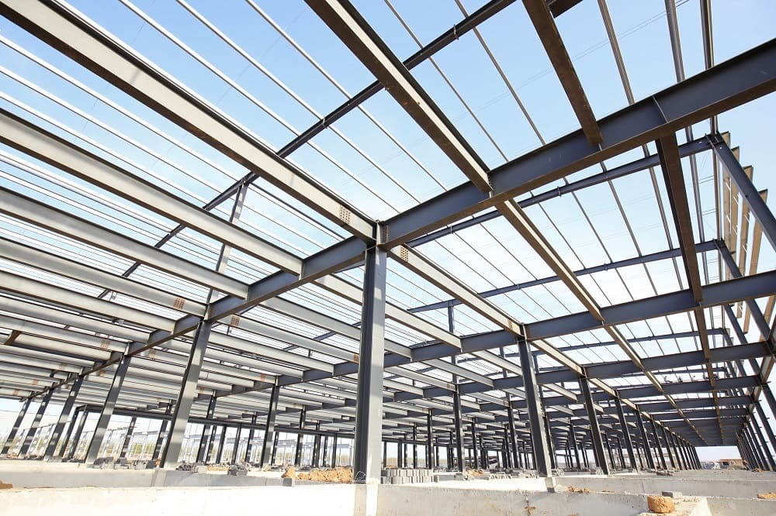
Column
Beams

Walls

Wall bearing framing includes the development of masonry walls on the outer limits and interior of the building. The structural steel members are then fixed to the masonry walls using bearing and end steel plates and anchor bolts. The design and construction of the wall bearing framing depends on the load intensity and the span distance between successive supports.
(Buildings, 2021)

Roof

Roof structure is at the top of a building which normally offers security from the elements. A roof structure will often meet the functions of weather resistance, force and stability, fire resistance, thermal insulation, protection and privacy.
(Buildings, 2021)

Floor

The floor I believe best suited for this structure is precast concrete. This is where a structural concrete topping with reinforcement steel and the topping thickness should be covered by at least 30mm. By using this type of floor, it means that normally it will require no fire protection for up to a range of 60 minutes. It also offers a flexibility of internal wall positions.
(Structville, 2022)

Wind load

Wind is usually found to be the major load and is primarily a horizontal force. The structural systems that take in wind loads tend to be separate to those for dead loads. Wind loads will more often than not vary on the wind velocity and the shape the building.
(Buildings, 2021)

B - Identify And Annotate Drawings (Part 1)
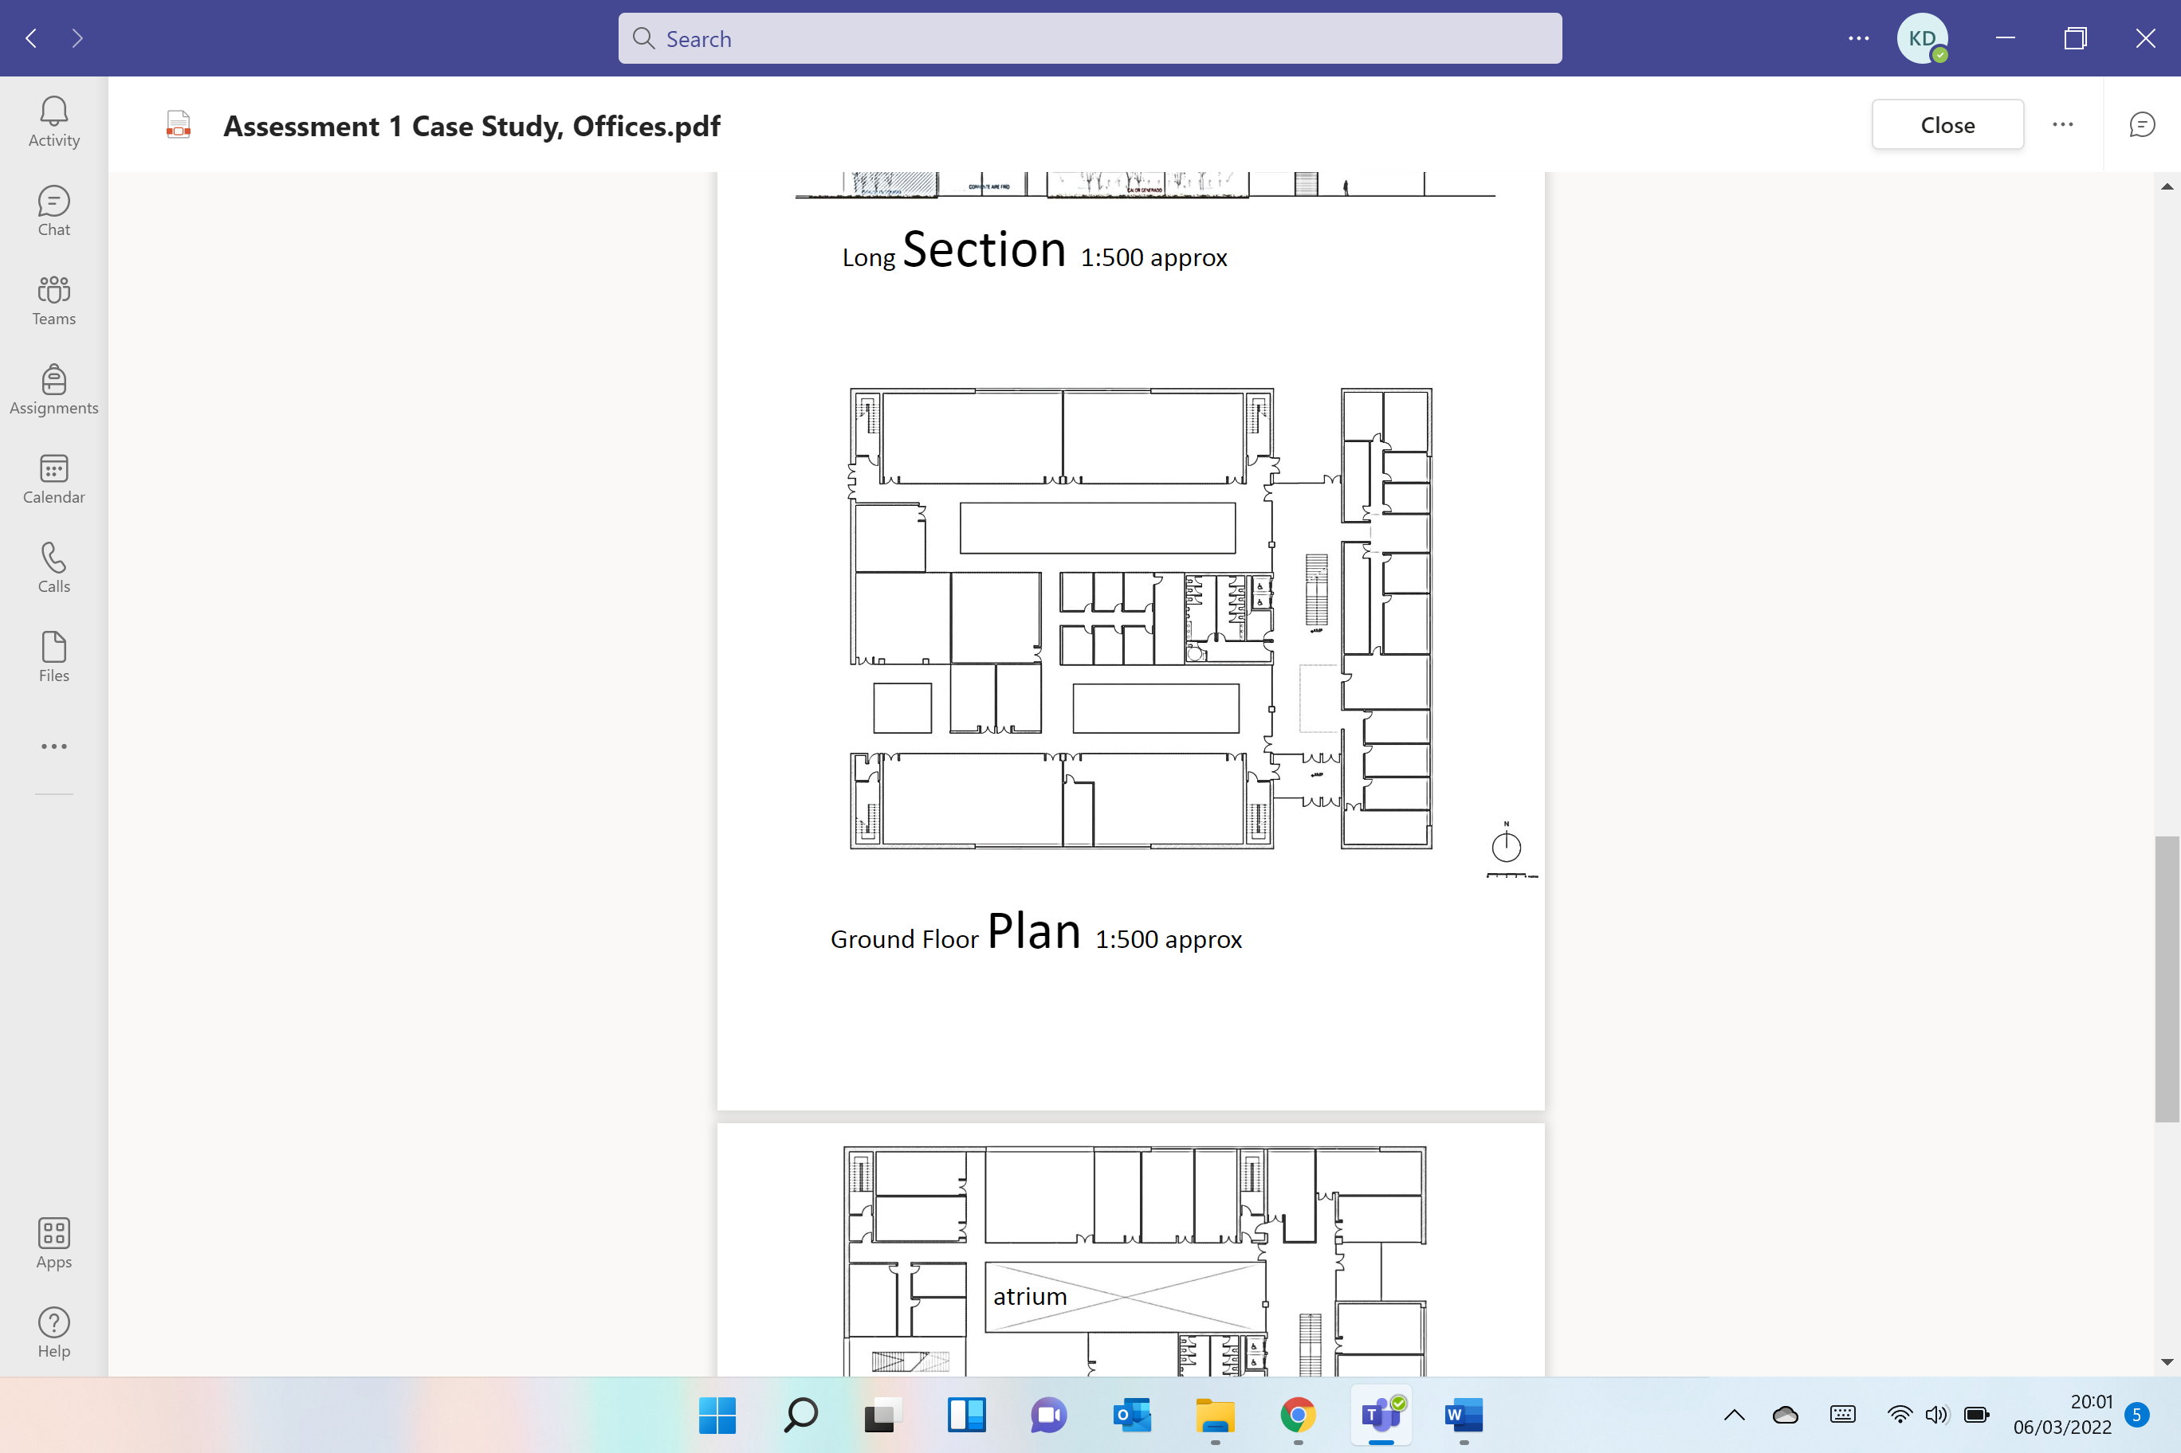

Key
Pile Foundation
Columns

Beams

A - System Of Enclosure (Part 2)
The term enclosure is provided to any section of a building that physically separates the external from the interior environment. It is often referred to as the ‘building envelope’.
The physical components of the building enclosure include
- The roof system.
- The above-grade wall system (including windows and doors).
- The below-grade wall system.
- The base floor system.
The Principles of a building enclosure would include things such as strength, heat and air flow, the stability and durability of materials, fire resistance and cost.
There are four areas of overall functions for building enclosure. They are as follows:
- Support - To support, resist and transfer all structural forms of loading imposed by the interior and exterior environments.
- Control - To control, air transfer, heat, sound, access and security, privacy, the provision of views and daylight.
- Finish - To finish the enclosure surfaces in terms of visual, aesthetic and durability.
- Distribute - To distribute services or utilities such as electricity, communications and water.
(Buildings, 2021)

External Walls

Stone walls are constructed of stones used either in a random rough or jagged form or roughly dressed in square or a rectangular shape. Walls of this type are ordinary. Stones are usually laid with a relatively deep bed joint of mortar to have capacity for irregularities. Lime based mortar is preferred with long runs of stone walling as it is less likely to prone to thermal or movement cracking than ordinary cement mortar. Below is a list of types of stone walling.
- Random rubble uncoursed
- Square random rubble
- Squared random rubble with through snecks
- Random rubble with brick lacing. Brick lacing provides strength and feature

(Kovac, 2020)

Cladding - Rainscreen

A rainscreen cladding is the most efficient cladding system for construction envelope purposes. A poor face insulation entails a significant energy loss in buildings. Combining rainscreen cladding with an exterior insulation system will provide the building with numerous advantages. The biggest of them all being an increase of thermal and acoustic insulation. A phrase known as the ‘chimney effect’ takes place within the cavity. This results a variation of temperatures, which is a natural convection process. All this taking place within the cavity itself.
(Cupapizarras, 2022)
During the summer months when the temperature rises, the convention process makes the warm air lift so that it is now renewing the air inside the cavity with a cooler one. Alternatively, during the winter months when the temperature decreases and the air gets cooler, the air inside the cavity is not generating enough heat to lift, which helps the insulation layer contain the heat inside the building. This chimney effect avoids overheating during summer and helps maintaining a warm and steady interior temperature during winter.
(Cupapizarras, 2022)
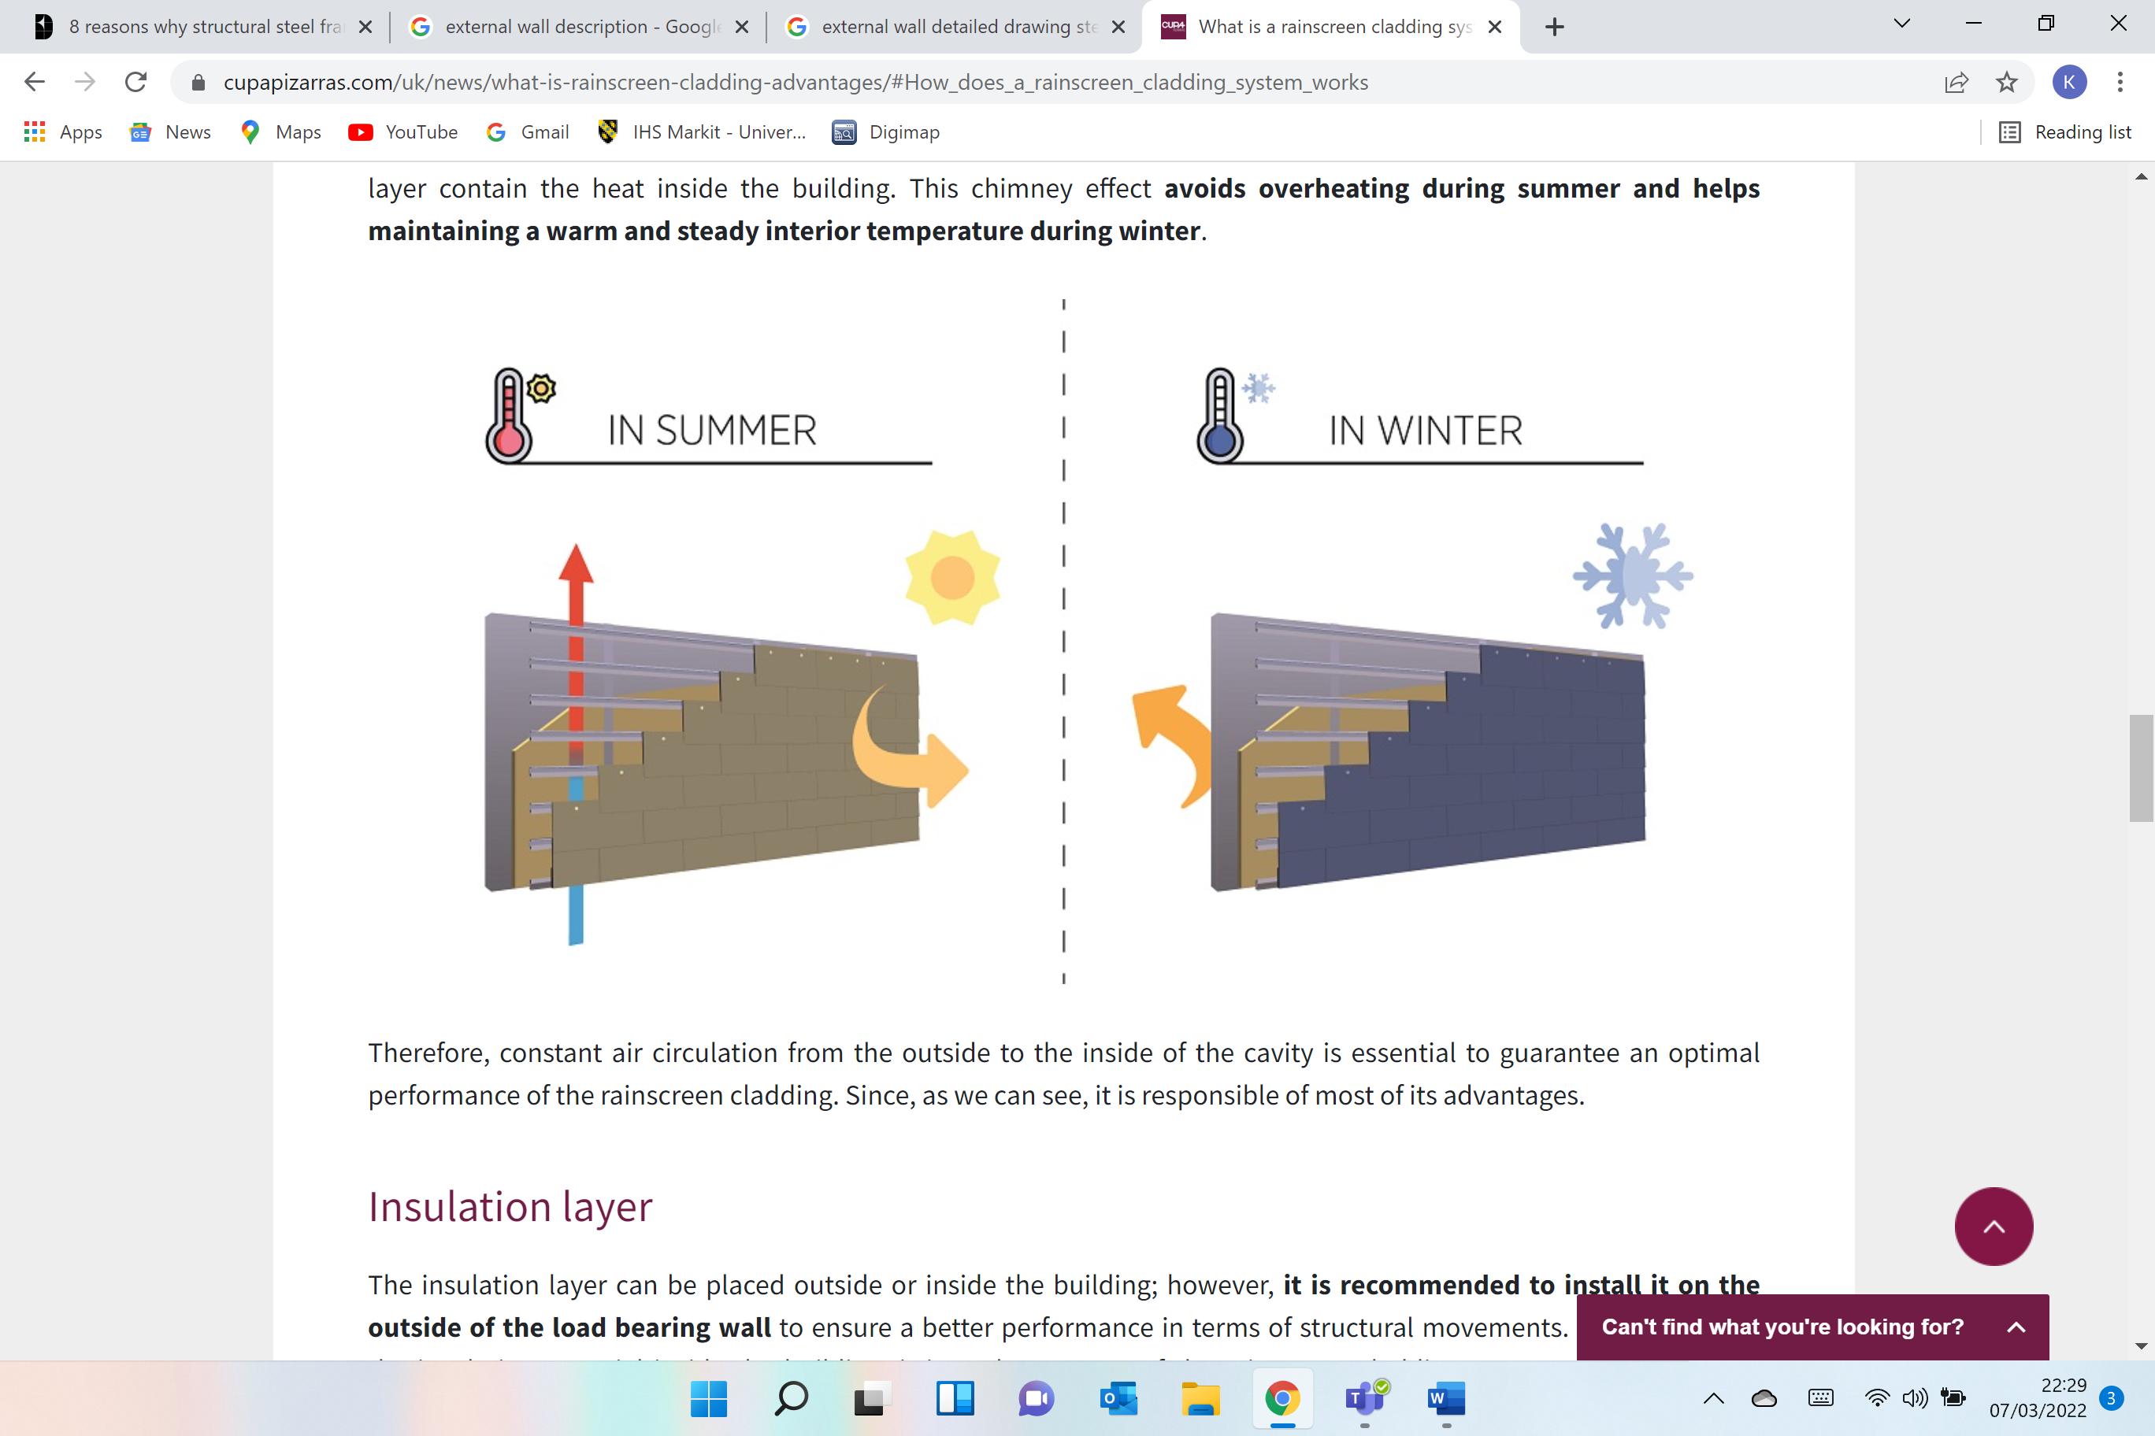

The insulation layer can be positioned outside or inside the building. However, it is suggested to install it on the outside of the load bearing wall to ensure a better performance in terms of structural movements.
(Cupapizarras, 2022)

What are the advantages of using rainscreen cladding?
- Rainscreen cladding lessens condensation and humidity happening both from inside and outside the building. The constant circulation of air inside the air cavity works as an additional protection layer and removes any excess water.
- By the air cavity maintaining a more balanced in the building construction envelope, it will help prevent the risk of cracks appearing and any further structural issues so it will then minimise any structural movements. Now that it is not subject to severe temperature adjustments, it is less likely to suffer expansion or contraction movements.
- The insulation layer is optional, but when we combine it with the rainscreen cladding system, the thermal and acoustic insulation of the building improves significantly.
- The rainscreen cladding makes cooling the building easier during summer and provides a better control of the heating during winter, favouring both thermal comfort and energy saving.
- Rainscreen cladding systems require almost zero maintenance.
(Cupapizarras, 2022)
Images below showing rainscreen cladding.
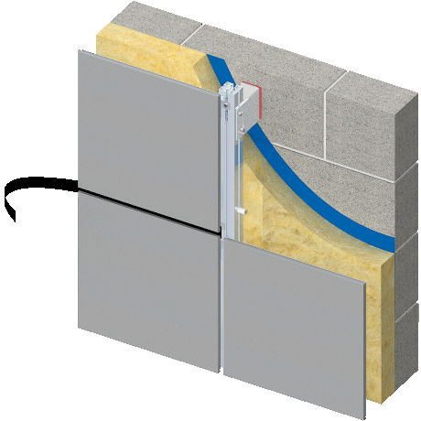
(Images, n.d.) (Images, n.d.)

B - Identify And Annotate Drawings (Part 2)
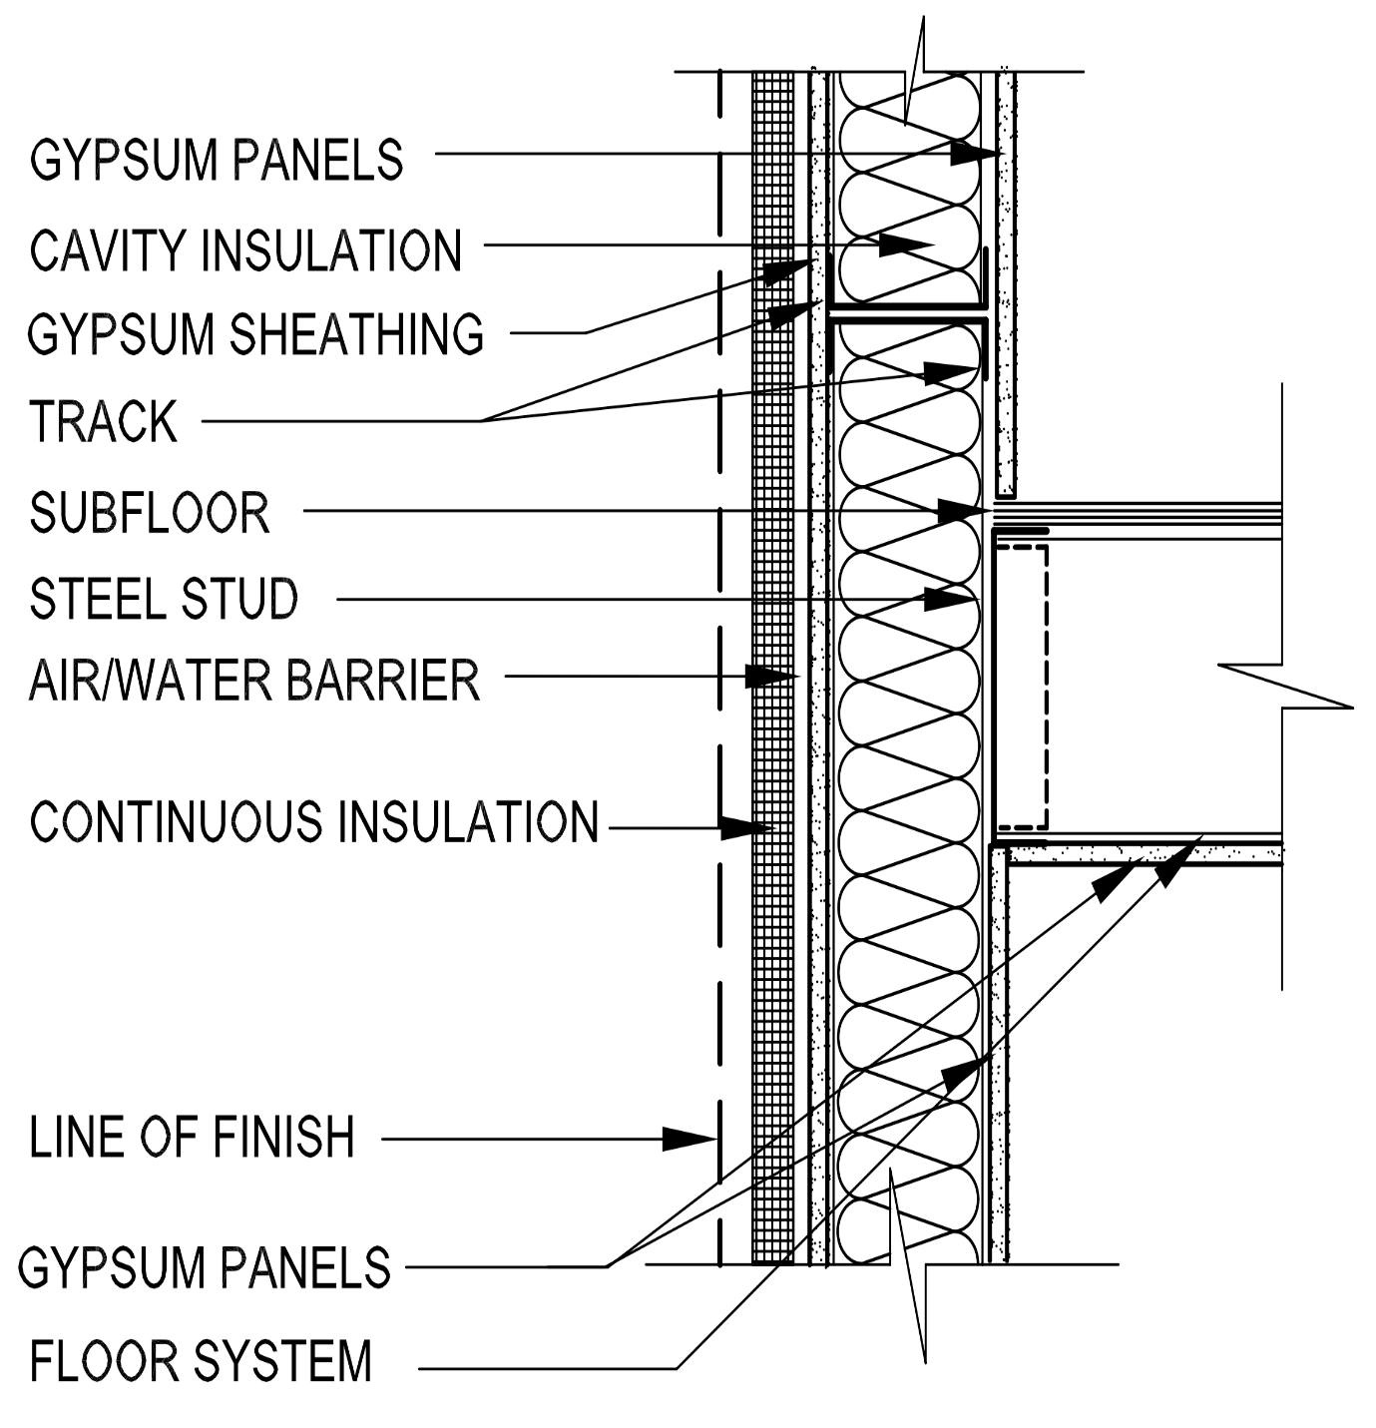
(Images, n.d.)

References
Buildings, D., 2021. Designing Buildings. [Online]
Available at: https://www.designingbuildings.co.uk/wiki/Steel_frame
[Accessed 25 02 2022].
Buildings, D., 2021. Designing Buildings. [Online]
Available at: https://www.designingbuildings.co.uk/wiki/Steel_structure_introduction
[Accessed 25 02 2022].
Buildings, D., 2021. Designing Buildings. [Online]
Available at: https://www.designingbuildings.co.uk/wiki/Steel_structural_framing_systems#Steel_structural_systems
[Accessed 06 03 2022].
Buildings, D., 2021. Designing Buildings. [Online]
Available at: https://www.designingbuildings.co.uk/wiki/Roof_structure
[Accessed 06 03 2022].
Buildings, D., 2021. Designing Buildings. [Online]
Available at: https://www.designingbuildings.co.uk/wiki/Wind_load
[Accessed 06 03 2022].
Buildings, D., 2021. Designing Buildings. [Online]
Available at: https://www.designingbuildings.co.uk/wiki/Principles_of_enclosure
[Accessed 07 03 2022].
Buildings, D., 2021. Designing Buildings. [Online]
Available at: https://www.designingbuildings.co.uk/wiki/Pile_foundations
[Accessed 04 03 2022].
Checkatrade, 2022. Checkatrade. [Online]
Available at: https://www.checkatrade.com/blog/cost-guides/steel-building-prices/
[Accessed 05 03 2022].
Construction, S., n.d. Steel Construction. [Online]
Available at: https://www.steelconstruction.info/Sustainability#:~:text=Steel%20can%20be%20reused%20and,is%20routinely%20recovered%20and%20reused.
[Accessed 04 03 2022].
Cupapizarras, 2022. Cupapizarras. [Online]
Available at: https://www.cupapizarras.com/uk/news/what-is-rainscreen-cladding-advantages/#How_does_a_rainscreen_cladding_system_works
[Accessed 07 03 2022].
House, N., 2020. Nitter House. [Online]
Available at: https://nitterhouseconcrete.com/precast-concrete-vs-steel-framing-vs-wood-framing/
[Accessed 24 02 2022].
Images, G., n.d. Google Images. [Online]
Available at: https://www.google.com/search?q=beams+columns+and+bracing+steel+frame&tbm=isch&ved=2ahUKEwjfx4zOqK_2AhUFdRQKHWS4AT0Q2-cCegQIABAA&oq=beams+columns+and+bracing+steel+frame&gs_lcp=CgNpbWcQA1CmBViXMWDLMWgAcAB4AIABbIgBkgySAQQxOS4ymAEAoAEBqgELZ3dzLXdpei1pbWfAAQ
[Accessed 26 02 2022].
Insider, L., 2022. Law Insider. [Online]
Available at: https://www.lawinsider.com/dictionary/structural-elements#:~:text=Structural%20Elements%20means%20the%20roof%2C%20the%20slabs%2C%20the%20beams%2C,Building's%20structure%20and%20supports.
[Accessed 05 03 2022].
Kovac, K., 2020. Chudley & Greeno Building Construction Handbook. Oxon: Karl Kovac.
Kovac, K., 2020. Chudley & Greeno's Building Construction Handbook. 12 ed. Oxon: Karl Kovac.
MPA, n.d. MPA. [Online]
Available at: https://mperryassociates.com/blog/what-beams-columns-structural-engineering/
[Accessed 05 03 2022].
Services, M. I., 2020. MR Industrial Services. [Online]
Available at: https://mrindustrialservices.co.uk/advantages-of-steel-frame-construction-you-need-to-know-of/
[Accessed 26 02 2022].
Structville, 2022. Structville. [Online]
Available at: https://structville.com/2020/07/types-of-floor-systems-for-steel-framed-buildings.html#Non-composite_beams_with_precast_units
[Accessed 06 03 2022].

