Working Title
“What do Esports need to accomplish to be recognized as being on the same level as Sports”
Industry – Business Industry
Since the very first event dating back to the 1970’s and developer funded tournaments being introduced from 2010 onwards. E-sports has grown more and more each year. Back in 2017 “ESL” (Electronic Sports League) welcome 173,000 people in person and over 4.6 million unique users to watch people complete at the Spodek arena in Katowice, Poland.
Similarly on the sporting side their most recent large scale sporting event was the euro 2020 final between England and Italy in which around 62,000 fans travelled to watch the clash between the 2 teams and around 31 million viewers watching either on their T.V or online. (UEFA, 2021).
With audience members being in the millions and showing no signs of stopping. This bring about the question that I am going to be research for this research project which is “What do Esports need to accomplish to be recognized as being on the same level as sports”.
Research Aims and Objectives
Primary Research Aim
To research what people, think Esports need to change to become recognised like sports”.
Objective 1
Critically analyze the audience between both and determine what factors into someone’s decision when deciding what sport to watch.

Objective 2
Analyze in depth the effect age has on whether people are going to consider watching Esports over regular sports.

Objective 3
Analyze to what extent gender has on whether people are going to consider watching Esports over regular sports due to the lack of representation in their chosen sport/ Esport.

Background
The reason this topic has chosen this is because researchers want to understand how why people chose to watch the top sporting players kick a ball for 90 minutes while other people watch the top Esports stars of their chosen game complete a match for 90 minutes. (Nevill, A.M., Balmer, N.J. and Williams, A.M., 2002).
Where My Study Fits Into The Field
My study fits into this field because with both sports and esports bringing in millions of viewers around the world and showing no signs of stopping as well as there being a gap in this field as not much research has been done of this topic. I believe that researching the chosen question will provide a huge leap into understanding the difference between both and helping them to achieve a large picture of what is going on when people watch sports compared to esports.

Research Methods
This topic may sound not worth investigating to some researchers and people and people might have doubts and not think the scale of this project is large enough but having witnessed both events online I personally believe that there is a large enough audience that will benefit from these questions have been researched.
Qualitative or Quantitative
My research will be mostly qualitative as it is heavily researchable and doesn’t have many variables to it apart from replicating the same conditions when reconducting experiments. (Cook, T.D. and Reichardt, C.S. eds., 1979). My research will also be heavily qualitative as a lot of it will be expressed in words and concepts rather than through numbers and graphs as my topic is a new topic and there wouldn’t be much research out them to source from. (Thomas, G., 2017).
Collection Methods
My approach to this project will be an approach consisting of primary research and secondary research. These will be a mix of qualitative and quantitative data to ensure maximum amount of information as well as collecting the best information available and secondary research from journals, books, articles, interviews, questionnaires to get the best amount of information from the public and receiving the most no bias answers possible to ensure nothing is tipping the project in favour of one side (Hofstee, E., 2006).
Study Participants
The study participant will mainly be the public as they are widely available, and a lot are willing to complete surveys and questionnaires online especially during the COVID era and post COVID era. I will also be trying to contact different people who have experienced this topic and get their opinion on it to have the most accurate representation of the subject. These public will be the best source of answers towards this topic as they provide non bias answers and a lot will have experience one or both chosen topics.(Randolph, J., 2009).

According to (Otzen, T. and Manterola, C., 2017). Study participants can also contain study population which refers to the group of participants that will be recruited to participate in the study. Whilst preparing for this it is critically important to specify the characteristics of eligible participants or any characteristic that would make certain people ineligible for partaking in your study to ensure you receive the correct participants .

Since my study is pretty much neutral give or take a few minor conditions I wouldn’t need many exceptions apart from people who have benefited from this taking place their opinions would be considered just made sure only to use for non-bias topics.

Length of Study
The length of the study including research preparation will take around 4 months altogether with the last month being dedicated to writing everything up and completing the research project. (Thomas, G, 2017).
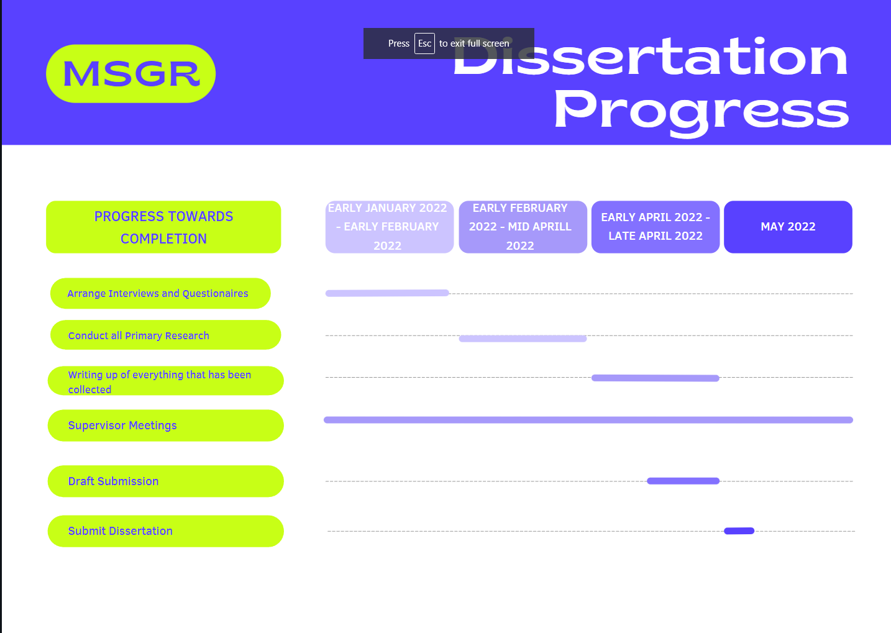
Ensuring Research Integrity
Ensuring research integrity means conducting your research in a way so that it allows anyone using it to have confidence and trust in the methods that you used to obtain said research. (Wright, P.M., 2016), (Martinson, B.C., Crain, A.L., De Vries, R. and Anderson, M.S., 2010).
Reliability and Validity
Research and validity refer to the concepts used to evaluate the quality of the research conducted. This means that I need to take precautions when researching people and using their full name in the public without the consent making sure that I do receive their consent for anything that is used by them and that it is specially stated with evidence to back this up in case they call me out on it in the future there is sufficient evidence to shut down their claim as everything will have been documented as it has been taken.

Resources & Planning

Timetable For Completion
Early January 2022 – Early February 2022
Arrange all interviews and prepare any questionnaires/ letters or emails in preparation for them to be sent out. Whilst checking in with dissertation supervisor as to ensure everything is going as smoothly as it can be.
Early February 2022 – Mid April 2022
Send out all emails and questionnaires and conduct any primary research as well as purchasing any books or locating any research papers or any form of media that I require for my project. Checking in with dissertation supervisor to ensure everything is going to its intended place and that everything is correctly formatted and literate.
Early April 2022 – Late April 2022
Writing up of everything that has been collected including research and ensuring everything is properly referenced and any research is ethically sourced and only used for what has been confirmed with the public.
Dissertation Supervisor Meetings
Meetings to ensure everything is going smoothly and to clear up any misunderstandings or answer any questions that have been may have popped up while conducting this project and to ensure everything is on track for completion.

Draft Submission Deadlines
This is where certain sections of the project need to be completed by to ensure everything is progressing smoothly and for the supervisor to read over and then let me know of any changes that need to take place.

9am Monday 25th April

Full Dissertation Submission
End date of project where final submission is sent off for external marking.
9am Friday 13th May

References
Bernard, H.R., 2017. Research methods in anthropology: Qualitative and quantitative approaches. Rowman & Littlefield.
Brannen, J., 2017. Combining qualitative and quantitative approaches: an overview. Mixing methods: Qualitative and quantitative research, pp.3-37.
Cook, T.D. and Reichardt, C.S. eds., 1979. Qualitative and quantitative methods in evaluation research (Vol. 1). Beverly Hills, CA: Sage publications.
Devers, K.J. and Frankel, R.M., 2000. Study design in qualitative research--2: Sampling and data collection strategies. Education for health, 13(2), p.263.
Dulock, H.L., 1993. Research design: Descriptive research. Journal of Pediatric Oncology Nursing, 10(4), pp.154-157.
ESL. (2017). Intel and ESL Welcome 173,000 Fans at World’s Biggest Esports Event in History. Available: https://www.eslgaming.com/press/intel-and-esl-welcome-173000-fans-world-s-biggest-esports-event-history. Last accessed 30th November 2021.
Hofstee, E., 2006. Constructing a good dissertation. Sandton: Epe.
Martinson, B.C., Crain, A.L., De Vries, R. and Anderson, M.S., 2010. The importance of organizational justice in ensuring research integrity. Journal of empirical research on human research ethics, 5(3), pp.67-83.
Nevill, A.M., Balmer, N.J. and Williams, A.M., 2002. The influence of crowd noise and experience upon refereeing decisions in football. Psychology of sport and exercise, 3(4), pp.261-272.
Otzen, T. and Manterola, C., 2017. Sampling techniques on a population study. Int. J. Morphol, 35(1), pp.227-232.
Randolph, J., 2009. A guide to writing the dissertation literature review. Practical Assessment, Research, and Evaluation, 14(1), p.13.
Thomas, G., 2017. How to do your research project: A guide for students. Sage.
UEFA. (2021). EURO 2020 semi-finals and final: Wembley capacity increased to more than 60,000. Available: https://www.uefa.com/uefaeuro-2020/news/026a-1294bb69ec39-89bc7ae2b3d7-1000--wembley-capacity-raised-for-semis-final/. Last accessed 30th November 2021.
Wright, P.M., 2016. Ensuring research integrity: An editor’s perspective.

