

Qualitative Research

"An investigation into the moral judgement in ethical beliefs of Bangladeshi young fashion consumers"

Student Number: 1804142
DBA-Oct 18

Abstract
Moral judgement delineates the perceptions and the decisions that people make through moral sets of domains and ideas. Ethical belief, on the other hand, refers to the perspective that the people hold regarding a subject matter that is influenced by the moral judgement or orientation of the people. This research aims at investigating the way moral judgement influence the ethical belief of young Bangladeshi fashion consumers. The objective of this study involves explaining the different dynamics of moral judgement considering the fashion industry consumers, explaining the different issues involved in ethical beliefs of the young fashion consumers, determining the relationship between the moral judgement and ethical belief and also recommending the way Bangladeshi fashion companies can positively influence the buying choices of the customers to ensure their sustainable growth. To achieve these research objectives the researcher has opted to follow the interpretivism research philosophy and also opted to apply inductive research approach. The researcher will use the exploratory research design and will conduct an interview for data collection. For interview 85 young fashion consumers and 15 employees working in Bangladeshi fashion companies will be chosen through the convenience sampling technique. For data analysis, thematic data analysis tools will be used. The researcher expects that there will be a significant correlation between the moral judgement and ethical belief of the young Bangladesh fashion consumers by the end of this research.

Contents
Abstract 2
1 Introduction 4
1.1 Background of the Research 4
1.2 Rationale 5
1.3 Aim 6
1.4 Objectives 6
1.5 Questions 6
2: Literature Review 8
2.1 Introduction 8
2.2 Concept of Moral Judgement and Ethical Belief 8
2.3 Factors affecting the Moral Judgement in Ethical beliefs of Bangladeshi Young Fashion Consumers 8
2.3.1 Moral Domain 8
2.3.2 Moral Judgement 9
2.3.3 Moral Behaviour 10
2.3.4 Individual Moderators 10
2.3.5 Situational Moderators 11
2.4 Conclusion 13
2 Method 14
3.1 Philosophy 14
3.2 Approach 14
3.3 Strategy 15
3.4 Choice 16
3.5 Data collection and analysing tools 17
3.6 Research Timeframe 18
4 Expected Conclusions 19
Reference 23
Part 2: Reflective Essay 27
Reference 31

PART 1: Research Plan

1 Introduction

1.1 Background of the Research
Bangladesh is known for its ready-made garments industry as the RMG sector in Bangladesh contributes to 81.2% of the export income (Haider, and Shakib, 2018). Alongside with the export industry, the local fashion industry is also thriving maintaining a growth rate of over 10% for the last few years. In the future as well, this industry is also aiming to attain further growth because the local consumers are getting more prone to locally produced fashion products (Haque, and Azmat, 2015). The local clothing brands are also being able to live up the expectations of the local consumers which also contributing to the growth of this industry. According to the reports revealed by Huq et al (2016) all the local consumers have reported at least 10% in their sales revenue in the latest year ended 2018-2019. With the growth of this industry, the competition is also thriving because more and more companies are entering this industry. The rise of the online fashion retailing companies is also adding to this. Irrespective of all these positives, the fashion products manufacturers in Bangladesh are blamed for not maintaining ethical workplace environment because they have been often blamed for unsafe workplace, poor maintenance of the employee rights, not following of the laws and regulations and also not following the environment guidelines at the same time (Islam, 2018).
These issues have long been ignored by the local fashion consumers because in the past the consumers were not cautious that much regarding ethical codes and practices and also moral judgement was not important to the Bangladeshi fashion consumers as mentioned by (Kamal, and Deegan, 2013). With the time the situation has got changed as the youth consumers in the fashion industry got more cautious regarding the moral judgement and their moral judgement has started to influence their ethical view and also are having a profound impact on their buying behaviours at the same time as stated by (Khan, et al, 2016). The companies are also viewing the ethical issues with more importance because the brand image and also the customer's loyalty is associated with it. This research is going to investigate the way individual moral judgement affects the ethical beliefs of the customers of the Bangladeshi young fashion consumers precisely.

1.2 Rationale
According to Niebuhr (2013), the moral judgement of the consumers is getting more sophisticated day by day with the encroachment of globalisation and also with the fast-changing dynamics of the business world. Parker (2011) added to this discussion by stating that moral judgements are complex as they vary individual to individual as the perceptions among the people also are very different from each other. Park et al (2012) supported this by adding that moral judgement depends on the individuals thinking regarding a subject matter. Rahman et al (2011) had a different view as he stated that though moral judgements vary from individual to individuals still the core focal points of moral judgement remain the same. Richardson et al (2012) stated that the moral judgement of the individuals does have a significant impact on the ethical belief that has an influence on everything. Siddiqui and Uddin (2016) also opined the same by adding that moral judgements do affect the ethical beliefs fully and the preferences of the customers do get shifted by this. Teulon (2014) mentioned that as moral judgements shape up the ethical beliefs hence, they also influence the buying behaviour. Although numerous previous studies like Vaughn, L., (2015); Uddin and Razu (2019) did show the impact of the moral judgement on the ethical beliefs none of them was specific enough in identifying the specific factors of the moral judgements and their correlation with the ethical beliefs of the consumers and their impact on the consumers buying behaviours as well. This is the research gap as this research will depict how different points of moral judgement affect the ethical beliefs of the customers in the fashion industry of Bangladesh. No previous research has been done considering Bangladesh’s fashion industry context highlighting the impact of the moral judgement on the ethical beliefs of the young consumers. Hence, there is a huge research gap from this context as well. This research will fill this gap as well because it will consider the context of the Bangladeshi young population of the fashion industry and will investigate and judge how the moral judgements affect their ethical behaviours in terms of favouring a particular brand. This research will be helpful for future researches as well because the future researches can use this research as a base at the same time. This research will also contribute in helping the business managers working in the fashion industry in understanding the significance of the moral judgements in shaping up the ethical beliefs and also will pave the way by which the fashion retailing companies can use moral beliefs favourably in order to attract more customers.

Aim
The aim is to investigate the way moral judgement influences the ethical beliefs of Bangladeshi fashion customers.

Objectives
The research objectives are:
- To critically appraise different aspects of the moral judgement considering the context of Bangladeshi young fashion consumers
- To evaluate the context of the ethical beliefs and the core issues involved in it, in terms of the Bangladeshi young fashion consumers
- To determine the relationship between the moral judgements and ethical beliefs of the young fashion consumers of Bangladesh
- To depict the way outs for the fashion retailing companies in shaping the moral judgements and ethical beliefs favourably in order to attract their buying behaviours

Questions
The main research question is:
- How does moral judgement affect the ethical beliefs of the young fashion customers of Bangladesh?
The sub research questions are:
- What are the appraise different aspects of the moral judgement considering the context of Bangladeshi young fashion consumers?
- What is ethical belief and what are the core issues involved in it, in terms of the Bangladeshi young fashion consumers?
- What are the way outs for the fashion retailing companies in shaping the moral judgements and ethical beliefs favourably in order to attract their buying behaviours?

2: Literature Review

2.1 Introduction
Ethics and moral judgement have been considered an intriguing factor among researchers of the business arena. In various industries and various situations, the concept of ethics and moral judgement has been analysed by researchers. Here, moral judgement in ethical beliefs of the Bangladeshi fashion customers will be analysed to build up the literature ground of the study.

2.2 Concept of Moral Judgement and Ethical Belief
Though moral and ethics are generally considered to be the same thing and used in the same situation, social researchers have associated moral with personal beliefs whereas ethical beliefs are thought to be a result of the group or social perception of right or wrong (Park et al. 2012). According to Niebuhr (2013), moral judgement is a personal belief about what is right and wrong. Defining moral judgement, Vaughn (2015) stated that moral is the individual set of ethical codes that directs the code of conduct in a person. The definitions of moral provided by the authors indicate moral is more of a personal code of conduct and behaviour. On the other hand, Irwin (2009) argued that ethics is more applicable in a social setting where it represents the perception of right or wrong in a group of people. Agreeing with Irwin (2009) Teulon (2014) stated that ethics is the perceived thinking and beliefs existing in a social group that determines what is good or bad in that society or group. The definitions of ethics and moral indicates that individual moral is a subset of group ethics.

2.3 Factors affecting the Moral Judgement in Ethical beliefs of Bangladeshi Young Fashion Consumers

2.3.1 Moral Domain
According to Graham et al. (2011), the moral domain is a theory that states that the perception and concept +of morality in a person develops during his/her childhood and the base of morality in a person is set during this period of life which impacts the later perception of morality in that person. In this theory, it is argued that moral reasoning is different compared to various other types of social knowledge that determines ethics (Arsenio and Lemerise, 2004). This theory is contradictory to the global stage theory of morality proposed by Kohlberg (1981) where he argued that morality in a person is developed in different stages of life. Richardson et al. (2012) argued that people use the moral domain in the complex situations where cultural expectation, rights, or emotion is involved whereas the general understanding of morality developed in different stages of life is applied in normal situations. This can lead to understanding the behaviour of Bangladeshi young fashion consumers. For example, Azad (2019) stated that a large number of young consumers decided to boycott “Aarong” a famous fashion brand in Bangladesh as a retaliation to the brand unethically influencing the transfer of a magistrate that revealed fraudulent activities of Aarong. This can be attributed to the moral domain of young fashion customers of Bangladesh as Aboud (2006) stated that parents in Bangladesh teach their child from early childhood that the right reaction to unethical corporate or business entities is to boycott the businesses altogether. However, the different stages of moral development are also applicable in the Bangladeshi young fashion customers. Research by Siddiqui and Uddin (2015) revealed that Bangladeshi young fashion consumers viewed the Rana Plaza collapse incident where more than 1100 people died as a result of the absence of morality in the owner of the building whereas adults ageing 40 or more viewed this as a lack of strict laws to prevent such accidents. This shows that the perception of moral can be different in different stages of life. Therefore, both the moral domain and different stages of moral development are applicable to assess the ethical beliefs of the young customers of Bangladesh.

2.3.2 Moral Judgement
The moral judgement of the Bangladeshi young consumers or young consumers of countries with a similar culture or economic status has been discussed in various research papers. In a study, Arli et al. (2015) found that moral and trust of the young people in Indonesia and Thailand heavily influences their moral judgement when they are faced with a complex situation. Bucci et al. (2012) stated that ethical judgement is demonstrated by most of the millennial given that they have access to the right information about product origin and business ethics. This suggests that moral judgement using which millennial decided between right or wrong at a personal level has a strong influence on the actions taken by young consumers. However, Huq et al. (2016) investigated this issue from the perspective of Bangladeshi consumers and found that the moral judgement and ethical beliefs of Bangladeshi young fashion consumers are negatively affected by false, misleading, and advertising with subliminal messages. This finding is in sync with the study of Bucci et al. (2012) in the sense that young consumers demonstrate positive moral judgement when information is properly presented and available to them whereas the study of Huq et al. (2016) found that negative presentation of information leads to false sense moral judgement. However, a study by Islam (2018) found that young fashion consumers in Bangladesh are becoming more aware of problems of false advertising and they are focusing more on buying from businesses that present information properly. Comparative analysis of the findings suggests that moral judgement of the young consumers of Bangladesh is associated with the information provided to them but increasing awareness about false marketing is contributing towards developing a higher level of awareness about ethical marketing.

2.3.3 Moral Behaviour
The study of Chowdhury and Akter (2018) conducted on 1177 young consumers of the fashion industry found that young consumer prefers businesses that provide durable clothes and provide their employees with a good working condition. This suggests that the young fashion consumers of Bangladesh portray ethical behaviour while buying from fashion brands. According to Khan et al. (2016), ethical behaviour in the business world is the application of ethical value in deciding to which brand to buy from based on the application of ethics by the businesses. In this sense, the study of Chowdhury and Akter (2018) support that ethical consumerism is demonstrated by the young fashion consumers of Bangladesh. In another study, Haider and Shakib (2018) found that portrayal of social imaging that aims at social betterment in the advertising activities of fashion brands is directly linked with the increased intention to buy from the brands. This also indicates to the fact that moral behaviour is demonstrated by the buyers of the fashion industry of Bangladesh. However, Uddin and Razu (2019) found that advertising activities when directed by a manipulative agenda, can influence the young consumers of Bangladesh even if the products and services are not sourced ethically. This suggests that the young generation consumers of Bangladesh can be influenced to buy from businesses through the application of manipulative marketing. Nevertheless, this finding doesn't rule out the importance of moral behaviour among the young consumers of Bangladesh rather it shows that the application of manipulative marketing can sometimes mislead young consumers. Overall, it seems that ethical behaviour is a strong factor to be considered to understand moral judgement in ethics in Bangladeshi young consumers.

2.3.4 Individual Moderators
Individual moderators such as motivational orientation and intention are influencing the moral judgement in ethics in Bangladeshi fashion consumers. In this regard, Chowdhury and Akter (2018) found that functionality in the workplace is preferred by both male and female consumers. This suggests that workplace functionality in fashion brands is an individual moderator of customer ethics in the Bangladeshi young generation fashion consumers. Parker (2011) found in his study that fashion brands sourcing their products from sustainable sources are more preferred by the fashion industry consumers of Bangladesh, specifically, consumers ageing from 18 to 30 were more likely to choose a fashion brand that sources products from ethical and sustainable sources. Therefore, ethical sourcing can be identified as another individual moderator of ethical judgement in Bangladeshi young fashion consumers. However, Khan and Rodrigues (2015) found that the lack of information provided to the consumers might cause the consumers to buy from businesses that engage in unethical activities. In comparison with the previous finding, this finding suggests that ethical sourcing might be considered as an important individual motivator of moral judgement in ethics in the Bangladeshi fashion consumers but unavailability of information might still cause them to choose an unethical fashion brand. In their study, Ferdous and Polonsky (2013) found that the ethical intention of the salespeople of businesses acts as an individual moderator of consumer buying intention among the young consumers of Bangladesh. In this regard, they recommended businesses to increase the ethical intention of the salespeople to gain the trust of the young generation of Bangladesh. Rahman et al. (2011) found that transparency maintained by businesses works towards increasing brand loyalty among ethical consumers of the young generation in the Bangladeshi fashion industry. Various researchers have pointed to various individual moderators that motivate the young consumers of the fashion industry. Their findings might have been different but they agree on the base issue that ethical business practices increase the motivation among the young consumers of the fashion industry of Bangladesh to buy from the businesses.

2.3.5 Situational Moderators
Situational moderators show the differences in individual levels between different individuals (Ilies et al. 2011). This has been investigated in the context of young consumers’ ethics of fashion brands of Bangladesh. In this regard, Anisul Huq et al. (2014) found that positive impact of CSR programs of fashion industry brands increases brand loyalty in 35% of the young consumers whereas good quality product can increase brand loyalty among 75% of the young consumers. Both findings support the fact that young apparel industry consumers are likely to become loyal to brands demonstrating ethical business practices. However, the good quality of products is more important as a situational factor in increasing brand loyalty. In another study, Haque and Azmat (2015) found that good working condition provided to the workers is preferred by young consumers of the apparel industry of Bangladesh. However, they found that pricing the product ethically based on product quality is more important than providing a good workplace condition. These findings also show that situation moderators are different in different individuals. Another finding by Kamal and Deegan (2013) puts the importance of situational moderators in perspective. They found that the financial condition of buyers can impact on the level of ethical behaviour demonstrated by the young generation buyers of the fashion industry in Bangladesh. They argued that many young buyers buy from companies with less recognition in the market even though they intend to buy from more recognised brands for ethical business practices as a result of not having the financial ability to buy from the ethical brands. This clearly shows that situational factors can influence the moral judgement in ethics in the Bangladeshi young consumers of the fashion industry. The findings might have pointed to different situational factors impacting on the moral judgement and ethics of the young buyers but the findings support the fact that situational moderators are important influencers of consumer ethics and moral judgement among the young consumers of Bangladeshi fashion brands.

2.4 Conclusion
Moral judgement in ethics in the Bangladeshi consumers is impacted by various factors such as ethical sourcing, informative advertising, providing the employees with a good workplace condition, pricing the products based on their quality, providing good quality products, and so on. These factors are important in increasing the buying intention of the buyers. These factors have also been identified to be influencing the construction of the moral judgement of the young generation fashion consumers of Bangladesh, leading to the understanding that young consumers of Bangladesh demonstrate strong moral judgement when buying from the apparel brand in Bangladesh. However, some situations factors have found to be impacting negatively on the moral judgement of misleading young consumers. Nevertheless, the increasing awareness among the young consumers of the fashion industry might overcome the negative influencers in the future.

Method

3.1 Philosophy
In this research interpretivism, philosophy will be preferred as the researcher will opt to determine the cause-effect relationship among the different issues affecting the moral judgement with the ethical beliefs of the customers in the retail industry. Hence, interpretivism will be the most suited research philosophy here. Positivism will help the researcher in assessing the existing information and will help to find out the extent to which the moral judgement of young customers affects their ethical orientation regarding fashion products. The interpretivism philosophy will help to bring out exact reasoning and justifications of issues affecting moral judgements and ethical beliefs of the customers in the precise manner involving the practical contexts and human participants and also will help to enable deep understanding of the subject matter. The researcher will avoid positive philosophy because interpretivism can’t depict accurate reasoning rather it gives an understanding of the research context which only shows the results avoiding the understanding of the context. In interpretivism philosophy, the elements or background is explained where deep understanding is made but positivism philosophy lacks preciseness hence it has been avoided (Goddard, & Melville, 2015).
Interpretivism is more convenient because it allows justification-based reasoning explaining the full details of what leads to what which in this context will help the researcher in finding out the core reasoning explaining the moral judgements and ethical beliefs of the customers in a precise manner (Han, et al, 2015). The interpretivism philosophy will also contribute to finding out the specific impact of the different pillars of moral judgement of the youth customers of the fashion industry of Bangladesh on their ethical beliefs and preferences. The interpretivism will help to exactly prove the impact and also will help to delineate the nature of the relationships among the different aspects of the moral judgement with the ethical belief of the customers.

3.2 Approach
Maintaining the alliance with the interpretivism philosophy inductive approach will be preferred because it paves the way for the exact reasoning and also allows to maintain structured research frame in order to draw precise results showing the extent to which moral judgement affects the ethical behaviours of the youth customers from the fashion industry of Bangladesh.
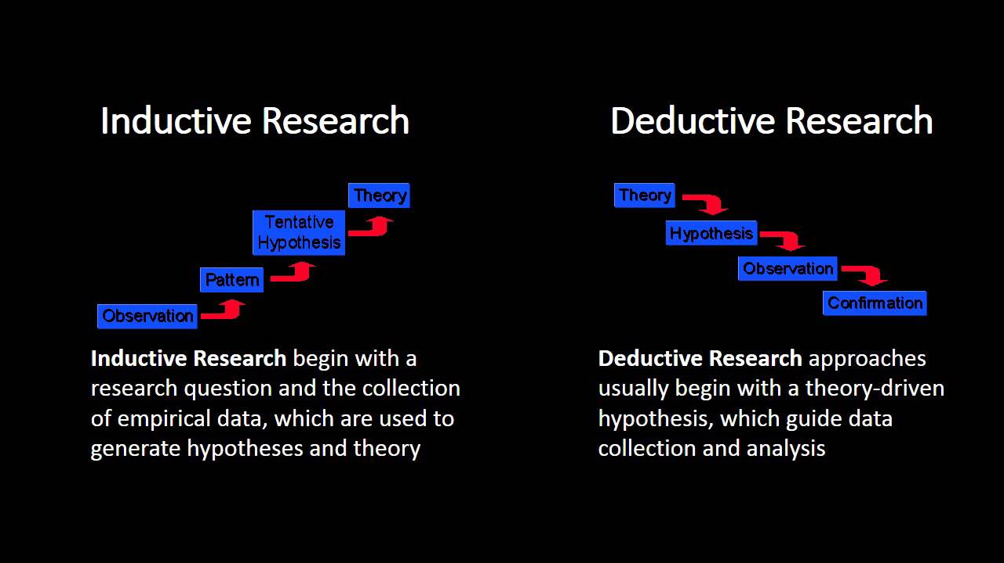
Figure 1: Research Approach
Source: (Pedro, 2012).
Deductive approach enables the researcher to look into the existing theories at first and then develop a pattern or hypotheses to confirm that by analysing the existing data or facts but here the research context is new and not enough data is available in the context of the moral judgements and ethical behaviours in the context of Bangladesh hence inductive approach is preferred. As the impact of the issues that form moral judgements on the ethical behaviours are not proven in the context of the young fashion consumers of Bangladesh and there are not enough existing theories and data are available on this hence inductive approach will help the researcher to consider these and design plans to investigate the way moral judgements affect the ethical beliefs of the young consumers considering the fashion industry of Bangladesh. The researcher didn’t opt for the deductive approach because here, no re-confirmation of the existing theory will be explored and also at the same time the researcher won’t do any experiments as well which suits with inductive approach (Ketchen, & Bergh, 2014). Moreover, the inductive approach will result in understanding the context of the research better and also is suitable for the longitudinal time frame. Hence, inductive research approach has been preferred here.

3.3 Strategy
In this research, the researcher will mainly focus on collecting the qualitative primary data to depict the way moral judgement affects the ethical beliefs of the customers. There are different research strategies that can be followed by the researcher. The list of research strategies can be understood as follows:
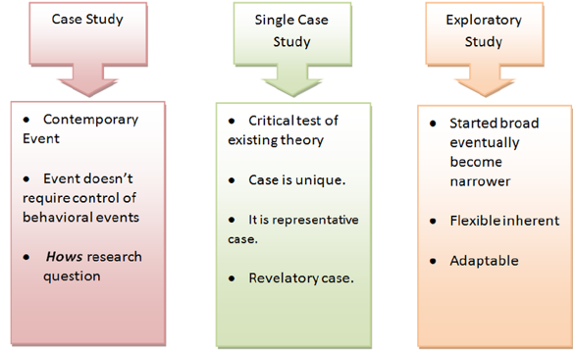
Figure 2: Research Strategy
Source: (Ketchen, & Bergh, 2014)
Here the researcher will select the exploratory research strategy by which the researcher will consider the big picture of the moral judgements and ethical beliefs at first considering the fashion sector of Bangladesh and the impact analysis will be done to delineate the way moral judgements affect the ethical behaviours. The exploratory research design will help the research to maintain enough flexibility according to the core aims and objectives of the research (Keys, 2015). The exploratory research strategy will also help the researcher in completing this research in an organized manner depicting the core outcomes of the research in a precise way. The researcher avoided case study method because here individual case studies won’t be enough to draw a conclusion regarding the moral judgements and ethical behaviours among the young customers in the fashion industry of Bangladesh.

3.4 Choice
The research choice determines the nature of the data collected by the researcher. In the quantitative research choice, the researcher collects the data that remains in the mathematical or numeric format. Quantitative research choice involves the application of mathematical and statistical tools to delineate the exact outcome for the research. The qualitative research choice, on the other hand, focuses on the collection of theoretical data or descriptive data. The mixed research approach, on the other hand, allows both quantitative and qualitative data collection.
In this research qualitative research choice will be prepared as the researcher is going to collect qualitative data for this research. Qualitative research is important in understanding the context of the research fully and also helps to make a deep interpretation of the research subject matter as well. Here, the researcher preferred qualitative research choice mainly because it matches with the interpretivism research philosophy. Qualitative research choice is also supported by the inductive research approach at the same time (Kothari, 2014). The research timeframe here involves longitudinal timeframe that also supports the qualitative research context. The researcher avoided quantitative the selection of the quantitative research choice because quantitative research choice matches with the deductive approach and also at the same time goes well in terms of the hypotheses testing which is not in this case. Moreover, though quantitative research choice can produce exact results they are not able to reflect the context of the research.

3.5 Data collection and analysing tools
The researcher will collect both primary and secondary qualitative data for this research. The primary qualitative data will be collected through the in-depth semi-structured interview. Here, for an interview, the research population involves both the young fashion customers from Bangladesh and also employees working in the different fashion companies as well. The researcher will select 85 participants from the young fashion customers of Bangladesh through the convenience sampling technique. Convenience sampling helps to select the research participants based on convenience of reach and it will help the researcher to select the research participants without much difficulties (Newman, & Benz, 2011). The customers-oriented interview will involve different open-ended questions regarding the different aspects of the moral judgement and their relationship with the ethical behaviours of the customers. The researcher will also conduct employee interview to collect their thinking and opinions regarding the research subject matter. Collect data through the employee interview will help to make the more practical analysis of the research context and will help the researcher to interpret the moral judgement and also the ethical belief of the young consumers from the company’s context better. For an employee interview, 15 employees will be selected from the fashion industry companies of Bangladesh through the convenience sampling technique. The interviews responses will be collected mostly through the skype video calls and in special cases, the personal visit will be made. Pre-permission will be taken for collecting the responses of the interview data. As the qualitative data will be collected in this research context, hence thematic data analysis tools will be used here. Thematic data analysis will help the researcher in keeping consistency in the research work and also in presenting the summary of the qualitative data in a structured manner.

3.6 Research Timeframe
The research timeframe is below:
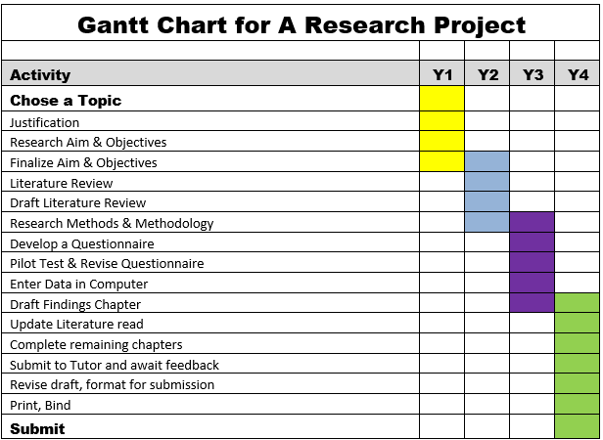

4 Expected Conclusions
By completing this research, the researcher is hopeful that there will be a strong correlation between moral judgement and the ethical belief of the consumers in the fashion industry of Bangladesh. The researcher is hopeful that all the aspects of the moral judgement of young consumers will have a significant impact on the ethical belief. By the end of this research, the researcher is also expecting that the ethical belief will also have a significant impact on the buying attitudes of the customers of the fashion industry of Bangladesh.
Studies like Anisul Huq et al (2014) did found the significant impact of the moral judgement on the ethical belief of the customers because moral judgement shapes up the perceptions of the people which depicts the likings and disliking of the people at the same time shaping up particular ethical belief. Arli et al (2015) also found the same as the study depicts that ethical belief is influenced by different moral domains, judgement and also the moral behaviours and these factors influence the way people perceive something. Azad (2019) found that ethical belief of the customers is significantly affected by both individual and situational moderators. Bucic et al (2012) found that the individual moderators of the ethical behaviours are complex to understand and interpret as these factors vary significantly from the individuals to the individuals. A similar study conducted by Chowdhury and Akter (2018) in the UK context delineates that the individual moderators of the ethical beliefs are commonly affected by the background, ethnicity, religious view, family background and status of the people and these factors shape up the ethical beliefs of the young fashion consumers living in the UK. Another study conducted by Ferdous and Polonsky (2013) reveals that the situational moderators of the moral beliefs among the young consumers from the UK involve the organisational policies, goodwill’s and also the practices. This whole issue has been covered by Haider and Shakib (2018) which can be depicted as follows:
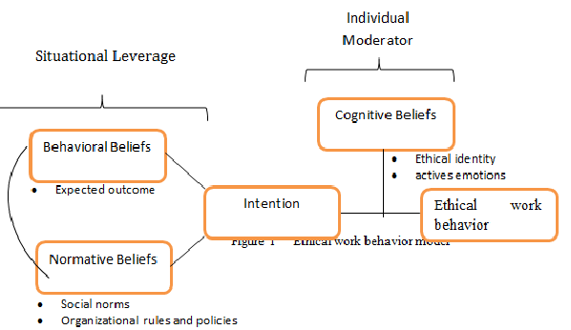
Figure 3: Situational and Individual Moderator
Source: (Haider, and Shakib, 2018)
Haque and Azmat (2015) opined that the individual moral domains and also moral judgement significantly affect the buying intention in the fashion and apparel industry which has been confirmed by the findings made by Huq et al (2016) which is below:
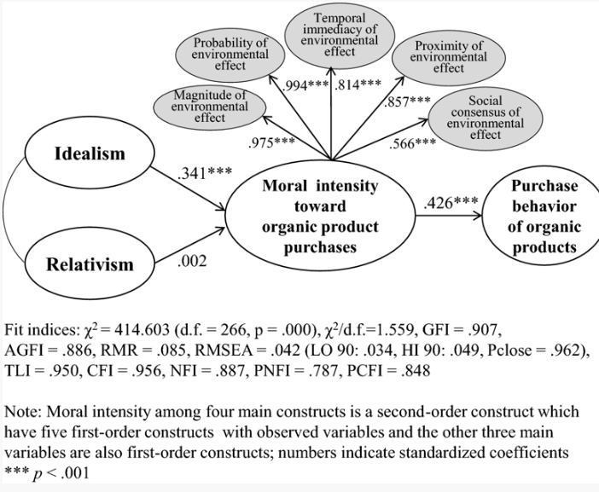
Figure 4: Ethics impact
Source: (Huq, et al, 2016).
From the above findings, it can be understood that due to moral intensity the consumers are more prone to make organic products buying that has no adverse impact on the environment and also consumers prefer the products that are more socially responsible and also at the same time cares about the surroundings. Ilies et al (2011) opined that the concept of moral judgement and also ethical beliefs are getting more established with the time with increased pollution proximity and also with the emergence socially responsible buyers’ group across the globe. Islam (2018) also justified the above findings by depicting that the sales of the companies that brand themselves as an ethical producers have increased to a great extent in the recent years and also is expected to grow at a sustainable rate in the future at the same time which depicts the importance of the moral judgement and ethical belief in the fashion industry to a large extent. Kamal and Deegan (2013) summarized the arguments by stating that in the future even in the developing countries like Bangladesh the fashion consumers will be more concerned of the moral judgements and also the ethical beliefs in order to make their buying preferences.
In this study, the researcher will follow the qualitative study and under the qualitative study, exploratory research design has been chosen to be followed to complete this research. Different qualitative research method involves case studies, ethnography and grounded theories. The researcher ignored case study strategies because here the past incidents are considered that may not be enough to indicate the present situation hence case study has been avoided. The ethnography and also grounded theory has been ignored mainly these involve experiment-based research context that goes with the scientific research context which is not the case for this research. The exploratory research design has been preferred over the other research design mainly because it will help the research in designing the research maintaining enough flexibility highlighting the core goals and objectives of the research. The pros of the qualitative research are that it involves a more practical understanding of the context and also helps to determine the small changes in the research outcome over a particular period of time. The other advantages of the qualitative research are that through this the in-depth understanding of the research context can be made by involving a relatively small sample number (Preser, 2014). Other advantages of the qualitative research choice are that it brings more specification regarding the research context also helps to remove the biases among the data sets to a large extent. Qualitative research choice also helps to maintain the structure and also enables the detailed reasoning for the research outcomes. The limitations of the qualitative research method involve that this research mainly focuses on the subjective view of the research. Moreover, the data collection in qualitative research is to some extent time-consuming. The statistical interpretations and also exact result representation can’t be possible under the qualitative research (Raftery, 2014). The researcher requires a sufficient amount of knowledge to be able to apply qualitative research method. The researcher also needs to repeat the same procedure over a period of time in the qualitative research approach. The data rigidity also can’t be maintained in qualitative research. Here, the qualitative research method will help the researcher in bringing out the context of the moral judgements and also the ethical beliefs covering the changes and also the core issues that affect them over the period of time precisely by involving the practical context of the research. here, the researcher doesn’t want to restrict the boundary of the research as the researcher wants to capture the full scenario highlighting the context of the moral judgement and ethical beliefs of the fashion consumers. The qualitative research will help to result in in-depth context analysis and the desired results highlighting the actual scenario (Samuels, et al, 2009). The researcher is expecting that the desired research outcome can be reached in the appropriate way.

Reference
Aboud, F.E., (2006). Evaluation of an early childhood preschool program in rural Bangladesh. Early Childhood Research Quarterly, 21(1), pp.46-60.
Anisul Huq, F., Stevenson, M. and Zorzini, M., (2014). Social sustainability in developing country suppliers: An exploratory study in the ready made garments industry of Bangladesh. International Journal of Operations & Production Management, 34(5), pp.610-638.
Arli, D., Tjiptono, F. and Winit, W., (2015). Consumer ethics among young consumers in developing countries: a cross national study. Social Responsibility Journal, 11(3), pp.449-466.
Arsenio, W.F. and Lemerise, E.A., (2004). Aggression and moral development: Integrating social information processing and moral domain models. Child development, 75(4), pp.987-1002.
Azad, A. (2019). Consumer Rights Protection: Shahriar's transfer withdrawn. [online] Dhaka Tribune. Available at: https://www.dhakatribune.com/bangladesh/dhaka/2019/06/04/aarong-buster-magistrate-s-transfer-stalled [Accessed 11 Sep. 2019].
Bucic, T., Harris, J. and Arli, D., (2012). Ethical consumers among the millennials: A cross-national study. Journal of Business Ethics, 110(1), pp.113-131.
Chowdhury, T.A. and Akter, T., (2018). Fashion attributes preferred by young Bangladeshi consumers while buying casual clothes: A multi-dimensional approach. Journal of Fashion Marketing and Management: An International Journal, 22(4), pp.540-556.
Ferdous, A. and Polonsky, M., (2013). Predicting Bangladeshi financial salespeople’s ethical intentions and behavior using the theory of planned behavior: implications for developing countries. Asia Pacific journal of marketing and logistics, 25(4), pp.655-673.
Forte, A., (2004). Business ethics: A study of the moral reasoning of selected business managers and the influence of organizational ethical climate. Journal of Business Ethics, 51(2), pp.167-173.
Goddard, W. & Melville, S, (2015). Research Methodology: An Introduction, 2nd edition, Blackwell Publishing
Graham, J., Nosek, B.A., Haidt, J., Iyer, R., Koleva, S. and Ditto, P.H., (2011). Mapping the moral domain. Journal of personality and social psychology, 101(2), p.366.
Haider, T. and Shakib, S., (2018). A Study On The Influences of Advertisement On Consumer Buying Behavior. Business Studies Journal.
Han, H., Wang, W. and Mao, B. (2015). Borderline-SMOTE: a new over-sampling method in imbalanced data sets learning. Springer, pp.878--887.
Haque, M.Z. and Azmat, F., (2015) . Corporate social responsibility, economic globalization and developing countries: A case study of the ready made garments industry in Bangladesh. Sustainability accounting, management and policy journal, 6(2), pp.166-189.
Huq, S.M., Nekmahmud, M. and Aktar, M.S., (2016). Unethical practices of advertising in bangladesh: a case study on some selective products. International Journal of Economics, Finance and Management Sciences, 4(1), p.10.
Ilies, R., Johnson, M.D., Judge, T.A. and Keeney, J., (2011). A within‐individual study of interpersonal conflict as a work stressor: Dispositional and situational moderators. Journal of Organizational Behavior, 32(1), pp.44-64.
Irwin, T., (2009). The development of ethics: a historical and critical study.
Islam, R., (2018). Ethical Standards of Bangladeshi Online News Media: A Qualitative study.
Kamal, Y. and Deegan, C., (2013). Corporate social and environment‐related governance disclosure practices in the textile and garment industry: Evidence from a developing country. Australian accounting review, 23(2), pp.117-134.
Ketchen, D., & Bergh, D. (2014). Research methodology in strategy and management. Amsterdam: Elsevier.
Keys, P. (2015). A methodology for methodology choice. Syst. Res., 5(1), 65-76.
Khan, Z.R., Rodrigues, G. and Balasubramanian, S., (2016). Ethical consumerism and apparel industry-towards a new factor model.
Kohlberg, L., (1981). Essays on moral development (Vol. 1, pp. 409-412). San Francisco: Harper & Row.
Kothari, C. (2014). Research methodology. New Delhi: New Age International (P) Ltd.
Newman, I., & Benz, C. (2011). Qualitative-quantitative research methodology. Carbondale, Ill.: Southern Illinois University Press.
Niebuhr, R., (2013). Moral man and immoral society: A study in ethics and politics. Westminster John Knox Press.
Park, M., Kjervik, D., Crandell, J. and Oermann, M.H., (2012). The relationship of ethics education to moral sensitivity and moral reasoning skills of nursing students. Nursing ethics, 19(4), pp.568-580.
Parker, E., (2011). Steps towards sustainability in fashion: snapshot Bangladesh.
Pedro, L. (2012). International Journal of Social Research Methodology: Theory & Practice. (2012). International Journal Of Social Research Methodology, 15(6), ebi-ebi.
Preser, R. (2014). A methodology of damage. International Journal Of Social Research Methodology, 1-14.
Raftery, A. (2014). Bayesian Model Selection in Social Research. Sociological Methodology, 25, 111.
Rahman, S., Haque, A. and Rahman, M., (2011). Purchasing Behavior for Pirated Products A Structural Equation Modeling Approach on Bangladeshi Consumers. Journal of Management Research, 11(1), pp.48-58.
Richardson, C.B., Mulvey, K.L. and Killen, M., (2012). Extending social domain theory with a process-based account of moral judgments. Human Development, 55(1), pp.4-25.
Samuels, W., Biddle, J., & Emmett, R. (2009). Research in the history of economic thought and methodology. Bingley: Emerald JAI.
Siddiqui, J. and Uddin, S., (2016). Human rights disasters, corporate accountability and the state: Lessons learned from Rana Plaza. Accounting, Auditing & Accountability Journal, 29(4), pp.679-704.
Teulon, F., (2014). Ethics, moral philosophy and Economics. Ipag Business School, pp.1-10.
Uddin, M.A. and Razu, A.R., (2019). Influences of Facebook Advertisement on the Buying Behavior of Youth Groups: A Comparative Study of Bangladesh and Turkey, International Journal of Academic Research in Business and Social Sciences, 9(2)
Vaughn, L., (2015). Doing ethics: Moral reasoning and contemporary issues. WW Norton & Company.

Part 2: Reflective Essay
The aim and also the objectives of the research influence the selection of the research choices. The data collection orientation and also the outcome orientation of the research are determined based on the quantitative and qualitative research choice selection. The quantitative research choice involves the objective oriented research choice where numeric data is analysing, interpreted and presented by applying different statistical techniques (Wilkinson, 2009). The qualitative research, on the other hand, focuses on the subjective view of the research that aims at collecting reasoning's, opinions and judgements regarding a research context to delineate an overall understanding of the research. there are different strategies used in the quantitative and qualitative study for data analysis (Welman, et al, 2012). In quantitative strategy, the common strategies include descriptive, co-relational, quasi-experimental and also experimental strategy. Under the qualitative research method, the different research strategies followed include exploratory, grounded theory, case study, ethnography and historical model. The selection of the quantitative and also the qualitative research choice is mostly influenced by the philosophy and also the approach selection of the research (Schuessler, 2009). For example, in the context of the positivist philosophy and also in the context of the deductive approach, quantitative research choice is often preferred as hypotheses testing causal relationship is involved in these kinds of the study. In terms of the short research time horizon, the quantitative research choice is often preferred. On the other hand, in the context of the interpretivism research philosophy and also in the context of the inductive research approach qualitative research choice is often preferred (Scruggs, & Mastropieri, 2015). In terms of the longitudinal research qualitative research choice is often preferred at the same time because this enables the opportunity for a deep understanding of the research context.
The one easier to use and the reasoning
Comparing the context of both quantitative and qualitative research, it can be commented that quantitative research is easier to use compared to qualitative research. The reason for that in the quantitative research choice, the research can be completed within a short time horizon. The data collected in the quantitative research choice is far easier and also at the same time, the data collection can be made within a structured framework at the same time. In the quantitative study, no deep knowledge regarding the research context is required for completing the research because here the understanding of the research context isn’t required and this research approach only considers the results (Saunders, et al, 2014). In the quantitative research choice, it is easier to reach a conclusion as statistical tools have been applied that help to reach an exact conclusion. On the contrary qualitative research needs background experience and knowledge to be applied. Qualitative research choice is time-consuming to apply because here in-depth understanding of the research context is required. There is no fixed boundary for data collection in the qualitative research choice because the data collection in the qualitative research choice remains flexible. Exact conclusion in the qualitative research choice is very difficult to be made because here the research context is explored to make understanding, not precise results (Samuels, et al, 2009). Moreover, qualitative research choice involves the research context regarding which there are fewer data available that also makes the qualitative research choice difficult to be implemented. The data collected in the qualitative research choice requires time and also effort to be interpreted clearly. The outcome in the qualitative research is also very difficult to be determined because by qualitative research choice the indication can be gained not the exact reasoning.
Preferred research choice: Qualitative and the reasoning
In my doctoral research, I have opted to apply qualitative research to depict the impact of the moral judgement on the ethical belief of the Bangladeshi young fashion consumers. Although, it has been previously discussed that quantitative research choice is easier to be applied but I have opted for qualitative research choice. The reason for that I am opting to complete doctoral research where the context understanding is very much important which is unable to be achieved through the quantitative research choice. Moreover, as I am going to complete doctoral research hence, knowledge regarding the background of the research is also very much important for me and I have enough knowledge regarding this research subject which is enough to implement qualitative research technique. Moreover, my doctoral research involves longitudinal time horizon that means I will be able to conduct research for multiple periods of time which will enable me to make the deep understanding of the research context that also suits the qualitative research context. Other than these my research is aimed at investigating a complex matter related to moral judgements and also the ethical belief of the consumers that also require long term investigation and deep analysis to be interpreted in the right manner. Moreover, as there are few or no previous researches done on this topic considering the context of Bangladesh the researcher won’t be able to make rigid data collection plan hence flexibility is required in terms of data collection for this research which is not possible in the quantitative research choice. Qualitative research choice, on the other hand, will provide enough help and assistance in maintaining flexibility to cover the wider context of the research to make exact summary demonstrating the way moral judgement affect the ethical behaviours of the young consumers from the fashion industry. Quantitative research limits the data collection boundary as the data is collected in a rigid way maintaining a fixed format which is not in the case for the qualitative research as by qualitative research the researcher in this context will be able to collect extra information that can help the researcher in drawing logical conclusion for the research precisely covering all the required facts and information as appropriate. Hence, for my doctoral research, I have preferred to apply qualitative research choice.
Similarities and differences
There are significant similarities and dissimilarities identified between the qualitative and the quantitative research choice that I have identified through my experiences. I have observed that qualitative research is used to discover ideas with general objectives whereas quantitative research is aimed at testing the hypotheses with specific questions (Raftery, 2014). In the qualitative research the deep observation is made and then interpretation takes place on the other hand in the quantitative research the events are measured and testing is done appropriately. In the qualitative research, the data remains in the unstructured or free format on the other hand in the quantitative research the structured data is considered and also the categories are specified accordingly (Preser, 2014). In the qualitative research, the research results are subjective whereas in the quantitative research results are objective in nature. In the qualitative research, the intimate involvement of the researcher is required whereas in the quantitative research deep involvement is not required. In the qualitative research small sample number is required, whereas in the quantitative research large sample number is required. The origins of the quantitative research are from natural science, on the other hand, the origins of the qualitative research are social science (Newman, & Benz, 2011). In the quantitative research positivism, philosophy is considered whereas qualitative research involves interpretivism or naturalism. Qualitative research involves inductive and involves more flexibility. Quantitative research involves deductive approach or less flexibility. In the quantitative research, theory testing is done whereas in the qualitative research the new theory is built. In the quantitative research, the researcher acts as the outside or observer whereas in the qualitative research the researcher acts as the insider or the participants (Kothari, 2014). People are regarded as objects in quantitative research whereas, in qualitative research, the people are considered as the object. The qualitative research is more field-based compared to quantitative research. The research focus is more individualistic in terms of quantitative research whereas, in qualitative research, the research focus is more group based (Keys, 2015). The data collected in the qualitative research involves interviews, observations and focus group study. On the other hand, in quantitative research, the research data is collected through the surveys and structured interviews mainly.

Reference
Keys, P. (2015). A methodology for methodology choice. Syst. Res., 5(1), 65-76.
Kothari, C. (2014). Research methodology. New Delhi: New Age International (P) Ltd.
Newman, I., & Benz, C. (2011). Qualitative-quantitative research methodology. Carbondale, Ill.: Southern Illinois University Press.
Preser, R. (2014). A methodology of damage. International Journal Of Social Research Methodology, 1-14.
Raftery, A. (2014). Bayesian Model Selection in Social Research. Sociological Methodology, 25, 111.
Samuels, W., Biddle, J., & Emmett, R. (2009). Research in the history of economic thought and methodology. Bingley: Emerald JAI.
Saunders, M., Lewis, P. and Thornhill, A.,(2014). Research methods for business students, 5th ed. Essex: Pearson Education Limited.
Schuessler, K. (2009). Covariance Analysis in Sociological Research. Sociological Methodology, 1, 219.
Scruggs, T., & Mastropieri, M. (2015). Applications of research methodology. Amsterdam: Elsevier JAI.
Welman, C., Kruger, F., Mitchell, B., & Huysamen, G. (2012). Research methodology. Cape Town: Oxford University Press.
Wilkinson, S. (2009). Focus group methodology: a review. International Journal Of Social Research Methodology, 1(3), 181-203.

