7 - While Loops in Python

When we program, we often need to repeat sections of code. These are known as loops. They allow us to run sections of code several/hundred/thousand/million times, without having to copy and paste our code several/hundreds/thousands/millions of times!

There are two categories of loop in programming – for and while

Both of these exist in Python, we will start with the while loop.

While loops are usually used when the number of passes through the loop (iterations) is not known for sure in advance. While is often used when user input is involved.

(Note: In practice there is a bit of a grey area in when to use while loops and when to use for loops – but don't worry about that for the moment!)

In the example below, the user is required to enter a number that is 10 or below. The while loop will keep checking their choice until it is valid (ie if the user enters a number above 10, the loop will keep prompting for input until they get it right)

As with if/elif/else, we tab in the content of the loop in Python.

print("Please enter a number, must be 10 or below")
myNumber = int(input())
while myNumber > 10:
print("That number was out of range:")
print("Have another go!")
myNumber = int(input())
print("End of program")
tab in for
loop content

outside loop,
back to normal
program flow

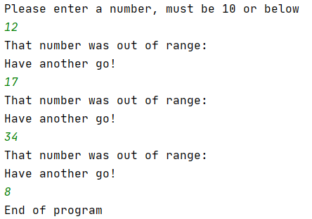

The loop keeps going until the input is below 10 (the user finally entered 8 above)
Let's do another example.

In the example below, the user is invited to guess what my magic number is (spoiler: it's 8 )

We don't know how many guesses it will take the user to guess right, so a while loop is appropriate:

myNumber = 8
print("Try to guess my number: ")
guess = int(input())
while guess != myNumber:
print("Sorry, that's wrong")
print("Try again: ")
guess = int(input())
print("End of program")
tab in for
loop content

outside loop,
back to normal
program flow

loop

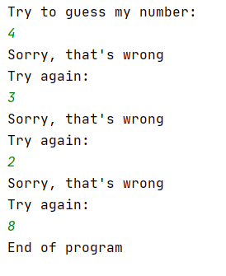

As we can see, the loop continues until the condition is no longer true (ie guess and myNumber are equal):

It is possible to use else with while in Python (although not in most other programming languages)

Taking the previous example, I have added an else as shown below:

myNumber = 8
print("Try to guess my number: ")
guess = int(input())
while guess != myNumber:
print("Sorry, that's wrong")
print("Try again: ")
guess = int(input())
else:
print("You got it!")
print("End of program")
The else will run when the loop has ended:

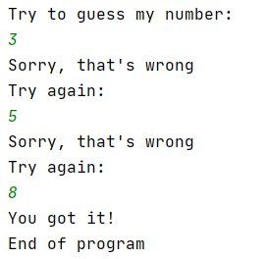

Loop Increment

If you are using a while loop that requires the value of a variable to change, you must provide a loop increment, otherwise the loop will continue forever.

Here is an example of an infinite loop:

print("Let's count up, we'll start from 1 and end at 10")
myCounter = 1
while myCounter <= 10:
print("Counting...", myCounter)
print("End of program")
loop

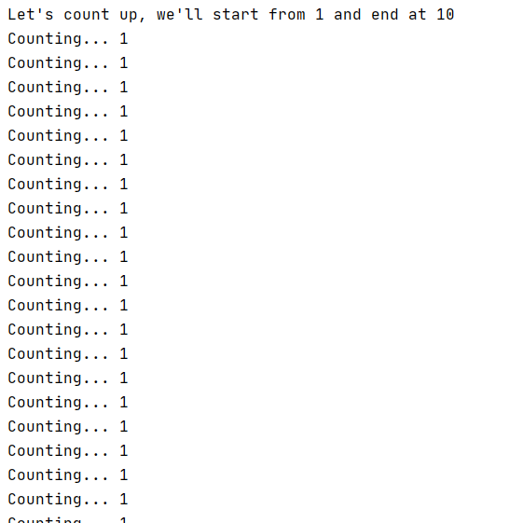

In the above example, the value of myCounter never changes, it stays at 1 and can never reach 10.

We can see this in the screenshot above. The program keeps going forever!

For the above program to work correctly, the value of myCounter needs to change. I intend to count up by 1, so I need to add an increment to my loop.

print("Let's count up, we'll start from 1 and end at 10")
myCounter = 1
while myCounter <= 10:
print("Counting...", myCounter)
myCounter = myCounter + 1
print("End of program")

increment

loop

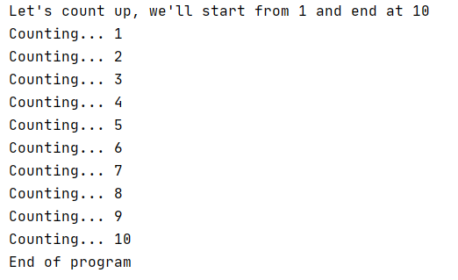

When you are incrementing, you can also write in a shortened form:

myCounter + = 1

This does exactly the same thing as: (ie adds 1)

myCounter = myCounter + 1

Of course, you don't have to increment by 1, you can do it with any value.

For example, we could count up in even numbers:

print("Let's count up, we'll start from 2 and count the even numbers up to 20")
myCounter = 2
while myCounter <= 20:
print("Counting...", myCounter)
myCounter += 2 # note: same as myCounter = myCounter + 2
print("End of program")



