Digital Skills and Research Methods
“The impact of Virtual Learning Environment (VLE) – Moodle on students’
learning experience at the University of Wales Trinity Saint David London” Campus.
Name- Calin Hortolomei
Student Number-1917705
Module Title-Digital skills and Research methods

Table of Contents
Introduction 3
Primary Data Collection 4
Secondary Data Collection 10
Analysis of acquired primary data 14
Thematic Analysis 15
Conclusion 17
Reference List 18
Appendix 19

Introduction
The pandemic has had a huge adverse impact on the education sector as the schools and colleges have been shut down and the only mode of interaction and learning that is taking place is through the virtual learning environments. The following discussions would involve collecting both primary as well as secondary data for assessing the impact that these virtual learning environments have on students and teachers and the kind of challenges that are being currently faced by them.

Primary Data Collection
In order to understand the impact that virtual learning environment has on student experiences, 12 students from University of Wales Trinity Saint David London Campus were approached with the survey questions. The survey had to be conducted online due to mobility restrictions because of the pandemic. Their responses have helped in understanding the impact in an effective manner. These have been enumerated in the sections below:
- To what extent are you comfortable with the virtual learning environment?
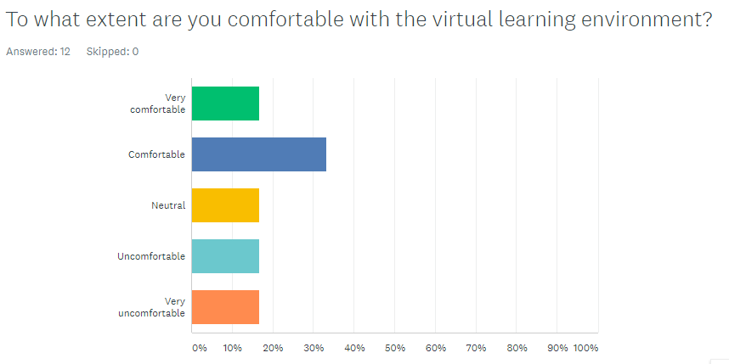
Figure 1: Survey Questions
(Source: Created by the learner)
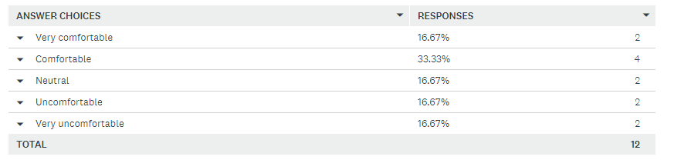
Figure 2: Opinion of the respondents
(Source: Created by the learner)
The data gained from the students reflect that around 33% of them are comfortable with the virtual learning environment while 16.67% of them were found to be uncomfortable. Another 16.67% of the respondents stated that they were neutral or very comfortable. This shows that there is a mixed feeling and attitude towards these new forms of learning.
- Do you believe that classroom learning offers better learning opportunities for students?
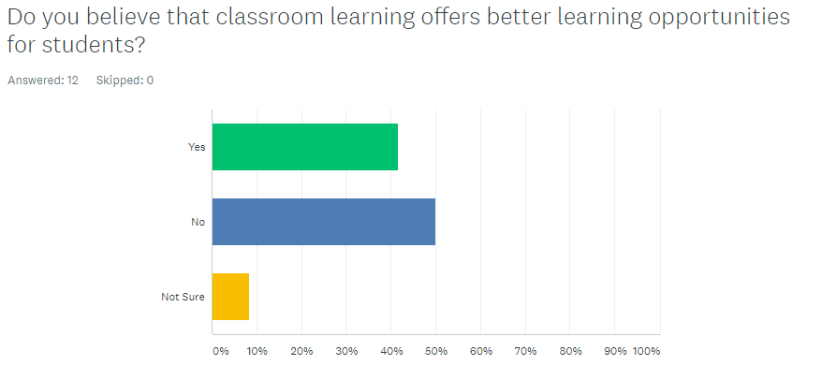
Figure 3: Survey Questions
(Source: Created by the learner)
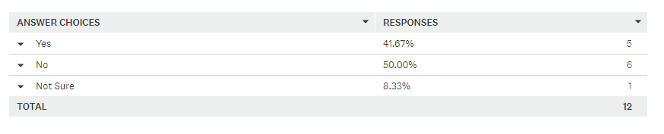
Figure 4: Opinion of the respondents
(Source: Created by the learner)
41.67% of the respondents were of the opinion that classroom learning offers more effectual learning opportunities for students. On the other hand, 50% of them negated this idea while the rest 8% were neutral regarding this issue.
- To what extent are you facing problems while adapting to the virtual learning environment?
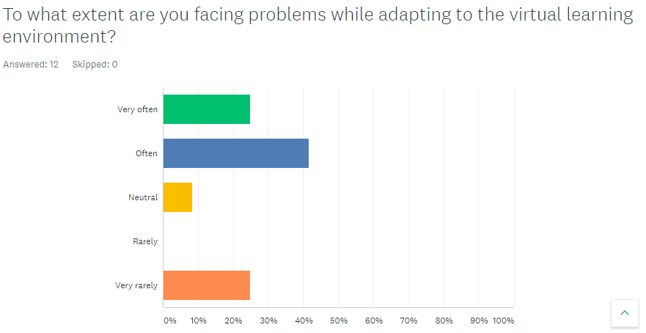
Figure 5: Survey Questions
(Source: Created by the learner)
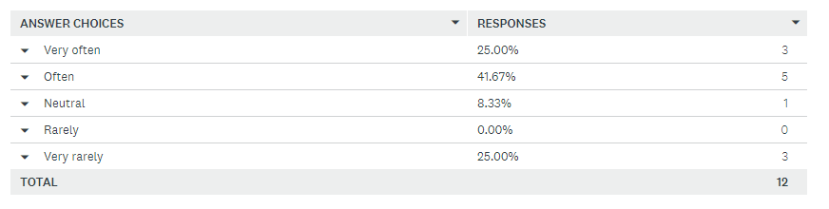
Figure 6: Opinion of the respondents
(Source: Created by the learner)
It has been found that around 41 % of the students often face problems in adapting to the new virtual learning environment. 25% were found to be facing these problems very often while 8% were reportedly neutral. On the contrary, it was also found that 25% of the respondents vary rarely had any problem with the virtual learning environment.
- To what extent do you agree that virtual learning environment provides a more relaxed and flexible learning opportunity for students?
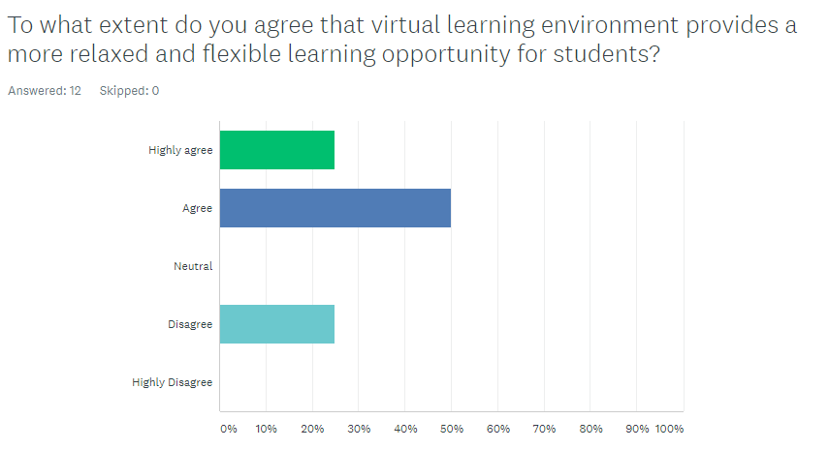
Figure 7: Survey Questions
(Source: Created by the learner)
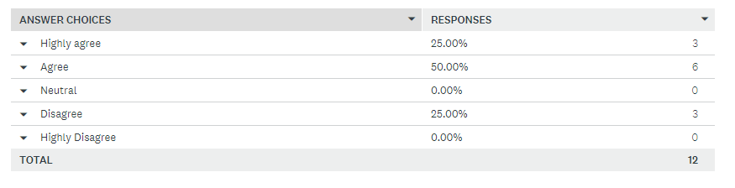
Figure 8: Opinion of the respondents
(Source: Created by the learner)
50% of the respondents agreed to the fact that the virtual learning environment provides a more effective and flexible learning opportunity for students. However, 25% of them also disagreed to the notion while the rest 25% were found to be agreeing to this idea highly.
- Out of those given below, what is the most pertinent challenge of virtual learning?
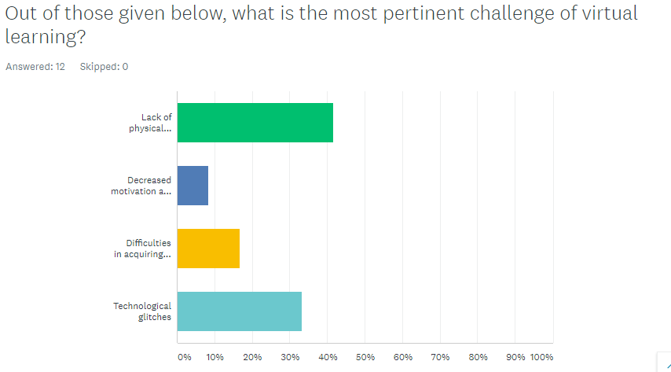
Figure 9: Survey Questions
(Source: Created by the learner)
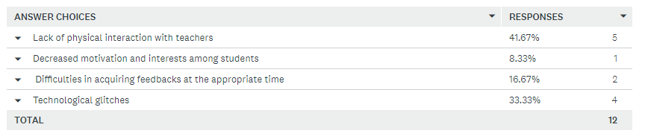
Figure 10: Opinion of the respondents
(Source: Created by the learner)
41% of the students were found to believe that lack of physical interaction with their teachers was the most pertinent challenge of the virtual learning environment. On the other hand, 33% of them stated that they faced technological issues while 16% of them regarded issues in acquiring feedbacks as the prime problem of the new learning environments. It was also found that 8% of them regarded decreased interests among students as another challenge.
- To what extent are you willing to return to normal classroom classes?
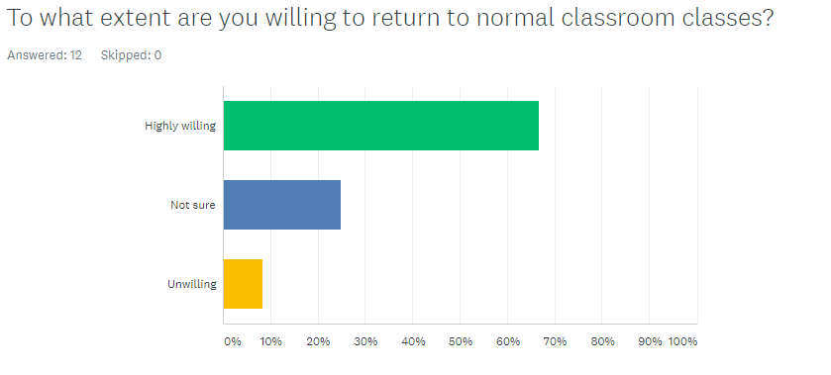
Figure 11: Survey Questions
(Source: Created by the learner)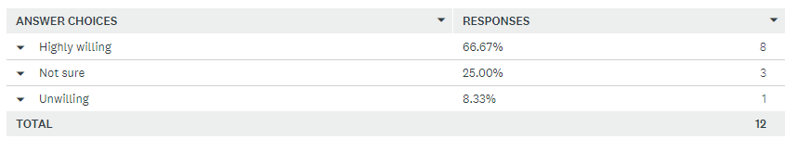 Figure 12: Opinion of the respondents
(Source: Created by the learner)
It has been found that 66.67% of the respondents were highly willing to return to their physical classes as soon as the mobility restrictions are ceased. On the other hand, 25% of them were found to be unsure about this notion. In addition to this, it was also found that around 8.33% of them were unwilling to return to their physical classes.

Secondary Data Collection
Theme | Journal | Author | Year of Publication | Summary
Theme 1  Benefits and significance of  implementing virtual learning environment | Impact of virtual learning for improving quality of learning in higher education. In 2 nd International Conference on Education and Distance Learning–1 st July.  THE ADOPTION OF VIRTUAL LEARNING ENVIRONMENT IN BLENDED CLASSES: AN EMPIRICAL STUDY. Issues in Information Systems, 19(4). | Hettiarachchi, S. and Wickramasinghe, S.,  Vaidyanathan, G., | 2016  2018 | This article helps in identifying some of the most important benefits of having a virtual learning environment for students. It states that it boosts communication by offering various channels in the format of discussion forums, surveys, polls and opportunities for instant feedback  Dynamic home pages may also be created for representing the subjects effectually  The article helps in reflecting the huge significance of the VLE platforms in creating, storing, accessing and using class resources. They facilitate the teachers in effectual curriculum designing, planning as well as personalisation of the learning experiences of students. It also helps students in being organised as teams for different group work. It also ensures to support student learning progresses and facilitate proper assessments. It offers various communication systems like video or audio conferencing, emails and announcements.
Theme 2  Difficulties associated with virtual learning environment | Impact of implementing a virtual learning environment (VLE) in the EFL classroom. Íkala, Revista de Lenguaje y Cultura, 22(3), pp.479-498. | Herrera Mosquera, L., | 2017 | This study highlights the difficulties of using such virtual platforms for learning. It reflects the opinion of several teachers who find them to be uncomfortable and challenging as there is a huge amount of perceived technological weakness  In addition, it discusses the fact that some teachers and students may not have equal opportunities for accessing such technological devices which creates many difficulties in conducting these classes virtually
Table 1: Thematic Analysis Table
(Source: Created by the learner)

Analysis of acquired primary data
It may therefore be understood from all the data gained through the primary and secondary methods that the use of virtual learning environments has had combined effects on students and teachers as it has been perceived both in the positive as well as negative light. The pandemic situation has inevitably restricted movement and has made it impossible for the students to go for their classes physically. Therefore, these virtual learning environments have helped in ensuring that they are able to complete their courses in time. The survey intended to identify the perceptions and impact that these virtual classes had on the students. Some of them were found to be comfortable to the new learning method conducted online while others stated that they were not yet comfortable and acquainted with the learning process.
It was also important to know whether they felt that the classroom learning offered more efficient learning opportunities and it was found that a substantial percentage of students agreed to this notion. They believed that the physical classroom learning mode is more effective as it offers better learning opportunities for them. This underlines the fact that though there are several perceived benefits of this mode of learning, students prefer the physical modes of learning as it has several advantages and added benefits. For example, it was seen that most of the respondents of the survey has faced some kind of problem while trying to adapt to this form of virtual learning environment. This highlights that students are often faced with different kinds of problems while adjusting with the new learning forms. However, on the other hand, the students were also found to be agreeing to the fact that the virtual learning environment has helped in making their academic routine more flexible and relaxed. Although some of the students disagreed to this view, most of them were found to be assertive of this notion.
Lack of physical interaction with the teachers was found to be the most pertinent challenge that the students face because of the virtual learning modes. They also reported technological issues, problems in acquiring feedbacks as well as reduced interests among students as some of the other problems associated with the virtual learning environments. The survey also wanted to know to what extent they were interested to return to their normal classroom classes whereby most of them stated that they are high willing to return. Only a small percentage of students stated that they were unwilling to return to the physical mode of teaching as they have become comfortable with the virtual mode of learning. The survey has therefore implied that there are differences in opinions regarding the virtual learning classes. It is the responsibility of the authorities to ensure that the students are guided and supported throughout the process effectively so that they are able to overcome the pertinent challenges related to this mode of learning.

Thematic Analysis
Theme 1: Benefits and significance of implementing virtual learning environment
As has been mentioned by Hettiarachchi and Wickramasinghe (2016), the virtual learning platforms are hugely beneficial as it offers an effective online system allowing teachers to share different kinds of course materials with the students through the internet. It acts as a resource hub for a huge variety of class lectures and notes along with facilitating faster and effective work submission through virtual hand-in folders containing time windows. On the other hand, the students are offered the virtual hand-in folders having time windows where they may submit their work. The teachers also have the opportunity of maximising the use of the infinite storage space for worksheets, PowerPoint presentations and word documents that must be shared with the students.
In addition to this, the critical underpinnings of Vaidyanathan (2018)also suggest that these platforms are hugely beneficial for the students as it provides different kinds of popular learning environments such as Moodle, Blackboard and OnCourse and these have been used by several educational institutions for making their teaching processes better and more effectual. On the other hand, the teachers are also found to be interested in using the VLE for improving and enhancing the student learning outcomes while at the same time striving to combat the decrease in resources in the higher education sector.
Theme 2: Difficulties associated with virtual learning environment
The studies ofHerrera Mosquera (2017) have helped in identifying the different kinds of challenges and difficulties that are linked with the virtual learning environments. Contrary to the diverse benefits mentioned by Hettiarachchi and Wickramasinghe (2016), the author stated that it is impossible for some students to access the modern technologies for availing these classes for cultural as well as economic reasons. It is evident that all teachers and students do not have similar kinds of opportunities for accessing such technological devices. The discussions of Herrera Mosquera (2017) identify the fact that several teachers regard the virtual learning environments to be a waste of time while others think of it as a resource that does not have the capacity of offering added value to the process of teaching and learning. It has also been regarded that it does not have much contribution towards the learning process of students. Therefore, it is evident that these modes have both positive as well as negative aspects and the authorities must strive to ensure that the students and teachers are supported well throughout the process. This would help in ensuring that the learning process remains effective.

Conclusion
It may therefore be concluded that the virtual learning environments has made the learning process flexible and convenient for a substantialpercentage of the students. However, others face various kinds of difficulties and challenges while using such platforms and it is the responsibility of the authorities to ensure that the students and teachers are guided well so that they are able to attain maximum benefits out of these online modes while overcoming all the challenges effectively.

Reference List
Herrera Mosquera, L., 2017. Impact of implementing a virtual learning environment (VLE) in the EFL classroom. Íkala, Revista de Lenguaje y Cultura, 22(3), pp.479-498.
Hettiarachchi, S. and Wickramasinghe, S., 2016, July. Impact of virtual learning for improving quality of learning in higher education. In 2 nd International Conference on Education and Distance Learning–1 st July.
Vaidyanathan, G., 2018. THE ADOPTION OF VIRTUAL LEARNING ENVIRONMENT IN BLENDED CLASSES: AN EMPIRICAL STUDY. Issues in Information Systems, 19(4).

Appendix
Questionnaire
1) To what extent are you comfortable with the virtual learning environment?
- Very Comfortable
- Comfortable
- Neutral
- Uncomfortable
- Very uncomfortable
2) Do you believe that classroom learning offers better learning opportunities for students?
- Yes
- No
- Not Sure
3) To what extent are you facing problems while adapting to the virtual learning environment?
- Very often
- Often
- Neutral
- Rarely
- Very rarely
4) To what extent do you agree that virtual learning environment provides a more relaxed and flexible learning opportunity for students?
- Highly agree
- Agree
- Neutral
- Disagree
- Highly Disagree
5) Out of those given below, what is the most pertinent challenge of virtual learning?
- Lack of physical interaction with teachers
- Decreased motivation and interests among students
- Difficulties in acquiring feedbacks at the appropriate time
- Technological glitches
6) To what extent are you willing to return to normal classroom classes?
- Highly willing
- Not sure
- Unwilling

