University of Wales Trinity Saint David
School of Engineering

Geometry-Based Design Strategies for Reducing Sonic Boom in Civil Supersonic Aircraft
Independent Project
ACMA6013

Heather Came
2208198
25/09/2026

Declaration of Authenticity
This project is the result of the author's original research. It has been composed by the author and has not been previously submitted for examination which has led to the award of a degree.
Signed: Heather Came Date: 25 / 09/ 2026

Abstract

Sonic boom remains a major barrier to routine civil supersonic flight over land because pressure disturbances generated by an aircraft can steepen and merge into abrupt, ground-level, acoustic signatures. This dissertation evaluates how aircraft geometry can reduce boom intensity at the concept/design stage. The study uses a structured literature synthesis to compare geometry-led strategies against evidence quality, method bias and practical aircraft-design constraints.
The review shows that nose and forebody shaping, combined with smooth total equivalent-area distribution, are the most consistently supported low-boom geometry levers. These features influence the first compression and the later merging of pressure disturbances. Wing shape, thickness and lift distribution also affect the signature, but their value is more conditional because wing geometry is tightly coupled to lift-to-drag ratio, trim, structural depth, fuel volume and low-speed performance. Secondary devices and control-surface changes are best treated as refinements, not primary low-boom solutions.
The dissertation contributes an evidence-weighted design framework for early-stage low-boom aircraft geometry. It does not claim certification-grade acoustic prediction. Instead, it gives defensible design priorities: control the leading pressure rise through forebody shaping, manage shock coalescence through smooth equivalent-area distribution and refine wing and tail effects within aircraft-level constraints. Any near-field improvement must then be assessed using atmospheric propagation and loudness metrics before conclusions can be drawn about overland acceptability.

Contents

Declaration of Authenticity 2
Abstract 3
Contents 4
1 Introduction 7
1.1 Background and problem context 7
1.2 Research question, aim and objectives 10
1.3 Scope and contribution 10
1.4 Timing plan and risk control 11
1.5 Dissertation structure 12
2 Research Methodology 13
2.1 Research design 13
2.2 Search strategy and source selection 13
2.3 Inclusion, exclusion and quality appraisal 14
2.4 Data extraction and synthesis 15
2.5 Evidence-confidence framework 15
2.6 Methodological limitations and validity controls 17
3 Background and Design Context 18
3.1 Supersonic compressible flow and shock formation 18
3.2 Near-field signature, propagation and boom metrics 18
3.3 Geometry-signature coupling and equivalent area 20
3.4 First-order aircraft design constraints 20
3.5 Regulatory and environmental context 21
3.6 Background synthesis 23
4 Evidence Base: Methods, Metrics and Biases 24
4.1 Theoretical minimisation evidence 24
4.2 Computational and optimisation evidence 24
4.3 Experimental and human-response evidence 26
4.4 Method bias and comparability 26
4.5 Consequences of metric choice 27
4.6 Summary of evidence reliability 28
5 Literature Synthesis: Geometry Levers 29
5.1 Nose and forebody shaping 29
5.2 Fuselage and equivalent-area distribution 29
5.3 Wing planform, thickness and lift distribution 30
5.4 Empennage, control surfaces, inlets and secondary devices 31
5.5 Comparative evidence for geometry levers 32
5.6 Cross-lever interactions and conditionality 32
5.7 Case-study conclusions: Concorde and X-59 35
6 Comparative Evidence Map and Design Framework 36
6.1 Evidence-weighted comparison 36
6.2 Practicality overlay 37
6.3 Evidence-weighted design rules 38
6.4 Source-to-outcome design chain 39
7 Work Carried Out and Framework Evaluation 40
7.1 Work carried out 40
7.2 Purpose and method of the published-case evaluation 40
7.3 Evaluation against published cases 41
7.4 Results of the framework evaluation 43
7.5 Interpretation and limitations 43
8 Discussion 45
8.1 Mechanisms behind the strongest trends 45
8.2 Cross-study comparison and explanation of apparent differences 45
8.2.1 Wing geometry and configuration dependence 45
8.2.2 Near-field pressure and predicted ground loudness 46
8.2.3 Demonstrator and passenger-transport evidence 47
8.3 Trade-offs and engineering feasibility 48
8.4 Near-field evidence versus ground-level acceptability 48
8.5 Robustness of the evidence-weighted priorities 49
8.6 Effect of the limitations on the findings 50
9 Conclusions and Recommended Further Work 52
9.1 Conclusions and early-design guidance 52
9.2 Recommended further work 53
10 References 55
11 Appendices 60
Appendix A - Full Project Timing Plan 60
Appendix B - Evidence extraction template and examples 62
Appendix C - Risk register 63
Appendix D – Concorde and X-59 case-study comparison. 64

Figure 1 - Idealised N-wave sonic-boom pressure signature (National Park Service, 1994). 7
Figure 2 - Aircraft components (adapted from NASA Glenn Research Center, 2026). 8
Figure 3 - F-5E Shaped Sonic Boom Demonstrator and modified forebody (NASA, 2009) 9
Figure 4 - NASA X-59 integrated low-boom configuration (NASA, 2025). 9
Figure 5 - Project timing plan: activity details, dates and status 11
Figure 6 - Aircraft design process showing the interaction (Reed, Follen and Afjeh, 2000). 22
Figure 7 - CFD and supersonic aircraft development (Hirsch, 2007; Han et al., 2024) 25
Figure 8 - Low-boom geometry features (author annotations on NASA, 2013). 39
Figure 9 - Project timing plan: planned and actual Gantt schedule (Part 1) 60
Figure 10 - Project timing plan: planned and actual Gantt schedule (Part 2) 61
Figure 11 - Concorde geometry: front, side and plan views (Heritage Concorde, n.d.). 64
Figure 12 - NASA X-59 and principal geometric characteristics (NASA, 2025). 65

Table 1 - Principal variations from the original project plan 12
Table 2 - Project risk controls 12
Table 3 - Search strategy and purpose 14
Table 4 - Evidence-confidence framework 16
Table 5 - Representative sonic-boom overpressure values (adapted from Brandon, 2024). 19
Table 6 - Evidence types, strengths and limitations 27
Table 7 - Cross-study comparison of reported outcomes 33
Table 8 - Comparative evidence-map for geometry-based sonic boom reduction 36
Table 9 - Practicality overlay for concept-stage selection 37
Table 10 - Evidence-weighted concept-stage design rules 38
Table 11 - Practical outputs created in the project 40
Table 12 - Evaluation of the framework against published cases 42
Table 13 - Final early-design guidance 53
Table 14 - Evidence extraction fields 62
Table 15 - Example evidence extraction entries 62
Table 16 - Project risk register 63

Introduction

1.1 Background and problem context

Civil supersonic transport remains attractive because it can reduce long-distance journey times, but routine overland operation is constrained by the sonic boom (Maglieri et al., 2014; Loubeau and Page, 2018). A sonic boom is not a single event that occurs only when an aircraft first passes Mach 1 (Plotkin, 2002; Maglieri et al., 2014). It is generated continuously during supersonic flight as pressure disturbances propagate from the aircraft and reach the ground as an acoustic signature (Plotkin, 2002; Maglieri et al., 2014). Conventional configurations tend to produce an N-wave, as seen in Figure 1, with sharp pressure rises associated with the leading and trailing shock systems (Plotkin, 2002; Maglieri et al., 2014).

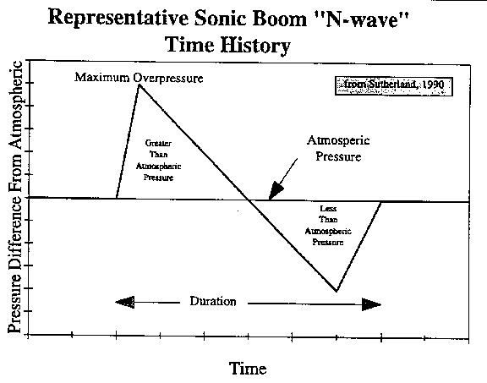
Figure 1 - Idealised N-wave sonic-boom pressure signature (National Park Service, 1994).

The continued growth of air travel also supports the relevance of faster civil transport. Global passenger demand reached a record level in 2024, increasing by 10.4% from 2023 and remaining above pre-pandemic levels (IATA, 2025). Business travel also remains important despite the increased use of virtual meeting platforms, with recent UK research identifying continued economic value from face-to-face business travel (GBTA, 2025). This does not demonstrate a commercial market for supersonic transport on its own, but it shows that reducing long-distance journey times remains relevant.
The regulatory importance of this problem is clear, as sonic boom is not only an aerodynamic phenomenon but also a certification, environmental and public-acceptance issue (Federal Aviation Administration, 2026a; Civil Aviation Authority, 2024; ICAO, 2025). The current regulatory and environmental context is discussed further in Section 3.5.
Geometry is a critical early-stage design lever because it affects how the source pressure signature is formed before atmospheric propagation (Seebass and George, 1972; Han et al., 2024). The principal aircraft components relevant to this study are shown in Figure 2; their geometry can affect the strength, spacing and merging of shocks (Seebass and George, 1972; Wintzer, Ordaz and Fenbert, 2015). This makes geometry more fundamental than late-stage local noise fixes, because the aircraft outer profile determines the pressure disturbances that later propagate through the atmosphere (Plotkin, 2002; Han et al., 2024). The challenge is that geometry favourable to low boom must also satisfy range, drag, trim, payload, visibility, structural and manufacturability requirements (Raymer, 2018; Han et al., 2024).

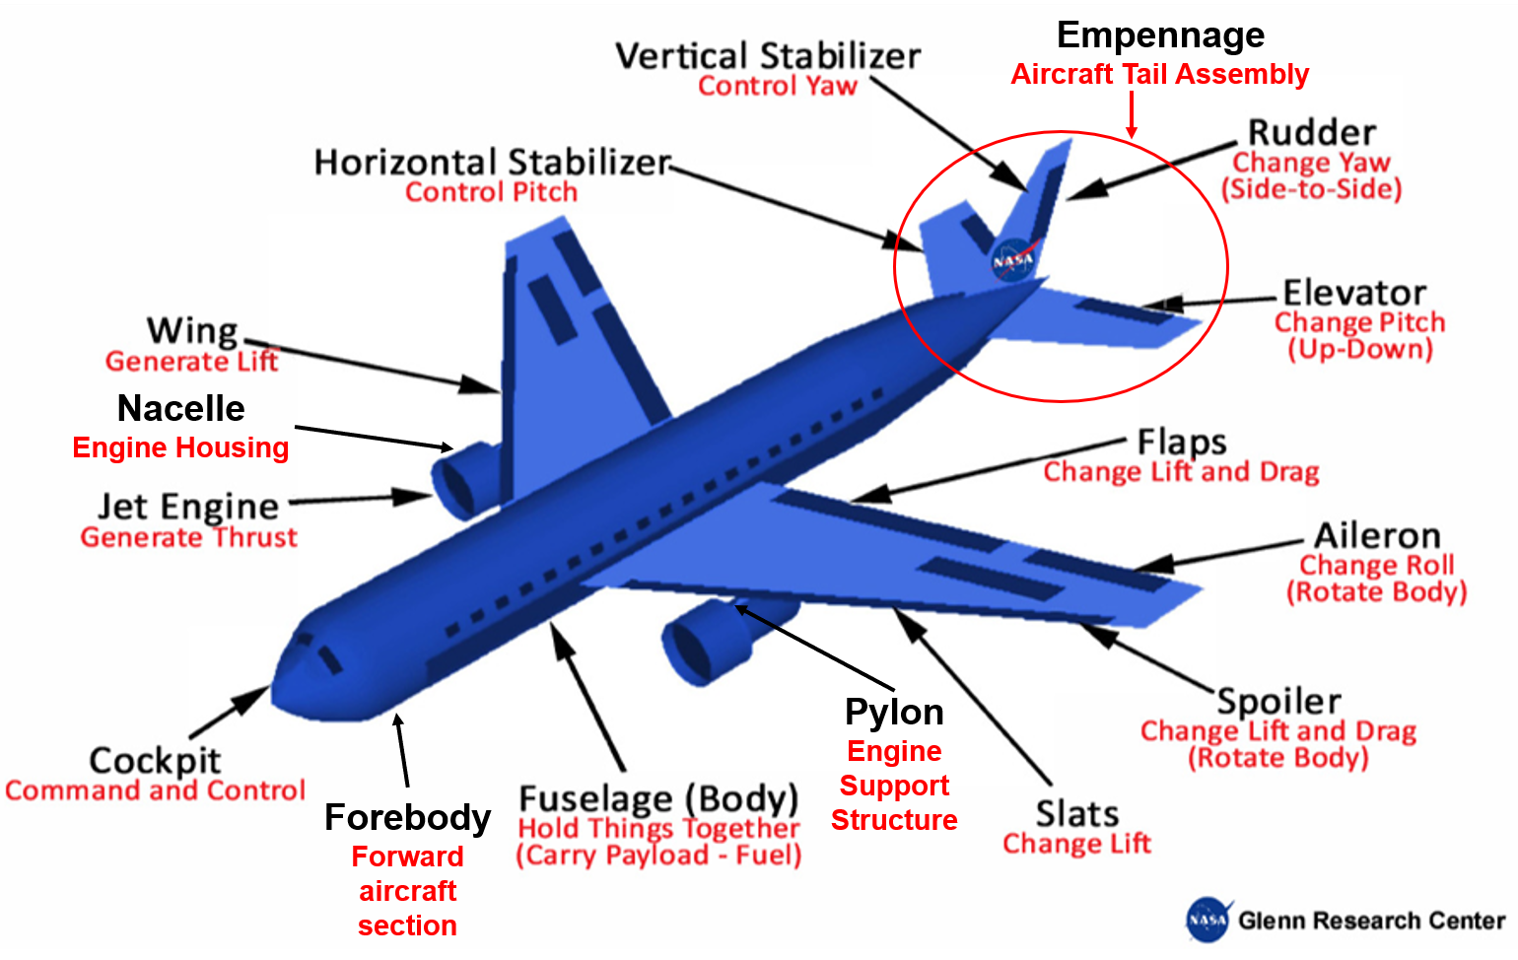
Figure 2 - Aircraft components (adapted from NASA Glenn Research Center, 2026).
Practical low-boom shaping has progressed from local geometry modification to integrated aircraft design. The F-5E Shaped Sonic Boom Demonstrator, shown in Figure 3, used a modified forebody to alter the shock-wave pattern and demonstrated this approach in atmospheric flight in 2003 (Pawlowski et al., 2005).

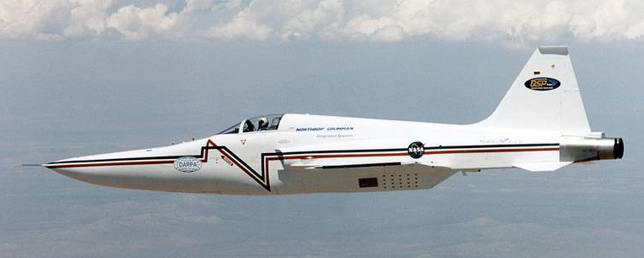
Figure 3 - F-5E Shaped Sonic Boom Demonstrator and modified forebody (NASA, 2009)

NASA’s X-59, seen in Figure 4, extends this approach through integrated shaping of the forebody, wing, engine installation and control surfaces around a target low-boom signature (Durston et al., 2023; NASA, 2026).

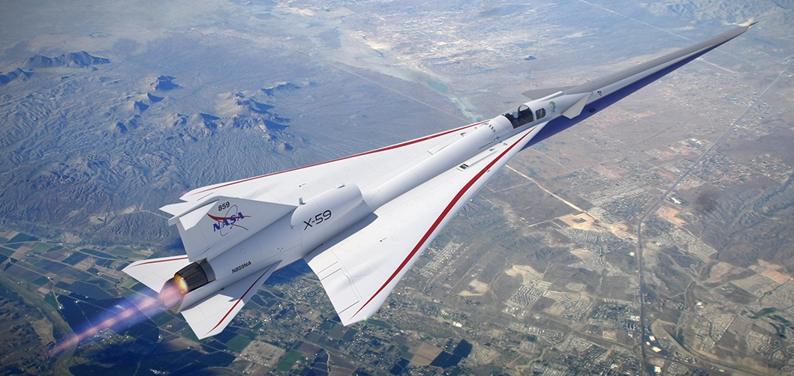
Figure 4 - NASA X-59 integrated low-boom configuration (NASA, 2025).

1.2 Research question, aim and objectives

The research question is: how can aircraft geometry be shaped to reduce sonic boom intensity during civil supersonic flight while remaining credible within practical aircraft-design constraints?
The aim is to evaluate geometry-led sonic boom reduction strategies and convert the strongest evidence into concept-stage design guidance for low-boom supersonic aircraft.
The objectives are to:
- explain the aerodynamic mechanisms linking supersonic geometry, near-field pressure signatures and ground-level boom;
- review the main research methods and metrics used to evaluate boom reduction;
- synthesize evidence on nose and forebody shaping, fuselage and equivalent-area distribution, wing geometry and secondary configuration features;
- compare evidence strength and limitations across theory, CFD, optimisation, wind-tunnel and human-response work;
- produce evidence-weighted design implications, limitations and further-work recommendations.

1.3 Scope and contribution

This dissertation focuses on geometry-led source shaping for civil supersonic aircraft, including nose and forebody design, fuselage and equivalent-area distribution, wing geometry, lift distribution and selected secondary surfaces. Atmospheric propagation, certification-level sonic-boom prediction, detailed structural design, cost modelling and high-fidelity CFD are outside the project scope, although their implications are considered when assessing the transferability and feasibility of the reviewed designs.
The project contributes an evidence-weighted framework that compares geometry strategies according to their likely sonic boom benefit, the strength of the supporting evidence and their practical aircraft-design constraints.

1.4 Timing plan and risk control

Figure 5 summarises the project activities, dates and status. The full planned-versus-actual Gantt chart is provided in Appendix A in Figures 9 and 10, and shows the delayed interim viva, the literature-led scope revision and the outstanding report submission and final viva. The principal variations from the original plan are summarised in Table 1, while the associated project risks and controls are presented in Table 2.

Figure 5 - Project timing plan: activity details, dates and status

Table 1 - Principal variations from the original project plan

Table 2 - Project risk controls

1.5 Dissertation structure

Chapter 2 outlines the methodology; Chapter 3 provides technical background; Chapter 4 evaluates methods and metrics; Chapter 5 synthesises geometry evidence; Chapter 6 develops the framework; Chapter 7 evaluates it; Chapter 8 discusses findings and limitations; and Chapter 9 presents conclusions and further work.

2 Research Methodology

2.1 Research design

This project used a structured evidence review methodology. This approach was appropriate because sonic boom reduction has been investigated through decades of theoretical, computational, experimental and human-response research (Maglieri et al., 2014; Han et al., 2024). In contrast, full CFD analysis, wind-tunnel testing and atmospheric propagation modelling are beyond the practical scope of this project. The project therefore evaluated and synthesised existing evidence rather than attempting to generate new, certification-level aerodynamic data.
The methodology was designed to answer three practical questions: which geometry-based design approaches have the strongest evidence, under what conditions are the findings applicable, and what aircraft-design penalties may accompany them? This focus avoids producing a descriptive history of supersonic aircraft and instead supports evidence-based engineering judgement.

2.2 Search strategy and source selection

The literature search was organised around four main themes: sonic boom physics, low-boom aircraft design, geometry and equivalent-area distribution, and methods used to evaluate boom reduction. The four themes were chosen to follow the same progression as the research question, from understanding how sonic boom is generated to identifying which geometry changes are most useful in practice. Sonic-boom physics provides the basis for understanding the pressure signature, while geometry and equivalent-area research identify the main design features that can influence it. Low-boom aircraft studies then show how these principles are applied to complete configurations, and the final theme considers the methods used to judge how reliable and transferable the reported improvements are. This structure allowed literature to be compared in a way that links aerodynamic theory with practical aircraft design.
The main databases and repositories searched were NASA NTRS, AIAA Aerospace Research Central, ScienceDirect, SAE Mobilus, Google Scholar and the university library catalogue. Priority was given to peer-reviewed journal articles, AIAA conference papers, NASA technical reports, recognised textbooks and official regulatory publications. Recent review papers were used to identify current research directions, while older seminal studies were retained where they provided the theoretical basis for sonic boom prediction and minimisation.
Representative search terms are shown in Table 3. Sources were first screened by title and abstract before the full text was reviewed for relevance. Reference lists from relevant studies were also examined to identify additional foundational or frequently cited work. The selected sources were then organised by theme to support consistent comparison and evidence extraction.

Table 3 - Search strategy and purpose

2.3 Inclusion, exclusion and quality appraisal

Studies were included where they examined links between aircraft geometry, equivalent-area distribution, pressure-signature development, sonic boom metrics or human response in civil or transport-relevant supersonic aircraft. Priority was given to sources that clearly defined the aircraft configuration, operating conditions, research method and assessment metric. Studies focused on hypersonic vehicles, launch vehicles, unrelated acoustic effects or military applications with limited relevance to civil transport were excluded. Industry webpages were used only for contextual information, such as programme status, and not as primary technical evidence.
The quality of each source was assessed against five criteria: transparency of the method, definition of the geometry and operating conditions, clarity of the sonic boom metric, consideration of aerodynamic or practical trade-offs, and relevance to civil supersonic aircraft. Greater weight was given to peer-reviewed studies, validated numerical methods and recognised technical reports. This appraisal was used to judge the reliability of each individual source before its findings were included in the wider evidence synthesis.

2.4 Data extraction and synthesis

For each core source, the extracted fields were geometry lever, aircraft or model type, Mach number or flight condition; where available, method, metric, reported trend direction, performance trade-off, limitation and relevance to this dissertation. The evidence was then grouped by geometry lever rather than by date. This thematic approach enabled comparison of mechanisms and trade-offs across studies.
Where studies reported different outcomes, the differences were examined in relation to method fidelity, flight condition, aircraft scale, loading, trim state and metric choice. This is important because low-boom design is sensitive to changes in geometry and loading, and because different studies do not always measure the same outcome (Park and Nemec, 2019; Rallabhandi and Loubeau, 2019; Han et al., 2024).
Seven core applied studies were purposively selected for direct cross-study comparison because they reported sufficient detail on geometry, operating conditions, method, metric, outcome and limitations. They therefore represent a comparison subset rather than the full literature base, reducing the risk of misleading comparisons between incompatible configurations or metrics. Together, they covered experimental body shaping, transport-scale design, CFD optimisation, wing and lift-distribution studies, and X-59 wind-tunnel testing. Their results were compared in Chapter 5 to identify repeated geometry trends and assess how transferable the findings were, rather than relying on individual reported improvements. Five of the seven studies were then carried forward into the published-case evaluation in Chapter 7 because, together, they represented different stages of low-boom evidence and allowed the framework to be checked across different aircraft configurations and research methods.

2.5 Evidence-confidence framework

While Section 2.3 assessed the reliability of individual sources, the evidence-confidence framework, shown in Table 4, assessed the strength of each overall geometry-related finding. Confidence was based on source quality, agreement between different research methods and the relevance of the findings to civil supersonic aircraft.

Table 4 - Evidence-confidence framework

Where studies disagreed, differences in flight conditions, aircraft scale, metric choice and modelling method were considered. Findings were therefore weighted according to evidence quality, convergence and transferability rather than the number of sources alone.
The clearest apparent disagreement was in the wing-geometry evidence. Jim et al. (2021) identified a trade-off between aerodynamic efficiency and low-boom planform shaping, whereas Kishi, Yashiro and Kanazaki (2023) reported a 2.41 PLdB (perceived loudness level) reduction after changes to wing geometry and lift distribution. Rather than treating these findings as directly contradictory, differences in aircraft configuration, modelling assumptions and trim were considered, and the wing evidence was therefore graded as medium confidence. This comparison is discussed in more detail in Section 8.2.1.

2.6 Methodological limitations and validity controls

The main limitation of the methodology is its reliance on previously published evidence. The reliability of the findings therefore depends on the quality, transparency and relevance of the original studies. This was addressed by prioritising traceable technical sources and recording the method, geometry, operating conditions, metric and limitations of each study before making comparisons.
A further limitation is that the reviewed studies did not all assess sonic boom in the same way. Near-field pressure, peak overpressure, rise time and perceived loudness describe different stages or features of the sonic boom response and cannot be compared directly (Leatherwood et al., 2002; Rallabhandi and Loubeau, 2019; Loubeau and Page, 2018). To reduce the risk of misleading comparisons, each reported result was interpreted using the metric and assessment stage used by the original study.
The findings were also sensitive to operating conditions and aircraft configuration. Mach number, altitude, scale, loading, trim and atmospheric conditions can all influence the pressure signature (Leal et al., 2021; Han et al., 2024). Results were therefore treated as conditional where the evidence was limited to a particular configuration or flight condition.
Validity was strengthened by using consistent extraction criteria, considering differences between studies before comparing their findings and separating source-signature evidence from claims about ground-level acceptability. Agreement across different evidence types was used to strengthen findings, while isolated or highly condition-specific results were treated more cautiously. The published-case evaluation was also clearly separated from physical validation, preventing agreement with existing studies from being presented as proof of predictive accuracy.

3 Background and Design Context

3.1 Supersonic compressible flow and shock formation

Supersonic flow occurs when an aircraft’s speed exceeds the local speed of sound, meaning the Mach number is greater than one (Anderson, 2021). At these speeds, pressure disturbances cannot propagate upstream, so compression waves can develop into shocks, across which pressure, density, temperature and flow direction change abruptly; expansion waves form where the flow turns away from a surface (Anderson, 2021). These compression and expansion processes govern the pressure field around the aircraft and the near-field signature from which sonic boom develops (Maglieri et al., 2014; Bonavolontà, Lawson and Riaz, 2023).
For sonic boom, the important issue is not merely that shocks exist, it is how shocks form, interact and coalesce as disturbances propagate away from the aircraft (Plotkin, 2002; Maglieri et al., 2014). Abrupt geometric changes create concentrated pressure disturbances, while smoother variations distribute compression over a longer length (Seebass and George, 1972; Darden, 1975). For example, a rapid increase in fuselage cross-sectional area or a sharp change in surface curvature can produce a concentrated compression (Seebass and George, 1972; Carlson, Mack and Morris, 1965). Low-boom geometry therefore does not eliminate supersonic shocks; it attempts to control their spacing, strength and evolution so that the ground signature becomes less sudden and intense (Seebass and George, 1972; Plotkin, 2002; Maglieri et al., 2014).
Although Seebass and George (1972) and Plotkin (2002) are older sources, they are retained because they establish fundamental sonic-boom principles that remain relevant to modern low-boom design. However, practical application lagged behind the theory because complete aircraft designs required geometry, lift, trim and other constraints to be considered together. Specialised sonic-boom shaping was not demonstrated in atmospheric flight until 2003 (Pawlowski et al., 2005), while advances in CFD and multidisciplinary optimisation have since made integrated low-boom design increasingly practical (Han et al., 2024).

3.2 Near-field signature, propagation and boom metrics

The near-field pressure signature is the pressure disturbance measured or computed relatively close to the aircraft (Plotkin, 2002; Park and Nemec, 2019). It is strongly influenced by aircraft geometry and loading (Park and Nemec, 2019; Han et al., 2024). The ground signature is produced after this disturbance has propagated through the atmosphere, where nonlinear steepening, absorption, wind, temperature gradients, humidity and turbulence can alter the waveform (Rallabhandi and Loubeau, 2019; Leal et al., 2021). A near-field improvement is therefore necessary but not sufficient evidence of lower perceived ground noise (Rallabhandi and Loubeau, 2019; Loubeau and Page, 2018).
Several metrics are used throughout literature to assess sonic boom (Leatherwood et al., 2002; Loubeau and Page, 2018). Peak overpressure is simple and physically meaningful, but it does not fully represent perceived loudness (Leatherwood et al., 2002; Loubeau and Page, 2018). Rise time, impulse, duration and loudness-based measures, such as perceived level, are also important because human response depends on waveform shape as well as pressure magnitude (Leatherwood and Sullivan, 1992; Leatherwood et al., 2002). NASA human-response studies found that shaped signatures could be perceived differently from conventional N-waves even when simple pressure metrics were similar (Leatherwood and Sullivan, 1992; Leatherwood et al., 2002; Loubeau and Page, 2018).
Representative peak ground-overpressure values for several historical supersonic aircraft are shown in Table 5 (Brandon, 2024). The values illustrate the range of conventional sonic-boom pressures reported across different aircraft and operating conditions. Peak ground overpressure is the maximum pressure rise above ambient pressure in the ground-level boom signature; a lower value therefore indicates a smaller pressure disturbance, although peak overpressure alone does not fully represent perceived loudness (Leatherwood et al., 2002; Loubeau and Page, 2018).

Table 5 - Representative sonic-boom overpressure values (adapted from Brandon, 2024).
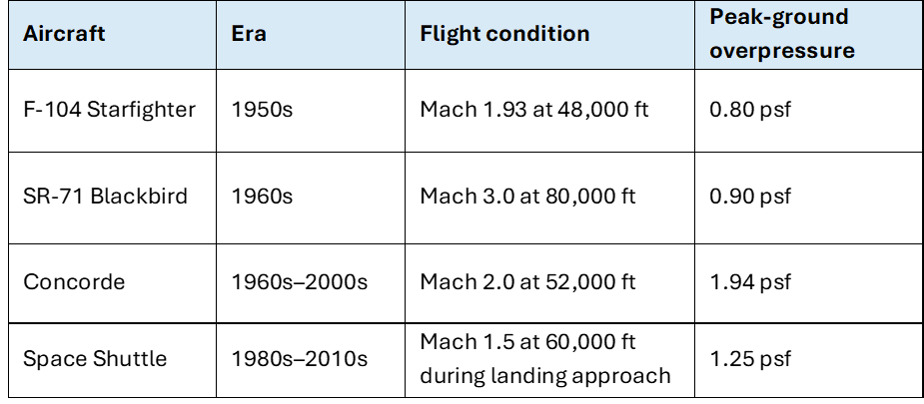

These values should not be interpreted as a direct ranking of aircraft geometry because peak overpressure is also affected by Mach number, altitude and operating condition. Modern low-boom aircraft therefore increasingly consider the complete pressure signature and perceived loudness rather than peak overpressure alone. NASA’s X-59 design target is approximately 75 PLdB at ground level (Brandon, 2024).

3.3 Geometry-signature coupling and equivalent area

Classical sonic boom theory links the pressure disturbance produced by a slender supersonic aircraft to how its volume and lift are distributed along its length (Whitham, 1952; Seebass and George, 1972). This is known as the equivalent-area distribution, as it combines the effects of the aircraft’s cross-sectional area and aerodynamic lift (Seebass and George, 1972; Darden, 1975). When this distribution changes gradually, pressure disturbances are spread more evenly (Seebass and George, 1972; Darden, 1975). In contrast, sudden increases or discontinuities can create stronger shock waves (Whitham, 1952; Seebass and George, 1972; Darden, 1975).
This principle is related to, but not identical with, the area-rule approach used to reduce wave drag (Raymer, 2018; Han et al., 2024). A geometry that varies smoothly along the body axis can reduce both wave drag and boom severity, but the optimum for drag is not automatically the optimum for boom (Carlson, Barger and Mack, 1973; Han et al., 2024). Low-boom design therefore requires a multi-objective approach: the geometry must manage pressure signatures while preserving acceptable lift, drag, stability and packaging characteristics (Carlson, Barger and Mack, 1973; Raymer, 2018; Han et al., 2024).

3.4 First-order aircraft design constraints

Sonic boom reduction cannot be treated as an isolated acoustic objective, as each geometry change can create wider aircraft design trade-offs (Carlson, Barger and Mack, 1973; Ding et al., 2023). For example, a longer and narrower forebody can soften the initial compression, but it may also increase structural weight, bending loads and systems-integration complexity (Carlson, Barger and Mack, 1973; Raymer, 2018). Similarly, a smoother fuselage distribution can improve equivalent-area behaviour, although this must be balanced against the need for cabin space, fuel capacity, landing gear, environmental systems and a practical, maintainable structure (Carlson, Barger and Mack, 1973; Li and Geiselhart, 2022; Raymer, 2018). Thin or highly swept wings may also reduce certain shock features, but they can limit structural depth, complicate fuel storage and affect low-speed lift performance (Raymer, 2018; Jim et al., 2021).
Low-boom aircraft design is therefore best understood as a trade-off between acoustic performance and overall aircraft feasibility. Geometry must be selected for specific operating conditions, particularly Mach number, altitude, aerodynamic loading and trim (Leal et al., 2021; Han et al., 2024). A design rule that is effective for a demonstrator aircraft may not transfer directly to a passenger transport, business jet or aircraft operating at a different cruise Mach number (Li and Geiselhart, 2022). For this reason, the design guidance developed in this dissertation is treated as conditional rather than universally applicable.

3.5 Regulatory and environmental context

Regulation is a major reason why low-boom geometry must be considered during aircraft design (Federal Aviation Administration, 2026a; Civil Aviation Authority, 2024; ICAO, 2025). Conventional supersonic flight over populated areas caused significant disturbance because the ground-level boom was sudden and intrusive (Maglieri et al., 2014; Loubeau and Page, 2018). Current standards development therefore focuses on whether future aircraft can produce noise levels that are acceptable, measurable and repeatable, rather than simply whether they can fly efficiently at supersonic speed (Civil Aviation Authority, 2024; ICAO, 2025).
For example, current United States regulation 14 CFR §91.817 restricts civil supersonic flight where a sonic boom may reach the surface unless specifically authorised (Federal Aviation Administration, 2026b). Internationally, ICAO Annex 16 establishes environmental standards for aircraft noise and engine emissions, while specific en-route sonic-boom certification procedures for future supersonic aircraft remain under development (ICAO, 2017; ICAO, 2023; ICAO, 2025).
The wider environmental impact must also be considered. A geometry that reduces sonic boom may still be unsuitable if it increases fuel consumption, emissions or airport noise (ICAO, 2024; Han et al., 2024). International Civil Aviation Organization (ICAO) has therefore highlighted the need to consider noise, emissions, ozone effects and wider climate impacts alongside renewed interest in civil supersonic aircraft (ICAO, 2024). Although this dissertation focuses on sonic boom, low-boom geometry would ultimately need to be assessed as part of the aircraft’s overall environmental and mission performance. In this context, mission requirements refer to the aircraft’s intended operating targets, including speed, range and passenger capacity.
This also supports considering sonic boom early in the design process. If boom reduction is delayed, key features such as aircraft volume, lift distribution, engine position and structural layout may already be fixed, reducing the scope for effective pressure-signature shaping (Wintzer, Ordaz and Fenbert, 2015; Han et al., 2024). Low-boom requirements should therefore influence early decisions concerning nose length, fuselage shape and wing placement (Bonavolontà, Lawson and Riaz, 2023).
The wider aircraft-development process is illustrated in Figure 6. This shows why low-boom requirements are most effectively considered during conceptual and preliminary design, before the aerodynamic shape and wider aircraft configuration become progressively fixed.

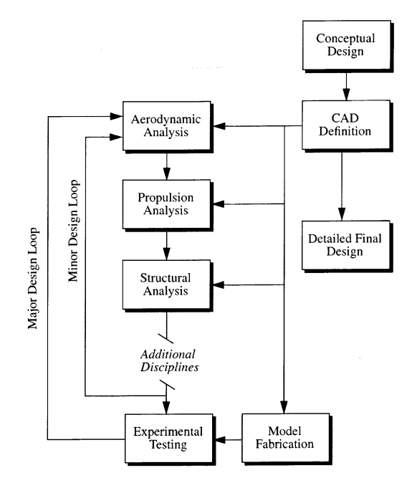
Figure 6 - Aircraft design process showing the interaction (Reed, Follen and Afjeh, 2000).

Modern CFD and optimisation tools fit primarily within the aerodynamic-analysis stage of Figure 6, while also supporting multidisciplinary trade-offs with structural, propulsion and overall aircraft-design requirements (Han et al., 2024).

3.6 Background synthesis

Low-boom geometry must be assessed as an integrated aircraft-level problem, with source-signature improvements subsequently evaluated through propagation, human-response and practical design constraints (Rallabhandi and Loubeau, 2019; Han et al., 2024).

4 Evidence Base: Methods, Metrics and Biases

4.1 Theoretical minimisation evidence

Theoretical minimisation studies provide the clearest explanation of how aircraft geometry affects sonic boom. Whitham’s slender-body theory showed that changes in an aircraft’s shape and lift distribution could be represented mathematically to predict how pressure disturbances develop around the aircraft (Whitham, 1952). Seebass and George then showed that sonic boom could be reduced by controlling the aircraft’s overall equivalent-area distribution rather than focusing on a single shock (Seebass and George, 1972). Carlson, Barger and Mack applied these principles to conceptual designs for a large supersonic transport, considering aerodynamic performance, weight, balance and mission requirements alongside boom reduction (Carlson, Barger and Mack, 1973). Darden later extended the theory to account for atmospheric effects, making it more relevant to practical aircraft studies (Darden, 1975).
At the time these early minimisation methods were developed, CFD was not advanced enough to model complete aircraft configurations at the level possible today. Researchers therefore relied mainly on analytical and simplified prediction methods, which were appropriate for the capability available at the time. As numerical methods and computing capability developed, CFD became increasingly practical for analysing more complex aircraft geometries and the interaction between different parts of the configuration (Hirsch, 2007; Han et al., 2024).
Although this evidence provides a strong explanation of the underlying mechanisms, the early theoretical methods still simplify aircraft geometry and flow behaviour (Plotkin, 2002). They cannot independently define the final shape of a transport aircraft with inlets, tail surfaces, structural requirements, trim and off-design operating conditions. The evidence is therefore used in this dissertation to explain why geometry trends occur rather than to prescribe a complete aircraft configuration.

4.2 Computational and optimisation evidence

CFD and optimisation studies are valuable because they can evaluate interacting geometry changes across a controlled design space. Adjoint and inverse-design methods allow designers to target pressure-signature changes and modify the aircraft outer mould line accordingly (Aftosmis, Nemec and Cliff, 2011; Wintzer, Ordaz and Fenbert, 2015). Recent reviews identify efficient low-boom optimisation as an active area, including surrogate models, multi-fidelity methods and integrated aerodynamics/boom trade studies (Bonavolontà, Lawson and Riaz, 2023; Han et al., 2024).
Figure 7 shows the development of CFD capability alongside the development of civil supersonic aircraft. Figure 7(a) shows the progression from potential-flow methods towards Euler and Navier–Stokes modelling as aircraft configurations and the problems being analysed became more complex. Figure 7(b) shows how supersonic transport concepts have developed towards lower sonic-boom loudness levels. These trends should not be taken to mean that advances in CFD alone caused the reduction in sonic-boom loudness, but they show how improved computational methods have allowed increasingly detailed aerodynamic analysis to support low-boom aircraft design.

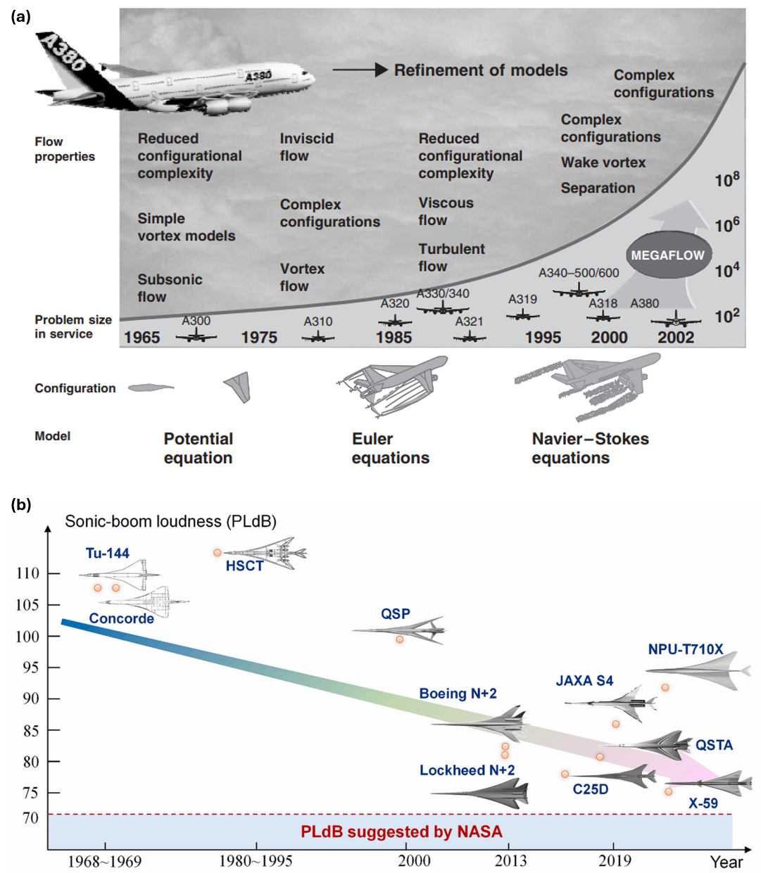
Figure 7 - CFD and supersonic aircraft development (Hirsch, 2007; Han et al., 2024)

However, CFD evidence is not automatically superior to other evidence. Results depend on grid strategy, turbulence modelling, boundary conditions, geometry parameterisation, propagation method and objective function (Park and Nemec, 2019; Rallabhandi and Loubeau, 2019; Han et al., 2024). An improvement in a CFD-generated near-field pressure trace does not necessarily lead to lower perceived noise at ground level, as atmospheric propagation and loudness must also be considered (Rallabhandi and Loubeau, 2019; Leal et al., 2021; Loubeau and Page, 2018). CFD studies are therefore used in this dissertation to explain physical mechanisms and identify the direction of geometry effects, rather than treating isolated numerical improvements as universal design rules.

4.3 Experimental and human-response evidence

Wind-tunnel tests add experimental evidence because they measure pressure fields around representative models (Durston et al., 2023). The X-59 wind-tunnel campaign used a 1.62% scale model and a pressure rail with 420 orifices to collect near-field pressure signatures (Durston et al., 2023). The wind-tunnel measurements provide experimental evidence of whether the expected pressure-signature behaviour occurs under controlled conditions (Durston et al., 2023).
The limitation is that wind-tunnel testing is still not the same as full-scale community exposure (Durston et al., 2023; Loubeau and Page, 2018). Scale effects, support interference, rail effects and limited atmospheric propagation mean that wind-tunnel evidence is strongest for source-signature behaviour (Durston et al., 2023). Human-response and community studies remain essential for linking shaped signatures to perceived acceptability (Leatherwood et al., 2002; Loubeau and Page, 2018).

4.4 Method bias and comparability

Table 6 summarises the main strengths and limitations of the evidence types used in this dissertation, highlighting why findings from different methods cannot be treated as directly equivalent. Results were compared cautiously because differences in method, scale, flight condition and metric can change the apparent benefit of a geometry modification (Park and Nemec, 2019; Rallabhandi and Loubeau, 2019). Greater confidence was placed in trends supported across theoretical, computational and experimental evidence.

Table 6 - Evidence types, strengths and limitations
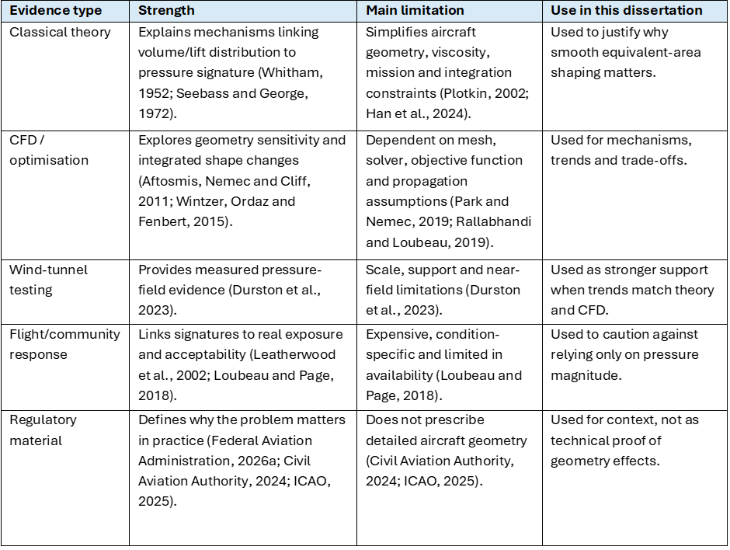

4.5 Consequences of metric choice

Metric choice changes the apparent value of a geometry change (Leatherwood et al., 2002; Rallabhandi and Loubeau, 2019). A design that reduces peak overpressure may still have a steep rise time, and a design that improves a near-field pressure trace may not produce the same improvement after atmospheric propagation (Leatherwood and Sullivan, 1992; Rallabhandi and Loubeau, 2019). Pressure-based metrics and loudness-based metrics should therefore not be treated as interchangeable (Leatherwood et al., 2002; Loubeau and Page, 2018). Peak overpressure is useful for explaining shock strength, but perceived level and related loudness metrics are more relevant when the final question is community response (Leatherwood et al., 2002).
This distinction affects source evaluation. A study that reports only a near-field pressure improvement is valuable for geometry-source understanding, but it does not prove acceptability (Rallabhandi and Loubeau, 2019; Loubeau and Page, 2018). A study that propagates the signature and reports loudness has greater relevance to public response but may give less direct insight into which geometry caused the change (Rallabhandi and Loubeau, 2019). The review therefore separates source mechanisms from final acoustic outcomes and avoids treating all reductions as if they were measured at the same stage of the prediction chain.
Percentage improvements also require caution. A reported reduction can appear persuasive but may be misleading if the baseline, Mach number, altitude, aircraft weight, metric or propagation model differs (Park and Nemec, 2019; Rallabhandi and Loubeau, 2019; Han et al., 2024). Numerical findings were therefore interpreted cautiously, with greater weight placed on repeated trends across independent methods than on isolated percentage improvements.
These differences also help explain why a single set of transferable geometry rules has not already been established. Studies have used different aircraft configurations, flight conditions, modelling methods and sonic-boom metrics, meaning that an improvement reported in one study cannot always be applied directly to another aircraft. More recent advances in CFD and optimisation have made complete aircraft-level analysis more practical, but the results still depend on the configuration and assessment method being used (Park and Nemec, 2019; Han et al., 2024). This is why the present study focuses on identifying repeated design trends and their limitations rather than trying to define one optimum aircraft geometry.

4.6 Summary of evidence reliability

Overall, the research provides stronger evidence for how aircraft geometry affects sonic boom than for identifying specific geometric designs that will be effective in every aircraft configuration. Smooth longitudinal source distributions are consistently supported, but aircraft configuration, operating condition, trim and metric choice prevent one geometry from being universally optimal (Seebass and George, 1972; Jim et al., 2021; Han et al., 2024). The resulting guidance is therefore conditional rather than numerical.

5 Literature Synthesis: Geometry Levers

The aircraft components discussed in this chapter are identified in Figure 2.

5.1 Nose and forebody shaping

Nose and forebody shaping are primary geometry levers because they influence the first major compression generated by the aircraft (Seebass and George, 1972; Darden, 1975). A short or rapidly expanding forebody produces a more concentrated pressure rise, whereas gradual area growth spreads the compression over a greater distance (Carlson, Mack and Morris, 1965; Seebass and George, 1972). Wind-tunnel testing of different slender-body shapes confirmed that changes in longitudinal body shape alter the pressure distribution surrounding the aircraft (Carlson, Mack and Morris, 1965). Classical minimisation theory also supports controlling the complete forward area distribution rather than attempting to weaken one shock in isolation (Seebass and George, 1972; Darden, 1975).
Modern low-boom aircraft apply this principle as part of an integrated configuration (Wintzer, Ordaz and Fenbert, 2015; Han et al., 2024). The X-59 does not rely only on an extended nose; its forebody, wing, engine installation and control surfaces are arranged to manage the overall pressure signature (Durston et al., 2023). Wind-tunnel measurements from a 1.62% scale X-59 model provide experimental evidence of its near-field pressure behaviour, although they do not independently demonstrate ground-level community acceptability (Durston et al., 2023; Loubeau and Page, 2018).
The evidence for controlled forebody area growth is therefore assessed as high confidence because the same physical principle is supported by theory, wind-tunnel testing and integrated aircraft studies (Carlson, Mack and Morris, 1965; Seebass and George, 1972; Darden, 1975; Durston et al., 2023). However, a longer forebody can increase structural weight, bending loads, packaging difficulty and visibility constraints (Carlson, Barger and Mack, 1973; Raymer, 2018; Han et al., 2024). The evidence supports gradual forebody shaping as a primary design priority, but not the use of maximum nose length without considering wider aircraft requirements (Carlson, Barger and Mack, 1973; Han et al., 2024).

5.2 Fuselage and equivalent-area distribution

Fuselage shaping affects how pressure disturbances develop after the initial forebody compression (Seebass and George, 1972; Darden, 1975). Equivalent area combines the effects of aircraft volume and aerodynamic lift along the longitudinal axis (Seebass and George, 1972; Darden, 1975). Abrupt changes in either contribution can create pressure disturbances that later merge into stronger shocks, while a smoother total distribution reduces the likelihood of concentrated pressure rises (Seebass and George, 1972; Carlson, Barger and Mack, 1973).
Carlson, Barger and Mack applied sonic-boom minimisation principles to conceptual designs for a 234-passenger transport operating at Mach 2.7 (Carlson, Barger and Mack, 1973). Their analysis considered aerodynamics, weight, balance and mission performance alongside sonic boom (Carlson, Barger and Mack, 1973). This demonstrated that equivalent-area principles could be applied at transport scale but also identified conflicts between favourable low-boom features and established aircraft-design practice (Carlson, Barger and Mack, 1973).
More recent multidisciplinary optimisation has developed this approach further (Li and Geiselhart, 2022; Han et al., 2024). Li and Geiselhart produced a computational low-boom transport concept carrying 40 passengers, with a low-boom cruise condition of Mach 1.7 (Li and Geiselhart, 2022). The resulting design satisfied mission and trim requirements and produced a predicted ground-noise level below 70 PLdB (Li and Geiselhart, 2022). However, the result remains specific to the selected aircraft, mission assumptions, computational methods and propagation model (Li and Geiselhart, 2022).
Total equivalent-area management is therefore assessed as high-confidence design guidance (Seebass and George, 1972; Carlson, Barger and Mack, 1973; Li and Geiselhart, 2022). The evidence shows that it must include the combined effects of the forebody, fuselage, lift distribution and aft components rather than treating fuselage shape in isolation (Seebass and George, 1972; Li and Geiselhart, 2022; Han et al., 2024). Its practical application is constrained by cabin volume, fuel storage, landing gear, aircraft systems, structure and manufacturing requirements (Carlson, Barger and Mack, 1973; Raymer, 2018; Li and Geiselhart, 2022).

5.3 Wing planform, thickness and lift distribution

Wing geometry affects sonic boom through both its physical volume and the lift it generates (Seebass and George, 1972; Jim et al., 2021). Sweep, thickness, camber, longitudinal position and spanwise loading alter shock formation and the lift-related contribution to equivalent area (Jim et al., 2021; Kishi, Yashiro and Kanazaki, 2023). The wing can therefore improve or weaken the target pressure distribution depending on how it interacts with the fuselage and other lifting surfaces (Jim et al., 2021; Kishi, Yashiro and Kanazaki, 2023).
Jim et al. used Bayesian optimisation to investigate low-boom wing planforms (Jim et al., 2021). Wing planform refers to the shape of the wing when viewed from above, including features such as sweep and taper. Their results identified a trade-off between planforms that used compression lift to improve lift-to-drag performance and those that produced smoother area distributions for sonic-boom reduction (Jim et al., 2021). This supports the view that wing geometry cannot normally be optimised for aerodynamic performance and sonic boom independently (Jim et al., 2021; Han et al., 2024).
Kishi, Yashiro and Kanazaki examined a ten-seat forward-swept-wing configuration fitted with a canard (Kishi, Yashiro and Kanazaki, 2023). A canard is a small lifting surface positioned ahead of the main wing. By changing the wing planform, wing position and lift distribution, the study reported a 2.41 PLdB reduction compared with the configuration without the canard (Kishi, Yashiro and Kanazaki, 2023). However, the analysis excluded the engine nacelle, used a fixed canard mounting angle and identified trim as an area requiring further investigation (Kishi, Yashiro and Kanazaki, 2023). The result therefore provides relevant evidence of the mechanism, but it should not be treated as proof that canards or forward-swept wings will reduce sonic boom in every configuration (Kishi, Yashiro and Kanazaki, 2023; Han et al., 2024).
Wing geometry is assessed as a medium-confidence lever (Jim et al., 2021; Kishi, Yashiro and Kanazaki, 2023). Its influence is supported by credible computational studies, but the outcome remains highly dependent on aircraft configuration, loading, trim and flight conditions (Jim et al., 2021; Kishi, Yashiro and Kanazaki, 2023). Wing modifications can also affect structural depth, fuel capacity, low-speed lift, aeroelastic behaviour and drag (Raymer, 2018; Jim et al., 2021; Han et al., 2024). The wing is therefore most credible as a supporting optimisation lever within an integrated equivalent-area strategy (Han et al., 2024).

5.4 Empennage, control surfaces, inlets and secondary devices

Tail surfaces, control-surface deflections, engine installations and pylons can alter the aft pressure signature and the aircraft’s lift distribution (Wintzer, Ordaz and Fenbert, 2015; Durston et al., 2023). Durston et al. tested the X-59 using alternative flap, aileron, stabilator and T-tail deflections (Durston et al., 2023). This showed that low-boom assessment must consider changes in control settings rather than evaluating only the clean nominal configuration (Durston et al., 2023).
Wintzer, Ordaz and Fenbert also incorporated cruise trim into the optimisation of a Mach 1.6 low-boom demonstrator (Wintzer, Ordaz and Fenbert, 2015). Their work shows that pressure-signature shaping cannot be separated from the control forces and aircraft loading required to maintain trimmed flight (Wintzer, Ordaz and Fenbert, 2015). Changes to the wing or forebody may require compensating tail or control-surface changes that alter the aft pressure signature (Wintzer, Ordaz and Fenbert, 2015; Durston et al., 2023).
The reviewed evidence did not provide comparable support for small local devices, including vortex generators, as primary sonic-boom controls (Bonavolontà, Lawson and Riaz, 2023; Han et al., 2024). These devices are therefore classified as low-confidence configuration refinements rather than core geometry levers. Any local pressure benefit would also need to be assessed against drag, maintenance and off-design performance (Raymer, 2018; Han et al., 2024).

5.5 Comparative evidence for geometry levers

The reviewed studies do not use a single common aircraft configuration, flight condition or sonic-boom metric (Carlson, Mack and Morris, 1965; Wintzer, Ordaz and Fenbert, 2015; Li and Geiselhart, 2022; Durston et al., 2023). Direct comparison of headline results is therefore limited (Rallabhandi and Loubeau, 2019; Han et al., 2024). However, placing the main studies alongside one another shows how the strength and transferability of a conclusion depend on the method, assessment stage and degree of aircraft integration. Table 7 compares the reported outcomes of the key studies alongside their configurations, methods and limitations.

5.6 Cross-lever interactions and conditionality

The geometry levers are strongly coupled (Wintzer, Ordaz and Fenbert, 2015; Li and Geiselhart, 2022; Han et al., 2024). A forebody change alters the first compression but can also affect aircraft length, mass distribution and the position of downstream disturbances relative to the wing (Wintzer, Ordaz and Fenbert, 2015; Han et al., 2024). Fuselage smoothing may improve the volume-related equivalent area, but this benefit may be weakened if the wing introduces an abrupt lift contribution nearby (Seebass and George, 1972; Jim et al., 2021). Wing changes can then affect trim and require modifications to the tail, control surfaces or engine installation, which alter the aft pressure signature (Wintzer, Ordaz and Fenbert, 2015; Durston et al., 2023).
A local geometry improvement cannot therefore be assumed to improve the complete ground signature (Wintzer, Ordaz and Fenbert, 2015; Han et al., 2024). Its value depends on whether the change remains beneficial after volume, lift, trim and aft-component effects have been combined (Wintzer, Ordaz and Fenbert, 2015; Li and Geiselhart, 2022). The strongest overall conclusion is that control of the complete source distribution is more transferable than any single prescribed nose, fuselage or wing geometry (Seebass and George, 1972; Li and Geiselhart, 2022; Han et al., 2024).
Table 7 - Cross-study comparison of reported outcomes
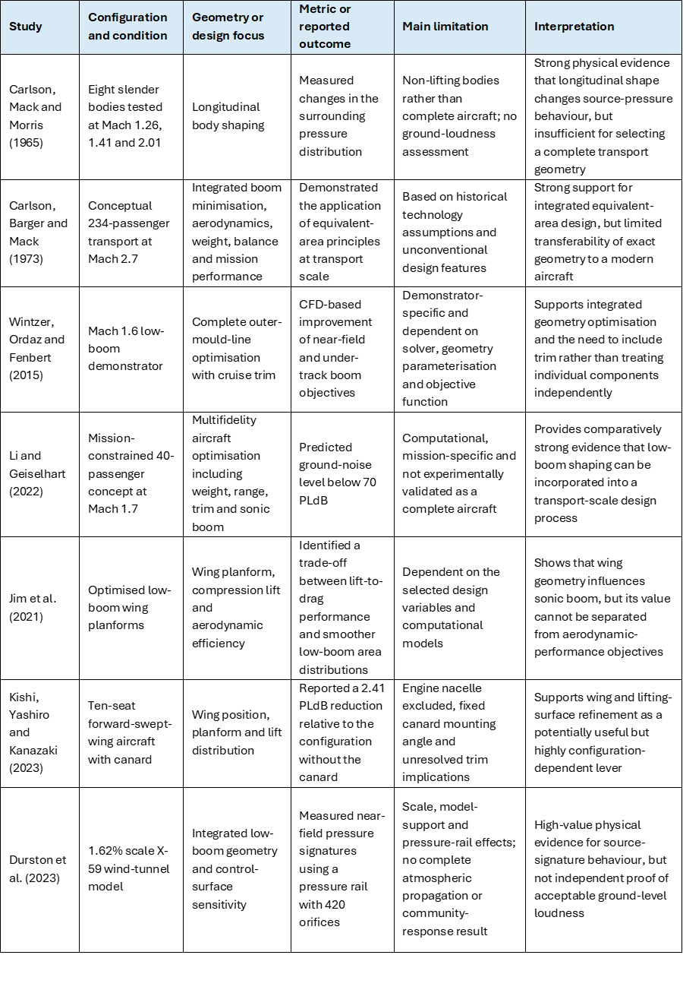

The comparison shows that the strongest agreement exists at the level of physical mechanism rather than fixed geometry. Carlson, Mack and Morris demonstrated experimentally that longitudinal body shape alters the surrounding pressure field, while Carlson, Barger and Mack showed how the same underlying principle could be incorporated into a transport-scale concept (Carlson, Mack and Morris, 1965; Carlson, Barger and Mack, 1973). Wintzer, Ordaz and Fenbert and Li and Geiselhart extended this approach using computational optimisation that included aircraft-level requirements such as trim, weight, range and mission performance (Wintzer, Ordaz and Fenbert, 2015; Li and Geiselhart, 2022). The methods and technologies differ, but the studies converge on the importance of controlling the complete longitudinal volume- and lift-related source distribution (Carlson, Barger and Mack, 1973; Wintzer, Ordaz and Fenbert, 2015; Li and Geiselhart, 2022).
The numerical results are not directly interchangeable. The predicted result below 70 PLdB reported by Li and Geiselhart, for example, is a propagated ground-level loudness result for one computational aircraft and mission (Li and Geiselhart, 2022). The 2.41 PLdB reduction reported by Kishi, Yashiro and Kanazaki is a relative improvement within a different ten-seat configuration (Kishi, Yashiro and Kanazaki, 2023). Durston et al., by contrast, measured near-field pressure rather than propagated perceived loudness (Durston et al., 2023). These values should therefore not be ranked as though they represented identical performance measures (Li and Geiselhart, 2022; Kishi, Yashiro and Kanazaki, 2023; Durston et al., 2023).
The wing studies also illustrate why evidence can appear to differ without being contradictory. Jim et al. identified tension between compression-lift performance and smoother low-boom planforms, while Kishi, Yashiro and Kanazaki obtained a measurable loudness improvement through changes to the canard, wing position and lift distribution (Jim et al., 2021; Kishi, Yashiro and Kanazaki, 2023). The latter result does not establish that canards or forward-swept wings are universally favourable (Kishi, Yashiro and Kanazaki, 2023). Instead, it shows that a wing-related lever can be effective when it corrects the source distribution of a particular aircraft (Kishi, Yashiro and Kanazaki, 2023). The omission of the nacelle and unresolved trim effects reduce the transferability of the exact numerical improvement (Kishi, Yashiro and Kanazaki, 2023).
The comparison therefore supports a distinction between confidence in a mechanism and confidence in a prescribed design. There is high confidence that gradual forebody growth and smooth total equivalent-area development reduce the risk of abrupt source-signature features (Carlson, Mack and Morris, 1965; Seebass and George, 1972; Darden, 1975; Han et al., 2024). There is lower confidence in any universal nose fineness ratio, wing sweep angle or control-surface arrangement (Jim et al., 2021; Kishi, Yashiro and Kanazaki, 2023; Han et al., 2024). Numerical improvements remain dependent on aircraft geometry, Mach number, loading, trim, propagation method and the metric selected (Park and Nemec, 2019; Rallabhandi and Loubeau, 2019; Han et al., 2024).

5.7 Case-study conclusions: Concorde and X-59

Concorde and the X-59 provide contrasting examples of aircraft-level sonic-boom design. Concorde demonstrates that efficient supersonic cruise and a slender configuration do not inherently produce a low-boom signature, whereas the X-59 illustrates an integrated approach in which the configuration is shaped around a target pressure signature (Maglieri et al., 2014; Durston et al., 2023). The transferable lesson is therefore the design process rather than a specific aircraft shape: low-boom performance requires the complete configuration to be considered and subsequently validated through appropriate prediction and testing methods. The full case-study comparison is provided in Appendix D.

6 Comparative Evidence Map and Design Framework

6.1 Evidence-weighted comparison

Design priority was assigned by combining expected source-signature influence, evidence confidence and aircraft-design penalty. The resulting evidence-weighted hierarchy is presented in Table 8.

Table 8 - Comparative evidence-map for geometry-based sonic boom reduction
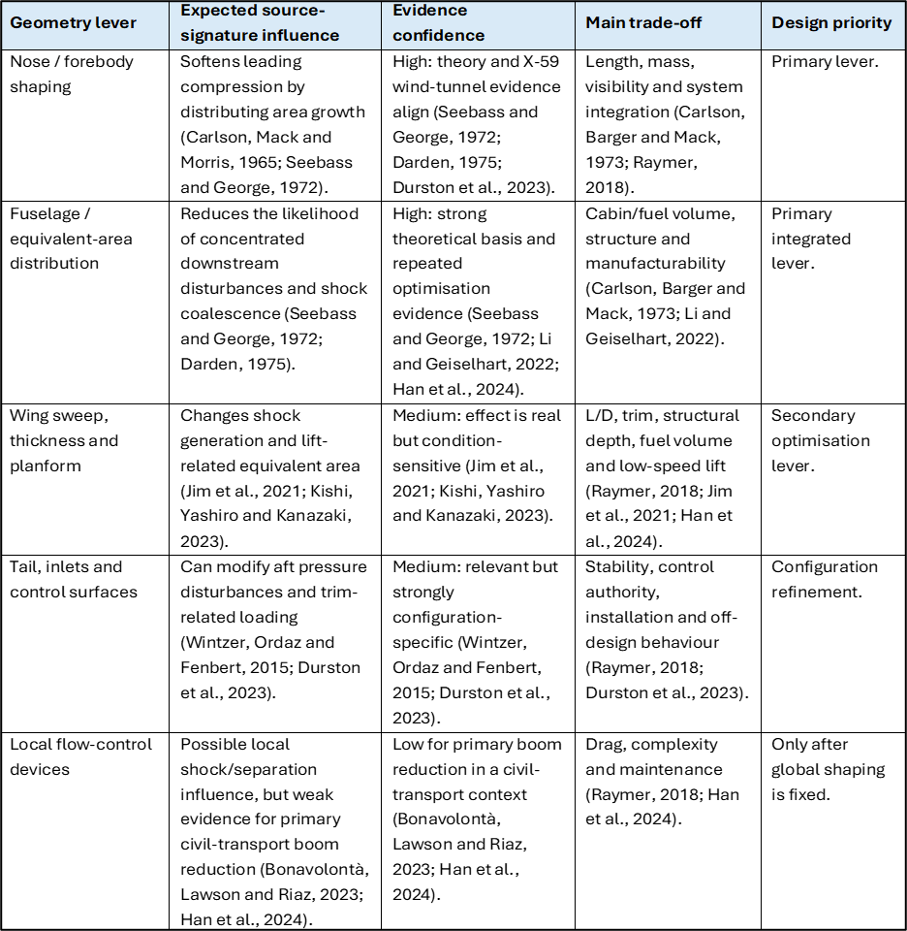

6.2 Practicality overlay

Green indicates generally manageable concept-stage integration; Amber indicates significant but potentially manageable trade-offs; Red indicates that the lever is unsuitable as a primary strategy without stronger evidence or further validation. Table 9 summarises the practicality of each design lever.

Table 9 - Practicality overlay for concept-stage selection
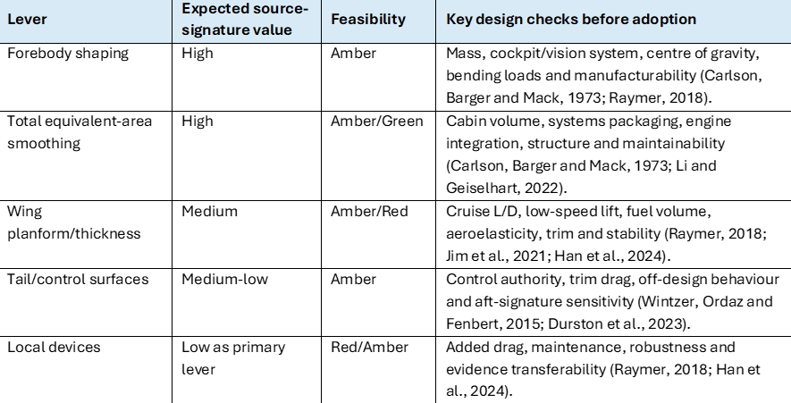

Concept-stage selection should therefore consider boom benefit, evidence confidence and practical integration together, rather than prioritising the largest predicted acoustic improvement in isolation.

6.3 Evidence-weighted design rules

The resulting evidence-weighted design rules are summarised in Table 10.

Table 10 - Evidence-weighted concept-stage design rules
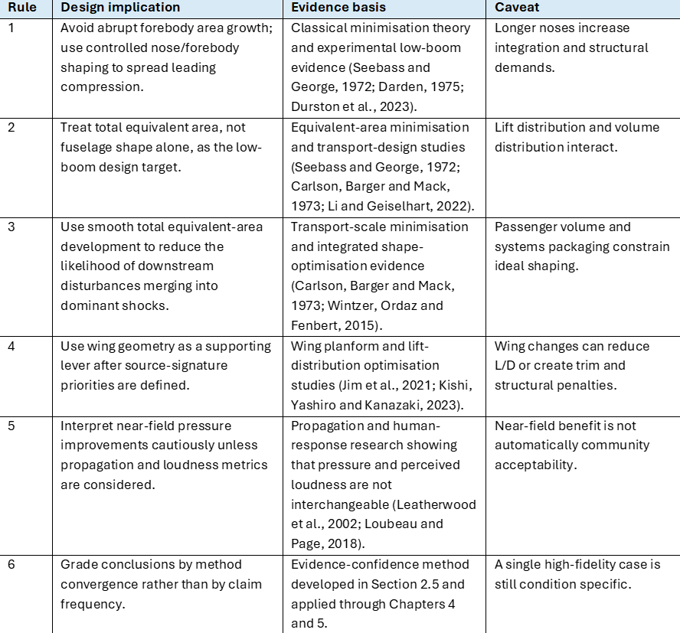

The main geometry features are summarised in Figure 8.
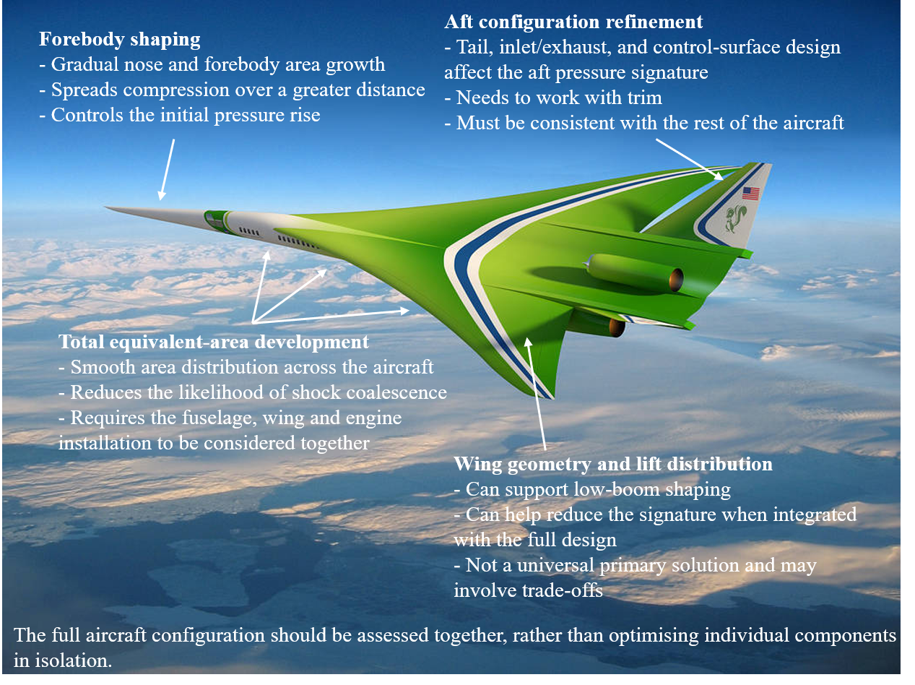
Figure 8 - Low-boom geometry features (author annotations on NASA, 2013).

6.4 Source-to-outcome design chain

The framework distinguishes source-signature behaviour, predicted ground noise and community acceptability because each stage introduces additional assumptions and uncertainty (Park and Nemec, 2019; Rallabhandi and Loubeau, 2019). A near-field geometry improvement therefore cannot demonstrate acceptable overland operation without appropriate propagation, loudness and exposure evidence (Loubeau and Page, 2018).
At concept stage, candidate geometry changes can be screened according to their likely source-signature benefit, evidence confidence and aircraft-design penalty. Changes supported by strong evidence and with manageable design requirements can be selected for further modelling, while those with limited evidence or significant design challenges can be considered at a later stage. The framework therefore helps identify which geometry changes should be investigated further, without claiming to predict their aerodynamic performance.

7 Work Carried Out and Framework Evaluation

7.1 Work carried out

The work carried out comprised structured evidence collection and extraction, development of the evidence-weighted framework, and retrospective evaluation against published aircraft studies.
The main project output is the evidence-weighted concept-stage framework presented in Chapter 6. The framework does not predict pressure or loudness numerically. Instead, it identifies which geometry characteristics should receive priority, how confidently each conclusion can be transferred, and which aircraft-level checks are needed before a concept is developed further. The main practical outputs of the project are summarised in Table 11.

Table 11 - Practical outputs created in the project

7.2 Purpose and method of the published-case evaluation

The evaluation tested whether the framework produced reasonable engineering judgements across published cases spanning different aircraft scales, methods, metrics and levels of integration.
Five cases were selected because they represented different stages of low-boom evidence:

- a transport-scale conceptual design;
- an integrated CFD-based demonstrator optimisation;
- a mission-constrained passenger-aircraft concept;
- a configuration-specific wing and canard investigation; and
- a physical wind-tunnel test of an integrated low-boom demonstrator.

For each study, an expectation was formed using three parts of the framework:

- whether the design controlled the forebody and initial compression;
- whether it considered total equivalent area and integrated aircraft loading;
- whether wing, trim and aft-configuration effects were included rather than treated independently.

Framework expectations were compared with reported outcomes, with agreement judged at the level supported by the evidence; computational consistency was not treated as equivalent to full-scale experimental validation.

7.3 Evaluation against published cases

Table 12 compares the framework expectations with the outcomes reported in the selected published cases.
Table 12 - Evaluation of the framework against published cases
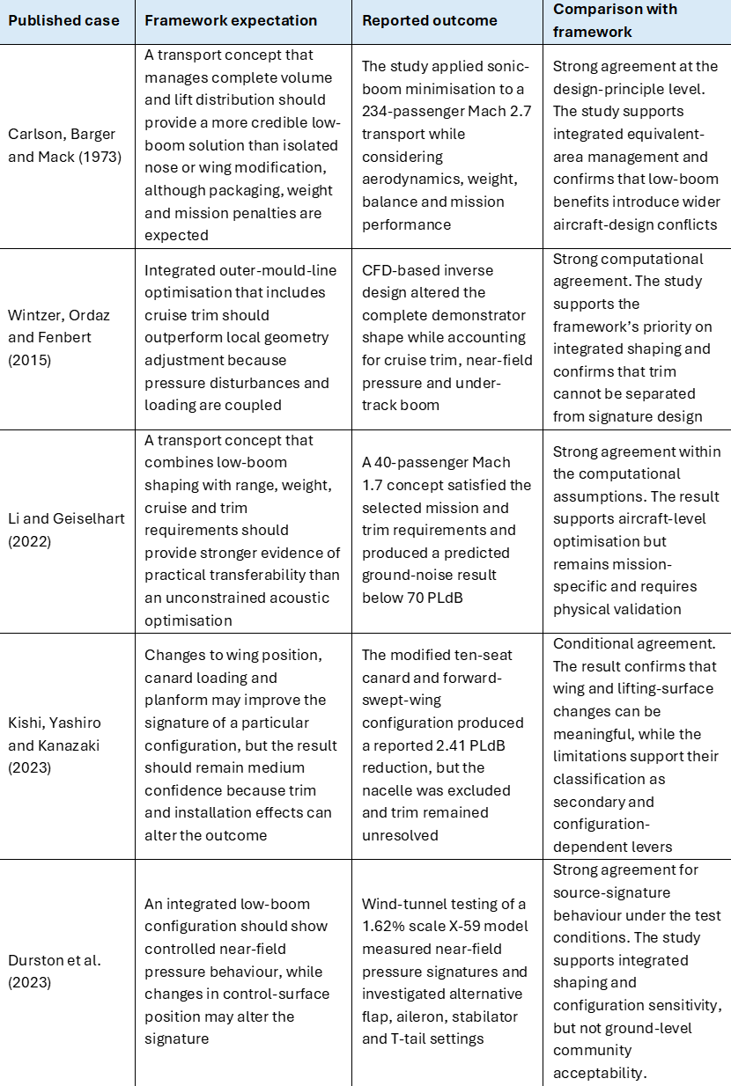

7.4 Results of the framework evaluation

The evaluation produced three main findings. First, the findings from all five cases were consistent with the framework’s emphasis on considering the complete aircraft geometry, rather than individual components in isolation. This supports the importance of managing the overall equivalent-area distribution when designing low-boom aircraft (Carlson, Barger and Mack, 1973; Wintzer, Ordaz and Fenbert, 2015; Li and Geiselhart, 2022).
Second, the cases supported the different confidence levels assigned to primary and secondary levers. Transport and demonstrator studies provided broad support for forebody and total equivalent-area shaping (Carlson, Barger and Mack, 1973; Wintzer, Ordaz and Fenbert, 2015; Li and Geiselhart, 2022). Whereas, the 2.41 PLdB improvement reported by Kishi, Yashiro and Kanazaki remained configuration-specific because nacelle and trim effects were unresolved (Kishi, Yashiro and Kanazaki, 2023). This supports classifying wing geometry as an important supporting lever rather than a universally primary solution.
Third, the evaluation reinforced the distinction between source-signature evidence and final acoustic acceptability. Durston et al. provide physical near-field evidence, while Li and Geiselhart provide later-stage propagated ground-loudness and transport-feasibility evidence; they therefore assess different stages of the source-to-outcome chain and are complementary rather than directly comparable (Durston et al., 2023; Li and Geiselhart, 2022; Rallabhandi and Loubeau, 2019). No selected case contradicted the high-confidence priority given to forebody and total equivalent-area shaping, although the hierarchy may change where a wing, canard, inlet or trim-related disturbance dominates.

7.5 Interpretation and limitations

The published-case evaluation provides an external consistency check rather than independent physical validation. Agreement with the selected published studies provides further support for the framework, but does not establish predictive accuracy, quantify pressure, loudness or aerodynamic changes, or demonstrate transferability to different Mach numbers, altitudes, loading conditions or trim states; publication bias may also favour positive reported outcomes (Fanelli, 2012; Leal et al., 2021; Han et al., 2024).
The evaluation is strongest when distinguishing broad design priorities: integrated source-distribution control receives greater confidence than isolated modification, wing and control-surface results remain conditional, and near-field evidence cannot independently establish ground-level acceptability. It is weaker when comparing two integrated low-boom aircraft because this requires quantitative pressure, propagation, aerodynamic and structural data.
The framework should therefore be used as an early screening and research-prioritisation tool to identify which geometry features warrant detailed investigation and which claims require greater caution.

8 Discussion

8.1 Mechanisms behind the strongest trends

The strongest trend is that gradual longitudinal shaping reduces pressure-signature abruptness (Seebass and George, 1972; Darden, 1975; Han et al., 2024). This is physically credible because a smoother source distribution spreads compression over the aircraft length, reducing the likelihood of abrupt pressure rises and shock coalescence (Seebass and George, 1972; Darden, 1975). Forebody shaping is especially influential because it affects the first compression, while total equivalent-area shaping influences how downstream disturbances develop (Carlson, Mack and Morris, 1965; Seebass and George, 1972). However, simply making the aircraft shape smoother is not enough; the aim is to influence the pressure disturbances that form the near-field signature (Seebass and George, 1972; Darden, 1975; Maglieri et al., 2014).
The second important trend is that low-boom geometry must be integrated (Wintzer, Ordaz and Fenbert, 2015; Li and Geiselhart, 2022; Han et al., 2024). A gradually shaped forebody that reduces the abruptness of the leading compression could still produce an unacceptable signature if the fuselage, wing or tail introduces large downstream disturbances (Seebass and George, 1972; Wintzer, Ordaz and Fenbert, 2015). Conversely, a refined wing cannot fully compensate for a poor forebody if the initial pressure rise is too abrupt (Seebass and George, 1972; Han et al., 2024). This explains why modern approaches use inverse design and optimisation across several geometry variables rather than changing one part in isolation (Wintzer, Ordaz and Fenbert, 2015; Han et al., 2024).

8.2 Cross-study comparison and explanation of apparent differences

8.2.1 Wing geometry and configuration dependence

The reviewed wing studies do not identify one universally favourable planform (Jim et al., 2021; Kishi, Yashiro and Kanazaki, 2023). Jim et al. found that planforms using compression lift could improve aerodynamic efficiency while producing less favourable area distributions for sonic-boom reduction (Jim et al., 2021). Kishi, Yashiro and Kanazaki, in contrast, reported a 2.41 PLdB reduction after modifying the wing planform, wing position and lift distribution of a canard-equipped forward-swept-wing aircraft (Kishi, Yashiro and Kanazaki, 2023).
These findings are not directly contradictory. Jim et al. examined the broader conflict between aerodynamic efficiency and low-boom planform development, whereas Kishi, Yashiro and Kanazaki evaluated a particular aircraft in which the canard and forward-swept wing could redistribute lift and alter the combined equivalent area (Jim et al., 2021; Kishi, Yashiro and Kanazaki, 2023). The Kishi study also excluded the engine nacelle, used a fixed canard mounting angle and did not fully resolve trim (Kishi, Yashiro and Kanazaki, 2023). The reported reduction therefore demonstrates that wing and lifting-surface changes can improve one configuration but does not show that the same geometry would remain favourable once propulsion installation and complete trimmed-flight effects were included (Kishi, Yashiro and Kanazaki, 2023).
Wintzer, Ordaz and Fenbert (2015) also considered cruise trim and changes to the overall aircraft shape when optimising their low-boom demonstrator design. This gives their conclusions greater relevance to integrated source shaping than a study in which wing geometry is modified with some aircraft components omitted (Wintzer, Ordaz and Fenbert, 2015; Kishi, Yashiro and Kanazaki, 2023). The combined evidence supports a medium-confidence judgement: wing geometry has a real influence on sonic boom, but its direction and value depend on how it alters lift distribution, trim and the surrounding aircraft geometry (Jim et al., 2021; Wintzer, Ordaz and Fenbert, 2015; Kishi, Yashiro and Kanazaki, 2023).

8.2.2 Near-field pressure and predicted ground loudness

Durston et al. measured near-field pressure signatures around a 1.62% scale X-59 model (Durston et al., 2023). Li and Geiselhart used computational methods to produce a mission-constrained transport concept with a predicted ground-noise result below 70 PLdB (Li and Geiselhart, 2022). The latter appears more directly connected to community exposure, while the former contains physical measurement rather than only computational prediction (Durston et al., 2023; Li and Geiselhart, 2022).
Neither form of evidence is sufficient alone. The X-59 wind-tunnel test provides stronger experimental confidence that the integrated geometry produces the intended source-pressure behaviour under controlled conditions (Durston et al., 2023). However, it does not include full-scale atmospheric propagation or human exposure (Durston et al., 2023; Loubeau and Page, 2018). The Li and Geiselhart study assesses a later stage of the prediction chain by reporting propagated ground loudness, but the result depends on the accuracy of the aerodynamic, propagation and optimisation models (Li and Geiselhart, 2022; Rallabhandi and Loubeau, 2019).
The studies should therefore be interpreted as complementary. Near-field measurement validates part of the source behaviour, while propagated loudness modelling examines the likely ground-level consequence (Durston et al., 2023; Rallabhandi and Loubeau, 2019). A robust low-boom development programme requires both (Han et al., 2024). Treating the reported results as directly comparable would be misleading because near-field pressure and PLdB represent different physical and assessment stages (Leatherwood et al., 2002; Rallabhandi and Loubeau, 2019).

8.2.3 Demonstrator and passenger-transport evidence

The X-59 and the transport concepts reviewed in this dissertation also answer different engineering questions. X-59 is intended to demonstrate quiet supersonic technology and support community-response research (NASA, 2026). Its long forebody and integrated geometry provide strong evidence of the design-by-signature process, but the aircraft is not required to accommodate a commercial passenger cabin, substantial payload or transport-level fuel volume (NASA, 2026; Li and Geiselhart, 2022).
Carlson, Barger and Mack and Li and Geiselhart provide greater transport-design relevance because they consider passenger capacity, mission performance, weight, balance or range (Carlson, Barger and Mack, 1973; Li and Geiselhart, 2022). However, the Carlson study reflects historical technology and a Mach 2.7 design condition, while the Li and Geiselhart result remains computational and specific to a 40-passenger Mach 1.7 mission (Carlson, Barger and Mack, 1973; Li and Geiselhart, 2022).
The apparent difference between demonstrator and transport studies is therefore a difference in purpose and constraint. X-59 provides stronger evidence that an integrated aircraft can be shaped around a target source signature and physically tested (Durston et al., 2023). Transport studies provide stronger evidence about the compromises introduced by payload, volume, range, trim and structural requirements (Carlson, Barger and Mack, 1973; Li and Geiselhart, 2022). The exact X-59 geometry should not be transferred directly to a passenger aircraft, but its integrated design and validation process remains highly transferable (NASA, 2026; Han et al., 2024).
The combined evidence supports the hierarchy developed in Chapter 6, but it also shows why the hierarchy must remain conditional. Forebody and equivalent-area shaping are the strongest general principles (Seebass and George, 1972; Darden, 1975; Han et al., 2024). Their detailed implementation must change when the aircraft’s payload, propulsion installation, trim, cruise condition and mission requirements change (Li and Geiselhart, 2022; Han et al., 2024).

8.3 Trade-offs and engineering feasibility

The main design conflict is between acoustic source shaping and aircraft practicality (Carlson, Barger and Mack, 1973; Han et al., 2024). Low-boom design tends to reward slenderness and smooth distribution, while commercial transport design requires payload volume, fuel capacity, structural efficiency, maintainability and operability (Carlson, Barger and Mack, 1973; Li and Geiselhart, 2022). Controlled forebody elongation can provide a strong source-signature benefit but may create visibility and mass penalties (Carlson, Barger and Mack, 1973; Raymer, 2018). Fuselage shaping improves equivalent-area behaviour but can conflict with cabin and systems volume (Carlson, Barger and Mack, 1973; Li and Geiselhart, 2022). Wing refinements are constrained by L/D, trim, fuel storage and structural depth (Raymer, 2018; Jim et al., 2021; Han et al., 2024).
This trade-off is why the dissertation avoids absolute recommendations such as 'use the longest possible nose' or 'use the thinnest possible wing'. The better design logic is conditional: prioritise smoother total equivalent-area development and control of the leading compression, then assess how these changes affect the aircraft’s overall performance, including drag, weight and stability (Carlson, Barger and Mack, 1973; Li and Geiselhart, 2022; Han et al., 2024). A geometry change is valuable only if its boom benefit survives the penalties it imposes on performance and feasibility.

8.4 Near-field evidence versus ground-level acceptability

A major source of uncertainty is that much of the geometry evidence concerns near-field pressure signatures (Durston et al., 2023; Han et al., 2024). These data are suitable for evaluating source behaviour, but ground-level loudness and exposure also depend on atmospheric propagation (Rallabhandi and Loubeau, 2019; Leal et al., 2021). Variations in temperature, wind and other atmospheric conditions can modify the waveform and perceived level, while human-response studies show that pressure magnitude alone does not determine acceptability (Leatherwood et al., 2002; Rallabhandi and Loubeau, 2019; Loubeau and Page, 2018; Leal et al., 2021).
A near-field improvement should therefore be described as a source-signature improvement unless propagation and loudness analysis have also been completed (Rallabhandi and Loubeau, 2019; Loubeau and Page, 2018). Geometry-led shaping is necessary for reducing sonic boom at source, but it is not sufficient on its own to demonstrate community acceptability or compliance with a future certification standard (ICAO, 2025; Loubeau and Page, 2018).

8.5 Robustness of the evidence-weighted priorities

The evidence hierarchy is robust when applied to the early design of a conventional civil supersonic aircraft whose pressure signature is influenced by several distributed volume and lift sources (Seebass and George, 1972; Han et al., 2024). Across theory, CFD, optimisation and wind-tunnel evidence, gradual forebody growth and controlled total equivalent-area development repeatedly reduce the likelihood of concentrated pressure disturbances (Carlson, Mack and Morris, 1965; Seebass and George, 1972; Darden, 1975; Durston et al., 2023). This convergence supports their classification as primary design priorities.
However, the hierarchy could change in several aircraft-specific circumstances. The first is where the lift-related contribution from the wing or another lifting surface dominates the equivalent-area distribution (Seebass and George, 1972; Kishi, Yashiro and Kanazaki, 2023). In such a configuration, wing position, planform, camber or canard loading may have a larger effect than a further forebody refinement (Kishi, Yashiro and Kanazaki, 2023). The Kishi, Yashiro and Kanazaki result illustrate this possibility, although its transferability is restricted by the assumptions of the study (Kishi, Yashiro and Kanazaki, 2023).
The second situation is where the engine installation or rear aircraft components produce a significant pressure disturbance (Wintzer, Ordaz and Fenbert, 2015; Han et al., 2024). An inlet, nacelle, pylon, tail surface or control deflection can weaken the benefit of forebody shaping by creating additional pressure disturbances along the middle or rear sections of the aircraft (Wintzer, Ordaz and Fenbert, 2015; Durston et al., 2023). This is why complete-configuration optimisation and testing are more reliable than isolated component analysis (Wintzer, Ordaz and Fenbert, 2015; Han et al., 2024).
The third circumstance is off-design or trimmed operation. A geometry may produce a favourable signature at its nominal cruise condition but require stabilator, flap, aileron or tail deflections when aircraft mass, centre of gravity or flight condition changes (Wintzer, Ordaz and Fenbert, 2015; Durston et al., 2023). Durston et al. showed that alternative X-59 control-surface settings affected the measured near-field signature (Durston et al., 2023). Low-boom design must therefore consider a range of realistic, trimmed states rather than only one ideal clean configuration (Wintzer, Ordaz and Fenbert, 2015; Durston et al., 2023).
The fourth circumstance is where transport packaging prevents the theoretically favourable geometry from being implemented. A longer forebody or smoother longitudinal area distribution may conflict with flightdeck visibility, structural weight, cabin volume, landing gear, fuel capacity or maintainability (Carlson, Barger and Mack, 1973; Raymer, 2018; Li and Geiselhart, 2022). In this case, a different design feature may be more suitable if it provides some reduction in sonic boom without significantly affecting the aircraft’s overall performance.
The fifth circumstance is a change in operating or atmospheric conditions. Shock position, loading and propagation behaviour vary with Mach number, altitude, aircraft weight and atmospheric profile (Leal et al., 2021; Han et al., 2024). A geometry optimised for one design point may not retain the same advantage throughout the operating envelope (Leal et al., 2021; Han et al., 2024). This limits the transferability of numerical results from individual studies and explains why the dissertation does not prescribe one universal nose length, wing sweep or equivalent-area curve.
The hierarchy should therefore be understood as an order of investigation, not an inflexible aircraft-design rule. Forebody and total equivalent-area shaping should normally be investigated first because they have the strongest and most transferable supporting evidence (Seebass and George, 1972; Darden, 1975; Han et al., 2024). Wing, tail, inlet and control-surface effects should then be reassessed using aircraft-specific aerodynamic, structural and acoustic data (Wintzer, Ordaz and Fenbert, 2015; Han et al., 2024). Where those data identify a dominant secondary disturbance, the configuration-specific priority should override the general hierarchy.

8.6 Effect of the limitations on the findings

The literature-led methodology means that this dissertation can identify supported design directions but cannot independently quantify their aerodynamic or acoustic performance. The conclusions are therefore strongest when explaining physical mechanisms and relative design priorities, but weaker when applied to exact geometric dimensions, percentage reductions or specific aircraft configurations (Han et al., 2024).
The published-case evaluation improves the external consistency of the project but does not provide independent physical validation. The framework was applied retrospectively to studies produced using different aircraft configurations, research methods and assessment metrics. Agreement between the framework expectations and the published outcomes increases confidence that the design hierarchy is not based solely on the internal reasoning of the dissertation. However, the evaluation cannot establish predictive accuracy or quantify pressure, loudness or aerodynamic changes. Its findings are therefore limited to concept-stage prioritisation and require further quantitative validation.
The available evidence is also uneven. Forebody and total equivalent-area shaping are supported by theoretical, computational and experimental studies, while evidence concerning secondary devices and manufacturability is less consistent. Wing effects are more difficult to isolate because planform, loading, trim, structure and operating conditions are closely coupled. Recent reviews similarly identify configuration coupling, model sensitivity and multidisciplinary trade-offs as continuing challenges in low-boom transport design (Bonavolontà, Lawson and Riaz, 2023; Han et al., 2024).
The engineering judgement developed from the evidence is that low-boom design should begin with control of the complete source-signature distribution rather than relying on late-stage local geometry modification. A conventional high-boom configuration followed by the addition of small local devices is less strongly supported by the reviewed evidence than an aircraft whose forebody, equivalent-area distribution, wing and aft components are developed around a target pressure signature from the beginning. This judgement is consistent with integrated optimisation studies that consider geometry, trim, mission performance and sonic-boom objectives within the same aircraft-level design process (Wintzer, Ordaz and Fenbert, 2015; Li and Geiselhart, 2022).
Low-boom benefit must also be balanced against aircraft-level feasibility. A geometry that produces a favourable pressure signature but creates unacceptable mass, drag, stability, payload or integration penalties would not represent a viable civil transport solution. Recent reviews similarly describe commercially credible low-boom aircraft as a multidisciplinary design challenge rather than an acoustic optimisation problem in isolation (Bonavolontà, Lawson and Riaz, 2023; Han et al., 2024).
The most defensible output is therefore not a single ideal aircraft shape, but a ranked set of evidence-weighted design priorities and caveats. Forebody and total equivalent-area shaping should guide early configuration development, while wing, tail, inlet and control-surface effects should be refined through aircraft-specific aerodynamic, structural and acoustic analysis (Seebass and George, 1972; Darden, 1975; Wintzer, Ordaz and Fenbert, 2015; Han et al., 2024).

9 Conclusions and Recommended Further Work

9.1 Conclusions and early-design guidance

The project objectives were met through a structured comparison of sonic-boom mechanisms, assessment methods and geometry-led design strategies. The review established that sonic boom is governed by shock formation, propagation and coalescence, with aircraft geometry controlling the near-field pressure source (Plotkin, 2002; Maglieri et al., 2014). Theory, CFD, wind-tunnel and human-response studies provide complementary but individually incomplete evidence, and differences in metric, configuration and operating condition limit direct numerical comparison (Leatherwood et al., 2002; Park and Nemec, 2019; Rallabhandi and Loubeau, 2019).
Across the geometry evidence, gradual nose and forebody shaping and smooth total equivalent-area distribution are the most consistently supported low-boom design levers (Seebass and George, 1972; Darden, 1975; Han et al., 2024). Wing geometry also influences the pressure signature, but its effectiveness is more configuration-dependent because it is coupled to lift, drag, trim and structural requirements (Jim et al., 2021; Kishi, Yashiro and Kanazaki, 2023; Han et al., 2024). Tail surfaces, control surfaces and other secondary features are therefore better treated as configuration refinements than as primary low-boom solutions (Wintzer, Ordaz and Fenbert, 2015; Durston et al., 2023; Han et al., 2024).
The research question is therefore answered by prioritising integrated longitudinal shaping at concept stage: gradual forebody area growth should control the initial compression, total equivalent-area distribution should limit downstream shock coalescence, and wing and aft-configuration changes should refine the target signature while maintaining aircraft-level feasibility (Carlson, Barger and Mack, 1973; Wintzer, Ordaz and Fenbert, 2015; Li and Geiselhart, 2022; Han et al., 2024). Final acceptability cannot be inferred from near-field improvement alone and requires atmospheric propagation, loudness assessment and validation under representative operating conditions (Leatherwood et al., 2002; Rallabhandi and Loubeau, 2019; Loubeau and Page, 2018).
The project therefore contributes an evidence-weighted concept-stage framework that converts varied and condition-dependent literature into practical design priorities, confidence levels and required validation checks rather than prescribing a single ideal aircraft geometry. The resulting early-design guidance is summarised in Table 13.

Table 13 - Final early-design guidance
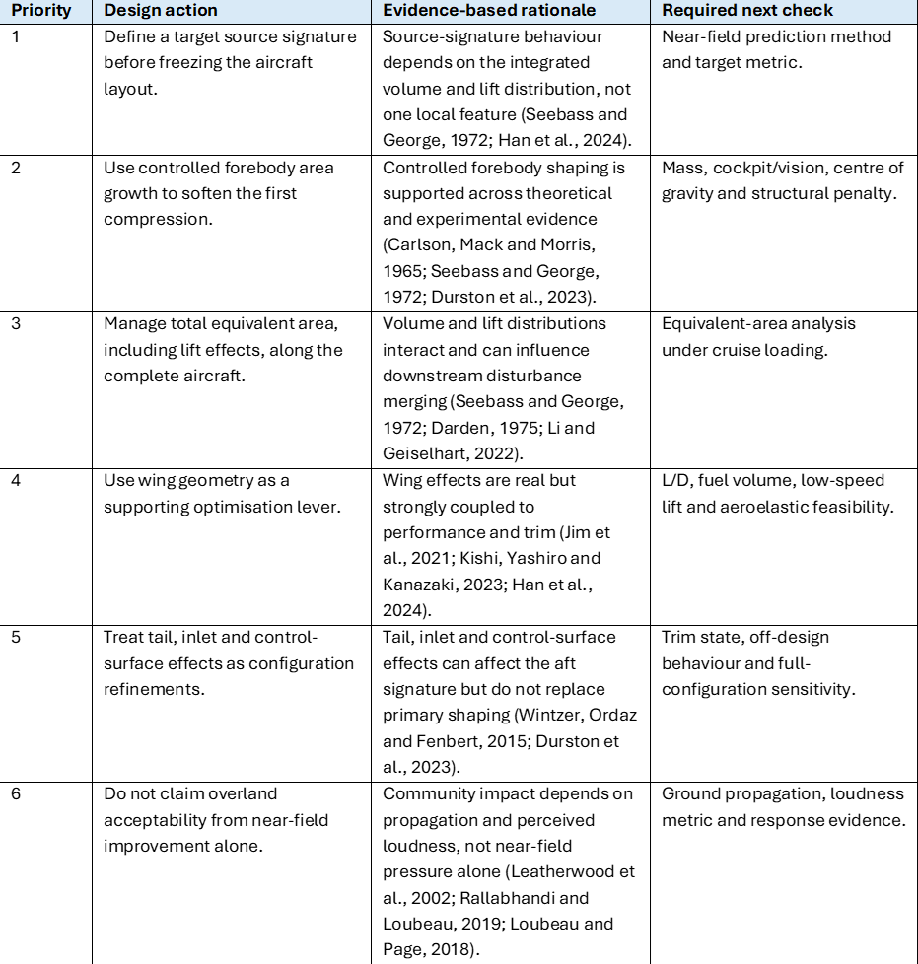

9.2 Recommended further work

The first stage of further work should be to develop and validate a CFD and atmospheric-propagation workflow against a published benchmark or relevant wind-tunnel case (Park and Nemec, 2019; Rallabhandi and Loubeau, 2019; Durston et al., 2023). Mesh-sensitivity, solver and modelling-uncertainty checks should be completed before the method is used to compare geometry variants (Park and Nemec, 2019; Han et al., 2024).
Once validated, a controlled parametric study could vary forebody fineness, total equivalent-area smoothness and one wing parameter at a fixed Mach number, altitude and aircraft loading condition (Han et al., 2024). The resulting near-field signatures should then be propagated to ground level and assessed using pressure- and loudness-based metrics (Rallabhandi and Loubeau, 2019; Leal et al., 2021; Loubeau and Page, 2018). This would allow the direction and magnitude of the geometry trends identified in this dissertation to be tested quantitatively.
A later stage should include aircraft-level trade-off measures such as drag, lift-to-drag ratio, trim, structural-weight proxy, usable volume and low-speed performance (Raymer, 2018; Li and Geiselhart, 2022). Further analysis could then examine additional flight conditions and atmospheric profiles (Leal et al., 2021; Han et al., 2024). This would extend the current concept-stage framework into a multidisciplinary assessment of both sonic-boom reduction and transport-aircraft feasibility.

10 References

Aftosmis, M.J., Nemec, M. and Cliff, S.E. (2011) 'Adjoint-based low-boom design with Cart3D', 29th AIAA Applied Aerodynamics Conference, Honolulu, Hawaii, 27-30 June. AIAA 2011-3500. Available at: https://doi.org/10.2514/6.2011-3500 (Accessed: 25 August 2026).
Anderson, J.D. (2021) Modern Compressible Flow: With Historical Perspective. 4th edn. New York: McGraw Hill.
Bonavolontà, G., Lawson, C. and Riaz, A. (2023) 'Review of sonic boom prediction and reduction methods for next generation of supersonic aircraft', Aerospace, 10(11), 917. Available at: https://doi.org/10.3390/aerospace10110917 (Accessed: 25 August 2026).
Brandon, J. (2024) X-59: GNC Architecture for NASA’s Supersonic X-Plane. CEAS EuroGNC 2024, Bristol, 11–13 June. NASA Technical Reports Server, Document ID 20240006461. Available at: https://ntrs.nasa.gov/citations/20240006461 (Accessed: 9 September 2026).
Carlson, H.W., Barger, R.L. and Mack, R.J. (1973) Application of Sonic-Boom Minimization Concepts in Supersonic Transport Design. NASA TN D-7218. Available at: https://ntrs.nasa.gov/citations/19730015338 (Accessed: 25 August 2026).
Carlson, H.W., Mack, R.J. and Morris, O.A. (1965) A Wind-Tunnel Investigation of the Effect of Body Shape on Sonic-Boom Pressure Distributions. NASA TN D-3106. Available at: https://ntrs.nasa.gov/citations/19660001963 (Accessed: 25 August 2026).
Civil Aviation Authority (2024) Prohibition of Supersonic, Transonic and Hypersonic Flight over land. Available at: https://consultations.caa.co.uk/air-traffic-management/prohibition-of-supersonic-transonic-and-hypersonic/consult_view/ (Accessed: 25 August 2026).
Darden, C.M. (1975) Minimization of Sonic-Boom Parameters in Real and Isothermal Atmospheres. NASA TN D-7842. Available at: https://ntrs.nasa.gov/citations/19750009271 (Accessed: 25 August 2026).
Ding, Y., Han, Z., Qiao, J., Nie, H., Song, W. and Song, B. (2023) ‘Research progress in key technologies for conceptual-aerodynamic configuration design of supersonic transport aircraft’, Acta Aeronautica et Astronautica Sinica, 44(2), 626310. Available at: https://doi.org/10.7527/S1000-6893.2021.26310 (Accessed: 10 September 2026).
Durston, D.A., Wolter, J.D., Shea, P.R., Winski, C.S., Elmiligui, A.A., Langston, S.L., Bozeman, M.D., Carter, M.B. and Bellido, C.A. (2023) 'X-59 sonic boom test results from the NASA Glenn 8- by 6-foot supersonic wind tunnel', AIAA AVIATION 2023 Forum, San Diego, California, 12-16 June. AIAA 2023-4317. Available at: https://doi.org/10.2514/6.2023-4317 (Accessed: 25 August 2026).
Fanelli, D. (2012) 'Negative results are disappearing from most disciplines and countries', Scientometrics, 90(3), pp. 891-904. Available at: https://doi.org/10.1007/s11192-011-0494-7 (Accessed: 25 August 2026).
Federal Aviation Administration (2026a) 14 CFR §91.817 Civil aircraft sonic boom. Available at: https://www.ecfr.gov/current/title-14/chapter-I/subchapter-F/part-91/subpart-I/section-91.817 (Accessed: 25 August 2026).
Federal Aviation Administration (2026b) 14 CFR §91.818 Special flight authorization to exceed Mach 1. Available at: https://www.ecfr.gov/current/title-14/chapter-I/subchapter-F/part-91/subpart-I/section-91.818 (Accessed: 25 August 2026).
GBTA (2025) UK Firms Could Miss Out on £319 Billion in Sales Without Strategic Business Travel Investment, New GBTA Study Finds. Available at: https://gbta.org/u-k-firms-could-miss-out-on-319-billion-in-sales-without-strategic-business-travel-investment-new-gbta-study-finds/ (Accessed: 10 September 2026).
Han, Z., Qiao, J., Zhang, L., Chen, Q., Yang, H., Ding, Y., Zhang, K., Song, W. and Song, B. (2024) 'Recent progress of efficient low-boom design and optimization methods', Progress in Aerospace Sciences, 146, 101007. Available at: https://doi.org/10.1016/j.paerosci.2024.101007 (Accessed: 25 August 2026).
Heritage Concorde (n.d.) Airframe Dimensions. Available at: https://www.heritageconcorde.com/airframe-dimensions (Accessed: 7 September 2026).
Hirsch, C. (2007) Numerical Computation of Internal and External Flows: The Fundamentals of Computational Fluid Dynamics. 2nd edn. Oxford: Butterworth-Heinemann. Available at: https://doi.org/10.1016/B978-0-7506-6594-0.X5037-1 (Accessed: 10 September 2026).
IATA (2025) Global Air Passenger Demand Reaches Record High in 2024. Available at: https://www.iata.org/en/pressroom/2025-releases/2025-01-30-01/ (Accessed: 10 September 2026).
ICAO (2017) Annex 16 to the Convention on International Civil Aviation: Environmental Protection, Volume I – Aircraft Noise. 8th edn, incorporating Amendment 15 (2026). Montreal: ICAO. Available at: https://store.icao.int/en/annex-16-environmental-protection-volume-i-aircraft-noise (Accessed: 9 September 2026).
ICAO (2023) Annex 16 to the Convention on International Civil Aviation: Environmental Protection, Volume II – Aircraft Engine Emissions. 5th edn, incorporating Amendment 12 (2026). Montreal: ICAO. Available at: https://store.icao.int/en/annex-16-environmental-protection-volume-ii-aircraft-engine-emissions (Accessed: 9 September 2026).
ICAO (2024) ICAO CAEP/12 Assessment Report: Understanding the Potential Environmental Impacts from Supersonic Aircraft: An Update. Available at: https://www.icao.int/environmental-protection/Documents/ScientificUnderstanding/ICAO%20CAEP12%20Assessment%20Report%20on%20the%20potential%20environmental%20impacts%20from%20supersonic%20aircraft.pdf (Accessed: 25 August 2026).
ICAO (2025) ICAO Environmental Report 2025. Available at: https://www.icao.int/environmental-protection/envrep2025 (Accessed: 25 August 2026).
Jim, T.M.S., Faza, G.A., Palar, P.S. and Shimoyama, K. (2021) 'Bayesian optimization of a low-boom supersonic wing planform', AIAA Journal, 59(11), pp. 4514-4529. Available at: https://doi.org/10.2514/1.J060225 (Accessed: 25 August 2026).
Kishi, Y., Yashiro, R. and Kanazaki, M. (2023) 'Low-boom design for supersonic transport with canard and forward-swept wings using equivalent area design method', Aerospace, 10(8), 717. Available at: https://doi.org/10.3390/aerospace10080717 (Accessed: 25 August 2026).
Leal, P.B.C., Schrass, J.A., Giblette, T.N., Hunsaker, D.F., Shen, H., Logan, T.S. and Hartl, D.J. (2021) 'Effects of atmospheric profiles on sonic boom perceived level from supersonic vehicles', AIAA Journal, 59(12), pp. 5020-5028. Available at: https://doi.org/10.2514/1.J059209 (Accessed: 25 August 2026).
Leatherwood, J.D. and Sullivan, B.M. (1992) Laboratory Study of Effects of Sonic Boom Shaping on Subjective Loudness and Acceptability. NASA TP-3269. Available at: https://ntrs.nasa.gov/citations/19930002432 (Accessed: 25 August 2026).
Leatherwood, J.D., Sullivan, B.M., Shepherd, K.P., McCurdy, D.A. and Brown, S.A. (2002) 'Summary of recent NASA studies of human response to sonic booms', Journal of the Acoustical Society of America, 111(1 Pt 2), pp. 586-598. Available at: https://doi.org/10.1121/1.1371767 (Accessed: 25 August 2026).
Li, W. and Geiselhart, K. (2022) 'Multi-objective, multidisciplinary optimization of low-boom supersonic transports using multifidelity models', Journal of Aircraft, 59(5), pp. 1137-1151. Available at: https://doi.org/10.2514/1.C036656 (Accessed: 25 August 2026).
Loubeau, A. and Page, J. (2018) 'Human perception of sonic booms from supersonic aircraft', Acoustics Today, 14(3), pp. 23-30. Available at: https://doi.org/10.1121/AT.2018.14.3.23 (Accessed: 25 August 2026).
Maglieri, D.J., Bobbitt, P.J., Plotkin, K.J., Shepherd, K.P., Coen, P.G. and Richwine, D.M. (2014) Sonic Boom: Six Decades of Research. NASA/SP-2014-622. Available at: https://ntrs.nasa.gov/citations/20150006843 (Accessed: 25 August 2026).
NASA (2009) Shaped Sonic Boom Demonstration. Available at: https://www.nasa.gov/image-article/shaped-sonic-boom-demonstration-10/ (Accessed: 13 September 2026).
NASA (2013) Updated Supersonic. Available at: https://www.nasa.gov/image-article/updated-supersonic/ (Accessed: 14 September 2026).
NASA (2025) Quesst: The Vehicle. Available at: https://www.nasa.gov/quesst-the-aircraft/ (Accessed: 7 September 2026).
NASA Glenn Research Center (2026) Airplane Parts and Function. Available at: https://www1.grc.nasa.gov/beginners-guide-to-aeronautics/airplane-parts-function/ (Accessed: 7 September 2026).
NASA (2026) Quesst: The Mission. Available at: https://www.nasa.gov/mission/quesst/ (Accessed: 25 August 2026).
National Park Service (1994) Report on effects of aircraft overflights on the National Park System. Chapter 4, Figure 4.5. Available at: https://www.nonoise.org/library/npreport/chapter4.htm (Accessed: 23 September 2026).
Park, M.A. and Nemec, M. (2019) 'Nearfield summary and statistical analysis of the second AIAA Sonic Boom Prediction Workshop', Journal of Aircraft, 56(3), pp. 851-875. Available at: https://doi.org/10.2514/1.C034866 (Accessed: 25 August 2026).
Pawlowski, J.W., Graham, D.H., Boccadoro, C.H., Coen, P.G. and Maglieri, D.J. (2005) ‘Origins and overview of the Shaped Sonic Boom Demonstration Program’, 43rd AIAA Aerospace Sciences Meeting and Exhibit, AIAA Paper 2005-0005. doi:10.2514/6.2005-5.
Plotkin, K.J. (2002) 'State of the art of sonic boom modeling', Journal of the Acoustical Society of America, 111(1 Pt 2), pp. 530-536. Available at: https://doi.org/10.1121/1.1379075 (Accessed: 25 August 2026).
Rallabhandi, S.K. and Loubeau, A. (2019) 'Summary of propagation cases of the second AIAA Sonic Boom Prediction Workshop', Journal of Aircraft, 56(3), pp. 876-895. Available at: https://doi.org/10.2514/1.C034805 (Accessed: 25 August 2026).
Raymer, D.P. (2018) Aircraft Design: A Conceptual Approach. 6th edn. Reston, VA: American Institute of Aeronautics and Astronautics.
Reed, J.A., Follen, G.J. and Afjeh, A.A. (2000) Improving the Aircraft Design Process Using Web-based Modeling and Simulation. NASA/TM-2000-209953. Cleveland, OH: NASA Glenn Research Center. Available at: https://ntrs.nasa.gov/citations/20000054685 (Accessed: 10 September 2026).
Seebass, R. and George, A.R. (1972) 'Sonic-boom minimization', Journal of the Acoustical Society of America, 51(2C), pp. 686-694. Available at: https://doi.org/10.1121/1.1912902 (Accessed: 25 August 2026).
Whitham, G.B. (1952) 'The flow pattern of a supersonic projectile', Communications on Pure and Applied Mathematics, 5(3), pp. 301-348. Available at: https://doi.org/10.1002/cpa.3160050305 (Accessed: 25 August 2026).
Wintzer, M., Ordaz, I. and Fenbert, J.W. (2015) 'Under-track CFD-based shape optimization for a low-boom demonstrator concept', 33rd AIAA Applied Aerodynamics Conference, Dallas, Texas, 22-26 June. AIAA 2015-2260. Available at: https://doi.org/10.2514/6.2015-2260 (Accessed: 25 August 2026).

11 Appendices

Appendix A - Full Project Timing Plan

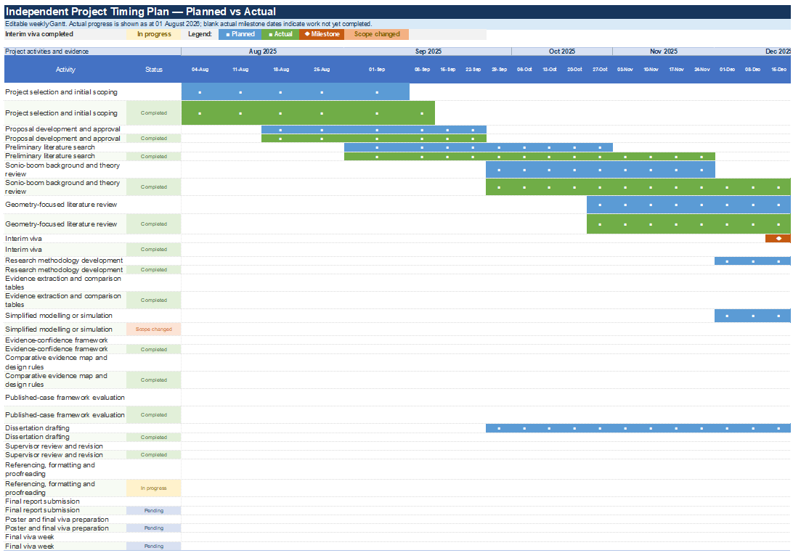
Figure 9 - Project timing plan: planned and actual Gantt schedule (Part 1)
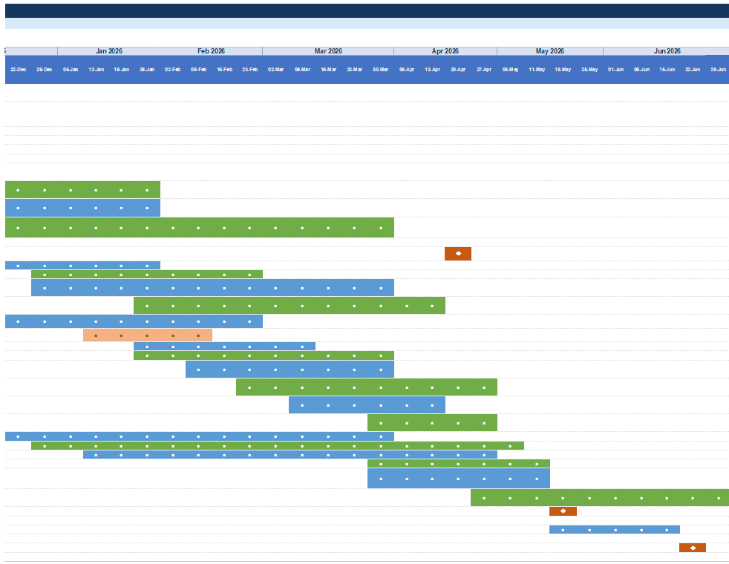
Figure 10 - Project timing plan: planned and actual Gantt schedule (Part 2)

Appendix B - Evidence extraction template and examples

Table 14 - Evidence extraction fields
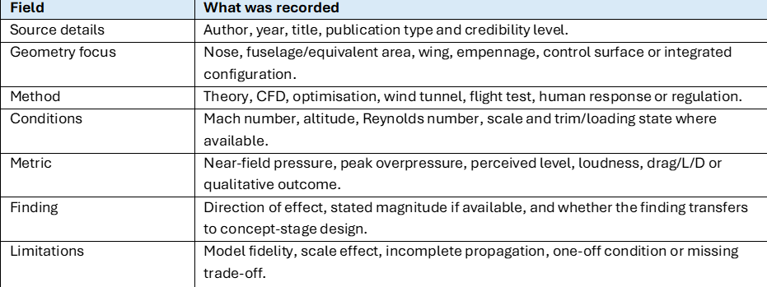

Table 15 - Example evidence extraction entries
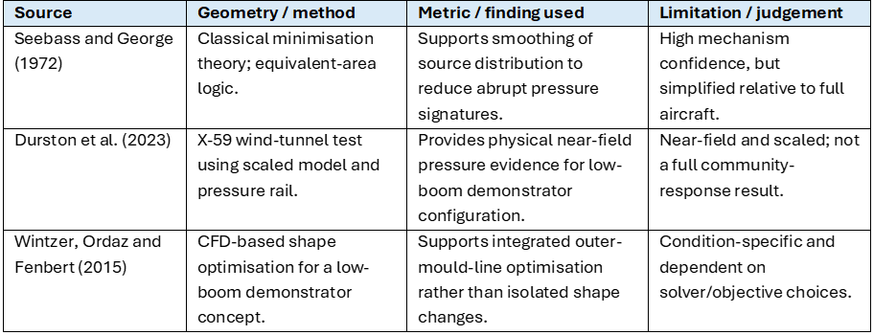

Appendix C - Risk register

Table 16 - Project risk register
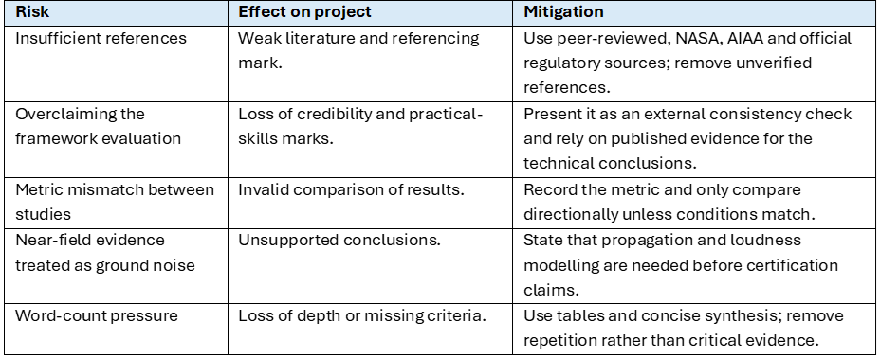

Appendix D – Concorde and X-59 case-study comparison.

Concorde, as seen in Figure 11, provides a useful historical reference because its successful supersonic cruise performance did not produce a low-boom ground signature (Maglieri et al., 2014). Its configuration generated a conventional N-wave, and the disturbance caused by sonic boom contributed to restrictions on routine overland supersonic operation (Maglieri et al., 2014). Concorde therefore demonstrates that efficient supersonic cruise and a slender aircraft shape do not automatically produce a community-acceptable sonic boom (Maglieri et al., 2014; Loubeau and Page, 2018).

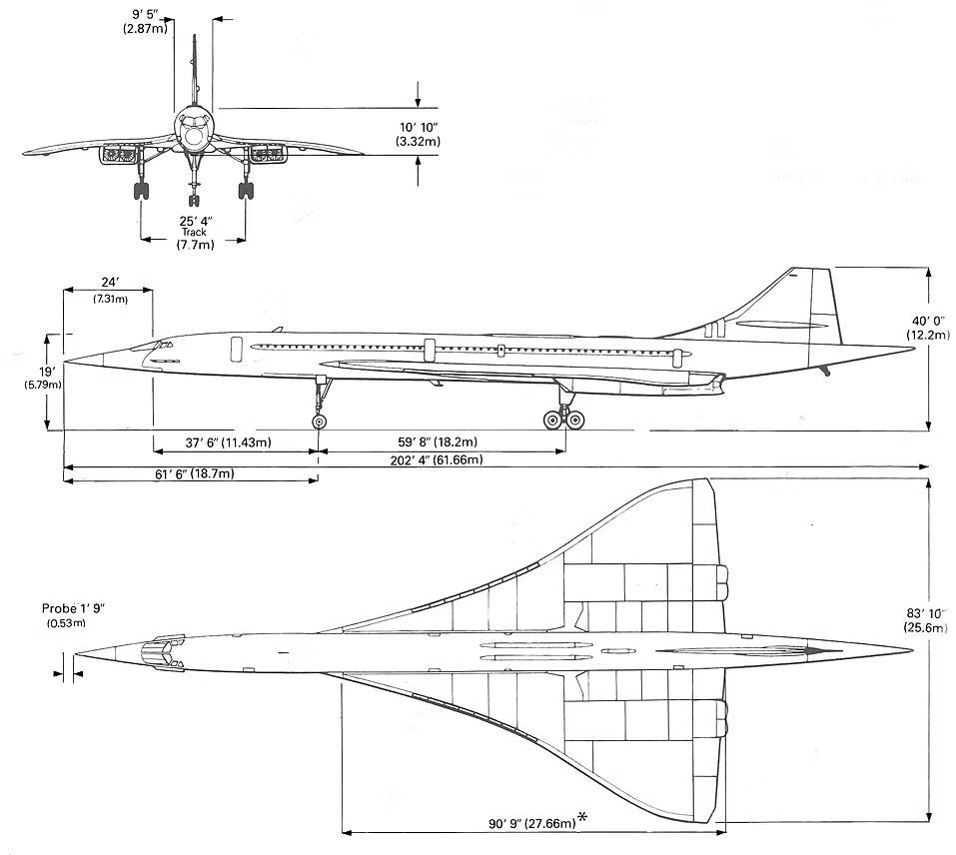
Figure 11 - Concorde geometry: front, side and plan views (Heritage Concorde, n.d.).

The X-59, as seen in Figure 12, follows a different design philosophy (NASA, 2026; Durston et al., 2023). Its configuration was developed around a shaped pressure-signature objective rather than treating sonic boom mainly as an operational restriction (NASA, 2026; Durston et al., 2023). Wind-tunnel testing has been used to assess the near-field signature and its sensitivity to configuration changes before flight and community-response evaluation (Durston et al., 2023).

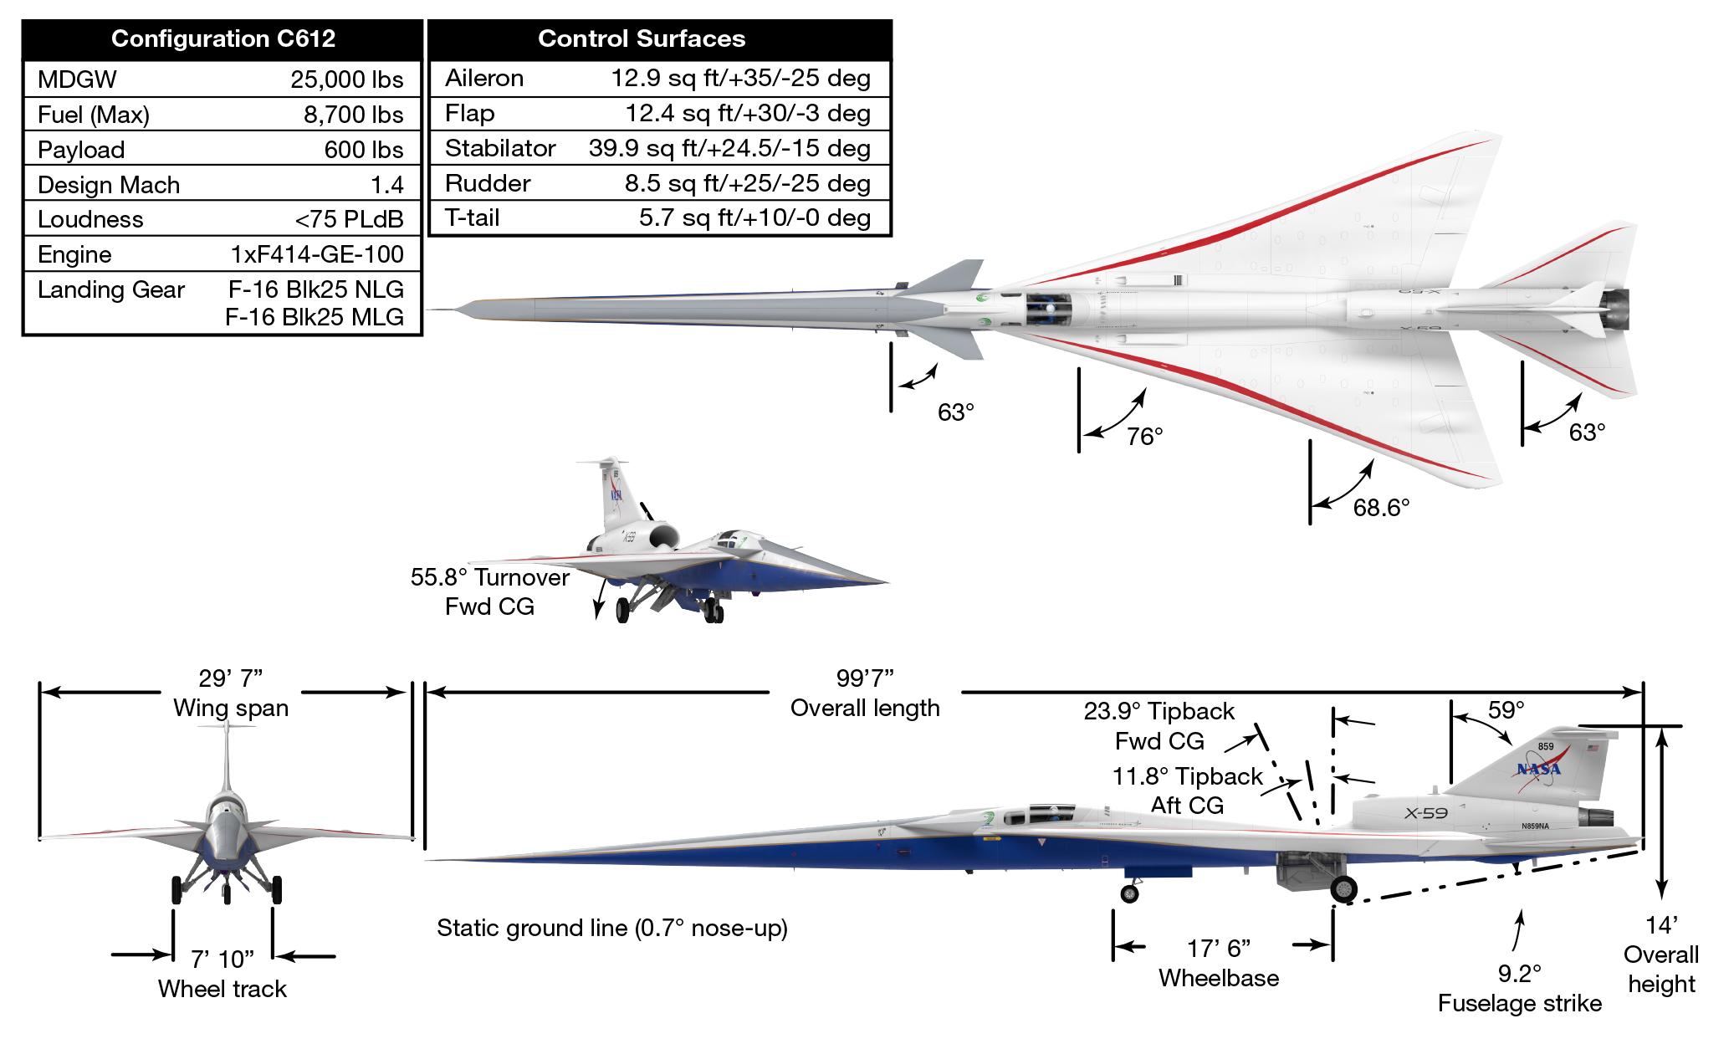
Figure 12 - NASA X-59 and principal geometric characteristics (NASA, 2025).

However, the X-59 is a research demonstrator rather than a passenger transport (NASA, 2026). Its geometry cannot be transferred directly to an aircraft that requires substantial cabin volume, commercial payload, fuel capacity and transport-level range (Li and Geiselhart, 2022; Han et al., 2024). The transferable lesson is therefore the design process rather than the exact aircraft shape: define a target signature, shape the integrated configuration around that target and validate the result through computation, physical testing, atmospheric propagation and human-response assessment (Wintzer, Ordaz and Fenbert, 2015; Durston et al., 2023; Rallabhandi and Loubeau, 2019; Loubeau and Page, 2018).

