Vasile Ene
1817171
LCBB4002
COMMUNITY ENGAGEMENT
RESIT/REWORK ASSIGNMENT 2
Lecturer: Tanja Nathan

Concept of reflective practice, brief explanation of my role play and reflective statement

The reflection process begins with the analysis of a situation or an activity that we undertake, this can establish at the level of consciousness if the activity, action or work done is beneficial to me personally as a single entity, through actions taken by others and if you can learn something or you can learn someone from the experience you had. “Reflective practice is the ability to reflect on one's actions so as to engage in a process of continuous learning”. Schön, Donald A. (1983)
The practice of reflective thinking has much older roots as some scholars have found precursors of this idea in ancient times in ancient philosophers such as Marcus Aurelius Suibhne, Seamus Mac (September 2009), or Buddhist teachings. Winter, Richard (March 2003) In the early twentieth century John Dewey established this concept of reflective practice and later Donald Schön in his 1983 book The Reflective Practitioner introduced new concepts such as action reflection and action reflection so professionals meet the challenges of their work with a kind of improvisation that can be and is improved through practice.
More than 100 years have passed since the appearance of the term and the concept of reflective practice in the sense we understand it today, during which time several definitions have been given this idea of ​​practicing reflection. Reflective practice offers you the opportunity to critically weigh the moral or material values ​​you refer to as well as the practical activity you undertake by examining them. Reflective practice involves "paying critical attention to the practical values and theories which inform everyday actions, by examining practice reflectively and reflexively. This leads to developmental insight". Bolton, Gillie (2010)
Reflective practice is an exercise that through the retrospective analysis of a situation through the information you discover as well as through the evaluation of the action to lead to a better understanding of the situation, to the accumulation of a learning experience that will be useful in a future, similar situation. This encourages us to be aware of our own thoughts and feelings, teaches us how to plan how to implement in everyday life the most beneficial, most successful actions. A person who reflects throughout his or her practice is not just looking back on past actions and events, but is taking a conscious look at emotions, experiences, actions, and responses, and using that information to add to his or her existing knowledge base and reach a higher level of understanding. Paterson, Colin; Chapman, Judith (August 2013)
Throughout the last century, researchers have created several models of reflective thinking in the need to establi sh reasoning about action.
Borton 1970
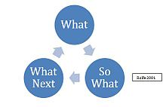 https://upload.wikimedia.org/wikipedia/commons/thumb/5/51/Steph_Rol_Model.jpg/220px-Steph_Rol_Model.jpg
Gibbs 1988
One theorist who supports reflective practice is Gibbs (1988) who developed the reflective cycle which included six stages of how children learn through first hand experiences, or ‘learning through doing’. Reflection in action allows practitioners to redesign what they are doing whilst they are doing it.

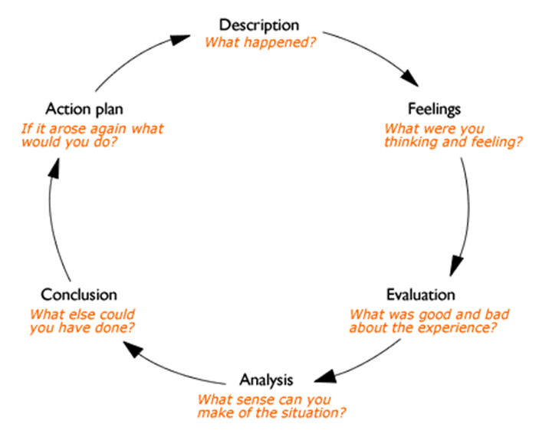
https://www.ed.ac.uk/files/styles/landscape_breakpoints_theme_uoe_desktop_1x/public/thumbnails/image/gibbs_cycle_600x600.png?itok=sVv1EyD3
Schön 1991 distinguishes between reflection-in-action and reflection-on-action.
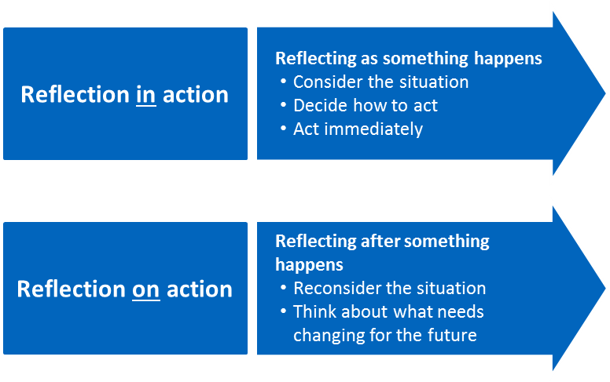https://www.cambridge-community.org.uk/professional-development/gswrp/media/refp_m3_aw_003.png
Johns 1995
Professor of nursing Christopher Johns designed a structured mode of reflection that provides a practitioner with a guide to gain greater understanding of his or her practice. Five patterns of knowing are incorporated into the guided reflection: the aesthetic, personal, ethical, empirical and reflexive aspects of the situation. Johns' model is comprehensive and allows for reflection that touches on many important elements. Johns, Christopher (August 1995)
“Reflective Practice is an essential part of developing new skills, but at a deeper level it grows the capacity of the individual to respond to challenges, make timely decisions, manage emotions, conduct productive relationships and cope with stress.” reflective-practice-guide_tcm18-12524.pdf
Brief explanation of my role play
This fact and after consulting with the role-playing partner I established a scenario that I put into practice. To present the role play I chose the current job and I tried with the role partner play to demonstrate the nature of the job and what role I have in the respective job. The role-playing partner is assigned the role of new employee in the department in which I work and I am the future work colleague who has a longer work experience and who has the task of presenting his work, job duties, function. and the importance of the position within the department in which he was employed. This has made it easier for me to briefly present Greencore, its founding, its position in the industry in which it operates, as well as its objectives and principles.
Model of reflection – Gibbs(1988)
Description of the event
I work in the bread warehouse where I deal with the reception and distribution of bread products and specialties. A sandwich is a food typically made from vegetables, sliced cheese or meat, seated on or between slices of bread, or in general any dish in which two or more pieces of bread serve as a container or shell for another type of food. "sandwich". Merriam-Webster. Merriam-Webster, Incorporated. Retrieved 29 March 2012
The sandwich is named after its supposed inventor, John Montagu, 4th Earl of Sandwich.
The Wall Street Journal described it as "Britain's largest contribution to gastronomy" What's Cooking America, Sandwiches, History of Sandwiches. 2 February 2007.
So bread plays an important role in creating a sandwich.
I considered that my work in this warehouse has an equally important role in all this complex gear called Greencore.
I can say that we are the first line in the work process because we distribute an important product when producing the finished product, bread is the first product that is distributed to the manufacturing lines.
Teamwork and the time set for each product lead to a close collaboration between team members, each having knowledge of each activity individually or about his / her individual activity but also knowing the activity of the partner to predict the next action which is extremely important when working with pre-set work times. This is important in the action of a team, the seriousness, the professionalism of the members gives you confidence in the work you do and this is one of the important points in creating a team union.
I am aware of the importance of the work I do, the capacity and the moment when the production lines start the production of each product. All the production that will be done depends on the start of this department, it depends on this sector. Teamwork and the time set for each product lead to close collaboration between team members.
The result is a harmonious collaboration and good results in work.
Feelings
The team is aware of the work that it has to do and is equally aware that the activity of the team is directly related to the activity of the entire production system, so we try to be as objective, direct and efficient as we do.
Everyone who participates in the production flow, directly or indirectly, is aware of the importance of the activity that a company undertakes in the production process, this process is a chain of actions that if all proceed normally and as established by the managers and they are put into practice by the following management persons as well as by the executives directly leading to the accomplishment of the established production and to the accomplishment of the production.
Everyone is aware that this is beneficial to all to a lesser or greater extent.
Within a team, the person with more work experience brings more value to the team, which brings unity in action and a better understanding. We all trust each other in terms of work experience and this gives you security and a sense of anticipation of actions.
Evaluation
In this activity it is important the training that is done to you, everything needs to be fast regarding the calculations because any product has a code a certain number of units etc, all these correlated with the certainty of knowledge and teamwork gives value to the work done.
For a good activity and for carrying out tasks with professionalism, it is necessary to communicate, understand the work process and know the job, this makes the connection between the team and makes the relations between workers collegial and professional.
Analysis
Within a team the person who has a greater work experience brings more value to the team this brings unity in actions and a better understanding. For a good activity and for carrying out the tasks with professionalism, it is necessary to communicate, to understand the work process and to know the work place, this connects the team and makes the relations between the workers to be destined and professional
The experience gained every day, overcoming the difficulties and all the other problems that can occur in a workplace, together we tried and we managed to fulfill our tasks, together we learn, because every day can bring something new and as I said, joint efforts bring good results.
Conclusion
After studying the practice of reflection I realize that in the presentation of the role play I had a too broad presentation of the workplace. Due to this fact I lost in the details of the first part of the presentation but I failed to present to him personally and more effectively the contribution that he will have in the workplace, in this way the main purpose of the role play was demonstrated an element of the job.
Considering the feedback that the designated partner for this role play has given me is far beyond my expectations and I consider it was a gesture of kindness and of a collegial understanding regarding the presentation I made. I am sure that only the constant study, a better focus on the subject and especially the attention with which the main points must be treated will materialize a more concise work, on the subject that will conclude the work.
Action plan
When I work with a group next time, I will talk to them about the strengths I have and what I know best. This will establish a closer relationship with the other members.
Surely we will decide to divide the work, I will insist on planning in advance what we expect from it.
I will propose to write the first introduction or the first section together, so that we have a reference, a starting point for the moment when we will prepare the personal work.
I am sure that this current experience is enough for me to suggest a more balanced division of tasks in the future.
I will ask if we can challenge our initial decisions so that we can be sure that we are making informed decisions to avoid group thinking.
If I have any questions, I will tell the group, in this way I will establish a stronger connection between us because it is not possible to know everything or to know everything.
I think that reminding me that I want the best possible result will make me disagree even when things are not going well.
For a good concretization of the learned the most useful thing was to reflect on those spent at the classes, the presentations of the other colleagues and my timid attempt to present the role play. Through reflective practice, I believe that I will be able to establish actions that prove to be beneficial compared to the other actions that will prove contradictory. Through perseverance, the study associated with the experience gained in the courses I am sure will open up new opportunities to accumulate the necessary knowledge and the capacity to progress.

References / Citations & Bibliography
Schön, Donald A. (1983). The reflective practitioner: how professionals think in action. New York: Basic Books.
Bolton, Gillie (2010) [2001]. Reflective practice: writing and professional development (3rd ed.). Los Angeles: Sage Publications.
Loughran, J. John (January 2002). "Effective reflective practice: in search of meaning in learning about teaching" (PDF). Journal of Teacher Education.
Paterson, Colin; Chapman, Judith (August 2013). "Enhancing skills of critical reflection to evidence learning in professional practice". Physical Therapy in Sport.
Suibhne, Seamus Mac (September 2009). "'Wrestle to be the man philosophy wished to make you': Marcus Aurelius, reflective practitioner". Reflective Practice: International and Multidisciplinary Perspectives. 10 (4): 429–436.
Winter, Richard (March 2003). "Buddhism and action research: towards an appropriate model of inquiry for the caring professions". Educational Action Research. 11 (1): 141–160.
Johns, Christopher, ed. (2010) [2002]. Guided reflection: a narrative approach to advancing professional practice (2nd ed.)
Johns, Christopher (August 1995). "Framing learning through reflection within Carper's fundamental ways of knowing in nursing"
Abelson, Jenn (10 November 2006). "Arguments spread thick". The Boston Globe. Archived from the original on 7 December 2008. Retrieved 27 May 2009.
https://www.ed.ac.uk/reflection/reflectors-toolkit/reflecting-on-experience/gibbs-reflective-cycle
"sandwich". Merriam-Webster. Merriam-Webster, Incorporated. Retrieved 29 March 2012.
Foundations of Restaurant Management & Culinary Arts Level Two. Pearson. 2011. p. 53.
What's Cooking America, Sandwiches, History of Sandwiches. 2 February 2007.
"Sandwich celebrates 250th anniversary of the sandwich". BBC News Online. 12 May 2012. Retrieved 18 May 2012.
Marks, Kathy (17 May 1997). "BLT: British, lousy and tasteless". The Independent. London.
https://www.cipd.co.uk/Images/reflective-practice-guide_tcm18-12524.pdf
https://en.wikipedia.org/wiki/Reflective_practice
https://en.wikipedia.org/wiki/Sandwich
https://en.wikipedia.org/wiki/Greencore

