Ionut Marius Rosu
1910143 | History and theory 1
An Example of Modern Architecture
Fallingwater – Frank lloyd wright

- Historical background
In 1935 Frank Lloyd Wright was commissioned by Edgar Kaufmann to design and build a weekend summer house for the family, near Bear Run, Pennsylvania. (Timeline - Fallingwater, n.d.)
Edgar Jonas Kaufmann and his wife Liliane Kaufmann formed an important Pittsburgh couple, known for their particular sense of style and taste. (Fallingwater | Frank Lloyd Wright Foundation, n.d.)
Frank Lloyd Wright was chosen because he shared the Kaufmann`s love for nature. This allowed him to recognise the clients desire for a building, that through innovation, would integrate and compliment the landscape of their “favourite county hideaway”. (Fallingwater | Frank Lloyd Wright Foundation, n.d.)
January 1936 sees the completion of the first set of working drawings. April of the same year marks the beginning of the construction. In July the foundations were completed and the living room cantilever was ready to be poured in August. (Timeline - Fallingwater, n.d.)
The year of 1937 marks the completion of building on Fallingwater`s site, with the Kaufmanns occupying their new property in December. (Timeline - Fallingwater, 2020)
In 1938 additional guest quarters were designed by Frank Lloyd Wright at the request of the Kaufmann family. The new guest quarters were set into the hillside above the main house with a covered walkway to link them together. (Fallingwater | Frank Lloyd Wright Foundation, n.d.)
Completion of the new guest house was achieved in 1939. (Timeline - Fallingwater, n.d.)
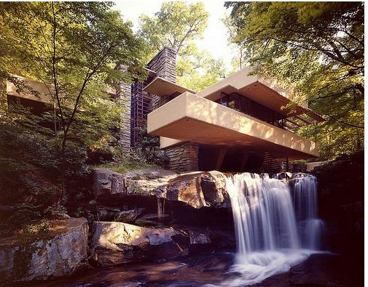
Frank Lloyd Wright`s Fallingwater. Source: Perez, 2010
- Plans and Section
Acknowledging the love for nature shared between him and his clients, Frank Lloyd Wright integrated the design of the house into the family`s favourite country retreat and he blended nature with the Kaufmann`s lives, by placing their future house on top of the waterfall. (Perez, 2010)
In a very De Stijl way, the design of Fallingwater is based on a central core and expands from it.
The house`s central core is the fireplace, “the heart of the home”, which Frank Lloyd Wright looked at as being the family`s gathering place. (Perez, 2010)
The main house is built on three floors. First floor is comprised from an open living room and a small kitchen. Second floor has three small bedrooms and present on the third floor is a study and a bedroom for the Kaufmann`s son, Edgar Jr. Every room relates to the natural surroundings of the house, and the living room has a staircase that heads to the waters underneath it. (Perez, 2010)
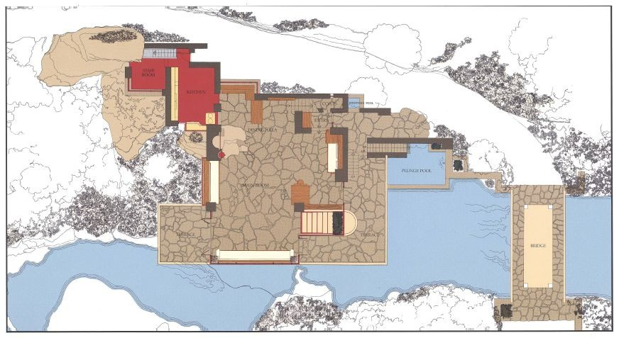
Fallingwater Main House, First Floor Plan. Source: Perez ,2010

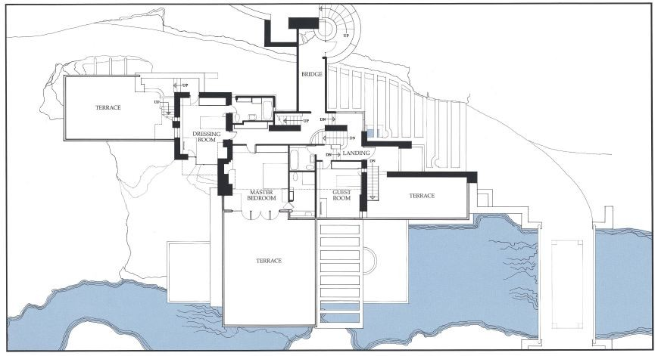
Fallingwater Main House, Second Floor Plan. Source: Perez,2010

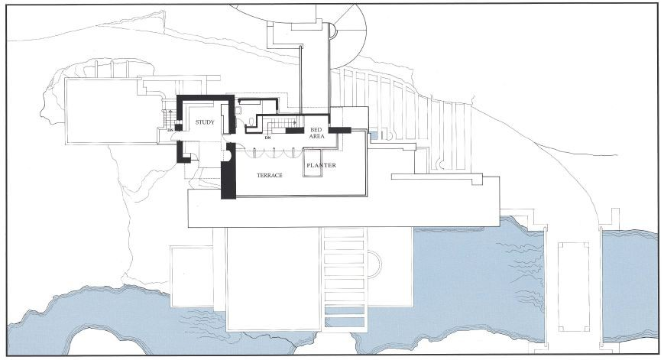
Fallingwater Main House, Third Floor Plan. Source: Perez, 2010

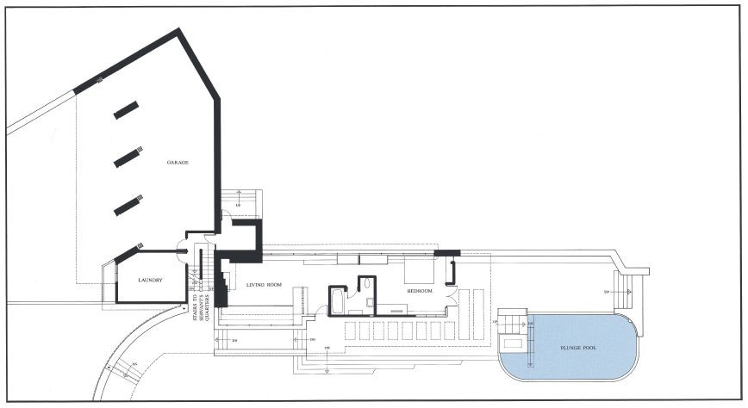
Fallingwater Guest House, First Floor Plan. Source: Perez, 2010

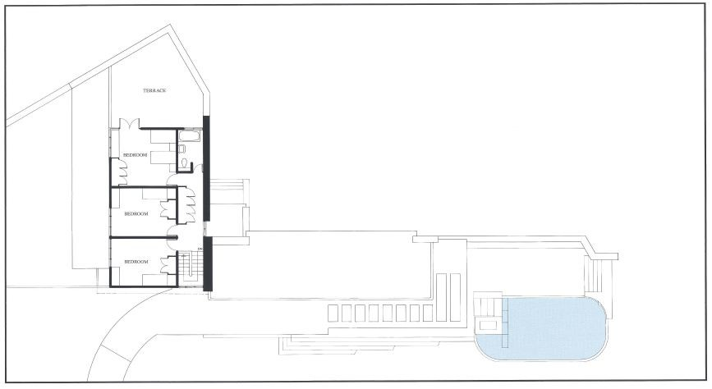
Fallingwater Guest House, Second Floor Plan. Source: Perez, 2010

Circulation in the house is achieved through dark and narrow passageways. Frank Lloyd Wright designed them this way in order to force a feeling of compression and maybe claustrophobia. This feeling is in total contrast to the one of expansion that comes when a person approaches the house`s outdoors. The low ceilings which in some places only reach 1.95 m, lead the eye to watch the outdoors. Cantilevered terraces act as “extensions towards nature” for the above mentioned spaces and they also give them beauty. Besides their function , this terraces add an element of sculpture as well, through their shape, that uses a series of right angles. “The terraces form a complex, overriding horizontal force with their protrusions that liberated space with their risen planes parallel to the ground.” (Perez, 2010)
To support these terraces, Frank Lloyd Wright collaborated with engineers Mendel Glickman and William Wesley Peters. As a result of this collaboration, the choice of materials was judged as the best way support the aforementioned terraces. (Perez, 2010)
Looking at the facades of Fallingwater , Frank Lloyd Wright is putting in antithesis the horizontal planes against the towering heights of the verticals. This is maybe best highlighted by the terraces which are set off by the sky-scraping chimney and by a four-storey box of windows. Same order seems to go on the inside as well. (Hinman, 2011)

- Materials and Light

The terraces are made from a structure of reinforced concrete. Although Frank Lloyd Wright never used this material for residential commissions before, and he also had little interest into it, concrete proved to be flexible enough to be poured into shaped moulds. Reinforcing the concrete with steel also gave it “ extraordinary tensile strength”. (Perez, 2010)
Floating above the stream below, the cantilevered terraces are made from local sandstone, in order to form a harmonious blend with the rock formations. (Fallingwater | Frank Lloyd Wright Foundation, n.d.)
Flagstone flooring is present on the premier space of the main house, on the enclosed bridge to the guesthouse and on the terraces. (Architectural Preservation Studio, 2017)
The interior walls display a combination of irregular stone and sandstone. The aforementioned flagstone flooring is cut raw, but its waxing and polishing treatment mirrors the surface of the river underneath. (Hinman, 2011)

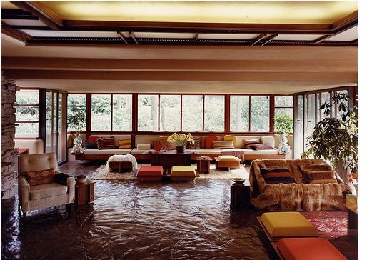
Fallingwater`s Living Room. Source: Perez,2010

Frank Lloyd Wright was known to design his projects up to the furniture and textiles. Given this aspect of his way to work, he also choose the material for the cabinetry and furniture, in this case North Carolina walnut veneer. (Hinman, 2011)
As mentioned in the “Plans and Section” part, the glass walls and windows bring the surrounding nature into the rooms. (Fallingwater | Frank Lloyd Wright Foundation, n.d.)
Same façade windows open at the corners, in order to brake the box and open the space towards the outdoors. (Perez, 2010)

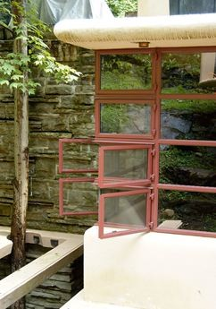Fallingwater`s Corner Opening Windows. Source: Perez, 2010

Lighting of the house is a dynamic game of tension between the dark, narrow corridors and the warm sunlight cast into the open rooms. Frank Lloyd Wright uses this tension throughout the home. The poorly lit spaces shift the attention towards the open spaces. This aspect further emphases the need for attention towards nature.

- Ideas and Theories Underpinning the Design

In 1930`s , architecture was based on the ideas of the Modernist Movement. These ideas included the introduction of straight planes, use of the engineers knowledge into the design and material choice , use of cantilevered elements and use of glass walls. (Standen and Harries, 2020)
It can be considered that these ideas have been filtered through Frank Lloyd Wright own architectural philosophy:
- Design for Democracy: providing the client with functional, eloquent and humane environments. Also, architecture should adapt to the client`s needs.
- Integrity and Connection: architecture is about enhancement of society`s wellbeing through the honesty of the building, and the building`s ability to nourish its occupants life.
- Nature`s Principles and Structures: A building`s design should compliment it`s context and inhabitants. It could be said that a building can be seen as an extension of it`s context, created in order to serve it`s inhabitant`s needs.
- Material and Machine: Frank Lloyd Wright showed his open-minded view on new materials and technologies by testing and implementing them into his architecture. This is viewed as a pioneering move in modern architecture.
- Architecture as the Great Mother Art: drawing his inspiration from the Japanese culture, in which every object, human and action were integrated “to make an entire civilisation a work of art”, Frank Lloyd Wright considered that beautiful architecture was designing a building that through it`s affordability and pleasing aesthetic served it`s occupants right to experience “a beautiful life in beautiful circumstances”. (About Frank Lloyd Wright | Frank Lloyd Wright Foundation, n.d.)
Fallingwater is a statement of the above through it`s placement, materials, terraces and decoration. By placing the house in the most dramatic part of the falls, Frank Lloyd Wright united man and nature. (Designing Fallingwater - Fallingwater, n.d.)
This man and nature unity is maybe best noticed when the cascading water from the outside can be heard in every corner of the house. Same concept of man and nature can be found at the fireplace, a rock cuts through it and by that, the waterfall is transported inside. (Perez, 2010)
Frank Lloyd Wright`s experimentation with materials is probably most evident in the technology implemented in building the terraces.
His open-minded nature allowed him to create this terraces by working with engineers and choose the right material for the cantilevers , even though it was his first time using reinforced concrete in domestic dwellings. (Perez, 2010)
Maybe the most striking aspect of Fallingwater is it`s ability to compliment it`s landscape, even though it`s a man made structure.
The beam`s curvature allow for the trees to grow through the trellis and a moss garden extends from the sandstone exterior walls towards an interior hallway. Nature`s four elements ca be found throughout the dwelling: earth is represented by the fireplace`s stone, the fire is at the home`s heart ( the fireplace), air comes through the living room`s hatch, hatch that also leads to the water , the stream below the house. (Hinman, 2011)

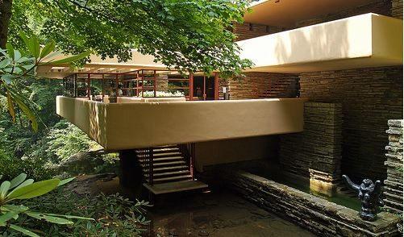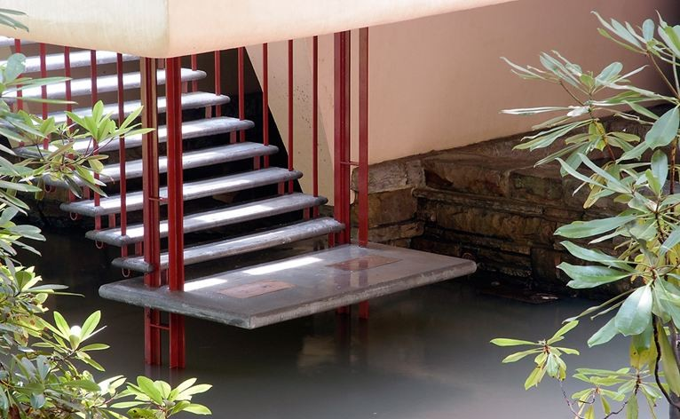
Fallingwater`s Living Room Staircase, Leading to the stream. Source: Perez, 2010

- Conclusion / Summary

Fallingwater is the work of a genius. From the pioneering cantilevers and the corner window details to the implementation of nature into it`s design, Fallingwater brings nature and human together in a harmonious manner.
Frank Lloyd Wright managed to read and fulfil his client`s desires and aspirations to have a holiday retreat into their favourite country hideaway. (Fallingwater | Frank Lloyd Wright Foundation, n.d.)
He managed to do it by creating a home that was designed following the trends of the Modernist Movement, of which he filtered through his own architectural philosophy.
A testimony to Fallingwater`s success was the Kaufmann`s inclination to entertain and their joy to share their holiday home with friends, family and the “architecturally curious”, who were hosted in the guesthouse. Edgar Kaufmann stated that he couldn`t imagine a life without his “retreat”. (Hinman, 2011)

Reference List:

- Frank Lloyd Wright Foundation. n.d. About Frank Lloyd Wright | Frank Lloyd Wright Foundation. [online] Available at: <https://franklloydwright.org/frank-lloyd-wright/> [Accessed 16 April 2020].
- Architectural Preservation Studio, 2017. DIGITAL DOCUMENTATION OF FRANK LLOYD WRIGHT’S MASTERPIECE, FALLINGWATER. [online] Ottawa: The International Archives of the Photogrammetry, Remote Sensing and Spatial Information Sciences, p.p.390. Available at: <https://www.int-arch-photogramm-remote-sens-spatial-inf-sci.net/XLII-2-W5/389/2017/isprs-archives-XLII-2-W5-389-2017.pdf> [Accessed 16 April 2020].
- Fallingwater. n.d. Designing Fallingwater - Fallingwater. [online] Available at: <https://fallingwater.org/history/about-fallingwater/designing-fallingwater/> [Accessed 16 April 2020].
- Frank Lloyd Wright Foundation.n.d.. Fallingwater | Frank Lloyd Wright Foundation. [online] Available at: <https://franklloydwright.org/site/fallingwater/> [Accessed 16 April 2020].
- Hinman, K., 2011. America's Greatest Work of Architecture. American History, 46(4), pp.p32-p41.
- Perez, A., 2010. AD Classics: Fallingwater House / Frank Lloyd Wright. [online] ArchDaily. Available at: <https://www.archdaily.com/60022/ad-classics-fallingwater-frank-lloyd-wright?ad_source=search&ad_medium=search_result_all> [Accessed 16 April 2020].
- Standen, I. and Harries, P., 2020. History And Theory 1.
- Fallingwater. n.d. Timeline - Fallingwater. [online] Available at: <https://fallingwater.org/history/timeline/> [Accessed 16 April 2020].

