Software Solutions for Business
Component 1 – Coursework: Portfolio

Student Name | [Nafisa Anjum Athay]
Student ID Number | [2510700@student.uwtsd.ac.uk]
Programme | CertHE Computing Skills for Workplace
Module | Software Solutions for Business
Module Code | ACCA4026
Lecturer | Kwame Assa-Agei / Fahed Ahmed
University | University of Wales Trinity Saint David

Contents
Introduction 3
Task 1: E-Commerce Website Builders / Software Solutions 3
1.1 Introduction 3
1.2 Shopify 3
1.3 Wix eCommerce 4
1.4 Comparison and conclusion 5
Task 2: Mind Mapping of Contemporary Software Applications 7
2.1 What mind mapping means 7
2.2 The advantages in business operations 7
2.3 A mind map of current business software 8
Task 3: Office Applications for Creating, Storing, Presenting and Analysing Information/Data 10
3.1 Microsoft Word 10
3.2 Microsoft PowerPoint 10
3.3 Microsoft Excel 11
3.4 Microsoft Access 11
3.5 A comparison of the four office applications 12
3.6 Practical test 1: IF function in Excel 12
3.7 Practical test 2: VLOOKUP 13
3.8 The assessment of practical testing 14
Practical Screenshot Evidence for Task 3 14
Task 4: Communication and Collaboration Applications 15
4.1 Microsoft Teams as a tool for communication 15
4.2 Trello as an online collaboration app 16
4.3 Comparison 16
4.4 Practical test: Microsoft Teams communication feature 16
4.5 Practical test: Trello collaboration feature 17
4.6 Evaluation 17
Practical Screenshot Evidence for Task 4 17
Conclusion 18
References 18

Introduction
The portfolio looks at software solutions which can assist with everyday business operations. Nowadays organisations make use of digital applications in order to manage information, communicate with both customers and colleagues, present their ideas, analyse data, co-ordinate activities and sell products or services online. The aim of this portfolio is to describe some of the software solutions, examine their advantages and disadvantages, and show how certain features can be applied to a hypothetical work situation. The examples are drawn from current software and involve imaginary data so that no private or sensitive business information is included.
The portfolio is divided into four tasks. The first task looks at two e-commerce website builders. The second task deals with mind mapping and includes a mind map of business software applications. The third task looks at Microsoft Word, PowerPoint, Excel and Access and assesses two Excel features by means of a practical simulation. The fourth task examines a communication application and an online collaboration application and describes the practical tests carried out on one feature from each. The purpose of the discussion is to go beyond just listing the features by explaining how each tool can enhance productivity, information management, communication or decision-making.

Task 1: E-Commerce Website Builders / Software Solutions

1.1 Introduction
E-commerce website builders are software platforms which enable an organisation to set up and run an online shop without having to design the whole website from scratch. Such platforms usually include facilities for website design, product catalogues, shopping carts, payment processing, order management and marketing as well as analytics. They have become more important since businesses are now able to reach customers who are outside their physical location and can keep their sales channels going continuously. The platform chosen should therefore take into account how easy it is to use, its scalability, the degree of integration it offers, cost, the level of control it gives over the design and the technical knowledge available within the business.

1.2 Shopify
Shopify is an e-commerce platform which is aimed at companies that wish to sell their products online, in physical locations and by means of other channels. The online store editor offered by Shopify includes support for themes and visual customisation, and the platform as a whole has a range of features such as checkout, inventory management, shipping, point-of-sale, marketing and analytics [1]. Moreover, Shopify has a large ecosystem of apps so that businesses can add special functions when the standard platform fails to meet a specific requirement [2].
One of the main benefits is that Shopify helps to lower the technical difficulties involved in setting up an online shop. A small business could choose a theme, add its products, set up payment options and start selling all without needing to build its own full-scale commerce system. The platform is also appropriate for companies that plan to grow since it includes tools for international sales, business-to-business transactions, operating through multiple sales channels and handling point-of-sale activities [1]. Thus, a business can start off with a fairly simple store and then later introduce more advanced processes.
It is not the case that Shopify is entirely free. While different plans offer various features, businesses might also have to pay for transactions, payments, apps, or development depending on their needs [2]. Although a large range of apps is advantageous, depending on a large number of third-party applications can make the store more complicated and lead to a higher overall cost. Shopify may therefore be a good choice for a business that prioritises speed, scalability and a wide commerce ecosystem, but the organisation should look at the total cost rather than just the basic subscription fee.

1.3 Wix eCommerce
Wix is a website builder that includes e-commerce features. The platform features templates, a drag-and-drop editor, product catalogues, mobile-optimised storefronts, payments, inventory management, marketing and analytics [3]. Moreover, it provides support for multichannel selling and includes integrations with external services. Wix also claims that its e-commerce tools are capable of handling product variants, subscriptions, digital goods, shipping, refunds and customer management [3].
Wix's greatest advantage lies in its visual method. Instead of having to rely mainly on coding, a small business owner who has only limited technical skills can choose a template and edit the pages with the help of a visual editor. The system thus proves to be suitable for a start-up, a local retailer or a service provider that wishes to establish a professional online presence in a short time. Moreover, the platform includes built-in SEO and marketing features, thereby decreasing the number of separate systems required for regular tasks [3].
The problem is that as the organisation's operations become more complex it may eventually need more specialised features. Even though Wix does offer APIs and a wide variety of e-commerce functions, highly specialised or enterprise-level requirements could still call for extra applications or technical support [3]. Because of this, Wix is especially attractive in cases where ease of design and integrated website management are important.

1.4 Comparison and conclusion
Both Shopify and Wix lower the technical skills needed to set up an online store, although the areas in which they excel are different. Shopify is primarily concerned with commerce and offers a wide range of tools for businesses that plan to grow. Wix, on the other hand, combines e-commerce with a general website creation environment and places more emphasis on visual design and how easy it is to make edits. Wix would therefore be suitable for a small retailer whose main concern is having an attractive website and who wants simple store management. In contrast, Shopify would offer a more robust platform in the long term for a business that anticipates more complicated inventory systems, sales channels, and integrations. Before reaching a final decision in either case, the organisation should compare the total costs, the necessary integrations, the staff's skills, and future growth prospects.

v
Table 1: Comparison of Shopify and Wix
Criterion | Shopify | Wix | Business implication
Primary strength | Commerce and scalability | Website design plus e-commerce | Choice depends on business priorities
Ease of use | High; visual store editor | High; drag-and-drop design | Suitable for users with limited coding skills
Extensions | Large commerce app ecosystem | Apps, APIs and integrations | Both can be expanded as needs grow
Potential limitation | Subscription/app/transaction costs | May require extra tools for complex needs | Total cost should be assessed before adoption

Task 2: Mind Mapping of Contemporary Software Applications

2.1 What mind mapping means
Mind mapping is a visual technique for organising information based on a central topic by putting the main idea in the centre and then linking the related ideas with branches and sub-branches. It can be used for generating, visualising, structuring and classifying information, and the Improvement Service regards mind maps as helpful for understanding complex business systems while emphasising that they should accompany rather than replace more formal documentation [4].
Mind mapping is useful in a business context since a great many problems encountered in the workplace involve a number of interconnected aspects. While a written list can indicate the various items it contains, it doesn't necessarily make the relationships between them clear. A mind map, on the other hand, allows related activities to be grouped together and shows how one issue is linked to another. For instance, a manager who is planning a new service could put 'New Service' in the middle and draw branches for customers, finance, marketing, technology, staffing and risks. Detailed actions could then be included in each of these branches. As a result, the planning process becomes simpler to discuss and to revise.
Studies of business education have also indicated that mind maps can show the way in which people organise their knowledge and link together different concepts. Somers et al. discovered differences in the methods used by students and faculty to represent complex business knowledge, proving the value of mind maps when it comes to examining connections and integrative thinking [5]. This implies that in a workplace a mind map could help a team to identify relationships which might not be obvious in a normal list.

2.2 The advantages in business operations
Mind mapping can be of use when planning; the manager can start with a main objective and then divide it into tasks, resources, deadlines and risks, thus obtaining an overview prior to the team going on to detailed documents or project software.
Second, it can be used for brainstorming and the generation of ideas. When working in a team, people can add branches without having to make an immediate decision about the order in which the ideas will appear in a formal report. This in turn encourages a greater variety of possible ideas.
Third, mind maps can aid communication since a complicated process can be shown in a visual form, enabling a team to see the main areas and the way they are connected. This is particularly useful in meetings and presentations.
Fourth, mind mapping can aid problem solving and decision making. Each of the different options can be put on a separate branch, with the benefits, disadvantages, risks and the resources required being attached to that option. This in turn makes it easier to compare the options.
Mind maps can also be used for organising knowledge. When a business puts into place a new system, it is possible for employees to draw a map showing the system's users, functions, procedures and support requirements. This map can then serve as a basis for training material.
The fact is that a mind map cannot take the place of detailed records; it might oversimplify complicated information and individuals could organise the same information in different ways. Hence, the best course of action is to use the mind map for getting an overview, for discussing ideas and for developing them, before making the final decisions in the relevant documents or business systems [4].

2.3 A mind map of current business software
The mind map that is provided has "Business Software Applications" at its centre and links this to six key areas: productivity, data analysis, communication, collaboration, e-commerce and customer/operations management. Under productivity are examples such as Word, Excel and PowerPoint; under data and analysis we have Excel, Access and Power BI; Teams and Outlook are given as examples under communication; Teams, SharePoint and Trello are listed as examples under collaboration; Shopify and Wix are included under e-commerce; and CRM/ERP applications are those listed under customer and operational management.
This map is not intended to imply that a single organisation has to have every application; rather, it illustrates the fact that business software usually consists of an ecosystem. For instance, the sales data generated by an e-commerce platform might be analysed in Excel or Power BI, while Discussions in Teams can be used to talk about the results and the resulting reports may be stored in SharePoint. The benefit lies in choosing the right tools and linking up the processes instead of merely gathering a large number of applications.

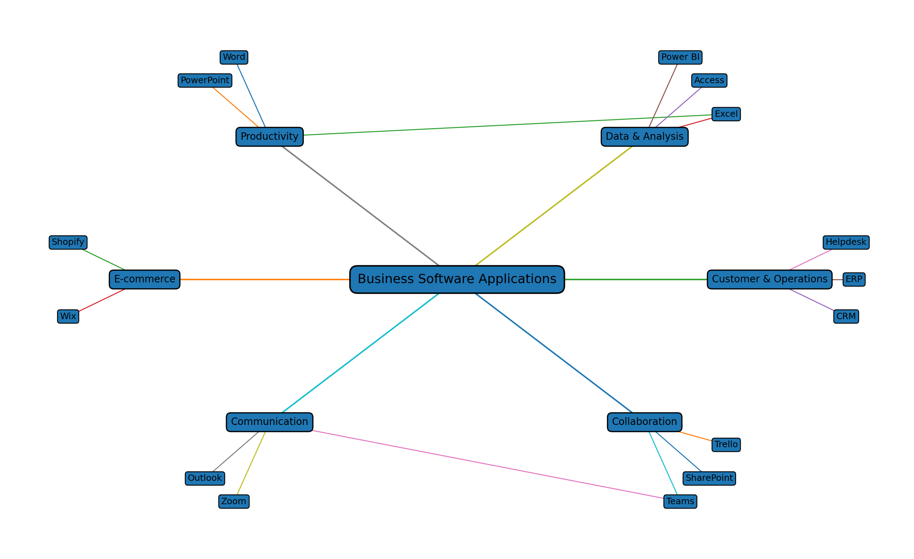
Figure 1: Mind map of contemporary software applications used to support business operations.

Task 3: Office Applications for Creating, Storing, Presenting and Analysing Information/Data

3.1 Microsoft Word
Microsoft Word is a word-processing programme with which one can create, edit, format, store and share business documents; it offers facilities for the use of templates, text formatting, tables, images, references, reviewing and collaboration. According to Microsoft, Word is a tool that enables documents to be created from blank files or templates, with text and media being added, documents being shared and changes being tracked [6]. Templates are especially useful in the case of documents that occur regularly since a business can set up a standard format once and then reuse it [7].
Word is suitable for use in business for preparing reports, letters, policies, meeting minutes, contracts, procedures and internal communications. The use of styles and headings helps to ensure consistency, and tables can be used to organise information that is structured. The 'Track Changes' feature aids review processes since colleagues are able to suggest changes and then accept or reject them [8]. Moreover, Word allows for real-time co-editing when documents are shared in the correct way, thereby decreasing the need to circulate several versions [8].
One of the key advantages of Word is its flexibility; it is something that many employees are familiar with and can be used for a variety of documents, from brief letters to extensive reports. The program's templates and formatting facilities can enhance the professional appearance of a document. However, it is not intended to take the place of a relational database or a specialised data-analysis program. With very large datasets management can become a problem and careless use of formatting may result in inconsistent documents. Moreover, version control can become difficult when users save a number of local copies rather than using a common storage system.

3.2 Microsoft PowerPoint
PowerPoint is software for the purpose of communicating information by means of slides and enables users to combine text, images, charts, audio, video, SmartArt and other visual elements. Microsoft has identified features including animations, transitions, pictures, charts, video, presenter view and speaker notes [9]. SmartArt can be used to show visual depictions of relationships and hierarchies [10].
In a business context, PowerPoint can be put to use in sales presentations, staff training sessions, project updates, financial reviews and management meetings. It is easier for charts to show trends than for large tables to do so, and speaker notes enable the presenter to keep the supporting points separate from those on the slides which are faced by the audience [11]. Presenter View is useful in situations where a presentation is being given to a second screen since the presenter can see the notes and the presentation controls while the audience sees the slides [11].
Its greatest benefit lies in the fact that it can convert information into a structured visual narrative, which helps in communication when the audience has to grasp a small number of key messages. Yet it is possible to misuse PowerPoint; having too much text, using excessive animation, or failing to establish a good visual hierarchy can make a presentation hard to follow. It may also lead to oversimplification since complex business information can be reduced to just a few bullet points. For this reason, PowerPoint should be used to support a clear message rather than act as a replacement for detailed analysis.

3.3 Microsoft Excel
Excel is a programme intended for entering, calculating, analysing and presenting data, and it includes formulas and functions as well as tables, charts, sorting and filtering facilities, conditional formatting and PivotTables. Microsoft regards Excel as a tool for carrying out calculations and for data analysis and offers functions such as IF and VLOOKUP together with PivotTable capabilities [12].
Excel is so useful in a business context since a great many operational procedures deal with structured numerical data; examples are sales tracking, budgeting, keeping records of stock, assessing staff performance, forecasting and carrying out customer analysis. Formulas eliminate the need for repeated manual calculations and enable the results to be updated whenever there is a change in the original data. Charts can assist managers in spotting trends, and PivotTables can be used to summarise large tables and to show comparisons and patterns [13].
One of the main advantages of Excel is its flexibility, since it is possible for a user to produce a basic worksheet rapidly and then turn it into a more advanced analysis. At the same time, this flexibility is a disadvantage as badly designed spreadsheets may include wrong formulas, duplicate data or inconsistent formats. Moreover, complex workbooks can be hard for another employee to understand and keep up to date. Excel must therefore have clear headings, consistent data types, validation, documentation and the proper access controls.

3.4 Microsoft Access
Microsoft Access is a program for managing databases and for storing structured information. Different from a simple spreadsheet, it is based on tables and the relationships between them. It includes tables for storing data, queries for retrieving or altering information, forms for entering data and reports for showing the results [14]. The use of relationships enables related records to be linked together across different tables, thus avoiding unnecessary duplication [15].
For instance, a small business could set up individual tables for customers, products and orders. Each customer would have their own customer ID, and an order could refer to that ID in order to link the transaction with the customer. A query could be used to get the orders for a certain period, while a report could show the totals in a structured way. Furthermore, forms can simplify the process of entering data and can also help in controlling the way users interact with the database [14].
The greatest advantage of Access is that it can deal with related information in a more systematic way than a simple spreadsheet; it is appropriate in cases where the data has definite relationships and when users need reusable queries, forms and reports. A disadvantage is that Access demands more knowledge of databases than Word or basic Excel and it might also be less suitable for very large enterprise databases or for highly distributed applications; in those situations a dedicated database management system would be more appropriate.

3.5 A comparison of the four office applications
The four programmes carry out different yet complementary functions: Word is best suited to structured written communication; PowerPoint is best for visual presentations; Excel is good at carrying out calculations and performing flexible data analysis; and Access is good at managing related records within a database. A business is not necessarily obliged to pick one application rather than another; instead the applications can be part of a workflow.
For instance, the sales department might keep detailed information about customers and their orders in Access, export the relevant information to Excel for analysis, prepare a management presentation in PowerPoint, and write a formal report in Word. This example shows that software should be chosen according to the task rather than because of the popularity of the application.

3.6 Practical test 1: IF function in Excel
In order to carry out the practical simulation, a fictitious sales dataset was created with no real customer or employee information being included. The dataset had columns for Employee ID, Salesperson, Sales Amount and Target Status. An example target amount of £5,000 was set. The IF function was applied in order to classify each salesperson depending on whether the sales amount had reached the target.
The formula used was:
=IF(C2>=5000,"Target Achieved","Below Target")
The IF function evaluates a logical condition and gives one result if the condition is true and a different result if it is false [16]. Once the formula has been entered in the first row it can be copied down to the other rows. In this way a spreadsheet is able to automate a repetitive business decision. When the sales amount is £6,200 the formula yields "Target Achieved"; when it is £4,200 the result is "Below Target".
It is useful since the manager does not have to check each sales figure by hand. The formula also updates automatically whenever the sales amount changes. It is better, though, to keep the target in a controlled cell rather than retyping it into the formulas in the production workbook, as this makes it easier to make future changes and reduces the risk of inconsistent thresholds.
The screenshots need to include the student's own Excel workbook, together with the formula bar where applicable, and the resulting values as well; the practical evidence shows that the feature has actually been tested and not merely described in a theoretical way.

3.7 Practical test 2: VLOOKUP
The second feature to be tested was VLOOKUP; a small fictitious reference table was made up with the entries Employee ID, Employee Name and Department. There was another transaction table which contained Employee IDs without the department name. VLOOKUP was then used to obtain the department from the reference table.
The formula used was:
=VLOOKUP(A2,$F$2:$H$6,3,FALSE)
VLOOKUP looks up a value in the first column of a selected range and then returns a value from a different column in the same row. Microsoft suggests that FALSE should be used when an exact match is needed [17], since with employee IDs the ID should relate to just one particular employee.
The advantage in practice is that it is possible to retrieve the information without having to type it out each time; in a business context the same idea can be applied to product codes, customer IDs, department codes or price lists. However, VLOOKUP does have some limitations since the lookup value must be in the first column of the range you select and the column from which the result is returned is specified by a number. Microsoft now advises that XLOOKUP should be considered in many cases as it is able to search in any direction and matches exactly by default [17]. That said, VLOOKUP is still an important basic Excel skill and is specifically included in this assessment.
The practical test shows the way in which Excel can combine data from various sections of a workbook and also highlights the importance of using consistent IDs and having well-structured tables. Should an ID be missing or entered incorrectly, the lookup might give an error or an unexpected result; it follows that any automation based on formulas must be checked against the original data.

3.8 The assessment of practical testing
The two tests show examples of different kinds of spreadsheet automation: IF applies a logical rule to each individual record, and VLOOKUP obtains related information from a reference table. Taken together, they illustrate how Excel can cut down on manual work and increase consistency. Yet the reliability of automation depends entirely on the data and formulas involved. Employees must understand what a formula is doing, should use consistent data structures and test results and only then should they use the formulas when making important decisions.

Practical Screenshot Evidence for Task 3

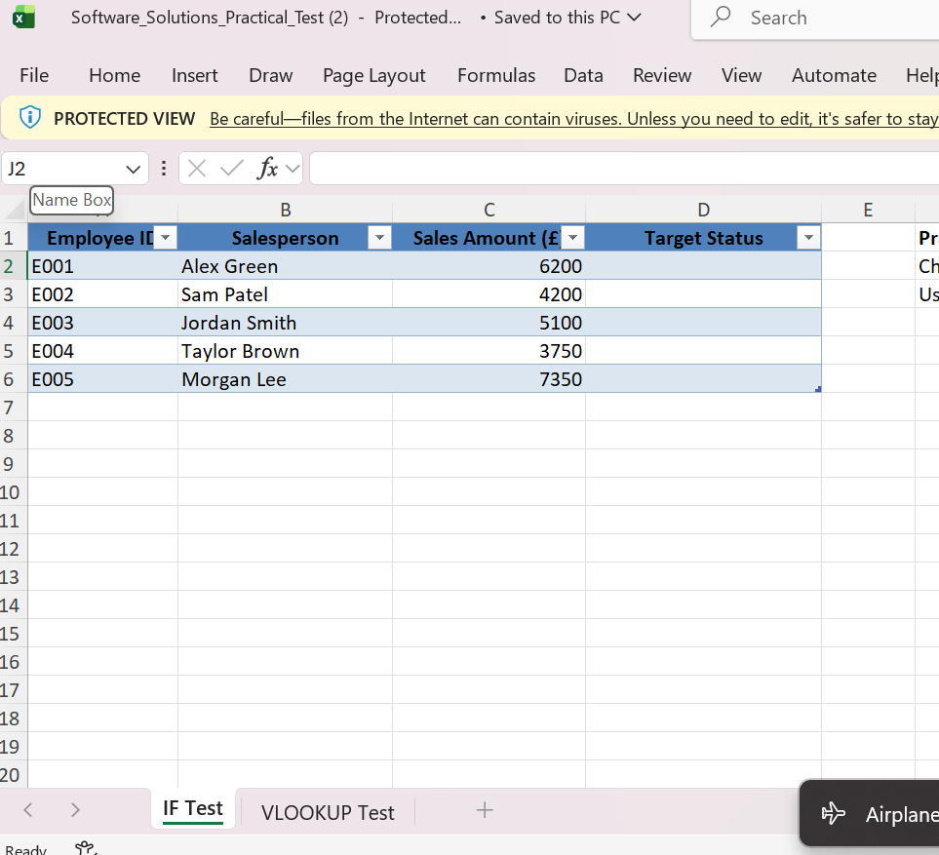

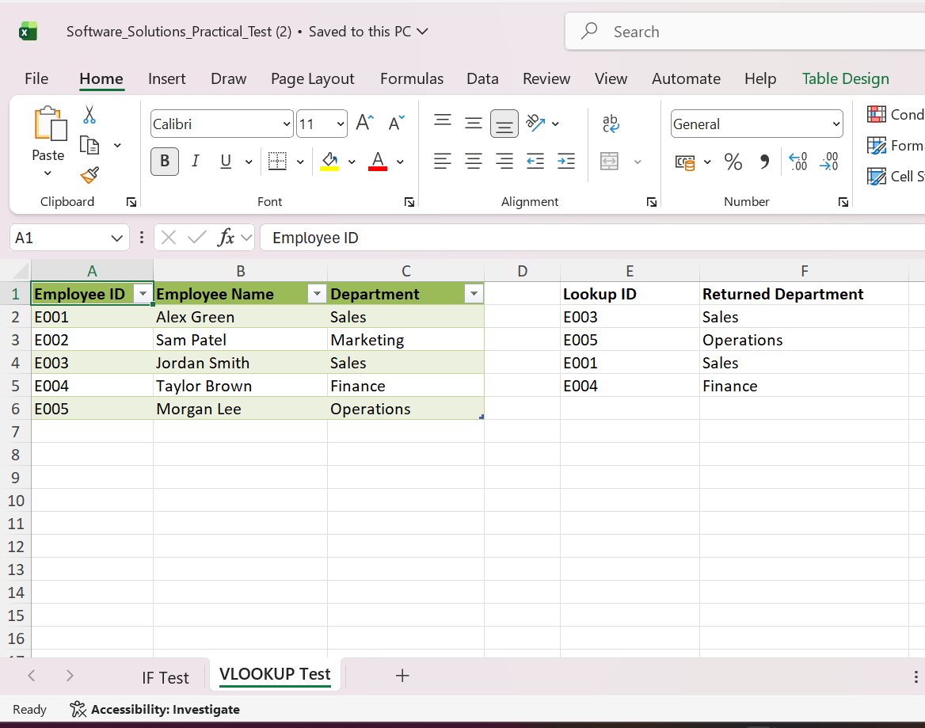

Task 4: Communication and Collaboration Applications

4.1 Microsoft Teams as a tool for communication
Microsoft Teams is a digital communication platform which offers chat facilities, meetings, calls, channels, and the ability to share files. It is thus possible to decrease reliance on separate communication systems since employees will be able to communicate and access shared materials all within the same environment. Microsoft states that meeting chat can be used both before, during and after a meeting, provided that the organisation's settings allow it [18]. It is also possible to use screen sharing to display a screen or a specific window while having a conversation [19].
A notable feature is chat. It is possible for employees to send short messages to one another without having to create a long series of emails. This is useful when dealing with operational questions, for giving out quick updates and for coordinating activities. Meeting chat also offers an additional means of communication since participants can put up information without disrupting the presenter [18].
A further feature is online meetings. With Teams people can take part in meetings using their desktop, web or mobile versions, and Microsoft offers a free version that gives users meeting access even if they do not necessarily need a full account in order to join a meeting [20]. This helps to enable distributed work since employees are not required to be in the same physical office.
It is also important to share files, since teams can do so via chats and channels using permissions to specify who can view or edit the content [21]. Channel files can be linked with SharePoint storage, which in turn provides more structured document management.
The key benefit of Teams lies in its integration feature, since communication, meetings and shared documents can all be gathered together for a team or a project, thus helping to reduce information fragmentation. On the other hand, Teams may produce an excessive number of notifications and conversations when the channels are not well managed, and employees might have difficulty finding important information if all the topics are covered in the same location. It is therefore necessary to have clear naming conventions, the right channels and established communication rules.

4.2 Trello as an online collaboration app
Trello is a visual work management application which makes use of boards, lists and cards. A team may use a board to stand for a project, lists to represent the various stages of the work and cards to stand for individual tasks [22]. The cards can include descriptions, checklists, due dates, attachments and other information [22]. Because of this Trello is appropriate for organising collaborative work in which team members need a shared view of progress.
The greatest advantage of using a visual board is that it provides transparency. Rather than having to depend on individual messages to explain what is being done, the team can see at a glance which tasks are pending, which are currently in progress and which have already been completed. Moreover, a project manager can break down a big activity into smaller cards and assign responsibility for them.
Trello is particularly useful for simple project management because the visual structure is easier to understand than a long text document. It can support marketing campaigns, event planning, content calendars, recruitment workflows and small technology projects. Its limitation is that very complex programmes may require more advanced resource management, reporting or enterprise controls. In addition, a board is only useful when team members update it consistently.

4.3 Comparison
Teams and Trello solve different problems. Teams is primarily useful for communication and information exchange, while Trello is useful for organising work and showing progress. They can complement each other. For example, a project team could discuss a problem in Teams, then record the agreed action as a Trello card. Teams could hold the conversation and shared documents, while Trello could provide the task status.
This separation is valuable because communication and task management are not the same activity. A message such as “the website banner needs updating” can easily be forgotten. Creating a task with an owner and due date makes responsibility clearer. Therefore, a business can gain more value when communication tools and collaboration tools are used as parts of a defined workflow.

4.4 Practical test: Microsoft Teams communication feature
The communication feature selected for testing is Teams chat. A simulated workplace conversation can be created with fictional messages such as “The weekly sales report is ready for review” and “I will check the figures before the meeting.” The test should demonstrate sending a message and, where possible, sharing a non-sensitive sample file or using screen sharing.
The screenshot should show the Teams interface and the fictional conversation without personal or confidential information. The test demonstrates how a short operational update can be communicated quickly to a colleague or team. If screen sharing is tested, a second screenshot can show the sharing controls or the shared window.

4.5 Practical test: Trello collaboration feature
The collaboration feature selected for testing is the creation and management of a Trello card. A fictional project board can be created with lists such as “To Do”, “In Progress” and “Completed”. A card titled “Prepare Monthly Sales Report” can be placed under “To Do”. A checklist can then be added containing “Collect data”, “Check figures”, “Create chart” and “Send report”.
This test demonstrates how collaboration software converts a general objective into visible tasks. Moving the card from “To Do” to “In Progress” and finally to “Completed” provides a simple visual representation of progress. The approach can improve accountability because the team can see what work is outstanding. However, the system depends on users keeping cards accurate and up to date.

4.6 Evaluation
The practical tests illustrate the distinction between communication and collaboration. While Teams facilitates quick interaction and the exchange of information, Trello organises work by breaking it down into tasks and stages. Yet neither of the applications ensures effective teamwork on its own and the organisation must still establish communication rules, define clear responsibilities, assign appropriate permissions, and keep the information up to date. When used together, though, the applications can help to create a workflow in which a discussion leads to an agreed action, the action is recorded as a task, and the task is then monitored until it is completed.

Practical Screenshot Evidence for Task 4
The evidence boxes should be replaced by screenshots taken from the student's actual Teams and Trello practical activities, with only fictional or non-sensitive information being displayed.
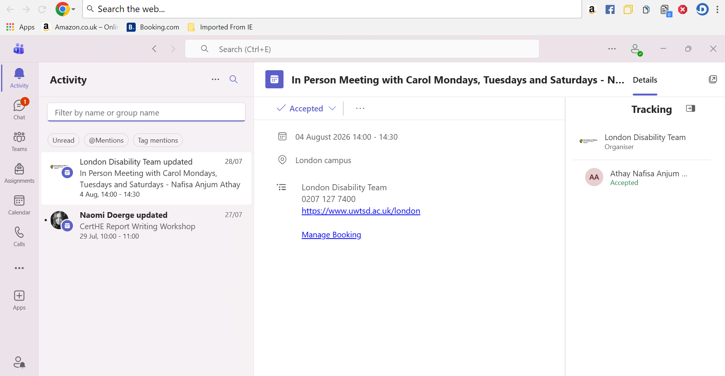
A simulated business chat on Microsoft Teams providing a brief operational update.
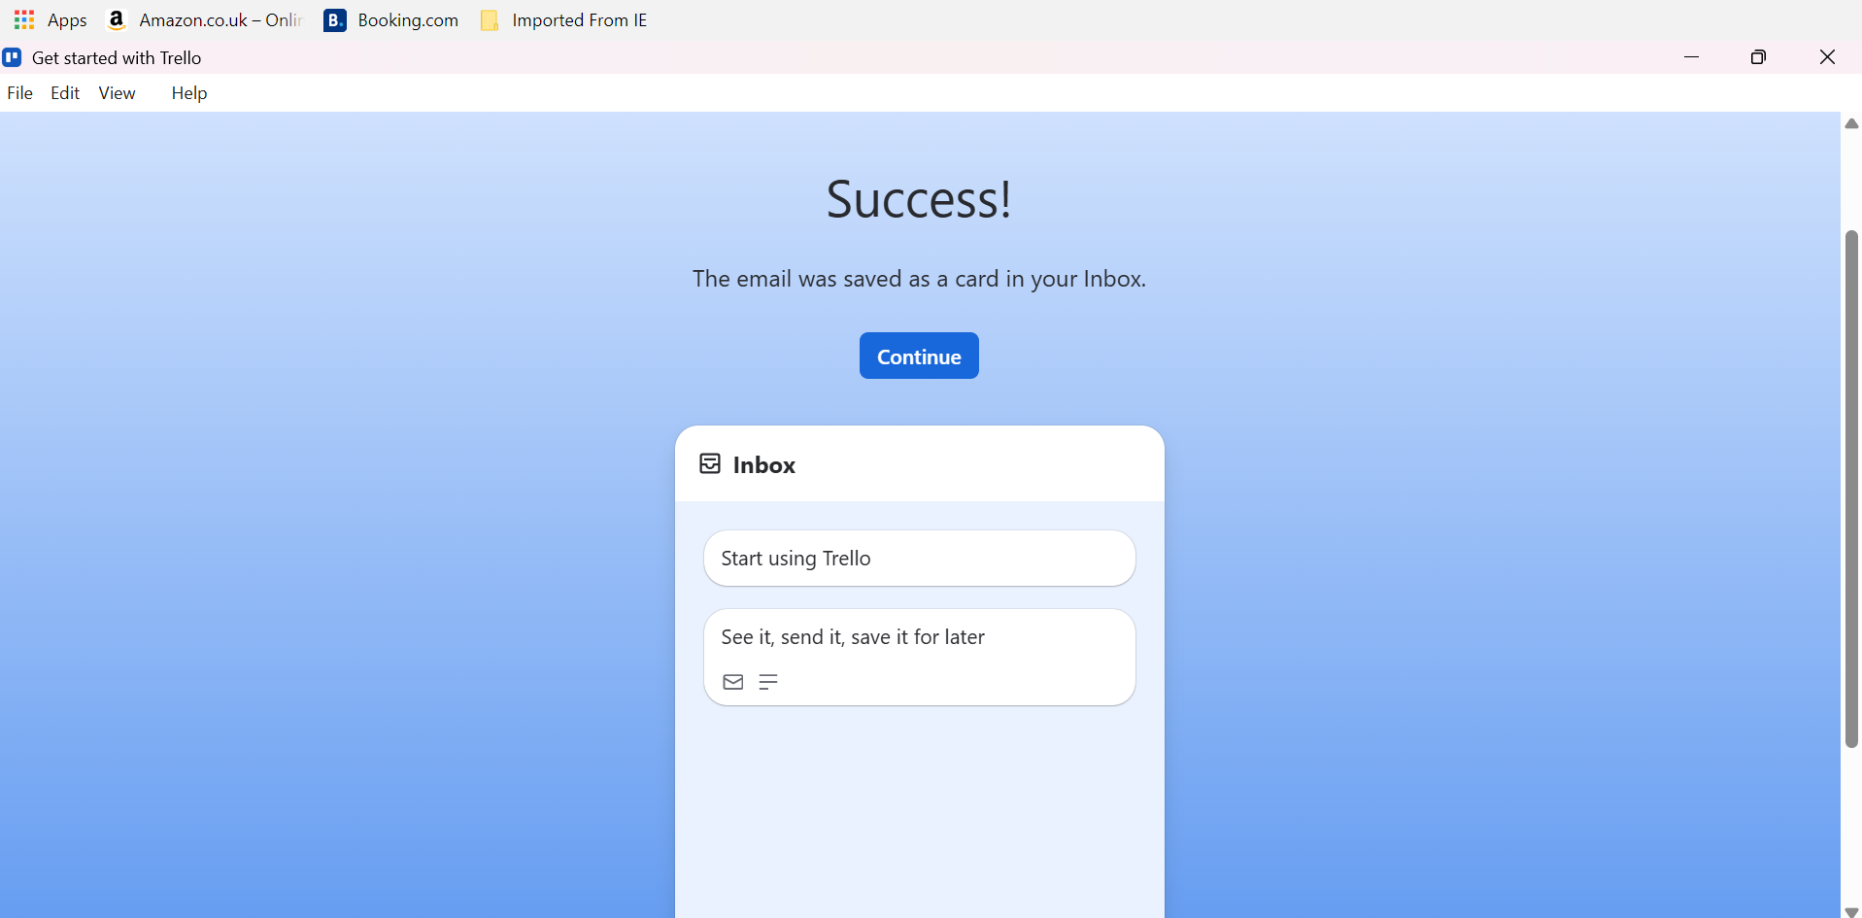

Conclusion
The examples show that different software applications meet different business requirements and that efficient use of technology relies on choosing the right tools for each task. Both Shopify and Wix are able to cut down on the technical work needed when setting up an online sales channel. Mind mapping helps employees to organise their ideas, examine the relationships between them and discuss complex matters before any formal documentation is created. Word, PowerPoint, Excel and Access offer complementary functions for written communication, presentations, data analysis and database management respectively. The practical Excel tests illustrate how the use of IF and VLOOKUP can reduce repetitive tasks and increase consistency provided that the data is properly structured. Lastly, Teams and Trello show the difference between communication and collaboration: Teams can facilitate quick interaction and the exchange of information, whereas Trello can turn agreed work into visible tasks and stages. In all cases, the benefits obtained depend on proper configuration, the users' skills, the quality of the data and clear organisational procedures.

References
[1] Shopify, “Build your online store: Use themes or go headless,” Shopify UK, 2026. [Online]. Available: https://www.shopify.com/uk/online.
[2] Shopify, “Shopify pricing: Find the right plan for your business,” Shopify UK, 2026. [Online]. Available: https://www.shopify.com/uk/pricing.
[3] Wix, “eCommerce features that help you sell more online,” Wix, 2026. [Online]. Available: https://www.wix.com/ecommerce/features.
[4] Improvement Service, “Mind Mapping,” Business Analysis Framework, 2020. [Online]. Available: https://www.improvementservice.org.uk/business-analysis-framework/investigate-situation/mind-mapping.
[5] M. J. Somers, K. Passerini, A. Parhankangas, and J. Casal, “Using mind maps to study how business school students and faculty organize and apply general business knowledge,” The International Journal of Management Education, vol. 12, no. 1, pp. 1–13, 2014, doi: 10.1016/j.ijme.2013.11.001.
[6] Microsoft, “Create a document in Word,” Microsoft Support, 2026. [Online]. Available: https://support.microsoft.com/en-gb/office/create-a-document-in-word-aafc163a-3a06-45a9-b451-cb7250dcbaa1.
[7] Microsoft, “Create a template,” Microsoft Support, 2026. [Online]. Available: https://support.microsoft.com/en-us/word/create-a-template.
[8] Microsoft, “Collaborate in Word,” Microsoft Support, 2026. [Online]. Available: https://support.microsoft.com/en-US/Word/training/collaborate-in-word.
[9] Microsoft, “PowerPoint help & learning,” Microsoft Support, 2026. [Online]. Available: https://support.microsoft.com/en-us/powerpoint/.
[10] Microsoft, “Learn more about SmartArt Graphics,” Microsoft Support, 2026. [Online]. Available: https://support.microsoft.com/en-US/Office/graphics-visuals/learn-more-about-smartart-graphics.
[11] Microsoft, “Add speaker notes to your slides,” Microsoft Support, 2026. [Online]. Available: https://support.microsoft.com/en-us/powerpoint/training/add-speaker-notes-to-your-slides.
[12] Microsoft, “What is Excel?,” Microsoft Support, 2026. [Online]. Available: https://support.microsoft.com/en-us/excel/get-started/what-is-excel.
[13] Microsoft, “Create a PivotTable to analyze worksheet data,” Microsoft Support, 2026. [Online]. Available: https://support.microsoft.com/en-us/excel/get-started/create-a-pivottable-to-analyze-worksheet-data.
[14] Microsoft, “Learn the structure of an Access database,” Microsoft Support, 2026. [Online]. Available: https://support.microsoft.com/en-us/access/learn-the-structure-of-an-access-database.
[15] Microsoft, “Create, edit or delete a relationship,” Microsoft Support, 2026. [Online]. Available: https://support.microsoft.com/en-us/Access/create-edit-or-delete-a-relationship.
[16] Microsoft, “IF function – nested formulas and avoiding pitfalls,” Microsoft Support, 2026. [Online]. Available: https://support.microsoft.com/en-US/Excel/if-function-nested-formulas-and-avoiding-pitfalls.
[17] Microsoft, “VLOOKUP function,” Microsoft Support, 2026. [Online]. Available: https://support.microsoft.com/en-us/Excel/functions/vlookup-function.
[18] Microsoft, “Chat in Microsoft Teams meetings,” Microsoft Support, 2026. [Online]. Available: https://support.microsoft.com/en-US/teams/meetings/chat-in-microsoft-teams-meetings.
[19] Microsoft, “Share your screen in a chat in Microsoft Teams,” Microsoft Support, 2026. [Online]. Available: https://support.microsoft.com/en-us/teams/chat/share-your-screen-in-a-chat-in-microsoft-teams.
[20] Microsoft, “Join a meeting in Microsoft Teams Free,” Microsoft Support, 2026. [Online]. Available: https://support.microsoft.com/en-us/teams/free/meetings/join-a-meeting-in-microsoft-teams-free.
[21] Microsoft, “Share files in Microsoft Teams,” Microsoft Support, 2026. [Online]. Available: https://support.microsoft.com/en-us/teams/files/share-files-in-microsoft-teams.
[22] Trello, “Trello 101: How to use Trello boards & cards,” Trello, 2026. [Online]. Available: https://trello.com/en/guide/trello-101.

