NAME: Josephine Hagan Mantey

Level : 5
Student ID: 1908217

Moodle Code: BMHP5002
Lecturer: Miss Magdalena Wronska

Title: Principles of Health & Social Care Practice

This academic easy , I will examine the person centered care, it’s benefits , limitations, i ethical underpinning in the health and Social care context. I will further be applying person centered care in a Breast Cancer context

A lot of times we meet patients , clients, customers etc who are being cared for or come our way for a particular service or product and the question asked was, was the product or services delivered in the interest of the client with respect to their choices, dignity, respect,empathy or we offered what we had.

Person centered can also be known as patient centered, family centered, user centered, individualized or personalised.

Person-centred care is when a person is cared for in a holistic, flexible, creative, personal and unique way ( Edvardsson, 2015) while a Person centered approach is practiced where a therapeutic relationship is established and fostered between caregivers , patients and families . Person centred care originated from a psychotherapist Carl Rogers , who was the father of person centred used this approach as a counsellor to emphasize the need of rebalancing the client- expect relationship and accept their capacity as self actualisation. Tim Kitwood also brought this approach to caring for dementia.

Person centred care concept involves working with patients needs, their involvement, having empathy and decisions sharing with them.

Theoretical frameworks of McCormark involves;
Interprofessional meeting Space: This is where there is a shared information among professionals , to create and transform their practice.

Prerequisites
This stresses on team attributes such as communicating among team members and patients
The care environment from which the patient is cared.
Person Centred care is based on different types of activities

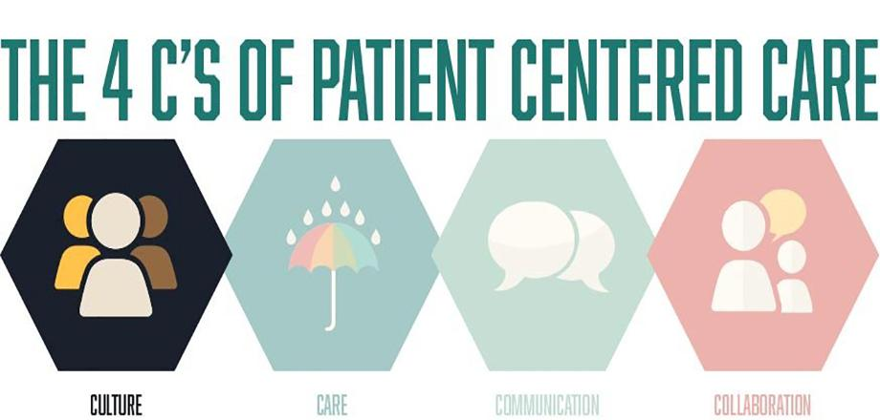

The 4 C’ s of Person Centered Care
Culture : the culture of a particular health care setting has an impact on the person centred care delivered to the patient. Does the organisation understand Preston centredness and what is their driving focus.
Care: The caring and empathetic nature of health caregivers impact positively on person centred approach.
Communication : Effective communication between patients and health care professionals enhances and promotes good treatment and pain control of patients and so when the communication is poor, patients struggle and do not cope well. Things like poor information or inadequate information shared with patients can hinder the effectiveness of person Centred Care
Collaboration : this is how patients and health care professionals are able to work together ( Snowden et al, 2015).

For example, Person centred is when the person being cared for becomes the main focus of the service delivered to her. This is bringing back a patient in the care plan and enforcing

Four Principles that underpin person centred Care includes ;
- Treating people with dignity , compassion and respect: Cancer patients feel anxious and often lose their value of importance when they get into care and so it is important to show them respect their choices and be empathetic. Showing them respect by accepting their preferences goes a long way in their treatment.
- Coordinating of Care , support and treatment: The patient’s care must be coordinated among other health professionals for a clear understanding of their needs, choices and preferences. For instance if a breast cancer patient has had surgery and she is having further medication treatment like chemotherapy or radiotherapy, all patients information should be shared confidentially among both the surgeons and medical oncology team for the appropriate treatment to be administered.
- Offer personalised care, support and treatment: This is where patients care , medications and treatment are customised to suit the patient. These individual different metabolism,immune systems and genetics calls for a customised treatment and therapies for each patient.
- Enabling services users to recognise and develop their strengths and abilities so they can live an independent and fulfilling life. Patients must have control of what they are doing and be involved in their care. Patient having this feel of connecting with the care coordinator

Person Centred Care for a Cancer Patient
This approach for Cancer patients tackles Six fields when attending to them which includes physical comfortability , emotional support, respect for patients choice or preferences and values, integration and coordination, involvement of family and friends and providing information, communication and education to help the patient to understand and be able to make informed decisions about their Care.

When a patient is being referred to a cancer hospital. For healthcare professionals to understand , know and build a relationship with the patient, the above areas are divided into 3 areas in a question. Firstly , patients will be asked after a consultation to understand what was discussed about their treatment options, concerns, their values and are allowed to choose treatment options. Secondly, a holistic needs assessment form is given to each patient stating specifically where they need help or assisted with. For example this could be transportation issues, psychological etc that they need to be assisted with. Thirdly is after the patient indicated their needs , preferences and values, was the assistance provided, did it supported and provided relief etc ( Zucca et al., 2014). For patients to feel empowered through person centred care, East Of England cancer alliance is implementing the Specialist Nurse approach where patients after being discharged from clinic when they finish their treatment are given an open access follow up. Patients get in touch with these nurses if they have any concerns or further appointments.
Person Centred Care has helped to identify issues with inequalities in provision of patient care.

An example of A Holistic Needs Assessment approach for a breast cancer Patient
Every patient is different and as result of this, each patient has a tailored plan and one of the ways used in planning their care in a person centred manner is through the Holistic Needs assessment.

Holistic needs assessment addresses and finds the needs and concerns of a patient in order for them to have personalised and supportive care through their cancer journey. This comes in a form of questionnaires which is given to the patient and after there will be a discussion with the patient and the Specialist Nurse ( www.Macmillan.org.uk, n.d).
Elizabeth Kubler- Ross, a psychiatrist explained 5 stages of grief each cancer patient goes through which were denial, anger, bargain,depression and acceptance.

A female breast cancer patient experiences self esteem issues,the sense of uncertainty and fear, sense of control over their lives alongside with the fact that her condition will bring a lot of changes and that why the Macmillan, UK have designed this approach so that not only the treatment, post treatment and recovery will be addressed but other issues as well through a holistically and comprehensive care plan ( Ng et al., 2017a).

The below image comprises a set of assessment measures which allows both patients and health professionals to reflect on the needs of patients and how best it can be achieved considering the fact that each patient is different.

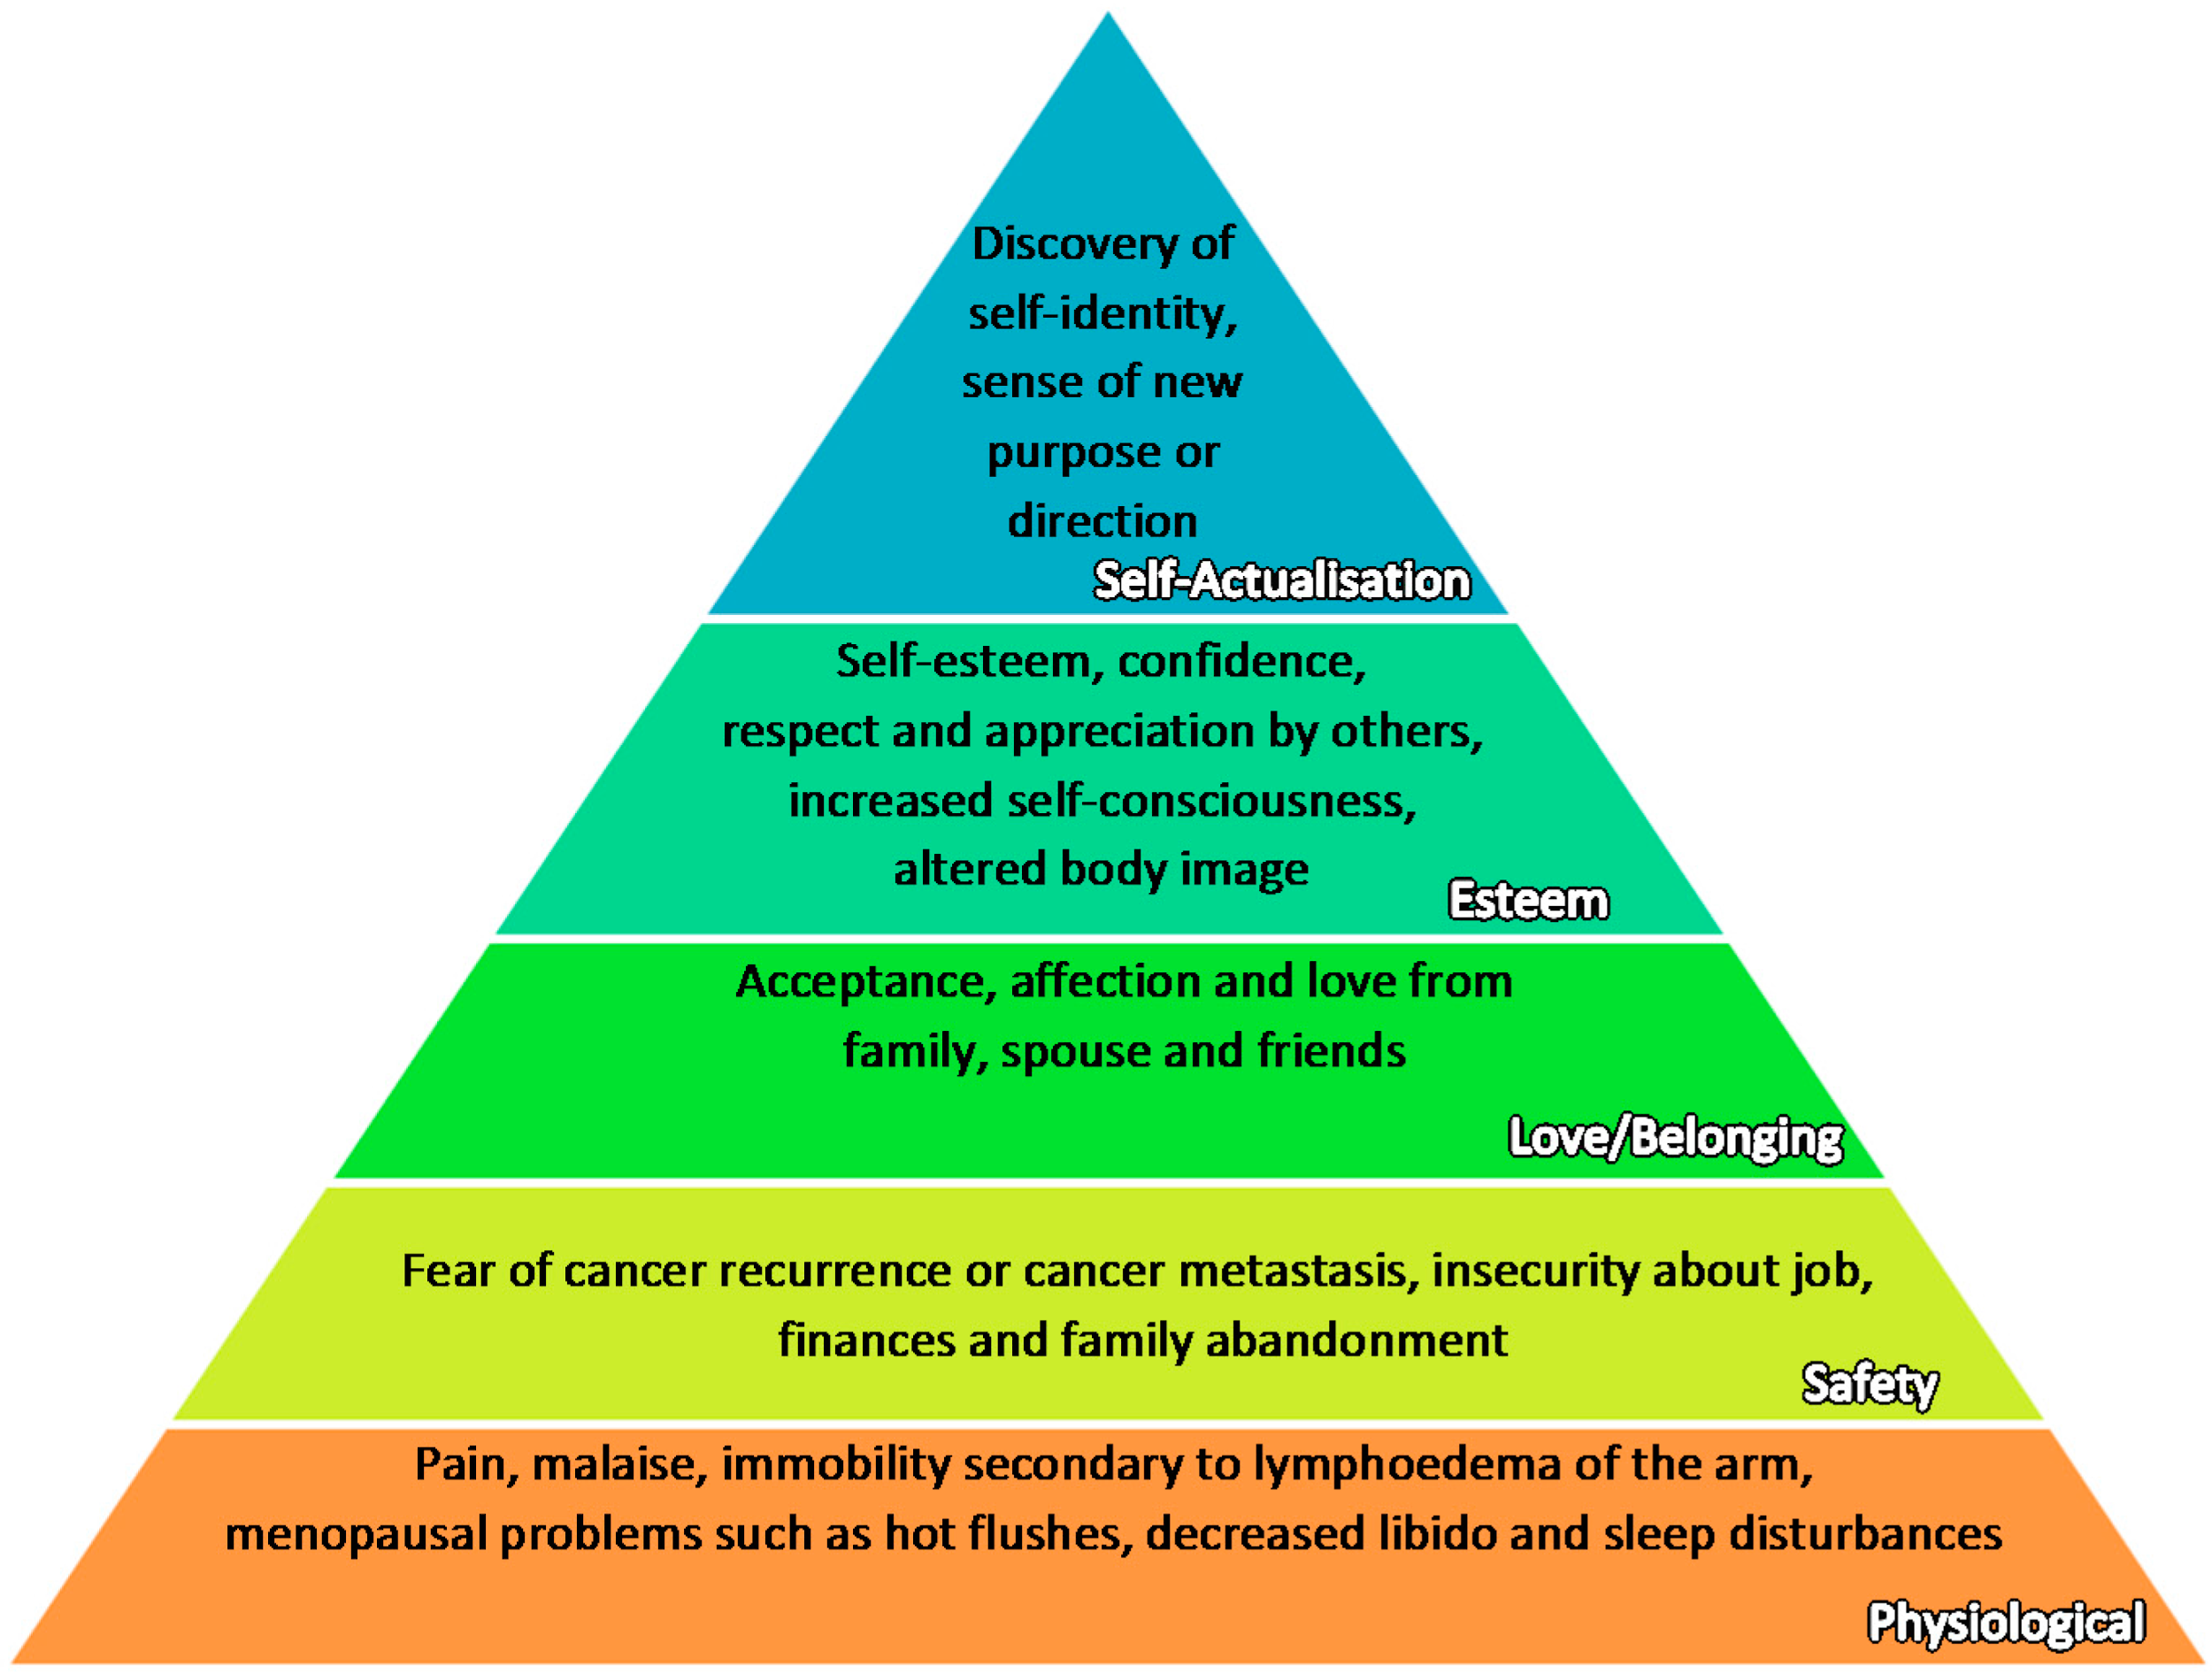
Figure 1. Maslow Hierarchy of Needs applied in the context of breast cancer, with reference from Institute of Medicine (US) (2008), Schmid-Büchi, S. et al. (2008), NCCS Breast Cancer Survivorship Programme (2016).

Patients needs during treatment is holistically classified under:
Side effects management
After surgery such as mastectomy, most patients undergo chemotherapy which has some side effects like osteoporosis nausea, oral ulcers, risk of infection. If it happens that patients are to have radiation, some side effects are skin irritation, early menopause and it’s symptoms ( hot flashes, mood changes etc).

Health care professionals advice during treatment
Patients are given well detailed information and are being signposted to breast cancer centers and helplines ( Macmillan hotline services ). For instance there are a full set of teams who deal with concerns and issues during breast cancer treatment with a section for patients to know what to expect at each point of their journey.

Complementary therapy
It is a conversational treatment along with breast cancer treatment. In line with treating not only the illness but the person in a person centredness, patients are referred to complementary therapies such as massage, acupuncture which a lot patients have testified they were relieved from stress and fatigue ( Breast Cancer Now, 2015).

Psychological management and Social Support
As mentioned, patients go through a lot in their cancer journey, some lose confidence and esteem. For instance one of the fears of women having chemotherapy is loss of hair. So there are counseling sections given the patients to build and reassure them. Sometimes nurses offer wigs for patients to help deal with that fear until hair grows back. This also includes support from family members and so they are included in the care as per patients presence.

Spiritual Care

As part of person Centered care, patients preferences , culture , beliefs and religion have to be respected. In most of the hospitals, they have allocated a place ( mosque & church) of Worship where patients can go and pray. There are imams and priests who offer prayers as per patients' requests.

Holistic needs assessment after Treatment
Most patients become anxious at the end of their treatment. Others feel they will be forgotten and the fear of recurrences. For instance patients are reassessed, reassured and given contact details to get in touch in case of any concerns. Patients are being checked through a follow up end of treatment appointments such as mammogram screening follow up, genetic testing for those eligible etc.
In places like Singapore, they have a Breast Cancer Foundation that educates and empowers patients while in the UK , we have Macmillan Support centers that help and give advice on cancer care after treatment such as information for return to work and knowing their right at the workplace.

Main benefits of person-centred care

Person Centered care is the main reason for developing high Quality care of healthcare. Research previously done according to Catalyst 2017, outlined that Person Centered Care brings uncommon benefits which includes;
Decreases the health services burden and better the health of others.

When patients' needs are the main focus of service delivery in a care center , its burden is reduced. For instance Health care providers will know the right staff to fit in a position other than employing someone who will not be of any use to the patient.

Person Centred Care improves the image or goodwill of a care provider.

Clinicians and non clinical staff become motivated and the increases productivity as a whole. For instance, a private hospital that is Customer centered and provides customized services for their patients means , patients will be happy with the services rendered then their profit margins will increase , staff will be happy with their job etc

Person centred care promotes positive self regard and increases one’s self efficacy.
Criticism and limitations of Person Centred Care
It is non directive . It is biased that person centred care is still intruding even if it does not direct.

The reflection aspect in the person centred care makes it like echoing what the patient says when seen by a clinician or a health professional.

It lacks structure and takes too long. We can see a possible solution for a client but health professionals deliberately do not say it because they would like to stay out of the patient’s way.

Roger claimed it worked for all disorders but it does not.
Person Centered is not easy to implement when families of the patients are not willing to work with the patient and the health professionals ( Epp 2003). In some cases , the families want to control the care while patients are left behind.

Recommendations
When health professionals are empowered with more resources and information, they will also empower the patient . It has to be understood among health professionals and shaped with daily planning.

Conclusion
Person centred care is good but it is limited if it is not integrated with other modalities.

Reference list

Breast Cancer Now. (2015). Complementary therapies. [online] Available at: https://breastcancernow.org/information-support/facing-breast-cancer/living-beyond-breast-cancer/life-after-breast-cancer-treatment/complementary-therapies.

Catalyst, N. (2017). What Is Patient-Centered Care? NEJM Catalyst. [online] Available at: http://bit.ly/HLnejm1117 [Accessed 7 Jan. 2021].

Edvardsson, D. (2015). Notes on person-centred care: What it is and what it is not. Nordic Journal of Nursing Research, 35(2), pp.65–66.

Epp, T.D. (2003). Person centered dementia care. [online] Available at: http://www.livingdementia.com/downloads/newsletters/2010/sep_oct/person-centered_dementia_care.pdf.

McCormack, B., Dewing, J. and Mccance, T. (2011). Developing person-centred care: addressing contextual challenges through practice development. Faculty of Science, Medicine and Health - Papers: part A. [online] Available at: https://ro.uow.edu.au/smhpapers/2471/ [Accessed 11 May 2020].

NCCS - National Coalition for Cancer Survivorship. (2014). The NCCS Definition of a “Cancer Survivor.” [online] Available at: https://www.canceradvocacy.org/news/defining-cancer-survivorship [Accessed 8 Jan. 2021].

Ng, Z., Ong, M., Jegadeesan, T., Deng, S. and Yap, C. (2017a). Breast Cancer: Exploring the Facts and Holistic Needs during and beyond Treatment. Healthcare, [online] 5(2), p.26. Available at: https://www.ncbi.nlm.nih.gov/pmc/articles/PMC5492029/ [Accessed 17 Sep. 2019].

Ng, Z., Ong, M., Jegadeesan, T., Deng, S. and Yap, C. (2017b). Breast Cancer: Exploring the Facts and Holistic Needs during and beyond Treatment. Healthcare, [online] 5(2), p.26. Available at: https://www.ncbi.nlm.nih.gov/pmc/articles/PMC5492029/.

Riddett, J. (2017). Person-Centred Practice in Nursing and Health Care: Theory and Practice (Second edition) McCormack Brendan and McCance Tanya (Eds) Person-Centred Practice in Nursing and Health Care: Theory and Practice (Second edition) 288pp £29.99 Wiley Blackwell 9781118990568 1118990560. Mental Health Practice, 20(6), pp.13–13.

THE HEALTH FOUNDATION. (2014). [online] Available at: http://www.health.org.uk/sites/default/files/PersonCentredCare_IdeasInAction_inbrief.pdf [Accessed 7 Jan. 2021].

www.macmillan.org.uk. (n.d.). Holistic Needs Assessment (HNA). [online] Available at: https://www.macmillan.org.uk/healthcare-professionals/innovation-in-cancer-care/holistic-needs-assessment [Accessed 8 Jan. 2021].

www.youtube.com. (n.d.). East of England Cancer Alliance- Patient Centered Follow Up Guidance - YouTube. [online] Available at: https://youtu.be/F4BKk3mn5xQ [Accessed 7 Jan. 2021].

Zucca, A., Sanson-Fisher, R., Waller, A. and Carey, M. (2014). Patient-centred care: making cancer treatment centres accountable. Supportive Care in Cancer, 22(7), pp.1989–1997.

‌

