
Z
APPENDIX GA36a

LEVEL 4 ASSESSMENT SPECIFICATION

Student name: | Zack Evans | Student ID number: | 1908686
Programme: | B.Sc Computing Portfolio
Module: | Information Engineering
Module code: | ACCB4012 | Contribution to Overall Module Assessment (%):
Lecturer: | B Holland | Internal Verifier: | S Maw
Assignment Title: | Database Design (The Book Store) | Word count (or equivalent): | 2000
Submission deadline: | May 1st 2020 | Return date of provisional marks & written feedback:
Submission method: | All written assessments, where practical and possible, must be submitted via Turnitin unless otherwise instructed by the Lecturer. (Please DO NOT put this assessment specification into Turnitin or it will match many similarities with other students’ submissions.)  Alternative submission method (if applicable):  Late submission of the assessment will result in a late penalty mark. Penalties for late submission: Up to one week late, maximum mark of 40%. Over one week late, 0%. Only the Extenuating Circumstances Panel may approve a change to submission dates.
Academic honesty / referencing: | Academic honesty is required. In the main body of your submission you must give credit to authors on whose research and ideas your work is based. Append to your submission a reference list that indicates the books, articles, etc. that you have used, cited or quoted in order to complete this assessment.

Module Learning Outcomes
(from module syllabus)
Produce systems specifications and use them appropriately in the development of a database design model.

Produce a database solution that involves problem solving techniques to create a prototype application.

TASK DESCRIPTION

The City Book Store has been running successfully in Swansea for many years. The shop has customers from all over the Principality and a number of loyal English, Scottish and Irish fans. They specialise in selling classic titles and new best sellers. In particular they try to look for first editions of many of the classics.

The following points document the working procedures of the book shop: -

- Staff place orders with suppliers (publishers and collectable book dealers). This is carried out mainly by intuition and guessing what the customers may be interested in.
- Customers will also place orders for copies of books, both popular titles and rare first editions. Some of their customers are avid collectors of great literature.
- They have many customers outside the Swansea area and for many years they have operated a mail order service. They publish a newsletter once every three months, detailing current interesting stock and new first additions that they have on their trade register.
- They have a small computer network running throughout the store but it is mainly used for word processing and what could loosely be termed as a data base (a collection of names and addresses of customers typed into one document which isn’t update regularly)

Due to the various factors such a prompt and friendly service and much media coverage of the works of a famous welsh author the company are gaining an ever-increasing customer base. To maintain their level of service, the company has decided that fast information retrieval and processing is a must. They realise it’s time to increase the use of the computer system. They require a user-friendly database system, in MS-Access ©, that will satisfy their processing needs.

Additional information

The database system should be menu driven. The design of the record structure of any tables you use has been left to your discretion.

The book shop would like to use the system to query information for customer seeking out specific titles in particular the classic rare first editions and produce relevant reports on availability.

Although this is a typical stock plus mail order system, the shop would like to maintain its friendly service and customer care that has gained them their reputation. They hope the system will allow for this flexibility.

Guide to Successful implementation of assignment requirements:

Initial design
- Tables successfully created
- Appropriate relationships between table
- Tables populated with suitable data
- Appropriate menus created
- Appropriate forms created
- Appropriate reports created
- Query produced from a single table

Implementation of Successful Querying and use of SQL
- Create relationships using SQL
- Add records to tables using SQL
- Create a relationship (Foreign Key) using SQL
- Produce a Report from a query
- Main Menus and form navigation work together correctly

Use of additional MS-Access functionality

- Produce calculation in a report
- Produce Master and Embedded forms
- Producing reports and forms from a macro query
- Menus are displayed immediately after the database opens

Documentation

Provide suitable user documentation and description of the database function

GUIDANCE FOR Students IN THE COMPLETION OF TASKS

NOTE: The guidance offered below is linked to the five generic assessment criteria overleaf.

- Engagement with Literature Skills
Your work must be informed and supported by scholarly material that is relevant to and focused on the task(s) set. You should provide evidence that you have accessed an appropriate range of sources, which may be academic, governmental and industrial; these sources may include academic journal articles, textbooks, current news articles, organisational documents, and websites. You should consider the credibility of your sources; academic journals are normally highly credible sources while websites require careful consideration/selection and should be used sparingly. Any sources you use should be current and up-to-date, mostly published within the last five years or so, though seminal/important works in the field may be older. You must provide evidence of your research/own reading throughout your work, using a suitable referencing system, including in-text citations in the main body of your work and a reference list at the end of your work.

Guidance specific to this assessment: N/A this is a practical assessment

- Knowledge and Understanding Skills
At level 4, you should be able to demonstrate knowledge of the underlying concepts and principles associated with your area(s) of study. Knowledge relates to the facts, information and skills you have acquired through your learning. You demonstrate your understanding by interpreting the meaning of the facts and information (knowledge). This means that you need to select and include in your work the concepts, techniques, models, theories, etc. appropriate to the task(s) set. You should be able to explain the theories, concepts, etc. to show your understanding. Your mark/grade will also depend upon the extent to which you demonstrate your knowledge and understanding.

Guidance specific to this assessment: Suitable development methods employed and justified. Using the above scenario, ensure that your system includes the following features: -

• User has the ability to add or delete information from any table.
• User should be able to view, on screen, Book, stock, order and customer details.
• User should be able to view ongoing customer orders.
• User should be able to query the system and print out relevant reports.

- Cognitive and Intellectual Skills
You should be able to present, evaluate and interpret qualitative and quantitative data, in order to develop lines of argument and make sound judgements in accordance with basic theories and concepts of your subject(s) of study. You should be able to evaluate the appropriateness of different approaches to solving problems related to your area(s) of study and/or work. Your work must contain evidence of logical, analytical thinking. For example, to examine and break information down into parts, make inferences, compile, compare and contrast information. This means not just describing what! But also justifying: Why? How? When? Who? Where? At what cost? You should provide justification for your arguments and judgements using evidence that you have reflected upon the ideas of others within the subject area and that you are able to make sound judgements and arguments using data and concepts. Where relevant, alternative solutions and recommendations may be proposed.

Guidance specific to this assessment: Provide evidence that the tables will link together in a relational database environment. For this section you should also provide evidence of the design techniques that you have used to develop the database system

You must use design techniques that you have been looking at to develop a suitable solution for the above scenario.

- An Entity Relationship Diagram Showing:
  - Entities
  - Relationships
  - Degree of Relationships
  - Membership Class
  - Annotated descriptions for each relationship

Documentation

Provide evidence that the tables will link together in a relational database environment.
Apply suitable data analysis and design techniques to create a logical design.

- Suitable tables created
- Suitable fields created
- Suitable foreign keys created
- Suitable relationships created
- Tables relate together correctly
- Verify the design meets user requirements
- Table design meets the rules of third normal form (3NF)
- Use references to books, journals, notes and web material used in the completion of the assignment
- Use Microsoft Visio to produce the final ERD document the tables and comment on the results achieved in Visio

- Practical Skills
At level 4, you should be able to apply the basic underlying concepts and principles to evaluate and interpret these within the context of your area of study. You should be able to demonstrate how the subject-related concepts and ideas relate to real world situations and/or a particular context. How do they work in practice? You will deploy models, methods, techniques, and/or theories, in that context, to assess current situations, perhaps to formulate plans or solutions to solve problems, or to create artefacts. This is likely to involve, for instance, the use of real world artefacts, examples and cases, the application of a model within an organisation and/or benchmarking one theory or organisation against others based on stated criteria.

Guidance specific to this assessment: Successful demonstration of software implementation

You are required to implement a database to meet the requirements of the Home From Home Database system using the Entity Relationship Model that you have developed. The system should contain the following:

• Tables (You table design should follow the ER diagram provided but you may wish to add additional attribute field to enhance the design)
• Forms
• Queries
• Reports
• Relationships
• Macros

- Transferable Skills for Life and Professional Practice
Your work must provide evidence of the qualities and transferable skills necessary for employment requiring the exercise of some personal responsibility. This includes demonstrating: that you can communicate the results of your study/work accurately and reliably, and with structured and coherent arguments; that you can initiate and complete tasks and procedures, whether individually and/or collaboratively; fluency of expression; clarity and effectiveness in presentation and organisation. Work should be coherent and well-structured in presentation and organisation.

Guidance specific to this assessment: Documentation
• Front page with name, topic etc.
• Screen Capture from the Relationship Diagram
• Output from all reports
• Screen Capture for each form used
• Evidence of SQL
• Brief user guide

Student FEEDBACK FORM

This section details the extent to which the assessment criteria are demonstrated by you, which in turn determines your mark. The marks available for each category of skill are shown. Lecturers will use the space provided to comment on the achievement of the task(s), including those areas in which you have performed well and areas that would benefit from development/improvement.

Generic Assessment Criteria | Marks available | Marks  awarded
1. Engagement with Literature Skills
.
2. Knowledge and Understanding Skills

 | 25
3. Cognitive and Intellectual Skills

 | 20
4. Practical Application Skills

 | 45
5. Transferable Skills for Life and Professional Practice

All work suitable presented and referenced. | 10

Assessment Mark (Assessment marks are subject to ratification at the Exam Board. These comments and marks are to give feedback on module work and are for guidance only until they are confirmed. ) | Late Submission Penalties (tick if appropriate) |  | %
 | Up to 1 week late (40% Max) |  | %
 | Over 1 week late (0%) |  | %

GENERIC ASSESSMENT CRITERIA

Level 4
In accordance with the Framework for Higher Education Qualifications, at the end of Level 4 students will be expected to have demonstrated knowledge of the basic underlying concepts and principles of a subject, and an ability to evaluate and interpret these within the context of that area of study. They should be able to present, evaluate and interpret qualitative and quantitative data in order to develop lines of argument and make sound judgements in accordance with basic theories and concepts of their subject(s) of study. They will have learned how to evaluate different approaches to solving problems, and will be able to communicate the results of their study/work accurately and reliably, and with structured and coherent arguments. They will be able to undertake further training and develop new skills within a structured and managed environment and will have the qualities and transferable skills necessary for employment requiring the exercise of some personal responsibility.

Level 4 | FAIL | MARGINAL FAIL | SATISFACTORY  (3rd / Pass) | GOOD  (2.2 / Pass) | VERY GOOD  (2.1 / Merit) | EXCELLENT  (1st / Distinction) | EXCEPTIONAL  (1st / Distinction)
Category | 0-29% | 30-39% | 40-49% | 50-59% | 60-69% | 70-84% | 85-100%
Engagement with literature (including reading, referencing,  academic conventions and  academic honesty) | Little or no evidence of reading and/or reliance on inappropriate sources.  Views and findings mostly unsupported and non-authoritative.  Referencing conventions used incoherently or largely absent. | Poor engagement with essential reading. No evidence of wider reading. Reliance on inappropriate sources, and/or indiscriminate use of sources. Heavily reliant on information gained through class contact. Inconsistent and weak use of referencing. | Engagement with a limited range of mostly relevant and credible sources but with some reliance on information gained through class contact. Some omissions and minor errors.  Referencing conventions evident though not always applied accurately or consistently. | Engagement with an appropriate range of literature, including sources retrieved independently. Some over-reliance on texts rather than other sources. Referencing may show minor inaccuracies or inconsistencies. | Engagement with a wide range of literature, including sources retrieved independently.  Selection of relevant and credible sources. Generally sound referencing, with no/very few inaccuracies or inconsistencies. | Engagement with an extensive range of relevant and credible literature. Consistently accurate application of referencing. | Exceptional engagement with an extensive range of relevant and credible literature. High-level referencing skills consistently applied.
Knowledge and understanding (Knowledge of the basic underlying concepts and principles of a subject.) | Major gaps in knowledge and understanding of the basic underlying concepts and principles of the subject matter. Inclusion of irrelevant material. Substantial inaccuracies. | Gaps in knowledge of the basic underlying concepts and principles, with flawed or superficial understanding. Some significant inaccuracies and/or irrelevant material. | Limited knowledge and understanding of the basic underlying concepts and principles within the subject area. Some elements may be missing. | Knowledge of the basic underlying concepts and principles is accurate with a good understanding of the field of study but lacks depth and/or breadth. | Competent knowledge of the basic underlying concepts and principles. Exhibits very good understanding. | Excellent knowledge and understanding of the basic underlying concepts and principles of the subject. | Exceptional, detailed knowledge and understanding of the basic underlying concepts and principles
Cognitive and intellectual skills  (Evaluate underlying concepts and principles of a subject and interpret qualitative and quantitative data in order to develop lines of argument and make sound judgements.) | Wholly or almost wholly descriptive work. Little or no evaluation of the underlying concepts and principles.  Failure to develop arguments, leading to illogical or invalid judgements. Minimal or no use of  evidence to back up views. | Largely descriptive work, with superficial evaluation of the underlying concepts and principles. Weak interpretation of data, flawed development of arguments and judgements. Information accepted uncritically, uses generalised statements made with scant evidence and unsubstantiated opinions. Ideas sometimes illogical and contradictory. | Limited attempt at evaluation of the underlying concepts and principles, tending towards description.  Can interpret qualitative and quantitative data but with some errors. Some evidence to support emerging arguments and judgements but these may be underdeveloped or with a little inconsistency / mis-interpretation. | Good evaluation of the underlying concepts and principles. Can interpret qualitative and quantitative data, with minor errors.  An emerging ability to use evidence to support the argument.  Mostly valid arguments and logical judgements. | Sound evaluation of the underlying concepts and principles. Can interpret qualitative and quantitative data accurately. Ability to devise arguments using evidence to make mostly appropriate and valid judgements. | Excellent evaluation of the underlying concepts and principles. Can interpret qualitative and quantitative data accurately and with some insight. Excellent ability to devise arguments using evidence and make appropriate and valid judgements. | Exceptional evaluation of the underlying concepts and principles based evidence. Outstanding interpretation of qualitative and quantitative data.  Exceptional ability to devise arguments using evidence and make wholly appropriate and valid judgements.
Practical skills  (Different approaches to solving problems in particular contexts.) | Limited or no use of taught, basic methods, materials, tools and/or techniques.  Little or no appreciation of the context of the application.  Very weak evidence of different approaches to problem-solving in particular contexts. | Rudimentary application of taught, basic methods, materials, tools and/or techniques but without consideration and competence. Flawed appreciation of the context of the application.  Weak evidence of different approaches to problem-solving in particular contexts. | An adequate awareness and mostly appropriate application of basic methods, materials, tools and/or techniques.  Basic appreciation of the context of the application.  Can identify problems in particular contexts and propose basic alternative approaches or solutions though there may be errors. | A good and appropriate application of basic methods, materials, tools and/or techniques.  Clear appreciation of the context of the application.  Good evidence of different approaches to problem-solving in particular contexts and proposes mostly appropriate solutions. | A very good application of a range of basic methods, materials, tools and/or techniques.  Very good consideration of the context of the application. Very good evidence of different approaches to problem-solving in particular contexts and proposes appropriate solutions. | An advanced application of a range of taught, basic methods, materials, tools and/or techniques.  The context of the application is well considered, and insightful.  Excellent evidence of different approaches to problem-solving in particular contexts and proposes appropriate solutions. | Exceptional levels of application and deployment skills in particular practical contexts. Outstanding identification of problems in particular contexts and formulation of wholly appropriate, thoughtful solutions / different approaches.
Transferable skills for life and professional practice  (Communicate the results of their study/work accurately and reliably, and with structured and coherent arguments; the qualities needed for employment requiring the exercise of some personal responsibility within a structured and managed environment.) | Work is poorly structured, disorganised, inaccurate and/or confusingly expressed. Very weak use of language and/or very inappropriate style. Failure to work effectively individual or as part of a group. Little or no evidence of the skills for employment requiring the exercise of some personal responsibility. | Work is poorly presented in a disjointed manner. It is loosely, and at times incoherently, structured, with information and ideas often poorly expressed. Weak use of language and/or inappropriate style. Flawed approach to individual or group work, meeting only partial obligations to others. Limited evidence of the skills for employment requiring the exercise of some personal responsibility. | Mostly ordered presentation and structure in which relevant ideas / concepts are reasonably expressed. Work may lack coherence and/or accuracy in places. Can work as part of a group, meeting most obligations to others but perhaps with limited involvement in group activities.  Demonstrates the basic skills for employment requiring the exercise of some personal responsibility, with some areas of minor weakness. | Mostly coherent, organised and accurate work, in a suitable structure and is for the most part clearly expressed. Can work effectively independently and/or as part of a team, with clear contribution to group activities.  Demonstrates the skills for employment requiring the exercise of some personal responsibility, with some areas of strength and some of minor weakness. | Work is accurate, coherent, fluent, well-structured and organised.  Can work effectively independently and/or as part of a team, with very good contribution to group activities. Demonstrates very good skills for employment requiring the exercise of some personal responsibility, with just occasional minor weakness. | Work is coherent, very fluent and is presented professionally. Can work effectively independently and/or as part of a team, with an excellent contribution to group activities. Demonstrates excellent skills for employment requiring the exercise of some personal responsibility with an appetite for further development. | Work is accurate, exceptionally coherent, very fluent and presented well. Can work effectively independently and/or as part of a team, with an exceptional contribution to group activities. Demonstrates exceptional skills for employment requiring the exercise of some personal responsibility with an appetite for further development.

THIS DOCUMENT IS ALSO AVAILABLE IN WELSH

Information Engineering

Database Design – (The City Book Store)

Zack Evans - 1908686

The City Book Store Database

Tables Created
When creating the tables for the City Books Store I had to take into account of Customer data as well as staff data. So I needed to have two separate tables that could be used for foreign keys. Within these tables I we would need to store basic information about staff and customers as well as a unique identifier to actually reference to from other tables.
The two tables created were:
- Staff
- Users
After this we would need to make a table that would help out with the stock / order system where the company could easily manage how many books they have in stock as well as manage when they last ordered a book / edition.
- Stock
This table will be used to store the information about books in stock. This will also store the the quantity, price, what edition of book it is as well as the books title and genre. This would make it easier to check how much stock they have left.
To help out with managing transactions such as customer purchases as well as staff orders we would need a transaction table to would manage these.
- Transactions
This table will be used to manage the different transactions and will be used for two purposes. Manage staff orders for customers. As well as manage customer purchases. This allows us to easily pull out how many books purchases we get from a book. This could bring out good query reports for the Book Shop and help out to decide how much to stock at certain dates or even for new books.
Relating to customers we need to manage the news letters as well as the customers requests.
- Customer_Requests
- Newsletter_signups
These both use a foreign key to the customers table. Newsletter_signups allow the Book Store to easily get a list of Customers and then insert that into the emailing list / mailing list where they customer can receive their newsletter. The customer requests table allows us to manage what customers would want and query upon that to see how much we would need to stock and for the future.
Overall, the tables created are fairly normalised where it stops data from being duplicated.

Rows Created

Customers Table
- ID, Auto Number
- First_Name, Short Text (35 Characters), Required
- Surname, Short Text (100 Characters), Required
- Dob (Date of Birth), Date/Time, Formatted for Short Date (##/##/####)
- Email, Short Text, Validation Rule, Required
- Address, Short Text (255 Characters)
I think the rows setup for this table are fairly straight forward / professional. We restrict the user from entering a mass amount of data that would be useless as well as validate the email field to reduce user error. We also reduce user error by adding a formatting to the DOB field where it only allows inputs that are only valid such as 01/01/2000.
This table will be fairly normalised due to it being easy to reference a record within this table. So that other tables needing customer information will easily be able to reference an id and then pull the information from that.

Staff Table
- ID, Auto Number
- First_Name, Short Text (35 Characters), Required
- Surname, Short Text (100 Characters), Required
- Dob (Date of Birth), Date/Time, Formatted for Short Date (##/##/####)
- Email, Short Text, Validation Rule, Required
- Address, Short Text (255 Characters)
This table is the exact same as the customers table. This helps to restrict data being inputted as well as helps implementing the data into forms and reports easily where customer data has already been implemented.

Customer Requests
- ID, Auto Number
- Book_Title, Short Text, Required
- Edition, Short Text (50 Characters), Required
- Genre, Short Text (50 Characters), Required
- User_Id, Foreign Key, Integer
This table will be used to manage customer requests. We put in the basic information of the Books Title, Genre and Edition. So for this we require all the fields for the Requests. This helps to stop incomplete data. This meets the requirements of user requests where the staff cane easily insert data on what the customer wants.

Newsletter
- ID, Auto Number
- Customer_ID, Number, Required
- Date_of_signup, Date, Required
Due to most the of important information being linked to the customer table. All we need is a foreign key to the newsletter table so that we can gain the customers information when we do a query on all customers within the newsletter. This table is relevant as well as the rows. Since it allows the staff to easily add a customer to the newsletter and check when they were added and easily make a query on that.

Books
- ID, Auto Number
- Book_Title, Short Text, Required
- Edition, Short Text (50 Characters), Required
- Genre, Short Text (50 Characters), Required
- Price, Currency, Required
This table is relevant due to the fact it allows the staff to easily manage stock and do a query on how much stock left they have on a book / edition of a book.

Transaction
- ID, Auto Number
- Book_ID, Number, Required
- Staff_ID, Number, Required
- CustomerID, Number, Required
- Quantity, Number, Required
- Price, Currency, Required
- T_date, Date, Required
- Bought?, Boolean
This table is relevant due to the usefulness of being able to produce Invoices, and other reports from this table. The bought row is used to distinguish between Books bought by customers or if it was supplied by a dealer.

Table Relations

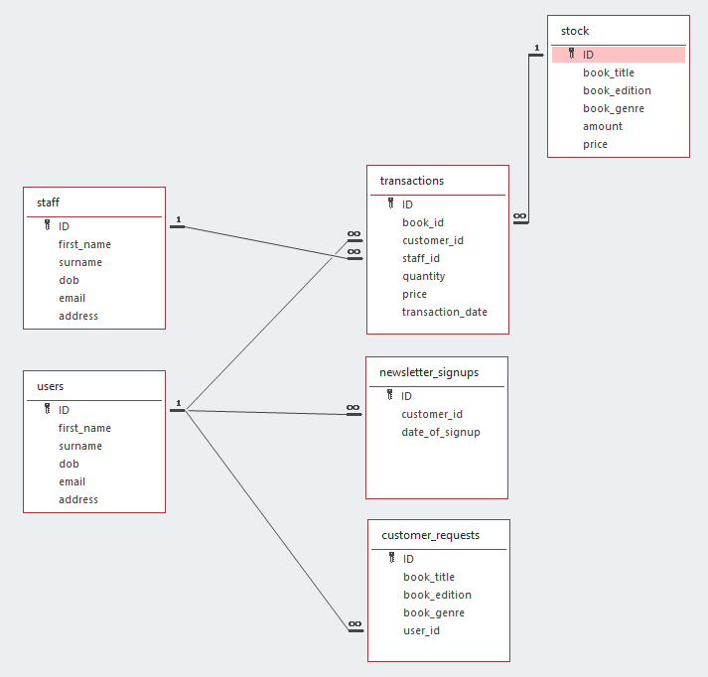

Access Reports

Newsletter Report
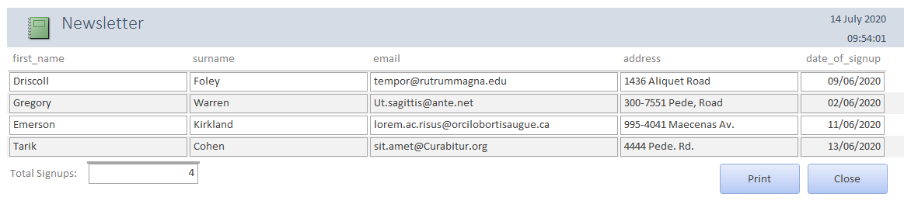
This report is used to check on the Newsletter signups and link the newsletter and customer tables so that we can display the customers name, email and address so its useful to collect all the emails and addresses needed to send out the digital or even physical mail.

Growth Report
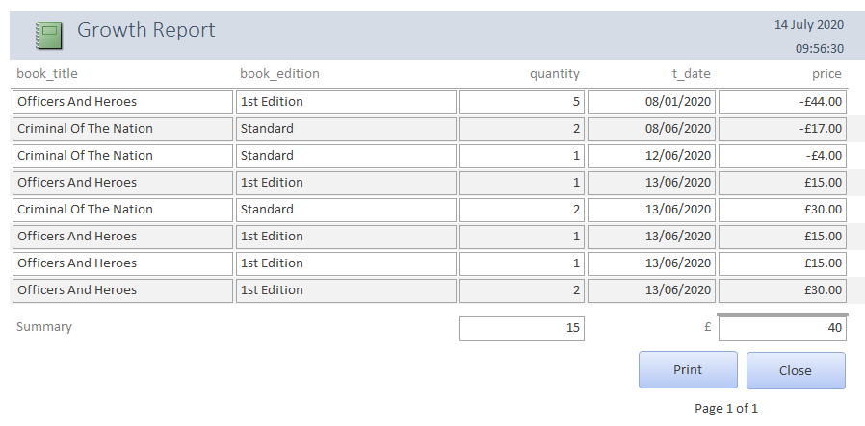
This report is used to manage all purchase’s and sales that the store has made. It also sums up how much they made in that period. This report works by using a query that looks between two dates. The user inserts two valid dates and searches the transactions table for records between those dates. After that it sums up the total amount made, and amount of transactions made within those dates. The report is also ordered by date making it easier to search for a specific purchase.

Expense Report
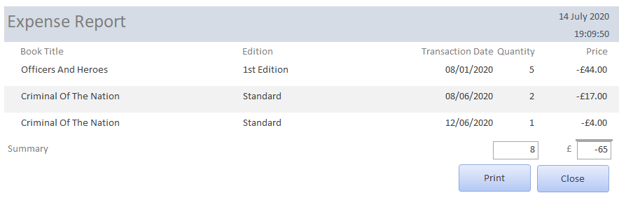
This report can be used to find of the expenses between two dates. Making it easier to manage how much the store is spending at certain dates and even on certain books. Making it easier to bulk buy and possibly save money. This also shows how many books have been bought in the dates.

Access Menus

Main Menu
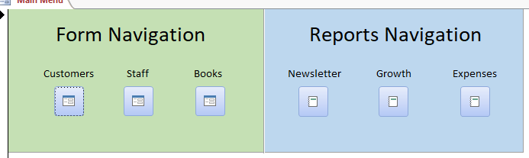
This menu allows the user to navigate to all aspects of the Access Database. If they want to change a record then all they need to do is goto the Form Navigation section. If they want to look at Users signup to the newsletter or even the profit / growth report then they can insert two dates and view the report and also the similar expenses report.

Customers Form
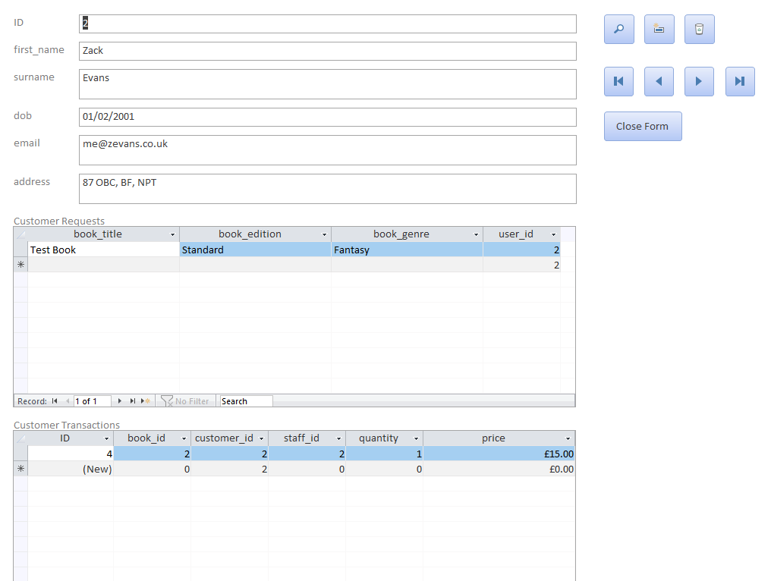
This form allows the user to edit customer details. The macro’s to the right allow the user to search within a field, create a new record, delete a record, navigate around the table and allows the user to close down the form.
The features within this form allows the staff to edit the customer requests table where it automatically inserts the customers id and all the staff needs to do is inser the book title, book edition and genre. If the staff wants to edit the customer transactions then all they need to do is fill in the details and make sure they tick “Bought?”. This specifies if the user bought the book or not. Also inserting a positive number for the transactions table.

Inserting Data
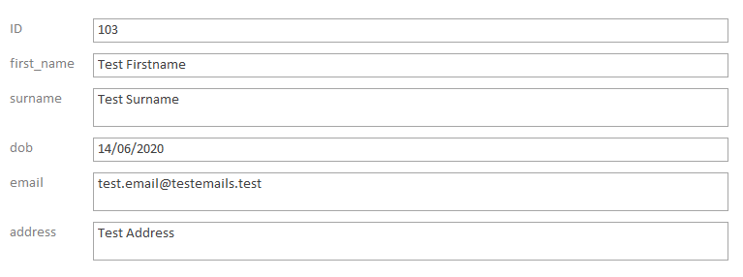
Filling in the users details.
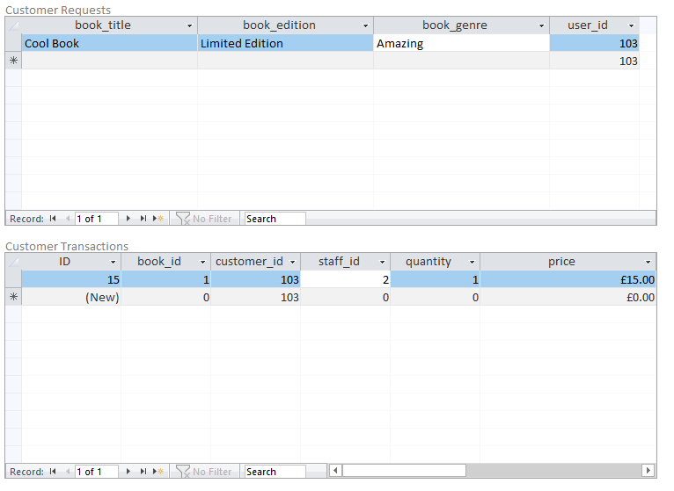
Inserting customer requests and transactions.

Staff Menu
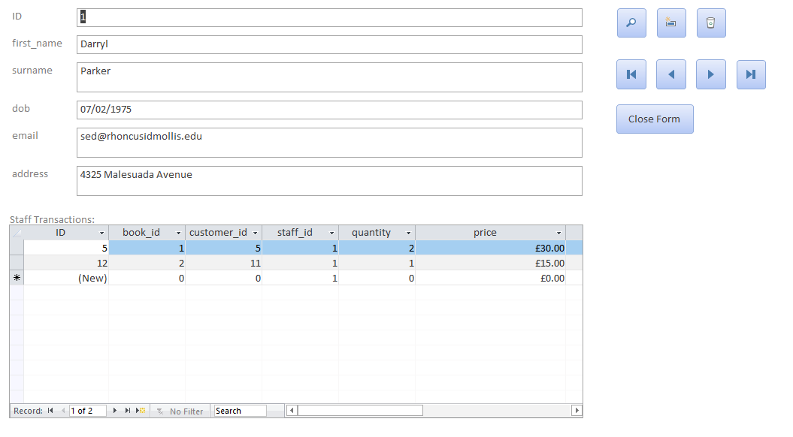
The form is similar to the customer form. The only difference is that the transactions table is the only table staff relate to.

Book Menu
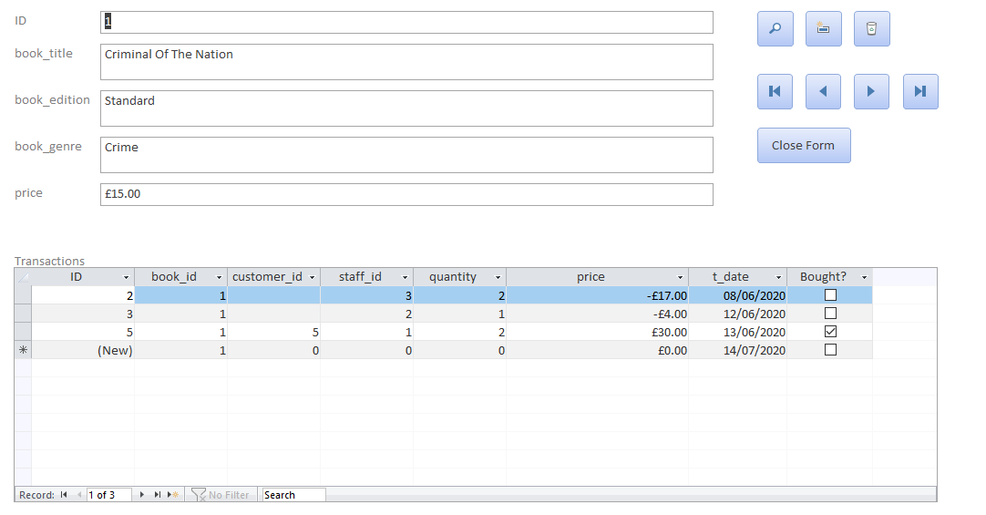
This menu allows staff to look and add, edit and delete books. This means that the staff can edit a typo or even anything about a book. It also allows staff to add transactions to the book. This means if they recently got a order of books delivered, then they can mark down the transaction as a non-bought purchase and put in the quantity as well as the buying price in negative so that it shows on the growth report.

Evidence of SQL

Creating Foreign Key Relationship with already existing table
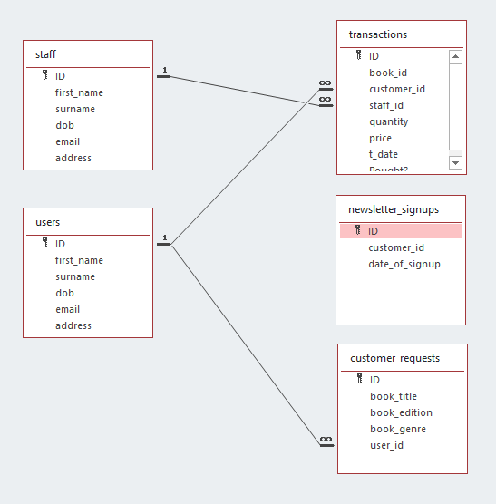
SQL used:
ALTER TABLE newsletter_signups
ADD CONSTRAINT FK_CustomerID
FOREIGN KEY (customer_id) REFERENCES users(id);

After run:
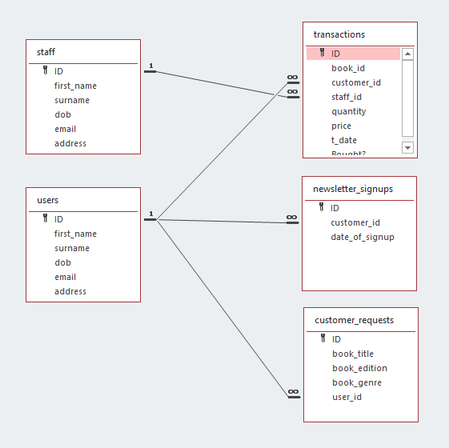

Using this SQL query, I made a One to Many Relation that’s also a Foreign Key between the Users table and the newsletter Signups table. This was all achieved after reading up reference [1].

Insert query into Staff
SQL Used:
INSERT INTO staff (first_name, surname, dob, email, address)
VALUES ('Sam', 'Evans', '06/04/1998', 'testemail@test.test', 'This is an address 123');

Result:
With this query I created a single record within the staff table. This was achieved by reference [2] where I learned how to insert a query via sql.

User Guide
The user guide will be going over the different aspects of the database and how to manage and maintain it. It will go over any issues that might occur. We will be going over the different menus you will face. The ways to use them and how to solve any bugs that may occur. And we will be going over the reports as well and how the business could use them.

Main Menu
The main menu is the navigation main point. It is also the first form you see when you launch the database Where you can go to every Form that can be used as well as the reports.

Customers Form
This form allows you to easily edit the customers record, as well as the Requests that relate to that customer and the Transactions. If you want to add, edit or even delete records relating to the customer then you can easily edit the fields or even use the buttons to create / delete records. Most fields are validated meaning that input errors will be minimised. Make sure before deleting a customer to delete all customer request and transactions relating to that customer. Otherwise you will be prompted a relation error when trying to delete a customer.
To leave the customers form, simply click the “Close Form” button. This will lead you to the main menu form.

Staff Form
Just like customers. The staff form is a duplicate of the customers table where you can simply edit, add, delete staff when needed. This form also allows the user to edit all the transactions that the staff has made. This allows the user to delete, edit and add new transactions relating to the staff member. Make sure that any book purchases for stock are listed as a negative number. This is due to the fact we use these records to calculate the turnover over a certain period. Making it easier to find out how much we are spending and earning.
Make sure before deleting staff to delete all records relating to the staff member or simply update fields to a different foreign key or leave it null.
Just like the customers form. You can simply use the Close Form button to go back to the main menu.

Newsletter Report
This report allows staff to view all clients that have signup to the newsletter. It’s a simple way to retrieve the users name, email and address in a formatted way to easily use.
To print off the report please use the print button and then proceed to the print button within Access to view your printing options.
Just like the forms you are allowed to use the close button to return to the main menu.

Growth / Financial Report
This report prompts you to insert two dates. A starting date and an ending date. From these two dates it checks between the start and end dates to see if any transactions were made within the query. If so then it retrieves the data and displays this in the report. This report also displays the total earnings / losses and the amount of transactions made in that period.
This report can be used for, weekly, monthy and yearly turnovers.
Just like the other report you can simply print / exit the report with the two buttons.

Expense Report
Just like the financial report. This report uses two dates to find the records between the dates. Then it displays the data in the specified dates. But this report is a bit different. This report only shows the expenses. Meaning it is easier to view the amount of books bought, how much they cost overall and how the business could possibly save money.
Just like the other report you can simply print / exit the report with the two buttons.

User ERD
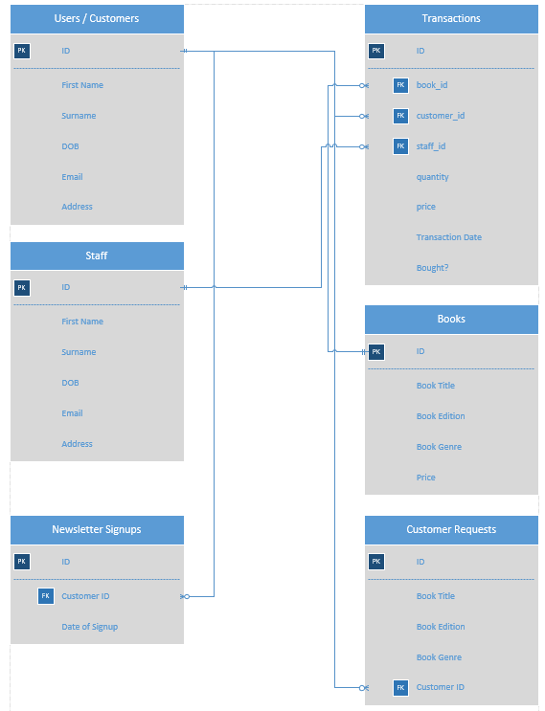

From what I have designed and created in Visio with the ERD. I think the normalisation within the whole database is well done due to no duplicate data can occur. Except for the Request. But this doesn’t matter due to the fact that the data will be deleted when the request has been resolved. It will be transformed into a transaction record where its linked to the books and customer table.

References
[1] SQL Foreign Key: https://www.w3schools.com/sql/sql_foreignkey.asp (w3schools)
This reference is used to learn how to create a relation between two tables within the database.
[2] SQL Insert: https://www.w3schools.com/sql/sql_insert.asp (w3schools)
This was used to learn how to insert a record via sql.

