THE GLOBAL BUSINESS ENVIRONMENT
Environmental Analysis of an industry
Assessment 2

Student name: Nicoleta-Madalina Rusu(2121755)
MODULE CODE : LCCB4005
Lecturer: Dr Nadeem Mirza

Contents
Introduction 3
Background of the Company 3
Changes made by the firm in last few years 4
Environmental concerns raised by Stakeholders 6
Evaluation of changes that might help the firm to gain a competitive advantage 7
Recommendations 9
Conclusion 10
References 11

Introduction
An environmental study assists firms in identifying internal and external elements that may have an influence on their operations, both positively and negatively. The major purpose of this report is to analyse the environment of the chosen company in an effective manner. The report evaluates the change in the fashion organisation in Marks and Spencer that will be discussed. This will help the organisation to sustain its business growth and also its reputation by reducing the issues faced by the company. Further, the effect of stakeholders on M&S will be evaluated in this report and this will help the organisation to regulate its business chain in future. Lastly, an appropriate recommendation will be provided that will help M&S to improvise its previous changes, and gain a competitive position in the desired manner.

Background of the Company
Marks & Spencer PLC, or M&S, is a significant British apparel and food business. The headquarters of the firm are in London. Marks & Spencer originated as a market booth in Leeds, Yorkshire, in 1884. With over 22 million customers per week, the firm is one of the largest merchants in the United Kingdom. However, in today's highly competitive market, the operational management style of a store is critical to gaining a competitive edge and generating profitability (Marks and Spencer, 2022). The company focuses on providing effective quality, good food, hardware, clothing and other homeware items to millions of customers from different parts of the world.
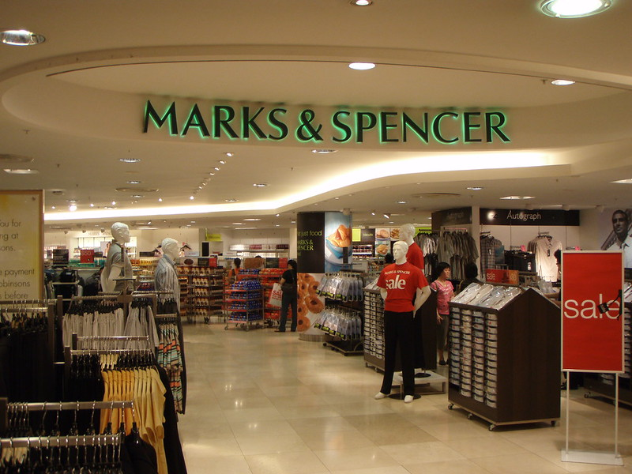
Figure 1 Marks and Spencer
(Source: Marks and Spencer, 2022)

Changes made by the firm in last few years
It has been analysed that Marks & Spencer wants to continue as domestic shopping and clothes migrate online and are delivered straight to the house. With the channel adjustments, the business claims that "rapid changes are the only choice" due to increased competition from discounters in its competitive market sector. M&S's new strategy asks for a £380 million cost reduction through enhanced efficiency and waste reduction, as well as a sped-up closure. They announced the closure of 110 stores yesterday in order to expedite building repairs. They want to spend 27% less money on apparel and pastimes and instead invest in online clothing, house sales, and law enforcement services. Its website accounts for 35% of total regional sales (al Habibi, 2019). The firm has a new shopping centre named Welham Green. According to the corporation, M&S also plans to reclaim its "unique" role in UK family life by "reinforcing essential purchasing goals with new approaches to families and everyday circumstances."
There are various changes that have been adopted by Marks and Spencer and this can be evaluated with the help of the SWOT analysis model.
Strength  - Marks & Spencer's most valuable asset is its brand image, which impacts customer decisions.  - The buyer will rely on a variety of factors to ensure quality. The corporation sells clothing, food, furniture, and money, among other things.  - Customers who believe one item is of the same quality as another are attracted to purchase something else, benefiting the brand.  - They have excellent personnel, which is essential in running a firm. It is beneficial to the company's international presence. | Weakness  - M&S has delayed the introduction of its customer loyalty card. If M&S consumers did not have these cards at all of their other stores, this would be a big problem.  - The majority of the women's clothing was provided by M&S. The vast majority of clients would have been female (Gareche, et al., 2019).  - Women's tastes should have been known to a small number of female executives. Internal squabbles erupted among the company's management.
Opportunity  - M&S has a keen eye for a wide range of items.  - The use of technology in this area would help the corporation to manufacture additional items that would improve the taste of its customers.  - The threat of new rivals is always there in any established organisation. According to company history, M&S lost a trendy market share in Oasis with equivalent spending.  - Others, such as cheap stores and supermarkets, presented a danger to the company's operations. BHS, Top Shop, and ASDA may all represent a threat in this region (Gürel and Tat, 2017). | Threats  - Raw material providers have increased bargaining power when new enterprises enter the market (Gürel and Tat, 2017).  - In reality, if other companies' suppliers have greater trade power, they will produce more revenue than M&S. Customers' bargaining power has always grown in a growing market and with the introduction of new businesses.  - There are now several options on the market when there was previously only one. Buyers' negotiating power has greatly grown.

Environmental concerns raised by Stakeholders
Marks & Spencer's stakeholders include employees, suppliers, consumers, and rivals. Investors and securities regulators are also shareholders in publicly traded companies. These people are worried about timely financial disclosure, the implications of senior management retirements, and ethical difficulties. Businesses must handle certain issues in order to maintain solid relationships with their stakeholders and long-term prosperity (Wilson and Beard, 2014). Some of the major concerns raised by the stakeholder of Marks and Spencer company are as follows:
- Governance: Policy management should address stakeholders' concerns regarding M & S Company's activities and how it safeguards the interests of its shareholders. The same regulations that govern the selection of directors and the involvement of independent directors on pay commissions should apply to publicly listed firms. Standard clearance from a small number of investors is required for private enterprises.
- Ethics: M&S employees should be trained in legal and ethical business practices. In addition to maximising profits, fairness entails acting in the best interests of all parties involved. Not to M&S companies that overpromise or underdeliver. Instead, stakeholders may build trust by setting small goals and consistently reaching or exceeding them (Polman and Bhattacharya, 2016).
- Disclosure: Stakeholders are concerned that a failure to present financial and other facts on time may result in poor judgments. M&S management often responds to investment analysts, shareholders, and the media, and they publish quarterly and yearly financial reports. Financial information should also be made available to partners and employees in order to acquire the trust of stakeholders and resolve shareholder concerns.
- Community: Succession planning is critical for stakeholders concerned with the company's long-term sustainability. Founders, managing directors, and senior executives departed the M & S Company for a range of reasons, including retirement, resignation, or dismissal. The management board of an M&S corporation should appoint a superior commission to fill senior management positions with inner or external candidates. Although internal candidates are frequently familiar with the operations of an M & S firm and may not have a high learning bend, external recruitment may give a fresh perspective and make significant improvements (Jones, et al., 2016).

Evaluation of changes that might help the firm to gain a competitive advantage
Marks and Spencer are recognised across the world for its true significance due to its organised and information-oriented supply chain administration and supplier style management (Marks and Spencer, 2022). Standardization includes a uniform aesthetic, goods consistency, shop design, presentation, and even service programme workers that adhere to a strict code of behaviour. The most significant advantages of standardisation management are the lowering of various management costs and the capacity for consumers to astound Marks & Spencer, enabling it to be more competitive. Marks and Spencer's corporate philosophy is "client loyalty." According to clients, the typical Marks & Spencer items chosen include a diverse range of high-quality and reasonably priced commodities.
Furthermore, as customers' reliance on product design and after-sales services grows, Marks & Spencer has launched a variety of initiatives. In recent years, Marks & Spencer has moved its focus to customer knowledge, an internal management structure for adopting a simple and quick decision-making method, and "purchasing" and "selling" for competitive advantages. Marks and Spencer retail as an industry has its own strategic momentum which can be analysed with the help of Porter's five forces model (Alrawashdeh, 2013).
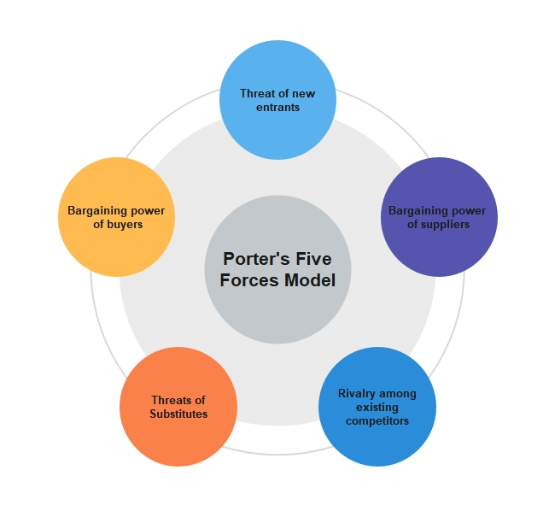
Figure 2 Porter Five Forces Model
(Source: Alrawashdeh, 2013)
- The threat of New Entry: Low-cost retailers are more exposed to the threats posed by new entrants as a result of their contribution to lower retail entry barriers.
- The threat of Substitutes: Most retail products' technological content is not higher, and they are more likely to be simulated, making the alternative more dangerous.
- The bargaining power of Suppliers: The most developed nations' retail and development firms are increasingly bargaining in the retail industry. When raw material suppliers entered the industry, the newcomers gained negotiating leverage. Naturally, if the suppliers to other enterprises have larger trading power, they will create more than M&S.
- The bargaining power of Buyers: In retail marketplaces, customer leverage is becoming more prominent, leading merchants to seek a low-cost, high-quality service strategy.
- Rivalry among competitors: A variety of tissue types, various geographies, and a three-dimensional cross-competitive environment are now formidable retail company competitors (Hove and Masocha, 2014).
M&S retail enterprises have employed a number of strategic tactics to boost efficiency in the face of strong competition. Porter's competitive theory should be used, a strategy developed, and attempts made to address social development.
The competitive advantage and strategic aim of the M&S company are to select target marketplaces, planned optimization, or a collection of market segments to promote its competitive advantage as part of its services. Businesses may be more economically responsive than rivals to suit their demands since they desire a portion of the customer. To prevent powerful front-line competitors, a common method of discovering the weakest link in present rivals by selecting a target market would be disrupted. For market research and market segmentation, the M&S target strategy should be used. Businesses in this market may acquire a competitive edge. The goal of the M&S strategy should take into account the features of the target market, such as the number of stores, the breadth of the product line, and pricing methods (Hove and Masocha, 2014). Both the cost management strategy and the differentiation technique can be utilised concurrently to achieve the aims.

Recommendations
For effective growth and success of Marks and Spencer, there are some commendations that need to follow by the organisation are as follows:
- Using cutting-edge business technology, Marks & Spencer will supply clients with one-of-a-kind services via e-commerce and e-commerce. It needs to extend its overseas activities, mainly in Asian countries such as Nepal, India, and China.
- Despite the global crisis and salary cuts, Marks & Spencer maintains its place in the top 10. Marks & Spencer, on the other hand, must make the firm safer and more stable, since competitors utilise a variety of marketing strategies to keep the business worldwide.
- Marks & Spencer should look for suppliers outside the EU to save money and supply customers with lower-cost items. Marks & Spencer should also restructure their shop so that customers have sufficient space, security, and comfort when glancing, trying on clothes, and making purchases (Hwangbo, et al., 2018). Management at Marks & Spencer will leverage automated production technology to reduce decision-making time. Marks & Spencer is searching for employees who are innovative, passionate, punctual, honest, and trustworthy.
- M&S has made substantial efforts to resolve a number of the issues raised in this report. However, in today's extremely competitive market, M&S should adopt an ideal strategy to growing competition by cutting costs for both people and material resources, researching low-cost laboratories outside, and greatly enhancing service effectiveness and innovation.

Conclusion
According to the above-mentioned research, competitive market circumstances, corporate management practices, and supplying retailers with better sales are crucial for achieving a competitive edge. As the market environment evolves, M&S will update the business plan, and the strategy's ongoing execution will reflect evolving client demands. Porter researches M&S, engages with possible social growth and employs a number of strategies to increase M&S's attractiveness in the worldwide environment for a diverse spectrum of customers. The outcomes of the inquiry and discussion help the fashion industry the most.

References
al Habibi, B., 2019. HR practices of Marks & Spencer, Selfridges, Primark, and Sainsbury’s (Doctoral dissertation, University of Science & Technology).
Alrawashdeh, R., 2013. the competitiveness of Jordan phosphate mines company (jpmc) using porter five forces analysis. International Journal of Economics and Finance, 5(1), pp.191-200.
Gareche, M., Hosseini, S.M. and Taheri, M., 2019. A comprehensive literature review in competitive advantages of businesses. International Journal of Advanced Studies in Humanities and Social Science, 8(3), pp.223-240.
Gürel, E. and Tat, M., 2017. SWOT analysis: a theoretical review. Journal of International Social Research, 10(51).

