
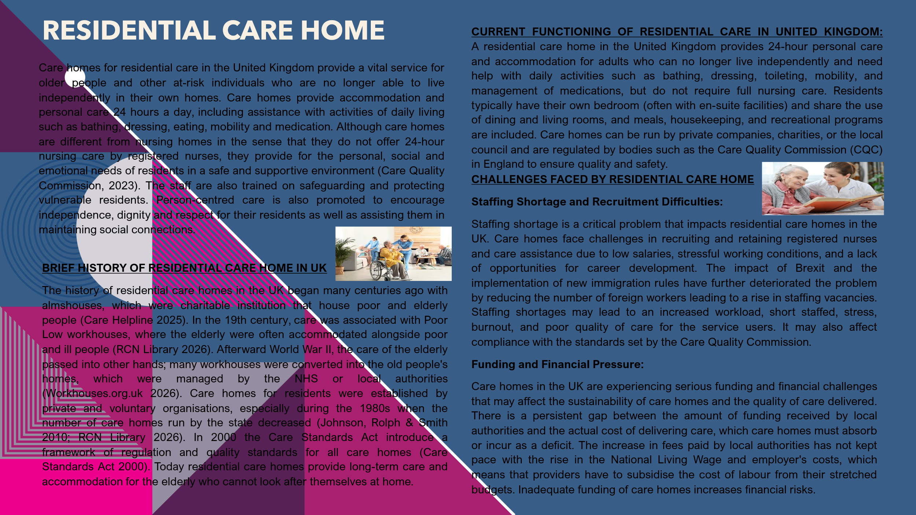
AMBULANCE SERVICES IN UK
A significant component of the healthcare industry is ambulance services. For people who are gravely injured or unwell, ambulance services offer transportation and emergency medical care. Ambulance services have evolved throughout time from basic transportation services to more specialised emergency medical services for people who are seriously injured or acutely unwell, ensuring timely access to appropriate treatment. (WHO 2019). The history of ambulance services, their operation, and their significance in improving people's quality of life will all be covered in this article.
The concept of ambulances has existed for many centuries. In the early days, soldiers were transported from battlefields in carts or stretchers. The first organized ambulance service was established in the late 18th century by a surgeon in Napoleon's army named Dominique Jean Larrey, who designed "flying ambulances" to transport soldiers (History of the ambulance, 2025; Dominique Jean Larrey, 2025)
Organised civilian ambulance services first appeared in the United Kingdom in the nineteenth century. Horse-drawn ambulances were first introduced in metropolitan places such as Liverpool in the 1880s. These ambulance services were occasionally affiliated with hospitals and charity. Later, motorised ambulances supplanted horse-drawn ambulances, which were more efficient
One of the major changes occurred in 1948 when the National Health Service (NHS) was formed. The NHS provided free access to healthcare for all people in the UK at the point of use, funded through general taxation (DHSC 2018; The National Archives n.d.). The ambulance service was also incorporated into the new national system, bringing emergency care and patients transport under public provision. This meant that emergency care and transport were available to all people, not just those who could pay for it. (NHS England, n.d.; The National Archives, n.d.)
Today, Ambulance services in England and the UK are now staffed by highly trained emergency responders. Medical services. There are no longer only transit providers. Paramedics and Emergency medical technicians (EMTs) Trained to evaluate patients, provide lifesaving care and make informed judgements. The ideal destination for care.
When an individual calls 999, the call is answered by a control centre. The individual's call is evaluated by a triage system to establish the level of urgency. The most urgent calls, such as cardiac arrest, are responded to immediately. Ambulance services offer care such as CPR, oxygen therapy, defibrillation, pain medication, and wound management.
Additionally, contemporary ambulance services collaborate with other NHS departments. Patients are sometimes treated in their homes rather than in hospitals. In addition to making patients more comfortable, this strategy lessens the strain on emergency rooms (NHS England, 2023). In addition, the ambulance service responds to significant incidents, mental health conditions, and traffic accidents.
However, the ambulance services are currently dealing with a few problems. The longer waiting times could be due to hospital delays, lack of staff, and demand. The waiting times that are longer than the national response times have been observed (BBC, 2023). The ambulance crew is continuing critical care despite everything.
Ambulance services are important in improving the quality of life of the users of the services. First, they save lives. Quick medical attention during emergencies such as heart attacks and strokes can prevent deaths and disabilities. Early medical attention can make a big difference in the recovery process.
Ambulance services bring comfort to the public. The community is assured of their safety due to the availability of ambulances at all times of the day and night. This is especially important for the elderly, the sick, and families with young children.

References: Task 1
Care Helpline (2025) A history of care homes. Available at: https://www.carehome.co.uk/advice/a-history-of-care-homes (Accessed: 19 February 2026).
RCN Library (2026) Care Homes: Subject Guide. Available at: https://www.rcn.org.uk/library/Subject-Guides/care-homes (Accessed: 19 February 2026).
Workhouses.org.uk (2026) The end of the workhouse/Workhouses history. Available at: https://www.workhouses.org.uk/ (Accessed: 19 February 2026).
National Assistance Act 1948 (1948) Wikipedia. Available at: https://en.wikipedia.org/wiki/National_Assistance_Act_1948 (Accessed: 19 February 2026).
Johnson, J., Rolph, S. and Smith, R. (2010) ‘Uncovering history: private sector care homes for older people in England’, Journal of Social Policy, 39(2), pp. 235-253.
Care Standards Act 2000 (2000) Wikipedia. Available at: https://en.wikipedia.org/wiki/Care_Standards_Act_2000 (Accessed: 19 February 2026).
Care Quality Commission (n.d.) Service types: residential care homes. Available at: https://www.cqc.org.uk/guidance-regulation/providers/regulations-service-providers-and-managers/service-types (Accessed: 19 February 2026)

References: Task 2
BBC (2023) Ambulance waiting times and NHS pressures. Available at: https://www.bbc.co.uk/news/health (Accessed: 21 February 2026).
NHS England (2023) Ambulance services and urgent emergency care. Available at: https://www.england.nhs.uk/urgent-emergency-care/ (Accessed: 21 February 2026)..
World Health Assembly (2019) Emergency care systems for universal health coverage: ensuring timely care for the acutely ill and injured. Geneva: World Health Organization. Available at: https://apps.who.int/gb/ebwha/pdf_files/WHA72/A72_R16-en.pdf (Accessed: 21 February 2026
Dominique Jean Larrey (2025) Wikipedia. Available at: https://en.wikipedia.org/wiki/Dominique_Jean_Larrey (Accessed: 18 June 2025
History of the Ambulance (n.d.) Liverpool Medical Institution. Available at: https://www.lmi.org.uk/history-of-the-ambulance (Accessed: 19 February 2026).
National Health Service Act 1946 (n.d.) Wikipedia. Available at: https://en.wikipedia.org/wiki/National_Health_Service_Act_1946 (Accessed: 19 February 2026).
History of the National Health Service (n.d.) Wikipedia. Available at: https://en.wikipedia.org/wiki/History_of_the_National_Health_Service (Accessed: 19 February 2026).
NHS England (n.d.) Milestones of the NHS. Available at: https://www.england.nhs.uk/about/nhs-history/ (Accessed: 19 February 2026).
NHS ambulance services (n.d.) Wikipedia. Available at: https://en.wikipedia.org/wiki/NHS_ambulance_services (Accessed: 19 February 2026).
London Ambulance Service (n.d.) Wikipedia. Available at: https://en.wikipedia.org/wiki/London_Ambulance_Service (Accessed: 19 February 2026).

