4/22/2019
Liam Salter
Student Number: 1702256
Course: Web Development
Application Development Report

Table of Contents
1. Abstract. 2
2. Application Development Concepts (Task 1). 2
2.1. Security Vulnerabilities – Risks, Impact and Countermeasures. 2
2.2. Relevant Software Design Pattern. 3
3. Requirements (Task 3). 3
3.1. Introductory description of the application and target audience. 3
3.2. Primary requirements. 4
4. Design. 4
4.1. Design Principles followed. 4
5. Implementation. 5
5.1. Models, Views and Controllers used. 5
5.2. Screenshots of all completed pages. 5
6. Evaluation. 6
6.1. Verification and Validation. 6
6.2. Final evaluation of the program. 6
6.3. Reflection. 6
7. Appendices. 7
7.1. Appendix 1. 7
7.2. Appendix 2. 7
7.3. Appendix 3. 8
7.4. Appendix 4. 8
7.5. Appendix 5. 9
7.6. Appendix 6. 9
7.7. Appendix 7. 10
7.8. Appendix 8. 10
7.9. Appendix 9. 11
7.10. Appendix 10. 11
7.11. Appendix 11. 12
References 13

Abstract.
This report discusses application development concepts by detailing security vulnerabilities, the risks, impacts and countermeasures of these security risks, a relevant software design pattern is detailed. Application requirements were discussed by introducing the application and detailing the primary requirements of the app. Relevant software design principles are detailed. Implementation is discussed by detailing the models, views and controllers used and screenshots of the application are provided. Finally, an evaluation of the application is discussed by testing and validating the application, a final evaluation of the application is detailed and finally a reflection and future features discussion takes place.

Application Development Concepts (Task 1).

Security Vulnerabilities – Risks, Impact and Countermeasures.
As technologies continue to develop and evolve within web application development, the amount of potential security flaws and vulnerabilities will also grow. One of these security vulnerabilities is SQL Injection. SQL Injection is one of the earliest forms of web hacking created and still is one of the most common forms of web hacking. SQL Injection commonly occurs when a web app asks for user input, such as login credentials. However, instead of inputting user details, an appropriate SQL statement is used instead, and the database behind the website can read an execute said statement. The most common example of an SQL Injection attack statement would be: " or ""=" [1]. The impact of SQL Injection can be devastating towards the database(s) behind the web app. One such impact would be unauthorised access to certain areas of the web app and the database, which can be detrimental to user personal data and privacy. Another impact which is far worse is that the database can be directly altered. In a worst-case scenario, the “DROP” SQL statement can be used to drop the entire database and all stored information along with it. A common method of countering SQL Injection would be to add parameters to the input form which do not allow certain special characters, such as quotes, mathematical equations etc.
Another potential security vulnerability which web applications face is Cross-Site Scripting, also known as XSS. As detailed in a journal written by Dr. Felician Alecu, Lecturer of the University of Bucharest, like SQL Injection, XSS is one of the more common forms of web hacking. XSS is a method web hacking where an attacker attempts to steal sensitive data from users by infecting web applications with malicious scripts. XSS typically aims to utilise dynamic web pages that are interpreted by web browsers, this means that the malicious scripts will be input on the web page, such as “<script>DoSomethingMalicious()</script>”, however the scripts will be executed on the hosts local machine, the sensitive information is quietly collected in the background then finally the information is sent back to the attacker [2]. The impact of XSS is devastating to a victims personal/private information as this information is quietly collected and sent away without the victims’ knowledge. This could lead impacts such as account hijacking if website account information is stolen, identity fraud if personal information is stolen, monetary fraud if the banking details are stolen etc [3]. There are 3 primary methods to counter XSS. The first method being ‘Escaping’. Simply, this method utilises escaping user input all together. If the user cannot input any data, malicious external scripts cannot be executed. Another method being ‘Validating Input’. This method is very similar if not identical to method to prevent SQL Injection, where certain characters are not allowed if there is user input available on the web application. The third method of prevention is known as ‘Sanitising’. This method involves accepting user input, however before input reaches its destination, the data is scrubbed clean of any potential mark-up, which is then replaced by an acceptable format [4].

Relevant Software Design Pattern.
The Factory software design pattern is a design pattern where an object known as a “factory” is created, and this object can create other objects without the use of constructors [5]. As detailed by Toni Sellares, lecturer at the University of Girona.
“The Factory Method Pattern defines an interface for creating an object but lets the subclasses decide which class instantiate. Factory method lets a class defer instantiation to subclasses.”- Toni Sellarès.
The factory pattern allows the encapsulation of object creation, it also allows the writing of and extension of newly created instantiated objects, without modifying the methods code, which directly follows the open closed software design principle, which is derived from SOLID. There are two types of factory method implementation, one being a creator which declares an abstract method then a concrete creator implements the factory method, the second method of implementation is a creator defines a default (pre-defined) implementation for the factory method [6]. There are three primary advantages using the factory design pattern. The first advantage being provides an interface approach to code, rather than implementation, this compliments abstraction. The second the advantage being it removes instantiation of proper implementation classes from client code. The third advantage being that using the factory method makes the code more robust, decreases coupling and makes the code easily extendable [7].

Requirements (Task 3).

Introductory description of the application and target audience.
Razer Store is a web application where the user can browse a selection of real-world products from Razer. The user can select any product and view the individual real-world specifications of the product. The user is also able to register an account with the web app and use that login for future use. With further knowledge, the user would also be able to sort products by their choice and complete a purchase of any product, but ultimately was not able to be implemented.

Primary requirements.
The primary requirements for the web application have been divided into two section, Technical Specifications and Non-Functional Specifications [8].
Technical Specifications:
- User must be able to register/login.
- User must be able to see details of each product.
- Administrative users must be able to perform CRUD operations on products.
- User must be able to complete a booking*.
- User must be able to sort products*.
Non-Functional Specifications:
- High quality images must be used.
- The design must be professional.
- The colour scheme must be appropriate and matching.
- Text must be readable.
Due to lack of understanding in certain areas, some of the requirements were not able to be met, these are marked with an ‘*’.

Design.

Design Principles followed.
Software Design Principles can help a great deal with software design and development. One of these design principles is derived from SOLID. The Liskov Design Principle. This design principle was created by Barbara Liskov in 1987 [9].
“Functions that use pointers or references to base classes must be able to use objects of derived classes without knowing it”. – Barbara Liskov.
This principle emphasises strong, behavioural subtyping. This means that wherever an object of parent class is used, the object of the child class can take its place with no trouble. Methods and/or classes that utilise a parent class or interface should not need to know the behaviour of the child classes, because if the principle is followed, the behaviour of the child class should be the same as the parent [10].
Another design principle that is derived from SOLID is the Interface Segregation Principle. This design principle was created by Robert C. Martin in 1996 [11].
“…no client should be forced to depend on methods it doesn’t use”. – Robert C. Martin.
This principle describes that if interfaces become too large, then classes may end up using methods they don’t use. This exacerbates the problem high coupling. As described by the University of Uppsala, coupling is the effect of one class being reliant on another class or another classes methods, this is bad as effective object oriented programming utilises abstraction, however this goes against abstraction [12]. By creating smaller interfaces, classes can multiple interfaces as required.
Both of these design principles followed as C# is an object oriented language, as specified in a document by Microsoft [13], and abstraction is strived for in object oriented programming.

Implementation.

Models, Views and Controllers used.
The web application also utilises many models, views and controllers to provide the overall design and functionality. The Views used were ‘_Product’ and ‘_Layout’, the former view was created from scratch to display all available product cards. The cards include the name of the product, an image of the product and the price of the product. The cards redirect to the details page of the corresponding product. The data is retrieved using Razor [14], for example “@Html.DisplayFor(model => model.Name)”. The latter view was pre-created and slightly modified. The modification allowed for a smoother user experience. A navigation link to the Products page was inserted.
The primary controller used was ‘ProductsController’. This controller accepts input and converts it into commands that either the model or views can work with [15]. For example, there are edit, create, delete and read operations on the controller, however, for security, an authorisation statement has been implemented on all CRUD operations save read operations, and only an admin user can perform these operations. ‘[Authorize(Policy = "IsAdmin")]’ was used.

Screenshots of all completed pages.
There is a Welcome page, see Appendix 1 for screenshot of the Welcome page. There is a Products page, see Appendix 2 for screenshot of Products page. There is a Details page for each product, see Appendix 3, 4 and 5 for screenshots of a few Details pages. There is a Login page, see Appendix 6 for screenshot of the Login page. Finally, there is an Edit page (which is not fully functional), see Appendix 7 for screenshot of the Edit page.

Evaluation.

Verification and Validation.
The first test is to test login, as seen in Appendix 8, login/register is fully functional.
The second test is to test if the product cards redirect their respective details page. As seen in Appendix 9, redirects are fully functional.
The third test is to test admin product editing. As seen in Appendix 10, editing is semi functional.
The final test is to test responsiveness. As seen in Appendix 11, responsiveness is responsive.

Final evaluation of the program.
As a finished product, there is room to improve in certain areas, such as making CRUD operations within the web application ‘fully’ functional. Another being getting sorting to a functional area. Another being getting a product ordering system functional. However, aspects of the program that were completed are fully functional and professionally designed meet the requirements. These being a login and register system fully functioning, a display all products on a web page using partials and views are fully functioning. The web application is designed with professionalism in mind, the colours match, the site is easy to navigate, and all information is displayed in a tidy, professional manner. Finally, admin users can initialise CRUD operations through the web application, however the operation is not able to be finalised due to the feature being incomplete. Overall, the author is happy with the final web application, however there could be more room to improve.

Reflection.
In reflection, given more time, in the future, there would be more effort dedicated to getting a sorting and ordering system fully functional. Another aspect which could be improved for future implementations is utilising more tables in the database, which relates to the ordering system as previously mentioned. Another future recommendation could be adding more pages with other functionalities such as contact forms. Another future recommendation could be along with a sorting system, this could be styled in a unique way.

Appendices.

Appendix 1.
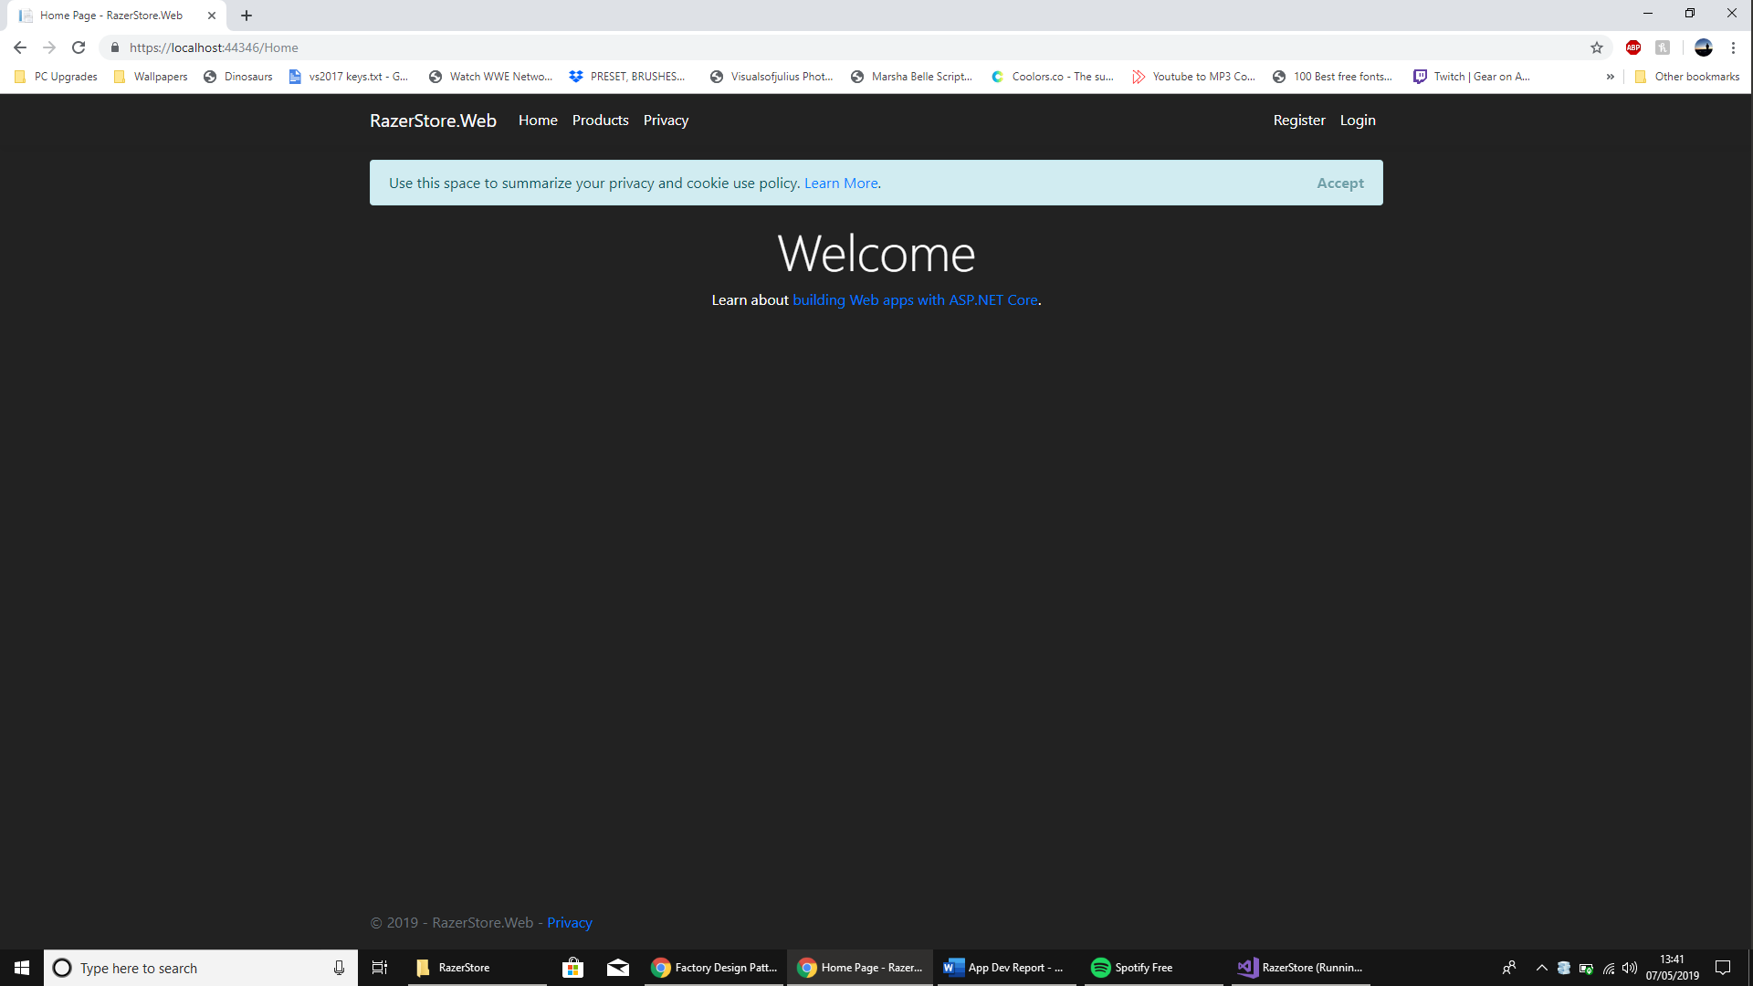

Appendix 2.
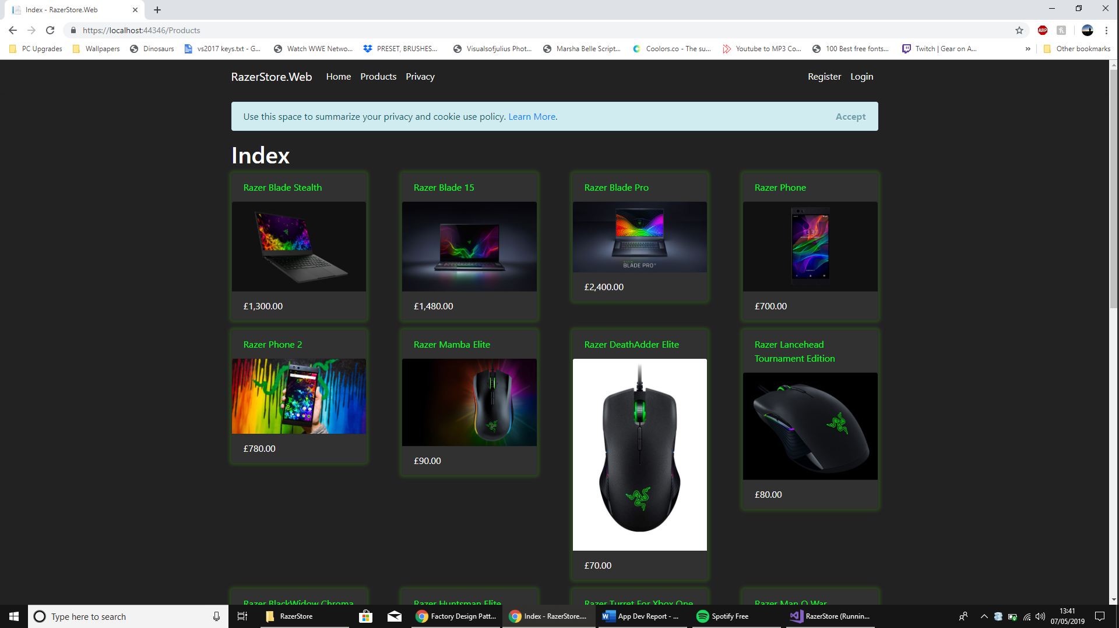

Appendix 3.
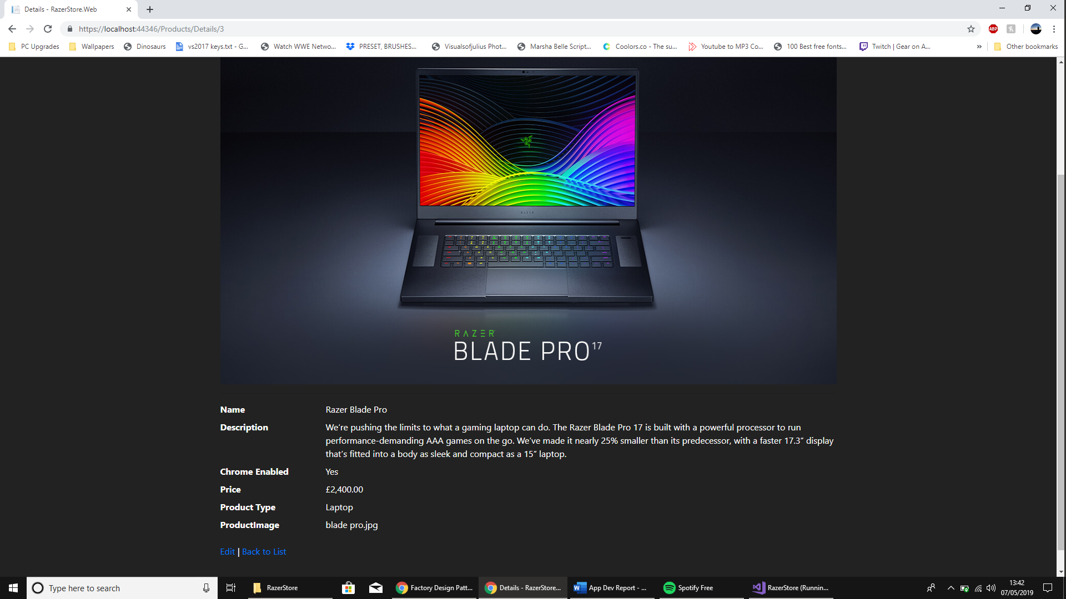

Appendix 4.
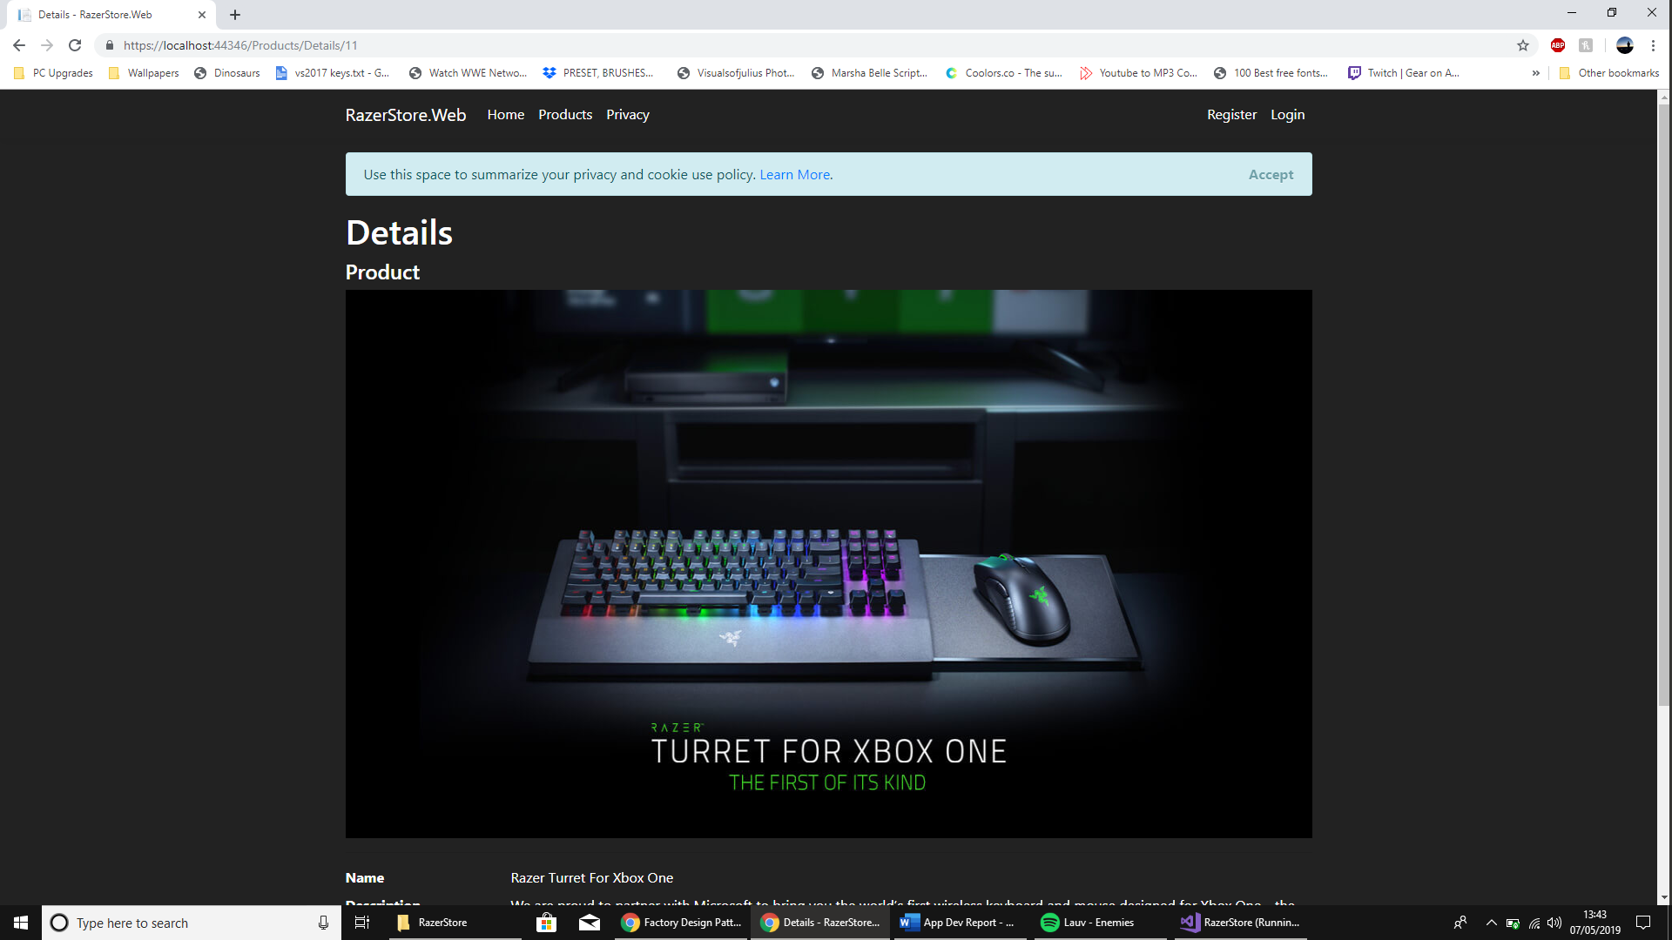

Appendix 5.
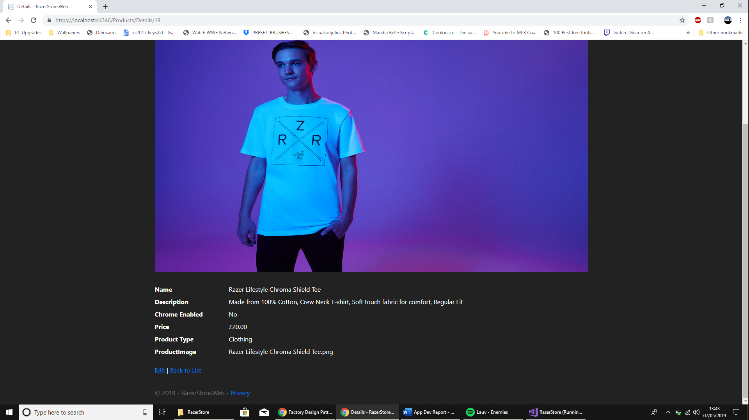

Appendix 6.
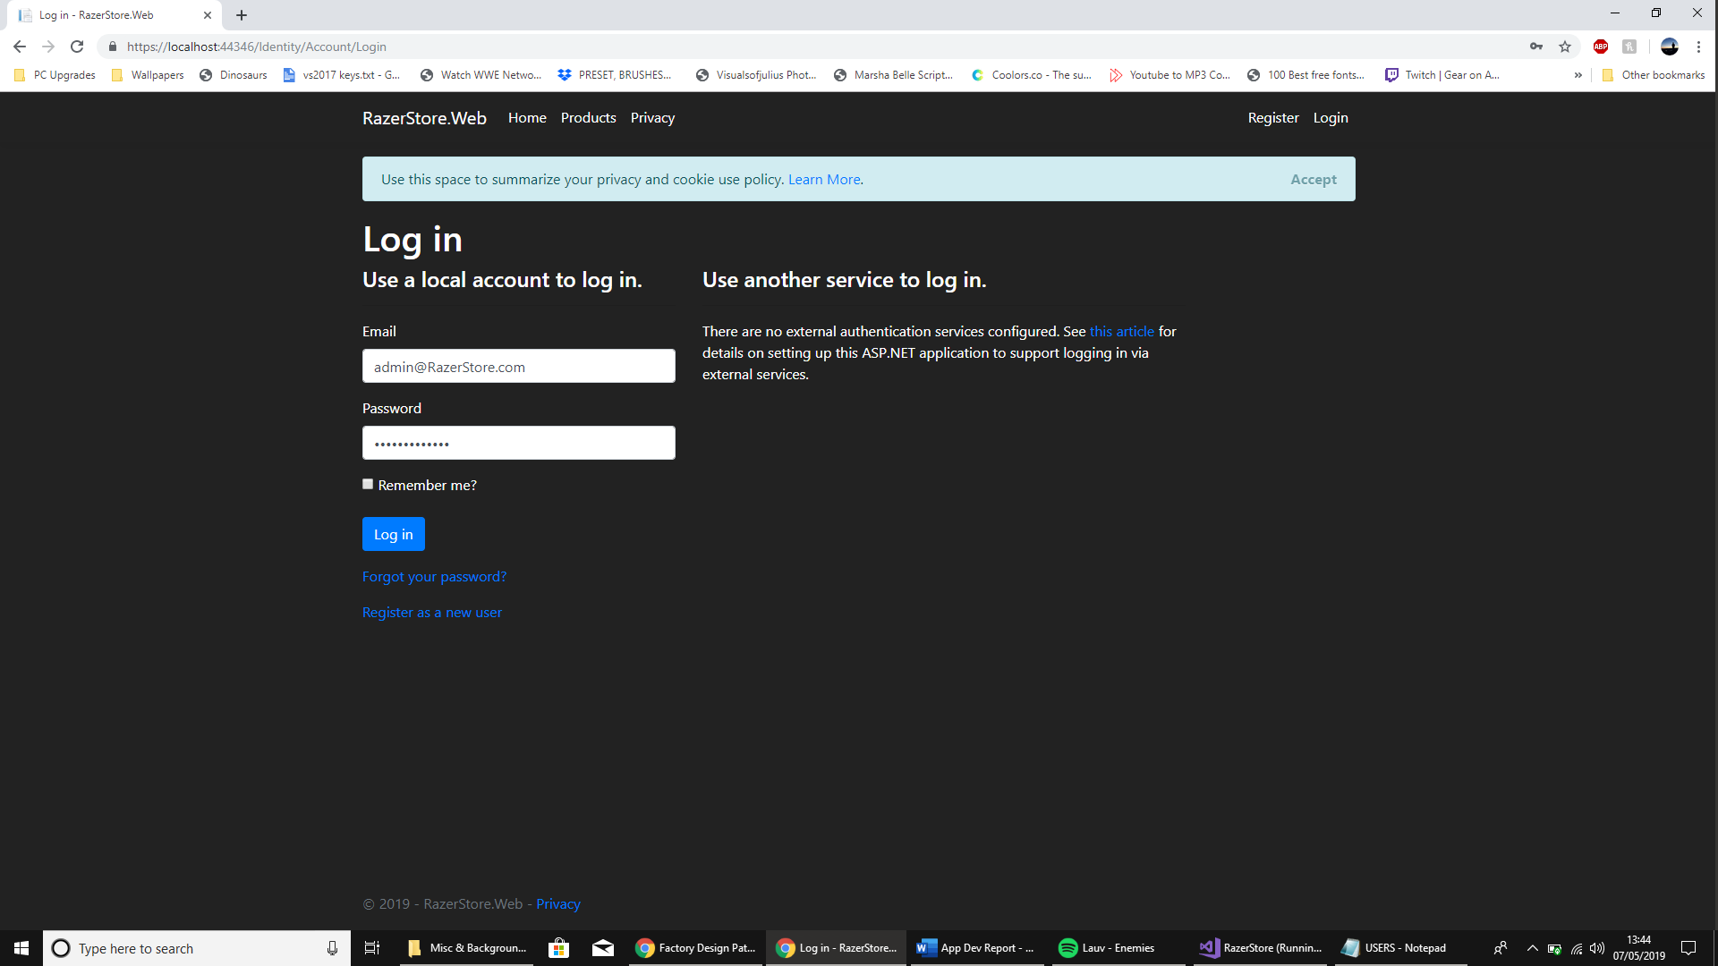

Appendix 7.
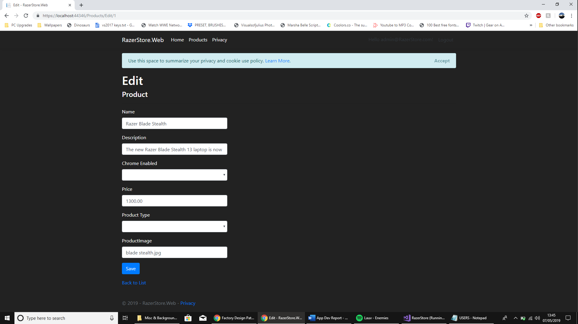

Appendix 8.
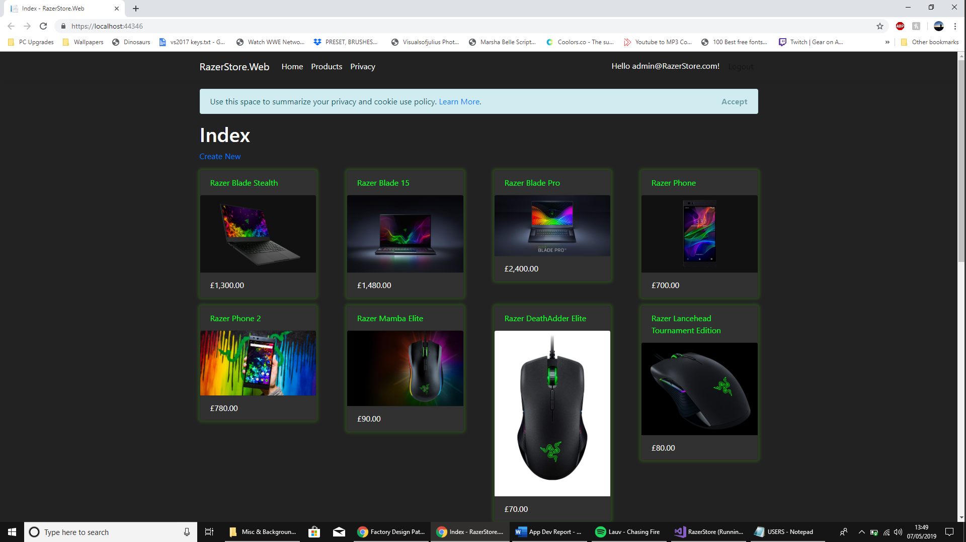

Appendix 9.

Appendix 10.

Appendix 11.
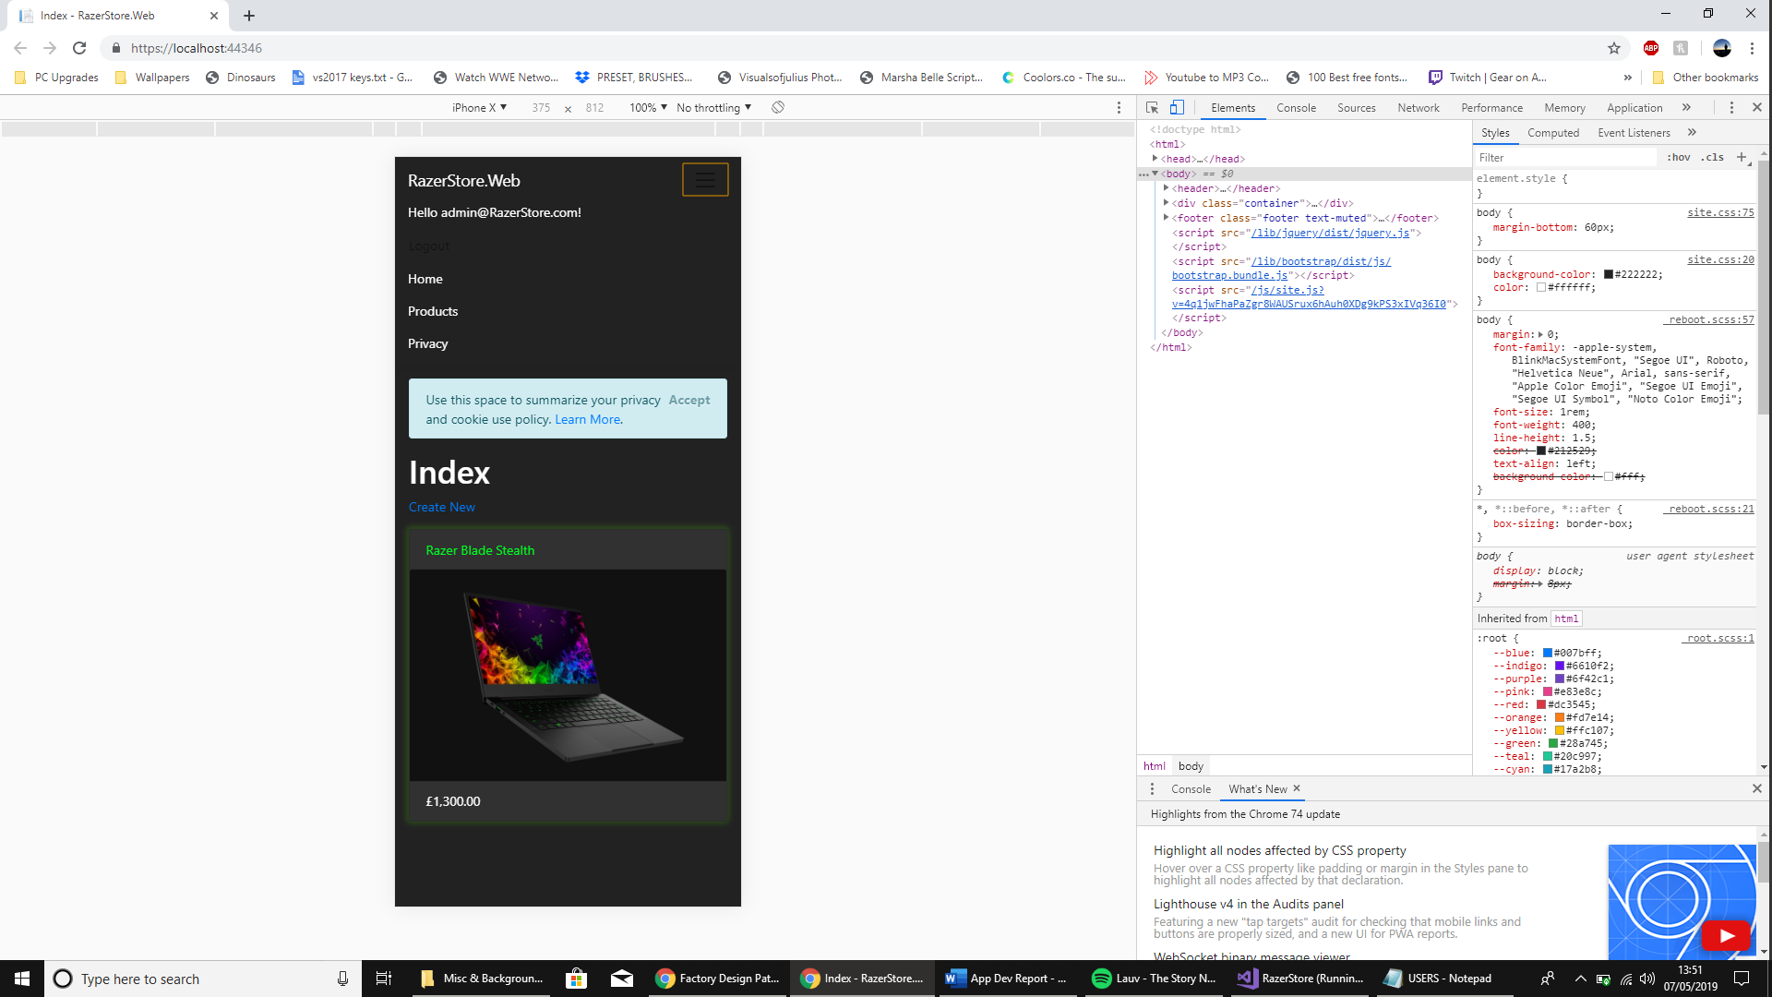

References

[1] | W3Schools, “SQL Injection,” [Online]. Available: https://www.w3schools.com/sql/sql_injection.asp. [Accessed 6 May 2019].
[2] | D. F. Alecu, “Oeconomics of Knowledge,” Cross Site Scripting (XSS) in Action, vol. 4, no. 3, p. 10, 2012.
[3] | Marius, “THE REAL IMPACT OF CROSS-SITE SCRIPTING,” Dionach, 29 July 16. [Online]. Available: https://www.dionach.com/blog/the-real-impact-of-cross-site-scripting. [Accessed 6 May 2019].
[4] | S. Vonnegut, “3 Ways to Prevent XSS,” CheckMarx, 9 October 2017. [Online]. Available: https://www.checkmarx.com/2017/10/09/3-ways-prevent-xss/. [Accessed 6 May 2019].
[5] | A. Wilson, “What is a Factory Design Pattern?,” Codeburst.io, 11 August 2017. [Online]. Available: https://codeburst.io/what-is-a-factory-design-pattern-d3315ccc912b. [Accessed 6 May 2019].
[6] | T. Sellarès, “Factory Pattern,” University of Girona, Girona.
[7] | JournalDev, “Factory Design Pattern in Java,” [Online]. Available: https://www.journaldev.com/1392/factory-design-pattern-in-java. [Accessed 6 May 2019].
[8] | WeMakeWebsites, “HOW TO WRITE A WEBSITE SPECIFICATION,” WeMakeWebsites, 26 February 2018. [Online]. Available: https://wemakewebsites.com/blog/how-to-write-a-website-specification. [Accessed 6 May 2019].
[9] | A.M.Turing Award, “BARBARA LISKOV,” [Online]. Available: https://amturing.acm.org/award_winners/liskov_1108679.cfm. [Accessed 6 May 2019].
[10] | M. Dacey, Overview of Design Principles, Swansea: Mike Dacey | UWTSD, 2018.
[11] | Robert C. Martin, “Robert C. Martin (Uncle Bob),” CleanCoder, [Online]. Available: https://sites.google.com/site/unclebobconsultingllc/. [Accessed 6 May 2019].
[12] | Uppsala University Department of Information Technology, “MODULE: Coupling and cohesion,” Uppsala University Department of Information Technology, Uppsala.
[13] | Microsoft Corporation, “Object-Oriented Programming (C#),” [Online]. Available: https://docs.microsoft.com/en-us/dotnet/csharp/programming-guide/concepts/object-oriented-programming. [Accessed 6 May 2019].
[14] | Microsofthttps://docs.microsoft.com/en-us/aspnet/core/mvc/views/razor?view=aspnetcore-2.2, “Razor syntax reference for ASP.NET Core,” [Online]. Available: https://docs.microsoft.com/en-us/aspnet/core/mvc/views/razor?view=aspnetcore-2.2. [Accessed 6 May 2019].
[15] | Microsoft Corporation, “ASP.NET MVC Controller Overview (C#),” [Online]. Available: https://docs.microsoft.com/en-us/aspnet/mvc/overview/older-versions-1/controllers-and-routing/aspnet-mvc-controllers-overview-cs. [Accessed 6 May 2019].

Image References:
All images that were used during the development of the application were sourced from https://www.razer.com/
Razer owns all rights to their products, logos and intellectual property. Content was used for transformative purposes only.

