Nature, and our connection to the Earth.

Manifesto Writing
8 statements
The importance of nature in my life, the effect nature gives to us in our daily life, how it can help our creativity, how it can heal ourselves, how nature is alive and wants to communicate with us, the problems caused by our disconnection with nature, our soul purpose, the rhythms of life.


What means a lot to me is our connection with the Earth, something which is very lost and forgotten in this modern day. Our Earth has played a big part of our lives. As a humanity, earth gives us water, our food, provides shelter, warmth, everything we need to survive and thrive, in fact, our bodies are literally made from the depths of the land, yet, somehow, we, as a species have decided to disconnect ourselves from this living, loving force. It seems, the more we disconnect ourselves from nature, the more our intelligence seems to be lost. (Selin Kesebir, Pelin Kesebir, 2017) We like to hide ourselves away in boxes high above the ground, yet, loneliness and depression has become a global disease. Humans are very proud and complicated, striving for so much and overtaken by greed, yet, the simplicity of nature is so satisfying to the heart, and is truly where we belong. Humans are foolish, we can understand from many ancient cultures which valued the Earth and found great satisfaction in accepting whatever the earth gave to them through grace, that they're cultures were based on higher principles and lived a more harmonious lifestyle where people did not face problems like we do now. There are many economic problems we face today, all resulting due to our society being completely unsustainable.(Moravčíková Danka, Fürjészová Tímea, 2018) Human traits of ego and pride have separated each one of us and we are each to blame for this due to many layers of conditioning, and the nature of the world. Deep down we wish to be satisfied as our soul nature is satisfaction, and out of satisfaction comes service, however, due to our misconceptions, we look for satisfaction in taking rather than giving. We take shelter of fleeting moments of happiness, rather than seeking for the pleasures which are eternal. The more one observes the ways of nature, the more one learns about who they are by nature. Nature is filled with clues and mystical secrets to unlocking the world within us. Through observing the ways of nature, one learns, as his body is part of nature, so, surely there is some connection. I believe greatly that ancient cultures knew this, not by ‘mystic powers’ or books ext, but rather, simply by simple observation and consciousness of nature. We can see in herbalism through the process of doctrine of signatures, our ancestors used to identify the properties of the herb by its visual qualities. (Charis Boke, 2019) For example the herb- Eyebright is seen to have qualities of an eye and is used to treat eye infections, Lungwort spotted leaves were also seen to treat lungs due to it looking like a diseased lung. So there is a certain voice nature has, a certain way she communicates with us. When we begin to listen we can hear, as is stated -“the universe is infinitely suggestive. Any object of the world can pass from a closed, mute existence to an oral, open state to be appropriated by society…” (Barthes 1957, p.181) So we see how that perhaps there is a personality, a force behind the creation around us which is trying to speak to us in so many ways, if we begin to only listen.

Bibliography

[1] Selin Kesebir and Pelin Kesebir, A Growing Disconnection From Nature Is Evident in Cultural Products, 2017
https://journals-sagepub-com.ezproxy.uwtsd.ac.uk/doi/pdf/10.1177/1745691616662473

[2]Moravčíková Danka, Fürjészová Tímea- Ecovillage as an Alternative Way of Rural Life: Evidence From Hungary and Slovakia, 2018
https://www-proquest-com.ezproxy.uwtsd.ac.uk/docview/2168801305?OpenUrlRefId=info:xri/sid:primo&accountid=130472

[3] Chris Boke- Plant listening, How North American herbalists learn to pay attention to plants, 2019
https://web.a.ebscohost.com/ehost/pdfviewer/pdfviewer?vid=1&sid=9a03b656-97e3-4c86-a045-4d01f9ffb919%40sessionmgr4006

[4] Barthes, R. (1957). Le mythe aujourd’hui. In Mythologies (pp. 181–233). Paris: Éditions du Seuil.

Word Count- 502

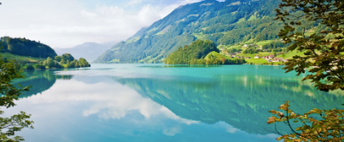
Observational Writing

So, nature, being our healer, in so many ways, through the mind, body and soul is surely where we should have more interaction with. Even having our feet bare, touching Earth is seen so have many amazing health benefits. It is no mystery that all these things are true. It does not take a genius or 1 millions scientific evidences to convince one of all of this. It only takes common sense. When you look at how humans currently live, disconnected completely from the organic flow of life, and everyone is completely miserable. These high suicide rates, increasing statistics of depression and anxiety, they're not normal. It’s completely abstract to the true nature of our true selves and how society is actually supposed to be. (Clinton Ober 2010). In this picture we can see how this would usually be used for some kind of marketing, but actually the reason why these companies do so well in their customer response, is because this is where we belong! So of course people would be attracted to taking a holiday there. In our ‘civilized’ life we are completely disconnected from this pure natural world around us, and it’s almost an intuition that we feel we need to go to nature to ‘take a break’, because really, thats where we feel mostly at solace. As Carl Jung states- “Whenever we touch nature we get clean. People who have got dirty through too much civilization take a walk in the woods, or a bath in the sea. They shake off the fetters and allow nature to touch them.It can be done within or without. Walking in the woods, lying on a the grass, taking a bath in the sea, are from the outside; entering the unconscious, entering yourself through dreams, is touching nature from the inside and this is the same thing, things are put right again.” (Carl Jung 1928).
So what is the solution to the fact we should live closer to nature? Does this mean that we should leave the society we are living and live in the forrest? No. According to Ayurveda, meaning, The knowledge of life, man has 4 biological and spiritual instincts: Religious, financial, procreative and a requirement of freedom. Balance of good health relies upon fulfillment of these 4 instincts. So the man to be healthy, he doesn't just require good food, but also good relationships, good economic situation ext. (Dr. Ranvir Pahwa 2004) One doesn't just abandon all the egos needs, and lives seperate, we need relationship and love in order to survive and we need money to maintain our body. If one falsely renounces they could just live a life of frustration. Renunciation for the common man is better when they're at a later stage of life, named Vanaprasta. If everyone just renounces to the forrest it wouldn't be realistic or practical. Maybe for some this is possible, but not for many. We have a conditioned nature that needs to be expressed but we must learn to do this in a way which is conducive and intelligent. Joseph Campbell states- “The goal of life is to make your heartbeat match the beat of the universe, to match your nature with nature”. (Joseph Campbell, 1983) How can one express their nature and propensity to serve without community? And what is the ideal type of society where people can harmoniously express their nature without being caught up in the ‘rat race’ or capitalist ladder. One very conducive and… sustainable idea is building Self sufficient communities. Many people around the world have recognized the global epidemic of economic crisis, and coming to the realization that the government are not really addressing the issue as it should. people have taken it upon themselves to build communities and a lifestyle where they can strive towards being completely independent from the exploitive and manic modern day economy.

Bibliography

Clinton Ober, Earthing book, 2010- https://www.google.co.uk/books/edition/Earthing/DtQVwPcBrr4C?hl=en&gbpv=1

Dr. Ranvir Pahwa, Ayurveda – The Science of Life An Ancient Medicine, 2004.
http://www.rpsalthealthcentre.com/Publications/ayurveda_science_of_life.html

Joseph Campbell- A Joseph Campbell Companion: Reflections on the Art of Living, 1983
https://www.jcf.org/works/titles/a-joseph-campbell-companion/

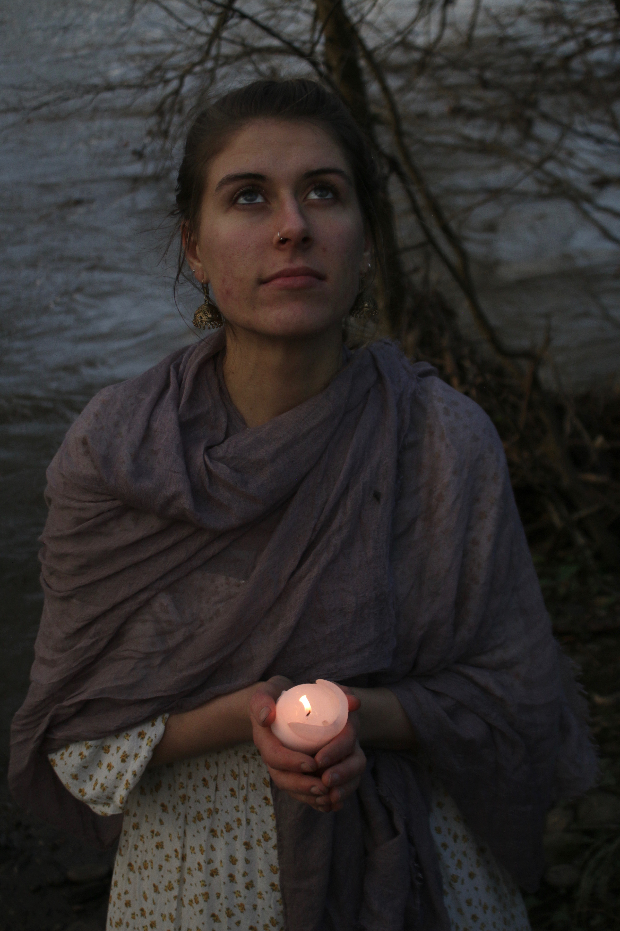
Carl Jung Carl Jung Dream Analysis: Notes on a Lecture Given in 1928- https://improvisedlife.com/2020/08/17/carl-jung-and-mary-oliver-on-touching-nature-from-the-inside-and-outside/

Word count- 524

Practice-basedwriting:

In a film a have started creating, I want people to realize that they need to start living more organic lives and thinking of a more sustainable future. Just to plant a seed, of what we are missing- a more organic and simple lifestyle. Just imagine: the food you ate was all grown by you or people you personally knew, the milk you used was from cows which were honored and loved all their lives, you looked towards raising children in a community which would help you along the way, where the elders took pleasure in guiding with wisdom. Where there was a loving and supportive network, children were taught depending all on their nature, and they were each and raised depending on their qualities. The film is of a girl ‘from future ages’ inquiring from her grandmother, what the world was like (now). I wanted to give the message that the economy may one day collapse and we may have to start living rurally, the way we had been doing for many thousands of years prior to our industrialized modern culture. The scenes will show her imagining what the world was like which seems so alien which the grandmother is trying to explain.
In fact at the rate the economy is growing it just cannot maintain itself if everyone keeps on using mass production. (NIELSEN, Ron William, 2018) If people lived simply and only ate what they needed, living locally and from the land, we would have an abundance to keep all citizens going. The access of consumerism which each person in our modern society is held accountable for is more the problem rather than the actual mass of people. It’s described people just produce far over than what they need and consume overly excessive amounts. (Martin Hensher 2020)
In Varnashram, a Vedic structure of society, this is the type of community which we all thrive in. One which has a common purpose of service and spirituality, and everyone has their own specific roles which is not brought about by egoistic tendencies but instead living according to their god-given nature which has been nourished and recognized since birth. Living this type of lifestyle brings us to the ‘mode of goodness’ described in Vedic literature as ‘sattva guna’. The material world is made up of the three modes, passion ‘rajas’, ignorance ‘tamas’ and goodness ‘sattva’, coming to the mode of goodness brings more tranquility and harmony, whereas the mode of ignorance and passion brings more frustration, depression and social problems ext.(Harivilas Das 2014). Varnashrama Dharma is there to make us more socially active. It lives on the understanding that our social problems begin when the individual has internal problems, such as lust, greed envy. So the point is to address the root cause of the issue instead of trying the fix the problem externally. For example, our modern society likes to treat the problem of violence by having prisons but if society was structured in such a way where people weren't overtaken by the lower modes of material nature then there would be no knife crime ext. The Vedic literature and the science behind it was given to the saintly kings so that they could protect the citizens, protect them spiritually, protect them from their own material tendencies (Srila Prabhupada 1969)

Bibliography

NIELSEN, Ron William, The future of economic growth in the World’s largest economies, P113, 2018
https://search-proquest-com.ezproxy.uwtsd.ac.uk/docview/2187126621?accountid=130472&pq-origsite=primo

Martin Hensher Health care, overconsumption and uneconomic growth: A conceptual framework, 2020
https://www-sciencedirect-com.ezproxy.uwtsd.ac.uk/science/article/pii/S0277953620306390

Harivilas Das Varnashrama Dharma- Perfect Organization of Society. 2014 (page 17) https://ebooks.iskcondesiretree.com/pdf/His_Grace_Harivilas_Prabhu/Varnashrama_Dharma_-_Perfect_Organization_of_Society_by_His_Grace_Harivilas_Prabhu.pdf

Srila Prabhuada- Bhagavad Gita as it is, purport of Chapter 4 text 1, 1969- https://asitis.com/4/1.html

Word count- 539 words

