Natasha Nothando Tshili
Student Number: 2020475
Module Title: Professional Career Development
Module Code: BMSW4005_LON
Assignment Title: Task 2 Report
Lecturer’s Name: Anita Nan
Reflection on my career Development Journey

Table of Contents
Introduction 2
Recruitment and Selection 2
SWOT Analysis 4
What employers want 6
Self- Motivation 6
Learning Styles 7
Employment SMART Goals 8
Lifeline 8
Personal Development Plan 9
Conclusion 10
References 11
Appendices 12

Introduction

The purpose of this report is to reflect on what I have learned during the professional career development module, and . Several aspects will be considered such as a reflection using Gibb’s model of reflection on my role play, my readiness for employment, analyzing what motivates me and my learning styles. I will analyse my strengths and weaknesses, SMART goals and develop a personal development plan to guide me on my journey to achieve these goals.

Recruitment and Selection
I will be using Gibbs’ model of reflection (1988), to reflect on my role play interview I conducted for task 1 with my partner Rasel Khan. My reflection below is based on my interview for a data analyst role and I will analyse why my interview went the way It did and create an action plan for how I can improve my future performance in job interviews.

Description
I conducted a role paly interview with my partner Rasel Khan, where I had to play the role of an interviewee for a data analyst job position, and we switched over and I played the interviewer for a restaurant supervisor role with Rasel as the interviewee.

Feelings
When I was getting interviewed at first, I felt confident given that I had a chance to practice my responses to the questions. However, towards the end of the interview I forgot to ask the interviewer the question I had prepared to ask him. This made me feel nervous about the grade I was going to receive , I felt frustrated with myself because I messed up on the easiest part of the role play.

Evaluation
The beginning of my interview went well, because I formulated my answers to include examples, based on my instructor Anita’s advice. However, my focus on ensuring that my responses were not too short and maintaining a relaxed demeanor distracted me and I got too excited to wrap up the role play.

The interview worked out well because I listened and applied the feedback from my practice interview in week 9 and increased my responses length to include some examples. This led to me scoring full marks on the marking criteria. According to an Indeed (2021) article about interview tips, it recommends using the STAR method which stands for situation, task, action and result. This is the best way to answer questions and formulate your examples using this method for a clear storyline. I applied this method after Anita’ recommendations.

Analysis
The ending was of my interview not going was based solely of nerves and in the moment, I realized I had made a mistake. I had included the interviewer’s question in my practice the prior week. However, by the time I realized I skipped the question it was too late to go back and correct it.

Conclusion
I learned that adequate preparation ensures clearer communication and well formulated response in an interview. Moreover, I learned that preparation of what you will say is better because you seem more relaxed and confident when responding, this gives a more natural demeanor. Lastly, I will remember to always maintain composure, to avoid going blank at the end of an interview.

Action Plan
I will keep a small note of the main points I will cover in a role play, to remind me of what to say. Moreover, I will use the STAR Method to formulate my responses to avoid filler words and clearly articulate myself. Finally, I will practice before my role play or a real interview, to have more confidence in my responses.
Figure 1. Gibb’s reflection Model(Gibbs, 1988)

SWOT Analysis

I completed a SWOT analysis on myself to access my personal strengths and weaknesses and used these to identify my opportunities and potential threats to me achieving my employment goals.

When looking at my strengths, I identified that leadership and confidence was one of my strengths. I also have strong numerical skills, communication and training skills. An example of this was during my university degree I tutored, engineering student and calculus students for 2 years and during my role as an analyst I trained new consultants. My weaknesses are procrastination, talking too fast and poor listening skills. These are weaknesses I attribute to my nature, and I intentionally try to be an active listener.

From my strengths and weaknesses, I investigated my opportunities. I have an opportunity to study an MBA based on my desire to enter leadership and management in a reputable firm and eventually start my own organization. I also can consult for business start- ups, as I have a passion for assisting new companies to source suppliers, market and plan out their businesses. Equally, my weaknesses pose threats in lowering my productivity in my studies if I do not stop procrastinating. My other weakness of poor listening can lead to a loss of relationships or clients if I do not correct this.

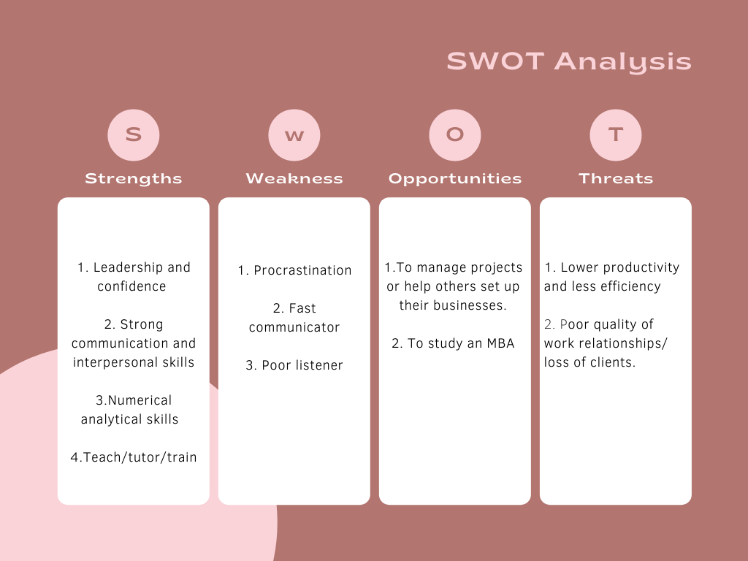
Figure 2. Personal SWOT Analysis

What employers want
Employers want their employees to have good adaptability skills. According to an Indeed(2021) article on the job description of a data analyst, they listed skills such as problem-solving skills, leadership and technical skills. This means the employee must be able to shift their focus if targets change or accommodate changes along their job role. This could be through lifelong learning and continuous training, to adapt to the fast-changing technology industry. This also calls for employees to have the ability to be creative in problem solving by reading widely about the current climate in their field. I believe I have these qualities because I worked as an actuarial analyst and we had to read and quickly understand communiques, to update our methods to comply with laws that changed weekly. This resulted in me being flexible to adapt and adjust my work processes, all while maintaining quality work, offering creative solutions to problem solving and adhering to strict deadlines. I had to lead different valuations from data through to reports and government forms and this required me to be knowledgeable about new industry trends and changes to keep a high standard of work and improve efficiency each year.

Self- Motivation
Self-motivation is based on one’s ability to be self-assured in their goals and their ability to succeed. Self- motivation is based on four factors, that are highlighted by the Mind Tools Content Team (2016), these are self-confidence and self-efficacy, positive thinking, focus and strong goals, and motivating environment. It entails having an optimistic mindset as well as having the drive and focus to achieve those goals. Self-motivation is nurtured by being in an environment that encourages you and reassures your ability to succeed. My goal is to lead the specialty coffee import industry. I am motivated by my strong worth ethic, self-belief and resilience. For example, I got a job earning £70,000 without completing my degree based on skill and my willingness to learn. This example motivates me that my new goals are attainable with hard work. However, this time I need to improve on self-efficacy which is defined based on psychologist Anthony Bandura’s work as , ‘a belief in our own ability to succeed, and our ability to achieve the goals we set for ourselves.’ (Mind Tools Content Team, 2016). I will do this by reminding myself I am worthy of having my future role, because I successfully passed through rigorous selection processes.

Learning Styles

VAK Learning Styles are based on modalities, and they are visual, auditory, and kinesthetic learning styles. VAK was designed by Walter Burke and developed by Neil Fleming in 1987 (Macmillan,2018) and the theory says that people have different ways in which they receive and learn information. Visual learns from seeing , which includes\ using diagrams, charts and demonstrations . Auditory learns from hearing, audio books, talking to themselves and reading out loud. Kinesthetic learns from movement, they prefer hands on work, practical courses and they are usually good at sports and directions. I am a visual learner and I easily pick up from demonstrations, charts and diagrams. In university I would always create process charts to show how I solve math problems, and this is what made me the top tutor for engineers, despite me studying mathematics. I could give them a visual of what they were solving.

According to McLeod (2017), David Kolb’s learning theory (1984) focuses on 4 learning styles, based on a combination of either concrete experience (CE) (feeling), active experimentation (AE) (doing), reflective observation (RO) (watching) and abstract conceptualization (AC) (thinking). From these, he developed 4 distinct learning styles accommodating( feeling and doing), diverging(feeling and watching), converging (doing and thinking) and assimilating (thinking and watching). I am a converging learning style, and this means I am more inclined to specialist and technology abilities. This is reflected in my career as an analyst and studying mathematics in my first degree. I had to shadow an associate in the firm during my internships and I would go back to my desk and imitate many of the shortcuts he used and memorize them. This is how I learned most of my skills and I landed a full-time position.

Employment SMART Goals

SMART goals refer to the setting of goals that are specific, measurable, achievable, realistic and timely. The importance of SMART goals is they give you ,’a sense of direction and helps organize and reach your goals.’ ( Corporate Finance Institute, n.d.). I have set some SMART goals for myself in the following areas, education and training, personal goals and self-employment goals.

In my education I would like to get my MBA in a finance related field by 2025 and eventually obtain my project management certification by 2030, after obtaining job experience as a project manager in the data analytics field. I would also love to learn about coffee quality compliance in a 6-week online course starting in April 2022. My personal SMART goals are to learn Kinyarwanda and French to intermediate level through a tutor, I will enroll in 2-month courses for both languages, one in August and another in November.

Lifeline
When looking at my lifeline, I started off with childhood goal of becoming an actuarial analyst and although I was successful, but work life balance was lacking. I landed my dream job at a competitive salary by the age of 23. I wanted to move forward with some personal life goals I had and take some time to rethink my career goals. I met my husband and we got engaged a year later and I was married and expecting our first baby before the pandemic. However, when the pandemic started, I was heavily pregnant and was not thinking of returning to work. According to Ibarra(2007) her research speaks of a transition phase where someone experiences confusing feelings when deciding what to do after career breaks. She talks about people experiencing somewhat of an identity crisis, as they are transitioning into new goals. During my post-partum period, I applied for university because I discovered that without a university degree, I would always feel insecure about my future career trajectory. I decided that I wanted to pursue the Leadership and Management program and complete my MBA.
Adapted from (OpenLearn, n.d.)
Birth 10 20 30 40
Low points
Engaged, married and first baby
Accepted into UWTSD Leadership & Management BA Hons
Landed actuarial analyst job
Resigned and moved
Pandemic and jobs hunting

Personal Development Plan

A personal development plan, also known as a PDP, is an action plan used for outlining and tracking career goals. It is used to order the steps, both long term and short term required to achieve these goals.

My short-term career goals are to complete a coffee quality compliance course and complete 2 language intermediate courses in French and Kinyarwanda. I will enroll in two intermediate language courses in 2022. I am taking a coffee quality compliance course online for 6 weeks in April 2022, this is for my long-term goal with my husband to start a coffee import business from East Africa to the UK, Australia and North America.

My mid-term goals are to complete my bachelor’s degree in Leadership and Management by 2023 and then proceed to get my MBA.

My long-term goals are to start a coffee import business with my husband by 2031. I will also start small e- commerce businesses selling jewelry, e-books and planners by 2024. My final goal is to complete my MBA by 2025.

Conclusion
In conclusion, I have numerous career goals and plans and through this module I have learned how to assess my readiness for employment and to employ others. In the next 5 years I will be focused on increasing my skill sets through taking short courses over my university holidays and by completing my degree. I will also improve my language skills, as I will need them to communicate with future employees and to conduct research on the coffee industry. I will research e- commerce and also complete courses to fill my knowledge gaps.

References

Corporate Finance Institute (n.d.). What are SMART Goals?. Available at: https://corporatefinanceinstitute.com/resources/knowledge/other/smart-goal/ [Accessed on 23 December 2021]

Gibbs G. (1988). Learning by Doing: A guide to teaching and learning methods. Further Education Unit. Oxford Polytechnic: Oxford

Ibarra H (2007). Identity Transitions: Possible Selves, Liminality and the Dynamics of Voluntary Career Change. Available at: https://sites.insead.edu/facultyresearch/research/doc.cfm?did=2720 [Accessed on December 26 2021]

Indeed Editorial Team (2021). 21 job Interview Tips: How to Make a Great Impression. Available at: https://www.indeed.com/career-advice/interviewing/job-interview-tips-how-to-make-a-great-impression [ Accessed on 21 December 2021]

Indeed Editorial Team (2021). What Is the Job Description of a Data Analyst. Available at: https://www.indeed.com/career-advice/finding-a-job/data-analyst-job-description [ Accessed on 21 December 2021]

Kolb D. (1984). Experiential learning: experience as the source of learning and development. Englewood Cliffs, New Jersey: Prentice Hall.

Macmillan F. (2018). VAK Learning styles: what are they and what do they mean?. Available at:
https://engage-education.com/aus/blog/vak-learning-styles-what-are-they-and-what-do-they-mean/#! [Accessed on 22 December 2021]

McLeod S. (2017). Kolb’s Learning Styles and Experiential Learning Cycle. Available at: https://www.simplypsychology.org/learning-kolb.html [Accessed on 21 December 2021]

Mind Tools Content Team (2016). How Self-Motivated Are You? Available at: https://www.mindtools.com/pages/article/newLDR_57.htm [ Accessed on 22 December 2021]

OpenLearn (n.d.). 2.1 Your career lifeline. Available at: https://www.open.edu/openlearn/ocw/mod/oucontent/view.php?id=28130&section=2.1 [Accesssed on December 15 2021]

Appendices

Appendix 1: Application Form

Job application form

Application for Data Analyst -

Name: Natasha Tshili
Education and training
Please give details:

University of Louisville
Mathematics and Finance
Studied 3 years out of 4 years (Incomplete Degree)

University of Wales Trinity St. David
CertHE Leadership and Management Skills for the Workplace Level 4

Mercer, Marsh and McLennan Trainings for Actuarial Analysts
-Valuation Training (Post-Retirement Medical and Retirement)
-Accounting Training US GAAP and Global Accounting
-Government Forms Training
-Excel Data Cleaning and Data Visualization

Qualifications
Please give details:

Actuarial Valuation Training with Mercer
Data Training with Mercer
Cert HE Leadership and Management Skills for the Workplace

Employment history

Your current or most recent employer

Name of employer: Marsh & McLennan

Job title: Actuarial Analyst

Length of time with employer: 1 year and 2 internships (10-week internships)

Reason for leaving: Relocation

Duties: Cleaning Data, Data Visualization, Coding, Complex Calculations, Actuarial valuations (DB and DC plans), Data Analysis, Experience Studies, Government Forms, Training Valuation Analysts, Global Accounting Reporting and Project Manager of the US Pension Process Committee

Previous employers
Please tell us about other jobs you have done and about the skills you used or learned in those jobs.

Employer: University of Louisville JB Speed Engineering School
Job Title: CRLA Tutor for Calculus and Engineering Analysis
Skills Learned/ Used: Interpersonal Communication Skills, Time Management, Active Listening, Patience, Problem Solving, Advanced Mathematical Skills

Employer: American Campus Communities- Housing Developer for Universities
Job Title: Resident Assistant
Skills Learned/ Used: Interpersonal Communication Skills, Time Management, Organizational Skills, Microsoft Office, Sales, Marketing, Events Planning, Customer Service

Supporting statement
Please tell us why you applied for this job and why you think you are the best person for the job.

I applied for this position because of the world-renowned recognition your firm has. I am especially intrigued by the passion and drive of the firm to be a leader in the data analysis research and development space. I know that this role, in this company will facilitate my growth in the data analysis field and aligns with my long-term goals of being a senior data lead consultant.

The skills and experience I possess make me a great fit based on the job role requirements. Particularly, my interpersonal communication skills, technical skills, attention to detail and time management skills. I would make a great addition to the team because I complete projects on time, on the first attempt, and I keep my teams updated immediately when faced with setbacks to take advantage of their skill sets. I am driven by always improving and being a lifelong learner, and I will be an asset to my teams in the advancement of our processes.

Right to work in the UK
Do you need a work permit to work in the UK? Yes / No

References
Please give the names and contact details of 2 people who we can ask to give you a reference. We may ask them before an employment offer is made. We will not ask your current employer until we get your permission.

Declaration
I confirm that to the best of my knowledge the information I have provided on this form is correct and I accept that providing deliberately false information could result in my dismissal.

Name: Natasha Tshili

Signature: N.Tshili

Date:30/10/2021

Appendix 2: 5 interview questions

1. What are your strengths and weaknesses?
2. How do you address staff tardiness and poor performance?
3.How would you deal with a situation in which two employees are engaged in a heated argument that can be heard by customers?
4. How do you ensure that food health and safety regulations are followed by restaurant staff? 5. Where do you see yourself in the next 5 years?

Appendix 3: Personal Development Plan (PDP)

Personal Development Plan
 | Short-Term Time Frame  What do I want to  accomplish in the next  three to six months? | Mid-Term Time Frame  What do I want to  accomplish in the next  six months to two years? | Long-Term Time Frame  What do I want to  accomplish in the next  two to three years?
Section 1 - My Goals  What are my overall goals that I want to accomplish in this time period?  Example: become a Student Affairs Officer; learn computer graphics | - Kinyarwanda intermediate language course  - French intermediate language course  - Coffee compliance course | - Get BA Leadership and Management Hons degree | - Open coffee business  - Get MBA  - Run successful e- commerce businesses in jewellery, digital products
Section 2 - Skills and Knowledge to be  Learned  What specifically do I need to learn? What project do I need to work on?  Example: Student advising;  Banner; Dreamweaver; develop a procedures manual | - Review my beginners language courses. | - Complete all modules for degree | - Learn about marketing and formulating digital planners and packaging  - Complete my BA degree  - Complete courses and visits to coffee producing countries
Section 3 - Next Steps  How am I going to acquire the skills and knowledge? How am I going to do this project?  Example: take Dreamweaver class; do an  informational interview; set up a project outline | I will enrol through online platforms and pay for the courses. | - Successfully completing course work  - Looking for internships to apply skills | - Go to Rwanda once a year during coffee season to attend conferences and network with coffee suppliers  - Successfully complete my BA with a 1st  - Study e-commerce, drop shipping
Adapted from: http://www.hr.ucdavis.edu/sdps/forms/IDP%20Final%2010.14.11.pdf

 | Short-Term Time Frame  What do I want to  accomplish in the next  three to six months? | Mid-Term Time Frame  What do I want to  accomplish in the next  six months to two years? | Long-Term Time Frame  What do I want to  accomplish in the next  two to three years?
Section 4 - Resources  What resources do I need?  Example: free time; funding | Computer and internet | - Library  - Online Research | - Youtube  - Free time  - Library  - Travel  - Savings
Section 5 - Time Schedule

What is my time schedule?

When will I start? | - Language courses will be in May and in September  - Coffee course will start in April, 2022 | - Currently enrolled in Level 5 | After 2023
When do I expect to finish? | By December 2022 all my short term tasks will be complete. | I will finish at the end of 2023. | - I will complete the business within the next 10 years  - My MBA by end of 2024  - E Commerce by the end of 2022
Section 6 - Completion  When have I completed each  step? | □____________  Date  □___________-  Date  □__________-_  Date | □_____________  Date  □__________  Date  □__________  Date | □__________  Date  □__________  Date  □__________  Date
Adapted from: http://www.hr.ucdavis.edu/sdps/forms/IDP%20Final%2010.14.11.pdf

