An Organisational Analysis of Marriott International: Structure, Culture, and Strategic Direction
Student Name: Daniel Nicusor Petrache
Student ID: 2246592
Module code: BMIH5004
Module Title: Management and Organisational Behaviour
Lecturer's name: Daniel Payne
Date of submission: 7th of March 2025

AI declaration
"I confirm that I have not used any Al tools in the research and creation of this assignment. I confirm that I have not presented any Al-generated materials as my work. I confirm I have copies of my drafts, notes, and other resources I used, which! May be asked to provide evidence"

Executive Summary

Marriott International is a worldwide famous hotel group founded in 1927, with a strong occurrence in over 130 countries and operating more than 8,000 properties. The company proposes the many brands that are providing to different customer segments, from luxury to budget accommodations. The main topics can include the investigation of organizational structure, culture, and goals, and an assessment of recent change initiatives. The exploration of the company’s strategic direction, and recommendations for development to be used in this report to sustain its competitive advantage in the hospitality industry. The organisational structure refers to how a company is organised in terms of hierarchy, decision-making, and daily operations. According to Mintzberg’s organisational structure theory, businesses can have various structures, for example divisional, functional, and matrix structures (Lukas Weidener et al., 2024). Marriott International follows a hierarchical structure with a centralised decision-making approach. The corporate culture can demonstrate the values, beliefs, and behaviors that can describe a company's work environment. The company assumes new skills and technologies that can increase sustainability efforts and evolve with market trends to meet the changing needs of customers. Furthermore, Marriott’s culture of diversity and inclusion is a significant example. The company has leadership development programs for understated employees and supports them to grow into managerial roles. This emphasis on the development of employee improvement, service quality, and satisfaction of the guests is making Marriott a chosen brand worldwide.

Table of Contents

1 Introduction 4
2. Organisation Structure, Culture, and Goals 4
2.1 Organisational Structure 4
2.2 Corporate Culture and Its Influence on Operations 5
2.3 Organisational Goals at Corporate and Hotel Levels 6
3. Recent Change Initiatives 6
3.1 Identification of Key Change Initiatives 6
3.2 Impact of Change Initiatives 6
3.3 Evaluation of Change Management 7
1. Unfreeze 7
4. Strategic Direction 8
4.1 Long-Term Strategic Vision 8
4.2 Key Strategies for Achieving Objectives 8
5. Recommendations 9
5.1 Areas for Improvement 9
5.2 Implementation Strategy 10
6. Conclusion 10
7. References 11

Introduction
Marriott International is a worldwide famous hotel group founded in 1927, with a strong occurrence in over 130 countries and operating more than 8,000 properties (Marriott.com, 2025). The company suggests the many brands that are providing to different customer segments, from luxury to budget accommodations. This report aims to critically evaluate the fact that Marriott operates at both commercial and individual hotel levels using specific management and organisational behaviour theories (Neupane and Khanal, 2022). The main topics can include the investigation of organisational structure, culture, and goals, and an assessment of recent change initiatives (Joseph and Gaba, 2019). The exploration of the company’s strategic direction, and recommendations for development to be used in this report to sustain its competitive advantage in the hospitality industry.
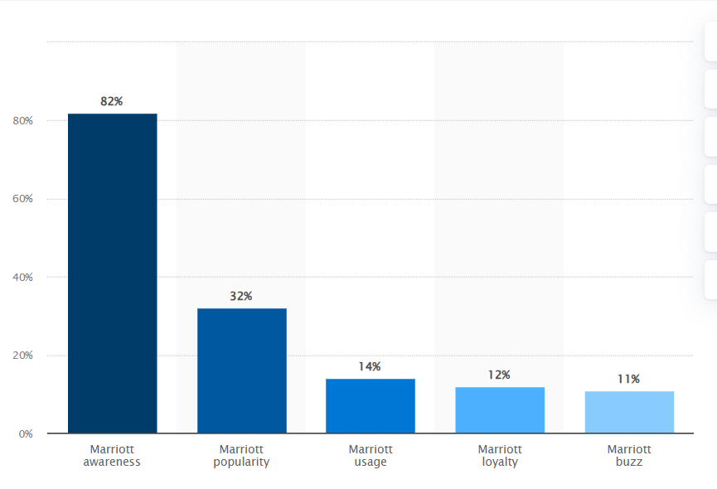

Figure 1: Marriott brand profile in the UK 2023
(Source: Statista, 2023)

Organisation Structure, Culture, and Goals

Organisational Structure
The organisational structure refers to how a company is organised in terms of hierarchy, decision-making, and daily operations (Joseph and Gaba, 2019). According to Mintzberg’s organisational structure theory, businesses can have various structures, for example divisional, functional, and matrix structures (Lukas Weidener et al., 2024). Marriott International follows a hierarchical structure with a centralised decision-making approach (Marriott.com, 2025). The company's main leadership style can leadership make important decisions at the corporate level. Individual hotel managers and regional leaders also have the freedom to make decisions that suit their local markets.
The Marriott has a united leadership team at the corporate level that can manage all its hotel brands. It is making sure that each follows the company's overall aims and brand standards (Eschenbrenner et al., 2023). The devolved method can allow the local managers to make decisions which are based on the regional preferences of the customer and market conditions. This structure balances to control and flexibility of the organisation. This structure can help Marriott maintain its worldwide brand constancy while familiarising itself with changing locations. Even though all Marriott hotels follow corporate strategies on customer service and quality (Fagyas and Datta, 2023).
A Marriott hotel in London can propose various services likened to meet the expectations of local guests (Neupane and Khanal, 2022). This mixture of integrated control and local flexibility can support Marriott International which can operate efficiently. This can inspire innovation, and deliver high-quality customer service.
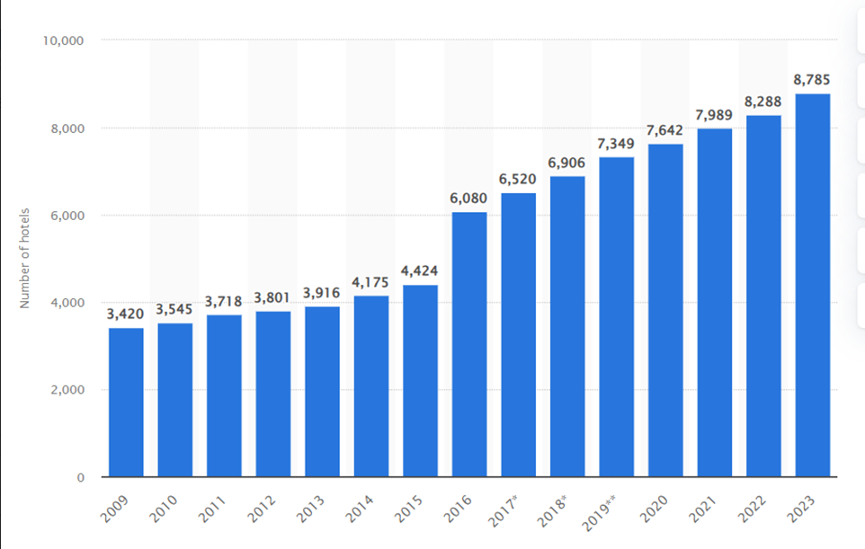
Figure 2: Number of Marriott International hotels worldwide 2009-2023
(Source: Statista. 2023)

Corporate Culture and Its Influence on Operations
The corporate culture can demonstrate the values, beliefs, and behaviours that can describe a company's work environment. The employees can interrelate with customers and each other. Two important theories that can support to definition of corporate culture are Hofstede’s Cultural Dimensions Theory and Schein’s Organisational Culture Model (Gheorghe and Muntean, 2024). The Marriott arranges both the employees and customers, making sure that the staff feel appreciated and encouraged. This leads to better service, higher job satisfaction, and solid relationships with customers. The pursuing excellence the Company can retain high standards in service and operations by continuously refining the hotel facilities, services of the customer, and employee training.
This assurance can support Marriott to stay competitive in the hospitality industry. Ethical business practices are significant to Marriott’s culture (Neupane and Khanal, 2022) The company can promote honesty, fairness, and transparency in handling with employees, customers, and business partners. The company assumes new skills and technologies that can increase sustainability efforts and evolve with market trends to meet the changing needs of customers. Marriott is committed to social responsibility and sustainability (Fagyas and Datta, 2023). It introduces the programs to decrease the environmental impact. It can also enhance the local communities, and encourage diversity and inclusion in the workplace.
These efforts can build Marriott’s worldwide status as an accountable and forward-thinking organisation (Fagyas and Datta, 2023). However, Marriott can create a solid corporate culture that can enhance the engagement of the employees, satisfaction of the customer, and long-term business success. This can emphasise people, innovation, and ethical leadership that can make Marriott a front-runner in the hospitality industry. On the other hand, Hofstede’s framework proposes that Marriott encourages a high level of individualism. The employees can make decisions that can improve the experiences of the guests.
This leads to better job satisfaction and inspiration among the staff. Meanwhile, Schein’s model defines the corporate culture at different levels (Gheorghe and Muntean, 2024). The artifacts that can define the visible elements like hotel design, uniforms, and service rituals. Also, the Espoused Values can define the mission of the company, leadership principles, and policies. At last, the basic assumptions are about the deep-rooted beliefs about the services of the customer, teamwork, and hospitality. Furthermore, Marriott’s culture of diversity and inclusion is a significant example. The company has leadership development programs for understated employees and supports them to grow into managerial roles. This emphasis on the development of employee improvement, service quality, and satisfaction of the guests makes Marriott a chosen brand worldwide.

2.3 Organisational Goals at Corporate and Hotel Levels
The Marriott’s goals emphasise growth, sustainability, and customer loyalty (Hristov and Searcy, 2024). It divides the aims into four financial areas, customer, and internal process. The learning growth is enhancing the revenue and profitability. The goal is to improve the experience of the guest and satisfaction. At the corporate level, Marriott's purpose is to enlarge into new markets, improve its sustainability efforts, and support the loyalty of the customer. The goals are increasing the occupancy rates and enhancing the experiences of the guests. The Marriott hotels in London can emphasise the business travellers that are proposing executive lounges and high-tech meeting rooms. On the other hand, the resorts in the Maldives highlight luxury tourism, providing private villas and high-class spa treatments.

Recent Change Initiatives

Identification of Key Change Initiatives

The identification of the recent change of Marriott has applied many initiatives to enhance operational efficiency and guest satisfaction (Marriott.com, 2025). The main recent initiatives include digital transformation, sustainability efforts, and AI integration (Martínez-Peláez et al., 2023). One of the most prominent changes is the introduction of the Bonvoy loyalty program which can combine with the many loyalty programs into one, improving the engagement of the customer. Moreover, Marriott has comprised AI-driven customer service, proposing personalised experiences over data analytics (Saarikko et al., 2020). Further initiatives can contain mobile check-in and keyless room entry, creating the experience of the guest unified and well-organised (‌G.A et al., 2019).

Impact of Change Initiatives
The impact of the change initiatives of Marriott International has presented many changes to increase the experiences of the customer, efficiency, and sustainability (Hristov and Searcy, 2024). One main initiative was the acceptance of digital technology, for example, mobile check-in, AI-driven customer service, and personalised experiences over the Bonvoy loyalty program (‌Saarikko et al., 2020). These innovations can enhance operational efficiency and improve the satisfaction of the guests (Carvalho, et al., 2019). The main important change was Marriott’s commitment to sustainability which is contained in the energy-efficient hotels, waste reduction programs, and eco-friendly practices (Hristov and Searcy, 2024).
These efforts can make worldwide environmental standards and meet the expectations of the customer for responsible hospitality. Marriott also improved throughout the COVID-19 pandemic by applying contactless services, developed cleaning protocols, and operational restructuring to ensure guest and employee safety (Carvalho et al., 2019). These changes facilitated to uphold the trust of the customer and business continuity throughout a challenging period. Furthermore, Marriott can hold innovation, digital transformation, and sustainability. It has maintained its position as a worldwide leader in the hospitality industry while meeting and developing customer needs.

Evaluation of Change Management

The Lewin’s change management model (Unfreeze, Change, and Refreeze) supports to evaluate the Marriott’s approach (Ellis, 2023).

Unfreeze
Marriott has recognised the industry to develop the change to train the employees about the benefits of digital transformations (Martínez-Peláez et al., 2023). Also, the hotel demands to increase in the demand for digital solutions.
- Change
Marriott International introduced AI-driven systems, mobile check-in, and new sustainability strategies (Saarikko et al., 2020). These policies can improve the operational efficiency and the experiences of the guests (Carvalho et al., 2019). These changes can required to implement the technology in the workforce to make it smoother.
- Refreeze
Marriott International successfully implemented these strategies into daily operations, making digital tools a permanent part of the business strategy (Neupane and Khanal, 2022). These improvements can strengthen the operational efficiency and satisfaction of the customers (Carvalho et al., 2019).

Strategic Direction

Long-Term Strategic Vision
The main objectives of Marriott International are to increase its presence in new markets, improve its luxury services, and strengthen its commitment to sustainability (Fagyas and Datta, 2023). The company follows a policy that combines diversity and cost leadership. Marriott proposes high-quality services in its finest hotels while upholding the competitive pricing for mid-range hotels. This balance can help Marriott attract a wide range of customers, from luxury travellers to budget-conscious guests. A main part of Marriott’s long-term understanding is global development.
The company continues to invest in new properties in developing markets to support its position in current locations. Moreover, Marriott is dedicated to innovation, refining the experiences of the customers through technology and sustainability initiatives (‌G.A et al., 2019).

Key Strategies for Achieving Objectives
The key strategy for achieving the objectives is to complete its planned goals, Marriott has applied numerous main strategies.
- Sustainability Strategy
The sustainability strategy of the Marriott is to emphasise decreasing its environmental impact through energy-efficient buildings, waste reduction programs, and eco-friendly initiatives (‌G.A et al., 2019). The company is committed to using renewable energy, minimising plastic waste, and refining the water conservation efforts in its hotels (Gheorghe and Muntean,2024). The sustainable practices of the Marriott not only meet with the environmental regulations but also appeal to environmentally conscious travelers who select to stay in eco-friendly hotels.
- Customer Loyalty Strategy
Customer loyalty is dynamic for Marriott’s long-term success. On the way to maintain the guests and encourage repeat visits, Marriott has established the Bonvoy rewards program (Sergeevna, 2024). This loyalty program lets members earn points for hotel stays, dining, and travel services, which can be redeemed for free stays, upgrades, and exclusive experiences (Gheorghe and Muntean, 2024). The personalised experiences, Marriott supports customer relationships and shapes long-term brand loyalty.
- Technology-Driven Innovation
Technology plays a vital role in Marriott’s strategy. The company assimilates AI, smart room technology, and digital guest engagement to increase efficiency and increase experiences (‌Saarikko et al., 2020). AI-powered chatbots assist customers with bookings, mobile apps can deliver a unified check-in process, and smart rooms that let the guests control the lighting, temperature, and entertainment systems with voice commands (D’Souza and D’Souza, 2023)

Recommendations

Areas for Improvement
There are following recommendations that can increase the operations by pointing to main areas of improvement to continue the competitive edge of Marriott International.
- Enhancing Digital Transformation
Marriott should invest in progressive digital technologies to recover the customer experience (‌Saarikko et al., 2020). Furthermore, increasing the AI-driven services, mobile check-ins, and smart room features will make a unified and personalised stay for guests (Saarikko et al., 2020). Strengthening the cyber security dealings will also be vital to protect customer data.
- Strengthening Sustainability Effort
Through increasing the worldwide expectations for environmental, social, and governance (ESG) standards, Marriott should incorporate eco-friendly initiatives. Increasing the energy efficiency, decreasing the waste, and accepting the more sustainable sourcing practices. It will support the international sustainability goals to decrease operational costs (Hristov and Searcy, 2024).
- Expanding Workforce Diversity and Training
Marriott can increase employee engagement by enhancing its diversity and inclusion programs. (Fagyas and Datta, 2023). Participating in leadership training and career development chances, primarily for understated groups, will expand workforce motivation and innovation.

Implementation Strategy

Aspect | Details
Who | Senior management, HR, IT, and sustainability teams are responsible for executing the strategy. Each team plays a vital role in ensuring a smooth implementation (Hristov and Searcy, 2024).
When | The implementation is divided into two phases: Short-term (1-2 years) for immediate improvements and Long-term (5 years) for sustainable growth and industry leadership.
Where | The strategy is implemented globally, but adaptations are made based on regional market needs, ensuring relevance and efficiency in different locations.
How | Marriott invests in AI-driven solutions, staff training programs, and sustainability initiatives. Digital transformation and eco-friendly practices are key elements of execution (Martínez-Peláez et al., 2023).
Why | The objective is to maintain industry leadership, enhance customer experience, and improve profitability through innovation, efficiency, and responsible business practices.

Conclusion
In conclusion, this report has critically evaluated Marriott International’s organisational structure, culture, goals, change initiatives, and strategic direction (Joseph and Gaba, 2019). Marriott’s success is determined by its solid corporate structure, innovative change management, and customer-focused strategies. On the other hand, areas for improvement can include promoting digital transformation, improving sustainability, and strengthening workforce diversity (Martínez- et al., 2023). Applying the recommended strategies, Marriott can sustain its competitive advantage and industry leadership. Continuous innovation and sustainability will be key to Marriott's long-term achievement in the hospitality sector.

References
‌ Carvalho, A.M., Sampaio, P., Rebentisch, E., Carvalho, J.Á. and Saraiva, P. (2019). Operational excellence, organisational culture and agility: the missing link? Total Quality Management and Business Excellence, 30(14), pp.1–20. doi: https://doi.org/10.1080/14783363.2017.1374833.
Chen, M.-M., Seach, K., Alessandro Inversini and Williams, N. (2023). Different cultures review hotels differently. Tourism and Hospitality Research. [online] doi: https://doi.org/10.1177/14673584231198410.
D’Souza, E. and D’Souza, K. (2023). A study on the impact of innovative technologies in the hospitality industry / Edgar D’Souza and Kevin D’Souza - UiTM Institutional Repository. Uitm.edu.my. [online doi: https://ir.uitm.edu.my/id/eprint/87652/1/87652.pdf.
Ellis, P. (2023). Managing change – the Lewin model 3: Refreeze - Wounds UK. [online] Wounds UK. Available at: https://wounds-uk.com/journal-articles/managing-change-the-lewin-model-3-refreeze/.
Eschenbrenner, B., Zlatic, A., Bechtel, M., Collins, B., Straley, C. and Gubbels, G. (2023). Marriott International: A Managerial Strategic Audit. [online] DigitalCommons@University of Nebraska - Lincoln. Available at: https://digitalcommons.unl.edu/honorstheses/632/
Fagyas, C. and Datta, P. (2023). An investigation of the factors associated with consumer behaviour at arrival, check-in and the check-out process: A case study Marriott International Inc. in the UK. Journal of Business & Retail Management Research, [online] 17(02). doi: https://doi.org/10.24052/jbrmr/v17is02/art-02.
‌G. A, F., Rasche, A. and Ponte, S. (2019). Multi-Stakeholder Initiatives on Sustainability: A Cross-Disciplinary Review and Research Agenda for Business Ethics. Business Ethics Quarterly, [online] 29(03), pp.343–383. doi: https://doi.org/10.1017/beq.2019.10.
Gheorghe, C. M., and Muntean, P. A. (2024). Influence of organisational culture in hospitality. Case study: four seasons. Romanian Economic Business Review, 19(1), 80-104.
‌ Hristov, I. and Searcy, C. (2024). Integrating sustainability with corporate governance: a framework to implement the corporate sustainability reporting directive through a balanced scorecard. Management decision. doi: https://doi.org/10.1108/md-10-2023-1995.
Joseph, J. and Gaba, V. (2019). Organisational Structure, Information Processing, and Decision-Making: A Retrospective and Road Map for Research. Academy of Management Annals, [online] 14(1), pp.267–302. doi: https://doi.org/10.5465/annals.2017.0103.
Lukas Weidener, Konrad Greilich and Melnykowycz, M. (2024). Adapting Mintzberg’s organisational theory to DeSci: the decentralised science pyramid framework. Frontiers in Blockchain, [online] 7. doi: https://doi.org/10.3389/fbloc.2024.1513885.
Martínez-Peláez, R., Ochoa-Brust, A., Rivera, S., Félix, V.G., Ostos, R., Brito, H., Félix, R.A. and Mena, L.J. (2023). Role of Digital Transformation for Achieving Sustainability: Mediated Role of Stakeholders, Key Capabilities, and Technology. Sustainability, [online] 15(14), pp.11221–11221. doi: https://doi.org/10.3390/su151411221.
Neupane, R. and Khanal, T.R. (2022). EVALUATION OF THE IMPACTS OF TRAINING ON EMPLOYEE PERFORMANCE IN THE UK HOTEL INDUSTRY: AN ANALYSIS OF EMPLOYEES’ PERSPECTIVES AT MARRIOTT INTERNATIONAL. International Journal of Research -GRANTHAALAYAH, [online] 10(3), pp.57–85. doi: https://doi.org/10.29121/granthaalayah.v10.i3.2022.4534.
‌Saarikko, T., Westergren, U.H. and Blomquist, T. (2020). Digital transformation: Five recommendations for the digitally conscious firm. Business Horisons, [online] 63(6), pp.825–839. doi: https://doi.org/10.1016/j.bushor.2020.07.005.
Sann, R., Chen, C. T., Liaw, S. Y., and Lai, P. C. (2024). Online complaint behaviour and resolution in hotels: do topographic factors matter? Anatolia, 35(4), 874-888.
Sergeevna, T. V. (2024). Examining the Effects of Organisational Culture on Guest Satisfaction in the Hotel Industry, The Ritz-Carlton Hotel Company Case.
Statista. (2023). Marriott brand profile UK 2023 | Statista. [online] Available at: https://www.statista.com/forecasts/1335619/marriott-hotels-brand-profile-in-the-uk [Accessed 26 Feb. 2025].
Statista. (2023). Marriott hotels worldwide 2023 | Statista. [online] Available at: https://www.statista.com/statistics/247285/number-of-marriott-international-hotels-worldwide/ [Accessed 26 Feb. 2025].

‌

‌

