28/11/2025
Amber Treharne (2502316)

1,643 words

Tourism Report on Download Festival

Tourism, Events and Leisure Industry (BMTP4018)

Deborah Jenkins

AI acknowledgement statement
I confirm that I have not used any AI tools in the research and creation of this assignment. I confirm that I have not presented any AI generated materials as my own work. I confirm I have copies of my drafts, notes, and other resources I used, which I may be asked to provide in evidence.

Executive Summary
This report reviews a UK tourism event in a specific destination. Download Festival is known as an inclusive modern rock and metal festival developed from the previous Monsters of Rock festival, making Derbyshire a significant destination for this genre of live music. After decades and many global changes, festival organisers have had to put measures in place to develop sustainability. Running a free shuttle bus service, providing wheelchair access, recycling and composting are just some of the ways this festival has grown to become more sustainable. Organisers are continuously collaborating with food and transport partners to go towards Derbyshire County Council’s aim to achieve net zero emissions by 2050. The reader can expect to find research from a range of sources including statistics and models to discuss findings on this festival and destination.

Table of Contents

- Introduction …………………………………………………....4
  - Destination and event overview …………………………. 4

- Impacts of Download Festival ………………………………. 5
2.1: Social
2.2: Economic
2.3: Environmental

- Visitor typologies and experiences ……………………………6

- Contemporary trends and challenges ………………………….7

- Conclusions and recommendations ……………………………8

- Reference List ………………………………………………….9

- Appendices …………………………………………………… 13

Introduction

Download Festival is an annual rock and metal music festival located in Donnington Park, Derbyshire, East Midlands. It is estimated that around 75,000 (Taylor, M and Tymon, J, 2024) festival goers visit Download each year to enjoy their favourite bands, socialise with like- minded people and experience a variety of activities on – site. In 2022 the festival had a record attendance of “130,000 revellers” (Last Minute Musicians, 2023) after Covid-19 with the appeal of international iconic bands on the lineup. Download is a well- known music festival amongst fans who enjoy niche rock genres. Due to the festival’s marketing and presence on social media, the festival is increasing in popularity and have had to adapt to modern changes. The purpose of this report is to discuss research found on this festival specifically, to review and highlight green sustainability issues more event managers need to be aware of.

Destination and event overview

Getz suggests the significance of events in tourism as “It involves both tourists who travel specifically for events, and other tourists who attend events while on holiday” (Getz, 2024). The purpose of Donnington Park as the location for this event is that it is next to East Midlands airport, major road links and it is in a central location in the UK, allowing it to be accessible for those travelling by any form of transport, from areas of the UK or internationally. Although often used for motor racing, Donnington Park’s “gently sloping ground” (Visit Leicester, 2025) and large-scale makes it a convenient area to host a music festival.

After researching, D. Everley a writer for loudersound.com suggests how historical Donnington Park is as a well- known destination for this hard rock and heavy metal event. Previously named ‘Monsters of Rock’, this festival was introduced in 1980 with a famous line-up of international bands to fill a gap in the market. These niche genres of music had increased in popularity with the “new wave of British heavy metal” (Mills, M, 2023), gaining demand for these concerts in the UK. This led to hundreds of thousands of fans travelling for this festival, much more than the organisers initiated. Since then, the location has been named “the spiritual home of rock” (Barnes, L. and Kacper Misiarz, 2025) in the UK with its historical significance amongst fans of this music. Download Festival was introduced in 2003 as full re brand by Live Nation (Bailey, 2025). Their goals were to resurrect annual visitors’ appeal to this type of music festival with improved aspects of safety, added social, cultural and improved environmental benefits to fit in with updated modern expectations. With new modern trends, the name “Download” derived from the marketing concept where attendees could download songs digitally from bands on the lineup and as a new approach to connect with audiences in the 21st century (Conway, N. 2017).

Impacts

2.1: Social impacts
A festival like Download being on the impressive scale that it is, comes with positive, negative, long term and short-term impacts by hosting it in a repeat destination every year. Social impacts of this event include the positives of meeting life- long friends and having priceless experiences that attendees could remember for the rest of their lives. On the other hand, a negative impact of this includes complaints from local residents in the area from the noise of the loud live music. BBC News reported that police had received “a number of complaints” and residents up to “15 miles” away could even hear loud feedback coming from the festival late at night; multiple people reported to the police (bbc.co.uk, 2023). Live music is performed for a maximum of 5 days at the festival, meaning this is a negative short-term impact although it could be seen as long term for the residents of Derbyshire as some will dread every next recurring year the festival continues for. This relates to Doxey’s Irridex model as after over two decades of tourism growth residents have complained regarding this festival with attitudes of annoyance and hostility.

2.2: Economic impacts
Download Festival helps to increase tourism, support businesses, vendors and provide a space for organisations to become recognised. Negative long-term impacts affecting the economy include rising costs to keep the festival going resulting in higher ticket prices for guests (Bugel, S, 2022), higher cost of living for local people and short-term issues in the local area with problems such as high traffic, congested roads and local services. With the number of travellers expected for festivals it is important to be aware of potential travel concerns like traffic jams. For this year’s Download Festival the BBC reported on road closures that took place to prevent festival goers from “cutting through residential areas” (Martin and Hunt, 2025) on back roads disturbing residents further. Everyone is affected when an event of this scale is suddenly placed in a residential area.

2.3: Environmental impacts
This festival gives a platform to campaign groups such as “Greenpeace, Every Can Counts, Climate Live and Music Declares Emergency” (Download Festival, 2025) making audiences aware of climate change and global environmental impacts. Download’s partnerships with Big Green Coach and Liquid Death cans of recyclable water suggest that music festivals are pushing towards a more sustainable and environmentally friendly future. Although according to a study by Brennan, M., et al 50% of people who took part in the study recycle more often at home whereas 47.7% responded with that there is no difference and 2.3% responded with “more often at a festival”. This could imply that half of attendees who go to music festivals are not recycling or taking reducing waste into account when they are at the destination (Brennan, M., et al, 2019). Meaning that the negative environmental impacts of this event could be long-term if event organisers don’t continue working to combat the issue.

Visitor Typologies and experiences

Customers are made up of 60.27% men and 39.73% women (Similarweb, 2025) suggesting that diversity and inclusion is a significant trend which festivals in the UK have recognised. Inclusivity is very important for festivals to ensure the attraction feels safe to a wider target audience. In this context this implies that women are increasingly feeling safe enough to go to music festivals of this nature. Download Festival manager A. Copping talks on inclusivity in festivals mentioning the importance of having a range of female artists which may not have been the case years ago, especially in a rock and metal festival usually owned by men (Guitar.com | All Things Guitar, 2022).
Maslow’s Hierarchy of Needs is used to define needs ranked into five levels: “Physiological, security, recognition, esteem and personal accomplishment needs” (50MINUTES.COM, 2025, p.4). In the context of festivals, this model suggests that attendees have a range of needs for them to be satisfied and get the most out of their experiences. This model implies that fans attend Download festival for the need of affiliation and validation. It is important for this audience as it is a festival with a community-based feeling, including categories of people likely to have similar interests as it is specifically targeted to fans of rock and metal music. Everything in the festival is marketed for what this group of people enjoy. For example, on site guests can have tattoos, look around vinyl record and guitar stalls as these features appeal to the alternative fans of this festival. O’Hagan, L. discusses the seriousness of their identity so called metalheads “thereby fostering a sense of togetherness centred around exclusivity and shared values” O'Hagan, L. (2021). This example shows how this festival means more to its intended audience than others as it is categorised as a fandom and niche event. According to Plog’s model of tourist typologies, Download festival appeals to allocentric and midcentric tourists as they seek novelty and adventure. They want a unique and unexpected experience.

Contemporary trends and challenges

Overtourism and sustainability issues still need to be addressed for festivals. Overtourism could be defined as “tourism-led perceived overcrowding” in spaces where local people used before with no disruptions (Colomb & Novy, 2016; Milano et al., 2019 as cited in Yrigoy, I. et al, 2024, p.818). Overtourism deeply affects attendees as well as the local community as queues everywhere make it extremely difficult to do everyday tasks, especially if camping ticket holders want to make the most of the facilities and activities the event has to offer. It makes an impact on this festival as its large crowds are difficult to control, affecting local infrastructure, roads and transport links, ultimately making a negative impact on the local community.

Conclusion
Overall, Download Festival has developed based on contemporary changes and trends, but more can be put in place to ensure a sustainable future for festivals in the UK on this large scale. Developers have ensured that the festival is inclusive, they have limited single use plastics and given attendees ecofriendly options for accommodation, transport and food.
Although energy is still being used when guests choose to use unsustainable forms of transport, guests and vendors cook food, source water, when the festival uses packaging and lighting throughout the destination.

Recommendations

- The festival could completely ban single use plastics and provide each guest with reusable bottles included with their tickets.

- Developers could use wind and/or solar power electricity for stage lighting and washing machines.

- Organisers could work on having public transport from all locations using battery powered buses.

- Tourism technology like VR and AR could be used in events to broadcast Download festival live for VR and mobile users. This could combat overtourism when cutting numbers of attendees. It also gives guests who could not attend an experience to watch the artists live in the same environment as if they are still there in the moment.

- Organisers need to ensure all local people are aware of the event so that traffic, congestion and loud music doesn’t appear unexpected to them.

Reference List

Bailey, P. (2025). The Story Behind DOWNLOAD FESTIVAL: From Ruins To Resurrection. [online] Primordial Radio - Your Rock and Metal Community. Available at: https://primordialradio.com/download-festival-history-the-story-behind-from-ruins-to-resurrection/ [Accessed 2 Nov. 2025].

Barnes, L. and Kacper Misiarz (2025). ‘I’ve been coming to Download festival since 1984’. BBC News. [online] 15 Jun. Available at: https://www.bbc.co.uk/news/articles/clyny53kdg4o. [Accessed 30th Oct. 2025]

bbc.co.uk (2023). Download festival faces noise complaints, police confirm. BBC News. [online] 9 Jun. Available at: https://www.bbc.co.uk/news/uk-england-leicestershire-65854271 [Accessed 17 Nov. 2025].
‌

Biggreencoach.co.uk. (2019). Coach Travel, Festival Tickets. Gig Tickets. The largest coach travel company in the live music festival industry | Big Green Coach - The Events Travel Company. [online] Available at: https://www.biggreencoach.co.uk/. [Accessed 31st Oct. 2025]

Big Green Coach - The Events Travel Company. (2025). Download Festival 2026. Available at: https://www.biggreencoach.co.uk/events/download-festival-tickets-coach-travel/ [Accessed 23 Nov. 2025].

Brennan, M., Jo, C.S., Connelly, A. and Lawrence, G., 2019. Do music festival communities address environmental sustainability and how? A Scottish case study. Popular Music, 38(2), pp. 252-275.

Bugel, S. (2022). ‘There is no safety net’: music festivals in UK raise ticket prices as costs soar. [online] the Guardian. Available at: https://www.theguardian.com/music/2022/oct/21/music-festivals-uk-raise-ticket-prices-costs-soar.

Conway, N. (2017). Download Festival: The Evolution of Rock - RAMzine. [online] RAMzine. Available at: https://ramzine.co.uk/featured/download-festival-the-evolution-of-rock/ [Accessed 15 Nov. 2025].

Download Festival (2023). Download Festival. [online] Download Festival. Available at: https://downloadfestival.co.uk/. [Accessed 30th Oct. 2025]

Download Festival. (2025). Charter. [online] Available at: https://downloadfestival.co.uk/charter/. [Accessed 18th Nov. 2025]
‌
Everley, D. (2025). ‘I don’t think anybody can be prepared for how big the crowd was. A sea of denim and leather as far as you can see’: The epic story of Monsters Of Rock, the greatest heavy metal festival of them all. [online] Louder. Available at: https://www.loudersound.com/features/monsters-of-rock-history-of-the-heavy-metal-festival. [Accessed 27th Oct. 2025]

Getz, D. (2008). Event Tourism: Definition, Evolution, and Research. Tourism Management, 29(3), pp.403–428. doi:https://doi.org/10.1016/j.tourman.2007.07.017.

Guitar.com | All Things Guitar. (2022). Download Festival boss says ‘all festivals need to look at how diverse they are’. [online] Available at: https://guitar.com/news/events-news/download-festival-boss-says-all-festivals-need-to-look-at-how-diverse-they-are/ [Accessed 21 Nov. 2025].
‌
Last Minute Musicians (2023). Music Festival Statistics for the UK in 2023. [online] Last Minute Musicians Blog. Available at: https://www.lastminutemusicians.com/blog/music-festival-statistics-for-the-uk-in-2023/. [Accessed 28th Oct. 2025]

Martin, D. and Hunt, D. (2025). Temporary road closures in place for Download traffic. BBC News. [online] 11 Jun. Available at: https://www.bbc.co.uk/news/articles/czj4zprp8p7o. [Accessed 17 Nov. 2025]

McLeod, S. (2025). Maslow’s hierarchy of needs. Simply Psychology. Available at: https://www.simplypsychology.org/maslow.html.‌ [Accessed 23rd Nov. 2025]

Mills, M. (2023). Forget the 80s – the best time to be a British metalhead is now. The Guardian. [online] 14 Mar. Available at: https://www.theguardian.com/music/2023/mar/14/forget-the-80s-the-best-time-to-be-a-british-metalhead-is-now. [Accessed 28th Oct. 2025]

50MINUTES.COM, 2025, Maslow's Hierarchy of Needs: Understand the true foundations of human motivation, Primento Publishing, VLEBOOKS-9782806265876

O'Hagan, L. (2021) “My musical armor” : exploring metalhead identity through the battle jacket. Rock Music Studies, 9 (1). pp. 34-53. ISSN 1940-1159

Similarweb (2025). Website Performance. Similarweb website. Available at: https://pro.similarweb.com/#/digitalsuite/websiteanalysis/overview/website-performance/. [Accessed 20th Nov. 2025]
‌
Taylor, M. and Tymon, J. (2024). Download Festival: Metal fans praise event with ‘great’ atmosphere. BBC News. [online] 14 Jun. Available at: https://www.bbc.co.uk/news/articles/c3ggrrry62po. [Accessed 27th Oct. 2025]

Trees For Cities (2018). Home | Trees for Cities. [online] Trees for Cities. Available at: https://www.treesforcities.org/. [Accessed 31st Oct. 2025]

Visit Leicester. (2025). Download Festival. [online] Available at: https://visitleicester.info/point-of-interest/download-festival/ [Accessed 15 Nov. 2025].

Yrigoy, I. et al. (2024) ‘Co-opting overtourism: tourism stakeholders’ use of the perceptions of overtourism in their power struggles’, Journal of sustainable tourism, 32(4), pp. 818–834. Available at: https://doi.org/10.1080/09669582.2023.2178445.

Appendices

Appendix 1:

This table depicts the research found by Brennan, M., Jo, C.S., Connelly, A. and Lawrence, G., (2019) showing the types of respondents and the percentage who take sustainable factors into consideration more often at home or more often at a festival.
This is discussed on page 6 of this report.

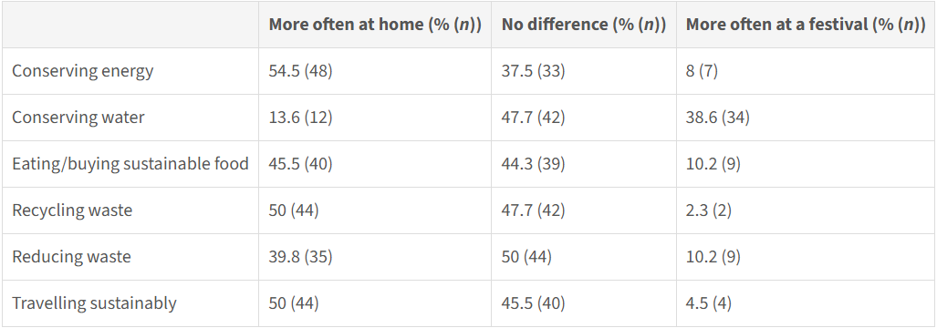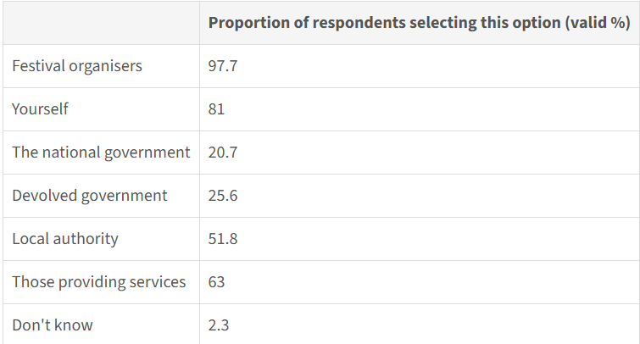
(Brennan, M., Jo, C.S., Connelly, A. and Lawrence, G., 2019)

Appendix 2:

The pyramid below depicts Maslow’s Hierarchy of needs model as mentioned on page 6:

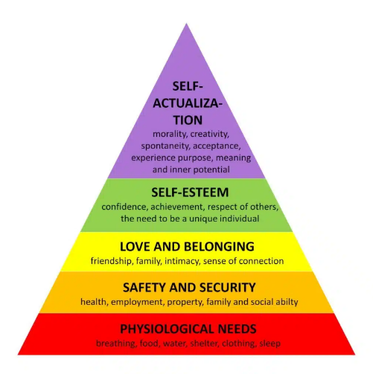
(McLeod, 2025)

Appendix 3:
As well as Big Green Coach providing convenient, direct travel to music events all over the UK (Biggreencoach.co.uk, 2019)

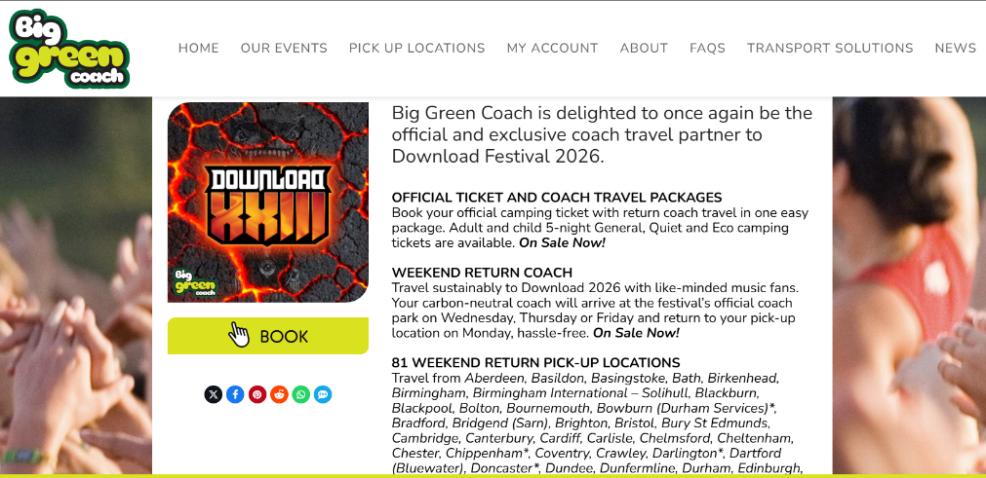
(Big Green Coach - The Events Travel Company, 2025)
‌
Appendix 4:
To elaborate on Environmental impacts mentioned on page 5:

Measures to ensure this festival is sustainable have been considered like the option for customers to “eco- camp” in a calmer environment. For this option, guests must agree to a pledge ensuring they collect all belongings, to not leave any litter after the festival. The festival also has sources on their website for attendees travelling, recommending different forms of transport to reduce carbon emissions using their carbon calculator (Download Festival, 2025).

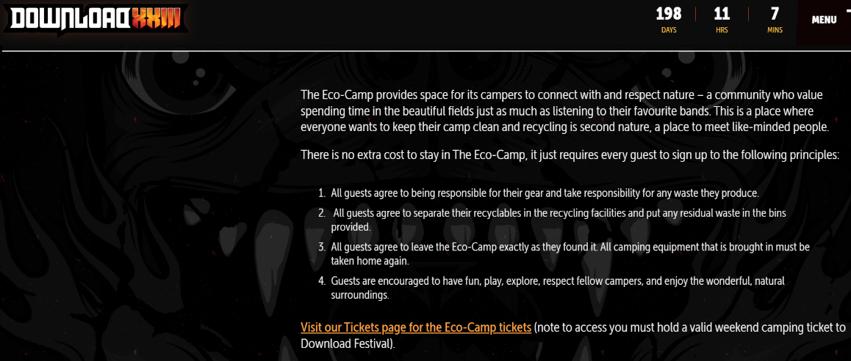

Appendix 5:
For those who still aren’t persuaded by the ecofriendly alternatives, the festival donates £1 from every car parking pass to Trees for Cities: the only charity in the UK “dedicated to urban trees” Trees For Cities (2018).


