Additional Learning Needs Legislation in Wales
Introduction - The Welsh Government (2020) want to transform expectations, experiences and outcomes for children and young people with additional learning needs. SNAP Cymru (2020) report that there will be changes to the way in which children and young people’s special educational needs (SEN) are identified, assessed, and met in Wales. In January 2018, the Additional Learning Needs (ALN) and Educational Tribunal Act was passed. The new ALN system set out in the Act will be implemented over a three-year period, commencing in September 2021 (Welsh Government, 2020). This new statutory framework will replace the existing Special Educational Needs Framework which is ‘no longer fit for purpose’(Dauncey, 2019). Within the new Framework children and young people under the age of 25 with additional learning needs will have Individual Development Plans (IDP) which will set out the support that the learners have a legal right to receive. The reform will be easier for the learners, their parents, and carers to be involved, as well as other agencies such as education, social services, and health services. There are 11 aims to the new legislation (Welsh Government, 2020). This poster will focus on three of the aims and how they will impact on the practitioner’s role.
Individual Development Plan
Individual Development Plans (IDP’s) will replace statements of educational needs (SEN) and individual education plans (IEP’s) for the learners who are currently supported through Early Years Action or Early Years Action Plus (Welsh Government, 2020). IDP’s must be prepared for the child where an ALN has been recognised and the school or local authority that maintains an IDP must secure the additional learning provision. Furthermore, children and their parents / carer’s will have the right to appeal to the Education Tribunal with regards to the decisions made by the local authority in relation to their additional learning need or their individual development plan. The local authority will then need to try and resolve such disputes (Welsh Government, 2020).
Age 0-25 years
The current framework supports children (0-16) who have SEN and young people (16 +) who have LDD and currently operates two separate systems. The new Act will be a single legislative system. This system will give support to all children and young people with ALN from birth to 25 years (Welsh Government, 2020). Identification and intervention in relation to ALN should take place as soon as possible and all statutory agencies will need to collaborate effectively between services involved with the child, the parents / carers, and the child / young person (Welsh Government, 2017). However, SNAP Cymru (2016) identified that the Act does not specify that assessments should be made in a timely manner or after an agency has identified a need that it will be met. This process could have an extra demand on additional provision, which may not be able to meet the needs of all children, putting extra pressure on practitioners.
Additional Learning Needs Coordinator
The new ALN Act will introduce a new statutory role: An Additional Learning Needs Coordinator (ALNCo). This role replaces the current Special Education Needs Coordinator (SENCO). All mainstream schools, maintained nurseries, pupil referral units and further education institutes in Wales must have a designated person, or more than one person, known as an ALNCo. This person will be responsible for coordinating provision for learners with ALN. The ALNCo will be required to form part of the senior leadership team as this will ensure a proactive institution in identifying and supporting the children and young people’s needs. ALNCo’s will be highly qualified and have expertise in an extensive range of ALN (Welsh Government, 2017). However, this could have financial implications due to extra costs (SNAP Cymru, 2016).

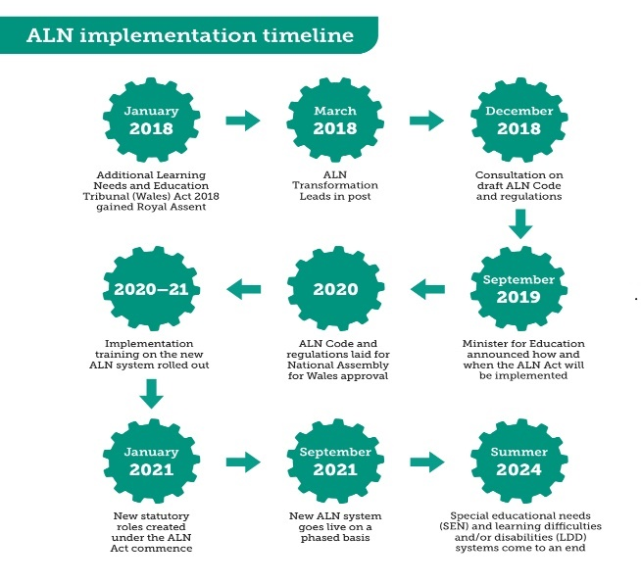(Welsh Government, 2020)
Conclusion – The new Additional Learning Needs and Educational Tribunal Act (2018) will not only benefit learners with ALN, it will also help to create a fair and inclusive education system, where all children and young people are supported to overcome barriers to learning and participation, to achieve their full potential. However, for this to happen within our education system the ALN Code within the system must be followed and the importance of continued professional Development and training must be adhered to (Nutbrown, 2011) as well as the importance of equality in practice and pedagogy (Nutbrown and Clough, 2013).

