

PRINCIPLES OF HEALTH AND SOCIAL CARE PRACTICE
Name: Jeneba Marah
Student number: 1816724
Module title: Principles of Health And Social Care Practice (BMHP5002)
Module lecturer name: Barbara Chinyani

Table of Contents
Introduction 3
Underlying concept of person-centred care 3
Theoretical underpinning of person-centred care 5
Ethical underpinning of person-centred care 7
Main benefits and limitation of person-centred care 9
Application of person-centred care in to practice 10
Recommendation for improving person-centred care 12
Conclusion 14
Reference list 15

Introduction
Health and social care practice of reference to as growing areas which mainly apprenticeships and are designed with various equipment which will help in delivering high quality safe and the compassionate care to certain persons. Thai will help in easy and fast recovery. There are mainly five principles based on standards of care being built which includes dignity, respect, compassion which also includes responsive care and the support and wellbeing. This essay will be dealing with a certain person's ventured care along with underlying theories and ethical consideration. Their application on patients suffering from "dementia" and strategic recommendations.

Underlying concept of person-centred care
"Person- centred care" mainly focuses on elders including both residential and clients and determining their emotional needs and the preference of care which mainly constituted their lifestyles. The main emphasis which is given in this type of care is focusing on building relationships which will help in building of knowledge, skill and level of confidence which lead in more effectively managing and making an informed decision of their own health and care. Main goal of "person centred care" is development and creation of partnership among care home staff and mainly people who were suffering from "dementia" and cancer and supporting their families in dealing with this situation. This also helps in enhancing their quality of lifestyles and quality of care through which they undergo while treating certain types of diseases (Liebler and McConnell, 2020).
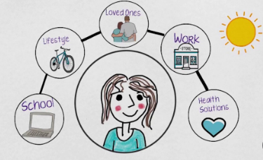
Figure 1: "Person centred care"
(Source: Influenced by Liebler and McConnell, 2020)
There are certain values which were being provided while determination of person centred care which includes a variety of guiding principles which will be helpful in putting all interest of individuals who are receiving care or are getting support at the centres everything which they are doing (Harper and Dickson, 2019).
Delivering of "person centred care" mainly involves caring for patients beyond their critical condition which will be helpful in tailoring their services which mainly suits individuals wants and needs. There are different types of principles which are included in "person centred care" which includes the following like: they will need to treat people in patients with dignity and compassion along with respect which will be helpful in easy recovery. They will also have to provide coordinated care with social care workers and service provided and support while their treatments. Recording of all personal needs will help in planning care strategies. This will help in providing personalised care and support depending on personal circumstances and damages which they have faced in their lives. Another principle is involving patients in decision making processes and helping them in taking actions so that they can live independent lives (Higgins et al. 2019).
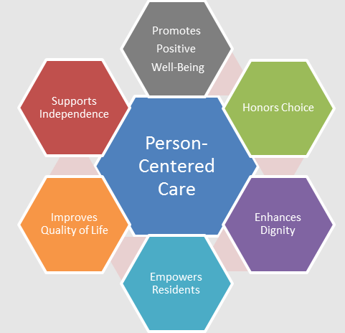
Figure 2: Principles of "person centred care"
(Source: Influenced by Higgins et al. 2019)

Theoretical underpinning of person-centred care
There are mainly six types of nursing theories which will help in determining and gaining several principles of care. The nursing theory 1 helps in sustaining "person centred care" which will help in understanding all needs and demands and also help in making individuals stable in understanding their own decisions for planning their care treatment plans. “Theory of interpersonal relationships'' will also help in development of strong personalised bonds between nurses and patients and there are various elements which will need to be accomplished like personal environment, health and nursing treatments. Caregivers and service providers need to have certain knowledge regarding earlier life and reason if their illness and their background which will be helpful in planning strategies for caregiving plans. Knowledge regarding the health hazards and their allergies will also be helpful in providing care to them. "person centred care" which was being followed in the UK will help in providing motivation to the individual in understanding their own decision regarding their treatment methods (Al-Ramahiet al. 2017).
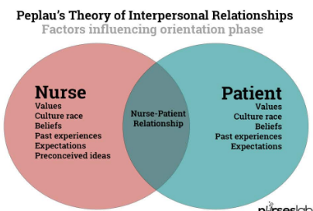
Figure 3: Theory of interpersonal relationships
(Source: Influenced by Al-Ramahiet al. 2017)
Another underpinning theory, which will help in determining and understanding "person centred care" (PCC) for certain people who are suffering from different diseases which need and require utmost care from caregiver and family members. Lydia Hall has developed “care cure core theory” which mainly centres in certain elements of learning of nurses who are considered as the main caregivers in principles of social and health care services. The term care in person centred principle reference to care and treatment which were being provided by nurses for easy recovery and training of their diseases (Dearing and Cox, 2018). This also includes undertaking your own decisions which will be helpful in leading an independent life. Cure refers to medical treatment and attention which were being given to patients from the medical fraternity. Term cure refers to treatment plans which were given by nurses in treating certain diseases which include "dementia" and cancer. Main aim of this theory is focusing on patients and planning their treatments based on their own needs and demands (Mitchell and Pearce, 2021).
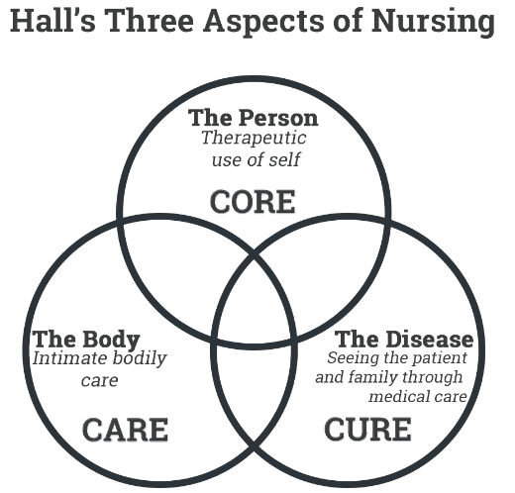
Figure 4: Care, Cure Core theory
(Source: Influenced by Mitchell and Pearce, 2021)

Ethical underpinning of person-centred care
PCC goes beyond the rational ethics which were there were certain assumptions which help in determining that persons are not only main centred of any types of medical treatment but also are at par with providers which help in strengthening their relationship. There has been a paradigm shift from patient centred care to "person centred care". Patients were also termed as persons with exceptional backgrounds, relationships and capabilities. There has been a congruence relationship between PCC and ethics as the social environment helps in development of most recurring relational ethical actions. There are certain ethical considerations which are being undertaken in determining "person centred care" like principles of autonomy and consideration of their cultural background which will be helpful in understanding environmental and planning of treatments. The patients have all right in choosing their ways and processes of treatment along with making decisions regarding this which will help in fulfilling their demands and leading an independent life (Jaarsmaet al. 2017).
There are two main approaches which were included in ethical reasoning of PCC which includes normative ethics which were based on different types of rights and obligations of particular individuals and another one is the teleological ethics which determines various anticipating consequences of any actions taken. The government of the United Kingdom has planned development of certain strategies which will in providing certain skills and education training which will help in supporting their workforce. The UK government has planned in development of partnerships with “skills for health and skills for care” which help in development of transferable skills and knowledge (Ryan, 2018). Ethical considerations based on “person centred approaches” mainly underpins certain existing diseases like "dementia", persons suffering from learning disability and mental health and end of life care core skills and framing of certain frameworks. Ethical consideration which needed to be maintained refers to providing responsive and respectful caregiving approaches and also taken into consideration about various types of demands and needs which were posed by patients treated as persons and their preference principles. I mainly contribute to patient empowerment by incorporating their decision making processes on treatment plans (Surret al. 2017).
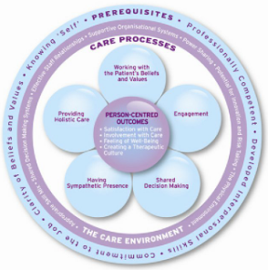
Figure 5: Ethical Consideration of "person centred care"
(Source: Influenced by Surret al. 2017)

Main benefits and limitation of person-centred care
There are certain benefits which are observed by patients undergoing "person centred care" which are as follows: this care approach mainly focuses on the most intricate of specific individual needs which are mainly essential in understanding mental health and emotions which will help in easy recovery. This will also be helpful in determining various approaches based on mind, body and soul which are interconnected entities. This will help in involving various decisions taken by them which were related to their life and health. Caregivers should also treat them with respect and dignity which will help strengthen their relationship (Muntheet al. 2018). Another benefit is that it helps in boosting the relationship between caregiver and care receiver. Caretaking of individual responses and demands help in showing respect and encouraging diverse positive responses which help in building interaction. Providing a feeling of encouragement, independence and dignity to loved one while offering "person centred care". Other strategies which can be used are involving them with other activities which will help in increasing their engagement like yoga, meditations and knitting. Person centred care also helps in improving quality of care by paying equal attention to physical, mental as well as spiritual health (Muntheet al. 2018).
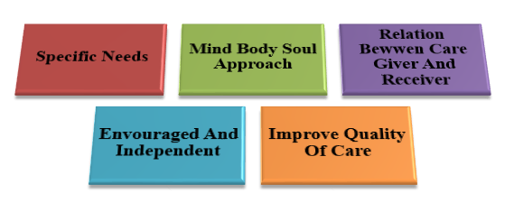
Figure 6: Advantages of "person centred care"
(Source: Influenced by Muntheet al. 2018)
On the contrary there are certain limitations which are being faced while implementing and initiating person centred care which are as follows: this includes lack of leadership ideas and conceptualization which will help in motivating patients in decision making process and determining and choosing their treatment which will help in easy recovery and treating their diseases. Another limitation is determination of lack of goals which will help in incorporating sufficient activities for determining "person centred care" and engaging them. Lack of communication between caregiver and care receiver will lead to the creation of a gap which lacks in providing care to patients suffering from mental illness, learning disability and "dementia". This type of treatment leads to increasing personal and financial costs because of customers' treatment in the home environment. There has been a high risk of compassion fatigue which leads to exclusion of staff personhood and sometimes development of unfairness during the process of empathy (Tomaselli et al. 2020).
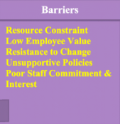
Figure 7: Disadvantages of "person centred care"
(Source: Influenced by Tomaselli et al. 2020)

Application of person-centred care in to practice
"Person centred care" is considered as essential for threatening "dementia" patients based on underlying philosophies of “Alzheimer's Association "dementia" care practise recommendation, 2018”. Persons suffering from "dementia" are referred to as persons suffering from loss of memory, language disability, problem solving skills and other thinking abilities. One of the most common causes of "dementia" is Alzheimer’s. There are certain steps which need to be followed sandwich will help in threatening these patients and will help in their easy recovery. The first and foremost thing is to provide them to take part in different activities which they enjoy the most. Person centred activities mainly help in preventingand managing effectively behavioural and various types of psychological symptoms which were being associated with "dementia" patients. There are certain key points which need to be taken into consideration which includes: treating this type of person will be treated with dignity and care and making them feel as part of society which will be helpful in controlling their behaviour (Corazziniet al. 2019).
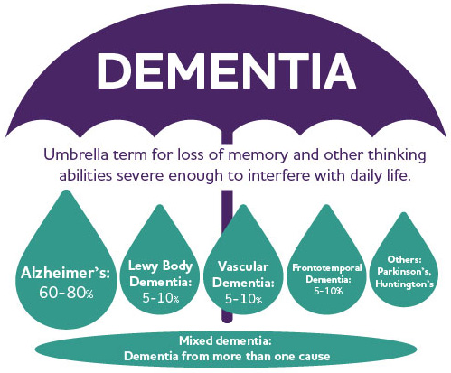
Figure 8: "Dementia"
(Source: Influenced by Corazziniet al. 2019)
After caring for them they have to understand and analyse their history, lifestyles, hobbies, cultural background and preferences which included things which were liked and declined and areas of interest which will help in planning their treatment and care plans and design of activities for keeping them engaged. Most important applications which were incorporated in planning of "person centred care" by looking from the point of view of the person suffering from "dementia". Caregivers need to provide certain opportunities which will help in enhancing their conversations, and strengthen their personalised relationships with other peoples which will help them in sharing their thoughts and ideas by implementing “theory of human care” (Eklund et al. 2019). Another important thing is that it must be ensured that these persons receive certain chances which will help in learning new things and take part in new activities like sewing, knitting and doing yoga, painting, learning music and musical instruments. Families of persons suffering with "dementia" must be involved in development of care plans based on "person centred care". Their knowledge and understanding regarding that person are extremely valuable for choosing rights and appropriate care plans (Eklund et al. 2019).
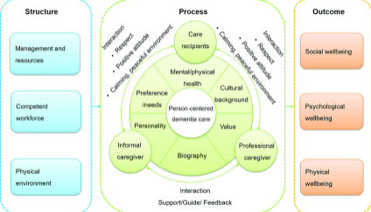
Figure 9: "Person centred care" for treating "dementia"
(Source: Influenced by Eklund et al. 2019)

Recommendation for improving person-centred care
There are certain strategies which can be incorporated in improving strategies and plans for "person centred care" which involves the following: these are showing of gratitude and should address all the basic human needs. Before planning treatment and care, the caregiver should ask the patient's family and individual regarding their preferences and choices, goals and expectations. They will also need to enhance their caregiving process and will need to cover all pollution irrespective of their religion, ethnicity, class and caste (Fazio et al. 2018). Caregivers must be well equipped with persistence, education regarding "person centred care" and determining strategic planning based on environment and situation. There should be certain automated platforms will be developed which will help in scheduling appointments and sending of thank you and welcome messages which will help in the development of bonding. They should also involve “care management software” which will help in providing seamless services to their patients along with their family members. Other certain platforms or software will be implemented which includes “patient care coordination” which were customized based on needs and demands of their patients and help in development of holistic care by collaborating with their family members and also enhancing their communication skills (Fazio et al. 2018).
These platforms will help in tracking patients care and identification of opportunities and providing patients access to their own medical records. This will also help in enhancing patient’s communication with medical professionals and improving care plan compliances. Apart from these there are certain other recommendations which were implemented including self-management and educational support which help in people to live long and imprinting their condition in the long run. Sometimes, opportunistic advice from health care professionals will be helpful in promoting good health symptoms and planning for immunization programs. These recommendations will help in effective planning and implementation of "person centred care" for treating certain diseases and for their easy recovery (Calkins, 2018).
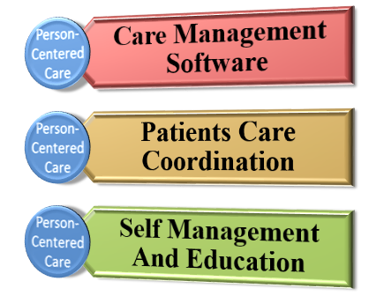
Figure 10: Recommendations for "person centred care"
(Source: Influenced by Calkins, 2018)

Conclusion
This essay has been dealing with principles of health and social care practises for certain diseases which can be cured by implementing "person centred care" plans. The concepts along with the underlying theories which will be helpful in analysing this type of treatment has been discussed. The ethical considerations and positive and negative impact of using PCC has also been discussed. The application of PCC in treating patients with "dementia" has been discussed along with effective strategies for improving their care plans.

Reference list
Al-Ramahi, M.A., Liu, J. and El-Gayar, O.F., 2017. Discovering design principles for health behavioral change support systems: A text mining approach. ACM Transactions on Management Information Systems (TMIS), 8(2-3), pp.1-24.
Calkins, M.P., 2018. From research to application: Supportive and therapeutic environments for people living with dementia. The Gerontologist, 58(suppl_1), pp.S114-S128.
Corazzini, K.N., Anderson, R.A., Bowers, B.J., Chu, C.H., Edvardsson, D., Fagertun, A., Gordon, A.L., Leung, A.Y., McGilton, K.S., Meyer, J.E. and Siegel, E.O., 2019. Toward common data elements for international research in long-term care homes: Advancing person-centered care. Journal of the American Medical Directors Association, 20(5), pp.598-603.
Dearing, J.W. and Cox, J.G., 2018. Diffusion of innovations theory, principles, and practice. Health Affairs, 37(2), pp.183-190.
Eklund, J.H., Holmström, I.K., Kumlin, T., Kaminsky, E., Skoglund, K., Höglander, J., Sundler, A.J., Condén, E. and Meranius, M.S., 2019. “Same same or different?” A review of reviews of person-centered and patient-centered care. Patient Education and Counseling, 102(1), pp.3-11.
Fazio, S., Pace, D., Flinner, J. and Kallmyer, B., 2018. The fundamentals of person-centered care for individuals with dementia. The Gerontologist, 58(suppl_1), pp.S10-S19.
Harper, L.M. and Dickson, R., 2019. Using developmental evaluation principles to build capacity for knowledge mobilisation in health and social care. Evaluation, 25(3), pp.330-348.
Higgins, A., Downes, C., Sheaf, G., Bus, E., Connell, S., Hafford-Letchfield, T., Jurček, A., Pezzella, A., Rabelink, I., Robotham, G. and Urek, M., 2019. Pedagogical principles and methods underpinning education of health and social care practitioners on experiences and needs of older LGBT+ people: Findings from a systematic review. Nurse education in practice, 40, p.102625.
Jaarsma, T., Cameron, J., Riegel, B. and Stromberg, A., 2017. Factors related to self-care in heart failure patients according to the middle-range theory of self-care of chronic illness: a literature update. Current heart failure reports, 14(2), pp.71-77.
Liebler, J.G. and McConnell, C.R., 2020. Management principles for health professionals. Jones & Bartlett Learning.
Mitchell, A. and Pearce, R., 2021. Prescribing practice: an overview of the principles. British Journal of Nursing, 30(17), pp.1016-1022.
Munthe, C., El-Alti, L., Hartvigsson, T. and Nijsingh, N., 2018. Disputing with patients in person-centered care: Ethical aspects in standard care, pediatrics, psychiatry, and public health. Journal of Argumentation in Context, 7(2), pp.231-244.
Ryan, G., 2018. Introduction to positivism, interpretivism and critical theory. Nurse researcher, 25(4), pp.41-49.
Surr, C.A., Gates, C., Irving, D., Oyebode, J., Smith, S.J., Parveen, S., Drury, M. and Dennison, A., 2017. Effective dementia education and training for the health and social care workforce: a systematic review of the literature. Review of educational research, 87(5), pp.966-1002.
Tomaselli, G., Buttigieg, S.C., Rosano, A., Cassar, M. and Grima, G., 2020. Person-Centered Care From a Relational Ethics Perspective for the Delivery of High Quality and Safe Healthcare: A Scoping Review. Frontiers in public health, 8, p.44.

