Knowledge and Information skills for the Workplace

University of Wales Trinity Sant David

              - Student name : Daniela Vidrascu
              - Student number: 1817905
              - Module title: Knowledge and Information Skills for the Workplace
BMSW5106
              - Assignment title : Knowledge and Information Skills for the Workplace
              - Lecture’s name: Md Kalam

Executive Summary
Knowledge management is the mechanism of defining, structuring, retaining, and sharing knowledge and experience of the employees within the area of an organisation (Maier, et all, 2019). The main objective of Knowledge management is to provide learning to improve the efficiency and productivity of the employees in the organisation. The report illustrated the knowledge management project of Amazon and depicted knowledge management tools and techniques. Amazon is an American multinational technology company. It focuses on e-commerce, cloud computing, digital streaming, and artificial intelligence. It is one of the largest five companies in the U.S. information technology. It is also one of the largest companies in the world. Knowledge management will help to improve the decision-making ability of the employees within the organisation. It will increase collaboration among the employees. Knowledge management has several tools that provide a central repository for all information, data, and knowledge which facilitate easy storage and retrieval. These are stores and retain knowledge, the lively flow of information, improve group works and conciliation, proper use of time and resources, Improves the quality of service, concentrates knowledge source, provide information to executives make the better business decision (Sanchez, 2017). These help the organisation to make a systematic knowledge management system to improve the performances of this company. Knowledge management of the organisation can be developed by using several techniques that will organise the knowledge management process to achieve the organisations' main objectives. These are tutoring and training, communities of practice, expertise location, documentation, guides, guidelines, tutorials; forums intranet and collaboration environments; learning and development environments; Case studies. So, by using these techniques, the organisation can improve their employee’s skills to perform better to achieve the main objectives of this. The be benefits of knowledge management for Amazon to keep a successful knowledge management system along with different models are used to illustrate the project.

Contents
Executive Summary 2
1.0 Introduction 1
2.0 Part 1: Knowledge and Information Management 2
2.1 Overview of Amazon 2
2.2 Knowledge Management 3
2.3 Importance of Knowledge Management 4
2.4 Role of Knowledge Management 5
3.0 Part Two 7
3.1 Evaluation of Knowledge and Information Management Models 7
3.1.1 SECI Model 7
3.1.2 The CHOO Sense-Making Model 8
3.1.3 WIIG Model 9
3.1.4 Krogh and Roos Model 10
3.2 The Role of KM Models in Creating and Managing Knowledge 11
3.2.1 Implication of KM model by Amazon 11
4.0 Knowledge management techniques used by Amazon 13
4.1 Implication of knowledge management techniques by Amazon 13
4.2 The areas where Amazon is not doing well in KM 14
5.0 Recommendation to recover the weakness 16
6.0 Conclusion 16
7.0 Reference List 17

1.0 Introduction
Knowledge management is the mechanism of structuring, retaining, and sharing knowledge and experience of the employees within the area of an organisation to provide learning to improve the efficiency and productivity of the employees. Knowledge management is a part of project management which is the mechanism of defining, structuring, retaining, and sharing knowledge and experience of the employees within the area of an organisation (Maier, et all, 2019). The main objective of Knowledge management is to provide learning to improve the efficiency and productivity of the employees in the organisation (Laudon, et all, 2014).
The main purpose of this report is to outline the project with the knowledge management system of Amazon to examine and evaluate different knowledge management models and identify the proper model for Amazon. The primary models including SECI Model, The CHOO SEUSE Making Model, and The WIIG Model, The EFQM, and the INUICSHUIC model are discussed where WIIG and CHOO SEUSE model is used to evaluate the knowledge management system of Amazon. The report aims to analyse these above matters a company named Amazon in this report.
Amazon is an American multinational technology company headquartered in Seattle, Washington. It was founded by Jeff Bezos in Bellevue, Washington on July 5, 1994 (Amazon, E.C., 2015). It focuses on e-commerce, cloud computing, digital streaming, and artificial intelligence (Varia, et all, 2014). It is one of the largest five companies in the U.S. information technology. It is also one of the largest companies in the world. I have illustrated the knowledge management project of Amazon and depicted knowledge management tools and techniques in this report.
The mains sections of the reports are knowledge management and how Amazon increase the efficiency of the workplace with a proper knowledge management system. The necessity of knowledge management will be discussed in the next section. The role of knowledge management and the impact it on Amazon along with the knowledge and information management of the company will be discussed in the next section. The role of knowledge management models in creating a diverse yet effective team for the company will be discussed as well. In the end, all necessary recommendation will be given for amazon on how it can improve or overcomes its limitations.

2.0 Part 1: Knowledge and Information Management

2.1 Overview of Amazon

Amazon is an American multinational technology company headquartered in Seattle, Washington. It was founded by Jeff Bezos in Bellevue, Washington on July 5, 1994 (Amazon, E.C., 2021). It focuses on e-commerce, cloud computing, digital streaming, and artificial intelligence. It is one of the largest five companies in the U.S. information technology. It is also one of the largest companies in the world. It has over 40 subsidiaries companies in the world. It provides many products and services such as several media, apparel baby products, consumer electronics, beauty products, groceries, health and personal-care items, industrial and scientific supplies, kitchen items, pieces of jewellery, watches, lawn and garden items, musical instruments, automotive items, sporting goods, tools, games, etc. It focuses on customer satisfaction instead of looking at competitors. Amazon determines the customer-driven strategies to be in the number one position (Varia, et all, 2014). In 2020, its total equity was US$ 93.404 billion. It was started its international market by establishing online sellers of books in the United Kingdom and Germany. It operates its business in many countries over the world now. It provides products at convenience and low price to the consumers. The amazon market is growing rapidly day by day. During the Corona pandemic, many businesses cut down their business whereas Amazon continuously grows its business by providing outstanding services online to the consumers. It has applied the best strategies to conduct the business in this period. Amazon has many employees to operate its activities (Sanchez, R. 2017). It follows various strategies to expand its business in the world. It provides product and services to its customer groups at a lower price. It creates a place in the market by satisfying the customers. The market share of Amazon increases day by day in the market which indicates that it will be number one position in future.

2.2 Knowledge Management
Knowledge management is a part of project management which is the mechanism of defining, structuring, retaining, and sharing knowledge and experience of the employees within the area of an organization (Maier, et all, 2019). Knowledge management helps organisations to lead their employees to work in the perfect way to achieve the organisations expected output (Sanchez, R. 2017). It also facilitates the flow of information among the employees within the organisation. Information management is also important for an organisation. We need much information in terms of operating businesses like information about products, information about our policy, information about various strategies, information about employee’s performances, and information about competitors. So, the organisations must manage knowledge and information in such a way that helps the organisations to achieve expected goals. The executives can share their experiences with their employees so that they can learn something from the Knowledge management process (Maier, et all, 2019).
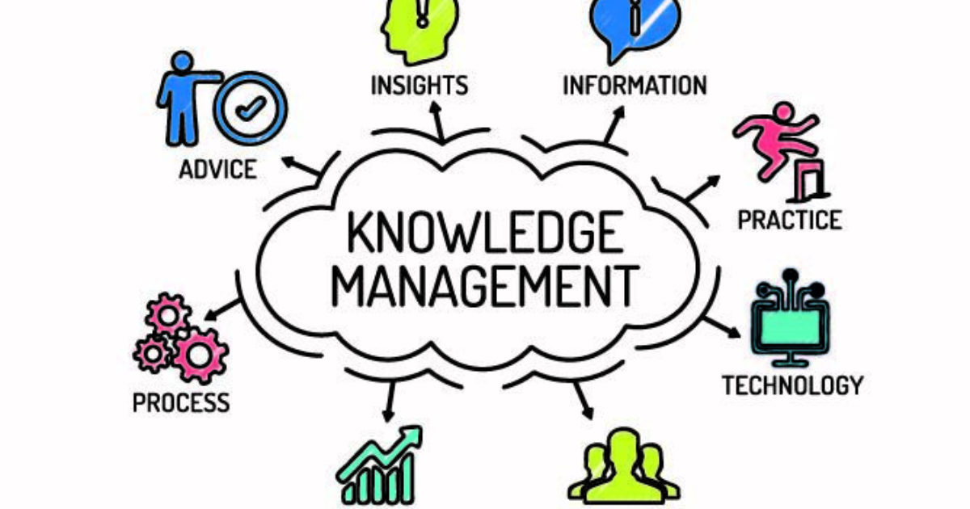
Knowledge management project helps the organisation to make a systematic knowledge management system to improve the performances of a company which can be developed by using several techniques that will organise the knowledge management process to achieve the organisations' main objectives (Laudon, et all, 2014). These are tutoring and training, communities of practice, expertise location, documentation, guides, guidelines, tutorials; forums intranet and collaboration environments; learning and development environments case studies. It can also depict the importance of knowledge management for the organisations to know the competitive advantages of any business organisation.
It improves the organisations' efficiency and retains knowledge for the company. It has three main areas such as accumulating knowledge, storing knowledge, sharing knowledge. It creates a learning culture within the organisation. Knowledge management typically covers two types of knowledge like tacit knowledge and explicit knowledge. Innovative thinking and understanding of body language are two areas of tacit knowledge. It is more intuitive than others. It is different to share with others. Explicit knowledge is information to take the decision or to help the executives in decision making. Successful knowledge management will improve organizational efficiency in many ways that ensure the specialised knowledge of the employees. Every organisation must have a proper knowledge management system to retain knowledge, to improve employee skills to create a learning-oriented culture within the organisation.

2.3 Importance of Knowledge Management
Knowledge management is very much important for any organisation to achieve the organisation’s main objective. The success of the organisation heavily depends on the workers where they must be well trained, skilled to perform their jobs toward achieving goals (Griseri, 2016). The organisation must make sure that a skilled workforce is built who can perform quick, informed decision that benefits the company. The organisation can achieve these qualities among the employees by proper knowledge management (Sanchez, R. 2017).
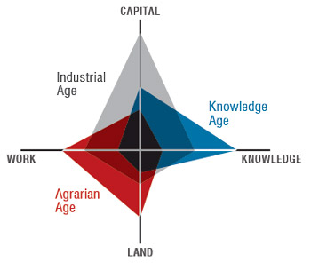
Figure: Knowledge management (Griseri, 2016)
If the organisations have unskilled employees, they cannot reach the final goal; they cannot provide better service to the customers and within the organisations. Knowledge management provides guidance to create, capture knowledge. It moves the business toward achieving expected goals easily. So, knowledge management is compulsory for the organisation to be succeeded. It helps to create an extraordinary workforce for the organisations. It also provides relevant information to operate the businesses. Knowledge management is also important for Amazon. As Amazon is a big company, it has many employees to perform their daily activities. It has many markets to serve the customers. The employees of Amazon must be more efficient to provide service to customers (Caruso, 2017). They must be more trained and skilled to perform their activities to satisfy customers. Knowledge management will create a learning and knowledge sharing environment among the employees of Amazon. For that Amazon must spend many dollars to manage knowledge within the organisation. As a result, the efficiency of its workers increases to perform their activities to serve the customers. So, the following benefits will arise for the company from knowledge management:
- Efficient workplace
- Faster, better decision making
- Improved collaboration
- Creating organisation knowledge
- Optimizing training process
Knowledge and information management provides the above benefits to organisations. It increases the organisations' capabilities to conduct the businesses. It also creates core competencies for the organisations by providing these facilities (Griseri, 2016). So, it can be said that knowledge management is very much important for every organisation.

2.4 Role of Knowledge Management
Knowledge management plays a vital role to satisfy customers and achieving competitive advantages over competitors (Caruso, 2017). Proper knowledge management has a positive impact on organisations to satisfy customers. Customer satisfaction is causally related to the performances of the employees. The performances of the employees depend on proper knowledge management. So, it can say that Customer satisfaction is related to knowledge management. It creates more efficient work within the organisation. It improves better decision-making ability among the employees (Griseri, 2016).
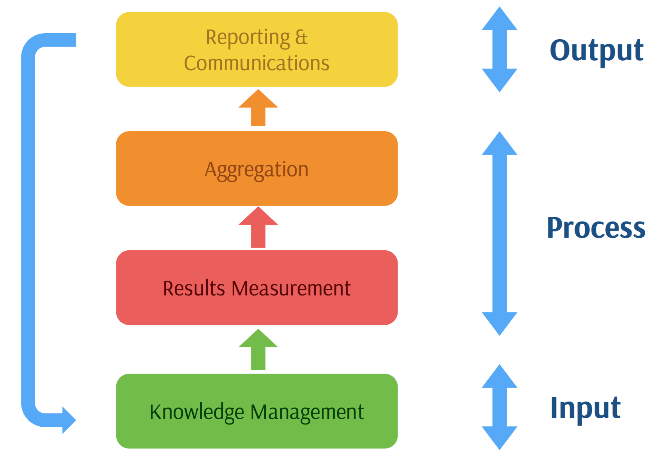
Figure: Role of KM (Caruso, 2017)
It increases collaboration among the employees to accomplish group works. It builds organisational knowledge to operate the business successfully. It optimizes employee onboarding and training process. Overall, it increases employee happiness and retention. The above capabilities increase the employee’s performance quality to satisfy customers. So, the customers are satisfied by getting outstanding goods services from the organisation. It is a major competitive advantage of a firm to create satisfaction among the customer groups (Haslinda and Sarinah, 2017). It will enhance the market share of the firm. Knowledge management also creates many competitive advantages to lead in the market. If customers get better service in the firm rather than competitors, it will create positive awareness among the customer groups to transact with this firm. It helps to increase the market for the products of this firm. If this firm launches a new product in the market, it will get a competitive advantage because of its previous activities of providing services by the employees. Effective knowledge management helps the employees to invent new things for the firm which is a competitive advantage of it. Knowledge management creates a learning-oriented culture within the organisation which is a competitive advantage of it. Knowledge management helps to build a strong and skilled employee group for the organisation which provides a competitive advantage to the organisation (Gourlay, 2017). By improving knowledge within the organisations, a firm can produce better quality products to serve the customers. The better quality of the products creates a competitive advantage for the firm to be a success over competitors. So, it can be said that knowledge management creates customer satisfaction and a competitive advantage for the firm in many ways.

3.0 Part Two

3.1 Evaluation of Knowledge and Information Management Models
As knowledge management is an integrated part of organisations, they use several models to manage knowledge assets. There are various models and theories such as The Choo Sense-Making Model, The WIIG Model, SECI Model, The EFQM Model, The Inukshuk Model, The Von Krogh and Roos Model etc. (McAdam, et all, 2018). I have described the pros and cons of these above models in the following part.

3.1.1 SECI Model
It is a model of knowledge creation and transfer theory introduced by Nonaka and Takeuchi. It proposed four terms that knowledge can be combined and converted that shows the process of knowledge sharing and creation in the organisation (Hoe, 2018).
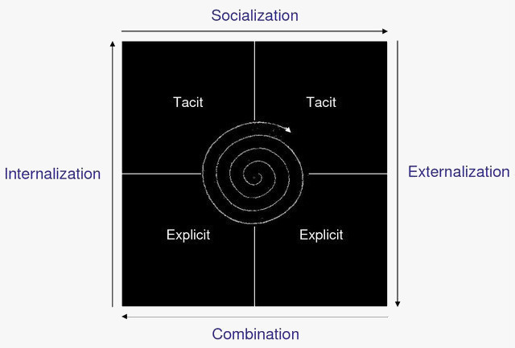
Figure: SECI Model (Gourlay, 2017)
Socialisation: Knowledge is passed on through practise, guidance, imitation, and observation. It is an indirect approach that is tacit to tacit.
Externalisation: It covers indirect to direct way that is tacit to explicit. It plays an important conversion mechanism. Tacit knowledge is converted into the document, manuals, etc.
Combination: It also covers a direct way approach that is explicit to explicit. It is the simplest form that combines knowledge sources to create new knowledge.
Internalisation: It is direct to the indirect way that covers explicit to tacit. The knowledge is internalised in this mechanism (Haslinda, 2017).
By using this model, knowledge is continuously transformed and created as employees’ practice, collaboration, interaction, and learning process. It helps the organisations to build a learning-oriented culture that helps to manage knowledge assets properly. It is a dynamic model to create knowledge. It has practical applicability but it is strongly related to the strong culture of the organisation which is a core conversion theory of knowledge management (Caruso, 2017).

3.1.2 The CHOO Sense-Making Model
It is another model of knowledge management. It focuses on three major categories.
- Sense-Making
- Knowledge Creation
- Decision Making Skills
These three steps contribute a major role in the management of knowledge assets within the organisation. Many organisations use this model to improve knowledge assets.
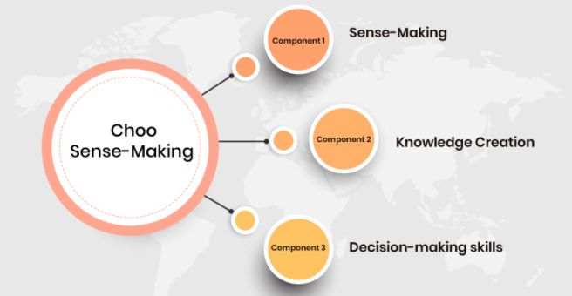
Sense-Making: It is a long-term target that gives the warranty that the organisations will adapt and continue to prosper in dynamic and complex situations through activities of advertising and interpretation of essential information that enables it to understand change situations, trends, and scenarios about customers, suppliers, competitors and many external environment factors (Gourlay, 2017).
Knowledge Creation: It is an important process of this model that allows the organisations to create or gather, organise information to generate new knowledge by a learning-oriented process in the organisation (Sarinah, 2017). It helps to improve capabilities, to increase skills among the employees. It helps to develop new products in the organisation. Overall, it creates knowledge assets for organisations.
Decision-Making Skills: In these steps, the organisations must choose the best employee among those employees to improve decision-making skills. It will enhance the employee’s performances to achieve goals. It helps to make decisions that are successful for the organisation.

3.1.3 WIIG Model
It is a popular knowledge management model for the organisation based on four basic principles (Wiig, 2013). This model helps the organisations to define different levels of knowledge to retrieve good knowledge for the company. It is related to holding knowledge, pooling knowledge, applying knowledge, and building knowledge.

Figure: WIIG Model of Knowledge Management (Wiig, 2013)
This model is based on four basic principles. These are in the following part.
- Completeness
- Connectedness
- Congruency
- Perspective and purpose
Completeness: The available information from various sources must be complete to make use of this information. If information is not complete, it will prevent understanding properly to develop an efficient workforce. So, completeness of the information is made sure in this model (Varia, 2014).
Connectedness: The various knowledge objects must relate to each other to share organised information within the organisations. It assures that the information is well understood and well defined.
Congruency: All the facts, beliefs, perspectives, concepts, values, assumptions, and the relational link must be consistent to be congruent. The information must be more reliable to manage good knowledge.
Perspective and Purpose: It is a mechanism through which we know information from a particular view for a specific objective. We organise much of our knowledge from dual dimensions of perspective and purpose (Gourlay, 2017).
The above models help the companies to manage their knowledge properly to achieve the goal. These help the organisations to create a learning-oriented knowledge group within the organisations.

3.1.4 Krogh and Roos Model
It is also an important model of knowledge management that follows the principles connectionist approach which examines the nature of knowledge management from five factors. These are:
- Employees
- Communication
- Organisational Structure
- Links between members
- Management of human resources
These above matters care problems related to knowledge management issues. It focuses to stimulate individual knowledge development, group sharing of knowledge, and retention of valuable knowledge assets (Varia and Mathew, 2014). It also differentiates individual knowledge and social knowledge. The employees can learn from notes and various knowledge representation programs.

3.2 The Role of KM Models in Creating and Managing Knowledge
Knowledge management models help the organisation to create knowledge assets and to manage created knowledge assets for the success of business in the market (Haslinda, et all, 2017). KM models give us a specific framework to process knowledge assets. We get organised guidance to create and manage knowledge assets properly to achieve goals. Knowledge management models help organisations to access all relevant information and resources by employees when they need that (Collinson, et all, 2004).

3.2.1 Implication of KM model by Amazon
Amazon uses different knowledge management techniques based on the situation and what needs the company. For example, the company focus on the interests of the employees and offer them different target to fulfill the criteria. During COVID-19, managers ask the employees how they can work from their place without going outside and one of the employees suggested them to use online supervision to observe their workflow and performance. One of the employees offered a way where the company will deliver their product on certain days of a week to ensure the flow but taking proper health measurement. This proved their knowledge and how they use it for the sake of the organisation. It gives a clear demonstration of work to perform different tasks among the employees (Mathew, et all, 2014). For example, Amazon uses a km model to create and manage knowledge; it will be able to provide relevant information and resources to its employees and they will get specific direction on what they should do works, how they should do these works maintain the pandemic measurement.
Knowledge management models not only help organisations to keep important knowledge within the organisations but also keeping the impact after employees leave the business. For example, if the employees, who are highly experienced in operating businesses, leave the current business, their experiences will be kept in the organisations by using proper knowledge management models for future use of knowledge assets (Haslinda and Sarinah, 2017). Knowledge management models also avoid duplicated efforts as these are used to creating new knowledge continuously, these cannot allow the use of duplicated efforts. The organisations can invent new process to manage and create knowledge by using various km models which helps the companies to take advantages of existing expertise (Gourlay, 2017).
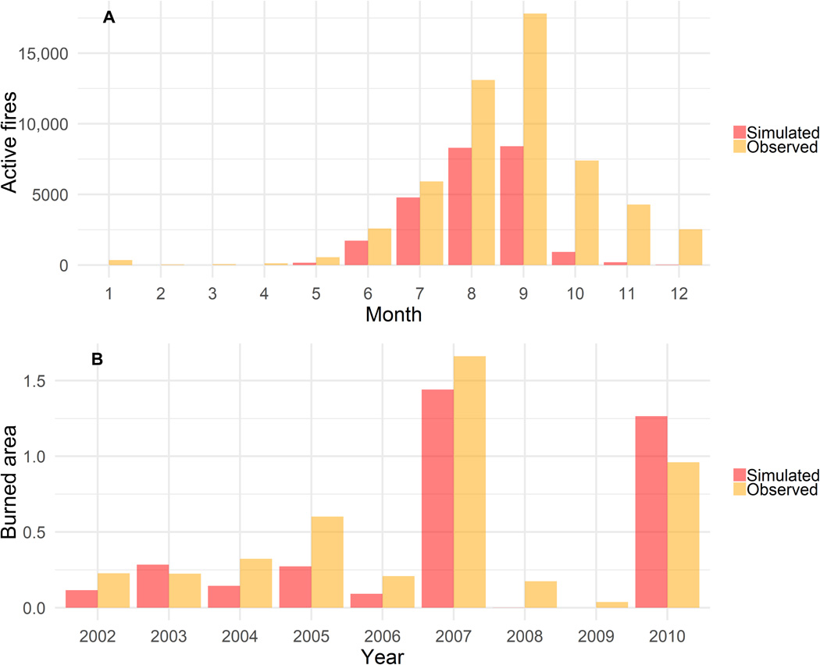
The effectiveness of knowledge management of Amazon grows continuously by applying their expert knowledge. Because the company uses application tracking system (ART) to hire their employees where different types of keywords are used to justify the interest of the employees who can fulfill the need of the situation. Besides, the organisations get a group of experts who possess many experiences from knowledge management culture. It develops collaboration among the employees to continue the works within the businesses (Haslinda and Sarinah, 2017). It helps organisations to improve efficiency in doing works in the workplace.
Km model used by Amazon helps to standardise process and procedures for knowledge management that creates a systematic culture for managing knowledge assets. It creates discipline in the organisations. For that, the productivity of the employees will increase. For example, the capacity to perform different tasks will be improved by applying a systematic learning-oriented km model. It also helps the organisations to capture knowledge for future use in terms of conducting the business operation.
This model helps to arrange tutoring and training that transfers knowledge from knowledge holders to trainee. It helps the organisation to keep documentation, guides, guidelines that can be archived and captured easily (Varia and Mathew, 2014). It provides strong proof of the company’s standings. The employees of the organisations can learn many things from these. Overall, it will help the organisations to create a strong workforce to achieve final goals. So, every organisation should develop a systematic knowledge management model to create, acquire, to retrieve the knowledge to possess a better position in the market.

4.0 Knowledge management techniques used by Amazon
Amazon is the largest technology-based company in America as well as in the world. It is using various knowledge management techniques to accomplish its goals. For example, Amazon follows the WIIG model to create, gather, and improve knowledge assets to achieve business success. Amazon has typically established its knowledge management techniques based on four principles. These are completeness, connectedness, congruency, perspective, and purpose (Wiig, 2013). Amazon collects information and resources from various relevant sources which are meaningful. Amazon provides specific guidance to its employees to be well-understood and well-defined relations among different knowledge objects. Amazon provides all the facts, concepts, and perspective that are consistent. The employees get consistent knowledge from the Amazon knowledge management system where the company using WIIG model.

4.1 Implication of knowledge management techniques by Amazon
There are huge benefits using knowledge management techniques where Amazon enjoys many benefits in terms of creating values. Some examples from the company are given:
One portal, one interface: The consumers can get all products of amazon in one portal that facilitates the transactions. For example, we get food, electronics, clothing, and books through the same portal that provides the same user experiences. It provides the employees with a common, familiar, and easy to use the gateway to workplace knowledge in the organisations (Gourlay, 2017). It increases employee’s skills to serve the customers.
Consistent Presentation: Consistency influences a lot in organisations. Amazon provides consistent information by using the knowledge management model. It helps the employees to track and archive information. The ability of the employees improves day by day to provide customer services (Collinson, 2004).
Modular Content: Amazon can enable the employees to quickly access only the needed content by using the knowledge management model. It reduces wastage of time scanning elaborate documents. It increases the productivity of workers.
Distributed upstream content creation: Amazon can create contents in such a way that seem that comes from one place. It is more suitable for customers and employees to use.
Magical Personalisation: Productivity and efficiency are increased by using the knowledge management model. It will grow personality among employees to work smartly within the organisations (Parcell, 2004).
Crowdsourcing: knowledge management techniques create formal communities of practice which are especially important for an organisation. It creates knowledge and awareness among users that facilitates the acceptance of the company.
Feedback: Amazon is the most popular c-commerce sites in getting users to give meaningful feedback. It is only possible because of the good knowledge management system. Feedback is the most fruitful way to gauge the knowledge management model (Gourlay, 2017). It helps the users to differentiate important topics based on feedback. It does simplify the employee’s works.

4.2 The areas where Amazon is not doing well in KM
Though Amazon is leading e-commerce from the top, the company has some factor to improve the knowledge for future success. Knowledge management is a continuous process where the company need to adapt new technology and implement new strategies to adapt with globalisation. But sometimes sticking to some beneficial techniques increase the business margin for temporary. So, Amazon should avoid thinking about short-term benefits and focus on long-term benefits. For example, Amazon can adopt mini map techniques along with SECSI model to improve the efficiency of the existing employees instead of hiring new employees. This not only reduce the cost but helps to get experience stuff and improved candidates for certain works.
As KM is continuously transformed and created as employees’ practice, collaboration, interact, and learning process, Amazon should build a learning-oriented culture that helps to manage knowledge assets properly. The company work culture is bit hard to adopt for the employee which should be easy and decentralize for the growth of the company (Collinson and Parcell, 2004).
Amazon is way behind of keeping their expertise which increase the ability of the rival company and know their strategy from them. The management has faster decision-making capability, but it should not let their experience employee leave easily in rush judgment. This will share their expertise to their competitor and let them suffer building new expertise with the cost of extra money (Hadrich, 2019).
Amazon’s cloud server is also faced huge risk where the wrong API of the GitHub opens the hole to use their service from GitHub using circle-ci which is wasting their resources. The company should increase the security and upgrade their server and API to efficiently enable to service to the users.
The payment system of the company is proving they are suffering from expertise in this sector, they should open trial system like GCP which will increase the interest on using the service and become a potential customer of the company. The upgrade and update system should be optimized. The feedback system should be open wide with automated interaction with the users to increase the acceptance of their feedback system as well.

5.0 Recommendation to recover the weakness
The cultural framework of Amazon knowledge management framework can be improved by investigating their weakness which were discussed on the previous sections. At first the company need to share its library for every employee to know its diverse work culture and get knowledge about the previous flaws. Moreover, Amazon should increase the security of their data centre and servers. The company can easily ensure this by implementing updated hardware and software with newer API. The company must value its experience employee and try to keep them so there will less hassle to recruit the stuff and manage the workplace without any hassle (Maier and Hadrich, 2019). The existing KM model also need to be changed more frequently which will increase the capabilities and enrich the knowledge of the employees. The management team always use dynamic model and newer technique to make a diversified workplace and let everyone enjoy their workplace. This will increase the efficiency of the employees and benefit the company in long-term. Besides, Amazon should modernize their knowledge management system and take initiatives to overcome its drawback to reach the peak of development.

6.0 Conclusion
It can be concluded that knowledge management is an integral part of businesses. It helps the businesses to be succeeded. There are several KM theories that we have described above. By using these models, a business can reach its expected goal. It improves the productive quality of the employees within the organisations. It contributes to creating, capturing knowledge assets for the organisations. It creates opportunities for employees, users and customers. Every business must research several knowledge management theories to operate businesses continuously by creating a strong workplace. It keeps the businesses updated by providing related information. So, we must track the information needed to operate the business successfully. Businesses must expend many dollars to bring a remarkable change in the organisations in the area of knowledge and information management system. Amazon must improve their KM techniques to possess the number one position in the market.

7.0 Reference List
Amazon, E.C., 2021. Amazon web services. Available in: http://aws. amazon. com/es/ec2/ (February, 2012).
Caruso, S. (2017). A Foundation for Understanding Knowledge Sharing: Organizational Culture, Informal Workplace Learning, Performance Support, and Knowledge Management. Contemporary Issues in Education Research, 10(1), 45-52.
Choo, C.W., 2016. Sensemaking, knowledge creation, and decision making. The strategic management of intellectual capital and organizational knowledge, pp.79-88.
Collinson, C and Parcell, G (2004) Learning to Fly: Practical Knowledge Management from Leading and Learning Organizations, Capstone, England.
Gourlay, S., 2017. The SECI model of knowledge creation: some empirical shortcomings.
Griseri, P. (2016). Management Knowledge: A Critical View. Houndmills, Basingstoke, Hampshire: Palgrave.
Haslinda, A. and Sarinah, A., 2017. A review of knowledge management models. Journal of international social research, 2(9).
Hoe, S.L., 2018. Tacit knowledge, Nonaka and Takeuchi SECI model and informal knowledge processes. International Journal of Organization Theory & Behavior.
Laudon, K., & Laudon, J. P. (2014). Management information systems: Managing the digital firm. Thirteenth edition. Pearson: London
Maier, R. and Hadrich, T., 2019. Knowledge management systems. In Encyclopedia of Knowledge Management, Second Edition (pp. 779-790). IGI Global.
McAdam, R. and McCreedy, S., 2018. A critical review of knowledge management models. The learning organization.
Sanchez, R. (2017) Knowledge management and organizational competence. (Online) Oxford University
Varia, J. and Mathew, S., 2014. Overview of amazon web services. Amazon Web Services, 105.
Wiig, K.M., 2013. Integrating intellectual capital and knowledge management. Long-range planning, 30(3), pp.399-405.
Wiig, K.M., 2013. Knowledge management: an introduction and perspective. Journal of Knowledge Management.

