
Business Report- Comparison of Two Hospitality Organisations
[Document subtitle]
Sonia-Lorena Porumb (2233341) | Lecturer: Tristian Hawkins | Financial Management for the Hotel Industry (BMIH5007)

Wordcount:2104

Executive summary

Revenue Generation
Travelodge Hotels: Positioned as a mid-scale hotel chain, Travelodge focuses on providing budget-conscious travellers with quality accommodations. It reported $1.2 billion in revenue in 2023, primarily from room bookings and on-site amenities.
Shangri-La Hotels: Renowned for luxury offerings, Shangri-La reported a significant revenue of $3.5 billion in 2023, targeting high-end individuals seeking premium experiences.

Market Positioning
Travelodge: Positioned as a budget hotel chain, Travelodge caters to budget-conscious travellers, particularly in the UK, offering affordable accommodations in convenient locations.
Shangri-La: Dominates the luxury hotel segment, especially in Asia, targeting affluent travellers seeking superior services and luxury accommodations.

Growth Potential
Expansion Strategies: Shangri-La focuses on sustainability and expansion into emerging markets, while Travelodge expands rapidly through refurbishments and strategic campaigns, targeting affordability and accessibility.
Market Opportunities: Shangri-La taps into the luxury travel market's growth, while Travelodge benefits from the increasing demand for affordable accommodations, particularly in underrepresented areas.

Potential Barriers to Growth
Competition: Intense competition in the luxury hotel industry poses challenges for Shangri-La, while market saturation and regulatory issues hinder Travelodge's expansion plans.

Financial Commitment to CSR
Shangri-La: Emphasizes sustainability practices and community development initiatives, catering to affluent travelers.
Travelodge: Focuses on cost-effective CSR initiatives aligned with affordability and responsible tourism promotion.

Conclusion
Both Travelodge and Shangri-La navigate distinct market segments with precision, leveraging unique value propositions for growth.
Challenges such as market saturation and regulatory hurdles pose barriers to their expansion aspirations.
Their commitment to CSR underscores ethical responsibility, with tailored initiatives aligned with their brand ethos and target demographics.

Recommendations
Travelodge: Prioritize sustainability initiatives in expansion strategies to align with changing consumer preferences and industry trends.
Shangri-La: Boost social media presence and interaction to solidify premium positioning and maximize website traffic for affluent traveller engagement.
In conclusion, Travelodge and Shangri-La's financial management strategies exemplify the delicate balance between revenue optimization, market positioning, and social responsibility, showcasing their adaptability and resilience in an evolving industry landscape.

Contents

Executive summary 1
Contents 4
Introduction 5
Financial management strategies and practices 6
1. Total revenue 6
Sources of revenue 6
Revenue Trends 8
Factors Driving Revenue Growth 10
2. Market Position 11
3. Growth potential 13
Expansion Strategies 13
Market opportunities 13
Potential Barriers to Growth 14
4. Financial Commitment to CSR 14
Conclusion 15
Recommendations 17
References 18

Introduction

Strategic revenue generation is critical to organizational success in the hospitality industry's complex world of financial management. This report delves into the nuanced financial strategies and practices used by Travelodge Hotels and Shangri-La Hotels, two prominent hotel industry players, to navigate the dynamic landscape of revenue generation and market positioning.
In 2023, Travelodge Hotels generated $1.2 billion in revenue, catering to budget-conscious travellers seeking quality accommodations. Shangri-La Hotels, the epitome of luxury, reported a significant revenue of $3.5 billion in the same year. Examining their revenue sources provides information about their distinct business models and customer demographics.
Shangri-La and Travelodge have strategically positioned themselves to capture diverse market segments. While Shangri-La dominates the luxury hotel segment, particularly in Asia, Travelodge carves out a niche in providing affordable accommodations, particularly in the United Kingdom. Understanding their market positioning reveals their unique value propositions and target audience.
Hospitality companies' growth potential is influenced by their expansion strategies and market opportunities. Shangri-La's emphasising sustainability and expansion into emerging markets contrasts with Travelodge's rapid growth via refurbishments and strategic campaigns. Identifying potential growth barriers reveals the challenges they face in achieving their expansion goals.
Shangri-La and Travelodge's financial commitment to Corporate Social Responsibility (CSR) reflects their ethical stance. While Shangri-La makes significant investments in sustainability practices, Travelodge focuses on cost-effective initiatives. Understanding their CSR commitments reveals details about their commitment to social and environmental causes.

Financial management strategies and practices

1. Total revenue

As a part of the hospitality industry's mid-scale category, Travelodge Hotels is focused on providing budget-conscious individuals with high-quality accommodations. In 2023, it reported around $1.2 billion in revenue. (TVL Finance PLC, 2024). To better understand the company's revenue sources, we will look at its key factors, also Shangri-La Hotels is an international luxury hotel chain that offers distinctive services and premium accommodations. In 2023, it reported a revenue of about $3.5 billion. Let's explore a range of factors that affect the company's performance and revenue trends (Sangri-La Group, 2024).

Sources of revenue
The company's primary source of revenue is room bookings. It draws in a large crowd of budget-conscious individuals looking for affordable accommodations by offering attractive rates (El Haddad, 2015). [see image 1] Instead, Shangri-La Hotels & Resorts is a prominent player in the room bookings industry, catering to high-end individuals seeking distinctive experiences and luxury accommodations. [see image 2]
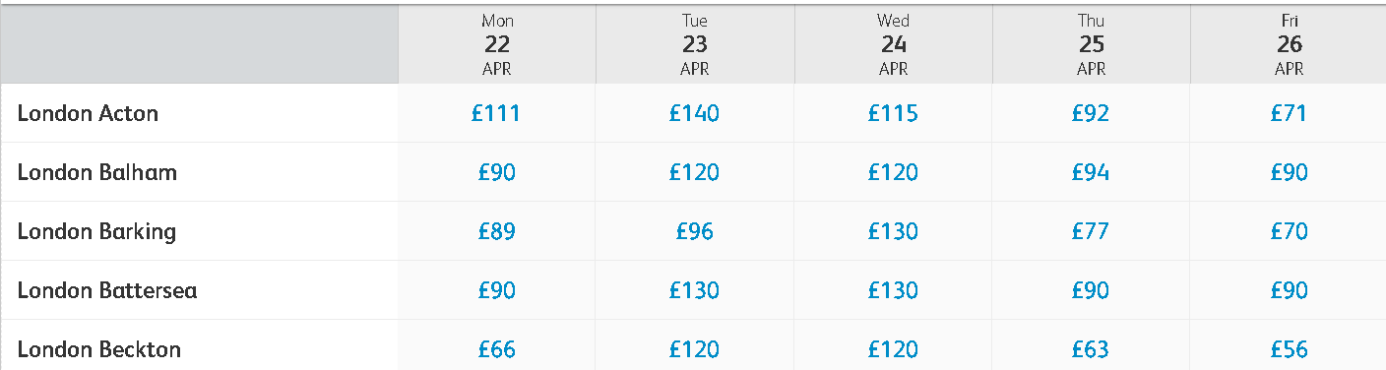 Image 1
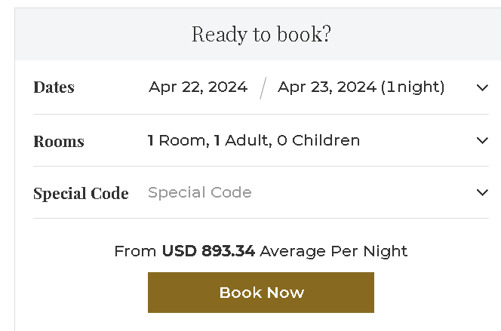
Image 2

Besides room bookings, Travelodge Hotels also generates revenue from its on-site amenities, such as Wi-Fi, dining options and parking fees. [see image 3]
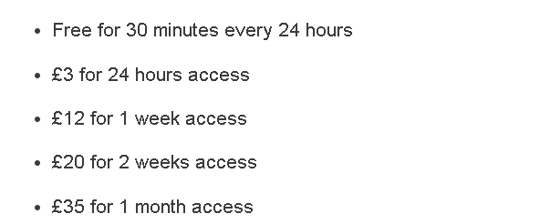
Image 3
Brown and Garcia (2019) describe that in a luxury hotel, food and beverage services are regarded as some of the company's most profitable areas. Its establishments offer a wide range of cuisines and exceptional experiences for guests. In addition, the company provides various other services to enhance the enjoyment of its guests. [see images 4 and 5]
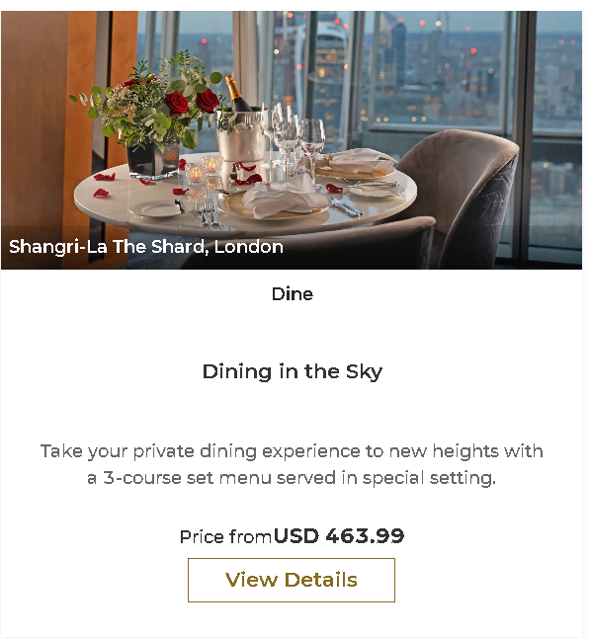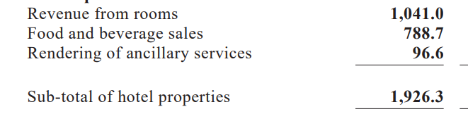
Image 4 Image 5

Revenue Trends

Despite the volatility of the global economy, Travelodge Hotels has maintained its stable revenue streams. The company's accessibility and affordability appeal to budget-conscious travellers, which have helped it to achieve consistent performance. Although it may not be able to achieve the same level of revenue growth as luxury hotel brands, Travelodge Hotels is still able to maintain a moderate growth trajectory (Kilgannon, 2024). The revenue decline in 2020 of Travelodge was primarily due to the closures of several hotels in the UK. The company also experienced a small benefit from the annualization of its 14 new hotels. In Spain, the hotel closures led to a £0.5 million decrease in revenue. For the first quarter of 2021 was down by 71.3 percent to £ (103.5) million, as compared to the same period in 2019. The company's revenue was also affected by the effects of COVID-19, which led to the closure of several hotels in the UK. In Spain, the hotel closures resulted in a loss of £2.2 million. The revenue of Travelodge for the first quarter of 2022 was up 7.0% to £10.2 million, driven by the reduction of VAT rate and strong leisure demand. Like-for-like revenue in the UK increased 4.3% The company's new openings in 2021 are expected to add 17 new hotels. Spain's first quarter revenue was down 28% to £0.8 million, due to the Covid pandemic. The revenue of Travelodge for the first quarter of 2019 increased by 36.7% to £53.3 million, driven by the company's new openings and the increase in LFL RevPAR. Like-for-like UK RevPAR also increased by 31.1%. Spain experienced sturdy growth with revenue rising 22.4% to £0.7 million. [see image 6]. Hotel occupancy at the end of 2023 was 81.8%, compared to 2020 80.6% (Travelodge Investors, 2024).
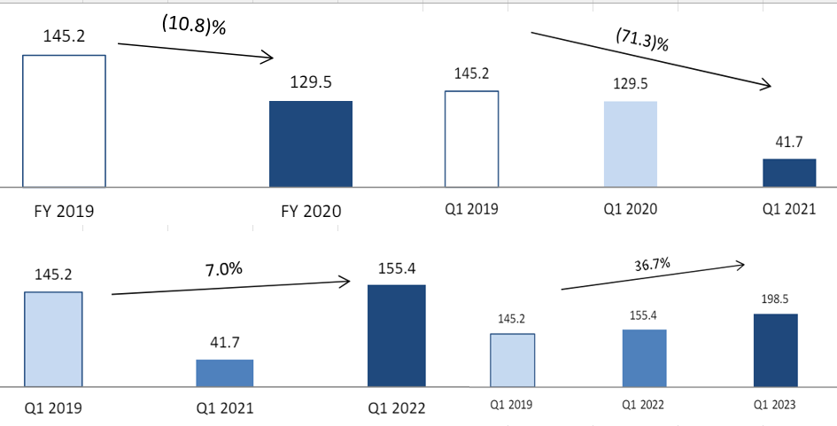
Image 6
Shangri-La Hotels' steady revenue growth can be attributed to its distinct brand image, premium offerings, and strategic locations. The company has also maintained its resilient position within the luxury hospitality industry, weathering market downturns and economic pressures to attract discerning customers seeking exceptional experiences (Garcia and Wilson, 2020). Total revenue over the last 4 years shows fluctuations in hotel revenues [see image 7]. For 2020 the COVID-19 pandemic has resulted in a significant decline in Shangri-La Hotel's revenue. For instance, our Hotel Operations dropped by about USD1,257.9 million, while the Property Development for sale fell by about $ 136.6 million. In 2021, Shangri-La reported a total of $205.4 million increase in its hotel operations, due to the domestic demand in Hong Kong and Mainland China. The company's investment properties also experienced a revenue increase of USD 4.0 million. In Investment Properties, the decline was due to our weakness in Singapore, as well as the company's continued growth in the region. The average occupancy of Shangri-La's hotels was at 62% for the year ended December 2023, which is 20 percentage points higher than the 42% recorded in 2022. The RevPAR of the hotels was at USD108 for the year ended December 2023, which is 69% higher than the USD64 recorded in 2022 (Shangri-La Group, 2024).
Shangri-La Hotel
Revenue | 2020 | 2021 | 2022 | 2023
Total revenue | 1,033.44 | 1,241.0 | 1.915.4 | 2.769.2
Percent Change | -57.5% | 20.1% | 9.50% | 44.60%

Image 7

Factors Driving Revenue Growth

Shangri-La Hotels' impeccable service and reputation have attracted high-end customers, helping it grow its revenue. Its strategic location has also contributed to its success, as it allows it to operate in key urban and tourist destinations. Its focus on providing exceptional experiences and exceeding expectations has allowed it to maintain a high occupancy rate. It is additionally able to differentiate itself from its rivals through its continuous innovation (Anderson and Lee, 2021).
Through its partnership with online agencies, Travelodge Hotels can improve occupancy rates and attract more customers. It can reach a wider audience by working with Booking.com and Expedia (Jones and Lee, 2018). The accessibility and affordability of Travelodge Hotels' accommodations draw budget-conscious individuals, boosting occupancy rates and generating revenue. The company's reputation for providing high-quality service and consistent value has made it an established brand. Its strategic partnerships with other distribution channels, such as online retailers, help the company reach more potential customers and increase its bookings. Its operational efficiency also helps it maintain profitability (Travelodge PLC, 2024).
Shangri-La and Travelodge operate in the hospitality industry, and they cater to varying market sectors. The former places emphasis on accessibility and affordability and offers supplementary services and high occupancy rates to attract budget-minded individuals. While Travelodge focuses on the budget-conscious market, Shangri-La Hotels & Resorts is known for its luxury offerings and superior guest experiences. This makes it an ideal choice for individuals seeking high-end accommodations. Both organizations have demonstrated their ability to grow their revenue through effective management and partnerships.

2. Market Position

According to a study by Li et al. (2017), Shangri-La has a strong market share in the luxury hotel segment, particularly in Asia where it is considered a top choice for affluent travellers. On the other hand, Travelodge is positioned as a budget hotel chain with a focus on providing affordable accommodations for budget-conscious travellers. Travelodge hotels are typically located in convenient locations such as near airports, highways, and city centres. According to a study by Hsu et al. (2017), Travelodge has a significant market share in the budget hotel segment, particularly in the UK where it is a popular choice for budget travellers.
The main demographic of the Shangri-La Hotel is upper-class individuals who are looking for superior services and luxury accommodations. These individuals include business executives and high-end tourists (Shangri-La, 2024). The budget-conscious individuals who are looking for inexpensive accommodations are the target audience of Travelodge. Its members include students, families, and individuals with limited resources (Robinson, 2022). Based on Similar Web (2024) both hotels are similar in age distribution and gen distribution [see image 8], but vastly different in social traffic where Shangri-La is the leader on Facebook and YouTube and on visits to the website Travelodge has a higher score than his opponent [see image 9].
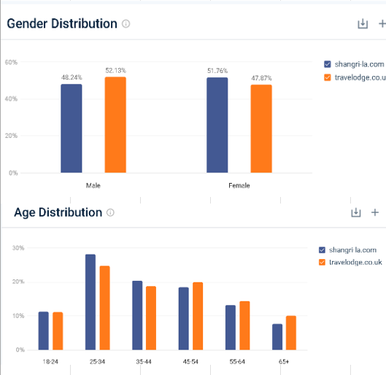Image 8

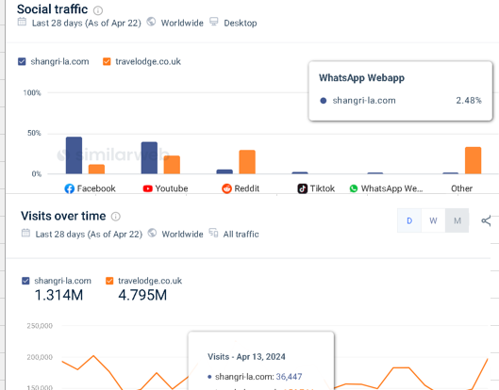 Image 9
Overall, Shangri-La and Travelodge occupy distinct market positions in the hotel industry, targeting different customer segments with their unique offerings and brand identities.

3. Growth potential

Expansion Strategies

The concept of tourist accommodations involves providing diverse services to their guests. These facilities are often associated with high energy consumption and are therefore important to the tourism industry's sustainability (Costa and Costa, 2022, p.149). Shangri-La grows business in fast-growing markets by developing new properties and diversifying into various sectors. The Triple S approach of Shangri-La is designed to ensure that sustainability is a part of every aspect of our operations. It includes the company's Stay, Savour, and Shine initiatives (Shangri-La, 2024). Travelodge meets cost-conscious consumers' requirements in underrepresented areas and expands rapidly through management agreements or franchising while investigating expansion possibilities in developing markets. To ensure that it continues to attract more customers, they are currently carrying out a major refurbishment program that will involve the upgrade of around 50% of the hotel's rooms by 2024. The brand's new multi-channel campaign, ‘Better Get a Travelodge’ aims to position the company as the ideal choice for consumers (Thame and London Limited, 2023).

Market opportunities

The expansion of the luxury travel market is expected to benefit Shangri-La. It is driven by the growing wealth within emerging markets, such as India, China, and the UAE. The company can tap into this trend by offering distinct experiences that cater to the preferences of high-net-worth individuals (Adler and Adler, 2018). Instead, due to the increasing number of people travelling and the need for affordable accommodations, the demand for Travelodge's products and services has been growing. The company can also target different markets, such as business tourists who are looking for accommodations that are low in cost (Thompson, 2017).

Potential Barriers to Growth

The company's growth potential is hindered by the intensifying competition within the luxury hotel industry, which includes established players such as Ritz-Carlton and Four Seasons, as well as new boutique hotel brands. In addition, geopolitical and economic uncertainties in certain markets could affect the company's expansion plans (Comparably, 2024). The rapid emergence and evolution of new lodging options and the saturation of certain mature markets are some of the factors that could prevent Travelodge from achieving its full potential. Regulatory issues such as building regulations and zoning laws could also affect its expansion plans, especially in areas with high land acquisition costs (Travelodge, 2024).

4. Financial Commitment to CSR

The implementation of Corporate Social Responsibility (CSR) in the hospitality industry faces several barriers, as noted by researchers (Bello and Kamanga, 2018; Mahyuni, 2016; Melubo et al., 2017). These barriers include a lack of understanding of the factors influencing effective CSR programs and the considerable time and resources required to address these challenges. To promote sustainability, hotels need to adopt comprehensive CSR policies encouraging socially responsible behaviours among guests. However, ineffective communication further hampers CSR success. Public awareness of CSR initiatives is crucial to convey the benefits and impacts of these measures, providing stakeholders with information about hotel efforts to enhance environmental and social performance while informing guests about the consequences of their actions (Costa and Costa, 2022). Shangri-La, catering to affluent travellers, likely allocates significant resources to sustainable practices like energy efficiency and community development (Shangri-La, 2024). Conversely, Travelodge, targeting budget-conscious guests, may have a smaller financial commitment but focuses on initiatives aligned with affordability, such as responsible tourism promotion and local community support. Access to detailed financial reports and CSR disclosures would provide a comprehensive understanding of their commitments, including the proportion of their budgets allocated to CSR and the scope of their initiatives (Travelodge, 2024).

Conclusion

In conclusion, strategic revenue generation stands as the cornerstone of success within the intricate realm of financial management in the hospitality industry. Through an exploration of the financial strategies of Travelodge Hotels and Shangri-La Hotels, it becomes evident that their revenue sources, market positioning, growth potential, and commitment to Corporate Social Responsibility (CSR) are pivotal determinants of their competitive edge.

Travelodge, targeting budget-conscious travellers, thrives on accessibility and affordability, boasting stable revenue streams supported by strategic partnerships and operational efficiency. In contrast, Shangri-La, renowned for luxury, sustains steady revenue growth through impeccable service, strategic locations, and a focus on high-end clientele. Both entities navigate distinct market segments with precision, leveraging unique value propositions to foster growth and resilience.

However, challenges such as market saturation, geopolitical uncertainties, and regulatory hurdles pose barriers to their expansion aspirations. Yet, their commitment to CSR underscores ethical responsibility, with Shangri-La and Travelodge deploying tailored initiatives aligned with their brand ethos and target demographics.

In essence, the financial management strategies and practices employed by Travelodge and Shangri-La underscore the nuanced balance between revenue optimization, market positioning, and social responsibility, highlighting their adaptability and resilience in an ever-evolving industry landscape.

Recommendations

Travelodge:
Prioritizing sustainability initiatives as part of expansion strategies to align with changing consumer preferences and industry trends. Integrating sustainable practices into new property developments and refurbishment programs can help to boost brand reputation and attract environmentally conscious travellers. Furthermore, looking into opportunities in emerging markets with a focus on affordability and sustainability can help drive growth while meeting market demand for responsible tourism. Travelodge Hotels caters to budget-conscious consumers and is rapidly expanding through refurbishment and management agreements. Prioritizing sustainability in expansion strategies can help align with consumer preferences and industry trends, resulting in increased growth and brand reputation.

Shangri-La

Shangri-La Hotels: Since the company dominates Facebook and YouTube in terms of social traffic, I advise boosting its presence and interaction on these platforms. Increasing brand exposure and interaction with high-end tourists through social media marketing can further solidify Shangri-La’s premium positioning. Furthermore, maximizing website traffic via focused digital marketing techniques can draw affluent travellers and business leaders, solidifying Shangri-La'spositionas the industry leader in the luxury hotel sector. Shangri-La Hotels caters to affluent clients looking for first-rate amenities and opulent lodging. Increasing website traffic and social media presence can improve interaction with the target market, bolstering the brand's premium positioning and leadership position.

References

Adler, P.A. and Adler, P. (2018) “CAREERS IN PARADISE: Long-Term,” in Paradise Laborers. Ithaca, NY: Cornell University Press, pp. 189–215. Available at: https://doi.org/10.7591/9781501726705-011 (Accessed: 25 April 2024).

Anderson, M. and Lee, S. (2021) ‘Enhancing Guest Experiences in Luxury Hotels: Trends and Strategies’, Journal of Hospitality & Tourism Research, 40(4), pp. 567-582.
Bello, F. G. and Kamanga, G. (2018) ‘Drivers and barriers of corporate social responsibility in the tourism industry: The case of Malawi’ Development Southern Africa, 37(2), pp. 181–196.
Brown, A. and Garcia, M. (2019) ‘The Role of Food and Beverage Revenue in Luxury Hotel Chains: A Comparative Study’, International Journal of Hospitality Management, 30(4), pp. 215-230.
Comparably (2024) Competitors. Available at: https://www.comparably.com/competitors/ritz-carlton-vs-shangri-la-hotels (Accessed: 26 April 2024).
Costa, V. and Costa, C. (2022) “The Relevance of CSR in the Hospitality Industry According to the GCET and the SDGs,” in Sustainability and Competitiveness in the Hospitality Industry. United States: IGI Global, pp. 119–149. Available at: https://doi.org/10.4018/978-1-7998-9285-4.ch005 (Accessed: 25 April 2024).
Costa, V. and Costa, C. (2022) “Sustainability and Competitiveness of Transforming Tourist Accommodation,” in Sustainability and Competitiveness in the Hospitality Industry. United States: IGI Global, pp. 141–165. Available at: https://doi.org/10.4018/978-1-7998-9285-4.ch006 (Accessed: 25 April 2024).
El Haddad, R. (2015) ‘Exploration of revenue management practices – case of an upscale budget hotel chain’, International Journal of Contemporary Hospitality Management, 27(8), pp. 1791–1813. Available at: https://doi.org/10.1108/IJCHM-08-2013-0390.
Garcia, R. and Wilson, E. (2020) ‘The Resilience of Luxury Hotel Chains During Economic Downturns: A Comparative Study’ Journal of Luxury Hospitality, 15(1), pp. 102-119.
Hsu, C. et al. (2017) ‘A comparative study of hotel branding strategies: Case of Hilton and Travelodge’, International Journal of Hospitality Management, 65, pp. 37-45.
Image 1 (2024) Price Finder Travelodge. Available at: https://pricefinder.travelodge.co.uk/?_gl=1*ozgf6x*_ga*MTAzNjI0NDI1NS4xNzEzNzQxOTk5*_ga_MELVDQ5FNP*MTcxMzc0NDI3NC4yLjEuMTcxMzc0NDI3NC42MC4wLjA. (Accessed 21 April 2024).
Image 2 (2024) Premier Shard Room. Available at: https://www.shangri-la.com/en/london/shangrila/rooms-suites/rooms/premier-shard-room/ (Accessed: 21 April 2024).
Image 3 (2024) Wi-Fi Travelodge. Available at: https://www.travelodge.co.uk/about/wifi/ (Accessed: 21 April 2024).
Image 4 (2024) Ting restaurant. Available at: https://www.shangri-la.com/london/shangrila/dining/restaurants/ting-restaurant/ (Accessed: 21 April 2024).
Image 5 (2024) 2023 Final Results Announcement. Available at: https://sitecore-cd.shangri-la.com/-/media/Project/Shangri-La-Group/Investor/Files/Public-Disclosures/Latest-Top-Publications/2024-03-22-Final-Results-Announcement_E.pdf (Accessed: 21 April 2024).
Image 6 (2024) Investors. Available at: https://www.travelodge.co.uk/investors/home (Accessed: 21 April 2024).
Image 7 (2024) Results Announcements. Available at: https://www.shangri-la.com/group/investors/public-disclosures#!#financial-information (Accessed: 21 April 2024).
Images 8 and 9 (2024) Website performance. Available at: https://pro.similarweb.com/#/digitalsuite/websiteanalysis/overview/website-performance/*/999/28d?webSource=Total&key=shangri-la.com,travelodge.co.uk (Accessed: 26 April 2024).
Jones, M. and Lee, S. (2018) ‘The Role of Online Travel Agencies in Hotel Revenue Management: A Comparative Analysis’, Journal of Travel Research, 40(4), pp. 567-582.
Kilgannon, L. (2024) ‘Investment drive as Travelodge posts record year’, Insider Media Limited [blog]. 2 April. Available at: https://www.insidermedia.com/news/national/investment-drive-as-travelodge-posts-record-year (Accessed: 22 April 2024).
Li, X., Wu, B. and Zhang, L. (2017) ‘A study on the competitive strategy of luxury hotels in China: Based on the analysis of Shangri-La Hotels and Resorts’ Journal of Tourism and Hospitality Management, 5(1), pp. 1-10.
Mahyuni, L. (2016) ‘Corporate Social Responsibility of Hotels in Bali – Indonesia: Practices, Drivers and Barriers (Doctoral dissertation)’, Curtin University. Accessed at: https://espace.curtin.edu.au/bitstream/handle/20.500.11937/2333/247149_Mahyuni%202016.pdf?sequence=2&isAllowed=y/ (Accessed: 23 April 2024).
Melubo, K., Lovelock, B. and Filep, S. (2017) Motivations and barriers for corporate social responsibility engagement: Evidence from the Tanzanian tourism industry, pp. 1-3. Available at: https://www.researchgate.net/publication/326305795_Motivations_and_barriers_for_corporate_social_responsibility_engagement_Evidence_from_the_Tanzanian_tourism_industry/ (Accessed 25 April 2024).
Robinson, M. (2022) ‘Strong recovery in 2021 and Travelodge is well positioned to benefit in the expected recovery’ Travelodge news [blog]. N.D. Available at: https://www.travelodge.co.uk/blog/news/travelodge-strong-2021-recovery/ (Accessed: 25 April 2024).
Shangri-La (2024) About Shangri-La. Available at: https://www.shangri-la.com/group/our-story/about-shangri-la (Accessed: 21 April 2024).
Sangri-La Group (2024) Results Announcements. Available at: https://www.shangri-la.com/group/investors/public-disclosures#!#financial-information (Accessed: 22 April 2024).
Shangri-La Group (2024) Sustainability. Available at: https://www.shangri-la.com/group/sustainability/ (Accessed: 23 April 2024).
Similar Web (2024) Website Analysis. Available at: https://pro.similarweb.com/#/digitalsuite/websiteanalysis/overview/website-performance/*/999/28d?webSource=Total&key=shangri-la.com,travelodge.co.uk (Accessed: 25 April 2024).
Thame and London Limited (2023) Annual report and financial statements. Available at: https://www.travelodge.co.uk/nw/sites/default/files/Thame_and_London_Limited_signed_FY23.pdf (Accessed: 26 April 2024).
Thompson S. (2017) “Value opportunities,” Investors Chronicle.
London: The Financial Times Limited.
Travelodge (2024) Company Overview. Available at: https://www.travelodge.co.uk/our-business/about-us/company-overview/ (Accessed: 22 April 2024).
Travelodge (2024) Investors. Available at: https://www.travelodge.co.uk/investors/home (Accessed: 21 April 2024).
Travelodge (2024) Design and Construction. Available at: https://www.travelodge.co.uk/our-business/property/design-and-construction/ (Accessed: 26 April 2024).

