“No doctor chooses to strike without good reason.”

Phillip Banfield, Chair of the British Medical Association (Banfield 2016)

In September 2015, Jeremy Hunt, the Secretary of State for Health at the time, wanted to impose items from the Conservative manifesto on junior doctors in England through proposed new contracts. These contracts would see junior doctors working 07:00 until 22:00 and while they would see an increase in basic pay, there would be no overpayments. (Wintour 2015).
The union argued that the increase in working hours would see junior doctors facing a 40% pay cut and therefore refused to re-enter negotiations unless the Secretary of State for Health dropped the threat of imposing the new contracts with extensive preconditions (BMA 2016). Hunt responded by claiming the Department of Health were not cutting the pay bill for junior doctors, rather they wanted to see the basic pay increase as per average earnings (Association Press 2017).

BMA | NHS
Aim: To have a junior doctor contract that is safe for patients; fair for juniors; and good for the NHS.  (Banfield 2016) | Aim: To deliver a 7 day NHS.  (Hunt 2016)
Table 1: The BMA and NHS aims for the new junior doctor contract
The International Labour Organisation (2003) defines employment relations as the legal link between the employer and the employees where an individual delivers a service or work under particular circumstances and receive remuneration in return. It is argued that by today the interpretation of employment relations extends more widely and following a rise in rights in the workplace and a decline in the influence of the trade unions, it reflects an increasing individualisation of the employment relationship (CIPD 2017a). Due to the lack of guarantee about the outcomes or duration of the employment relationship, management of this relationship is a challenge for HR professionals and is characterised by a co-operative need and the possibility of conflict (Taylor and Woodhams 2016).
Definitions can be split into two schools of thought, one that is regulatory focused such as Gennard and Judge’s (2010, p225) view that employment relations regulates the employment relationships by establishing “rules, regulations and agreements.” While the other school of thought is more relationship focused with the spotlight on individual relationships with an emphasis in assisting line managers to establish relationships with employees, based on trust (CIPD 2005).
A PESTLE analysis can be used to analyse the external factors affecting the employment relationship, as seen below.
P | E | S | T | L | E
Political | Economical | Sociological | Technological | Legal | Environmental

Figure 1: PESTLE Model
(Source: CIPD 2017c)
An evaluation of how external factors have contributed to the resulting conflict can be seen below.
Political | - UK Government want to provide a 7 day NHS while not increasing the cost of the NHS by too much  - UK Government propose new contract to replace current contract.  - Welsh Government have dealt with the issue differently to the UK Government
Economical | - Demand for junior doctors to work a 7 day week  - Recent recession  - Junior doctor salary and overtime costs
Sociological | - Increase in expectation and standards by UK Government on junior doctors
Technological | - No specific technological factors to this issue
Legal | - European time regulations  - Trade Union Act
Environmental | - Differences in neighbouring countries
Table 2: PESTLE Analysis of the junior doctor conflict
The National Audit Office (2016) state that there are around 824,000 clinical staff counted working in the NHS in England during 2015-16, those directly involved in patient care. This included 141,000 doctors and 329,000 nurses, midwives and health visitors. The diagram below demonstrates the proportion of the different roles employed in the NHS in England in 2014.
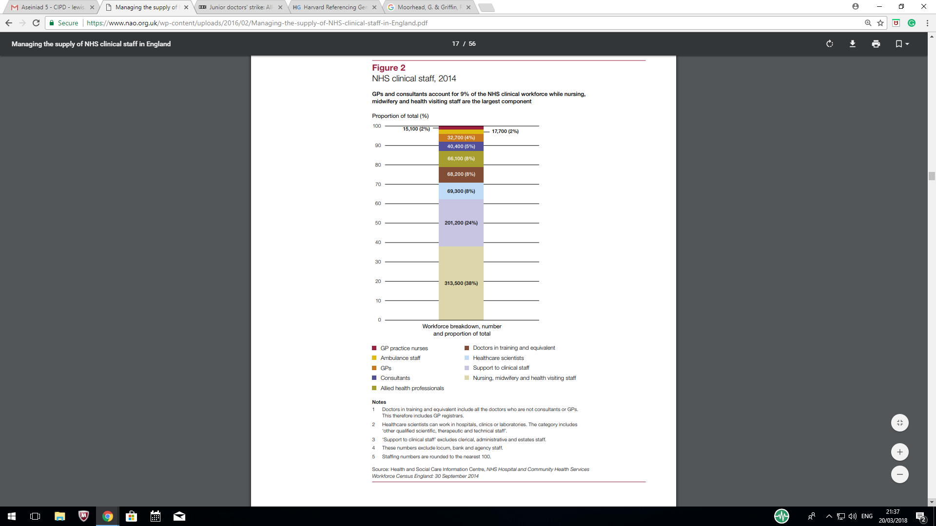
Figure 2: NHS England Clinical staff in 2014
Source: National Audit Office, 2016
The National Audit Office (2016) stated that on 31 March 2014 there was a shortfall within the staff post of junior doctors and equivalent of 4.3% which was equivalent to 2,550 further required. This impacted on factors such as balance of power and the psychological contract. With the junior doctors in demand and short supply, this provided them with a greater balance of power. However, the psychological contract meant that they worked longer hours to complete the job as they had a 4.3% deficit in staff numbers.

Alan Fox (1966) suggested managers may adopt one of two basic views: the unitarist and the pluralist perspective. Unitarism is an approach that views everyone in the organisation as a team member where managers and staff member share a common purpose (Price 2007). The Pluralist approach sees the organisation as a set of individual subgroups with their own loyalties with their own set of objectives and interests. (Self-Management Notes 2016). The two dominant sub-groups in this approach are management and trade unions.
However, ideas around corporate responsibility and stakeholder have begun to conflux the deliberation around unitarism and pluralism, with most employers adopting a mixed model” (CIPD 2005, p15).
Junior doctors as a group are unitaristic however, looking at the NHS as a whole the doctors are an element of the pluralistic approach of the way the NHS works. Despite differences being acknowledged and the NHS engaging the various groups within it to work together to achieve their common goal of providing a national health service, conflict is inevitable. This particular conflict is managed through policy, contract and procedural change in the NHS through negotiations by the BMA union and the UK Government.
There are many factors that are relevant to the breakdown in relationship in the conflict discussed in this paper. The main factor is the stakeholders. Though there are many stakeholders that feed into the employment relationship, these are the current UK Government, Government agencies such as ACAS and EHRC. These all have an impact on the management of employment relations with the UK Government as an employer of the junior doctors in addition to a legislative role.
The Chair of the BMA stated that “No doctor chooses to strike without good reason – it goes firmly against the grain and our sense of professional duty.” (Banfield, 2016). While junior doctors in England were striking, no junior doctors were on strike in Wales as Health is a devolved issue and a different approach had been taken by the Welsh Government in addressing the issue with the BMA. This demonstrates how conflict was and can be resolved, however Banfield (2016) stated that “the UK government has repeatedly threatened to impose an unsafe and unfair contract in England, while Welsh Government has rejected imposition in favour of a more mature collaborative approach”.
The Labour Market is defined by Claydon and Thompson, 2010 as consisting of “workers who are looking for paid employment and employers who are seeking to fill vacancies”. Despite there being a psychological contract between the employer and employees the unwritten expectations can have a different understanding from each side. The individual contributions from the junior doctors can be seen through their skills and ability as they train for several years with an expectation to achieve a high salary and paid overtime. The combined loyalty and effort is expected as part of the psychological contract as a junior doctor would ethically not be able to leave before completing specific tasks. The employer provides a job for life with continued training and a career plan with the salary being a string benefit. Managing expectations within the psychological contract is when employers make it clear to recruits about what they can expect from their job (CIPD, 2018).
CIPD (2017) refer to the need to focus on positive behaviours and outcomes while taking a proactive approach to problem-solving as can be seen by Welsh Government and the BMA, while this relationship in England between UK Government and the BMA has broken down. This political agenda is an external factor affecting the conflict. While leadership styles, culture and policies are internal factors, the difference between the Welsh and English situation demonstrates the strength of effect of these factors on the conflict.
Q2 EMPLOYMENT LAW
There is an essential difference a contract of service that is simply a contract of employment and a contract for services that applies to subcontractors and freelance workers (CIPD 2017e). The employers need to ensure clarity from the outset about the type of contract, as employees have many more rights in law than non-employees (CIPD 2017e). There are various types of employment contract including full-time and part-time contracts; fixed term contracts; agency staff; freelancers, consultants, Contractors; and zero hour contracts (UK Government, 2017).

The junior doctors’ full-time and part-time contracts are at the centre of the conflict between the BMA and the UK Government. The BBC (2016) demonstrates how the government position compares with that of the BMA proposals and the current rates in 2016 prior to the changes.

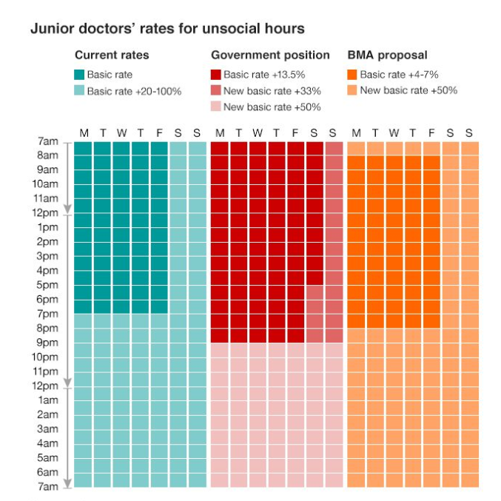
Figure 3: Junior doctor’ rates for unsocial hours demonstrated through the 2016 rates, the Government position and the BMA proposal.
(Source: BBC 2016)

The main source of UK employment law derives from a number of sources including Acts of Parliament and decisions on points of law made in the courts. (CIPD 2017a). In addition, European employment relations law-making is also a source following the UK joining the European Economic Community (later the European Union) in 1973. (CIPD 2017a). Decisions of the Court of Appeal and the Supreme Court also become part of the law (Chartered Institute of Legal Executives, 2017).

Three examples of changes in recent employment law are:
- The Trade Union (Wales) Act 2017
- Equality Act 2010 (Specific Duties and Public Authorities) Regulations 2017
- European Working Time Directive

The Trade Union (Wales) Act 2017 makes “provision about industrial action and trade union activity in relation to the operations of, and services provided by, devolved public authorities” (Legislation 2017). The Act aims to amend the Trade Union Act 2016 to reverse the effect of those provisions to protect the delivery of continued public services in Wales (Bowyer 2017, p5). This could affect any future striking of the NHS in Wales.

The Equality Act 2010 (Specific Duties and Public Authorities) Regulations 2017 ask for the NHS (along with other specified public bodies) to make their first gender pay gap reports based on data gathered on 31 March 2017 (CIPD, 2018b). This may reveal a gender pay gap in the junior doctor roles within the NHS. The Guardian (2016) reported that the new contract for junior doctors discriminates against females and refers to the section of the proposed contract at the time that stated “any indirect adverse effect on women is a proportionate means of achieving a legitimate aim”.
The European Working Time Directive has meant that more doctors are required to deliver NHS services as staff are no longer able to work for so many hours (National Audit office, 2016).
CIPD (2017d) define the recognition of a trade union when it is either independent or “recognised by an employer, or two or more associated employers, for the purpose of collective bargaining”. While recognition of a trade union may be by voluntary agreement between the parties it can also be via an application made for statutory recognition (CIPD, 2017d).
BMA is the recognised trade union for doctor sin the UK as the voice of the profession and hold responsibility for negotiating pay and conditions of service for the doctors at a local and national level (BMA 2017). The BMA represented the junior doctors in the conflict with the UK Government.
Q3: EMPLOYEE VOICE
Employee involvement is an environment where employees have an impact on decisions and actions that affect their jobs (Heathfield, 2018).

Employee participation is not as strong as employee involvement and is defined as an employee participates in a business activity, sharing the activity with others. “These others form one team with the employee and the team is responsible for completion of a goal or project” (De la Morreaux, 2018). As employee participation has a collective view as opposed to an individual view, this is most applicable to the junior doctors’ strike. With the junior doctors being the team for the “completion of various goals”, for example a consultation with a patient.

There is no commonly agreed definition of employee partnership, however Riley refers to partnership working as an enterprise-union partnership agreements are sub-sets of employee involvement. Couper (2005) states that “Partnership is a pluralist model of work – it respects different interests but is built on a shared commitment to the success of the organisation”. It could be argued from a Union perspective that a true ‘partnership’ should provide an independent collective representation and balance of power between the employees and the employer.

Non-union representative have statutory rights to paid time-off to perform their duties and in some cases to receive training and there are 7 specific areas (ACAS 2014). The UK Government (2018b) state that a Union receives recognition when the Union asks the organisation to recognise them voluntary and if they agree than the union is officially recognised. Or, if the organisation does not recognise the Union and they have more than 21 employees then the union can apply for statutory recognition from the Central Arbitration Committee (CAC). The BMA are a recognised union representing the junior doctors in a collective form.
An unofficial strike is defined as “a strike that is not approved by the strikers’ trade union” (Collins Dictionary, 2017). Secondary action is illegal and is defined as taking part in a strike in sympathy with those working for a different employer (UK Government, 2017) There is no protection from dismissal for employees that take part in unofficial industrial action, which is sometime known as ‘wildcat strikes’ (TUC, 2017).
Dromey (2016) refers to the employee voice as “the ability of employees to express their views, opinions, concerns and suggestions, and for these to influence decisions at work”. Employee voice can also be seen as a management tool with it being “only a means to an end of improving organisational performance” (CIPD, 2017f). Trade union can use collective bargaining as a tool for the employee voice to be heard and can lead to an agreement which are known as collective agreements (ACAS, 2018).

Q4: CONFLICT
There are many similarities in defining conflict, as it is simply defined as a disagreement between at least two parties in the workplace (Bloisi 2007, ACAS 2014a). Kabanoff (1991) refers to managing conflict as a method to improving organisational decision making and resource allocating.
While conflict at work takes many forms it could be as simple as two workers simply not getting on with each other or an individual has a grievance against their manager (ACAS, 2014). Grievance is defined as concerns, problems or complaints that are raised by employees with their employer (ACAS, 2008). The discipline procedure is defined as a process for dealing with perceived employee misconduct (HR Zone, 2018).
Conflict can be either official or unofficial. Williams and Adam-Smith (2010) state that organised conflict is seen in the form of strikes, protests, demonstrations, boycotts, go-slow and overtime bans. While unorganised conflict can be seen through theft, sabotage, absence and resignation. The conflict around junior doctor contracts is defined as official conflict due to the actions by the employees was demonstrated in the in the form of union strikes.
While the unitarist perspective does not accept conflict existing, the pluralist viewpoint states that conflict can be beneficial and a lack of conflict can lead to lethargy and apathy (Moorhead and Griffin, 1992). Furthermore, Furnham (2005) refer to conflict being desirable as it drives forward change.
There are different forms of industrial conflict, the figure below demonstrates two-dimensions of workplace conflict.
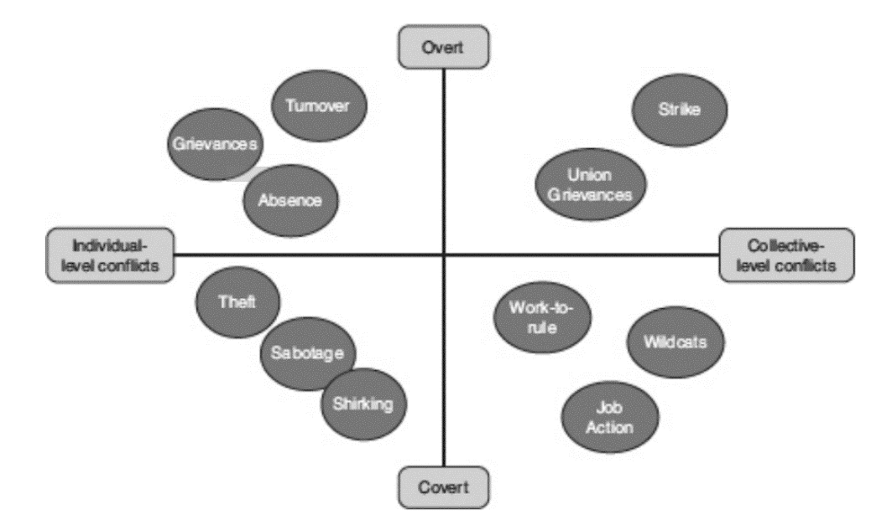
Figure 4: Two dimensions of workplace conflict
Source: Gall & Cohen, 2013
The covert forms of industrial conflict are less visible and often while the overt forms can be seen as conflict expressions through specifically institutionalised channels (Gall & Cohen, 2013). Godard 1992 refers to collective forms of conflict in the workplace that stems from an unwillingness from management to acknowledge an employees’ voices in decision affecting their work environment. While individual forms of conflict are most often unorganised and are normally personal or interpersonal (Gall & Cohen, 2013).
As seen in the diagram above, the junior doctors’ contract dispute between the BMA and UK Government falls in the top right hand side as part of the overt and collective conflict through striking. ACAS (2014a) refer to various sources of conflict. These can be split into organisational based factors and interpersonal factors as seen in the table below:
Organisational based factors include | Interpersonal factors include
- poor management  - unfair treatment  - unclear job roles  - inadequate training  - poor communications  - poor work environment  - changing needs and expectations  - lack of equal opportunities  - bullying and harassment  - unresolved problems from the past  - increase in workload | - the personalities involved  - ignoring common values

Table 3: Organisational and interpersonal factors

The junior doctors’ contract conflict has aspects of both organisational and interpersonal based factors. While it mainly falls within the organisational based factors of conflict, specifically ‘changing needs and expectations’ due to the UK Government wanting a 7-day NHS service. It is also apparent that there is an element of ‘ignoring common values’ which is to provide a first class health service. This dispute has certainly seen a two-sided argument with regards to the ‘common values’ with the main driver being providing first class health care for patients, but the discrepancy and the conflict rising to the brim when discussing the time requirement and pay in delivering this service.

Misbehaviour is defined as the action of misbehaving that is bad behaviour (Oxford Dictionaries, 2018). This could include unethical or illegal behaviour. Misconduct is defined as “unacceptable or improper behaviour, especially by an employee or professional person” (Oxford Dictionaries, 2018). This is an action or conduct that would be classed as inappropriate, improper or incorrect. Both misconduct and misbehaviour could lead to grievance or disciplinary procedures.
Recently Employment Tribunals fees which were introduced under a Fees Order in July 2013 were abolished on 26 July 2017 following the Supreme Court decision. This has seen an increase in claims and statistics published by the Ministry of Defence in December 2017 showed an increase of 64% in single claim applicants during quarter 3 of 2017 compared to quarter 3 of 2016 (Gers, 2018). This demonstrates an increase in individual claims that is likely to continue to grow.
This conflict is the first ever “all-out doctors' strike” (BBC 2016) and is not a sector that is prone to striking. The situation differs in Wales with the Welsh Government responded differently to the BMA compared to the UK Government. If the UK Government had reacted in the same way as the Welsh Government then no strikes would have taken place, as per the situation with junior doctors working in Wales. The conflict could have been resolved quicker and achieved a more equal conclusion.
Recently Employment Tribunals fees which were introduced under a Fees Order in July 2013 were abolished on 26 July 2017 following the Supreme Court decision. This has seen an increase in claims and statistics published by the Ministry of Defence in December 2017 showed an increase of 64% in single claim applicants during quarter 3 of 2017 compared to quarter 3 of 2016 (Gers, 2018). This demonstrates an increase in individual claims that is likely to continue to grow.
ACAS (2014) refer to a six step guide to managing conflict at work by answering the questions outlined below. It is advisable for managers to address these questions in order to gain a fuller understanding of the conflict and a way to prevent similar conflict from occurring in the future.

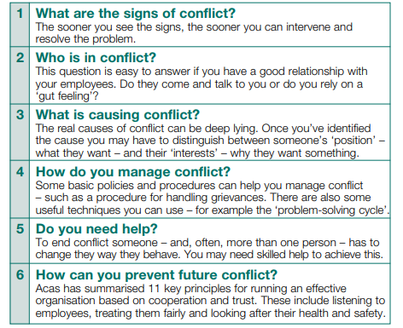
Figure 5: Six steps to managing conflict
(Source: ACAS, 2014)

HR staff can assist line managers through coaching as an aim to produce optimal performance and improvement at work. While it focuses on specific skills and goals it can have an effect on an individual’s personal attributes such as social interaction or confidence which can be beneficial (CIPD, 2018c). In guiding line managers through disputes handling process, skills such as listening and negotiation will be advised. There are also process that can support line managers in dealing with situations where there has been misconduct or misbehaviour, these are the grievance and disciplinary procedures.
ACAS (2013) refers to mediation, conciliation and arbitration as three approaches for conflict resolution. It states that mediation aims to repair and rebuild the employment relationship with a third party mediator and there is a need for both parties to voluntarily enter into it. ACAS (2013) acknowledges that conciliation is where mediation takes place where a complaint has been made to the employment tribunal about employment rights. It further draws attention to the difference with arbitration as the third party this time is asked to make a decision based on both sides presenting their evidence. All three types of resolution are voluntary.
While mediation can be seen as the first step in conflict resolution in the workplace, if there is no agreement then arbitration can be seen as the next step. However, when attempting resolve issues with employment rights, it is apparent that conciliation is the most satisfactory approach. The junior doctors’ contract situation was mediated by ACAS in order to reach a resolution by both parties (ACAS 2016).
Recommendations
- Both the BMA and UK Government should keep the lines of communications open and hold regular meetings to discuss supply and demand and how the current contract is performing from an employee and employer perspective.

- The BMA should continue to communicate and survey junior doctors, asking for their views on the current contract and their work situation annually.

- Both the BMA and the UK Government should aim to have more of a partnership approach to their relationship and try and build further bridges by ensuring active listening during talks.

References
ACAS. 2008. Discipline and grievances at work handbook. [ONLINE] Available at: http://www.acas.org.uk/media/pdf/r/2/D_G_Booklet_8-08_for_web.pdf. [Accessed 6 March 2018].
ACAS. 2013. Mediation, conciliation, arbitration: What's the difference?. [ONLINE] Available at: http://www.acas.org.uk/index.aspx?articleid=4130. [Accessed 15 March 2018].
ACAS. 2014a. Managing conflict at work. [ONLINE] Available at: http://www.acas.org.uk/media/pdf/j/o/Managing-conflict-at-work-advisory-booklet.pdf. [Accessed 14 February 2018].
ACAS. 2014b. Non-Union Representation in the Workplace. [ONLINE] Available at: http://m.acas.org.uk/media/pdf/9/o/Non-union-representation-in-the-workplace-advisory-booklet.pdf. [Accessed 14 March 2018].
ACAS. 2016. Acas update on junior doctors' dispute. [ONLINE] Available at: http://www.acas.org.uk/index.aspx?articleid=5737. [Accessed 15 March 2018].
ACAS. 2018. Collective bargaining. [ONLINE] Available at: http://www.acas.org.uk/index.aspx?articleid=1879. [Accessed 6 March 2018].
Banfield, P. 2016. Why aren’t the doctors in Wales on strike today?. [ONLINE] Available at: https://www.bma.org.uk/connecting-doctors/bmacymruwales/b/weblog/posts/why-aren-t-the-doctors-in-wales-on-strike-today. [Accessed 15 February 2018].
BBC. 2016. Junior doctors' strike: All-out stoppage 'a bleak day'. [ONLINE] Available at: http://www.bbc.co.uk/news/health-36134103. [Accessed 6 March 2018].
Bloisi, W. 2007. An introduction to human resource management. Maidenhead: McGraw-Hill Education.
BMA. 2017. BMA as a trade union. [ONLINE] Available at: https://www.bma.org.uk/about-us/bma-as-a-trade-union. [Accessed 6 March 2018].
Chartered Institue of Legal Executives. 2017. The Legal System of the United Kingdom. [ONLINE] Available at: https://www.cilex.org.uk/about_cilex/about-cilex-lawyers/what-cilex-lawyers-do/the-uk-legal-system. [Accessed 6 March 2018].
CIPD. 2005. Change agenda: What is employee relations?. [ONLINE] Available at: https://moodle.uwtsd.ac.uk/pluginfile.php/49697/mod_resource/content/1/what-is-employee-relations_2005.pdf. [Accessed 22 February 2018].
CIPD. 2017a. Employee relations: an introduction. [ONLINE] Available at: https://www.cipd.co.uk/knowledge/fundamentals/relations/employees/factsheet. [Accessed 15 February 2018].
CIPD. 2017b. Employee voice. [ONLINE] Available at: https://www.cipd.co.uk/knowledge/fundamentals/relations/communication/voice-factsheet. [Accessed 27 February 2018].
CIPD. 2017c. PESTLE analysis. [ONLINE] Available at: https://www.cipd.co.uk/knowledge/strategy/organisational-development/pestle-analysis-factsheet. [Accessed 27 February 2018].
CIPD. 2017d. Trade union recognition and industrial action Q&As. [ONLINE] Available at: https://www.cipd.co.uk/knowledge/fundamentals/relations/employees/trade-unions-questions. [Accessed 6 March 2018].
CIPD. 2017e. Contracts of employment. [ONLINE] Available at: https://www.cipd.co.uk/knowledge/fundamentals/emp-law/terms-conditions/contracts-factsheet. [Accessed 6 March 2018].
CIPD. 2018a. The psychological contract. [ONLINE] Available at: https://www.cipd.co.uk/knowledge/fundamentals/relations/employees/psychological-factsheet. [Accessed 27 February 2018].
CIPD. 2018b. Recent and forthcoming legislation. [ONLINE] Available at: https://www.cipd.co.uk/knowledge/fundamentals/emp-law/about/legislation-updates. [Accessed 6 March 2018].
CIPD. 2018c. Coaching and mentoring. [ONLINE] Available at: https://www.cipd.co.uk/knowledge/fundamentals/people/development/coaching-mentoring-factsheet. [Accessed 6 March 2018].
Collins Dictionary. 2017. Definition of 'unofficial strike'. [ONLINE] Available at: https://www.collinsdictionary.com/dictionary/english/unofficial-strike. [Accessed 28 February 2018].
Couper, W. 2005. Employment Relations Matters. [ONLINE] Available at: http://m.acas.org.uk/media/pdf/0/j/emplmatwinter2005final_1.pdf. [Accessed 6 March 2018].
De la Morreaux, A. 2018. The Difference Between Employee Participation & Employee Involvement. [ONLINE] Available at: http://smallbusiness.chron.com/difference-between-employee-participation-employee-involvement-13013.html. [Accessed 6 March 2018].
Dromey, J. (2016) Going digital? Harnessing social media for employee voice. London: IPA. Available at: www.ipa-involve.com/ resources/publications/goingdigital-harnessing-social-media-foremployee-voice. [Accessed 6 March 2018].
Furnham, A. 2005. Psychology of Behaviour at Work: The Individual in the Organisation. Taylor & Francis, Inc.
Gall, G., & Cohen, S. (eds). 2013. The collective expression of workplace grievances in Britain. 1st ed. Basingstoke: Palgrave Macmillan.
Gers, D, (2018). Employment Law Update. In March Employment Club. Mercure Hotel, Swansea, 8 March 2018. Swansea: Blake Morgan.
Godard, John. 1992. “Contemporary Industrial Relations Ideologies: A Study of Canadian Academics.” Relations Industrielles, Vol. 47, No. 2 (Spring), pp. 239–66
Heathfield, S. 2018. Employee Involvement. [ONLINE] Available at: https://www.thebalance.com/employee-involvement-1918100. [Accessed 6 March 2018].
Hunt, J. 2016. NHS 7 day services and the junior doctors' strike. [ONLINE] Available at: https://www.gov.uk/government/speeches/nhs-7-day-services-and-the-junior-doctors-strike. [Accessed 15 February 2018].
HR Zone. 2018. What is a Disciplinary Procedure?. [ONLINE] Available at: https://www.hrzone.com/hr-glossary/what-is-a-disciplinary-procedure. [Accessed 6 March 2018].
International Labour Organisation. 2003. Employment Relationship. [ONLINE] Available at: http://www.ilo.org/ifpdial/areas-of-work/labour-law/WCMS_CON_TXT_IFPDIAL_EMPREL_EN/lang--en/index.htm. [Accessed 15 February 2018].
Kabanoff, B. 1991. “Equity, equality, power and conflict”. Academy of Management Review, Vol. 16 No. 2, pp. 416‐41.
Moorhead, G. & Griffin, R., 1992. Organizational Behavior: Managing People and Organizations. 3rd ed. Boston: Houghton Miffin.
National Audit Office. 2016. Managing the supply of NHS clinical staff in England. [ONLINE] Available at: https://www.nao.org.uk/wp-content/uploads/2016/02/Managing-the-supply-of-NHS-clinical-staff-in-England.pdf. [Accessed 14 March 2018].
Price, A., 2007. Human Resource Management in a Business Context. 3rd ed. Cengage Learning: Hamshire.
Oxford Dictionaries. 2018. Misbehaviour. [ONLINE] Available at: https://en.oxforddictionaries.com/definition/misconduct. [Accessed 6 March 2018].
Oxford Dictionaries. 2018. Misconduct. [ONLINE] Available at: https://en.oxforddictionaries.com/definition/misconduct. [Accessed 6 March 2018].
Self-Management Notes. 2016. Conflict. [ONLINE] Available at: http://selfmanagementnotes.info/conflict. [Accessed 15 February 2018].
The Guardian. 2016. Female doctors may be forced to quit over new contract, experts say. [ONLINE] Available at: https://www.theguardian.com/society/2016/apr/01/female-doctors-new-contract-medical-royal-colleges. [Accessed 6 March 2018].
TUC. 2017. Guide to industrial action. [ONLINE] Available at: https://www.tuc.org.uk/workplace-guidance/industrial-action. [Accessed 28 February 2018].
UK Government. 2017. Contract types and employer responsibilities. [ONLINE] Available at: https://www.gov.uk/contract-types-and-employer-responsibilities. [Accessed 6 March 2018].
UK Government. 2018. Industrial Action Strikes. [ONLINE] Available at: https://www.gov.uk/industrial-action-strikes. [Accessed 28 February 2018].
UK Government. 2018b. Employers: recognise a trade union. [ONLINE] Available at: https://www.gov.uk/trade-union-recognition-employers. [Accessed 6 March 2018].

List of tables
Table 1: The BMA and NHS aims for the new junior doctor contract
Table 2: PESTLE Analysis of the junior doctor conflict

Table 3: Organisational and interpersonal factors

List of figures
Figure 1: PESTLE Model
Figure 2: NHS England Clinical staff in 2014
Figure 3: Junior doctor’ rates for unsocial hours demonstrated through the 2016 rates, the Government position and the BMA proposal.
Figure 4: Two dimensions of workplace conflict
Figure 5: Six steps to managing conflict

