MANAGING PROJECT
REPORT

IRINA TANASE
1920088

EXECUTIVE SUMMARY

The organization requests the preparation of the report to identify the tools and techniques for the successful completion of the management project. Organizing, tracking, and executing work within projects is made easier by project management. Projects are collections of tasks designed to accomplish a specific goal. Advantages of Using Project Management Tools: improved communication, customizable workflows, time tracking, improved Communication and automated progress tracking. Disadvantages of Using Project Management Tools: cost, integration issues, data security and complexity. It is important for companies using rewards and incentives across departments to select Project Management Tools and Techniques. You will be able to achieve your organization's goals by using Project Management Tools and Techniques. The major recommendation is to understand very well the purpose of the project before starting it.

TABLE OF CONTENT

1. INTRODUCTION 4
2. FINDINGS 4
2.1. Tools and techniques used in project management within the workplace. 4
2.2. Tools and techniques were engaged with in order that the project could be planned and implemented 7
2.3. Communication and Stakeholders 11
3. CONCLUSION 13
3.1. Future improvement in managing a project within an organization. 13
4. REFERENCES: 14

INTRODUCTION

The preparation of the report is done by Irina Tanase, leader of the "Cancer Research UK" Organization and is requested on 24.06.2024. The main purpose of the report is to discover the best techniques and tools that help the organization to successfully complete a management project. The research materials used are website, journals, and articles. All the techniques and tools used to complete a project management will be elaborate in report.

FINDINGS

Tools and techniques used in project management within the workplace.

To manage projects effectively, you need knowledge, tools, and techniques that allow you to achieve goals and meet success criteria. An organization's resources are managed toward the completion of a project, task, or event by project management. It includes personnel, finances, technology, and intellectual property in both one-time projects and ongoing activities. Budgets and timelines are usually part of every project. To keep things running smoothly on time, and within budget, project managers use a triage process. To ensure the project is completed on schedule, the project manager may keep all members of the team on task as the timeframe approaches (Investopedia, 2021).
PROJECT LIFE CYCLE
Project managers use the project management life cycle to guide their projects to success. This includes the entire process of starting up an idea and completing it. Knowing the different phases of project management helps project managers to see the big picture and to handle each stage better. In Jira, project managers can organize ideas, prioritize them, and share customized roadmaps with other teammates (Atlassian, 2024). In order to streamline the project lifecycle process, several factors need to be considered:
Visibility of projects has been improved
Managing risks more effectively
Improved communication with stakeholders
SMART GOAL ANALYSIS
Management of projects is guided by specific, measurable, achievable, relevant, and time-bound objectives. Team alignment and achieving specific goals within a set deadline is ensured by them. By setting SMART goals for your project management, you will be able to achieve success and boost your career (Eby, 2023)
Specific | A specific goal is necessary for an effective goal.
Measurable | Setting specific goals is essential, but making sure they're measurable makes it easier to monitor progress and determine when you've accomplished them.
Achievable | A serious reality check is required at this point in the process.
Relevant | Taking the big picture into account is crucial here. What motivates you to set your goals?
Time-bound | When a goal is reached, you and your team need to agree on how to measure success.

WBS
WBS describe how a project is deconstructed visually, hierarchically, and based on deliverables. The diagram helps project managers break down their projects' scopes and visualize all the tasks needed to complete each one. An outline of a work breakdown structure chart can help you plan a project's steps. WBS diagrams show the project deliverable and the associated tasks and work packages. Under the WBS levels below, task, deliverables, and work packages are divided into subcategories to indicate how the project will be completed. Work breakdown structures are outlined and implemented using project management software. Project management software can be especially useful when combined with a Gantt chart incorporating WBS levels and task hierarchies (Project Manager, 2022).

GANTT CHART
In project management, Gantt charts are used to create schedules for projects. A project schedule shows which tasks will be completed in what order, when they're due, and their duration. A Gantt chart is composed of two parts: a grid on the left and a timeline on the right (Project Manager, 2022). Using a work breakdown structure to identify the tasks within a project, program or portfolio, Gantt charts show planned activity against time. When there are many stakeholders and a large team, a timeline is essential for keeping tasks on track.

QUAD CHART
Strategic planning uses Quad Charts because they offer a structured and visual way to analyze key aspects of a situation. Through this concise representation, decision-makers can quickly identify key factors affecting an organization as well as formulate effective strategies. As in the SWOT analysis framework, information in a Quad Chart is organized into four quadrants, each covering a specific category (LTS, n.d.).

SWOT ANALISYS
Managing projects successfully requires a knowledge of a variety of methods and techniques. A SWOT analysis is a key element of project management. When a project is being planned, a SWOT analysis is performed to identify the strengths, weaknesses, opportunities, and threats to the project. Before beginning a project, organizations can gain insight into the team's strengths and weaknesses based on this analysis (Schneider, 2022).

STAKEHOLDER ANALISYS
Identifying and assessing stakeholders is a strategic process for determining if a project will succeed or fail. Whether a project succeeds or fails is determined by these stakeholders. The stakeholder analysis helps project managers determine what stakeholders need, what they expect, and how they can benefit from the project. This allows them to develop targeted engagement strategies for all stakeholders (Martins, 2023).

Risk Assessment
In the project risk management plan, the process for managing risks is detailed, while at the risk assessment meeting, the project team identifies, categorizes, prioritizes, and mitigates or avoids these risks. An important part of risk management is risk assessment. Identifying risks and assessing them are essential steps early in the project. A project's risk should be continuously assessed throughout the project's lifecycle. When updating the risk register, make sure the corresponding risk assessment is updated as well. A project's scope and risk management plan determine the frequency of reassessments (larger projects require more reassessments; smaller projects require fewer), (Bell, 2022).

Tools and techniques were engaged with in order that the project could be planned and implemented

SMART GOAL ANALYSIS
In order to set smart objectives, you need to identify areas where your business needs to improve. The company may grow or production may be streamlined. For the organization "Cancer Research Uk" my mission is to create the online donation page and the creation of leaflets.

GANT CHART
A Gantt chart visualizes all information as horizontal bar graphs. A simple glance at the chart allows project managers to see task schedules, dependencies, and progress. Team members are empowered to deliver on time when all tasks are planned in advance and visible in one place.
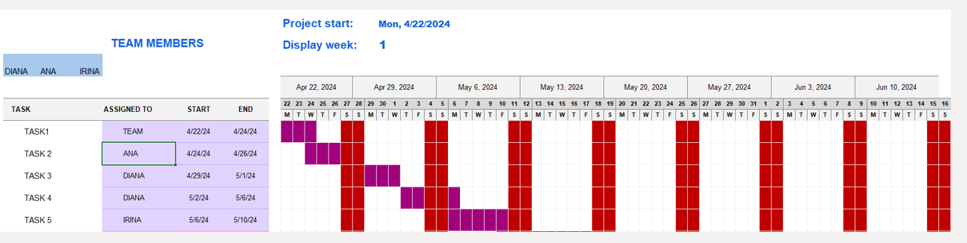
Figure 1. Cancer Research UK Gant Chart
The "Cancer Research Uk" team started the project on 22.04.2024 and it was completed on 10.06. 2024. The project was analyzed weekly.

QUAD CHART
For the project to be planned and implemented the Quad Chart is a very important tool because it works by organizing complex information into four distinct quadrants, allowing a clear and concise visual representation of key aspects of the Cancer Research Uk organization.
Aim: to achieve a world where more people survive cancer
Objective 1: Raise funds to finance innovative and impactful cancer research projects.
Objective 2: Support the service of the company
Stakeholders:
1.Employees
2. Volunteers
3. Donors
4. Healthare Providers
5. NHS
6. Community Groups
7. Goverment Officials and Policy Makers
Desire and results:
Created a fundraising link and Research a facebook page linked with the Cancer Uk.
Gained donations towards the charity page.
Measures of success:
Raising awareness
200£ raised
Impact on Patient Care

SWOT ANALISYS CANCER RESEARCH UK
Strengths:
Strong Research Infrastructure
Skill Researchers and Dedicated
Research Initiatives
Weaknesses:
Funding Limited
Clinical Trial Succes Rate
Opportunities:
Technological Advances
Partnership and Collaborations
Threats:
Research Organization Competing
Shifting Funding Priorities
STAKEHOLDERS CANCER RESEARCH UK
A stakeholder analysis involves stakeholder mapping. Decide what your project's focus will be before you begin. Stakeholders will be determined by this. Follow these steps once you've determined which stakeholders to include in your stakeholder map:
1. List the Stakeholders
2. Analyze Stakeholders
3. Prioritize Stakeholders
4. Engage Stakeholders
Identifying and analyzing your stakeholders is the first step in working with them. Project Managers can help with that. Keep your stakeholders engaged with our award-winning project management software.

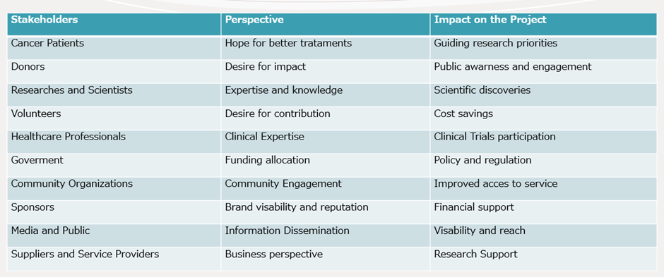

Figure 2. Cancer Research Uk Stakeholders Analysis Table.

RISK ASSESMENT
The task of risk assessment is to determine the quantity or quality of a risk that is associated with a specific situation or threat (Simplilearn, 2013).
Qualitative:
Team members are lacking in experience
With the amount set to increase, it might be too high.
Quantitative:
The company does not communicate well
Financial difficulties faced by donors.

Communication and Stakeholders

All verbal and written communication between a company and those affected or interested in its activities is stakeholders’ communication. It is crucial that this communication is of high quality. As stakeholders, they may influence a variety of activities and even their results based on their level of influence. There are two types of abilities: positive and negative (Dupont, 2022). As stakeholders, you receive support and input for your project or business. Having a diverse group of people involved in your project will help your project and/or organization succeed. Mismanagement of stakeholder relations can lead to the failure of a project (Kimberley, 2022). The role of communication is crucial to stakeholder engagement and management, since it facilitates information sharing, expectations management and understanding.
Strategic approaches to team communication with stakeholders:
Determine the needs of stakeholders
Getting to know your stakeholders will help you communicate more effectively.
Make the Right Channel Choices
Communicating with stakeholders is impossible without addressing the elephant in the room - that there are an ever-increasing number of channels available today.
Feedback is encouraged
Stakeholders should be able to provide feedback through your stakeholder communication. Multiple methods of contact are needed to connect with stakeholders (phone, email, face-to-face, messaging, comments, etc.) along with opportunities to participate.
The Establishment of a Cadence
Maintaining consistency and communicating regularly with stakeholders is crucial. Maintaining timely communication with your stakeholders is crucial to building their trust and confidence in you.
Keep track of all communications
Your stakeholder management system should track all stakeholder communication. Your organization and project may require this as a compliance requirement. This shows that you have engaged stakeholders genuinely.
Engage your audience
It is also important to regularly evaluate stakeholder communication so that you can incorporate what you've learned into future engagements.
The methods presented above are positive and had maximum efficiency in the success and completion of the report. But there were also negative parts between the team's communication with the interesting parts:
- Make assumptions
- It promises too much
- Be defensive
- Reject feedback
- Ignore the emotions

CONCLUSION

Tool and Technique specifics can be divided into distinct groups, allowing a systematic understanding of how each applies in various project management scenarios. A structured framework for determining a project's characteristics provides project managers with a framework for tailoring their approach. In this report, the techniques and tools used for the management project are Gant Chart and Quad Chart, SWOT analysis, Risk analysis, Project Life Cycle, Smart Goal Analysis, Work Breakdown Structure, Stakeholder Analysis and Risk Assessment.

Future improvement in managing a project within an organization.

1. Make sure your goals are flexible and clear from the beginning
As your needs change during the project, setting goals is an essential part of the planning phase.
2. Gain a clear understanding of the project's scope
A project's scope affects its budget, labor needs, and overall efficiency.
3. Maintain communication with clients and team members
Understanding client expectations and adapting to changing circumstances are also important aspects of communication.
4. Encourage teamwork
Since many projects require the cooperation of multiple people or departments, teamwork is essential.

REFERENCES:

Angela (2024). Stakeholder Communication: Benefits, Best Practices, and Management. [online] Simply Stakeholders. Available at: https://simplystakeholders.com/stakeholder-communication/.
Association for Project Management (2021). What is a Gantt chart? | APM. [online] Apm.org.uk. Available at: https://www.apm.org.uk/resources/find-a-resource/gantt-chart/.
Atlassian (2024). A Guide to the Project Life Cycle: Exploring the 5 Phases. [online] Atlassian. Available at: https://www.atlassian.com/work-management/project-management/project-life-cycle.
Bell, M. (2022). Introduction to Risk Assessment in Project Management. [online] Project Management Academy Resources. Available at: https://projectmanagementacademy.net/resources/blog/risk-assessment-in-project-management/.
Boogaard, K. (2023). How to write SMART goals. [online] Atlassian. Available at: https://www.atlassian.com/blog/productivity/how-to-write-smart-goals.
Eby, K. (2023). SMART Goals for Project Managers | Smartsheet. [online] www.smartsheet.com. Available at: https://www.smartsheet.com/content/project-management-smart-goals.
Dupont, F. (2022). How to Communicate with Stakeholders Effectively – and track and extract meaning from it all. [online] Boréalis. Available at: https://www.boreal-is.com/blog/communicate-with-stakeholders-effectively/.
Indeed Editorial Team (2021). 12 Project Management Strategies To Improve Efficiency. [online] Indeed Career Guide. Available at: https://www.indeed.com/career-advice/career-development/project-management-strategies.
Investopedia (2021). What Is Project Management? [online] Investopedia. Available at: https://www.investopedia.com/terms/p/project-management.asp.
Johnson, J. (2024). What are the Advantages and Disadvantages of Using Project Management Tools: Unveiling the Pros and Cons. [online] Medium. Available at: https://medium.com/@ezmi.tech/what-are-the-advantages-and-disadvantages-of-using-project-management-tools-unveiling-the-pros-and-85e8b70cd9d0 [Accessed 24 Jun. 2024].
Kimberley (2022). 5 Tips on How To Communicate With Stakeholders Effectively [Free Template Plan]. [online] Swift Digital. Available at: https://swiftdigital.com.au/blog/how-to-communicate-with-stakeholders/.
LTS, L. transition solutions (n.d.). Quad Charts: A Visual Approach to Strategic Planning. [online] balancedscorecard.ltslean.com. Available at: https://balancedscorecard.ltslean.com/Quad-chart.
Martins, J. (2020). 5 benefits of project management anyone can adopt — asana · asana. [online] Asana. Available at: https://asana.com/resources/benefits-project-management.
Martins, J. (2023). What is Stakeholder Analysis and Why is it Important? [online] Asana. Available at: https://asana.com/resources/project-stakeholder.
Project Manager (2022). Ultimate Guide to Gantt Charts. [online] ProjectManager. Available at: https://www.projectmanager.com/guides/gantt-chart.
Project Manager (2022). Work Breakdown Structure (WBS): The Ultimate Guide (with Examples). [online] ProjectManager. Available at: https://www.projectmanager.com/guides/work-breakdown-structure.
Schneider, A. (2022). A guide to SWOT analysis in project management. [online] monday.com Blog. Available at: https://monday.com/blog/project-management/swot-analysis-project-management/.
Simplilearn (2013). Risk Assessment in Project Management. [online] Simplilearn.com. Available at: https://www.simplilearn.com/risk-assessment-project-management-article.
Trappett, L. (2023). The Do’s and Don’ts When Communicating with Stakeholders. [online] Consultation Manager | The #1 Stakeholder Relationship Management Solution. Available at: https://www.consultationmanager.com/the-dos-and-donts-when-communicating-with-stakeholders/.

