DS 1 Template

My Screenshots/Photos
- Please add 4–6 screenshots or photos of your digital life.
- You can use your phone or laptop.
- For each screenshot, write one or two sentences explaining what it shows.

Screenshot/Photo 1
The pc has to many functions. send emails, research, play games do my homework.
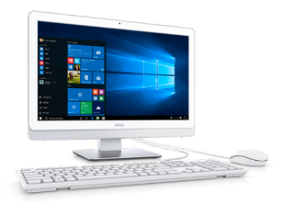

Screenshot/Photo 2
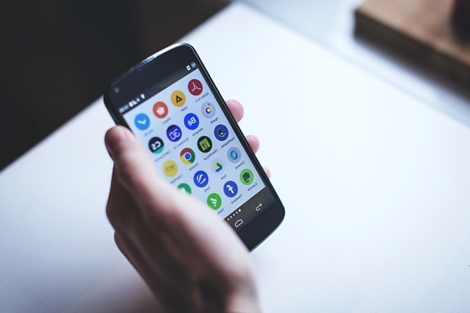
The smart phone is a good technologic they can do lots of things they can take photos they can send and receive emails they can assess to different apps

Screenshot/Photo 3
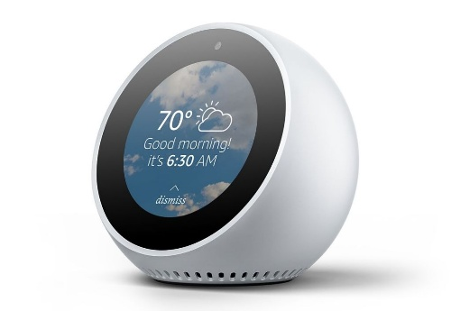The Alexa is good she connects to the phone with the camara, with the tv , and you talk with her and she can play music can tell you the weather can tell jokes she is very good I have Alexa …
This Photo by Unknown Author is licensed under CC BY-SA-NC

Screenshot/Photo 4
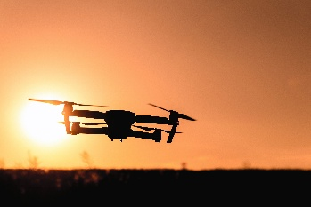
The drones can be very useful but very dangerous if you don’t know what you do. the drone is good because I can record beautiful things from the sky till wherever you want.

Screenshot/Photo 5
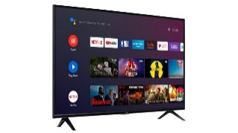
The smart tv are amazing now they have one technologic very good they can record, if you press a button you can talk and she do what you want they can be connect with Alexa .
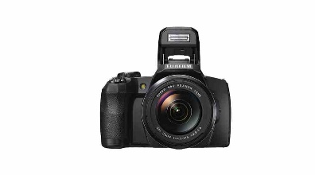
Digital camara is good you can take photos see if you like and then save our passe for the pc our laptop .

My Short Reflection
- Write 5–8 simple sentences about your digital life.
- You can use the sentence starters below if helpful.
I use the phone for everyday basis .
I think today in day no one can stay without phone because we can do so much with him , see the weather phone take pictures send email google anything

Sentence starters
- I use digital tools to …
- I feel confident when I …
- I want to improve …
- I often use these tools: …
- I sometimes feel nervous about …
- I hope this module will help me …
- Digital skills are important for me because …

SUBMISSION Checklist
Before you submit, please check:
​​​ ☐ I added 4–6 screenshots
☐ I wrote short sentences for each screenshot
☐ I wrote my short reflection
☐ My work is my own
☐ My file opens correctly
​​☒ My file opens correctly
Refencing
Tom’s Hardware (n.d.) News. Available at: https://www.tomshardware.com/news (Accessed: 25 October 2026).

Lane, N.D., Miluzzo, E., Lu, H., Peebles, D., Choudhury, T. and Campbell, A.T.</Person. (2010) 'A survey of mobile phone sensing', IEEE Communications Magazine, 48(9), pp. 140–150. doi:10.1109/MCOM.2010.5560598.

Milmo, D. (2025) What I discovered when I asked Amazon to tell me everything Alexa had heard. The Guardian, 24 May. Available at: https://www.theguardian.com/technology/2025/may/24/what-i-discovered-when-i-asked-amazon-to-tell-me-everything-alexa-had-heard (Accessed: 25 October 2026).
Drones (no date) BBC News. Available at: BBC News - Drones (Accessed: 25 October 2026). [feeds.bbci.co.uk]
In-text citation
The Independent (2026) ‘Smart TV standby UK EU regulations’. The Independent, 23 October. Available at: The Independent article (Accessed: 25 October 2026).

National Science and Media Museum (n.d.) 'History of digital photo manipulation'. Available at: National Science and Media Museum article (Accessed: 25 October 2026).

