Exercises for lists in Python (2)

2a. Using floats

Create an empty list to hold some temperatures (in Celsius).

temps = []

2b. Allow the user to enter 6 temperature readings into your list. Use .append() and a for loop.
Hint: Just do one temperature reading to start – you can add the for loop in afterwards

Sample output:

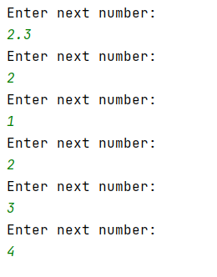

2c. Print out the numbers entered by the user in 2b above – nicely as shown below.

Sample output:

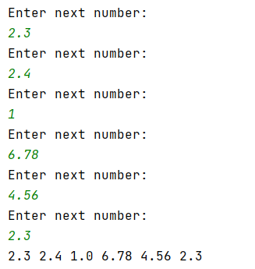

2d Print the item at index 3 of the list on the screen:

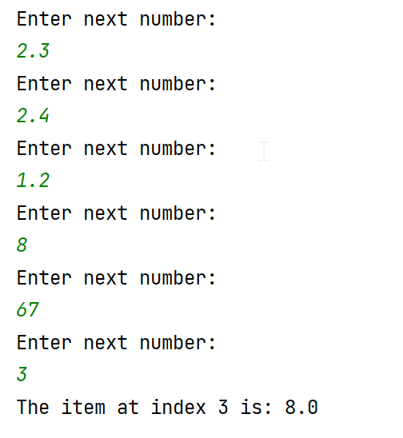

2e. Following on from 2d), this time, allow the user to choose which index they require:

Sample output:

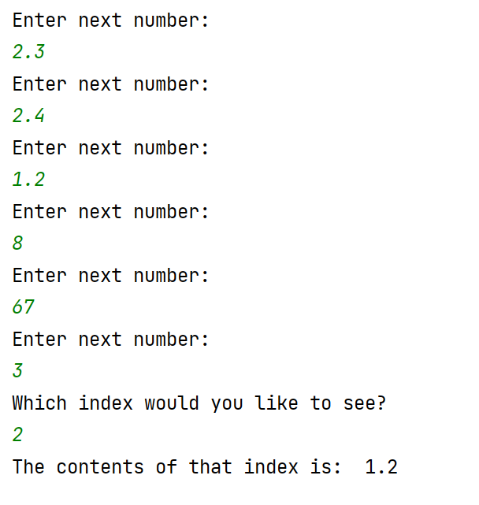

2f. Convert all the temperatures in the list from Celsius to Fahrenheit and print them on the screen (you will need to find a suitable formula) For testing purposes, 100C is 212F

3a Create a program with the following list:

theNumbers = [2, 4, 3, 7, 3, 1, 3, 8, 9]

3b Multiply every list item by 2 and print the result on the screen. Use a for…in range loop to help you:

Sample output:

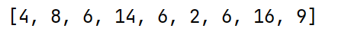

3c Find the average of the following list (ie add the contents of the list using sum() and then divide by the number of entries in the list)

theNumbers = [2, 4, 3, 7, 3, 1, 3, 8, 9]

Sample output:

4a. Create 2 lists, one of strings and one of integers with 8 entries. The string list will hold names, the integer list will hold telephone extension numbers eg. 4234, 6545

4b. Print the lists on the screen as shown in the sample output below, using a for…in range loop (Do not use a for…each loop as 2 lists are involved.)

Sample output:

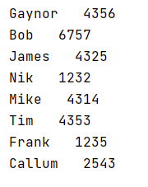

4c (Harder) Allow the user to enter a name. Look through the list and find the name. When you find it, print out the number associated with that name.

Sample output:

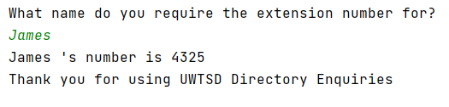

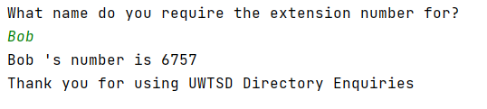

5. Lottery numbers

5a. Generate 6 lottery numbers store these in a list.

Sample output:

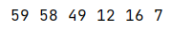

Note: Run the program a few times and you will see that duplicates appear sometimes, ignore this for now.

5b Sort your lottery numbers into order. Providing you have used a list in 4a) above, this is quite easy using the sorted() function Code: sorted(name_of_list_here)
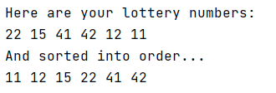

5c. (More challenging) Adapt your program to stop duplicates appearing in your final lottery number list

