Edwards, Anneliese
2005957
Manufacturing systems and simulation
ACMA6002

Table of Contents
Introduction 1
Discrete Event Simulation Model 2
Waste Identification 5
Value Analysis 7
System Analysis 9
Opportunity analysis 10
Conclusion 11
References 13
Appendix 1 14

Introduction

Discrete event simulation or DES is the method of process modelling used to represent the operation of a system as discrete events. This is an amazingly effective tool to use when trying to visualize and make improvements to a system as it is able to demonstrate any bottlenecks or redundancies in the system, allowing for key improvements to be made. (Jones, 2024)

A DES was produced to represent the CP laboratory system which is located within UWTSD. This is a process with several stations with different tasks such as, drilling, labelling, sorting, and inspecting, which are controlled with different conveyors, sensors, and operators in order to run, the DES, demonstrates each of these distinct operations. A benefit of using DES is that as well as demonstrating the flow throughout the process it uses dynamic timing, allowing for a more accurate real life estimation of the system, as each stage with cycle through a varying processing time, similar to what would happen in real life. (Henderson, 2025)

Discrete Event Simulation Model
The first step to producing the discrete event simulation model, was data collection. Once the system was identified, each step was timed in order to allow the system to be recreated. In order for these figures to be accurate, the same task should be measured several times in order to produce, a minimum, maximum and average value for each task, if there is typically variation in the values. The following values represent the minimum, maximum and average time in seconds each process function within the CP laboratory takes to complete. These values were input into the DES in order to produce an accurate, life-like model.
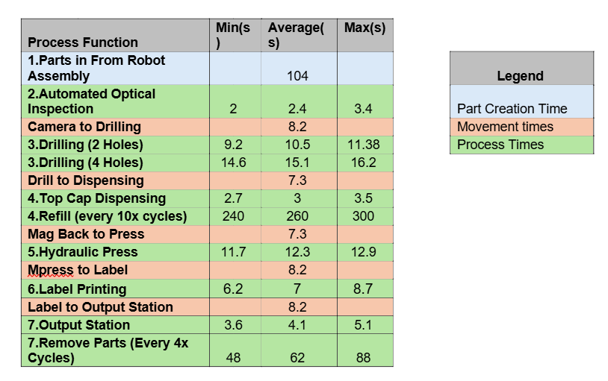

The model was created in Rockwell Arena simulation software, this is a discrete event simulation platform which can be used to create a flowchart model of a process, simulating the flow of entities throughout a process. Several process blocks, delays, holds, assign blocks and decision blocks were used throughout the DES in order to produce the required DES. (Rockwell automation, 2025)
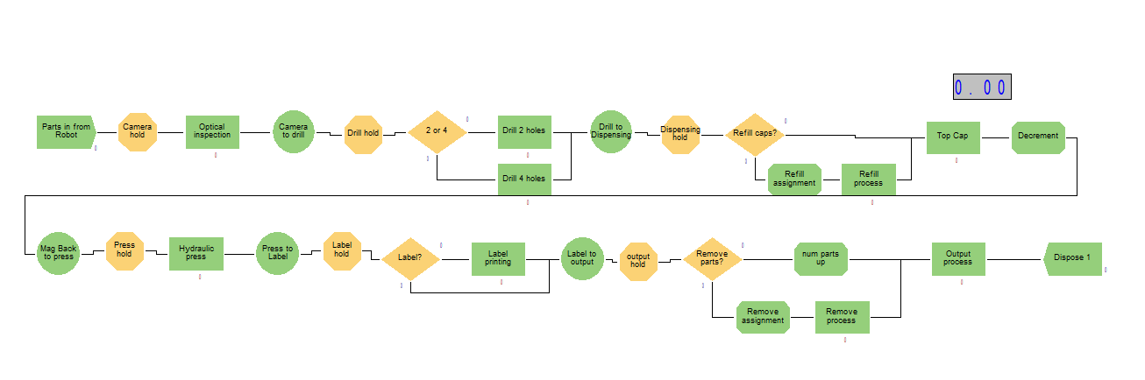
Appendix 1

When inputting new blocks into the system these can be for several functions, including, discrete processing, data definition, decisions, input, or output etc. When you select what block to input, you then need to define the entity. This includes naming the process, as well as allocating a resource to that task as well as defining the average, minimum and maximum time that task takes to complete. The resource allocated to the process, is what will complete the task, so it is important this is added to the process to ensure entities will move through the process.
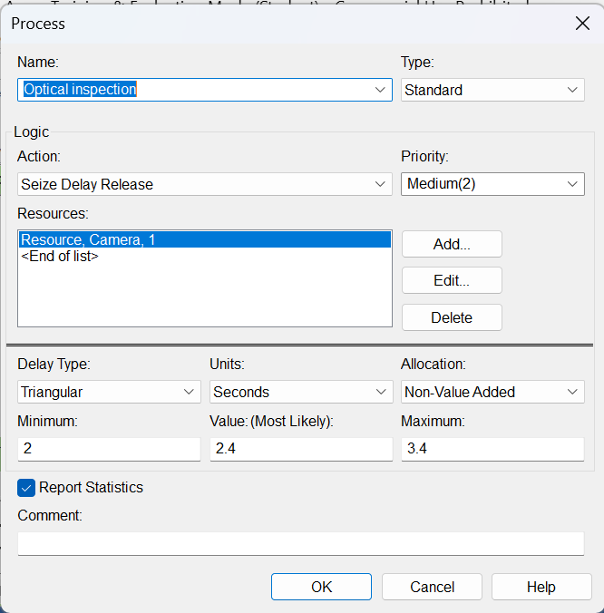
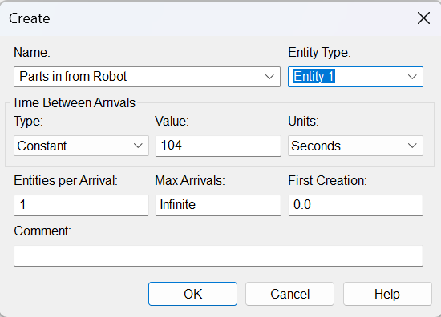

The entity is an object that flows through the model, this can either be a person or an object. This changes attributes or states as it moves through each process in the system, as well as triggers different events as it interacts and moves through each stage.

When allocating resources, either a new resource can be allocated for each task, i.e., a printer, drill or operator, or the same resource can be allocated and shared between multiple steps in the process. For example, the operator is a shared resource between the refill process and the remove process, so, it is built into the logic that the operator can only complete 1 task at once and if they are occupied completing one task, the other will ‘hold’ until the other task is complete. Other logic built into the model, includes, decisions, for example, whether to drill 2 or 4 holes at the drilling station, this was done via a decision block with a 2 way by chance set to 50%, so 50% of parts have 2 holes drilled and 50% have 4 holes drilled, the same drill is used for both scenarios so there is a drill hold to hold incoming components back while the drill is in use.

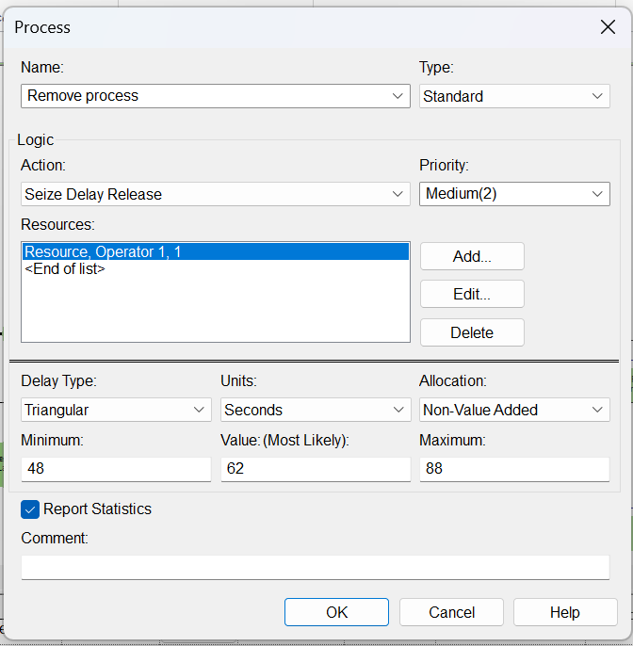
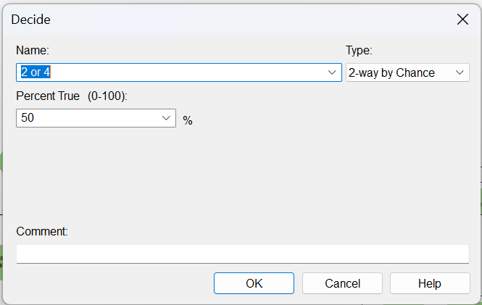

Waste Identification
This simulation showed certain bottleneck points within the system which could benefit from changes in order to improve the throughput of the system. The most common bottlenecks are at the dispending hold and output hold as at both of these points there is a potential for an operator to refill parts or remove parts from the process, one single operator is in charge of both of these tasks which is a potential cause of the issue, as well as the time it takes to complete the tasks. In order to resolve the bottle neck at the dispensing hold there are several possible solutions, including, increasing the number of top caps in the progress, so it doesn’t need to be refilled as often, increase the number of operators, so there is not a wait for refill or to reduce the time it takes to refill the top caps.

Similarly for the output hold, there are several potential solutions, including, increasing the number of parts that are able to be stored before removal, increase the number of operators, so there is not a wait for parts removal, or to reduce the time it takes to remove the components.
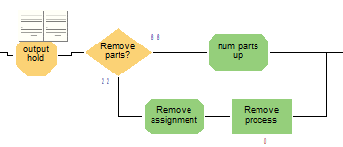
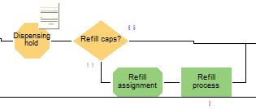

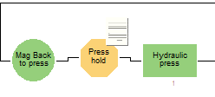

Bottlenecks are also observed at the press hold during the simulation; these delays are due to the availability of the hydraulic press for processing. This delay occurs after a buildup of items at the dispensing hold, as a number of items are released once the top caps are refilled, the increased demand at the next stage, the hydraulic press, then causes a bottleneck. So, it is also possible that if the bottleneck at the dispensing hold is resolved, it will also solve the delay at the press hold.

There would be a significant cost to employ a second operator, which may not be feasible in the manufacturing costs as it will greatly impact profits. It is possible that the removal process time can be reduced by implementing lean manufacturing techniques such as 5S, Poka yoke or by implementing standard working procedures. 5S is a lean tool developed in Japan, consisting of Seiri (Sort), Seiton (Set in Order), Seiso (Shine), Seiketsu (Standardize), and Shitsuke (Sustain). Its purpose is to organise work areas, improving efficiency by making parts easier to find and reducing process time. In disorganised spaces, finding tools and components is time-consuming, so by eliminating unnecessary items and standardising the workspace, task time can be reduced (Lean Principles in Operations and Supply, 2021). Poka-yoke is another Japanese term; it is an error proofing technique which is used to avoid mistakes within the manufacturing process by removing human error. The aim is to implement small changes or devices to the system, so it is obvious when errors occur, stopping the process, making it foolproof. By implementing Poka-yoke, it typically yields a 7-35% improvement in production times and a 35% improvement in error rates. (Trojanowska, 2023). Standard operating procedures or SOPs is the method of implementing a step-by-step procedure for a task to ensure it is completed the same way each time, this is again another way to remove human error from the process to ensure a task is completed consistently and correctly. This helps to remove time from the process as it is clear exactly what steps need to be taken and the expected results. (Zhou, 2025)

These would likely be less costly to implement and could also benefit the rest of the system as improvements could be identified throughout the system when implementing lean manufacturing. Increasing the number of parts which can be stored would also improve the throughput times as the operator would be required less often, this would also contribute towards reducing the bottlenecks at these points in the system. This could be done by implementing larger storage solutions, which should be possible at a small implementation cost.

Value Analysis
A value adding task is an action or process that transforms the material into a product or service, adding form, fit or function, that a customer is willing to pay for. In the manufacturing process there are value adding tasks, non-value adding tasks and necessary non-value-added tasks. (Countiho, 2021). The total value added can also be considered the total sale cost of the product, minus the total cost to produce the product, including wages and overheads, calculating the overall increase in value added throughout production in a physical value. (Implan, 2019)

There are several tasks throughout the process that are non-value adding, such as movement between stations, refilling caps, the optical inspection and removing parts. Although these are non-value adding, they are necessary tasks within the process, therefore cannot be removed. All of these tasks are considered nonvalue adding as they do not change the fit, form, or function of the component, therefore do not add any value to it, therefore a customer would not be willing to pay for these steps. Although they are deemed to be non-value adding they are key steps within the manufacturing process to ensure that the component quality is good (optical inspection) and also ensuring there are components on the line to be able to produce the product (Refill station), which are all key parts of the manufacturing process which could not be removed in order to save time or resources, therefore they must be considered necessary non value adding steps.

There are also several value adding stations, such as the press, label printing, drilling and top cap stations, these are all stations which either add something to the product or change is form, adding value to the product, which the customer would deem worth paying for.

The biggest loss of time and resources is due to the shared operator resource in the remove parts and refill caps stations; this leads to bottlenecks and loss of productivity. These are non-value adding tasks, however, are both deemed necessary. Therefore, both tasks need to be completed, however, these are areas where possible improvements can be made in order to remove waste from the system. Possible improvements that can be made to these sections include, reducing the time it takes to complete the task, this could be done by implementing standard operating procedures (SOP) or implementing new best working practices, to ensure the task is completed the same way each time, in the most efficient manner known. Another possible improvement which could be made to improve these sections is to increase the capacity of caps and parts before removal, this would reduce the number of removals and refills required during a shift, lowering the amount of downtime required to complete these tasks. Another potential solution is to implement an automated process in these sections, such as using a conveyor to remove the parts at the parts removal station, removing the need for the operator to empty the components, this would remove all downtime in this section throughout the day, however, would incur a significant cost to implement as several hardware components would be required, including sensors as well as implementing new programming.

As a whole, the CP Laboratory system is quite efficient, as there is minimal waste of time between tasks within the process due to the fact, the majority of tasks are automated, minimizing opportunities for waste, however, the utilization of each resource is quite low, therefore there is a wide area for throughput improvement by increasing the parts in. In terms of value analysis, the system is also already quite well optimized, as the system is already broken down into necessary functions, with mostly value adding or necessary non-value adding resources, each process has a function that is required during the manufacturing process, whether that change the fit or function of the part, or is required for quality control purposes. Therefore, in terms of value, the system is good, as there are no full processes that can be removed, however, the value added in the system could be improved by removing time waste in the system from redundant holds at resources which do not require them, also the throughput could be greatly increased, which would increase the value added per component, as the overall overhead cost of the components would be decreased due to the increased throughput per hour.

System Analysis
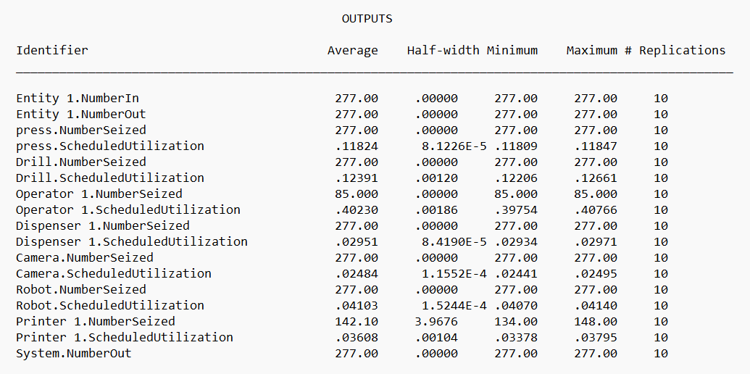
The simulation was run for ten iterations of 8 hours, simulating ten standard shifts in the CP Laboratory. The simulation produced the following report.
Fig. 2

A total of 277 entities were input to the system, as well as 277 outputs, meaning there were no losses of entities throughout the process and no components were ‘stuck’ inside the system.
The average scheduled utilization represents the amount of time each station is actually processing during the simulation time. Therefore, where there is low scheduled utilization, this means even though the resource is seized often, the station itself is only busy for short periods of time during the simulation. This can mean that the station either has a short processing time, or it is over capacity.
The half width is the confidence interval half width, which represents the precision of the estimate. In the report, the half widths are remarkably close to zero, meaning the averages presented are statistically reliable, as the closer it is to zero the more consistent the results are across all the iterations of the simulation.
The majority of the resources have low utilization, with the highest being operator 1, which has a utilization of ~40%. Therefore, the majority of the resources within the process are either exceptionally low usage or underutilized. The dispenser, Camera, Robot, and printer all have under 10% utilisation, whereas, the press and drill, have slightly higher usage, but are still underutilized at 11.8 12.4 percent utilization. With such low utilisations, this indicates the resources are over-allocated, suggesting waste in the system. Therefore, the system would be capable of processing much higher volume of parts with the same resources.

Opportunity analysis

A potential opportunity to improve the current state manufacturing system is to remove redundant ‘holds’ – the main holds which are used during manufacturing are the output hold and the refill hold – these have delays due to the need for operator involvement within the step. All other holds within the system have extraordinarily little to no use during the manufacturing process and could be removed in order to remove redundant steps from the process which are a waste of time and resources.

Another key waste within most engineering systems, is waste of movement. An operator needs to move between the refill station and the output station as they are responsible for both tasks. If the capacity of these stations could be increased, this would limit the involvement required, therefore, saving manufacturing time, as the tool would be down for refill / output less often. This could also be achieved by automating these stations, such as implement a conveyor or robot to take away the components from the output station, removing the need for the operator entirely, removing the wasted manufacturing time caused by the down time at this station.

Due to the low utilization of all the resources during the simulation – this indicates that the system is not at capacity, therefore, the number of parts could be increased significantly with the same resources, the throughput could be greatly improved, reducing overhead costs and improving profits.

There is also potential to remove of combine stations in order to reduce time waste during the process, for example, combining the optical inspection and camera drill sections by implementing an in-line inspection at the camera drill, rather than it being a separate section entirely, this would reduce production time by reducing part movement, this would also remove a hold from the system, further improving the time wastage.

Finally, there is the potential to implement a lean manufacturing technique such as 5S or Poka yoke in order to improve the overall efficiency of the system and remove the potential for errors. Poka yoke aims to remove the potential for errors by making the system fool proof, whereas the purpose of 5S is to organise work areas, improving efficiency by making parts easier to find and reducing process time. In disorganised spaces, finding tools and components is time-consuming, so by eliminating unnecessary items and standardising the workspace, task time can be reduced (Lean Principles in Operations and Supply, 2021)

Conclusion
In conclusion, a Discrete Event Simulation or DES, was produced for the CP Laboratory at UWTSD within Arena software. This produced a visual example of the system in order to create a real life example of how the system runs. This allowed for redundancies and inefficiencies to be identified in the system in order to make improvements. The system showed that several of the ‘hold’ sequences were not used and therefore may be redundant and could be removed in order to improve production times. As well as this, the utilisation of the stations were all extremely low, therefore, showing that the system is over allocated, indicating there is time waste in the system. Therefore, the throughput could be greatly increased with the same resources, improving the efficiency of the system. Multiple solutions were identified for the largest bottleneck in the system, which was identified to be the stations controlled by the operator, the refill and remove stations. These stations caused several bottlenecks throughout the DES simulation, showing these were the weak points in the system which needed the biggest improvement. Solutions such as increasing the capacity of these stations or automating them to prevent the need for human intervention and prevent the delays were identified in order to solve these bottlenecks.

References
Countiho, T. (2021, 05 25). The Value Added Process in Lean Manufacturing. Retrieved 09 2025, from Think Lean Six Sigma: https://www.thinkleansixsigma.com/article/value-added
Henderson, E. (2025, 05 30). Using Discrete Event Simulation to explore "what-if" waiting list scenarios in NHS Scotland. Retrieved 09 2025
Implan. (2019, 02 5). Understanding value added. Retrieved 09 2025, from Implan: https://support.implan.com/hc/en-us/articles/360017144753-Understanding-Value-Added-VA?utm_source=chatgpt.com
Jones, S. (2024, 11 20). What is discrete event simulation (DES) and how does it work? Retrieved 09 2025
Lean Principles in Operations and Supply. (2021). Operations and supply management 4.0, 6. Retrieved 01 2025
Rockwell automation. (2025). Discrete event modelling. Retrieved 09 2025, from Rockwell Automation: https://www.rockwellautomation.com/en-gb/products/software/arena-simulation/discrete-event-modeling.html
Trojanowska, J. (2023). Poka Yoke in Smart Production Systems with Pick-to-Light Implementation to Increase Efficiency. applied sciences. Retrieved 09 2025
Zhou, L. (2025). Applying Lean Standard Operating Procedure to Panelized Prefabrication in the Factory. IGLC 33. Osaka. Retrieved 09 2025

Appendix 1

