
Skills for the Workplace
Module Assignment Submission
Student Name: | Tina webb
Student Number: | 1910813
Module No: | BMSK4006
Module Title: | Part 2 Reflection

Statement of Confirmation of Authenticity
By the act of making this submission, the student declares that this is the work of the student named above. The work has not, in whole or in part, been knowingly presented elsewhere for assessment, or where assessment has been built on a previous assessment, this has been identified. Where materials have been used from other sources it has been properly acknowledged. If this statement is untrue, the student acknowledges that an assessment offence has been committed.
Attention is drawn to the plagiarism and unfair practice policies of both the University and of ILM.

Table of Contents
Part 2: Reflection on Skills developed during the Business Plan Project 2
2.1 Description 3
2.2 Feelings 3
2.3 Evaluation 3
2.4 Analysis 3
2.5 Conclusion 4
2.6 Action Plan 4
References 4

Part 2: Reflection on Skills developed during the Business Plan Project


Gibbs (1988)

2.1 Description

My first steps of what happened during the during the” lockdown of covid19”, was the thought I had of running my own business. the thought then the idea to do something about it, I done a lot of research into my idea of what competition was already out there, at the start I had in mind the name of my business, which I call TENDAHAND, which I thought was appropriate for the job, of grave caring, which involves cleaning the headstone, grass cutting, shrubs removed raking, planting, flower placing. Starting out I needed financing up front for all the cleaning materials and tools, insurances and advertisement that I had to do before I could start my business. So I approached my family who were very keen for this to work for me, at this stage the beginning they didn’t want me to get into any debt, with banks or business loans, so they helped me with the finance situation I also put my own savings into the business which brought my finance up to what I needed to start my business off. This was necessary for the planning of the advertising and those tools I needed to have for the business to start up, so this I did by setting up a website and the tools for the job in hand, also I needed insurance to cover me for any misfortune’s which could arise. The insurance I needed for my business is called sole trader/indemnity, this I found through researching what insurance was needed for my business, and lectures I attended helped me tremendously. I found them very useful extra meetings with my tutor helped me problem solve and plan, and also the internet worked well in this field of work I’m going into researching information which I will include shortly, I was also able to have business cards made up which I distributed to funeral homes, stonemasons, and cemeteries. the area I covered with these was Cardiff and the outskirts of Cardiff. I also wanted to offer the services of hair and makeup and dresswear of their choice for their family member who has passed away, I have worked in the past in funeral homes so I have the experience to do this type of work. I’m also a hairdresser and beautician, I was concerned about qualifications that I may have needed for this personal service I offer; I was glad to find out after researching this that there was no qualifications needed for this service I offer to be done. On receiving messages from my website from potential customers, I then contact them back to arrange a meeting at their home, or if it’s a phone call that came in, I would do the same contact them back to arrange a meeting. I have tried to keep my pricing competitive to other businesses in the same field of work as me, for the service I provide.
This website https://www.valeofglamorgan.gov.uk gave me the knowledge of who owns the land of cemeteries, this I found was the council, the plots are in a sense least to you for a one off fee for a period of 50years to 100years.
Also I needed to be able to find out where the plots are in the cemeteries if names or numbers are not known to the families of the diseased, so for this I found two websites which will help me in the future, https://www.ehow.co.uk<how7839781cemetery-plot-number-uk.html OR
https://www.ancestry.ca/cemetery/record.
The pest analysis template helped me evaluate how my strategy fitted into a broader environment of strategic thinking, it provides me with an overview of all the outside organizations which could be a threat, so this gives you knowledge on your decision making. The use of swot helped me analyse my strengths, weaknesses, and the opportunities for my business and the threats of others operating the same business that’s already out there. I have put a graph below of pest and swot.
I have also used a PDP performance development plan in my business plan, this will help me in the future, to employ the right person for the job, if I became extremely busy, I would need to employ someone to take the work load off me.
Also looking at the gibs refection cycle gave me food for thought on decision making and strategic thinking, of navigating people within your business/company in the future.

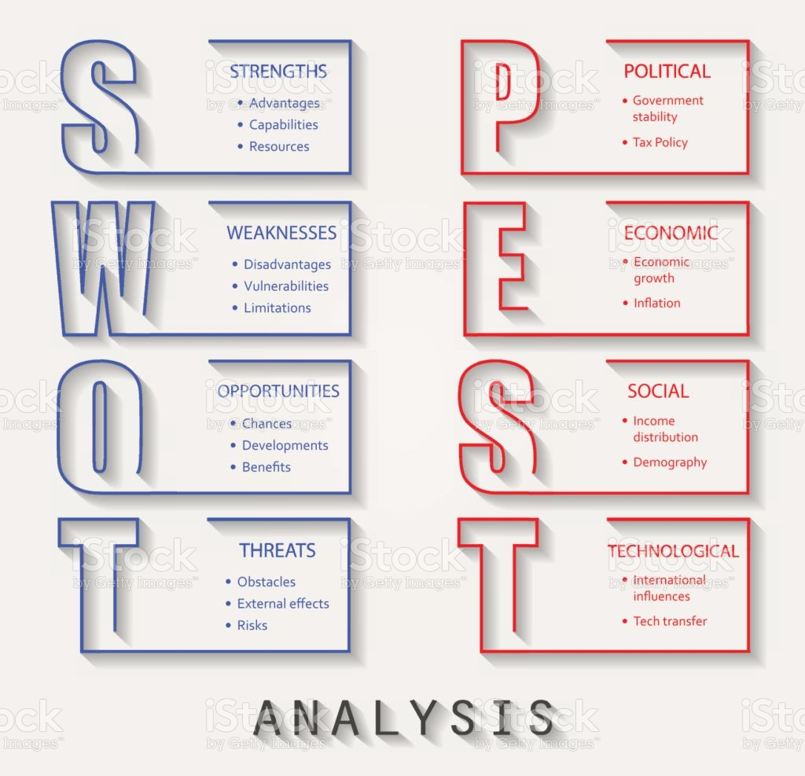

2.2 Feelings
In the beginning on planning my business I was full of excitement, with the thought of working on my own, nobody to answer to but myself. It was a new experience and new adventure I soon became anxious of going into it solely on my own, and the unknown territory I face ahead We were in lockdown at this point because of the “covid 19”,my feelings were very mixed up I had a lot of should I continue or should I just give up, at this point I was thinking how was I going to pay the moneys back to my family if it doesn’t work out for me. So then I turned the corner and gained positive thoughts ,after speaking to family members about my feelings of this, they simply gave me the drive to carry on and look forward to the future with no looking back, as the saying goes onwards and upwards, so this is what I’ve done to get where I am today.

2.3 Evaluation

The good points of my journey is that I came up with the idea of running my own business by myself, I had my families backing who were more than happy to help me on this journey of mine to be able to say I run my own business, that’s a great achievement, I have gained a lot of knowledge from my course “business management”. My tutor gave me a lot of encouragement throughout my course on this, and what also helps me having the knowledge to get around the internet for researching the information I needed to know about my business, This has helped me carry on to be where I am today.
The bad points are that trying to start a business on your own, you must plan out your days and weeks ahead sometimes there’s not enough hours in the day. To complete the research that’s needed for you to know about the business that you want to start up, the days soon turn into night if you’re not careful, and before you know it, tiredness gets in the way. You must always take time out away from your computer so that your thoughts don’t jumble up in your head, this I didn’t do enough of, so it’s taken me longer to complete my business plan. I also found it difficult to get to the bottom of the cashflow chart, I done researched into what other companies were charging to get some idea about this, so I could keep my prices competitive.

2.4 Analysis
The sense I made out of the situation, is that I will always have the backing of my family and the loyalty that comes with them This will always remain no matter what, and the technology that’s out there internet etc will always improve, so the research I found was incredibly satisfying and easy to read and follow. Whatever information I needed for my business to succeed I found having followed the swot analysis in my planning ahead has helped me on my way to achieve all that I have, also the pest analysis was a tactical business tool which I used to see what impact there is now on businesses and in the future, and the opportunities / threats due to social behaviours.

2.5 Conclusion
What else I could have done, I could have planned my days better around my every day schedules, which would have given me more time, getting into the habit of writing things down first, leaving myself notes as a reminder of what I must to do next, This would have been a good idea, so I have to enforce this upon myself in the future. To achieve more from myself. Again if it wasn’t lockdown with “covid19” I would have gone to the library to do research which would have given me a break from my computer, which I know from past experience would have helped me a lot to archive information on the work that I needed for this business plan.

2.6 Action Plan
If it arose again, Hopefully there wouldn’t be an out brake of covid19” and we wouldn’t be in lockdown, so that I could have gone out and visited the library where I find myself inputting a lot more of the information that I needed to be able to put this business plan together, better than on the computer all the time, I would manage myself better, giving myself time slots to get things done. Plan things ahead of time, write more things down for me to remember to get done, organize myself on a day to day, keep a weekly diary going, of what I’m to do next. I am a firm believer of this saying “work hard play later”.

References

Gibbs, G. (1988) Learning by doing; A guide to teaching and learning methods. London: FEU
https://www.valeofglamorgan.gov.uk
This website above is one of the council sites of them owning the cemetery ground.
, https://www.ehow.co.uk<how7839781cemetery-plot-number-uk.html
This website above is how you can find the number of the grave.
https://www.ancestry.ca/cemetery/record.
This website above is how you can find the grave by name.

