Module: Effective team working and Communication

(BMSW4002_LON)

Student: Shelly-Ann Williams

Student ID: 1916052

Tutor Name: Lloyd Beharry

Contents Page
Introduction 3
1. 4
2. 5
3. 6
4. 7
5. 8

Essay on effective communication

Introduction

Communication is the importing or exchanging of information by speaking, writing, or using some other medium.
Reference: Google Dictionary

Communication is important in management because for decision making and planning. When it comes to planning communication must be demonstrated in the workplace in order to achieve desired goal. Decision-making communication helps sort out current problems or situations to ensure the group runs smoothly. It is important for these reasons giving feedback to employees, relationships with other departments, conflict resolution, managing performances and building teams.

MODELS of COMMUNICATION

Firstly, communication can be made effective in any business organisation by just having certain qualities i.e. trust and loyalty as having those qualities helps to meet certain individuals needs in the workplace. This could be when giving advice, constructive criticism to develop their job role and sharing vital information. Effective communication is crucial for developing the organisation, it helps the manager plan, control and to organise without communication the organisation will collapse however, if there is open communication the team will exceed.

Communication can be made effective in the workplace by using simple words to ensure that all workers an understand what you are saying because if not, you can be misunderstood. Adding visuals can be a great help for some employees that may have a better understanding to pictures rather than words, this will be inclusive to any staff members that may have any learning difficulties e.g. dyslexia.
Sometimes workers, might find it easier to be spoken to one on one as some workers may feel uncomfortable and unfocused being spoken to in a large group.
Using body language also helps to make communication effective because it will pass your message on quickly and easily. Having eye contact, good body posture and positive facial expressions demonstrates that a worker is attentive. Using a appropriate tone of voice can comes across clear to your team mate. If for example, you spoke in an unbothered tone worker may feel uninterested in wanting to listen more or it could result to workers misunderstanding what you are trying to say.

2.

Shannon and weaver model of communication theory was created in 1949. Shannon was an American mathematical theory and weaver was a scientist. The theory was known as ‘mother of all models.’ The models started off by the concepts.
The information source which was the person who makes the message and sends it, then the transmitter converts the message into signals that channel the medium to send the message. The receiver translates the message from the signal the message then reached the destination (receiver) the receiver then provides feedback according to the message. The telegram then makes a noise to alert the receiver.
The presence of noise between encoded and decoded messages. The person who receives the message has to decode the message before interpreting it. In some cases, the receptor machine can also decode.



Shannon and Weaver: Model of communication

Referring to a case study, “Pedro and Maria,” Maria called her husband Pedro whilst he was at work (building site) asking him to buy chicken for her to cook on his way home from work. He replied yes. Pedro went home without buying the chicken and went straight into the kitchen, Maria then asked him where the chicken for her is to cook. Pedro then asked her what chicken and was confused. She then replied, “the one I told you to buy on your way home from work” He then replied, “he thought she said when you come home I will be in the kitchen.”
From this case study, the receiver did not receive the message because there was a lot of noise where Pedro works (building site) so the noise in the background caused him to not hear the message.

Wilber Schramm was another theorist (1954) that took over to expand the model of communication from Shannon and Weaver. Schramm had the idea that communication happens both ways from the sender and receiver. Schramm believed that coding and decoding are very important when it comes to effective communication.
Communication to Schramm’s is circular, a message is encrypted and sent to a person, once the message is sent, it gets decrypted and is sent to the receiver to interpret and decode before sending back a message.
Schramm changed the model and incorporated field of experience which is what is really understood between the sender and receiver. For example, a high educator professor teaching maths to a group of 4 year olds would not have much luck teaching them complex mathematical methods because they do not share the same field of experience that makes the message easily understandable.
Sometimes the Schramm model was not effective because it was impaired by background noises and misunderstandings which would affect the message getting across properly.
However, a benefit was that it was a very straight forward and simple approach.

https://www.toolshero.com/communication-skills/schramm-communication-model/

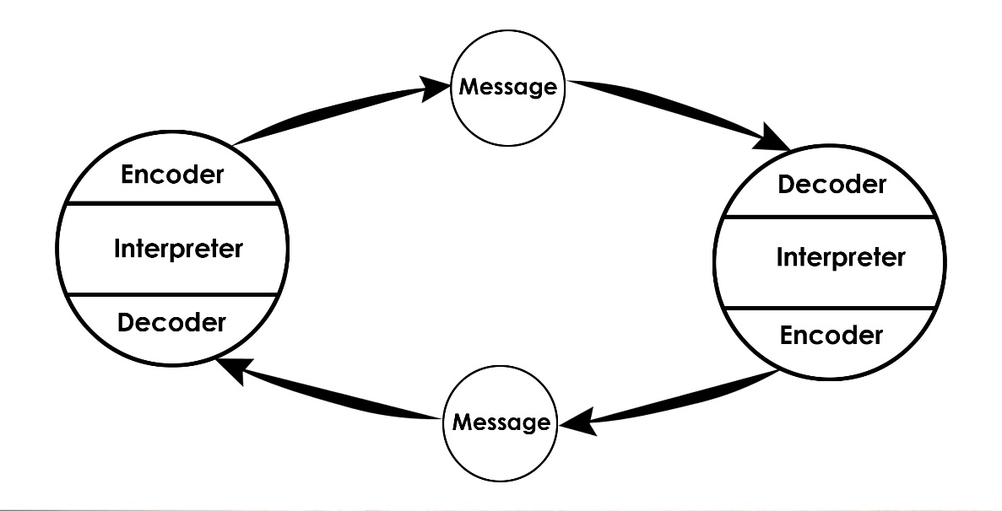
www.communicationtheory.org

Theorist, David Berlo in 1960 expanded the model of communication theory and called it, ‘Berlo’s SMCR Model Synchronisation,’ by describing the communication process and what different factors were to influence no feedback during the process. For the receiver to obtain the feedback the people must have the same attitude, source, knowledge, and communication skills to ensure the message is working effectively.

Berlo’s SMCR’s theory was a complex linear model. This model involves encoding and decoding that occurs before the sender sends a message and before the receiver receives the message properly. The model does not involve feedback.
There are four components, sender, message, channel and receiver all in which are affected by a range of factors in the image below.



Book: Chapter 29 www.communication447.books.google.co.uk

3.

Effective communication in my friend’s setting (primary school) is made effective especially around parents. They have an open and inclusive policy ensures that parents feel involved within their children’s learning and development. They do not always just share information about their children but have certain workshops which parents are invited to, to better their knowledge and the workplace ensure they are accessible to whatever questions the parents may have.
My friend’s primary school have developed their communication process and have updated it by instead of just using letters and books to show parents all the great things their child have done during the day, they have an app where all important relevant information is and where parents can regularly check and comment on what their children are doing throughout the day by observation, i.e. pictures and videos. This used to be a barrier of how communication was translated but they come up with the perfect solution which now it is working more effectively.

As a school and class, they do a lot of team activities that does not only show that as teachers they communicate but also teaching the children the importance of communicated and collaborating. My friend, as a teacher ensures she gives positive feedback to all children, sometimes it is not always about the negative feedback, but praising children is a great way of communicating especially as it pushes children to do more positive things. The only time negative feedback is used, is when children are getting told how they can improve their behaviour etc.

Outside agencies such as, social workers, therapists etc. The school ensures that information is being shared with them as they have a duty of care. If they are placed in a child’s record, then they need to be included as much as the parent to make sure the right solutions and record keeping is with them.

The way communication is kept flowing through the staff members is that, once a week my friend has a meeting in her setting. In this meeting information is shared and if anyone has any problems, they can use this meeting to speak. Not only that, but once a month the school has training. Within this training, all staff will get together in a group and do this training. Within the training, all staff are made sure to collaborate and take part in the activities.
Moreover, once a month senior leadership team will come around to observe teachers on how they are teaching. When the observation is over the leadership team will give back positive and critical feedback to let the teachers know what they can do to improve their teaching and what they are doing well. That feedback time gives teachers an opportunity to ask the leadership team questions also.

Schramm’s theory is clearly used in my friend’s workplace as you cannot speak to children the same way you will speak to colleagues due to their level of understanding. So instead, she adapts how she speaks to the children for them to understand.

4.

The different methods of communication are speaking, writing, and listening or reading.
Most communication is oral with one person speaking and other(s) listening. However, some forms of communication are not always spoken or written.

Verbal communication is important as it is the use of words and sounds to share information. E.g. it can be phone calls, face-to-face or video call. Verbal communication takes place when two or more people speak with each over.

Non-verbal communication refers to facial expressions, gestures, and body language between two or more people. For instance, making eye contact can show how a person feels on a situation i.e. irritated, showing confidence.

Written communication can be, sending messages, writing letters, taking down notes or rules and instructions. It also helps when writing down your problems to create a solution to help problem solve. It is important in every aspect of business.

Visual communication is information that can be visually seen through signs and symbols, drawings, and pictures. Visual communication can be more expressive than words.
A great example can be, on the roads there is visual signs to show you where to go, if you can go through a certain road and different instructions.

Active listening is important as it is the start of any type of communication. You need to listen to be able to respond to show that you understand and to be able to give feedback. This is a technique that councillors, managers, doctors etc use to solve problems and come up with solutions to help a person.
Article: www.drexel.edu.com posted on July 12th 2018

5.

Managers have key a role in establishing clear communication within the workplace. Management have a role is to plan, organise, employ staff, to lead tasks inside and outside of the workplace. All these jobs require communication for tasks to be done. When there is a problem within the workplace which leads the manager having to solve the issue, the manager needs to make sure that they communicate their authority without sending a message of disrespect and without losing their temper. Managers should have a firm but not angry tone when speaking to their employee. A relationship between a manager and an employee is important because without a good relationship the employee will not be able to perform to the best of their abilities so this is why it is vital managers speak to their employees with respect regardless of how angry they are.

With choice of language it is important that depending on how severe the situation and circumstance is between the manager and employee, if any of them have a problem they should find the right way to communicate whether that be on email or face to face. For example, if the situation is just about an employee wanting a day off of work the employee called just email or if it about something more severe a face to face meeting will be essential.
Managers need to balance level of formality when communicating with their employee. Certain words and phrases may not be appropriate in the conversation. Some words and phrases can come across as sarcasm which is why it is vital to level how formal you communicate with your employee. For example, using words like, ‘okay, alright,’ instead of, ‘I understand or to fix this we can.’ Can come across informal and can lead the employee to misunderstand what the manager is really trying to say.

Reference List

Article: www.drexel.edu.com posted on July 12th (2018)

Book: Chapter 29 www.communication447.books.google.co.uk

Google Dictionary: Oxford

Shannon and Weaver: Model of communication
www.businesstopia.net (2018)

Schramm’s Communication Model
https://www.toolshero.com/communication-skills/schramm-communication-model/

