

Student name: Ana Filipa Vaz Ferraz
Student ID: 2321715
Module name: Changemakers: Building your Personal Brand for Sustainable Employment
Module code: BMHP5015
Lecturer name: Caroline Salami

Developing Employability Skills and Professional Identity for a Career in Children’s Social Work

Table of Contents
Introduction 3
Personal Employability Skills Required 3
Qualifications 3
Job Description and Person Specification 4
Communication 5
Teamwork & Multi-Agency Collaboration 5
Resilience & Emotional Intelligence 6
Evaluation of my Skills 6
Qualifications and Experience 6
Swot Analysis 7
Strengths 7
Weaknesses 7
Opportunities 8
Threats 8
Building a Personal Brand and Professional Identity 8
5-Year Action Plan and Timeline to Become a Qualified Social Worker 9
Year 1 (2026): Foundation and Qualification 9
Year 2 (2027): Postgraduate Qualification 9
Year 3 (2028): Qualify & Register 9
Year 4 (2029): Consolidate Practice 9
Year 5 (2030–2031): Advance & Specialise 10
Conclusion 10
References 11

Introduction
This report focuses on my aspirations to become a children’s social worker within a local authority setting. Using a current job vacancy, this report will analyse the job description and person specification to better understand the skills, qualifications and experience required for this role. I will then compare this against my own skills, qualifications, and experiences, highlighting strengths, as well as areas needing further development. Furthermore, the report will focus on how I can build and promote my personal brand and professional identity. The report will end with an action plan and timeline highlighting the short-term and long-term actions I will take to achieve this career goal.
My interest in pursuing a career in social work stems from my lived experiences. I grew up in a community where many neighbours were affected by social inequality, financial hardship, and substance misuse. I was able to see for myself the impact these challenges had on children, young people, and families. This motivated me to strive for a positive change in the early experiences of children, so that they could grow in safety, protection, and with access to opportunities that would ensure they develop into stable and fulfilling individuals. I am also particularly drawn to working as a social worker because it reflects my personal values and commitment to improving Health and Social Care services in the UK.

Personal Employability Skills Required
Children’s social workers are responsible for assessing family situations and providing support when families face difficult and complex circumstances. They intervene during times of crisis to protect children and promote their safety. The role also involves working closely with families to help create stability and positive long-term change. Additionally, children’s social workers collaborate with other professionals, including police officers, teachers, health practitioners, and the courts, to ensure that children receive comprehensive and effective support (The Frontline, 2025).

Qualifications
A person can qualify to become a social worker through an apprenticeship, a university degree in social work approved by Social Work England, or an undergraduate degree in another subject followed by a master’s degree in social work, or through a graduate training scheme. These routes require qualifications at GCSE and A-level (National Careers Service, 2025).

Job Description and Person Specification
Hampshire County Council specifies the need for a licensed social worker registered with Social Worker England (SWE), who is committed to working with children and their families. The role requires a person who is mindful and empathetic, placing the child's wellbeing and future at the centre of their work (GOV. UK, 2025). Furthermore, social workers should have a solid understanding of the primary laws in the UK that govern working with children, including the “Every Child Matters” framework (DfE, 2009). Effective communication, strong negotiation skills, and the ability to work across multi-agency teams are also essential (NHS Jobs, 2025). For instance, using the Star model (Situation-Task-Action-Result) to interview children and their caregivers, with questions such as “Describe a moment when... or give me a specific situation where you… which requires the interviewee to share their story (Stojanovic, 2023). Diligence is critical when creating reports, evaluating risks, and developing strategies to safeguard children (GOV. UK, 2025). Main duties include conducting statutory assessments, developing care plans, advocating for children’s rights, and ensuring children are placed in stable, long-term settings. Responsibilities include working directly with children to support their social and emotional development, conducting statutory assessments to understand a child’s circumstances, and developing care plans that reflect the child's needs and preferences (NHS Jobs, 2025).
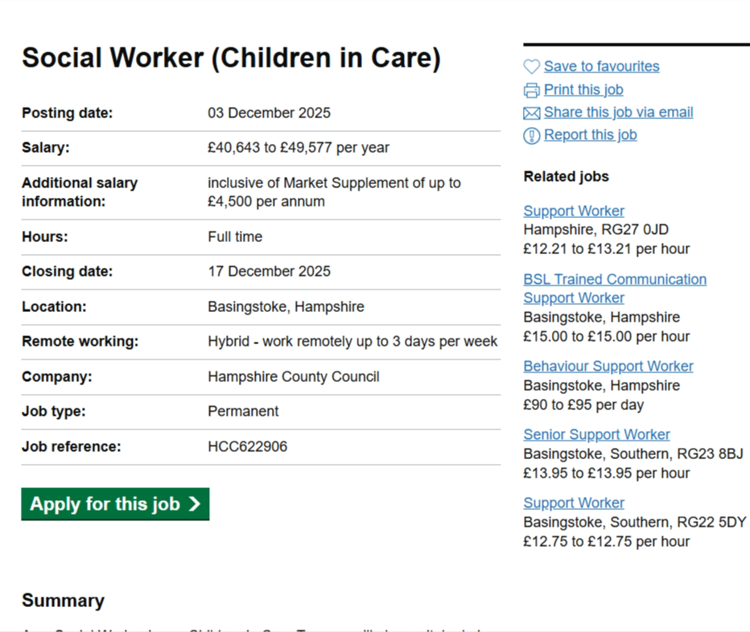
Figure 1: Social Worker Job Vacancy for Hampshire County Council.

Figure 2: Social Worker Job Vacancy for Adoption Service at Milton Keynes or London

Communication
Effective communication is essential when working with children, young people, families, and carers, as highlighted in the Common Core. It requires attentiveness to individuals' expressions and ensuring that children's voices are heard and valued. Social workers must consider the context and cultural backgrounds of those they engage with, adapting their communication styles as needed (DfE, 2010).
The STAR framework can guide conversations, prompting parents to reflect on specific situations, thereby ensuring informed decision-making based on children's experiences (Stojanovic, 2023).

Teamwork & Multi-Agency Collaboration
Effective teamwork in supporting children and families relies on collaborative working through multi-agency partnerships. Central to this approach is prioritising the needs of children and families in decision-making, with tools like early intervention, information sharing, consistent evaluations, and digital technologies (DfE, 2010). Timely and accurate information sharing among agencies is crucial for child safety and well-being. Practitioners must comply with laws and regulations on information management, sharing details responsibly while ensuring understanding from children and carers. Notably, sharing information may not always require consent, particularly in situations involving danger to a child or legal obligations (DfE, 2010).

Resilience & Emotional Intelligence
Emotional intelligence (EI) and resilience are essential for social workers, as they enable effective practice in stressful situations, emotionally charged environments. EI helps practitioners recognise and regulate their own emotions, empathise with children and families, and manage conflict through calm, respectful communication (Herland, 2023). For example, during a child protection visit, EI allows a social worker to de-escalate distress by validating feelings and maintaining composure. Resilience complements this by supporting recovery from setbacks, coping with exposure to trauma, and sustaining motivation despite heavy caseloads. Together, these skills protect practitioner wellbeing and ensure consistent, ethical decision-making, which is essential for safeguarding and promoting positive outcomes for vulnerable children (Lattas et al., 2025).

Evaluation of my Skills

Qualifications and Experience
I am currently completing my BSc in Health and Social Care and have undertaken safeguarding training. My voluntary experience in a children’s setting allowed me to practice empathy and patience. For example, I supported a child resident who was anxious about a routine change by listening and reassuring them, a transferable skill that can also help calm distressed adults. Feedback from my lecturer highlighted my commitment and willingness to help others, reinforcing my suitability for a profession that requires compassion and care.
Throughout my academic studies, I have gained both theoretical knowledge and practical insights into the complexities of human behaviour, social systems, and the importance of empathy and advocacy. These experiences have strengthened my motivation to support individuals and communities, promote social justice, and contribute to a compassionate and inclusive society. Holland’s Theory claims, therefore, that a person's employment preferences are a good indicator of their personality traits and that people are more fulfilled in their careers when their professions complement their unique traits (Mohn, 2024).

Swot Analysis
To critically assess my readiness for a position as a Social Worker, I reflected on my current strengths and development needs using a SWOT analysis.

Strengths
One of my strongest qualities is empathy. I genuinely care about others and find fulfilment in helping those in need. This aligns with the role’s requirement to build trusting relationships and ensure every child’s voice is heard (Hampshire County Council, 2025). Empathy enables me to connect with individuals and understand their emotions, which is essential for Child-Centred practice. I also consider myself resilient; I fight for what is right and advocate for those who cannot speak for themselves. This determination reflects the values of social work and the Professional Capabilities Framework domain of Rights and Justice (BASW, 2018).
Another strength is my motivation to learn. I am currently studying to become a social worker and recognise that professional growth is a continuous process. Applying Maslow’s Hierarchy of Needs, I am working towards self-actualisation by pursuing education and aiming to achieve competence and recognition in my future role (McLeod, 2025).

Weaknesses
While I am empathetic, I acknowledge that my emotional intelligence needs improvement. Managing my own emotions and responding calmly in high-stress situations is crucial for safeguarding and de-escalation (Powell et al., 2024). For example, during a group project, I felt frustrated when communication broke down. I realised I needed to pause, listen actively, and respond constructively rather than react emotionally. This experience taught me the importance of self-regulation, a skill I will strengthen through reflective supervision and resilience training (McLeod, 2025).
I also need to develop statutory practice knowledge and confidence in applying legislation, such as the Children Act 1989 (DfE, 2021), and the Working Together guidance (DfE, 2025). These are critical for risk assessment and care planning. Additionally, I lack experience in writing court reports and using digital case management systems, which are essential for accurate recording and multi-agency collaboration.

Opportunities
I will use the Assessed and Supported Year in Employment (ASYE) to gain statutory experience and shadow experienced practitioners. I plan to attend Continuous Personal Development sessions on trauma-informed practice and emotional intelligence (DfE, 2025). Engaging in reflective supervision will help me apply Kolb’s Learning Cycle, learning from experience, reflecting, conceptualising, and experimenting with new strategies (Oliver, 2025).

Threats
External factors could impact my progress toward becoming a social worker. The competitive job market for ASYE roles means securing a position may be challenging, especially in popular local authorities. High caseloads and workforce pressures in children’s services can affect well-being and limit development opportunities. Additionally, the emotional toll of working with vulnerable children and exposure to distressing situations could lead to burnout if not managed effectively (DfE, 2025). Policy changes or updates to safeguarding legislation may also require rapid adaptation. Finally, financial constraints during postgraduate study or apprenticeships could pose challenges. To mitigate these threats, I plan to apply for roles early, build resilience through reflective supervision, continue my personal development, and explore funding options for further study.

Building a Personal Brand and Professional Identity
My personal brand is centred around principles like empathy, resilience, advocacy, and a commitment to supporting marginalised individuals, aligning well with social work and healthcare. I aim to be recognised for promoting human rights and dignity while fulfilling legal obligations. My professional Curriculum Vitae (CV) will highlight my values and achievements, and I will enhance my LinkedIn profile with a headline emphasising my dedication to children's social work and lifelong learning. Additionally, I plan to create an online portfolio aligned with the Professional Capabilities Framework (BSSW, 2018). My advocacy skills, commitment to change, and alignment with the Career EDGE model enhance my employability (Pool, 2020). By engaging with professional networks and participating in relevant events, I will enhance my social capital and increase access to mentorship opportunities. These actions support my career advancement in social work (Royal College of Nursing, 2024).

5-Year Action Plan and Timeline to Become a Qualified Social Worker

Year 1 (2026): Foundation and Qualification
- Complete my Health and Social Care degree with good academic performance.
- Building my professional identity, including a CV, LinkedIn profile, and evidence of learning.
- Apply for voluntary or paid roles in social care (support worker, family support assistant) to gain frontline experience.
- Attend webinars, career fairs or forums hosted by local authorities or the British Association of Social Workers (BASW), to understand social work pathways and start building a network (BASW, 2024).

Year 2 (2027): Postgraduate Qualification
- Apply for an accredited MA Social Work (1–2 years) OR a Social Work Degree Apprenticeship (earn while you learn).
- Complete modules on law, safeguarding, child development, and ethics.
- Undertake two statutory placements (children and families, adults) to gain practical experience.
- Use the Gibbs Reflective Cycle to enhance emotional intelligence and resilience through supervision and reflective journaling (Oliver, 2025).

Year 3 (2028): Qualify & Register
- Graduate and register with Social Work England.
- Secure an Assessed and Supported Year in Employment (ASYE) in a local authority or children’s services team.
- Focus on building skills in risk assessment, care planning, and multi-agency working.
- Attend CPD workshops on trauma-informed practice and digital case recording (Oliver, 2025).

Year 4 (2029): Consolidate Practice
- Progress from NQSW to Experienced Social Worker.
- Take on more complex cases (court work, permanency planning).
- Begin specialist training (e.g., systemic practice, child exploitation).
- Continue networking and maintain CPD portfolio (Middlesex University,2015).

Year 5 (2030–2031): Advance & Specialise
- Apply for Senior Practitioner or specialist roles (Children in Care, Court Team).
- Consider Practice Educator training to mentor students.
- Explore leadership pathways or advanced qualifications (e.g., MSc in Advanced Social Work Practice).
- Maintain strong professional visibility through LinkedIn, BASW forums, and conferences (Middlesex University,2015).

Conclusion
This report explored the role of a Children’s Social Worker, summarising its responsibilities, such as statutory assessments, care planning, safeguarding, and multi-agency collaboration. Alongside the qualifications and behaviours required, such as Social Work England registration and adherence to professional standards. The analysis highlighted essential employability skills, including communication, resilience, teamwork, emotional intelligence, and digital literacy, supported by frameworks such as Every Child Matters, utilising models such as the STAR model.
Through a self-evaluation using the SWOT analysis and Gibbs Reflective Cycle, I identified strengths in empathy, resilience, and advocacy, while acknowledging areas for development in emotional regulation, statutory practice, and technical skills. These skills gaps are seen as opportunities for growth through structured CPD and supervised practice. Moreover, a five-year development plan outlined a clear pathway from completing my Health and Social Care degree, gaining frontline experience, progressing through an MA in Social Work and ASYE, and advancing to senior roles.
Concluding, I demonstrated how to establish a personal brand and professional identity through LinkedIn, BASW membership, and effective networking, utilising theories such as Holland’s Theory. I am optimistic about reaching my objective of being a licensed social worker who positively impacts children's lives by blending guided by values practice, lifelong learning, and initiative-taking planning.

References
British Association of Social Workers (2018). Professional Capabilities Framework (PCF). [online] Basw.co.uk. Available at: https://basw.co.uk/training-cpd/professional-capabilities-framework-pcf (Accessed: 16 December 2025).
British Association of Social Workers (2024). How to become a social worker. [online] Basw.co.uk. Available at: https://basw.co.uk/careers/how-become-social-worker (Accessed: 16 December 2025).
Department for Education (2009) EVERY CHILD MATTERS CHANGE FOR CHILDREN. [online] Department for Education. Available at: https://assets.publishing.service.gov.uk/media/5a7b9db0e5274a7318b8fd0b/change-for-children.pdf (Accessed: 16 December 2025).
Department for Education (2010). Common core of skills and knowledge for the children’s and young people’s workforce. [online] Available at: https://foundationyears.org.uk/files/2015/02/Common-core.pdf (Accessed: 18 December 2025).
Department for Education (2025). Working Together to Safeguard Children. [online] GOV.UK. Available at: https://www.gov.uk/government/publications/working-together-to-safeguard-children--2 (Accessed: 16 December 2025).
Department of Education (2021). The Children Act 1989 Guidance and Regulations, Volume 2: Care Planning, Placement, and Case Review. [online] Available at: https://assets.publishing.service.gov.uk/government/uploads/system/uploads/attachment_data/file/1000549/The_Children_Act_1989_guidance_and_regulations_Volume_2_care_planning__placement_and_case_review.pdf (Accessed: 14 December 2025).
Dimitra Lattas, Powell, Z., Adams, B., and Ross, R. (2025). Exploring De-Escalation Through Simulation-Based Education in U.S. and Australian Social Work. Deleted Journal, ISSN: 2837-6811(DOI: 10.1080/28376811.2025.2534560), pp.1–23. Doi: https://doi.org/10.1080/28376811.2025.2534560.
Frontline (2023). What is a social worker? [online] Frontline. Available at: https://thefrontline.org.uk/who-we-are/what-we-do/what-is-a-social-worker/ (Accessed: 16 December 2025).
Herland, M.D. (2021). Emotional Intelligence as a Part of Critical Reflection in Social Work Practice and Research. Qualitative Social Work, [online] 21(4), pp.662–678. Doi: https://doi.org/10.1177/14733250211024734.
Jobs.nhs.uk. (2025). Available at: https://www.jobs.nhs.uk/candidate/jobadvert/F0041-3805?searchFormType=main&keyword=Social%20Worker&page=1&language=en (Accessed 16 December 2025).
London (2025). Social Workers - Family Support and Safeguarding. [online] London Social Work for Children. Available at: https://www.londonsocialworkforchildren.com/jobs/ec3fde1b-9555-44cd-9d44-40bcaa737783 (Accessed 16 December 2025).
McLeod, S. (2025). Maslow’s hierarchy of needs. [online] Simply Psychology. Available at: https://www.simplypsychology.org/maslow.html (Accessed: 16 December 2025).
Middlesex University (2015). Social Work MA. [online] Middlesex - London. Available at: https://www.mdx.ac.uk/courses/postgraduate/social-work-ma/ (Accessed 22 December 2025).
Mohn, E. (2024). Holland’s Theory of Career Choice | EBSCO. [online] EBSCO Information Services, Inc. | www.ebsco.com. Available at: https://www.ebsco.com/research-starters/economics/hollands-theory-career-choice.
National Career Service (2017). Social Worker | Explore Careers. [online] Service.gov.uk. Available at: https://nationalcareers.service.gov.uk/job-profiles/social-worker (Accessed 16 December 2025).
Oliver, C. (2025). Social Work Guide. [online] www.thecompleteuniversityguide.co.uk. Available at: https://www.thecompleteuniversityguide.co.uk/subject-guide/social-work (Accessed 22 December 2025).
Pool, L.D. (2020). Revisiting the Career EDGE model of graduate employability. Journal of the National Institute for Career Education and Counselling, [online] 44(1), pp.51–56. Doi: https://doi.org/10.20856/jnicec.4408.
Powell, C., Brown, T., Yap, Y., Hallam, K., Takac, M., Quinlivan, T., Xenos, S. and Karimi, L. (2024). Emotional intelligence training among the healthcare workforce: a systematic review and meta-analysis. Frontiers in Psychology, [online] 15(Volume 15 - 2024 | https://doi.org/10.3389/fpsyg.2024.1437035). Doi: https://doi.org/10.3389/fpsyg.2024.1437035.
Royal College of Nursing (2024). Networking | Careers Resources | Royal College of Nursing. [online] The Royal College of Nursing. Available at: https://www.rcn.org.uk/professional-development/your-career/networking (Accessed 16 December 2025).

Stojanovic, M. (2023). The STAR Interview Method: How To Answer + Examples. [online] big interview. Available at: https://resources.biginterview.com/behavioral-interviews/star-interview-method/.
United Kingdom Government (2025). Social Worker | Job details | Find a job. [online] Dwp.gov.uk. Available at: https://findajob.dwp.gov.uk/details/17607565 (Accessed 14 December 2025).
United Kingdom Government (2025). Social Worker (Children in Care) | Job details | Find a job. [online] Dwp.gov.uk. Available at: https://findajob.dwp.gov.uk/details/17560501 (Accessed 16 December 2025).

