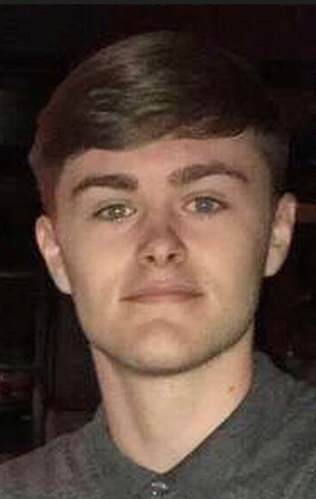
Please delete the box below and replace it with an “appropriate” passport style photograph that clearly shows your face. Your photo should be roughly the same size as the box:

Name: Declan Davies

Student number: 1902244

Student email address:1902244@student.uwtsd.ac.uk

Contact number: 07530749775

Please use the remaining space to give a brief outline of why you have chosen your course of study and any relevant special interests or experiences:

I choose this course because I have always enjoyed being in the outdoors, exploring unknown areas and visiting unique place. This course gave me the chance to do all things I love doing and I know I will love all the opportunities I am given throughout this course.

