


Computing and Engineering Technologies/ Technolegau Cyfrifiadura a Pheirianneg
School of Applied Computing/Ysgol Cyfrifiadura Gymhwysol

MAJOR PROJECT HANDBOOK

for

BSc (Hons) Applied Computing

2019/2020

Technolegau Cyfrifiadura a Pheirianneg / Computing and Engineering Technologies
Campws y Graig / Graig Campus
Coleg Sir Gar
Llanelli
SA15 4DN
01554 748000

Partner Institution

School of Applied Computing,  Faculty of Architecture, Computing and Engineering,  University of Wales Trinity Saint David  Technium 1  Kings Road  Swansea  SA1 8PH  +44 (0)1792 481000  http://www.uwtsd.ac.uk | Ysgol Cyfrifiadura Cymhwysol,  Cyfadran Dylunio Cymhwysol a Pheirianneg,  Prifysgol Cymru Y Drindod Dewi Sant  Technium 1,  ABERTAWE,  SA1 8PH  +44 (0)1792 481000  http://www.uwtsd.ac.uk

Vice Chancellor: | Professor Medwin Hughes
Major Project Coordinator: | Daniel Davies | daniel.davies@colegsirgar.ac.uk

TABLE OF CONTENTS

1. INTRODUCTION 4
2. THE PROJECT MODULE (from Programme Validation Document) 5
3. PROJECT PROPOSAL FOR LEVEL 6 DIRECT ENTRY STUDENTS ONLY 16
4. PROJECT DEADLINES 18
5. THE STUDENT-SUPERVISOR RELATIONSHIP 19
5.1 Your Supervisor 19
5.2 Responsibilities of supervisors 19
5.3 Responsibilities of students 20
5.4 Logbook/Blog 20
5.5 Attendance 20
6. ASSESSMENT 21
7. INTERIM VIVA (15%) 22
8. FINAL REPORT (55%) 23
8.1 SUGGESTED STRUCTURE FOR REPORT 23
8.2 GENERAL POINTS ABOUT REPORT 35
8.2.1 Spelling and Grammar 35
8.2.2 Word Limit 35
8.2.3 Style Requirements 35
8.2.4 Assessment 36
8.2.5 Plagiarism 37
8.2.6 Handing in your Project Report 38
9. FINAL VIVA (20%) 39
9.1 Demonstration (Experimental- and Development-based Projects) 39
10. EXHIBITION BOARD (10%) 41
10.1 Guidance for Exhibition Board 41
10.2 Exhibition Board examples/Degree Show 42
10.3 Handing in your Exhibition Board 45
APPENDIX 1: DECLARATION FORM AND FORM OF CONSENT 46
APPENDIX 2: ELECTRONIC DATABASES AND JOURNALS 47
APPENDIX 3: REFERENCING CONVENTIONS 48
APPENDIX 4: NUMERIC REFERENCING SYSTEM 51

1. INTRODUCTION

The Level 6 Project is a major piece of work undertaken by the student on an individual basis. The project is a 40 credit module on programmes. The student’s performance in the Project has a substantial influence on the class of degree awarded.

The stated aim of the project is:

“ ... to provide an opportunity for the student to develop and demonstrate their ability to manage a significant project of their own choice related to the major themes of their chosen course. The study will be based upon a sound research and development methodology and will demonstrate academic rigor through the use of analytical and technical skills to implement a suitable and appropriate project proposal.”

You have already selected a project through the Research Methods module in Year 2/Level 5 and produced a project proposal. Project supervisors will be confirmed at the start of Year 3/Level 6.

Throughout the year you will meet your Project Supervisor in a 20 minute timetabled slot every week. In addition, there will be occasionally be extra briefing sessions organised by the Project Co-ordinator. It is expected that students will supplement the timetable allocation with a considerable period of unsupervised work. The Project is looked upon as a final large scale integrating study.

Attendance of weekly supervision and briefing session is and student attendance as well as progress will be monitored carefully.

The completed Project will normally include a deliverable (software system, evaluation report, framework document, implementation plan etc). The project documentation should normally be between 12,000 and 15,000 words in length.

Useful tips:

• The project can be a deceptive experience. As the submission deadline is so far away when you start, there is a danger of wasting time in the early stages of the process.

• Start writing as soon as possible. There are dangers in putting off this task.

• Always allow as much time as possible for the final stages. Final amendments, organising, testing, debugging, word processing and doing a thorough job on the proof reading all take longer than you imagine. Something will always go wrong to thwart your schedule!

2. THE PROJECT MODULE (from Programme Validation Document)

Module Title | Major Project
Module Number | CSAC6000
Brief statement of Content | This module allows students to demonstrate their ability through a project of their own choice suitable to the theme of their course
ASC Group | Maths, IT and Computing (6)
Date of Validation and Credit Calibration (If different from date of validation) | June 2013
Module Value | 40
Level | 6
University Code | S96
Faculty responsible for delivery | FACE
Pre-requisite/co-requisite modules | Research Methods/Academic Seminar (for students other than direct entry to level 6 – see below for details pertaining to such students)
Programme Associations: | B.Sc. Computing Portfolio: All programmes.
- Compulsory | Yes (for B.Sc. Honours only)
- Core | None
- Optional | None
- Elective | None
Aims
This module provides an opportunity for the student to develop and demonstrate their ability to manage a significant project of their own choice, related to the major themes of their chosen course.

Module Intended Learning Outcomes (MILOs)
Upon successful completion of this module, the student will be able to:

- Evaluate critically the literature pertaining to a problem.

- Select and apply relevant research and/or development methods and techniques from the evidence gathered in order to solve the problem.

- Produce a deliverable applicable to the project type.

- Generate and justify appropriate results and conclusions, demonstrating awareness of the limitations of the research.

- Produce an organised and structured document that adheres to academic convention.

- Present the findings of the study to a specialist audience.

- Demonstrate transferable skills to show organised work as an individual with minimum guidance.

Indicative Content:
- Overview of research and development methodologies suitable for student projects.

- Overview of common statistical techniques

- Visualisation of different data types

- Establishing and justifying metrics, analysis of test results e.g. including software benchmarking,

- Contingency planning

- Development of documentation for academic projects

- Presentation

- Subject-specific content as required

Teaching & Learning Strategy and Implementation
A series of lectures will be provided during the first semester to cover the material defined within the indicative content. Direct-entry students will also be expected to attend a condensed version of the Research Methods module prior to beginning this module.

The module will be assessed through coursework. One aspect of that coursework will be viva voce.

The student’s supervisor and one other member of the academic staff with knowledge of the project’s topic area will assess the work. See below for assessment.

The proposed arrangements for marking projects are:

- The supervisor will act as the first marker for all projects for which they have supervisory responsibility.
- A different member of the academic staff of the university will second-mark projects.
- The two markers will mark the projects independently and then agree a consensus mark. If the two markers cannot agree, or the two marks are not within 10 points of each other, a third marker will be assigned. All markers will need to agree a final mark.
- All projects to be made available to External Examiner(s).
- All third-marked projects will be seen by the External Examiner(s).
- The student will be required to undertake an interim viva voce at approximately a halfway point through the module and a final viva voce at the end of the module. Present at a viva voce will be the student’s supervisor plus at least one other member of Academic Staff. The viva voce consists of a fifteen minute presentation by the student about their project, followed by a question and answer session where the student will have the opportunity to demonstrate their knowledge of the work undertaken, and to identify issues that may have been omitted from the final submitted document. Non-attendance at a viva voce will normally results in failure of the module.
- The student will produce a poster-board at the end of the module detailing their project in a succinct way, suitable for display to interested parties.

Indicative Contact hours (weekly hrs):
Lecture |  | 15
Seminar |  | 5
Tutorial |  | 10
Laboratory, Studio or Workshop |  | To be decided
Student Private Study |  | 370
TOTAL Hours: |  | 400
Semester(s) in which normally delivered |  | 1 and 2
Assessment
Weighting
40C | Students will commence their Level 6 studies with a project proposal already formulated. For continuing students, this proposal will normally be generated as an outcome of the level 5 modules Research and Development Methods. Direct entrants to level 6 will receive guidance and support prior to the start of the academic year.  All proposals will be reviewed by the Project Co-ordinator. The project selected must be appropriate to the themes of the student’s programme of study.  Based upon the proposal, each student will be allocated an individual supervisor. A nominal assessment type will be agreed at the start of the project:  - Survey-based  - Review-based  - Experimental-based  - Development-based  It is expected that BIT students would undertake Survey- and Review-based projects, CNets students would undertake Experimental-based projects, Mobile, Games, SE etc would undertake Development-based projects, while Engineering students would undertake Experimental- or Development-based project. However, it is not impossible that a student from a more technical stream could conduct a Review-based project, or a BIT student could conduct a Development-based project. Situations such as these will be carefully considered by staff to ensure that the project selected is appropriate to the themes and outcomes of the student’s programme and the students advised accordingly.  NB: In the case of Computing Portfolio students, in order to achieve BCS accreditation, the projects selected must be appropriate to the themes of the programme. SE and Games students must conduct an Experiment- or Development-based project in order to fulfil the BCS conditions for partial CEng credit.  Should the focus of a student’s project significantly change as the module progresses, it may be possible to change the assessment type on the advice of the supervisor and the Project Co-ordinator.  A series of lectures during the academic year will provide general support to students in preparing for assessment milestones and in relevant topics.  The student will be required to work on their own initiative in the production of the project and all associated documentation. The supervisor will provide support and guidance to the student. Additionally, a project handbook will be issued.
Coursework: |  |  | Final Report – 55%  Exhibition – 10%
Oral Examination/ Presentation: |  |  | Interim Viva – 15%  Final Viva – 20%

Interim Viva – 15%
This milestone enables the student’s progress to be checked and evaluated to ensure that they are on-course to complete their project. Feedback can be provided and adjustments can be made to the project at this stage.

 | Survey | Review | Experiment | Development
Knowledge and Understanding of Subject
Response to Questioning | 20 | 20 | 20 | 20
Research-informed Literature
Literature Review (level of progress, suitable synthesis of background material completed) | 40 | 40 | 40 | 40
Analysis
Discussion of Findings | 20 | 20 | 10 | 10
Practical Application and Deployment
Code examples/prototypes/demo | - | - | 10 | 10
Skills for Professional Practice
Project Plan | 10 | 10 | 10 | 10
Quality of Presentation | 10 | 10 | 10 | 10
TOTAL | 100 | 100 | 100 | 100

Final Report - 55%
The type of project undertaken by the student depends on the programme being studied and on agreement with the project supervisor. Four types of project are defined, Survey, Review, Experiment and Development. Different assessment weightings have been allocated to these projects according to the nature of the deliverable expected. Therefore, Experiment and Development projects where the deliverable is typically an implementation, design, simulation, etc., have assessment that has been weighted more towards this emphasis. Whereas, Survey and Review projects have assessment weighted more towards literature research and written analysis of results.

 | Survey | Review | Experiment | Development
Research-informed Literature
Introduction | 5 | 5 | 5 | 5
Literature Review | 20 | 35 | 20 | 15
Knowledge and Understanding of Subject
Methodology | 5 | 5 | 5 | 5
Survey Design | 15 | - | - | -
Requirements/Design | - | - | - | 5
Analysis
Results & Discussions | 25 | 25 | 25 | 25
Conclusions and Recommendations | 10 | 10 | 10 | 10
Practical Application and Deployment
Development | - | - | - | 15
Experimental Design | - | - | 15 | -
Skills for Professional Practice
Reflection | 10 | 10 | 10 | 10
Quality of Report | 10 | 10 | 10 | 10
TOTAL | 100 | 100 | 100 | 100
Final Viva/Demo – 20%
During this final stage the student is required to demonstrate their project to both markers. This enables authentication of the work to ensure it’s that of the student by providing an opportunity for close questioning of the deliverable. In addition, the markers will verify that the deliverable performs as indicated in the final report to allow marks to be adjusted accordingly. The presentation requires the student to defend their work in a formal setting before both markers. For students completing a survey or review, an extended viva is used to allow the student to provide a more in-depth justification for research approach, analysis and findings.

 | Survey | Review | Experiment | Development
Knowledge and Understanding of Subject
Response to Questioning | 30 | 30 | 30 | 30
Analysis
Discussion of Findings | 50 | 50 | 25 | 25
Practical Application and Deployment
Demo | - | - | 25 | 25
Skills for Professional Practice
Presentation Style | 10 | 10 | 10 | 10
Supporting Materials | 10 | 10 | 10 | 10
TOTAL | 100 | 100 | 100 | 100

Exhibition – 10%
The exhibition affords students the opportunity to develop their personal self promotion skills and encourage an entrepreneurial attitude towards their work. This will also be used to encourage students to publish their findings, and to promote their work to potential employers.

 | Common to all project types
Knowledge and Understanding of Subject
Clarity of Technical Description | 50
Skills for Professional Practice
Quality of Visual Display | 50
TOTAL | 100

Details of Outcome Assessment:
Outcomes | Assessment Criteria:  To achieve each outcome a student must demonstrate the ability to :
1. Evaluate critically the literature pertaining to a problem. | - Describe the aim of the research clearly  - Research, integrate and critically evaluate information from a variety of sources appropriate to the discipline.  - Define the relationship between the current and previous research in related topic areas, stressing similarities and differences  - Display evidence of the ability to identify key items in the literature and to interpret, analyse, synthesise and review them using appropriate methods.  - Reference literature pertinent to the research.
2. Select and apply relevant research and/or development methods and techniques from the evidence gathered in order to solve the problem. | - Employ an appropriate methodology, justifying and describing its application  - Consider professional, legal and ethical issues and how they will be controlled  - Demonstrate evidence of care and accuracy in recording and summarising date  - Demonstrate competence in independent work or experimentation.
3. Produce a deliverable applicable to the project type. | - According to type of project:  - Experimental/Development: Create a system that meets identified requirements.  - Survey: Undertake primary research and analyse the results  - Review: Undertake an analysis of the secondary evidence and synthesise the findings.
4. Generate and justify appropriate results and conclusions, demonstrating awareness of the limitations of the research. | - Compare the findings with the findings of similar studies and the literature  - Relate the findings to the aims and objectives of the project.  - Report coherently the results of the research.  - Consider the extent that the conclusions overturn or challenge previous beliefs.  - Delimit the new contribution and identify prospects for further work.  - Provide a personal reflection on the learning experience.  - Synthesise and apply the methods and techniques that have been learned, to review, consolidate and extend knowledge and understanding.
5. Produce an organised and structured document that adheres to academic convention | - Organise the written document logically and present in an attractive layout. Clearly delineate sections, and ensure that they contain appropriate content.  - Write in an appropriately academic style.  - Employ accurately a suitable referencing system and bibliography.  - Communicate the results of their work effectively, in a structured and coherent written format with correct spelling and grammar.
- Present the findings of the study to a specialist audience. | - Present information in a variety of forms, including orally and with visual media.  - Present topics for discussion succinctly and clearly  - Respond appropriately to questioning, demonstrating comprehensive knowledge of the topic.
- Demonstrate transferable skills to show organised work as an individual with minimum guidance | - Apply appropriate methods and techniques that have been learned, to initiate, plan and implement project.  - Manage their own learning and development, including the time management and organisational skills required for employment whilst recognising the need for lifelong learning.

Physical Resource Needs:
Reading List
Essential Texts | Avison, D. and Fitzgerald, G. (2007),Information Systems Development: Methodologies, Techniques and Tools, 4th Edition McGraw-Hill: Maidenhead.  Kranzler, J.H. (2010) Statistics for the Terrified, 5th Edition ,Pearson, NY.  McCormac, C and Davis, J. (2012)  Research Project Success: The Essential Guide for Science and Engineering Students, Royal Society of Chemistry  O’Leary, Z. (2013) Doing Your Research Project, 2nd Edition, SAGE Publications Ltd  Saunders, M., Lewis, P. and Thornhill, A. (2012), Research Methods for Business Students, 6th Edition FT/Prentice Hall: Harlow
Background Reading | Baase, S. (2012), A Gift of Fire: Social, Legal, and Ethical Issues for Computing and the Internet: International Edition, 4th Edition Pearson: NY  Collis, J. and Hussey, R. (2009) Business Research: a Practical Guide for Undergraduate and Postgraduate Students, 3rd Edition, Palgrave Macmillan: Basingstoke  Cottrell, S.(2011) Critical Thinking Skills: Developing Effective Analysis and Argument, Palgrave Study Guides, 2nd Edition, Palgrave Macmillan: Basingstoke  Davies, M. B. (2007) Doing a Successful Research Project, Palgrave Macmillan: Basingstoke  Dawson, C.W. (2009) Projects in Computing and Information Systems: a Student’s Guide, 2nd Edition Addison Wesley: Harlow  Denscombe, M (2010) The Good Research Guide, OU Press: Buckingham  Few, S (2012) Show Me the Numbers: Designing Tables and Graphs to Enlighten, Analytics Press: Burlingame.  Quinn, M. J. (2010) Ethics for the Information Age: International Edition, 4th Edition, Pearson: NY  Yin, R K, (2008) Case Study Research: Design and Methods, 4th Edition, Sage: Beverly Hills.
Journals | Appropriate journals from the core subject areas.
Web Resources | Appropriate websites from the core subject areas.

Equipment Requirements:
Room Requirements | Due to the varied nature of the possible projects, it is not practical to specify in advance exactly what resources will be required. It is a pre-requisite of any agreement to a project proposal that the necessary resources are available.
Staff Resource Needs:
Module Co-ordinator | Daniel Davies
Staff Delivering Module | Anthony James  Members of staff as appropriate to the project area (for supervision)

3. PROJECT PROPOSAL FOR LEVEL 6 DIRECT ENTRY STUDENTS ONLY
(example: ex-HND students)

For most students, the project proposal is completed in the Research Methods module at Level 5. However, direct entry level 6 entrants (example ex-HND students) will need to complete a proposal before starting work on their projects.

There will be an intensive course just before the start of Year 3 /Level 6 to assist the students who did not generate a proposal in Year 2/Level 5. Here are a few general guidelines:

The purpose of the project proposal is to establish exactly what is to be achieved by the project and to establish a plan to do this. It should be regarded as a sort of contract between you and your supervisor.

The final proposal should contain the following information:

- The course title.

- The project title.

- The name of the student undertaking the project.

- The name of the (proposed) supervisor.

- The date.

- A statement of the problem to be solved together with any background/rationale that might be appropriate.

- The aims of the project and the methods.

- An analysis of how the objectives are to be achieved including a breakdown of the project into identifiable sub-tasks.

- Resources (computer systems, application packages and programming languages etc to be used).

- References

- Plan with proposed timescales of work

- Completed Ethics form (if required – normally if working with medical data or vulnerable groups)

The following general points apply:

- The proposal must be well-structured and written in good, clear English with correct spelling and punctuation.

- You must adopt the specified standards for referencing. [See Appendix 3]

- The proposal should be prepared and printed using a word processor and laser/ink-jet printer. The pages should be numbered.

Following submission of the proposal, an individual project supervisor will be allocated to each student.

When selecting a project the following factors should be considered:

- The task must be achievable within the timescale.

- The project should be in a subject area appropriate to the degree title. Thus it is inappropriate, for example, for Business Information Technology students to engage in a project demanding detailed technical expertise in real-time programming.

- Industry-based projects are encouraged.

- Proposed projects must have an acceptable technical/analytical content.

- Projects should preferably include some element of design.

- The resource requirements of the project should be reasonable and adequate access to these resources be available. For example, projects involving speech recognition or video streaming will be approved only if the Project co-ordinator is satisfied that the required equipment will be available for use.

- A deliverable in the form of software, a systems design, methodological framework, s/w evaluation report, information systems strategy document, security policy etc must be produced.

- Daniel Davies has a list of possible project titles which may be consulted.

4. PROJECT DEADLINES

The deadlines for the project for 2019/20 are:

Interim Viva | Tues 28th, Wed 29th, Thurs 30th January 2020
Final Report | Thursday April 23rd 2020
Final Viva | Wed 6th, Thurs 7th and Fri 8th May 2020
Exhibition Board | Friday 15th May 2020

Exact details of viva timetables will be circulated by email closer to the time.

Please note that neither your supervisor nor the project co-ordinator are unable to grant extensions to the above dates. Any student requiring an extension must apply via the standard form to the University’s Extenuating Circumstances Committee.

A PROJECT WHICH IS NOT SUBMITTED WITHIN THE DEADLINE WILL BE REGARDED AS HAVING FAILED BY NON-SUBMISSION.

5. THE STUDENT-SUPERVISOR RELATIONSHIP

5.1 Your Supervisor

- Your supervisor is there to guide you, not to do or write your Project for you. The Project is your responsibility.
- Your supervisor will be available to see you, every week, at a mutually agreed time.
- Your supervisor is there to guide you but can only do so if contact is regular and frequent.
- Feed your supervisor material on a regular basis. It is unfair to expect detailed comments on a major part of your work at a moment's notice.
- Your supervisor will keep a record of your attendance and be asked regularly for a report on your progress.
- Your supervisor has the responsibility of bringing reasonable project resourcing requests to the appropriate person/committee.

5.2 Responsibilities of supervisors

- Help the student refine the original Project proposal. The emphasis must be on what is achievable.
- Advise the student of relevant data/literature sources and discuss approaches to the literature review.
- Discuss research design and choice of appropriate methods ensuring that the student has thought through the process adequately, and advice is given on how to refine the design/methodology process.
- Discuss the Plan of Action.
- Meet with student at agreed times, on average 20 minutes per week, and keep a note of contact and advice via triplicate form (one of which will be given to the student each week)
- Monitor and discuss student attendance and progress and advise the Project Co-ordinator of any students causing concern.
- Discuss research findings.
- Read and comment on draft chapters to help students identify any weaknesses in analysis and presentation.
- Read and comment on one complete draft of the Project if submitted in sufficient time.
- Read and comment on draft chapters to help students identify any weaknesses in analysis and presentation.
- Read and comment on one complete draft of the Project if submitted in sufficient time.
- Mark Project.
- Ensure resources (eg suitable equipment) are available for the project.
- Provide limited technical support as required.
- Recommend any necessary changes to the original proposal to the Project Co-ordinator.
- Complete a Project Supervision form after each meeting.
- Agree to all changes to the project proposal in conjunction with student and Project Co-ordinator.

5.3 Responsibilities of students

- To attend meetings with supervisor on a weekly basis and occasional meetings with project co-ordinator.
- To adhere to the Project Plan timetable and inform supervisor of any problems.
- To supply a complete final draft in sufficient time (agreed between supervisor and student) for reading and comment. Although he/she will be advised of presentational problems, the student is responsible for accurate citation, the standard of English, overall presentation and proof reading.
- To submit of the Project on the specified date and time.
- To give a presentation and answer questions about the project during the vivas.
- Report any problems concerning project supervision to the Project Co-ordinator.
- Maintain a logbook and ensure it is shown to supervisor at regular intervals.

As a general point, the Project process and the production of the Project are primarily the student's responsibility. The supervisor is there to help and guide but not to do the work or write it for you.

5.4 Logbook/Blog

The student is advised to keep a logbook or blog that records each continuous period spent on the project in chronological order, giving the date, starting and ending times, and a brief description of what was done in that time. Meetings with supervisors and others should be recorded. As a minimum the logbook should contain the signed and dated student copies of the Project Supervision Forms.

A logbook can be very helpful when you are writing up your project – it is easy to forget important details of work carried out when writing up later.

5.5 Attendance

Student attendance at project meetings with the project co-ordinator and with individual project supervisors will be monitored closely. Failure to attend project supervision meetings will be recorded and disciplinary measures taken.

6. ASSESSMENT

As shown in the Project Module in Section 2, there are a number of assessment points throughout the year. There are five required components:

Poster and demo (5%)
Interim Viva (10%)
Final Report (55%)
Final Viva (20%)
Exhibition Board (10%)

More detail about each part of the assessment is provided in the following chapters.

Deadlines for 2019/20 are shown in Section 4.

7. INTERIM VIVA (15%)

The Interim Viva will take place in two parts this year, the first is the poster and demonstration at the end of the first week (5%) and a presentation towards the end of Semester 2 (10%). The end of Semester 2 presentation is as follows:

 | Survey | Review | Experiment | Development
Knowledge and Understanding of Subject
Response to Questioning | 20 | 20 | 20 | 20
Research-informed Literature
Literature Review (level of progress, suitable synthesis of background material completed) | 40 | 40 | 40 | 40
Analysis
Discussion of Findings | 20 | 20 | 10 | 10
Practical Application and Deployment
Code examples/prototypes/demo | - | - | 10 | 10
Skills for Professional Practice
Project Plan | 10 | 10 | 10 | 10
Quality of Presentation | 10 | 10 | 10 | 10
TOTAL | 100 | 100 | 100 | 100

Students are required to attend a 30 minute oral examination of their project before at least two examiners. These are normally the student’s project supervisor and a second marker. Occasionally, other members of staff, e.g. the Project Co-ordinator, might be present.

During the viva voce the student should give a presentation on his/her project for 10-15 minutes using a Powerpoint presentation to assist. The student should summarise their project, presenting the aims and objectives and the main findings of the literature review, so far. The student should also present a plan eg Gantt chart for the rest of the project.

Remember that the second marker has no knowledge of your project, so your presentation should be pitched to accommodate the second marker.

For Experimental- and Development-based projects, students should present prototypes of code developed so far, and if practicable, demonstrate work produced so far.

8. FINAL REPORT (55%)

 | Survey | Review | Experiment | Development
Research-informed Literature
Introduction | 5 | 5 | 5 | 5
Literature Review | 20 | 35 | 20 | 15
Knowledge and Understanding of Subject
Methodology | 5 | 5 | 5 | 5
Survey Design | 15 | - | - | -
Requirements/Design | - | - | - | 5
Analysis
Results & Discussions | 25 | 25 | 25 | 25
Conclusions and Recommendations | 10 | 10 | 10 | 10
Practical Application and Deployment
Development | - | - | - | 15
Experimental Design | - | - | 15 | -
Skills for Professional Practice
Reflection | 10 | 10 | 10 | 10
Quality of Report | 10 | 10 | 10 | 10
TOTAL | 100 | 100 | 100 | 100

8.1 SUGGESTED STRUCTURE FOR REPORT

Each project is unique and consequently the sections covered may vary somewhat from project to project. Also some sections may be larger than others and be split into two chapters, especially if the project deals with the convergence of more than one technology.

The following is meant to be a guide to help you, not a straight-jacket. Each major section should be present in some way, although not necessarily in a chapter of its own. The chapter layout must be appropriate to each particular project.

Your supervisor should be consulted about the best layout for your particular project documentation.

1. TITLE PAGE

- Title of work
- Full name of student
- Name of Supervisor
- Name of Second Marker
- Project submitted as part of the requirements for the award of (change course as appropriate).
- Date of submission

IMPORTANT NOTE: By instruction of the External Examiner, your cover MUST be presented as shown below. No colours! No fancy designs! No underlining etc! No images other than the University logo! (The project coordinator will make the file containing the University logo available on Moodle for you to use)

It must look very similar to this:



A Study of the use of Wireless
Underwater Sensor Networks in Swansea Bay

by
Joe Bloggs

Supervisor: Daniel Davies
Second Marker: Anthony James

Project submitted as part of the requirements for the award of BSc(Hons) Computer Networks

April 2020

2. DECLARATION FORM AND FORM OF CONSENT (see Appendix 1)

This states that the candidate is the author of the Project and the work contained therein has been done by the candidate.

3. ABSTRACT (1 page or around 300 words)

The abstract is short summary of the entire project. It should summarise the important points and should include:

a) The overall aims and objectives.
b) A summary of the methods used.
c) A summary of the major findings and/or deliverables.
d) A statement of conclusions and recommendations.

Keep it concise. The idea of the Abstract is that someone could read it and decide from it whether it would be worth their while to read the whole report. Although it’s the first thing that appears in the report, it is the last thing to be written.

4. CONTENTS PAGE
Show the main chapter and the sub-chapters. Also provide a List of Tables/Figures.

CHAPTER 1 - INTRODUCTION

This chapter should start off by setting the context for the work:

- What is the project about? What are the initial aims and objectives for the project?
- Aim - what is the overall research question you're trying to answer?
- Objectives - what are the actions you're going to take to try to satisfy the aim?
- A brief description of what is coming up in the following chapters (this should be the final paragraph of the introduction).

Usually, you start with a very broad statement of the problem and refine that down to more specific items. Unless yours is a problem area with which all readers of your report will be familiar (very unlikely), you will want to describe the problem in some detail and give sufficient background information so that everyone can understand it.

You should then describe the objectives, aims or goals of your particular piece of work. Your overall aim was presumably to solve a particular problem or to answer a particular question. This could be broken down into a number of specific objectives that together work towards achieving the aim.

The introduction should end with a section that leads the reader in to the rest of the report. The important thing is to give your reader a clear picture of what your report is setting out to do.

CHAPTER 2 - RESEARCH & REVIEW OF LITERATURE

Year 3/Level 6 projects should include a comprehensive element of review and scholarly research. Your work is done in the context of an academic discipline, Computing. Show how your project fits into the framework of that discipline by reviewing books and papers describing the problem you are trying to solve and potential solutions to the problem.

- What other research has been done in your field?
- Who did this research?
- What were their results?
- How do these results relate to other researchers' work in the field?
- Split the literature review into sections, each looking at a different part of the research problem
- Write an introductory paragraph at the start of the chapter that briefly describes the sections
- Write a concluding paragraph at the end of the chapter that briefly sums up the most important points.

The Literature Review gives your reader sufficient background knowledge for them to be able to appreciate later why the approach you took was valid or best. Since they may not be familiar with either the problem or the possible solutions or both, you need to provide them with a basic grounding in the important and relevant material. This does not, however, mean that you should include a detailed tutorial.

You also need to demonstrate that you considered all the possible solutions to the problem and that you took all available material into account. This part of the review usually summarises quite succinctly approaches that have been taken by other people in similar situations. Some will have been successful and some not, and this should be indicated. It is perfectly all right to express justified disagreement with something you’ve read - “criticism” is often an excellent feature of a review.

The most important attribute that your review should possess is relevance.

It is strongly recommended that a first draft of this section is developed in the first term. You will also need to present your initial literature review at the Interim Viva. Ask your supervisor for advice.

CHAPTER 3 - RESEARCH AND/OR DEVELOPMENT METHODOLOGY

Research Methodology

Here you explain in detail the what, why and how of the procedures you used in order to generate the solution to the idea.

The rule is to describe your method in sufficient detail to allow the reader to replicate your study. What research methodology/methodologies did you use - experimental (hypothesis testing), investigative, action, survey, case-study etc? Do not include a review of all possible methods that could be used – the reader is interested in what method you chose and why.

For each of the layers of the research onion, decide which method you intend to use and explain:
  - Why you have chosen that method
  - What are the advantages of that method to your project
  - If there are any disadvantages to the method then how will you work around them?

Also indicated what evaluation criteria are to be used? What methods of testing and statistical analysis are to be used?

For Survey-based Projects
- What are the objectives of your survey? (SMART)
- Who is your target group?
- For each question you plan to ask:
  - What is the question?
  - Why are you asking it?
  - Are there any specific links to things in your literature review for this question?
- Is your survey valid? Why?
- Is your survey reliable? Why?
- Is your survey generalisable? How far?
- How did you prototype the survey?
- What changes did you make as a result of prototyping the survey?
- For any questions that have been changed, explain
  - What is the question?
  - Why are you asking it?
  - Are there any specific links to things in your literature review for this question?
- How do you intend to analyse your results?
- What, if any, statistical methods do you plan to use?
- If you are doing a questionnaire and an interview then these questions must be answered for both survey instruments.

For Experimental-based Projects
- What is your experimental hypothesis?
- What hardware are you using?
- What software are you using?
- What were your inputs?
- Is your experiment valid? Why?
- Is your experiment reliable? Why?
- Is your experiment generalisable? How far?
- How did you conduct the experiment?

Development Methodology (for Development-based Projects)

- For your chosen software development methodology explain:
  - Why you have chosen that method
  - What are the advantages of that method to your project
  - If there are any disadvantages to the method then how you will work around them.
- What software are you going to use, and why is it appropriate for the project?
- Do you need any particular hardware, and if so why?
- Materials and Tools. eg why are you using a particular package or language to design and develop your software?

CHAPTER 4 - DESIGN & IMPLEMENTATION
- For Development- and Experimental-based Projects only
For Chapter 4 for Survey and Review-based Projects, please see Page 32

This is a major section which describes your deliverable. It may be a software artefact, a new framework, a systems design, etc. This may span more than one chapter and will have title(s) which reflect its content.

Design

If you’ve built something to solve a problem, you had to make some design decisions along the way. Why did you choose to do something one way rather than another? Why did you choose to include one thing but leave out something else? Which factors did you think were most important and which did you choose to ignore?

Don’t just list your decisions; place them in a context. It should be possible for the reader to understand how your design decisions contributed to meeting your objectives. Also important is that you show the method by which you accomplished your design - “process” is as important as “product” to an engineer.

- What processes did you use?
- How did they contribute to ensuring that what you did was complete/consistent/correct?

It should be possible for the reader to understand how your design decisions contributed to meeting your objectives. Also important is that you show the method by which you accomplished your design - “process” is as important as “product” to an engineer. What processes did you use? How did they contribute to ensuring that what you did was complete/consistent/correct? Don’t just write about what you did, or how you did it. Why you did it is most important.

The starting point for your design is, of course, your requirements. In some projects the requirements are specified in advance. The customer provides a document that (in more or less detail) specifies the behaviour of the item to be constructed. More commonly, the customer has a more vague “need” for something, and it is part of the project itself to refine that into a more detailed set of requirements. A project that doesn’t have a written set of requirements is not a very good one, though it would not be normal to describe the requirements in much detail in the body of the report. It is better to include the requirements specification document as an appendix to your report. If a detailed discussion of how you elicited, analysed and specified the requirements is necessary, (for “necessary”, read interesting and relevant), it could be a separate chapter before this one.

A project that doesn’t have a written set of requirements is not a very good one, though it would not be normal to describe the requirements in much detail in the body of the report. It is better to include the requirements specification document as an appendix to your report. If a detailed discussion of how you elicited, analysed and specified the requirements is necessary, (for “necessary”, read interesting and relevant), it could be a separate chapter before this one.

The “design” stage is often held to be the key stage of your project. It is certainly the part of project reports that is most closely looked at by external examiners! It is the one where you can show off your ability to apply your engineering and commercial knowledge and skills to best advantage. This is precisely what you will be doing in your working life if your chosen career is in any way related to your degree.

In terms of computing projects, this section will include details of algorithms, data structures, file systems, user interfaces etc.

Implementation

After you designed your solution to your problem, you implemented it. This section normally describes how you did that. What tools and techniques did you use? What difficulties did you encounter, and how did you overcome them?

Some students believe that this section is equivalent to writing the internal documentation of a program. It isn’t. This chapter of your report should only address issues that are interesting. Mundane details about how the program is structured should be left out. On the other hand, if you developed a new algorithm or applied an old technique in a new way, then that is of interest and should be included.

Do not include all or significant amounts of code in your report, only include code fragments to illustrate a technique that was used. Focus on why you have implemented the system, application, program, etc., in the way you have to achieve the results you have obtained.

If, in your project, you designed something but did not build it, there may still be scope for an equivalent to this chapter, in that you could discuss issues that would probably arise during future implementation and provide advice on how potential problems could best be prevented or solved.

Involving potential users of the system in the evaluation is always a good idea. If this can be done in a simulation of the real environment, then so much the better. Feedback from users which is structured is more useful than their verbal comments.

You do not want to give lots of boring, mundane detail here. So, for example, you would not normally describe in excruciating detail exactly what tests you conducted and their results, but you would describe in general terms what you did (your strategy) and what results you obtained.

Development-based Projects
- What are the project requirements? How did you discover them?
- Explain any system models that you have created (e.g. Use Case, BPMD or E-R diagrams) to describe the system (use case documents accompanying a use case diagram can go in the appendices)
- Describe any interfaces you have created (e.g. using prototypes and storyboards)
- Describe problems or successes you had in coding the software
- Include code snippets where appropriate, but do not include pages of code
- Describe the testing of the software:
  - Unit testing (do the individual bits of code work?)
  - System testing (does the system as a whole work?)
  - Usability testing (does the interface work?)
  - Acceptance testing (does the user believe that it does what it's supposed to do?)
- If you are using an iterative methodology then document what you did in each iteration/timebox

Experiment-based projects
- For each experiment performed
- What were the results?
- If appropriate, show the results diagrammatically
- If appropriate, show the results of any statistical analysis
- Were they what you expected?
- If they are not what you expected, is there any reason for this?
- How does this link back to your literature review?
- Are there any interesting correlations in your data? If so, are they expected?
- Overall, are the answers what you would expect? If not then why not?
- If you have done multiple experiments, do they support each other or differ from each other? Do the experiments show what the literature review suggested would happen?

CHAPTER 4 – ANALYSIS
- For Survey- and Review-based Projects only
For Chapter 4 for Development- and Experimental-based Projects, please see Page 29-31

Survey-based Projects

- For each question in the survey:
- What were the results?
- If appropriate, show the results diagrammatically
- If appropriate, show the results of any statistical analysis
- Were they what you expected?
- If they are not what you expected, is there any reason for this?
- How does this link back to your literature review?

- Are there any interesting correlations in your data? If so, are they expected?
- If you have done interviews as well as questionnaires, do the interviews agree with or differ from the results of the questionnaires? Do the interviews agree with or differ from the literature review?

Use graphs and tables wherever possible to support your words. Further data may be included in the appendices.

Review-based projects
It may be appropriate to combine the Literature Review and Analysis sections, and place it after the Research and Development section. Ask your supervisor for guidance on this.

CHAPTER 5 – EVALUATION

Evaluation usually comes in one of two forms: either you compare what you did with your objectives, or you can compare what you did with what someone else did.

- What conclusions can be drawn from your data?
- Did your data back up the research in your literature review or disagree with it?
- Did you meet your objectives? If not, why not?
- Did you meet your aim? If not, why not?
- Overall, are the answers what you would expect? If not then why not?
- If you were to do it again, what would you do differently?

CHAPTER 6 - CONCLUSIONS AND RECOMMENDATIONS

- This section should summarise everything you've done
- Does your project suggest any further avenues for research?

This chapter is where you tie up all the loose ends in the previous chapters. It is most important that it relates to what you have described previously, and that it does so in a relevant and concise fashion.

In your summing-up, you need to show how what you did contributed to meeting the objectives you set in the introduction. In doing so, it is appropriate to repeat (in summary form) key points from your review, design, implementation and evaluation as necessary.

Any further work that can, or should, be undertaken to expand upon your work is to be highlighted, fully explained and justified. The benefits gained from your work should be identified (these are not to include personal benefits). Also, any recommendations should be included here.

It is perfectly OK to have some loose ends left at the end of a project. Sometimes there will be aspects you simply did not have time to address. Other times there will be things that you were unable to do because of force of circumstances. Above all, there will have been pointers raised during the course of the project that you did not anticipate and were not within your scope to tackle. All these things can be discussed in this chapter and, where further work can be identified, a distinct sub-section, “Suggestions for further work”, should be included.

CHAPTER 7 – REFLECTION
The key question here is:

- What did you learn while doing the project? How did it change you as a person?

You will need to reflect upon the work that you’ve done and there is a specific mark allocated to this in the marking scheme. Reflection is the process of looking back at something which has happened in order to show what you have learned from it. The purpose of reflective writing is to help you learn from a particular practical experience. It will help you to make connections between the documented theory and what you did in practice. Through reflection, you should be able to make sense of what you did and help yourself to do a superior job next time. Put simply - could you have done it better and, if so, how?

CHAPTER 8 – REFERENCES
A list of references (work directly quoted or paraphrased in your text) and its source. For more information on this, see Appendices 4 and 5.

CHAPTER 9 – BIBLIOGRAPHY
A list of background reading undertaken, but not necessarily directly quoted in the text.

DEMONSTRATION FILE
All students undertaking Development or Experiment projects should record a short demonstration of their work using screen capture software or a video camera and include it on a CD/DVD in the back of their Major Project report.

APPENDICES
Appendices to a report contain information that, while not important or interesting enough to be included in the body of the report, is nevertheless relevant. Common examples include program source code, program documentation, intermediate documents. Your report stands alone without these, but the reader may occasionally wish to refer to them.

The key word here is “occasionally”. If it is crucial to read something in order to understand some point being made in the report, then that “something” should be replicated in the body of the report.

- All data used in the development of the project.
- Annotated code for any programs developed.
- Examples of questionnaires
- A summary of questionnaire results.
- Test data used to evaluate the product.
- Tables too detailed for the main text
- Technical notes
- Copies of documents not generally available but referred to in the report

(Note: If you have a lot of program source code, do not print it all out, instead provide it on a CD or DVD)

8.2 GENERAL POINTS ABOUT REPORT

8.2.1 Spelling and Grammar

You should take care to present your work in an attractive, legible format.

Spelling and grammar should always be checked as part of the proof reading process. A poor standard of spelling will create a poor impression to the reader and will invariably be marked down as will poor sentence construction and punctuation. Be careful when using the spell checker on the word processing package that it is set to UK English and not US English.

8.2.2 Word Limit

The Project documentation has a word limit of 15,000 words. Other relevant material, eg code listings, may be included in appendices and are not subject to the word limit.

The word limit is set for the following reasons:

- The discipline to write at this length is considerable. It is a substantial piece of academic work yet it requires good editorial skills to avoid excessive length.
- It encourages incisiveness and a good grasp of technical/theoretical
issues to bring them into sharp focus.
- It necessitates a tight definition of the topic.
- It necessitates a meaningful analysis of the relevant literature not a mere
listing of sources with brief comments.
- It necessitates communication of complex ideas in clear and precise fashion.

Condensing a lot of information/ ideas into a well-structured answer within the word limit is a real skill. It shows you have the ability to sift information, construct an argument, and express yourself succinctly. If you have difficulty "pruning" material to fit a word limit, remember that economy of words and clarity of expression are important. Sometimes, it may be useful to create footnotes/endnotes or appendices so that you can refer to information without losing the thrust of your argument.

8.2.3 Style Requirements

You should make sure that the final submitted versions of your work conform with the following specifications. If in any doubt, consult your supervisor or the Project Co-ordinator.

- White, A4 paper in portrait format to be used. Seek guidance for illustrative material.
- Black word-processed print to be used. The font chosen for the main body of the finished work should be easy to read. eg Times New Roman, Arial, Calibri.
- Text should be double-spaced (or 1.5 spaced) and printed one side of page only.
- For successful binding, the left margin on each sheet should not be less than 40 mm, other margins to be not less than 20 mm.
- Pages should be numbered consecutively throughout the main text (including appendices) Numbering should be bottom centre of each page, approximately 10 mm away from the edge.
- Each chapter should begin on a separate page.
- Illustrative material should be arranged near the appropriate text. Where possible, avoid the use of folding/oversized material.
- Tables or figures should be given a number, a title and a source if not derived from original research work. As with other illustrative material, they should be placed as close as possible to any text reference and referred to by their number in the text.
- Don’t put your name in the header or footer of your project – just on the title page. This makes it easier for us to recycle after you graduate (paper with names on have to be disposed of in expensive confidential waste)

8.2.4 Assessment

The breakdown of marking criteria is shown in the Project Module in Section 2 of this handbook. In arriving at an assessment mark, a number of factors will be taken into account by the markers, some of which are listed below:

- The original aims and objectives of the Project were clear, satisfactory at honours degree level, and had been fully met.
- The relationship between the current and previous research in the topic area was defined, with similarities and differences considered.
- The methodology employed was appropriate and applied in a suitable manner. Where knowledge was gathered from external sources valid and reliable methods were used. Critical use was made of published work and source materials.
- Due credit was given to previous workers for ideas and techniques used by other authors. There is a clear appreciation of the relationship of the special theme to the wider field of knowledge. Where a conceptual framework was used/developed, use was made of it in a systematic way.
- The document was organised in a logical manner and the style is attractive.
- The ideas presented and software developed display original and creative thought.
- The work opens up possibilities for future projects and research.
- A working system that meets the requirements laid down in the project specification was developed.
- The system produced was evaluated through the application of appropriate test data.
- The challenging nature of the project.
- The degree to which the project is original, creative and interesting.
- The quality, reliability, timeliness and maintainability of the deliverable.

The more of the following your report has, the lower the mark it will attract:

- errors of fact;
- vague aims and objectives;
- vague requirements for artefacts;
- unexplained or ill-judged design decisions;
- little or no analysis, solely descriptive;
- trite conclusions;
- misinterpretations of literature;
- development of poor quality artefacts;
- work that was facile;
- little evidence of work done by the student;
- spelling mistakes, poor grammar, odd structure, crazy layout.

Some of the above are mutually dependent – a project with weak practical outcomes is likely to be weak on conclusions as well.

8.2.5 Plagiarism

Plagiarism is defined as the unacknowledged use of another's work as if it were one's own. To illustrate, if you when you are evaluating the state of the art of a subject area you come across a really good section in a textbook or research journal that made a salient point and you copied it without acknowledgement, that would be plagiarism. So using the words of another author, or even using figures from elsewhere, without saying where they came from is a serious academic offence. What you are doing really amounts to theft of another person's intellectual property and deception in trying to pass it off as your own work. This is regarded as very serious.

The following are clear examples of plagiarism:

- Using directly quoted material without placing it within quotation marks (or indenting and single spacing the quote);
- Paraphrasing the work of an author and attempting to pass it off as your own by not including a citation;
- Submitting the work of someone else as if it is your own.
- Incorporating a piece of program code within your solution without reference to the source.
- Inability to defend written work in a viva situation.

You can, of course use the ideas, program code and data of others - there is no problem if you acknowledge the source. That is why the referencing system is so important. See Appendices 4 and 5 for more detail on this.

Plagiarism is a serious matter and will not be tolerated. Disciplinary action will be taken against transgressors.

8.2.6 Handing in your Project Report

- Students must submit two copies of their project documentation. A CD/DVD/memory stick with source code, installation instructions etc. should also be supplied if required, one with each copy of the document.

- Each copy of your report should be spiral-bound or heat-bound. The Student Shop offers a cost-efficient heat binding service.

- Each copy of your report should have a signed copy of the Declarations and the Form of Consent. These should be included just after the title page. A copy of the forms can be found in Appendices 1 and 2.

- Although assignments are normally handed in to the library, project reports should be submitted to the School Office of the School of Applied Computing.

- All projects must also be submitted through TurnItIn.

The deadline for the written report is Thursday April 23rd 2020.

WARNING: Do not wait until the last minute to print your dissertation out or have it bound. Remember that many students will be working towards the same submission date. The Student Shop, printers in the library etc. may be overwhelmed with demand. Make sure you have sufficient ink/toner in advance and have your dissertation bound at least a few days in advance of the deadline.

9. FINAL VIVA (20%)

 | Survey | Review | Experiment | Development
Knowledge and Understanding of Subject
Response to Questioning | 30 | 30 | 30 | 30
Analysis
Discussion of Findings | 50 | 50 | 25 | 25
Practical Application and Deployment
Demo | - | - | 25 | 25
Skills for Professional Practice
Presentation Style | 10 | 10 | 10 | 10
Supporting Materials | 10 | 10 | 10 | 10
TOTAL | 100 | 100 | 100 | 100

Students are required to attend a 30-40 minute oral examination of their project before at least two examiners. These are normally the student’s project supervisor and a second marker. Occasionally, other members of staff, e.g. the Project Co-ordinator, might be present.

During the viva voce the student should give a presentation on his/her project for 15 minutes using a Powerpoint presentation to assist. The student should summarise the project, presenting the aims and objectives, main findings of the literature review, main results/conclusions and any recommendations for future work. The student will then answer questions about the work for a further 15 minutes.

Remember that the second marker has little knowledge of your project, so your presentation should be pitched to accommodate the second marker.

Warning: if the student is unable to answer questions about their project report, this may be an indication of Unfair Practice (see Section 8.2.5)

9.1 Demonstration (Experimental- and Development-based Projects)

For experimental- and development-based projects, there is a discrete mark for a demonstration of the work produced as part of your viva mark.

You should arrange a demonstration of your project deliverables. This should preferably be at the end of the viva, or arranged during the same week in the event that demonstration is impossible at the standard viva venue (for example due to requiring specialist hardware or software)

10. EXHIBITION BOARD (10%)

 | Common to all project types
Knowledge and Understanding of Subject
Clarity of Technical Description | 50
Skills for Professional Practice
Quality of Visual Display | 50
TOTAL | 100

10.1 Guidance for Exhibition Board

The exhibition board provides a summary of your work in a concise and visually attractive manner. It is used to show the external examiner (during his visit) an overview of your project. Very good exhibition boards will be used to show to future students as inspiration/motivation for future projects.
The ideal exhibition board should:
- be visually attractive
- provide a brief overview of your work
- initiate discussion and questions
The exhibition board is usually A1 size, and should cover the key points of your work. It should include illustrations as well as text (this helps to make your board visually attractive). You should clearly show the progression of the work by clearly numbering sections, or by using arrows to show the ‘flow’ of the work. You should also pay attention to presentation (e.g. straight cut lines).
The title of your project should appear prominently, with your name and degree programme below. The University logo should also appear (see “Title Page” for logo)

Advice: Do not use staples, drawing pins, or Blutack to attach your work to the board! It looks very messy and you will lose marks for visual attractiveness!

Some students prefer to have an A1 print made of the contents of their exhibition board.

A blank exhibition board made of black board (to stick your print to)
will be provided by UWTSD

10.2 Exhibition Board examples/Degree Show
We hold a Degree Show in TechHub in High Street, Swansea. This event is has two purposes:

      - For family, friends, students from lower years and most importantly, employers, to come and view the student work. The exhibition boards produced by the students formed an integral part of this event. Please keep in mind while creating your board that it might be seen by a future employer.
      - For staff to assess the boards – you will need to talk your staff through your board at the event, so attendance is compulsory!

Here are some of the previous graduating students at the Degree Show at Techhub with their exhibition boards, to give you some examples:

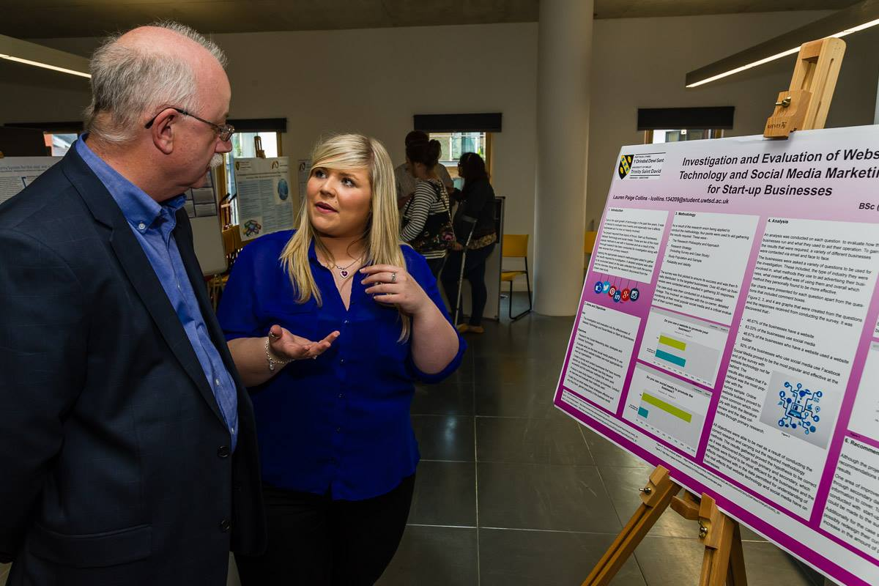

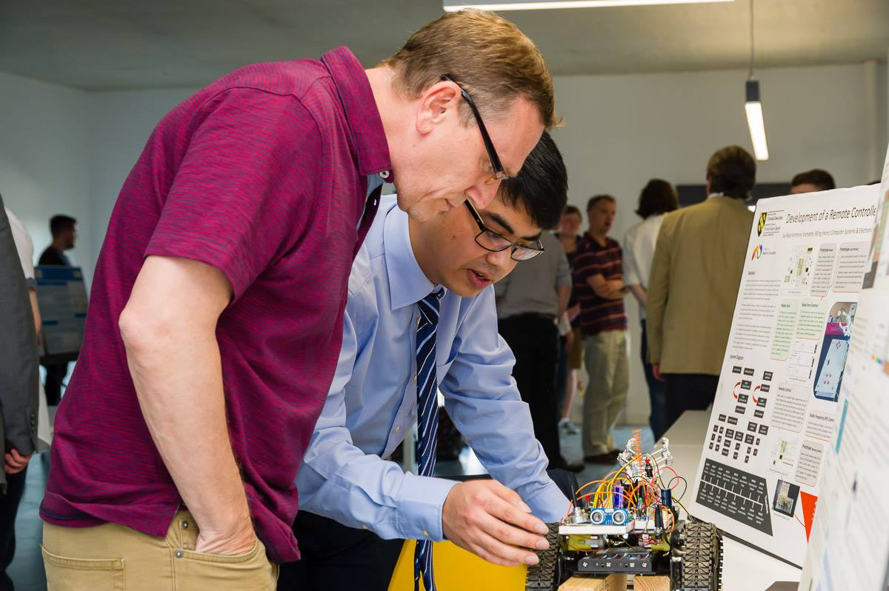

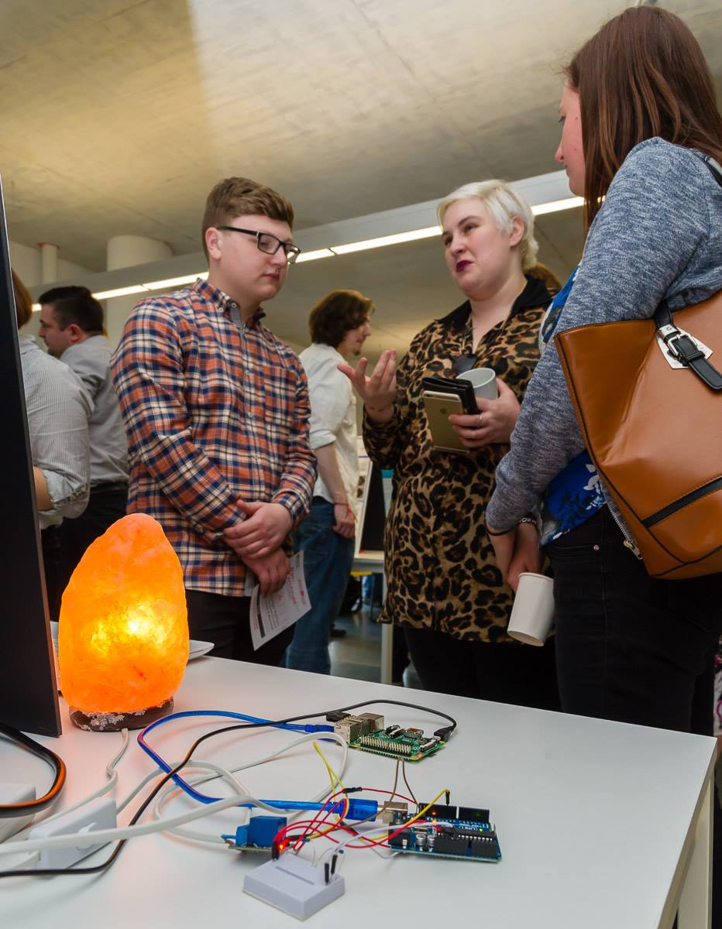

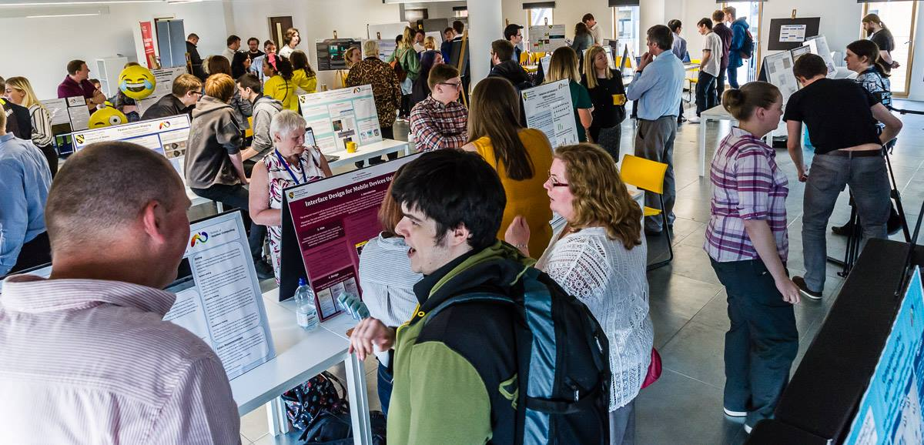
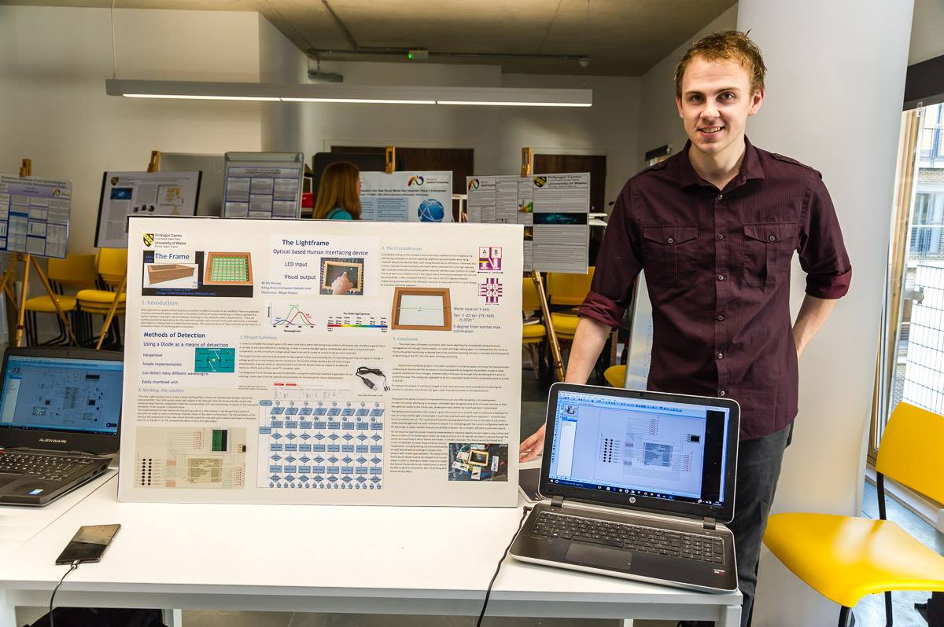

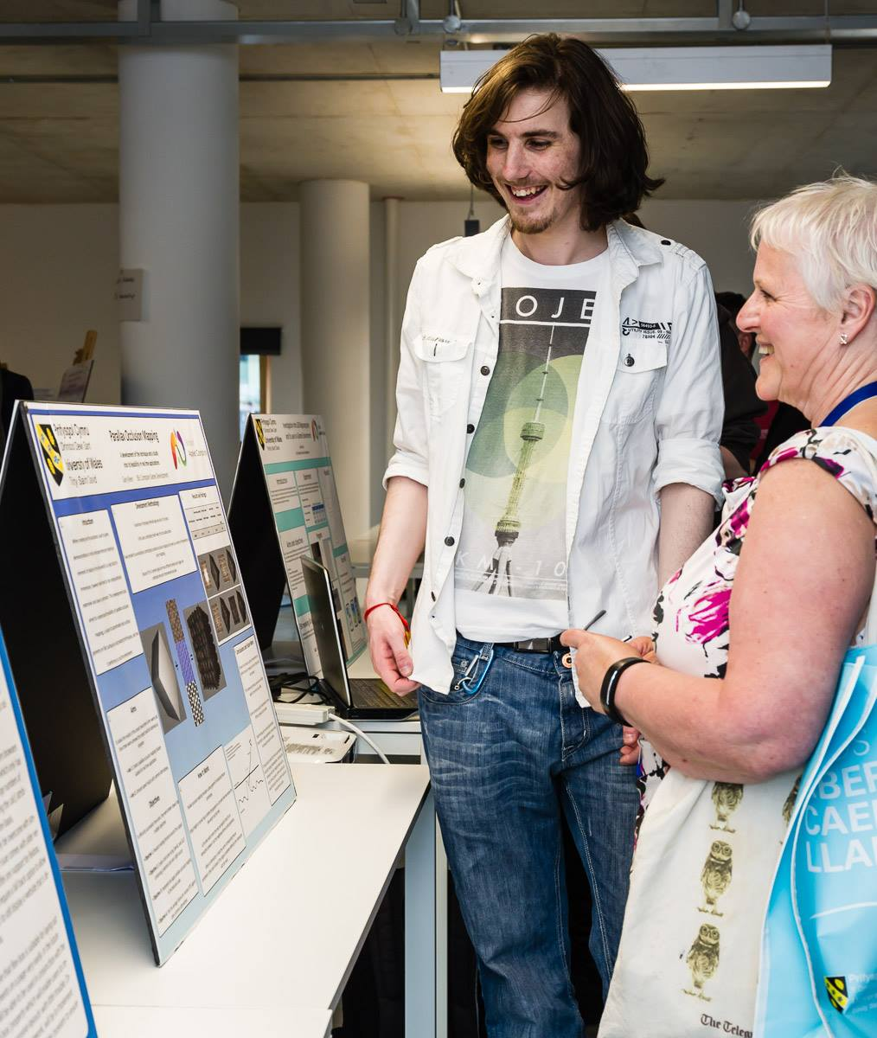

10.3 Handing in your Exhibition Board

Collect a blank exhibition board well in advance.

Hand in to Dan Davies in the School of Applied Computing Office by Friday April 24th 2020.

APPENDIX 1: DECLARATION FORM AND FORM OF CONSENT

DECLARATION

I, ............................................(FULL NAME)………………………………… declare that I am the sole author of this Project; that all references cited have been consulted; that I have conducted all work of which this is a record, and that the finished work lies within the prescribed word limits.

This work has not previously been accepted as part of any other degree submission.

Signed : .............................................

Date : ...............................................

FORM OF CONSENT

I ............................................(FULL NAME)………………………………… hereby consent that my Project, submitted in candidature for the B.Sc. xxxxxxxxxxxxxxxxxxxxxxxx degree, if successful, may be made available for inter-library loan or photocopying (subject to the law of copyright), and that the title and abstract may be made available to outside organisations.

Signed : .............................................

Date : ...............................................

(replace B.Sc. xxxxxxxxxxxxxxxxxxxxxxxxxxxx with the name of your degree)

APPENDIX 2: ELECTRONIC DATABASES AND JOURNALS

Library web pages available at http://apollo.sihe.ac.uk/library/
(Links from here to: General library information; Library catalogue; Subject Guides plus Electronic Journals and Databases)

The following databases are accessible via the web pages:

ACM (Association for Computing Machinery)
IEEE Xplore
ZETOC
ANTE
ASSIA
Science Direct
SWETSWISE
EMERALD MANAGEMENT REVIEWS
NEWSBANK
INDEX TO THESES

Additional useful websites:

British Library Public Catalogue: http://blpc.bl.uk
Swansea University Library Catalogue: http://voyager.swan.ac.uk

APPENDIX 3: REFERENCING CONVENTIONS

When you refer to a piece of work in an essay, report, program or academic paper, you must give adequate bibliographic information to allow the reader to trace the original document. (For note on Plagiarism See Section 8.2.5). So, if you wish to incorporate points made by another author or figures derived from a survey or report, acknowledge the sources used in the text of your project and give full details of the source in the reference list at the end of your work.

A reference is usually in two parts:

1. a marker at the end of the text being quoted or referred to, and
2. a complete citation in either a footnote or, more usually in computer science, collected with other citations in a “References” section at the end of your work.

Note sometimes you will find references at the foot of the page rather than at the end of the work but it is simpler to provide an alphabetical list at the end of the project.

The Numeric System

Citations use a sequential number scheme, with the citation number enclosed in square brackets corresponding to the appropriate reference provided at the end of the document.

Example :

In your work :

...... as Smith [14] has shown ......
...... blue has been shown [14] to be the best ......

In the Bibliography at the end :

[14] A. Smith, A Book Title, 2nd ed., Wiley, 2002
The numbering should be sequential as citations are used, the first reference used in the document should begin with one, the second is two, etc. If the same reference is used in the document then you may repeat the previously assigned reference number e.g.

In your work :

….. from Smith [1] we find that ……
….. Jones et al [2] also states …….
….. it has been shown [1] that ……
….. which matches similar findings [3] …..
…. other research [1][2][3] has proven …..
In the Bibliography at the end :

[1] A. Smith, A Book Title, 2nd ed., Wiley, 2002
[2] D. Jones, B. Thomas, Another Book Title, O’Reilly, 2004
[3] K. Smith, Yet Another Book Title, Chichester: Wiley, 2006

When using a reference you don’t explicitly need to specify the author(s) name, but specifying the author’s name can increase readability. Also, if many authors contributed to the book, paper, etc, then identify the first author and use “et al” to indicate that there were many contributors.

In your work :

….. it has been shown [2] that ……
….. Jones et al [2] also states …….

Quotations should be placed in quotes, italicized and tabbed from the edge, with a clear reference to the source. In addition, for clarity it is recommended that a single blank line be added before and after the quotation
For example:

“It becomes clear that, in most cases, the goal of finding out about people through interviewing is best achieved when the relationship of interviewer and interviewee is non-hierarchical and when the interviewer is prepared to invest his/her own personal identity in the relationship” Bloggs et al [6]

The author’s name (Bloggs et al) in the above is optional but is included for readability.

When should a citation be used?

- All direct quotes must be cited.

2. Even when you have translated an author’s words into your own (which you should make every effort to do), you must still give them credit by including a citation. When an entire paragraph of material is based on one author’s ideas, you only need place one citation at the end of the paragraph. Exceptions to this rule follow in (3) and (4).

3. All statistics that are cited require a citation immediately following the sentence in which they appear.

- All historical events and dates mentioned require a citation.

- References should be included for all websites used.

Reference Information and Structure

All references should be added to a “References” section included towards the end of the document.

The details which need to be included in references (author, title, etc) depend on the type of publication you are citing (articles, books, etc). For the commonest types of publication, the examples below show the information you should give, as well as the correct use of italics and punctuation.

Accessed from:
http://www.swan.ac.uk/lis/help_and_training/htmdocs/bibliographic_referencing/numeric_referencing_examples.asp
There are a number of referencing systems but the Numeric system is the system that MUST BE USED FOR THE Project. For a full explanation and examples of the numeric systems see Appendix 4.

APPENDIX 4: NUMERIC REFERENCING SYSTEM

Numeric Referencing Guidelines

The details which need to be included in references (author, title, etc) depend on the type of publication you are citing (articles, books, etc). For the commonest types of publication, the examples below show the information you should give, as well as the correct use of italics and punctuation.

Accessed from:
http://www.swan.ac.uk/lis/help_and_training/htmdocs/bibliographic_referencing/numeric_referencing_examples.asp
Book
Author(s) or editor(s) of book | Title of book: and sub-title if there is one (in italics) | Edition (if not the first) | Place of publication | Publisher | Year of publication
Author(s) and Title should be given as they appear on the title page inside the book. (The front cover may have less detail.) Information such as the year, place of publication and publisher is usually on the back of the title page.
Edition should be abbreviated: 2nd ed.
Place of publication is usually a town or city. For U.S. place names, give the two-letter state abbreviation as well.
Examples

[1] W.-K. Chen, Linear Networks and Systems. Belmont, CA: Wadsworth, 1993.
[2] S. Lin and D. J. Costello, Jr., Error Control Coding: Fundamentals and Applications. Englewood Cliffs, NJ: Prentice Hall, 1983.
[3] G. C. Clark, Jr. and J. B. Cain, Error-Correction Coding for Digital Communications. New York: Plenum Press, 1981.
[4] R. Steele and L. Hanzo, Eds., Mobile Radio Communications, 2nd ed. Chichester: Wiley, 1999.
[5] M. A. Soderstrand, W. K. Jenkins, G. A. Julien, and F. J. Taylor, Eds., Modern Applications of Residue Number System Arithmetic to Digital Signal Processing. New York: IEEE Press, 1986.

Chapter in a Book
Author(s) of chapter | "Title of chapter" (in quotes) | in Title of book (in italics) | Edition (if not the first) | Editor(s) of book | Place of publication | Publisher | Year of publication | Pages covered by chapter
Examples

[6] G. O. Young, “Synthetic structure of industrial plastics,” in Plastics, 2nd ed., vol. 3, J. Peters, Ed. New York: McGraw-Hill, 1964, pp. 15-64.
[7] S. Godsill, P. Rayner, and O. Cappé, “Digital audio restoration,” in Applications of Digital Signal Processing to Audio and Acoustics, M. Kahrs and K. Brandenburg, Eds. Boston, MA: Kluwer Academic, 1988, pp. 133-194.
[8] J. K. Hao and R. Dorne, “Study of genetic search for the frequency assignment problem,” in Artificial Evolution: European conference, AE 95, Brest, France, September 4-6, 1995 : selected papers,” J.-M. Alliot, Ed. Lecture Notes in Computer Science, 1063. Berlin: Springer-Verlag, 1996, pp. 333-344.

Journal Article
Author(s) of article | "Title of article" (in quotes) | Title of Journal (in italics) | Volume number (and issue number if there is one) | Pages covered by article | Date of Publication
Date of Publication should include the month or season if it appears on the journal: e.g. Feb. 1987; Winter 2000; Mar.-Apr. 1963
Examples
[9] G. Strang, “Wavelets,” American Scientist, vol. 82, pp. 250-255, 1994.
[10] I. S. Qamber, “Flow graph development method,” Microelectronics Reliability, vol. 33, no. 9, pp. 1387-1395, Dec. 1993.
[11] F. Bonomi and K. Fendick, “The rate-based flow control framework for the ABR ATM service,” IEEE Network, vol. 9, pp. 25-39, 1995.
[12] E. H. Miller, “A note on reflector arrays,” IEEE Transactions on Antennas and Propagation., to be published.

Article from Conference Proceedings (published)

Author(s) of article | "Title of paper" (in quotes) | in Title of proceedings (in italics) | Location and date of conference | Pages covered by article
Examples
[13] R. Bauer and J. Hagenauer, “Iterative source/channel-decoding using reversible variable length codes,” in Proceedings of the IEEE Data Compression Conference (DCC), Snowbird, UT, Mar. 2000, pp. 93-102.
[14] A. K. Salkintzis, C. Chamzas, and C. Koukourlis, “An energy saving protocol for mobile data networks,” in International Conference on Advances in Communication and Control (COMCON 5), June 26-30, 1995, pp. 107-113.
Paper Presented at a Conference (unpublished)
Author(s) of paper | "Title of paper" in quotes | presented at Title of conference | Location and date of conference
Unpublished papers are often made available as reprints to conference delegates but do not appear in collected conference proceedings, so no pagination should be given.
Examples
[15] F. Comellas and J. Ozón, “An ant algorithm for the graph coloring problem,” presented at ANTS ’98 – From Ant Colonies to Artificial Ants: First International Workshop on Ant Colony Optimization, Brussels, Belgium, Oct. 1998.
[16] L. Gao, J. Kurose, and D. Towsley, “Efficient schemes for broadcasting popular videos,” presented at the 8th International Workshop on Network and Operating Systems Support for Digital Audio and Video (NOSSDAV ’98), Cambridge, UK, July 1998.

Thesis or Dissertation
Author of thesis | "Title of thesis" (in quotes) | Qualification and type of report | University/Institution | Year of award
Qualification should be abbreviated as Ph.D., M.Phil., etc. The type of report (e.g. thesis, dissertation, etc) should be given as it appears on the document as the terminology may vary between countries. It is helpful to add the country unless the university is particularly well-known.
Examples
[17] E. F. Mastrovito, “VLSI architectures for computation in Galois Field,” Ph.D. dissertation, Linköping University, Sweden, 1991.
[18] A. Chini, “Multi carrier modulation in frequency selective fading channels,” Ph.D. dissertation, Carleton University, Canada, 1994.
[19] Y. W. Kim, “Study and implementation of system synchronization for DAB (Digital Audio Broadcasting),” Masters thesis, Korea Advanced Institute of Science and Technology, Korea, 1996.
[20] J. G. O. Moss, “Spread spectrum technologies for future communication systems,” D.Phil. thesis, University of Oxford, 1998.

Technical Report
Author(s) of report | "Title of report" in quotes | Series title and number (if applicable) | Place and date of publication
Technical reports are often not formally published and may not have clear publication details. Give as much information as you can so your readers can obtain the report if they wish.
If the place of publication is obvious from the series title there's no need to repeat it at the end.
Examples
[21] M. Krunz and S. K. Tripathi, “Scene-based characteristics of VBR MPEG-coded video traffic,” University of Maryland, CS-TR-3573, 1997.
[22] J. H. Stott, “Phase noise in OFDM: Further insights, including the use of weighting functions,” BBC, R&D Department, Technical Note no. R&D 0166(94), Dec. 1994.
[23] A. Dan, P. Shahabuddin, D. Sitaram, and D. Towsley, “Channel allocation under batching and VCR control in movie-on-demand servers,” IBM Research Report, 1994.
[24] International Telecommunications Union, “Terrestrial digital multimedia/television broadcasting system development in China,” ITU-T Document 6E/50-E, Geneva, Mar. 26, 2001.

Standard
Name of the organization which produced the standard | "Title of standard" (in quotes) | Catalogue code or number of standard | Date of publication
Standards are frequently issued in draft and revised versions. Make sure you cite all the catalogue/numbering and date information exactly as it appears on the document.
If the name of the organization appears in the catalogue code or number of the standard it can be abbreviated.
Examples
[25] International Standards Organisation, “Information technology – Generic coding of moving pictures and associated audio information: Video specification,” ISO/IEC 13818-2, Nov. 1994.
[26] Federal Communications Commission, “Code of Federal Regulations,” Title 47, Ch. 1, Part 73, Radio Broadcast Services. Secs. 73.683, 73.684 and 73.699.
[27] European Telecommunications Standards Institute, “Digital Audio Broadcasting (DAB) to mobile, portable and fixed receivers,” ETSI EN 300 401 v1.3.3, May 2001.
[28] Institution of Electrical and Electronic Engineers, “Wireless Medium Access Control (MAC) and Physical Layer (PHY) Specifications,” IEEE Draft standard 802.11 D3.1, Apr. 1996.

Patent
Author(s) of the patent | "Title of patent" (in quotes) | Issuing country/organisation and number of the patent | Date of filing
Examples
[29] L. Idoumghar, “Using a hybrid genetic algorithm to solve the frequency assignment problem,” Patent TDF, N. 01 06 885, May 2001.
[30] Z. Yang, “Terrestrial digital multimedia/television broadcasting system,” P.R.China Patent 00 123 597.4 filed Aug. 25, 2000, issued Mar. 21, 2001.
[31] S. Kawa, K. Kiyoshi, and S. Takeshi, “Route bus service controlling system,” U.S. Patent 4 799 162, Jan. 1989.

Unpublished Source
Author(s) | "Title of document" (in quotes) | Type of document | Date (if applicable)
The type of document might be an unpublished manuscript, e-mail or private correspondence, etc. Clearly these are not available to your readers but you should still give as much detail as you can.
Examples
[32] B. Chen and C.-E. W. Sundberg, “Adaptive multicarrier modulation for IBOC-AM,” Unpublished work.
[33] R. Cupo and M. Shariat, “All-digital AM system architecture,” Private communication, May, 1998.

Online Source
Author(s) | "Title of source" | Organization/Publisher/Date | [Online] | Available: access information | [Accessed: Date of access]
An online source may not always contain clear author or publisher details. When you cite an online source try to describe it in the same way you would describe a similar printed publication. If possible, give sufficient information for your readers to retrieve the source themselves.
The access information will usually be just the URL of the source. If the item is only available by e-mail, ftp or some other method, include a brief mention of how to obtain it.
As well as a publication/revision date (if there is one), the date of access is included since an online source may change between the time you cite it and the time it is accessed by a reader.
Examples
[34] T. Rahkonen, “Analysis of analog circuits using Volterra series,” University of Oulu, Oulu, Finland, 1999. [Online]. Available:
http://www.ee.oulu.fi/~timor/DCourse/Chp1_2.pdf. [Accessed: Sept. 14, 2002]
[35] S. McCanne and S. Floyd, “The UCB/LBNL network simulator,” 1997. [Online]. Available: http://www.mash.cs.berkeley.edu/ns/. [Accessed: Jan. 23, 1999]
[36] Advanced Television Technology Center, Inc., “ATTC introduces RF data capture project,” Press release, Mar. 2000. [Online]. Available: http://www.attc.org/RFCapture.PDF. [Accessed: Mar. 15, 2001]
[37] “AlphaCom Communications introduces VMSK technology,” The Business Journal Online, May, 2000. [Online]. Available: http://www.business-journal.com/LateMay00/Alpha.html. [Accessed: May 2, 2000]
[38] “A ‘layman’s’ explanation of Ultra Narrow Band technology,” Oct. 3, 2003. [Online]. Available: http://www.vmsk.org/Layman.pdf. [Accessed: Dec. 3, 2003]
[39] European Telecommunications Standards Institute, “Digital Video Broadcasting (DVB); Implementation guidelines for DVB terrestrial services; transmission aspects,” ETSI TR-101-190, 1997. [Online]. Available: http://www.etsi.org. [Accessed: Aug. 17, 1998]
[40] S. J. Salamon, “DTV receiver performance studies,” presented at the 49th Annual Broadcasting Symposium, IEEE Broadcasting Technology Society, Sept. 24, 1999. [Online]. Available: http://www.attc.org/BTS_Rx.PDF. [Accessed: Jan. 18, 2000]
[41] P. Karn, “General-purpose Reed-Solomon encoder/decoder in C,” Jan, 2002. [Online]. Available: http://www.ka9q.net/code/fec/. [Accessed: Oct. 8, 2002]
[42] A. Harriman, “Compendium of genealogical software,” Humanist, Jun., 1993. [Online]. Available e-mail: HUMANIST@NYVM Message: get GENEALOGY REPORT. [Accessed: Jun. 8, 2003]

