University of Wales Trinity Saint David
London Campus

Assignment 1
Programme: BA Business Management
Module: Data Handling & Business Intelligence
Module Code: LCBB5000
Lecture: Dr Amitave Banik
Student: Basiul Vlada ( 2028043 )

Table of contents

Introduction: 3
Explain 5 current intelligent business trends: 3
Cloud analytics: 3
Unified data management and analytics: 4
Augmented analytics: 4
Business activity monitoring: 5
Data storytelling: 5
Conclusion: 6
Reference list: 7

Introduction:
The purpose of the research is to discuss business intelligence and data handling. The research's purpose is to explain the 5 latest intelligent business trends cloud analytics, augmented analytics, data storytelling, business activity monitoring and unified analytics, and data management. The business intelligence trends are already useful to maintain the organizational performance with the help of adopting different strategic Incorporation. In this context different trends have been discussed in this assessment such as data security that is considered as one of the most important factors that needs to be incorporated within the organization for the purpose of creating protection for the data against theft. However, the data discovery is also one of the most important factors of the organization that is associated with analysing the pattern in the data with the help of which the organizational services can be improved according to the requirement of the customers. There are other friends as well that have been discussed within the assessment along with proper justifications.
(Ori.hhs.gov, 2022).

Explain 5 current intelligent business trends:

Cloud analytics:
Cloud analytics algorithms are used to identify patterns of use and predict future outcomes to make business decisions useful. Businesses are trying to get valuable customer insights and cloud analytics helps to do that (Daws, 2018). Through the cloud analytics, the company can get the access to remote the center data and through this a large amount of the data can be processed in the organization. Through the development of productivity, this is providing accurate results to the business organization. Through this the businesses can save an extra amount of money to hire an employee to get accurate data from customers that cloud analytics do it more accurately and a business can make better valuable decisions with the help of cloud analytics. Any employee in an organization does not have to give extra time for an update as it is done automatically (customerthink, 2022). For example, Gameloft is a mobile game development company that provides entertainment services digitally. The company achieved zero downtime deployment and was able to gain a high spike in traffic during the time of new game launches. The company experiences an increase of around 50% in their traffic. Problems like maintaining any data centers and physical servers that lead to a high cost, and focusing on maintenance rather than development, Gameloft fixes these problems with the help of cloud analytics. Gameloft can find success to improve the gamer experience and reduce the valuable time in the market (netsuite, 2022).
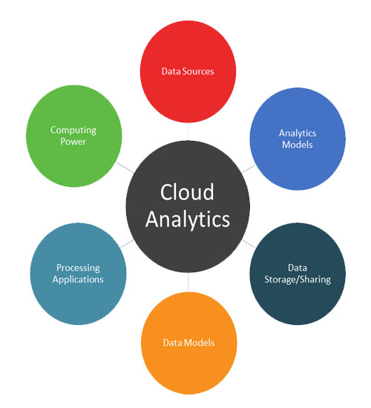
Figure 1: Cloud analytics
Source: (MicroStrategy, 2022)
Unified data management and analytics:
Unified data management helps to get a common space for data praising, cleansing, and transformation to get the business needed data and removes the unwanted data, so the business gets useful information very easily (Kang and Magdy, 2020). This is used for realizing the value of the data. THis is helpful for reaching the strategic business goals of the organization. This is helpful in creating the single data narrative through the data warehouse. A business does not have to visit multiple sources and channels to get the data as unified data analytics brings together all the data from various sources and channels. A business can get a clear picture of the way of success in the functions related to the product, customer journey, and sales. Businesses can get easy and proper answers to difficult challenges. Not only that a business can get easy solutions in product development, reducing customer churn, etc. (hypersense, 2022). For Example, Mark & Spencer uses adobe to focus on the experience of the customer. Mark & spencer uses unified data management to deliver relevant, truly exceptional, and real-time experiences for the customers. This help Mark & spencer helps to identify the problems in the business and solve them. The company automates the process which reduces a lot of time and helps to balance the customer experience and profit (ComputerWeekly, 2022). Therefore this is considered as the tool in the company that is helpful for building the bridge between the data sources and end-user. Through this the performance of the organizations is improved.
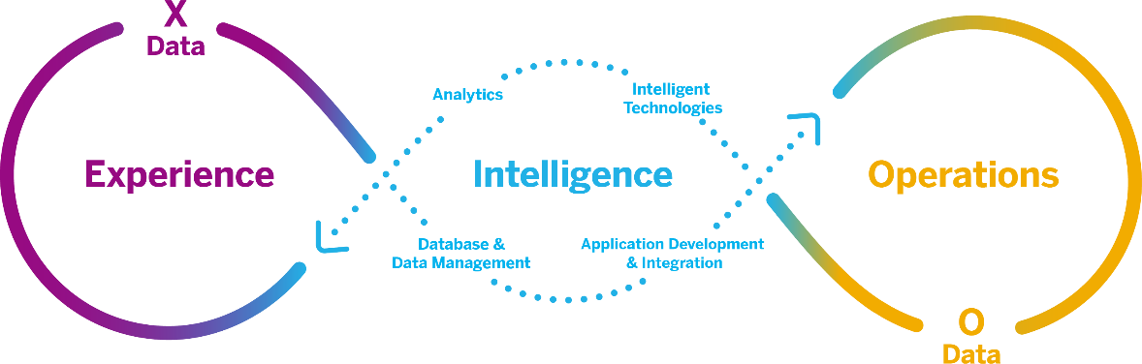
Figure 2: Unified data management and analytics
Source: (Graber, 2020)
Augmented analytics:
Augmented analytics is a system of analytics that uses artificial intelligence and machine learning that expands the ability of humans to interact with the relevant data and uncover insights into the business (Sun, 2022). Augmented analytics is helpful for the business in reducing the reliance through the manual process as well as generating the process of the insights. In the business, this is helpful for uncovering the insights. A business can clean and transform the data from various business resources in no time and many times businesses can boost their future digital transformation goals. A business does not need a data scientist but with the help of augmented analytics, businesses can generate recommendations at a high pace rate. Now a business can make better decisions by identifying the root cause at a fast speed. A company can see a huge reduction in cost as the company does not have to hire any data scientists (TechTarget, 2022). For example, Coca-Cola uses augmented analysis to analyze the data of the mentions and representations of their products on social media. Using coca cola boosts the click-through rate to 4 and improves their inventory on consumer trends. Coca-Cola uses it to serve its customer in a better way (Forbes, 2022).
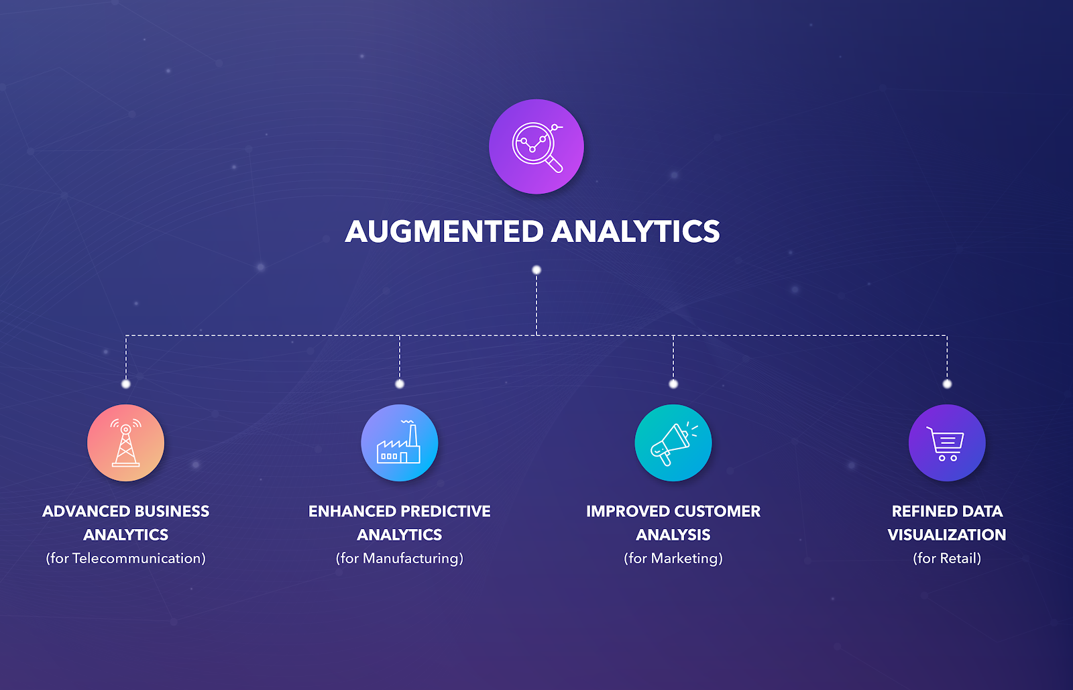
Figure 3: Augmented analytics
Source: (softengi, 2022)

Business activity monitoring:
Business activity monitoring uses in the business to get efficiency in processes and improve their performances. In the business organization, BAM is used for improving the effectiveness as well as speed of the operations of the business through keeping the track regarding the happening thing in the organization. In the business, this can be implemented through various types of the software tools (Shtal et al. 2022). Businesses can reduce the extra work of filtering the whole data and extra time between an event and the business response. Businesses can improve the efficiency of any process toward the goals. A business can increase the satisfaction level of customers and the quality of any product or service. For example, Amazon uses this tool to monitor the end-to-end experiences of the customer on their site and can identify any issue. Amazon gets timely alerts on any wrong work and that helps to stop there and recheck it. Amazon gets to understand the root cause of a performance issue and helps to resolve it (amazon, 2022).
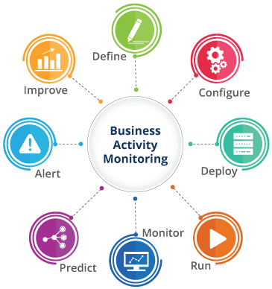
Figure 4: Business activity monitoring
Source: (Royal Cyber, 2022)

Data storytelling:
Data storytelling is something that is mainly used to analyze complex insights into simpler ones to understand (Taylor & Francis, 2022). Data storytelling refers to the ability for communicating with the insights from the specific dataset that is used with the visualizations as well as narratives. This can be used for inspiring action from the audience. Businesses can easily process the data into a good story. The stakeholders of any business can increase memory power and retain information easily with data storytelling. In this sense a business can get an improved insight that leads to a better and faster decision-making process that saves a lot of time and energy for the employees of the company (analyticsindiamag, 2022). Spotify uses data storytelling to give meaning and value that is impactful to the service of the company. Spotify uses it to engage a huge audience to use and create a good image of the company. Spotify creates anticipation and personalizes the user experience of the audience (canningspurple, 2022).
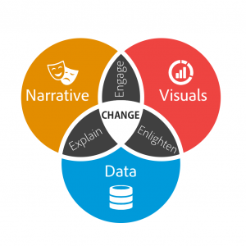
Figure 5: Data storytelling
Source: (Dykes, 2016)
Data security
Data security is one of the most important factors in the organization that can be adopted in the organization with the help of different strategic implementation organizations. It can be easily achieved with the help of controlling the access of the data. The data can also be controlled with the help of creating a backup and segmenting all the data. This can be useful for the purpose of maintaining security of data in the organization (Antoniou, 2018). However, the incorporation of a multifactor authentication process can also be included for the purpose of accessing the organizational data. This can be useful for the purpose of keeping a track of organizational data along with securing it. It has also identified that upgradation of database software into its latest version can also be adopted by the managers of the organization for the purpose of incorporating data security as database software upgradation can make the data more protected. Data security can also be achieved with the help of adopting cloud computing in the organization as it helps to secure the data in an appropriate manner.
Data discovery
Data discovery can be understood as the identification of databases in the organization for the purpose of identifying the associated trends and patterns within the data. Data discovery is one of the most important factors in recent days as it helps to provide information regarding the hidden insights of the data along with analysing potential security breaches so that it can be effectively worked upon. Data discovery can be done within the organization with the help of collecting the data from effective sources of information . After collecting the data from different sources, it can be placed together in a data warehouse. The data can be cleaned and prepared with the help of different methods to ensure that there are no errors, distortions and corruption in the data. After preparing the data, it can be analysed followed by developing insights of it (Muller et al. 2022). The data discovery can be useful within the organization for the purpose of recurring the patterns and trends in the market with the help of which the organizational services can be effectively enhanced so that the customers' needs can be fulfilled. Organizational managers can also use predictive analytics with the help of which the statistical algorithm can be used to analyse the data along with pattern analysis. This analytical technique can also be useful to visualize the purchasing pattern of the customers with the help of which the organization services can be developed.

Conclusion:
In this era, some technologies make businesses more useful in their way than the other competitors. In the assessment the evaluation of the specific sources using the sources have the major importance in evaluating the different areas of the information related to the topic. These are the sources that have the proper value in developing the future research paper relating to this topic. Through this proper knowledge can also be developed. So, it can be said that for more than five years the sources are relevant for the development of the research study.

Reference list:

Amazon , 2022. Monitoring and Observability | AWS Management & Governance. [online] Available at: <https://aws.amazon.com/products/management-and-governance/use-cases/monitoring-and-observability/?whats-new-cards.sort-by=item.additionalFields.postDateTime&whats-new-cards.sort-order=desc&blog-posts-cards.sort-by=item.additionalFields.createdDate&blog-posts-cards.sort-order=desc> [Accessed 30 July 2022].
analyticsindiamag , 2022. How To Use Effective Data Storytelling For Business Impact. [online] Analytics India Magazine. Available at: <https://analyticsindiamag.com/how-to-use-effective-data-storytelling-for-business-impact/> [Accessed 30 July 2022].
Antoniou, G.S., 2018, April. A Framework for the Governance of Information Security: Can it be Used in an Organization. In SoutheastCon 2018 (pp. 1-30). IEEE.
canningspurple , 2022. [online] Available at: <https://news.canningspurple.com.au/how-spotify-uses-data-to-tell-a-story/> [Accessed 30 July 2022].
ComputerWeekly.com. 2022. Marks & Spencer upskills internal talent with data science education. [online] Available at: <https://www.computerweekly.com/news/252511315/Marks-Spencer-upskills-internal-talent-with-data-science-education> [Accessed 30 July 2022].
customerthink , 2022. [online] Available at: <https://customerthink.com/top-10-companies-using-cloud-and-why/> [Accessed 30 July 2022].
Daws, R., 2022. Fitbit leverages Google Cloud to accelerate healthcare innovation Internet of Things News %. [online] Internet of Things News. Available at: <https://www.iottechnews.com/news/2018/apr/30/fitbit-google-cloud-digital-healthcare/> [Accessed 15 July 2022].
Dykes, B., 2016. Data Storytelling: The Essential Data Science Skill Everyone Needs. [online] Forbes. Available at: <https://www.forbes.com/sites/brentdykes/2016/03/31/data-storytelling-the-essential-data-science-skill-everyone-needs/?sh=3867386a52ad> [Accessed 3 August 2022].
Forbes , 2022. The Amazing Ways Coca Cola Uses Artificial Intelligence And Big Data To Drive Success. [online] Forbes. Available at: <https://www.forbes.com/sites/bernardmarr/2017/09/18/the-amazing-ways-coca-cola-uses-artificial-intelligence-ai-and-big-data-to-drive-success/> [Accessed 30 July 2022].
Graber, A., 2020. Unified Data and Analytics: A Partner’s Platform for Speed and Simplicity | SAP Blogs. [online] Blogs.sap.com. Available at: <https://blogs.sap.com/2020/06/11/unified-data-and-analytics-a-partners-platform-for-speed-and-simplicity/> [Accessed 3 August 2022].
hypersense. 2022. Unified Data Analytics | Augmented Analytics Platform | Data Analytics. [online] Available at: <https://hypersense.subex.com/aiglossary/unified-data-analytics/#:~:text=Unified%20data%20analytics%20helps%20businesses%20make%20sense%20of%20their%20data,AI%20initiatives%20in%20an%20organization.> [Accessed 30 July 2022].
Kang, Y. and Magdy, A., 2020, April. HiDaM: A unified data model for high-definition (HD) map data. In 2020 IEEE 36th International Conference on Data Engineering Workshops (ICDEW) (pp. 26-32). IEEE.
Khan, S., Shakil, K.A. and Alam, M., 2018. Cloud-based big data analytics—a survey of current research and future directions. Big data analytics, pp.595-604.
MicroStrategy. 2022. Cloud Analytics: Everything You Need to Know. [online] Available at: <https://www.microstrategy.com/en/resources/introductory-guides/cloud-analytics-everything-you-need-to-know> [Accessed 3 August 2022].
Muller, M., Lange, I., Wang, D., Piorkowski, D., Tsay, J., Liao, Q.V., Dugan, C. and Erickson, T., 2019, May. How data science workers work with data: Discovery, capture, curation, design, creation. In Proceedings of the 2019 CHI conference on human factors in computing systems (pp. 1-15).
NetSuite. 2022. How to Use Cloud Analytics. [online] Available at: <https://www.netsuite.com/portal/resource/articles/erp/cloud-analytics.shtml#:~:text=Cloud%20analytics%20allows%20companies%20to,data%20processing%20affordable%20and%20accessible.> [Accessed 30 July 2022].
Ori.hhs.gov. 2022. Data Handling. [online] Available at: <https://ori.hhs.gov/education/products/n_illinois_u/datamanagement/dhtopic.html#:~:text=Data%20handling%20is%20the%20process,as%20through%20non%2Delectronic%20means%20.> [Accessed 25 July 2022].
Royal Cyber. 2022. BAM. [online] Available at: <https://www.royalcyber.com/technologies/bam/> [Accessed 3 August 2022].
Shtal, T.V., BURIAK, M.M., AMIRBEKULY, Y., UKUBASSOVA, G.S., KASKIN, T.T. and TOIBOLDINOVA, Z.G., 2018. Methods of analysis of the external environment of business activities. Revista espacios, 39(12).
softengi.com. 2022. Augmented Analytics is the Future of Business Intelligence. [online] Available at: <https://softengi.com/blog/augmented-analytics-is-the-future-of-business-intelligence/> [Accessed 3 August 2022].
Taylor & Francis. 2022. Data storytelling is not storytelling with data: A framework for storytelling in science communication and data journalism. [online] Available at: <https://www.tandfonline.com/doi/full/10.1080/01972243.2021.1951415> [Accessed 15 July 2022].
techtarget. 2022. Top 5 benefits of augmented analytics. [online] Available at: <https://www.techtarget.com/searchbusinessanalytics/feature/Top-5-benefits-of-augmented-analytics> [Accessed 30 July 2022].

