Digital Signal Processing

&

Communications

Student:
Creighton Rees
Lecturer:
Dr Steve Mosey
Course:
Ordinance Munitions and Explosives: ACDA5008:DSP & Communications
Table of Contents

- Introduction
- Development of DSP & Communication
- Simulation Models
- Results
- Discussion
- Conclusion
References
Annex A – Complete ASK, PSK & QPSK Simulation Data

Introduction
  - It has been asked that a laboratory assignment be produced on the critical examination of the performance of various Digital Modulation Techniques such as Amplitude Shift Keying (ASK), Phase Shift Keying (PSK), and Quadrature Phase Shift Keying (QPSK) when various levels of Additive White Gaussian Noise (AWGN) is applied.
  - Simulation models of ASK, PSK and QPSK have been produced using MATLAB© Simulink© version R2020b update 4. A basic Digital Signal Processing (DSP) and communications schematic has been shown below in Figure 1 [1].
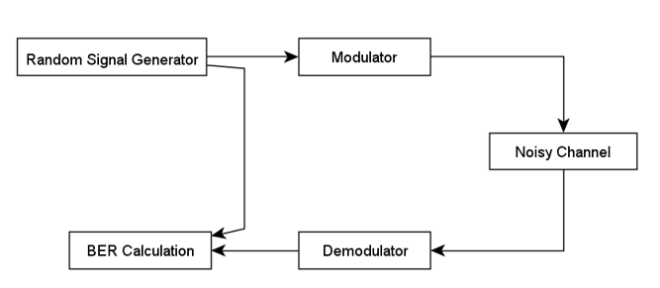
Figure 1 – Basic DSP & Communications System [1]
“Digital modulation is the process of encoding a digital information signal into the amplitude, phase, or frequency of the transmitted signal. The encoding process affects the bandwidth of the transmitted signal and its robustness to channel impairments.” [2]
  - Random Signal Generator
    - The random signal generator is the systems incoming data signal which can exists in several forms, a Bernoulli Binary Generator was used in the simulations for this assignment which generates random bits of data in the form of binary numbers, 1 or 0.
  - Modulator
    - The modulation techniques applied during this assignment will be ASK, PSK and, QPSK, other modulation techniques are available such as 16 QAM, 32 QAM and 64 QAM etc. Modulation and Demodulation will be discussed in further detail in Section 2 Development of DSP and Communications.
  - Noisy Channel
    - The Noisy Channel selected for this assignment is the AWGN Simulink block, the Signal to Noise Ratio (SNR) was initially set to 0dB - (no noise) and increased in intervals of 10dB up to -100dB.

Additive white Gaussian noise
Additive white Gaussian noise is a basic noise model used in Information theory to mimic the effect of many random processes that occur in nature. [3]
  - Demodulator
    - The demodulator technique applied will be dictated by the type of modulation used, for this assignment ASK, PSK and, QPSK demodulation systems will be used. Modulation and Demodulation will be discussed in further detail in Section 2 Development of DSP and Communications.
  - Bit Error Ratio (BER) Calculation
    - The BER Calculation will be the measure of the systems performance, it will count how many bits are in error over how many bits are sent and state the result as a ratio. The Error Rate Calculator Simulink block displays, the total bits sent, total errors, and the BER.
“The bit error rate (BER) of a transmission is the percentage of bits in the transmission that have errors as a result of noise, interference or other issues. The bit error rate can be used to determine the quality of a signal and the relative success of packet delivery. It can be an essential part of examining different types of systems for quality and efficacy.” [4]

Development of DSP & Communications

The modern world is built on the successful and effortless operation of DSP and Communications systems, it is an area which has grown with the wider applications of computer systems. Figure 2 [5] details some of the applications where the development of DSP has led.

“DSP is distinguished from other areas in computer science by the unique type of data it uses, signals. In most cases, these signals originate as sensory data from the real world: seismic vibrations, visual images, sound waves, etc. DSP is the mathematics, the algorithms, and the techniques used to manipulate these signals after they have been converted into a digital form.” [5]

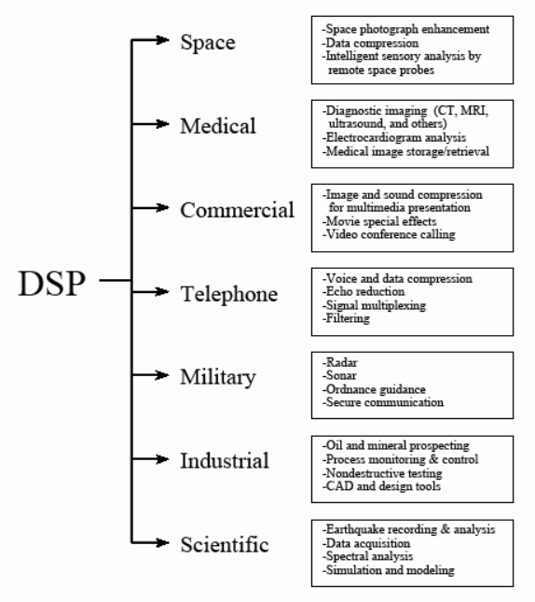
Figure 2 – DSP Applications [5]

  - ASK
    - Amplitude Shift Keying is generally used for fibre-optic applications and is the simplest form of digital modulation which can also be called on–off modulation. Figure 3 below shows a typical ASK modulated signal.
“In ASK, frequency and phase of the carrier wave is kept constant and only the amplitude is varied according to the digitized modulating signal. It is also referred as Binary Amplitude Shift Keying (BASK) as its usual operation is associated with only two levels.” [6]
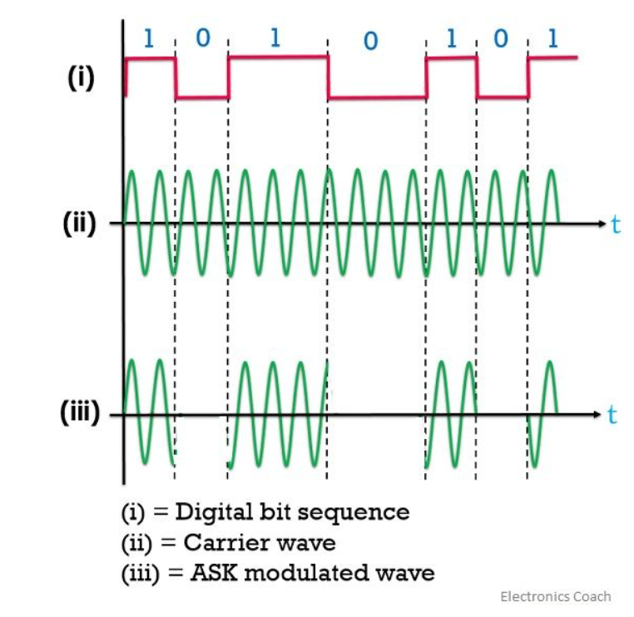
Figure 3 – Typical ASK Modulated Signal [6]
  - PSK
    - Phase Shift Keying is generally applied to Bluetooth™ and Local Area Network (LAN) wireless systems. While ASK is implemented using a variation of amplitude, PSK utilises a phase shift of the carrier wave at the modulator section. Figure 4 below shows a typical PSK modulation signal. PSK can operation also be shown through a constellation diagram although more useful when applied to QPSK modulation.
“This kind of modulation method uses a limited number of phases where each phase can be assigned with binary digits. Generally, every phase encodes an equivalent number of bits. Every bit’s pattern forms the symbol that is denoted by the exact phase.” [7]
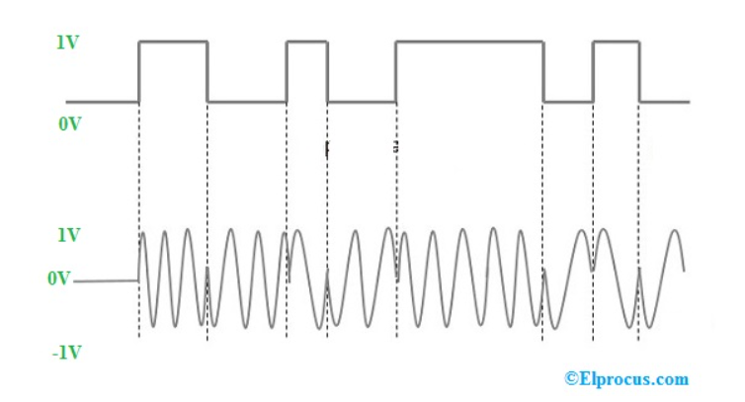
Figure 4 – Typical PSK Modulated Signal [7]
  - QPSK
    - Quadrature Phase Shift Keying is an expansion on PSK although the incoming data stream is split into two parallel data streams on bit pairs, the mod/demodulation is carried out by the same method as PSK, this allows for double the data to be sent on the same bandwidth.
    - QPSK has many applications similar to PSK with the addition of satellite and cable, the difference between them can be shown pictorially though the use of a constellation diagram shown in Figure 5 below.
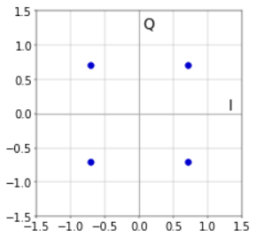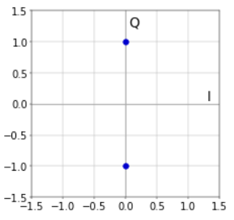
Figure 6 - Constellation Diagrams for QPSK and PSK Modulation respectively [8]

Simulation Models
  - Amplitude Shift Keying (ASK) Simulation Model
    - Figure 3 below shows the ASK simulation model created for the analysis. The simulation stop time was 50 seconds, the frequency and the amplitude of the carrier wave was set to 2*π*100 and 1, respectively, with a sample time of 1/10000. Both sine waves are in phase with each other, only the amplitude differs.
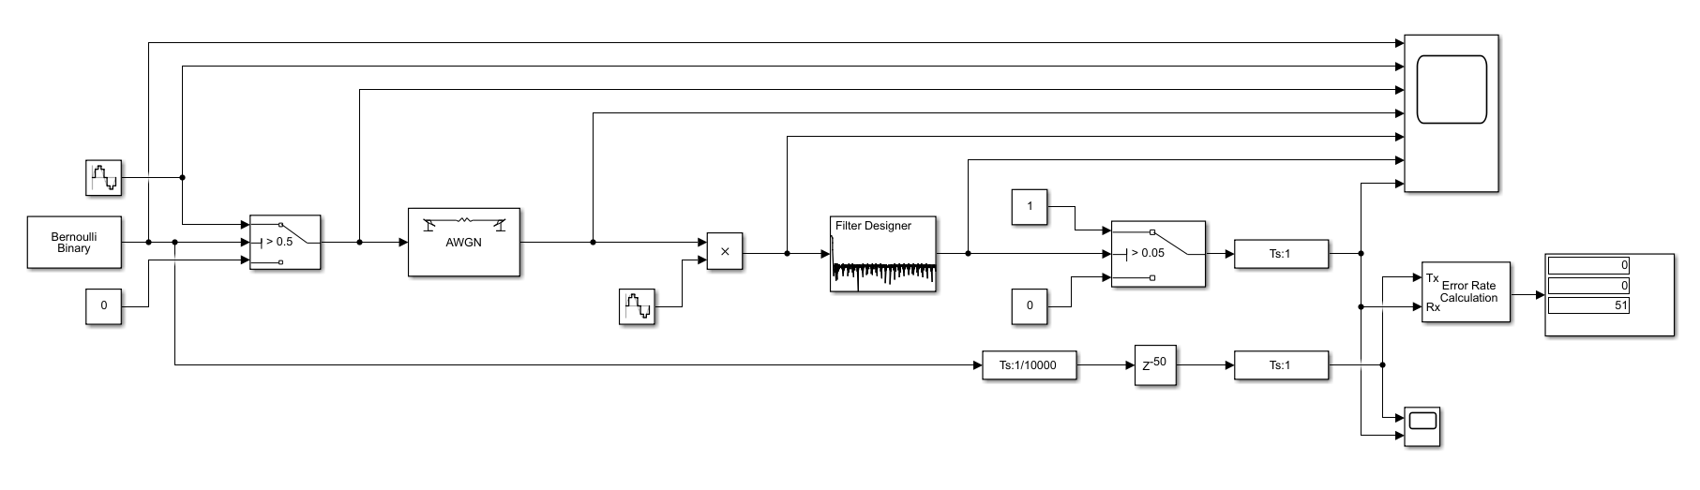Figure 3 – ASK Simulation Model – Extracted from MATLAB© Simulink©
  - Phase Shift Keying (PSK) Simulation Model
    - Figure 4 below shows the PSK simulation model created for the analysis. The simulation stop time was also 50 seconds, the frequency and the phase of the carrier wave was set to 2*π*100 and -1, respectively, with a sample time of 1/10000, while the amplitude is constant.
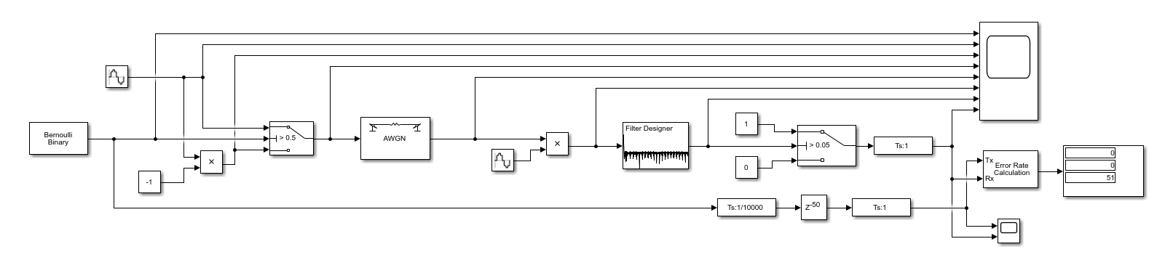
Figure 4 – PSK Simulation Model – Extracted from MATLAB© Simulink©
  - Quadrature Phase Shift Keying (QPSK) Simulation Model
    - Figure 5 below shows the QPSK simulation model created for the analysis. The simulation stop time was also 50 seconds, the frequency and phase of the I carrier wave was set to 2*π*100 and 0, respectively, and the Q carrier wave was set to 2*π*100 and π/2, respectively with a sample time of 1/10000, the amplitude is constant.
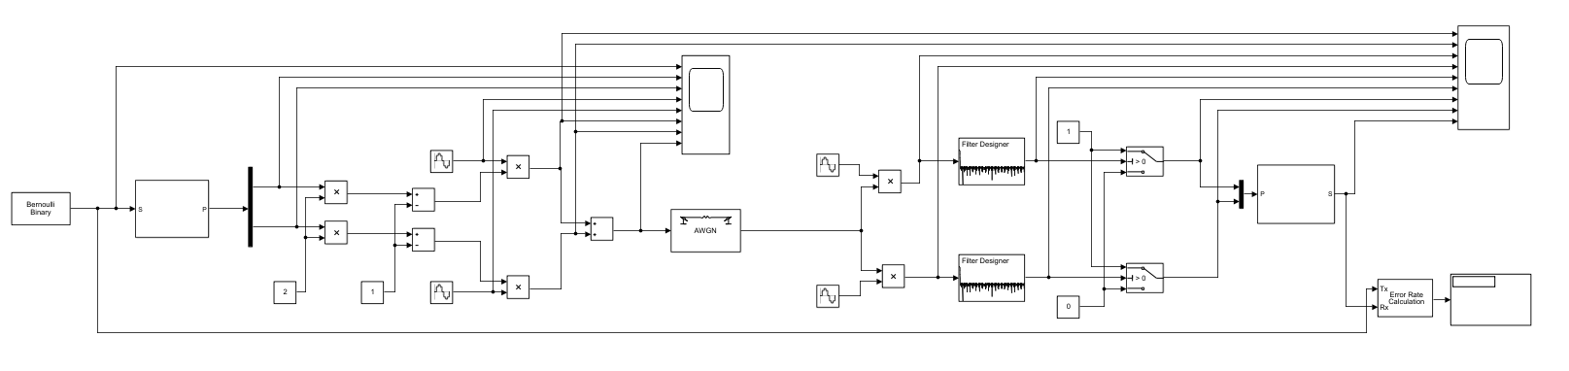
Figure 5 – QPSK Simulation Model – Extracted from MATLAB© Simulink©

Results

See Annex A for BER complete test data for all ten simulation runs, from 0dB to -100dB for ASK and PSK, and 0dB to -120dB for the QPSK systems because the simulation did not reach the pre-defined BER failure point of 50% at the -100dB mark.
  - Table 1 below shows the Average BER Test Results for 10 ASK, PSK and QPSK simulation runs. A graphical representation of the results has also been shown in Chart 1 - ASK, PSK & QPSK Modulation Bit Error Rate (BER) (%) Vs Signal to Noise Ratio (SNR) (-dB).

Simulation Run Average
PSK |  | ASK |  | QPSK
SNR (-dB) | BER (%) | SNR (-dB) | BER (%) | SNR (-dB) | BER (%)
0 | 0 | 0 | 0 | 0 | 0
-10 | 5 | -10 | 8 | -10 | 0
-20 | 17 | -20 | 31 | -20 | 21
-30 | 34 | -30 | 40 | -30 | 43
-40 | 42 | -40 | 47 | -40 | 49
-50 | 48 | -50 | 51 | -50 | 48
-60 | 48 | -60 | 53 | -60 | 49
-70 | 51 | -70 | 51 | -70 | 48
-80 | 49 | -80 | 47 | -80 | 48
-90 | 50 | -90 | 49 | -90 | 49
-100 | 47 | -100 | 47 | -100 | 49
-110 | N/A | -110 | N/A | -110 | 49
-120 | N/A | -120 | N/A | -120 | 53
Table 1 - Average BER Test Results for 10 ASK, PSK and QPSK simulation runs.

Chart 1 - ASK, PSK & QPSK Modulation Bit Error Rate (BER) (%) Vs Signal to Noise Ratio (SNR) (-dB)
  - Table 2 below shows the Standard Deviation (SD) for complete tests carried out for ASK PSK and QPSK simulation runs.
Standard Deviation of Simulations
SNR (-dB) | ASK BER | PSK BER | QPSK BER
0 | 0 | 0 | 0
10 | 0.03 | 0.02 | 0
20 | 0.04 | 0.03 | 0.07
30 | 0.07 | 0.08 | 0.09
40 | 0.07 | 0.05 | 0.03
50 | 0.06 | 0.08 | 0.06
60 | 0.08 | 0.09 | 0.09
70 | 0.08 | 0.07 | 0.1
80 | 0.05 | 0.07 | 0.07
90 | 0.05 | 0.07 | 0.03
100 | 0.09 | 0.06 | 0.1
110 | N/A | N/A | 0.08
120 | N/A | N/A | 0.07
SD Average | 0.06 | 0.06 | 0.06
Table 2 – Simulations Standard Deviation

Discussion
  - ASK
    - From the three digital modulation techniques used, ASK was the poorest performer when noise was added to the system. The BER increased sharply from -10dB to -20dB in comparison and reached the pre-defined failure point of 50% first at -50dB.
    - The average SD of all three simulations calculated at 0.06, the QPSK simulation was the only test that reached a SD of 0.1, Table 2 shows all three system simulations SD.
  - PSK
    - The PSK trend line shown in Chart 1 shows a smooth increase in BER as the systems noise is increased suggesting a more stable system with the addition of noise. The PSK simulation did not approach the failure point until -40dB but continued under the 50% mark up to -70dB before failure occurred.
  - QPSK
    - The QPSK simulation performed the best when noise was added to the system, the simulation did not log an error until a SNR of -20dB was reached, although at this point the BER was higher then the PSK simulation.
    - The intended simulations SNR limit of -100dB was pre-defined prior to the test, the QPSK simulation did not reach the BER failure point at -100dB, it was decided that the test continue using the same 10dB SNR increment until failure occurred.
    - The QPSK simulation finally failed at -120dB, although from -40dB the system was only 1% below failure and settled at this area for the duration of the test.

Conclusion
  - In future analysis it would be advised that a finer SNR variation be used, in place of 0 to -100dB at 10dB increments, a smaller range such as 0 to -20dB at 2dB increments should be used, the data may show a more defined picture with smaller increases to noise.
  - QPSK appeared to perform best during the simulations, although it would be incorrect to say one modulation technique is better than another all techniques have specific applications, possibly where bandwidth is limited but a high data rate is required QPSK would be applied.
  - The pre-defined BER failure point of 50% is excessively high and far exceeds anything that would be acceptable in industry if a lower value were selected for example, 30%, PSK would have appeared the better performer than both ASK and QPSK.
  - There are various forms of information that can be gathered from multiple sources and transformed into a transmittable signal. The choice of modulation used should be decided by the environment it will be used in, and the hardware and software that will be utilised.
  - Only three basic modulation systems have been discussed during this assignment, the complexity increases considerably with the QAM variants and new technologies are always being pursued, digital modulation and its development has played a key role not only in the advancement of countless business sectors, but the advancement of society itself.

References
DSP & Comms - L5 Module ACDA 5008 UWTSD - Course notes
[1] | D. S. Mosey, ACDA5008_sem1_CW1_2020_21, Swansea : University of Wales Trinity Saint David, 2020.
[2] | P. V. Jean Walrand, “Wireless networks,” in High-Performance Communication Networks (Second Edition), San Francisco, California, © Morgan Kaufmann 2000, 1999, p. 693.
[3] | Definitions.net, “Additive White Gaussian Noise,” Definitions.net, 01st Jan 2021. [Online]. Available: https://www.definitions.net/definition/Additive%20White%20Gaussian%20Noise. [Accessed 21 03 2021].
[4] | T. Inc., “Bit Error Rate (BER),” Techopedia Inc., 05th Jan 2021. [Online]. Available: https://www.techopedia.com/definition/33081/bit-error-rate-ber. [Accessed 16th 03 2021].
[5] | P. Steven W. Smith, “The Roots of DSP,” in The Scientist and Engineer's Guide to Digital Signal Processing, San Diego, CA 92127, California Technical Pub, 1997, p. 42.
[6] | E. Coach, “Amplitude-Shift-Keying,” electronics coach, 01st Jan 2021. [Online]. Available: https://electronicscoach.com/amplitude-shift-keying.html. [Accessed 22nd Mar 2021].
[7] | © Elprocus, “Phase Shift Keying (PSK) : Types and Its Applications,” © Elprocus, 7th May 2012. [Online]. Available: https://www.elprocus.com/phase-shift-keying-psk-types-and-its-applications/. [Accessed 23 03 2021].
[8] | T. R. TS, “What is a Constellation Diagram?,” 25th Mar 2019. [Online]. Available: https://tomroelandts.com/articles/what-is-a-constellation-diagram. [Accessed 23 Mar 2021].

ANNEX A - Complete ASK, PSK & QPSK Simulation Data
 |  | Simulation Bit Error Rate (BER) results
 | SNR (-dB) | Sim 1 BER | Sim 2 BER | Sim 3 BER | Sim 4 BER | Sim 5 BER | Sim 6 BER | Sim 7 BER | Sim 8 BER | Sim 9 BER | Sim 10 BER | Sim Avg BER | Error % | SD
ASK | 0 | 0 | 0 | 0 | 0 | 0 | 0 | 0 | 0 | 0 | 0 | 0 | 0 | 0.00
PSK | 0 | 0 | 0 | 0 | 0 | 0 | 0 | 0 | 0 | 0 | 0 | 0 | 0 | 0.00
QPSK | 0 | 0 | 0 | 0 | 0 | 0 | 0 | 0 | 0 | 0 | 0 | 0 | 0 | 0.00
ASK | 10 | 0.08 | 0.02 | 0.1 | 0.08 | 0.06 | 0.1 | 0.14 | 0.06 | 0.1 | 0.1 | 0.08 | 8 | 0.03
PSK | 10 | 0.08 | 0.05 | 0.08 | 0.04 | 0.04 | 0.02 | 0.06 | 0.04 | 0.04 | 0.06 | 0.05 | 5 | 0.02
QPSK | 10 | 0 | 0 | 0 | 0 | 0 | 0 | 0 | 0 | 0 | 0 | 0 | 0 | 0.00
ASK | 20 | 0.31 | 0.35 | 0.37 | 0.35 | 0.24 | 0.33 | 0.28 | 0.33 | 0.31 | 0.27 | 0.31 | 31 | 0.04
PSK | 20 | 0.16 | 0.18 | 0.16 | 0.18 | 0.2 | 0.22 | 0.18 | 0.14 | 0.1 | 0.18 | 0.17 | 17 | 0.03
QPSK | 20 | 0.23 | 0.23 | 0.06 | 0.26 | 0.28 | 0.26 | 0.21 | 0.28 | 0.13 | 0.19 | 0.21 | 21 | 0.07
ASK | 30 | 0.43 | 0.35 | 0.51 | 0.45 | 0.31 | 0.31 | 0.33 | 0.45 | 0.43 | 0.39 | 0.40 | 40 | 0.07
PSK | 30 | 0.27 | 0.39 | 0.25 | 0.37 | 0.35 | 0.29 | 0.31 | 0.49 | 0.27 | 0.43 | 0.34 | 34 | 0.08
QPSK | 30 | 0.45 | 0.28 | 0.45 | 0.51 | 0.55 | 0.32 | 0.49 | 0.34 | 0.47 | 0.47 | 0.43 | 43 | 0.09
ASK | 40 | 0.45 | 0.39 | 0.49 | 0.51 | 0.51 | 0.45 | 0.47 | 0.49 | 0.57 | 0.33 | 0.47 | 47 | 0.07
PSK | 40 | 0.49 | 0.45 | 0.35 | 0.41 | 0.37 | 0.51 | 0.39 | 0.37 | 0.45 | 0.45 | 0.42 | 42 | 0.05
QPSK | 40 | 0.56 | 0.46 | 0.47 | 0.51 | 0.45 | 0.53 | 0.51 | 0.49 | 0.49 | 0.47 | 0.49 | 49 | 0.03
ASK | 50 | 0.53 | 0.47 | 0.49 | 0.59 | 0.57 | 0.51 | 0.45 | 0.43 | 0.51 | 0.59 | 0.51 | 51 | 0.06
PSK | 50 | 0.45 | 0.47 | 0.47 | 0.59 | 0.55 | 0.33 | 0.49 | 0.53 | 0.49 | 0.39 | 0.48 | 48 | 0.08
QPSK | 50 | 0.43 | 0.43 | 0.45 | 0.55 | 0.45 | 0.57 | 0.43 | 0.51 | 0.40 | 0.57 | 0.48 | 48 | 0.06
ASK | 60 | 0.49 | 0.47 | 0.57 | 0.47 | 0.65 | 0.55 | 0.55 | 0.57 | 0.37 | 0.59 | 0.53 | 53 | 0.08
PSK | 60 | 0.43 | 0.47 | 0.35 | 0.49 | 0.37 | 0.51 | 0.53 | 0.57 | 0.63 | 0.49 | 0.48 | 48 | 0.09
QPSK | 60 | 0.40 | 0.40 | 0.62 | 0.45 | 0.55 | 0.66 | 0.45 | 0.53 | 0.45 | 0.43 | 0.49 | 49 | 0.09
ASK | 70 | 0.53 | 0.55 | 0.41 | 0.41 | 0.49 | 0.39 | 0.53 | 0.63 | 0.59 | 0.59 | 0.51 | 51 | 0.08
PSK | 70 | 0.41 | 0.59 | 0.59 | 0.53 | 0.47 | 0.47 | 0.59 | 0.49 | 0.53 | 0.41 | 0.51 | 51 | 0.07
QPSK | 70 | 0.49 | 0.47 | 0.38 | 0.34 | 0.60 | 0.51 | 0.64 | 0.34 | 0.51 | 0.51 | 0.48 | 48 | 0.10
ASK | 80 | 0.52 | 0.53 | 0.47 | 0.47 | 0.53 | 0.41 | 0.51 | 0.43 | 0.37 | 0.45 | 0.47 | 47 | 0.05
PSK | 80 | 0.55 | 0.57 | 0.41 | 0.43 | 0.49 | 0.61 | 0.53 | 0.51 | 0.41 | 0.43 | 0.49 | 49 | 0.07
QPSK | 80 | 0.43 | 0.51 | 0.45 | 0.55 | 0.55 | 0.6 | 0.38 | 0.45 | 0.43 | 0.47 | 0.48 | 48 | 0.07
ASK | 90 | 0.51 | 0.45 | 0.41 | 0.59 | 0.51 | 0.47 | 0.53 | 0.47 | 0.51 | 0.49 | 0.49 | 49 | 0.05
PSK | 90 | 0.47 | 0.39 | 0.41 | 0.57 | 0.53 | 0.49 | 0.59 | 0.51 | 0.59 | 0.45 | 0.50 | 50 | 0.07
QPSK | 90 | 0.47 | 0.47 | 0.53 | 0.53 | 0.51 | 0.49 | 0.43 | 0.51 | 0.45 | 0.51 | 0.49 | 49 | 0.03
ASK | 100 | 0.47 | 0.33 | 0.59 | 0.43 | 0.61 | 0.47 | 0.57 | 0.39 | 0.39 | 0.47 | 0.47 | 47 | 0.09
PSK | 100 | 0.47 | 0.53 | 0.41 | 0.47 | 0.53 | 0.57 | 0.41 | 0.43 | 0.39 | 0.45 | 0.47 | 47 | 0.06
QPSK | 100 | 0.34 | 0.72 | 0.55 | 0.49 | 0.49 | 0.49 | 0.51 | 0.45 | 0.51 | 0.36 | 0.49 | 49 | 0.10
QPSK | 110 | 0.55 | 0.36 | 0.53 | 0.45 | 0.49 | 0.4 | 0.45 | 0.53 | 0.62 | 0.47 | 0.49 | 49 | 0.08
QPSK | 120 | 0.43 | 0.6 | 0.49 | 0.64 | 0.55 | 0.53 | 0.49 | 0.45 | 0.51 | 0.57 | 0.53 | 53 | 0.07
Annex A – Complete Data from All Simulation Runs for ASK, PSK, and QPSK Simulations

