Jemma Matthews
Student number: 2213319 University of Wales Trinity Saint David

Moving away from traditional education: Outdoor education and learning: ECIE6001
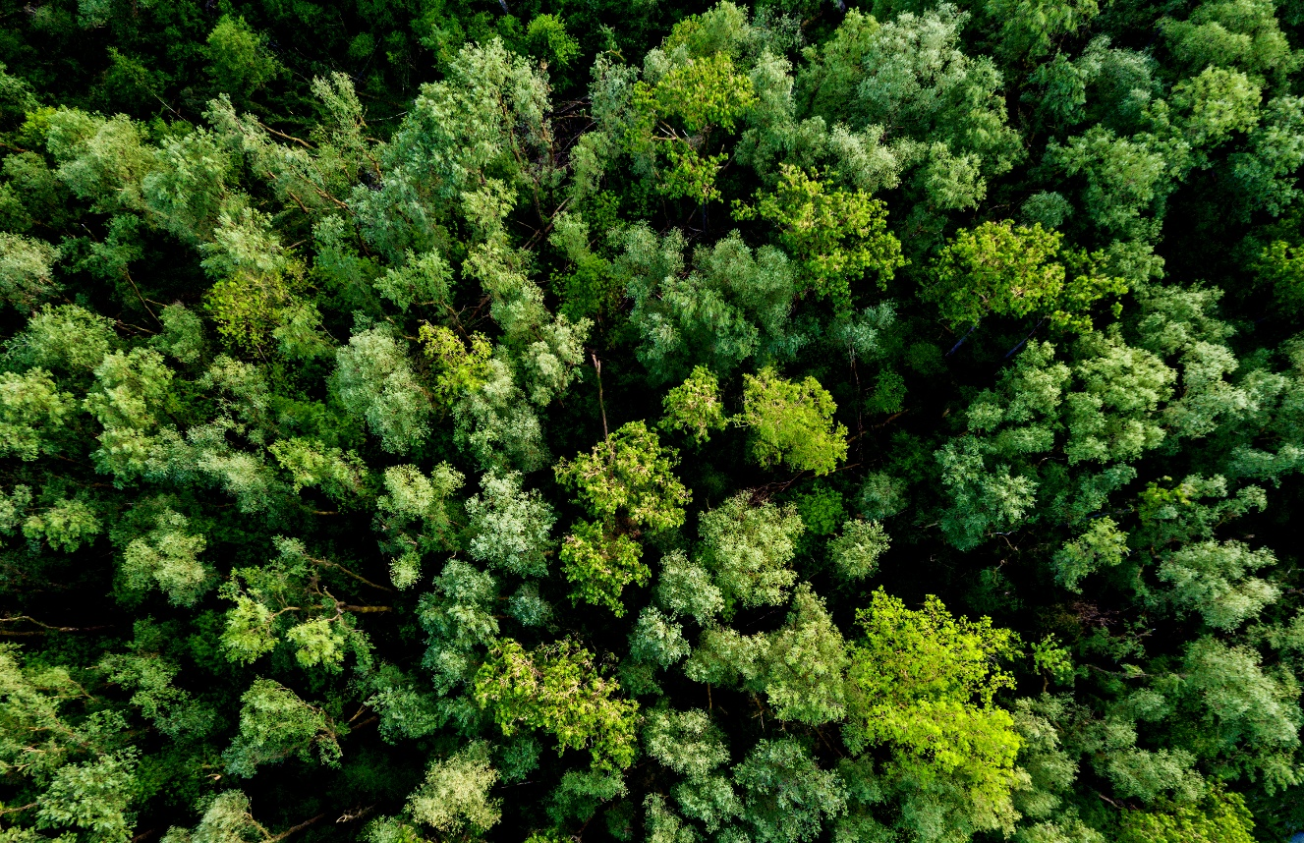
Contents:
Essay – Pg 3-8
Leaflet – Pg 9
Risk Benefit Assessment – Pg 10-11
Literature Review – Pg 12- 17

Compare and contrast the scope and approach to outdoor provision in two types of setting e.g. early years, primary, secondary, PRU, ALN units, etc.
This essay was written as part of the outdoor education and learning module which is being studied as part of an Inclusive Education degree at University of Wales Trinity Saint David. Outdoor learning is becoming more prevalent in recent years, and we are seeing more and more schools adopting a more biophilic approach and integrating nature and the outdoors in the learning environment. It can have a powerful impact on pupils through their school lives and provides multiple benefits to both physical and mental health. It can also help harness essential skills and build on their confidence as they learn to enjoy the outdoors in new and innovative ways (Evolve Advice, 2026). Outdoor learning is an educational approach that is designed to take learning outside the confines of a classroom and offers pupils are chance to connect with nature. It can involve a much more hands-on experience and is not restricted to a singular environment e.g. garden, forest or beach. It can help foster skills such as problem solving and improve cognition in pupils, working in tandem with traditional learning experience (EYR Team, 2025). The approach to outdoor learning can differ immensely depending on needs and abilities and provisions. Two provisions that have different scope and approaches are primary education and that of a pupil referral unit (PRU). Both these settings can find benefits in engaging in outdoor education, but the needs of learners can differ greatly. This essay will explore the different approaches both of these settings take and how it affects that of the children who take part.
There are many relevant theories and legislation that support the hypothesis and usage of outdoor education and the implementation in schools. One such theory is that of Biophilia coined by Edward O. Wilson (1984). This theory defined it as a innate needs human have to connect with nature on a genetic level, and that it can provide benefits to human health (Mischel, 2019). Another theory that supports the use of outdoor education is the Experimental Learning Theory by David Kolb (1984). This theory relies on a cycle of experiences, which many of these can be attained through outdoor activities. These can provide rich experiences and provide broader scopes for learning as well as incorporating a reflective element. This can allow learners to reflect and understand the skills and activities they’re conducting (Lynch, 2010). In it’s basic form, Kolb’s theory learning happens through doing and reflecting on how things are done. From there, learners can think about their experience and reflect on it. Learning ultimately begins with experience and outdoor education can provide many varied experiences and activities, due to the hands-on and practical nature and the importance of reflection is paramount as they can try this activity again with can further embed the learning outcome (Mcleod, 2025). Finally, another theory with relevance is Lev Vygotsky’s social constructivism (1962). He believed that learning in children happens through hands on experiences, similarly to Kolb. Social interactions play in huge part in learning according to Vygotsky, and he also places a lot of learnging responsibilities on the more knowledgeable other (MKO). This can be the class teacher or outdoor instructor who can guide the learning within a session and allow children to explore their abilities and develop skills (Redford, 2013). When applied to outdoor learning, this theory highlights the benefits outdoor learning can have and also highlights the importance of social interaction with both peers and the MKO. Vygotsky highlights the importance of play can improve confidence, social skills and communication (Mini Mudders, 2025).
When looking at outdoor education, there can be differing scopes and approaches to it depending on provision. Children at a primary school age are at pivotal ages when it comes to learning, and it important for them to know that learning can take place both in and out of the classroom. Outdoor learning often encourages a child-led approach and allows them a degree of exploration and engagement with the natural environment (Eco Active, 2021). Children are seen to be healthier and happier when they are regularly exposed to the outdoors, to not only to learn but to play. Learners in a primary school setting will specifically find benefits in play, as aforementioned with Vygotsky’s theory. One school in Cornwall have homed in on outdoor education, creating activities that promote leadership among the children. From these activities they have found their pupils to become more confident and creative in their play which in turn became transferable to their learning in the classroom (Eden Project, 2026). When looking at early primary school ages, the scope is most focused on developmental aims, with a more holistic approach. Learning outdoors at this age can aid social and cognitive development as well as emotional wellbeing which can also be applied across the curriculum e.g. measuring in maths or plants for science (White, 2019). Outdoor education was once considered quite limited, with pupils going outdoors for physical education or perhaps a one-off science lesson. This has however developed over time and this is notable in primary school settings leaning in towards a more child-led approach. Spontaneous and informal education allows a degree of flexible and encourages pupils to be creative and independent. It also allows the class teacher/instructor to follow the interests of the children and have a more natural approach to teaching (Jeffs and Ord, 2018). This approach was firmly backed by Friedrich Frobel who coined the term ‘kindergarten’. He believed that children should experience all elements in nature and encouraged play outdoors and gain life lessons such as sustainability (Frobel Trust, 2026). This highlights the importance of the pupil-led element and how although teacher support/surveillance may be necessary, it puts a lot of the responsibility for learning in the children’s hands.
Another provision that may conduct outdoor education is a Pupil Referral Unit (PRU). These settings can have a wide range of needs and is an alternative provision for those who are unable to attend a mainstream school due to exclusion, illness, behaviour etc. This type of setting can make good use with outdoor learning, especially as it is an alternative method to learning which some pupils may respond favourably to (Department for Education, 2014). PRUs are often the most common type of alternative provision and have been seen to respond well to outdoor learning and PRUs will often offer more experimental and flexible approach in order to support their leaners. Teaching can differ greatly from that of a mainstream school (Owen et al., 2025). Outdoor learning can be an effective intervention in a PRU setting. One programme that proves this fact is Path Hill Outdoors which is a great example of how to implement this with PRU pupils. One factor of their delivery is that they provide a more structured programme in smaller groups or a 1:1 basis designed with pupils in mind. It appears it is similar to the primary approach as it delegates some responsibilities to learners and have their needs at the focal point (Path Hill Outdoors, 2024). It is worthy noting that alternative provisions can differ beyond a PRU, with some parents choosing to have their children attending forest schools or farm school. These provisions have a stronger focus on outdoor education and are primarily outdoor based where PRUs may offer in the means of intervention and support as well as learning ( Oldham Council, 2015).
To conclude there are significant difference when it comes to the approach and scope of outdoor learning when looking at these two provisions. These differences highlight the different level and needs of the pupils in these setting and how this intervention can offer the most support. The benefits to outdoor learning however can be received at any age and encouraging this type of learning can provide some key lessons and enhance important skills from a young age. Whereas a primary setting would take a more nurturing and playful approach, those in a PRU may find skills that they are able to develop and hone into a potential craft and get them to think of potential careers or life opportunities. It is also a great opportunity to get learners out of a stagnant setting and allow them to explore and be at one with nature and the outdoors. Key theories can support why the use is beneficial and both settings and introducing learning outdoors as early as primary could provide long lasting benefits as they progress through education.

Reference list:

Department for Education (2014). Pupil referral units: converting to alternative provision academies. [online] GOV.UK. Available at: https://www.gov.uk/guidance/pupil-referral-units-converting-to-alternative-provision-academies [Accessed 31 Mar. 2026].
Eco Active (2021). ecoACTIVE | environmental education in East London. [online] ecoACTIVE | environmental education in East London. Available at: https://www.ecoactive.org.uk/blog/understanding-the-long-term-educational-benefits-of-outdoor-learning-in-primary-schools?gad_source=1&gad_campaignid=22918380623&gclid=EAIaIQobChMIkffwlavFkwMVXptQBh25VwKWEAAYASAAEgJ_kPD_BwE [Accessed 29 Mar. 2026].
Eden Project (2026). Embedding outdoor learning in a primary school. [online] The Eden Project. Available at: https://www.edenproject.com/learn/schools/teacher-training/embedding-outdoor-learning-in-a-primary-school [Accessed 29 Mar. 2026].
Evolve Advice (2026). Why do outdoor learning? [online] EVOLVE Advice. Available at: https://www.evolveadvice.co.uk/hqol [Accessed 26 Mar. 2026].
EYR Team (2025). What is Outdoor Learning? [online] Early Years Resources. Available at: https://www.earlyyearsresources.co.uk/blog/what-is-outdoor-learning/ [Accessed 26 Mar. 2026].
Frobel Trust (2026). Children and nature. [online] Froebel Trust. Available at: https://www.froebel.org.uk/training-and-resources/children-and-nature?gad_source=1&gad_campaignid=23308336546&gclid=EAIaIQobChMIsYaahfXJkwMVyY9QBh0YsB1HEAAYASAAEgIU_fD_BwE [Accessed 31 Mar. 2026].
Jeffs, T. and Ord, J. (2018). Rethinking outdoor, experiential and informal education: beyond the confines. Abingdon, Oxon ; New York, Ny: Routledge, pp.1–49. [Accessed 31 Mar. 2026].
Lynch, J. (2010). Institute for Outdoor Learning. [online] Available at: https://www.outdoor-learning-research.org/Portals/0/Research%20Documents/Horizons%20Archive/dt_h51.learningskills.pdf?ver=2010-11-15-140338-000 [Accessed 29 Mar. 2026].
Mcleod, S. (2025). Kolb’s Learning Styles and Experiential Learning Cycle. [online] Simply Psychology. Available at: https://www.simplypsychology.org/learning-kolb.html [Accessed 29 Mar. 2026].
Mini Mudders (2025). Outdoor Play and Learning for Kids. [online] Mini Mudders. Available at: https://www.mini-mudders.co.uk/post/how-outdoor-play-boosts-children-s-learning [Accessed 29 Mar. 2026].
Mischel, W. (2019). psychology | Definition, History, Fields, Methods, & Facts. In: Encyclopædia Britannica. [online] Available at: https://www.britannica.com/science/psychology [Accessed 26 Mar. 2026].
Oldham Council (2015). Alternative provision | Alternative provision | Oldham Council. Oldham.gov.uk. [online] doi:https://www.oldham.gov.uk/site/scripts/documents_info.php?categoryID=100005&documentID=3244. [Accessed 31 Mar. 2026].
Owen, D.K., Williams, D.M., Hodgson, D.A., Jones, M. and McAlister-Wilson, S. (2025). Realising the Curriculum for Wales in Education Other Than At School (EOTAS) provision including Pupil Referral Units (PRU): a qualitative study. [online] pp.14–32. Available at: https://www.gov.wales/sites/default/files/statistics-and-research/2025-07/realising-the-curriculum-for-wales-in-education-other-than-at-school-eotas-provision-including-pupil-referral-units-pru-a-qualitative-study_1.pdf [Accessed 31 Mar. 2026].
Path Hill Outdoors (2024). Alternative Provision | Pathhill. [online] Pathhill.com. Available at: https://pathhill.com/alternative-provision/ [Accessed 31 Mar. 2026].
Redford, M. (2013). Piaget, Vygotsky and Forest School – Nest in the Woods. [online] Nestinthewoods.co.uk. Available at: https://nestinthewoods.co.uk/piaget-vygotsky-forest-school/ [Accessed 29 Mar. 2026].
White, J. (2019). PLAYING AND LEARNING OUTDOORS : making provision for high quality experiences in the outdoor ... environment with children 3-7. Routledge. [Accessed 30 Mar. 2026].

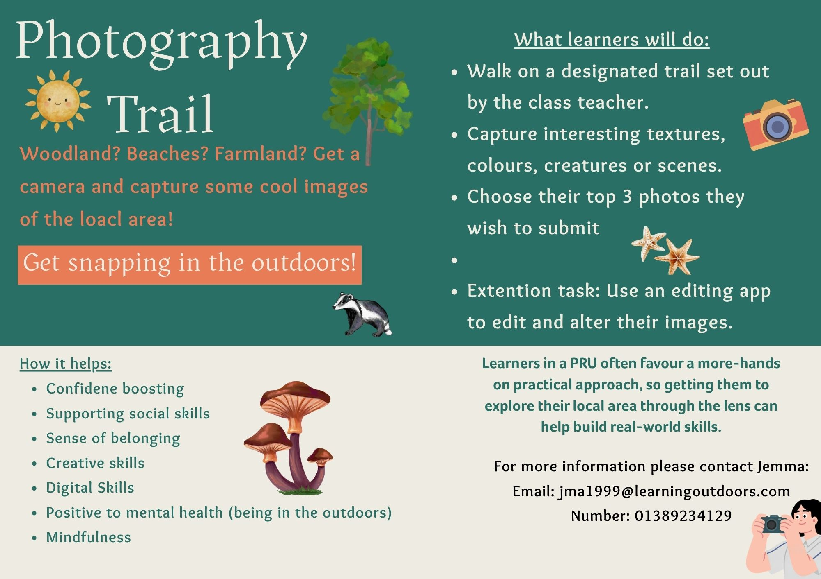
RISK BENEFIT ASSESSMENT

Location / Activity: | Photography Trail | Date: | 01/04/26
Assessor: | Jemma Matthews | Review date: | 07/04/26

The boxes in the table below will expand as you type into them; pre-entered text is simply for illustration. You should delete irrelevant items and replace with text relevant to your circumstances.
Your overall risk rating – Low, medium or high – is based on your judgement about whether the BENEFITS of the activity or opportunity outweigh the RISKS.

ACTIVITY | How will young people BENEFIT from this activity? | Possible hazards | Who is at risk? | PRECAUTIONS in place to reduce the risk of injury | Overall risk RATING: L/M/H
Woodland walk | Being in the outdoors will benefit both physical and mental health. This will give learners a chance to explore some of the local area in a supervised manner and leave confines of the classroom | Slips, trips and falls.  Cuts, grazes and abrasions.  Drowning (if passing water) | Young people; adults | - Keep on the set path led by class teacher  - Have pupils be mindful of where they step  - Keep a safe distance from any water  - Always carry first kit in case of injury. | Low
Photography | This is a creative skill that can build technology skills and enhance cognitive development. | Images of others taken without consent – supervision required  Slips, trips, falls.  Cuts, grazes and abrasions. | Young people/adults, members of the public. | - Closely monitor what images the young people are taking – opt to use cameras rather than mobile phones  - Ensure pupils are mindful of surroundings whilst they are taking pictures  - Always carry first aid kit in case of injury.  - Ensure members of the public are not featured in photographs.  - Have pupils be respectful of the environment | Low

Literature Review – The Role of Outdoor Education
This review has been written as part of a study for an Inclusive Education degree for University of Wales Trinity Saint David. Outdoor education is becoming more relevant in the educational system and involves any type of learning or play that occurs outdoors. There has been a surge of popularity in recent years as seen through the existence of forest schools and other specified outdoor provisions. Outdoor education can have numerous benefits, and its main aims can be to enhance skills and development as well as developing a deeper relationship with nature (Clarke , 2022). In this modern climate, it can be difficult to deliver in a traditional classrooms and teachers are required to become more creative to engage their learners, as well as differentiating their lessons and accommodating pupil’s needs. There is also the factor of mental health, and spending time in nature can improve this by promoting relaxations and reducing stress levels. “Nature Deficit Disorder” is a term used to describe some of the negative effects of not going outside and outdoor learning can be used to alleviate and combat this issue (Ennis, 2025). Inclusivity is also an imperative part in education and outdoor learning can really foster this by promoting a sense of community whilst also strengthening social skills. Promoting these can be effective in developing a sense of belonging and respect as well as deepening connections with nature and the wider world (Beausetha Juhetha Bruwer, Tan and Moscato, 2025). This review will look are the wider role of outdoor learning and what it brings to education and the lives of children and young people, whilst also looking at the supporting theories and the limitations it might face.
A key theory that would support an outdoor learning model is John Dewy’s learning theory (1938). This theory is supportive of the fact that learning occurs best through experiences, particularly those that require active engagement. It also promotes learning in a social environment so that learning can be also developed through peers and can become more meaningful on reflection (Cloke, 2023). These key components are frequently observed and utilised in outdoor education as it involves more hands-on activities and often requires pupils to work together e.g. scavenger hunts. Dewey’s theory firmly underpins the benefits to outdoor learning and how it may enhance cognitive development in comparison to learning in a traditional classroom. Outdoor education has also been recognised historically as a worthy intervention, with people such as Susan Isaacs and Margaret McMillan creating outdoor spaces withing school and open-air nurseries with emphasis on promoting health, wellbeing and play (Luds Kadimba, 2011). Another significant figure in the world of outdoor education is Maria Montessori. As part of her philosophy, she believed in the need for connection with the natural world and the importance that playing in the outdoors can have on a child’s development. The Montessori approach is becoming a well-known term as schools adopt the principles. In doing this, they offer more sensory experiences that promote physical, social and mental health. Furthermore, having younger children develop these connections with nature helps them have a more responsible outlook on nature and the environment as they grow up, creating more ethically informed citizens (Montessori Partnership, 2021).
These theories do provide the foundations of why outdoor education can be affective. One example of this is that natural environments help restore attentional capacity. Even just small purposeful breaks in nature can help restore attention, particularly after mentally demanding tasks such as a test. Exposure to the outdoors can act as a form of “reset” of the brain. This aligns with Kaplan’s Attention Restoration Theory (ART) which similarly proposed that breaks in nature can help restore attention (Mason et al., 2021). One such study investigated this theory and sound that those who received a short break in nature achieved better results in an arithmetic task afterwards, further supporting the benefits of outdoor exposure (Ginns, Muscat and Naylor, 2023). Outdoor education can also have a profound effect on cognition as taking part in nature-based activities and learning can help in creating a deeper understanding of the subject. This can be particularly prevalent in children who may not go outdoors frequently and getting them outdoors can activate the part of their brain that often lays dormant, enhancing problem solving skills and creativity (Katie is a teacher, 2025).
Green environments have also been known to have a beneficial impact on mental health and wellbeing. Whilst it has been linked to benefitting cognition, it notably has a similar effect on mental health, and it provides a way of regulating their emotions in a therapeutic setting. Those with additional learning needs (ALN) such as attention deficit hyperactivity disorder (ADHD) may also have a positive experience with outdoor learning, as nature can help learners who experience heightened stress, emotions or dysregulation they may experience in a tractional classroom (Alessandro Piedimonte et al., 2025). Further studies into schools who have made use of natural spaces and outdoor learning time. These have solidified the theory of the positive impact on mental health further. This is seen in school children with regular exposure, who showed protective effects against emotional distress or anxiety. This could be seen as a preventive method as we are seeing an incline in mental health challenges. Researchers so suggest however that nature-based learning should be seen as promoting good mental health as opposed to seeing it as a treatment measure (Lomax et al., 2024). Learning in the outdoors can also provide some enrichment social development, particularly when conducting group activities and challenges. One review reported reliable evidence that suggests outdoor activities help improve peer relationships, communication skills and overall teamwork (Manto-Markela Vasilaki et al., 2025). Finally, outdoor education can support a child’s socio-emotional growth, which can be done through collaboration and immersive experiences. This is becoming a factor that is increasingly important to nurture, particularly in more urban areas and rising concerns around children’s mental health (Mann, 2025).
Although there are numerous benefits to the use of outdoor learning, there are some challenges and limitations that pupils and teachers might encounter. One example of this is inconsistencies between early years and primary schools as access to outdoor learning reduces once children enter formal education (Frances et al., 2024). Another challenging factor is that of teacher confidence. Many teachers who are tasked with facilitating outdoor learning lack training in outdoor pedagogy and may ultimately struggle to conduct outdoor learning effectively (Klopčič and Torkar, 2025). This issue can be rectified with widespread training in delivering outdoor sessions, but this may be heavily dependent on budgets, environments and resources. There is also the challenge the curriculum poses on the delivery of outdoor learning. The curriculum may involve a tighter structure which could pose difficulties in embedding outdoor education into practise. There may also be an added pressure of academic expectations which some may see as taking children away from their formal qualitive learning (Parkin et al., 2026). There is a promising step in regard to the Welsh curriculum, as there are areas that support outdoor learning. One of the areas of learning is Health and Wellbeing which aligns with having children outdoors and in nature and reaping the benefits that this can bring. Along with this, two of the four purposes include creating ethically informed citizens and healthy and confident individuals. This again aligns with the concept of embedding outdoor learning into practise and takes away the focus on a fixed subject making it relevant to the curriculum (Welsh Government, 2023).
To conclude, this review aimed to explore outdoor learning, what challenges it faces and the benefits it grants. After looking into the theoretical perspectives and the relevant research, it is clear to see that outdoor education offers significant benefits to children and young people. These benefits range from that of physical health to mental health and even the cognitive development. When looking at theories such as John Dewey’s and that of Maria Montessori it is clear that they believe in the use of the senses and put emphasis on a more kinaesthetic learning environment. Their belief in learning being best when it is social and active heavily supports the use of learning outdoors and the themes of learning that can offer. Furthermore, these factors are reinforced further by Kaplan’s ART theory which evokes the beneficial effect natural spaces can have on restoring attention and focus. When exploring the relevant research into outdoor education, it is clear that these theories provide a solid foundation into how outdoor learning can be executed. It further underpins with evidence that shows the benefits to mental well-being as well as attention and regulation. Ultimately, outlearning can offer a sense of belonging and allow learners to develop key life skills and enhance themselves socially. There is also a key inclusive element as outdoor education can also be an effective intervention when working with those with ALN. It is clear however that outdoor learning still faces some notable challenges which and hinder it’s effectiveness. These can range from lack of training to lack of outdoor space. This, along with curriculum pressure and discrepancies between provisions does highlight the difficulties many might face when trying to adopt these practises. However, it is clear that in this modern climate there is a rising need to support the mental health and wellbeing of children, particularly with what they are susceptible to such as social media. This could be a significant driving force that encourages more schools and provisions to create more natural spaces and taking some time to get their learners outdoors. This may bring some promising long-term outcomes with the benefits that outdoor learning can bestow on pupils, it is something they can take into adulthood and become much more ethical and empowered citizens.

Reference list:
Alessandro Piedimonte, Lanzo, G., Campaci, F., Volpino, V. and Carlino, E. (2025). Spreading New Light on Attention Restoration Theory: An Environmental Posner Paradigm. Brain Sciences, [online] 15(6). doi:https://doi.org/10.3390/brainsci15060578. [Accessed 18 Apr. 2026].
Beausetha Juhetha Bruwer, Tan, V. and Moscato, M. (2025). Inclusivity in Outdoor Education. [online] All-means-all.education. Available at: https://book.all-means-all.education/ama-2025-en/chapter/inclusivity-in-outdoor-education-education-in-nature/ [Accessed 4 Apr. 2026].
Clarke , N. (2022). Outdoor Education - Past, Present and Future | Tapestry. [online] Tapestry. Available at: https://tapestry.info/outdoor-education-past-present-and-future/ [Accessed 4 Apr. 2026].
Cloke, H. (2023). John Dewey’s Learning Theory: How We Learn Through Experience. [online] Growth Engineering. Available at: https://www.growthengineering.co.uk/john-dewey/ [Accessed 4 Apr. 2026].
Ennis, J. (2025). Benefits Of Outdoor Learning For Students | The Learning Adventure. [online] The Learning Adventure. Available at: https://thelearningadventure.com/blog/general/benefits-of-outdoor-learning-for-students/ [Accessed 4 Apr. 2026].
Frances, L., Quinn, F., Elliott, S. and Bird, J. (2024). Outdoor learning across the early years in Australia: Inconsistencies, challenges, and recommendations. The Australian Educational Researcher, [online] 41(2), pp.2142–2145. doi:https://doi.org/10.1007/s13384-023-00685-x. [Accessed 19 Apr. 2026].
Ginns, P., Muscat, K. and Naylor, R. (2023). Rest Breaks Aid Directed Attention and Learning. The Educational and Developmental Psychologist, [online] 40(2), pp.141–150. doi:https://doi.org/10.1080/20590776.2023.2225700. [Accessed 18 Apr. 2026].
Katie is a Teacher (2025). The Power of Nature: How Outdoor Learning Boosts Academic Performance. [online] Katieisateacher.com. Available at: https://katieisateacher.com/2025/01/07/the-power-of-nature-how-outdoor-learning-boosts-academic-performance/ [Accessed 18 Apr. 2026].
Klopčič, M. and Torkar, G. (2025). Emerging themes of empirical research into outdoor science teaching: A systematic literature review. Journal of Outdoor and Environmental Education, [online] 21(1), pp.4–7. doi:https://doi.org/10.1007/s42322-025-00215-6. [Accessed 23 Apr. 2026].
Lomax, T., Butler, J., Cipriani, A. and Singh, I. (2024). Effect of nature on the mental health and well-being of children and adolescents: meta-review. The British Journal of Psychiatry, [online] 225(3), pp.400–406. doi:https://doi.org/10.1192/bjp.2024.109. [Accessed 19 Apr. 2026].

Luds Kadimba (2011). Why Is Outdoor Play Important for Children? Theorists Weigh In On Benefits. [online] Bright Hub Education. Available at: https://www.brighthubeducation.com/teaching-preschool/107367-theories-on-the-importance-of-outdoor-play/ [Accessed 4 Apr. 2026].
Mann, J. (2025). Honouring the value of outdoor learning with high-quality research. Journal of Adventure Education and Outdoor Learning, [online] 24(1), pp.1–4. doi:https://doi.org/10.1080/14729679.2025.2486851. [Accessed 19 Apr. 2026].
Manto-Markela Vasilaki, Aglaia Zafeiroudi, Ioannis Tsartsapakis, Grivas, G.V., Athanasia Chatzipanteli, Aphamis, G., Christoforos Giannaki and Charilaos Kouthouris (2025). Learning in Nature: A Systematic Review and Meta-Analysis of Outdoor Recreation’s Role in Youth Development. Education Sciences, [online] 15(3), pp.2–9. doi:https://doi.org/10.3390/educsci15030332. [Accessed 19 Apr. 2026].
Mason, L., Ronconi, A., Scrimin, S. and Pazzaglia, F. (2021). Short-Term Exposure to Nature and Benefits for Students’ Cognitive Performance: a Review. Educational Psychology Review, 34(2), pp.609–647. [Accessed 23 Apr. 2026].
Montessori Partnership (2021). The Montessori take on nature and outdoor play. [online] Montessori Partnership. Available at: https://www.montessoripartnership.com/2021/11/15/the-montessori-take-on-nature-and-outdoor-play/ [Accessed 4 Apr. 2026].
Parkin, N., Hobson, K., Poortinga, W., Stead, M., Newth, J., Reeves, J. and Gattis, M. (2026). ‘A completely different space’: Teachers’ perspectives on disadvantage, access to nature and outdoor learning. British Educational Research Journal. [online] doi:https://doi.org/10.1002/berj.70103. [Accessed 23 Apr. 2026].
Welsh Government (2023). Teaching and Learning in the outdoors: the Current State of Outdoor Learning in Schools in Wales Research. [online] pp.3–21. Available at: https://hwb.gov.wales/api/storage/177a33a6-7c70-4843-bb63-903e70a04154/teaching-and-learning-in-the-outdoors-the-current-state-of-outdoor-learning-in-schools-in-wales.pdf [Accessed 23 Apr. 2026].

