Name: Alexander Lemos (1917608)
Module: Foreign languages and culture awareness.
The third assignment: Hotel display board. Due date: 19, November, 2021.
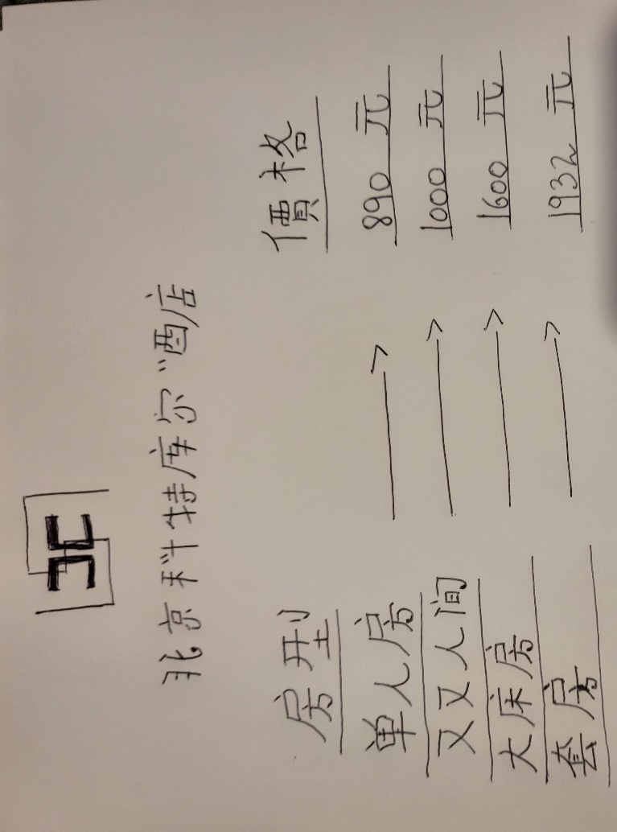
Lecturer: Jinping Li

