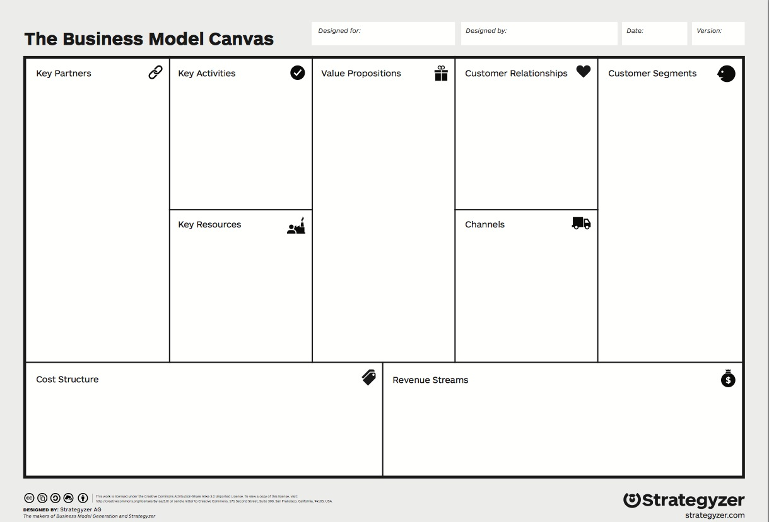
-
Oct/17
RAW Kitchen
Luiza, Leigh & Darren
- Affordable Food - In store sales
- Cash and Card Payments - Delivery
- Advertising
- Merchandise
- Locally produced
- Premises - Production Cost
- Licenses/taxes - Staff
- Food - Wifi
- Marketing - Maintenance
- Drinks - Staff/ salaries
- Website
- Social Media
- Gym
- Word of Mouth
- Universities/ fayres
- Take-away

- Staff
- Raw Materials
- Equipment
- Website
- Premises
- Marketing
- Gym Goers
- Young Adults
- Students
- Vegetarians
- People with dietary needs
- Online Feedback
- Student Offers
- Monthly Offers
- Suppliers
- Loyalty Card
- Fast Service
- Customer Service
- Cheap
- Healthy
- Food Nutrition
- Variety
- Social
- Take Away Food
- Convenient
- Delivery

- Food
- Smoothies/ Drinks
- Marketing
- Website
- Customer Service

- Gyms
- Delivery Companies
- Local Butchers
- Universities
- Students
- UniDays
- Farms
- Wholesalers
- Future Share Holders

