

Student name: Katarzyna Gluba
Student ID:2316845

Module name: Psychopathological Classifications and Provisions
Module code: (BMHP6029_LON)
Acknowledgement of the use/non-use of AI:

ANXIETY – PSYCHOLOGICAL RESEARCH
by KATARZYNA GLUBA

Introduction  Classification: Anxiety disorders  Anxiety disorders are the most prevalent mental health condition globally.​  Around 4.4% of the world’s population (about 359 million people) experience an anxiety disorder at any given time.​  Lifetime prevalence can be as high as 33.7% in large population studies.​  In the UK, over 8 million people are estimated to be living with an anxiety disorder at any one time.​  Generalised Anxiety Disorder (GAD) affects around 6 in 100 people weekly in England, with mixed anxiety and depression affecting 8 in 100.  Historical perspectives and treatments  - In the past, people with anxiety were often misunderstood and stigmatized, sometimes thought to be mentally weak or possessed.​  - Treatments in the 20th century evolved from sedatives and shock therapies to modern cognitive behavioural therapy and medications like benzodiazepines and SSRIs.  - Today, anxiety disorders are accepted medical conditions treated with evidence-based therapies, reducing stigma and improving recovery opportunities. |  | ANXIETY DISORDER  Definition (Aquin, J.P., et al. 2017)  An anxiety disorder is a mental health condition where a person experiences intense, persistent fear or worry that interferes with daily life.  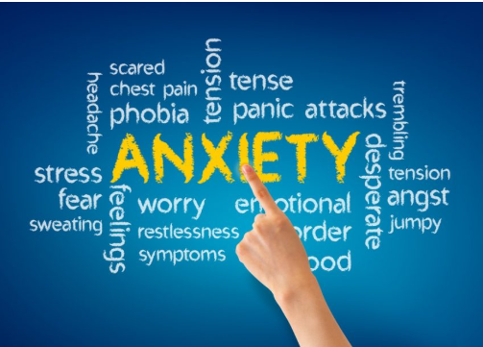  CAUSES  Anxiety disorders do not have a single cause but are linked to a mix of genetics (family history), brain chemistry, life experiences like trauma or high stress, and certain physical health conditions. Social and environmental factors—such as ongoing stress, childhood adversity, or substance misuse—can also increase risk.  SYMPTOMS (Allbaugh et al., 2025)  Common symptoms of anxiety disorders include intense fear or worry, a sense of panic, rapid heartbeat, sweating, dizziness, trouble sleeping, difficulty concentrating, restlessness, stomach upset, and avoidance of stressful situations.  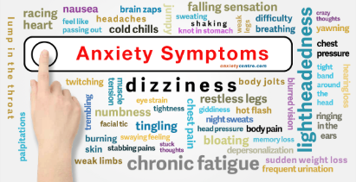  Diagnosis  Anxiety disorders are diagnosed through a combination of a detailed clinical interview about symptoms and their impact, using standard questionnaires, and by ruling out physical causes with a medical exam and tests if needed. Mental health professionals use criteria from the DSM-5 (such as duration, severity, triggers, and effect on daily functioning) to confirm a diagnosis and determine the specific type. |  | Current services and treatments  - Talking therapies: Cognitive behavioural therapy (CBT) and other psychological interventions are available through the NHS and privately; these help people learn coping skills and change unhelpful thinking.​  - Medication: Antidepressants, mainly selective serotonin reuptake inhibitors (SSRIs), are often prescribed; benzodiazepines or beta-blockers may be used in some cases.  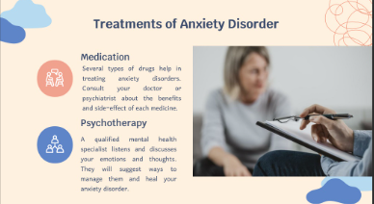  Recommendations  - Raise public awareness and reduce stigma so individuals feel safe seeking help early.​  - Expand access to talking therapies and evidence-based psychological treatments such as CBT through health services and digital platforms  Conclusions  Based on current research and best practice guidance, anxiety disorders are common but highly treatable with the right support. The most effective approaches combine cognitive behavioral therapy (CBT), evidence-based medication when needed (such as SSRIs), and lifestyle interventions like exercise or mindfulness. Early intervention, public awareness, and access to quality care can improve outcomes and quality of life for those affected.

References
- Aquin, J.P., et al. (2017) 'Anxiety Disorders and General Medical Conditions', Psychiatry Investigation, 14(2), pp. 173–182. Available at: https://pmc.ncbi.nlm.nih.gov/articles/PMC6526963/ [Accessed 22 November 2025].​
- National Institute for Health and Care Excellence (NICE) (2020) 'Generalised anxiety disorder and panic disorder in adults: management (CG113)', NICE Clinical Guideline. Available at: https://www.nice.org.uk/guidance/cg113 [Accessed 22 November 2025].​
- Chen, A., Metzger, E., Lee, S., & Osser, D. (2025) 'A Proposed Algorithm for the Pharmacological Treatment of Generalized Anxiety Disorder in the Older Patient', Journal of Geriatric Psychiatry and Neurology, 38(3), pp. 195–204. Available at: https://journals.sagepub.com/doi/10.1177/08919887241289533 [Accessed 22 November 2025].​
- Rodrigues, F.A.A. (2025) 'Generalized Anxiety Disorder (GAD) and its Relationship with Panic Syndrome and Depression', Healthcare Bulletin, 33(1), pp. 45–59. Available at: https://healthcare-bulletin.co.uk/article/generalized-anxiety-disorder-gad-and-its-relationship-with-panic-syndrome-and-depressi... [Accessed 22 November 2025].​
- Harvard Medical School (2025) 'Crossing line between good and bad anxiety', The Harvard Gazette, 30 September. Available at: https://news.harvard.edu/gazette/story/2025/09/crossing-line-between-good-and-bad-anxiety/ [Accessed 22 November 2025].​
- Allbaugh, L.J. et al. (2025) 'Understanding emotion dysregulation in PTSD – GAD comorbidity', Journal of Anxiety Disorders, 75, 102491. Available at: https://www.sciencedirect.com/science/article/pii/S0887618525000210 [Accessed 22 November 2025].​
- HARP-II Investigators (2012) 'The Harvard/Brown Anxiety Research Project – Phase II (HARP-II)', Journal of Anxiety Disorders, 26(2), pp. 203–212. Available at: https://pmc.ncbi.nlm.nih.gov/articles/PMC3319242/ [Accessed 22 November 2025].​
- JAMA Psychiatry (2024) 'Psychotherapies for Generalized Anxiety Disorder in Adults: A systematic review and network meta-analysis', JAMA Psychiatry, 81(3), pp. 215–229. Available at: https://jamanetwork.com/journals/jamapsychiatry/fullarticle/2810866 [Accessed 22 November 2025].​
- Nature Reviews Disease Primers (2017) 'Anxiety disorders', Nature Reviews Disease Primers, 3, 17024. Available at: https://www.nature.com/articles/nrdp201724 [Accessed 22 November 2025].​
- National Institute for Health and Care Excellence (NICE) (2020) 'Generalised anxiety disorder and panic disorder in adults: management (CG113)', NICE Clinical Guideline. Available at: https://www.nice.org.uk/guidance/cg113 [Accessed 22 November 2025].​

