

University of Wales Trinity Saint David
03/11/22/ECAD6007
Assignment
By Isabella Jane Witt

Title:

A critical evaluation and the identification of next teaching and learning steps focusing on a case study of an individual learner, based on an observed critical incident.

“a critical incident is an interpretation of the significance of an event. To take something as a critical incident is a value judgment we make, and the basis of that judgment is a significance we attach to the meaning of the incident” Tripp, (1993)

The definition of ‘Critical incidents’ originates from a biography, where it indicates a critical incident as a significant event or important moment that can be learnt from. Tripp, (2012). However, in order to critically evaluate, we must reflect on past experiences. Reflection within the teaching practice can be seen as not the steps that occur to the outcome, but the significant role of the outcome, and how it can influence future learning. But why is reflection so important?
It has been argued by Wheatley, (2002) that ‘Without reflection, we go blindly on our own way, creating more unintended consequences, and failing to achieve anything useful’. Practicing in a professional teaching environment involves constant review and complying with the growing knowledge and understanding surrounding the profession. (Bassot, 2016).
This critical evaluation will outline an incident observed at a Primary School through reflective practice, the new adapted approach will be implemented into future learning environments. This assignment will reflect on a behaviour management of an individual pupil with attention deficit hyperactivity disorder (ADHD), and how behaviour management can be effectively achieved. A full analysis will be provided to establish what has been learnt and carried forward into the professional teaching practice.

The role of critical reflection

The role of critical reflection is developed through years of critical reflection within the teaching profession. According to Tripp, (2012) a critical incident can occur in the classroom setting or learning environment. From this incident, there are usually several possible outcomes, all of which can be analysed critically. It is important to note that not all critical incidents are negative, but if the outcome has been carefully researched, developed in future practice, and enhance understanding and knowledge.

‘It is not simply what we teach, but how we teach and crucially, why we teach’- Curriculum of Wales: Overview (Welsh Government, 2017).

The new reformed curriculum in Wales has been developed by teaching professionals, educational experts and previous research. Curriculum of Wales: Overview (Welsh Government, 2017). The new curriculum has been built on the base of critical reflection. Asking questions and critically reflecting on the previous experiences of teachers in Wales.
Teachers within Wales must now meet the new Professional Teaching Standards. Teachers must demonstrate effective Pedagogy; teachers must adapt to new relevant material and influence the leaner. Collaboration, teachers must develop a good working relationship with colleague, to develop a good working practice. Leadership, the teacher must support and lead all pupils across the school. Professional Learning, the teacher should engage in relevant and new content. Innovation, ‘moving pedagogy forward’. Curriculum of Wales: Overview (Welsh Government, 2017). These are all essential of the professional to become an effective teacher and continue to evolve in their profession. There are several reflective models developed. Kolb’s 1984, Gibbs 1988, Schon 1978 and Brookfield 1998 & 2005. These have been used to reflect on teaching practice. Teaching professionals evaluated their practise and have used their skills and learnt experiences to improve learning outcomes of their learners. ‘Learning is the process whereby knowledge is created through the transformation of experiences.’ (Kolb, 1984, p. 38) Although, critical incidents are primarily essential for the teachers to develop their own practice and improve future teaching, Tripp, (2012) also expressed his desire to enhance the general status of teaching and develop the research surrounding education. Research has emphasised that teaching is constantly developing and improving, professionals within teaching must keep up with newfound research. And constantly asking themselves the question, what approach would I implement next time?

Observations

Following BERA guidelines “the confidential and anonymous treatment of participants’ data is considered the norm for the conduct of research”, Within this critical evaluation the school, staff, and the pupils observed will remain anonymous throughout. The individual pupil will be referred to as ‘pupil X’.
The observation took place at an English medium primary school based in Ystradgynlais in the local authority of Powys. Ystradgynlais is an old industrial town in the Swansea Valley’s, rich with old mining history. (Ystradgynlais & District, 2020). In the most recent school Estyn report published, it stated there were 210 pupils enrolled and 18 pupils attending nursery. The school provides 10 classes both mixed-age and single age throughout the school. The school identifies 37% of its pupils as having additional learning needs, drawn from other schools in the region. (Estyn 2015). The school currently provides 18% free schools meals, 1% below the national average of 19%. No pupils speak Welsh as a first language, and the school has very low attendance of ethnic minority pupils. This observation took place during an English Language lesson. The class had 24 pupils, 1 teacher and 1 LSA. The classroom was relatively small, pupils were working on group tables. (Estyn 2015).
The observation took place in the morning, during a year 6 English Language lesson. The class had 24 pupils, 1 teacher and 1 LSA. The classroom was relatively small for the number of pupils. Th pupils were working individually but could gain help from peers in group discussions. The pupils were sat on group tables. It is important to note that pupil X had previously been diagnosed with Attention- deficit hyperactivity disorder (ADHD).

Critical incident linked to Donaldson’s Four Purposes

The class teacher was due to take PPA time during the next lesson. I was informed by the class teacher that Pupil X had a reputation of distracting the class during lessons. Pupil X has previously been diagnosed with ADHD. Pupil X is seated on a table of 6, facing inwards.
Before leaving to begin PPA, the class teacher said to pupil X, ‘you can sit in this chair, but the power is in your hands’ and reminding pupil X that they start on a clean slate every morning. The teacher set pupil X a challenge, at a high standard, linked to Donaldson’s four purposes of becoming an ambitious, capable learner. Donaldson, (2015).
The class teacher had informed the LSA that if Pupil X misbehaves during the lesson, she is to send pupil X to the class teacher immediately. When the class teacher left, they said ‘remember what I said pupil X’ ‘yes miss/sir’. Pupil X made the decision to move themselves to another chair, for another pupil to be able to have access to the workbook but remained on the same table. Pupil X displayed mutual respect between themselves and another pupil, linked to Healthy, confident individual. Donaldson, (2015).
Pupil X answered questions during class discussion and remained on task throughout the lesson. Pupil X was engaged in class discussions, and had the confidence to answer questions, this is linked to healthy, confident individual, Donaldson’s four purposes. Donaldson, (2015). When the LSA was explaining unit 5, pupil X asked the LSA whether unit 4 pupils could start their work. The LSA engaged the pupils in scaffold learning, which allowed all pupils to understand the task. Pupil X table became chatty and distracted. Pupil X said, ‘we need to stop talking and continue with our work’. In this incident pupil X took responsibility for their learning and led by example. They encouraged their table effectively, contributing to becoming an enterprising, creative contributor, linked to Donaldson’s four purposes Donaldson, (2015). The LSA noticed this comment, and praised pupil X. The class teacher encouraged group work, but at a low volume level. Pupil received praise from the LSA throughout the lesson and remained on task. When the class teacher returned, the LSA informed the class teacher of pupil X’s good behaviour. Pupil X was rewarded with praise, and a merit. Pupil X showed pride through his body language and completing the English Language task. (Figure 1)
The focus of this critical incident is behaviour management, and how it can be implemented into the classroom. Research will also focus on positive reinforcement within the classroom, how this method can benefit a child with ADHD.

Literature review

‘The purpose of classroom management is not to teach a life lesson; rather, classroom management allows life lessons to be taught’. (Hulac and Briesch, 2017, P4)

Behaviour management is arguably the top concern in modern schools. (Parsonson, Dr B, S. 2012). Behaviour management can be defined as allowing the students ownership of their own behaviour, in a way that considers their peers. (Hulac and Briesch, 2017). Behaviour management is a universal issue, and the professionals are continuing to establish ways to increase student engagement and reduce disruption within the classroom. Although, this is not always as easy and simple as it seems. Similarly, (Hulac and Briesch, 2017) defines behaviour management as the teachers flow to ensure disruptive pupils engage in learning, but also focus on academically relevant material. Agreeing with this, (Parsonson, Dr B, S. 2012), identified behaviour to disrupt the flow in the classroom, however also identified behaviour management as a key aspect of the environment, and expressed that it is not teaching, but without it, pupils would not learn. The focus moves to the behaviour management and not the academic prospective. ‘If the classroom is not under control, no teaching can occur, and no curriculum can be taught.’ (Hulac and Briesch, 2017, p3).
Attention- deficit hyperactivity disorder (ADHD) is defined by Spohrer. K E. (2006) is a medical condition of people who have a developmental, behavioural and cognitive difficulties. An ADHD person struggles to control impulsive to act on the undesirable behaviour, often receiving the blame and made to feel guilty about difficulties out of their control. (Hughes and Cooper, 2007). According to Spohrer. K E. (2006) the factors changing behaviour to ADHD include persistence, pervasiveness and intensity. These within a classroom can be extremely challenging, and classroom strategies for ADHD children can be implemented to achieve the best learning environment for all pupils. Children with ADHD can cause significant disruption in mainstream schools, presenting challenges for teachers. (Hughes and Cooper, 2007). Strategies within school are developed to minimise disruption and allow each child to reach their potential.
Creating an effectively managed environment is the most essential skill within teaching. This is a concern for teachers, maintaining a high level of learning, but managing the behaviour is a hard task teacher are faced with within modern classrooms. This leads to the difficulty of managing the classroom setting and has been recognised as one of the main reasons teachers will leave the profession. (Hulac and Briesch, 2017). Although this is another major concern within the teaching profession, more concerning is the anti-social behaviour displayed when students leave school and enter ‘real world’ society. (Hulac and Briesch, 2017). Similarly, Van Lier et al (2004) states that children who are disruptive within the classroom are at a higher risk of many negative outcomes such as school and academic failure, poor relationships, substance use, conviction of crimes and mental health issues. Likewise, Hulac and Briesch, (2017), agrees with this finding. Pupils increase their likelihood for presenting poor social skills, exhibiting behavioural problems and developing mental health concerns.

‘Teachers are the ones who interface with these students on a daily basis and who can play an important role in these children’s lives’ (Bell, 2013 p, xxii)
Effective classroom management has been a well-researched topic and provides teachers with guidance and strategies to implement into their classroom. Setting clear expectations and rules. Kern and Clemens (2007) identifies that establishing a set of rules and expectations is associated with an effective classroom setting. Students should have the opportunity to contribute to the expectations set. The sense of involvement has been proven the display pupils to effectively following the classroom expectations. Similarly, Parsonson, Dr B, S. (2012), reiterates that clear, simple rules and expectations applied in the classroom promotes a fair environment. Research has suggested that setting clear rules for a child with ADHD benefits classroom behaviour. Rules set by the classroom teacher that ‘derive constraints imposed by a teacher-centred, curriculum focussed method.’ Hughes and Cooper, (2007). Curriculum of Wales: Overview (Welsh Government, 2017), states that pupils need clear expectations and acceptable behaviour displayed on the classroom walls and easier visible to pupils, linked into the pedagogy of setting challenges and expectations. In order to pupils to follow these expectations, teachers should lead by example. (Kern and Clemens 2007).
Classroom seating arrangement. The traditional ‘row seating’ approach has been proven to increase the quality and quantity of work completed and promote the desired behaviour. (Macblain, 2014). However, Vygotsky’s social constructivism disagrees with this traditional seating plan, his research found children learn best through social interaction with peers. (Vygotsky L. S., Kozulin A. 1989). The new Curriculum of Wales: Overview (Welsh Government, 2017), curriculum guidelines encourage group discussions and interacting during learning. Although Bennet & Blundell (1983) also agrees with seated rows, he found that there was an increase in work completed within the classroom. However, this traditional approach limits class discussion and reduces students asking questions, Kern and Clemens (2007) arguably this can limit academic improvements. Zentall, (1995) study found that ADHD children that have a semicircle seating plan, in small groups are more successful and encourages the desired behaviour of classroom rules set.
Another classroom management technique clearly demonstrates the use of praise, research suggests this is an effective way to engage pupils in good behaviour and continue this good behaviour. (Madsen, Becker and Thomas 1968). Similarly, Parsonson, Dr B, S. (2012), reiterates that four verbal statements of praise for every display of good behaviour, improves a child behaviour. Furthermore, teacher increasing the occurrence of praise can make a significant impact on pupils’ behaviour. (Kern and Clemens 2007, p. 68). However, thirty pupils in a classroom, this can be unsustainable. Behaviour can be modified through conditioning.

‘Praise is an effective way to encourage children to engage in the desired behaviour as it focuses on a child’s effort rather than on what is actually accomplished’ new Curriculum of Wales: Overview (Welsh Government, 2017).

The Behaviourist B F Skinner developed ‘Operant conditioning’. He was interested in the behaviour that is both physical and social environment. (Nye, 1980). ‘He sees humans as active organisms, capable of emitting a wide variety of such behaviours.’ (Nye, 1980, p.22). The term defined by ‘strengthening effect that occurs when operant behaviour has certain consequences.’ (Macblain, 2014, p.29). Majority of these experiments took place in the laboratory, and his work was originally tested on animals but later his researched moved to human behaviour. (Nye, 1980). Skinner was interested in the effect of reinforcement on an individual’s behaviour, known as operant conditioning. (Macblain, 2014). The concept that the conditioning is from the learner, and not the object used in Pavlov, Thorndike and Watsons research. Pavlov concentrated on the ‘simple, reflective type responses.’ (Nye, 1980, p.26). The approach although similar, had very distinctive differences. Skinners more active approach, and the voluntary response of certain behaviours. (Nye, 1980, 26). Furthermore, DuPaul and Stoner (1994), concluded that ADHD children also respond to positive reinforcement and praise. This study found that this engagement improved the performance of the pupils and suggested that positive reinforcement should primarily be the behaviour management strategy for ADHD children. Reis, (2002) reported that teachers found that positive reinforcement increased good behaviour and decreased the occurrence of negative behaviour in children with ADHD. Reinforcing Skinners results of Operant conditioning. DuPaul and stoner (1994), it should also be noted that alongside positive reinforcement, ADHD children benefit from mild negative consequences. Skinner proposed the use of positive reinforcement through smiles and praise to increase desired behaviour. However, Macblain, (2014) found that rewards and reinforcement are very different. According to Nye, (1980), rewards will not necessarily reinforce desired behaviour. Skinner acknowledged this and found that even though physical rewards may not have the desired effects, simply listening will reward and reinforce the desired behaviour. (Nye, 1980).
To conclude, behaviour management is the fundamental key to learning within a classroom. For pupils with or without ADHD, research has clearly shown that behaviour management strategies can be implemented to improve the learning environment, that can be crossed over. However, research is lacking individuality. Research has suggested behavioural management techniques that can improve pupils with ADHD behaviour within the classroom setting but does not tackle the issue per pupil. One pupil will not reaction the same as another to certain behaviour management techniques.
It is important to note that the new formed curriculum of Wales, reiterates the importance for setting rules and expectations, positive reinforcement and setting clear expectations.

Reflection

This critical reflection has identified clear steps to implement within the classroom setting in order to maximise academic progression of pupils and improve behaviour management. Research has suggested that setting high expectations and clear rules should be integrated into the classroom, which is supported by Kern and Clemens (2007). The classroom will display clear and visual expectations that should be followed within the classroom, this will allow pupils to be consistently reminded of what is expected of them in line with the Curriculum of Wales: Overview (Welsh Government, 2017). Although, this strategy can benefit every child, setting high expectations has been proven to benefit children with ADHD. The critical incident reflected on classroom expectations, which demonstrated the pupil remaining on task and focusing during the entirety of the lesson. Alongside setting high expectations, classroom seating plans have been a highly debated topic throughout the educational journey; however, it has become apparent that pupils with ADHD display significant improvement in their behaviour when in a group setting, agreeing with Zentall, (1995) research. However, it is important to note that these strategies can complement each other to build a successful classroom setting. This critical reflection has highlighted the importance of group seating to enhance discussion and classroom questions, that will be applied to the classroom setting in future practice. Skinners Operant Conditioning has shaped positive reinforcement within the classroom setting and has arguably evolved into successful behaviour management technique. ADHD children benefit greatly from verbal positive reinforcement, supported by Dupaul and Stoner (1994). Furthermore, this research specified that positive reinforcement should be the primary behaviour management strategy. In future practice, positive reinforcement will be implanted in the form of regular praise and weekly rewards.
This critical reflection has highlighted the importance of setting clear expectation, seating management and positive reinforcement in order to create a positive, academically thriving environment.
In order to reflect effectively John Dewey developed attributes of reflection. Openminded, being able to adapt to surrounding. Responsibility to move forward with individual teaching practice. (Rodgers, 2002). Whole heartedness doesn’t fear commitment or to change their mind. Critical reflection allows enhancement to teaching profession, and without reflection models, education would become stagnant. Kolb developed the learning cycle, which consisted of four stages. Concrete experience, reflection observation, abstract conceptualisation and active experimentation. Kolb stated that ‘for learners to be successful, they must involve themselves fully, openly and without bias to new experiences’ (Kolb 1984, p30), these began effective when they are implemented from theory to teaching, to analyse and draw conclusions from experience. However, Gibbs (1988), disagreed with Kolb’s model and developed a reflection model with six stages, including concluding and considerations of future events. Described what happened, emotional response, consider what was good and bad, make sense and evaluation, specific conclusion and build a plan based on reflection.
Schon developed the reflective model considering reflection in action and reflection on action. Reflection in action referring to the experience and considering the event as it happens. Reflection on action, considering what could be changed if the event was to happen again. (Schon, 1978).

To conclude, the new curriculum in Wales has advanced education in Wales, and the teaching practice. The curriculum focuses on a variety of aspects, and how these can be implemented within the classroom. Behaviour management for children with and without ADHD has been highlighted as a vital contributor to creating a successful environment, linking to four purposes. The four purposes play a fundamental role for pupils to take responsibility of their own learning: becoming a confident healthy individual, ambitious capable learners, enterprising creative contributors and ethnical informed citizens. Donaldson, (2015). The role of critical reflection has been highlighted as an essential to the growth of the teaching practice, referring to the evolving status of teaching practice and development of research in education. Combining the new curriculum and critical reflection, allows for the future practice to be of the highest standards. The five teaching standards enables the advancement of the curriculum of Wales, and development of teachers: Pedagogy, collaboration, innovation, professional learning and leadership. Gibbs reflective cycle and the five teaching standards combined, enhances the profession of teaching. Constantly adapting and improving and continuing the reflective cycle process. Providing the best teaching in Wales for the future generation.

References

Bassot. (2016). The reflective practice guide : an interdisciplinary approach to critical reflection.

Bell, P. (2013) A Teachers Guide to understanding the disruptive behaviour disorders. Bloomington. AuthorHouse.

Donaldson, G. (2015) Successful futures: Independent review of curriculum and assessment arrangements in Wales. Available at: http://gov.wales/sites/default/files/publication/2018-03/successful-futues.pdf (Accessed: 13 October 2022)

Dupaul, G. and Stoner, G. (1994) ADHD in the schools. Assessment and intervention Strategies. 3rd end. New York. Guilford

Estyn 2015, Golwg Y Cwm School report. Available at: https://www.estyn.gov.wales/system/files/2020- 08/Ysgol%2520Golwg%2520Y%2520Cwm_0.pdf (Accessed: 3 November 2022)

Hughes and Cooper, (2007). Understanding and Supporting Children with ADHD. Strategies for teachers, parents and other professionals. London. Sage Publication.

Hulac D,M & Briesch A, M. (2017)Evidence- Based strategies for effective Classroom Management. Guilford Publication.

Kern, L and Clemen, N, H. (2007) Antecedent Strategies To Promote Appropriate Classroom Behavior, 44(1), pp. 65-73.

Kolb, D. A. (1984). Experiential Learning: Experience as the Source of Learning and Development. Englewood Cliffs, New Jersey: Prentice-Hall.

Macblain, S. (2014) How Children Learn. 1st edn. London. Sage Publication ltd.
Nye, R, D. (1980) What is B.F Skinner really saying? Prentice- Hall, Englewood Cliffs, N. J.

Parsonson, Dr B, S. (2012) Evidence- based Classroom behaviour management Strategies, 13(1), pp. 16-21.

Reis E M. (2002) attention deficit hyperactivity disorder: Implications for Classroom Teacher. 29(3) p 175- 177.

Rodgers, C. (2002) Defining reflection: Another look at John Dewey and reflective thinking, 104(4), pp. 843-850.

Spohrer. K E. (2006) Supporting Children with Attention Deficit Hyperactivity Disorder. 2nd edn. London. Continuum.

Tripp, D. (2012) Critical Incidents in teaching [electronic resource] developing professional judgement. Classic edn; New York.

Van Leir, O. A. C., Mythen, B. O., Van Der Sar, R. M., &Crijnen, A. A. M. (2004). Preventing Disruptive Behavior in Elementary Schoolchildren: Impact of a Universal Classroom-Based Intervention. Journal of Consulting and Clinical Psychology.

Vygotsky L. S., Kozulin A. (1989). Thought and language. Cambridge, MA: MIT Press

Welsh Government (2017) Curriculum of Wales: Overview. Available at: https://gov.wales/curriculum-wales-overview. (Accessed: 13 October 2022)

Wheatley, M. (2002) It’s an interconnected world. Available at: https://www.margaretwheatley.com/ (Accessed: 13 October 2022).

Ystradgynlais & District (2020) History and heritage. Available at: http://www.ystradgynlais-history.co.uk/ (Accessed: 14 October 2022)

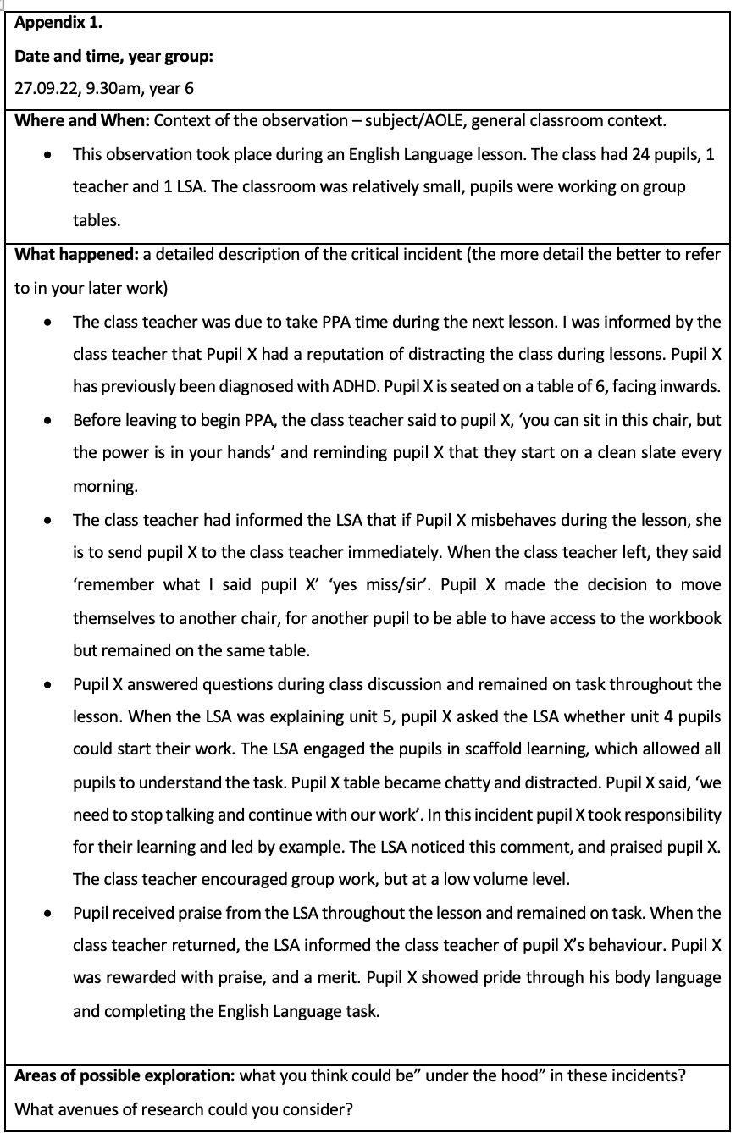

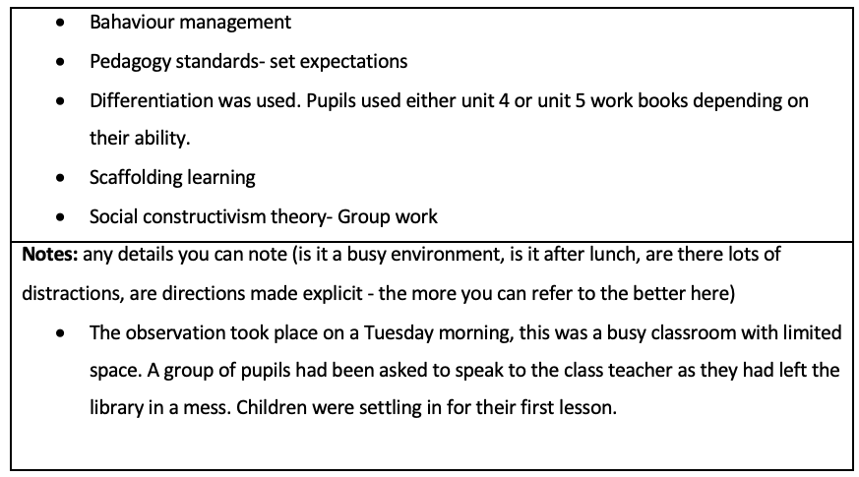

Figure 1 displays a reflection made on 26/09/22 in a year 6 classroom. The observation displays strategies to manage behaviour management for a pupil with ADHD. Reference: Own work, (2022). Critical incident, University of Wales Trinity Saint David, unpublished.

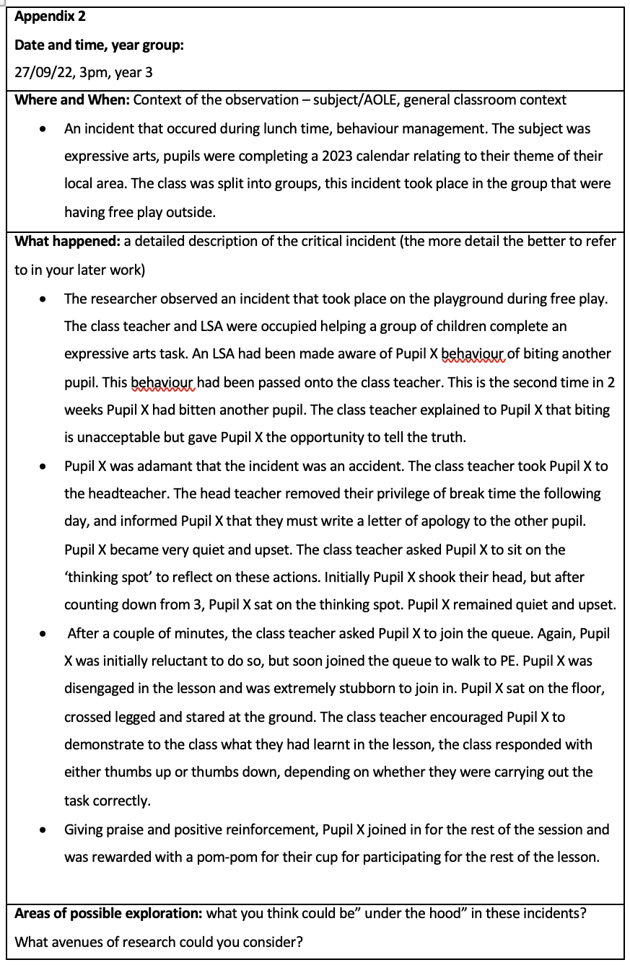

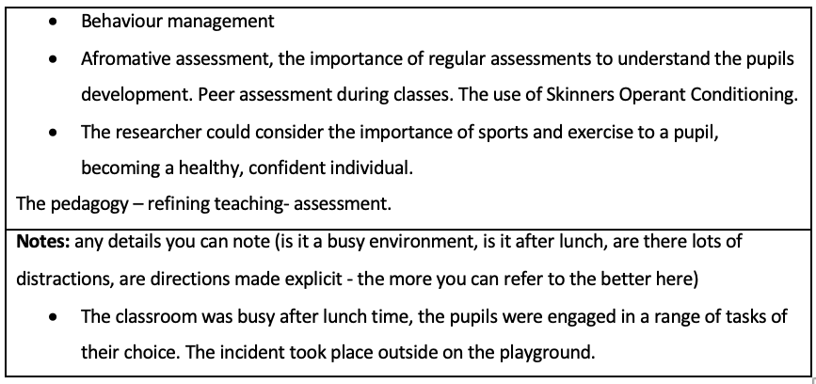

Figure 2 displays a reflection made on 27/09/22 in a year 3 classroom. The observation displays strategies on how behaviour management can be effective within the classroom. Reference: Own work, (2022). Critical incident, University of Wales Trinity Saint David, unpublished.

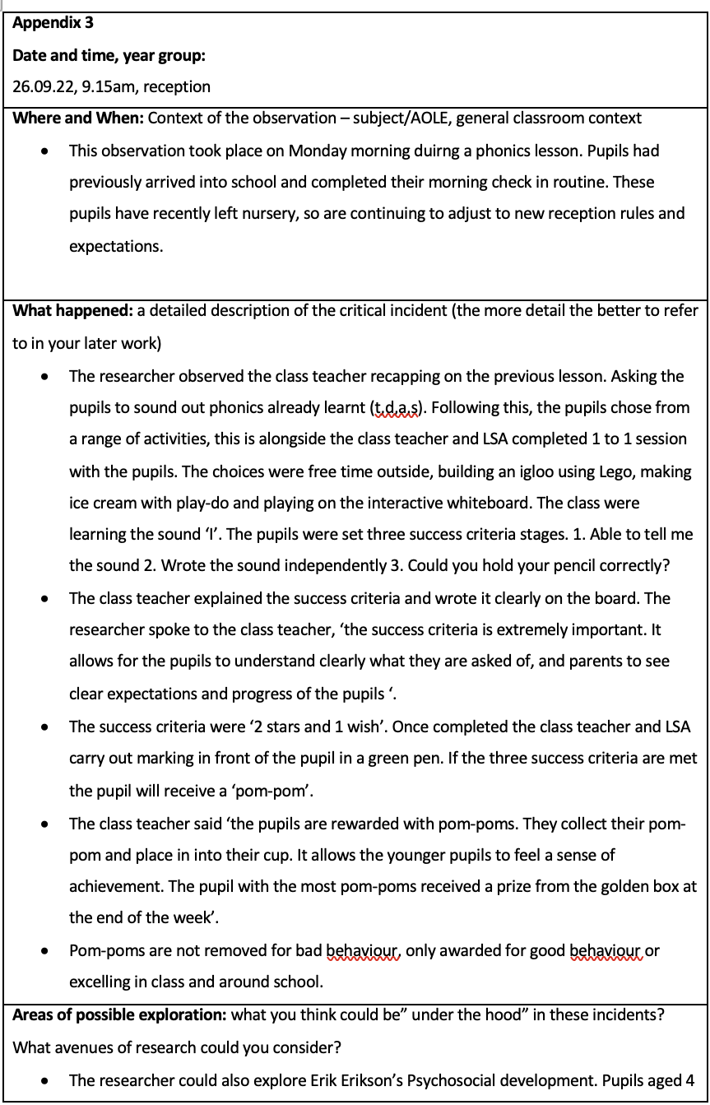

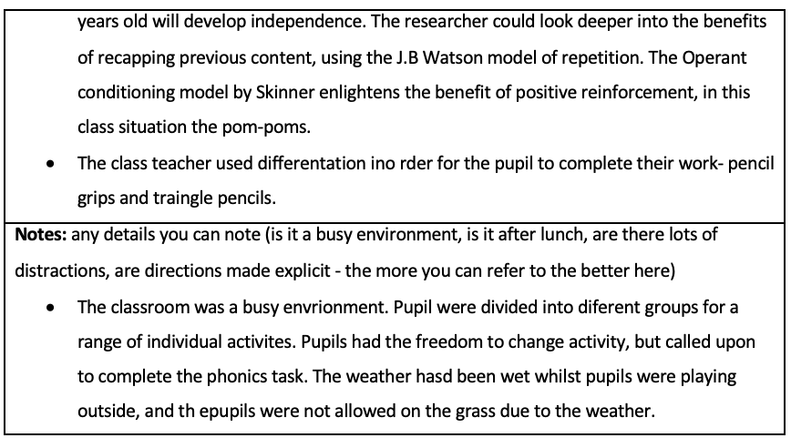

Figure 3 displays a reflection made on 26/09/22 in a reception classroom. Reference: Own work, (2022). Critical incident, University of Wales Trinity Saint David, unpublished.

